MicroNSL Module – Neuron Spiking Simulation in Java

Eduardo Zuloaga
M. Llofriu, A. Weitzenfeld

Abstract

Neurons in the brain exhibit a specific spiking behavior in transmitting impulses between one another. When a Neuron has received enough electrical charge to reach a predetermined membrane potential, the neuron will fire and send charge to all neurons connected to its axons. When we simulate a network and observe this behavior within a computer, we’re able to see some interesting patterns occur.

1. Introduction

The idea behind simulating a basic spiking neural network (SNN) in a program is simple at surface level: we create a Neuron object, instantiate a number of them, and have them send charges to each other while reading their membrane potentials and keeping track of when they spike. Because these events occur as in the same domain of space-time, the entire simulation space must be kept synchronous, thus we will need to orchestrate the simulation via an event manager. At each time step the event manager will process all spikes, queue any new ones, and advance the simulation.

2. Java Classes

At the most basic level, the simulation will consist of the Java classes NeuronSpike, the main driver class, SpikeEventMgr, our singleton event manager, and Neuron, which will receive some voltages, spike, and send some voltages. The Neuron class is the foundational first-class citizen of our project. How it works is as follows: our Neuron will be connected to a number of other output Neurons and keep a ledger of its connections in a List<Neuron> object. It will receive a number of voltage signals from other Neurons, orchestrated by the SpikeEventMgr instance. If its voltage surpasses a predefined threshold, the Neuron will spike and tell the SpikeEventMgr instance to deliver a signal to the output Neurons at the correct time step. The diagram below describes the process visually.

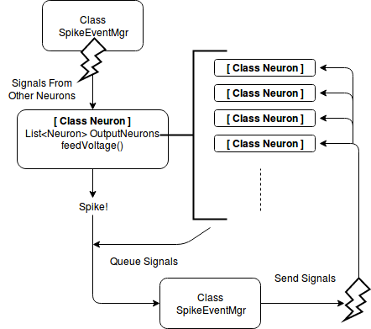
The Neuron class was, however, abstracted and split into two different subclasses, GenericNeuron and OscillatorNeuron, for reasons we will discuss momentarily.

The SpikeEventMgr class exists to consume and queue requests for voltage transmission from Neuron to Neuron at an arbitrary time step, as well as keep a ledger of all spike events that occur for plotting purposes. SpikeEventMgr maintains all queued spike events in a List<SpikeEvent> object. Amidst potentially confusing naming conventions it is imperative to understand what a “spike event” is in the context of the event manager: it is an event where a Neuron is to receive an impulse at a given time, not where a Neuron is meant to spike at that time. Every element in the SpikeEvent list contains data pertaining to the target Neuron, when the transmission should be received, and the magnitude of the signal. When the simulation advances to a new time step, SpikeEventMgr will traverse its spike event list and carry out all events designated for that time. In this way we keep the simulation synchronous. This model functions well under the assumption that all spike events are queued for times after the current time, lest we find ourselves time traveling.

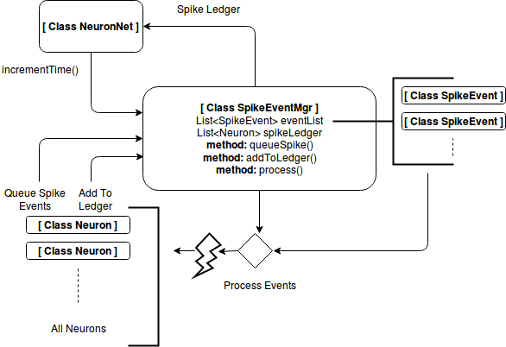
Generating some Neuron objects manually and sending a charge to one of them was enough to give us proof of concept, but in order to see anything meaningful we need to procedurally generate an SNN. This task can be accomplished by generating the network by layers – each layer houses a certain number of Neuron instances which are each connected to some Neuron instances in the previous layer. The NeuronNet class exists for this purpose.

NeuronNet will take in as constructor parameters: the number of layers, an array of integers in which each index represents a layer and each element represents the number of Neurons to be generated, an array of integers to describe connectivity between each layer to the one previous, and some miscellaneous data pertaining to Neuron properties. Using this information, it will generate all the required Neurons and group them into layers, all of which it will store in a List object called layerList, and make axon connections between them based on connectivity parameters. NeuronNet also houses the capability to manage instances of a special Neuron subclass called OscillatorNeuron, which exists only to externally inject voltage into the generated network and can be added and removed at will when the simulation runs.

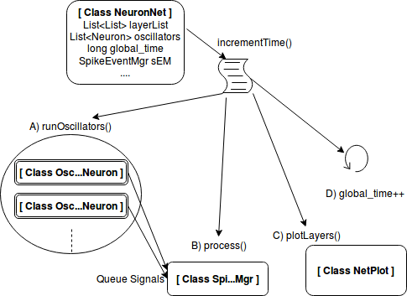

For this purpose the Neuron class is abstracted into two subclasses: GenericNeuron and OscillatorNeuron. GenericNeuron is to be used as a procedurally generated Neuron and is considered part of the SNN. The OscillatorNeuron is generated and used after the simulation begins, sitting on a non-existent “meta” layer feeding voltage to a single GenericNeuron. There are three types of Oscillator types: “Continuous”, spiking at a consistent rate, “Probabilistic”, having a defined probability to spike at each time step, and “Sine”, which works similar to the Continuous class under the hood but its spike rate oscillates on a sine wave with a user-specified wavelength.

The NetPlot class uses the spike ledger from SpikeEventMgr to plot out layers and their spiking neurons on the screen. The ControlPanel class spawns a GUI from which oscillators can be added and removed.

3. Observations

The main title (on the first page) should begin 1-3/8 inches (3.49 cm) from the top edge of the page, centered, and in Times 14-point, boldface type. Capitalize the first letter of nouns, pronouns, verbs, adjectives, and adverbs; do not capitalize articles, coordinate conjunctions, or prepositions (unless the title begins with such a word). Leave two 12-point blank lines after the title.

4. Author name(s) and affiliation(s)

Author names and affiliations are to be centered beneath the title and printed in Times 12-point, non-boldface type. Multiple authors may be shown in a two- or three-column format, with their affiliations italicized and centered below their respective names. Include e-mail addresses if possible. Author information should be followed by two 12-point blank lines.

5. Second and following pages

The second and following pages should begin 1.0 inch (2.54 cm) from the top edge. On all pages, the bottom margin should be 1-1/8 inches (2.86 cm) from the bottom edge of the page for 8.5 x 11-inch paper; for A4 paper, approximately 1-5/8 inches (4.13 cm) from the bottom edge of the page.

6. Type-style and fonts

Wherever Times is specified, Times Roman or Times New Roman may be used. If neither is available on your word processor, please use the font closest in appearance to Times. Avoid using bit-mapped fonts if possible. True-Type 1 fonts are preferred.

7. Main text

Type your main text in 10-point Times, single-spaced. Do not use double-spacing. All paragraphs should be indented 1/4 inch (approximately 0.5 cm). Be sure your text is fully justified—that is, flush left and flush right. Please do not place any additional blank lines between paragraphs.
Figure and table captions should be 10-point boldface Helvetica (or a similar sans-serif font). Callouts should be 9-point non-boldface Helvetica. Initially capitalize only the first word of each figure caption and table title. Figures and tables must be numbered separately. For example: “Figure 1. Database contexts”, “Table 1. Input data”. Figure captions are to be centered below the figures. Table titles are to be centered above the tables.

8. First-order headings

For example, “1. Introduction”, should be Times 12-point boldface, initially capitalized, flush left, with one blank line before, and one blank line after. Use a period (“.”) after the heading number, not a colon.

8.1. Second-order headings

As in this heading, they should be Times 11-point boldface, initially capitalized, flush left, with one blank line before, and one after.

8.1.1. Third-order headings. Third-order headings, as in this paragraph, are discouraged. However, if you must use them, use 10-point Times, boldface, initially capitalized, flush left, preceded by one blank line, followed by a period and your text on the same line.

9. Footnotes

Use footnotes sparingly (or not at all) and place them at the bottom of the column on the page on which they are referenced. Use Times 8-point type, single-spaced. To help your readers, avoid using footnotes altogether and include necessary peripheral observations in the text (within parentheses, if you prefer, as in this sentence).

10. References

List and number all bibliographical references in 9-point Times, single-spaced, at the end of your paper. When referenced in the text, enclose the citation number in square brackets, for example [1]. Where appropriate, include the name(s) of editors of referenced books.

[1] A.B. Smith, C.D. Jones, and E.F. Roberts, “Article Title”, Journal, Publisher, Location, Date, pp. 1-10.

[2] Jones, C.D., A.B. Smith, and E.F. Roberts, Book Title, Publisher, Location, Date.

11. Copyright forms and reprint orders

You must include your fully-completed, signed IEEE copyright release form when you submit your paper. We must have this form before your paper can be published in the proceedings. The copyright form is available as a Word file, <copyright.doc>, as a PDF version, <copyright.pdf>, and as a text file in <authguid.txt>.
Reprints may be ordered using the form provided as <reprint.doc> or <reprint.pdf>.

