**ECG MONITORING SYSTEM WITH ARDUINO**

**Abstract**

The healthcare monitoring systems has emerged as one of the most vital system and became technology oriented from the past decade. Humans are facing a problem of unexpected death due to various illness which is because of lack of medical care to the patients at right time. The primary goal was to develop a reliable patient monitoring system using IoT so that the healthcare professionals can monitor their patients, who are either hospitalized or at home using an IoT based integrated healthcare system with the view of ensuring patients are cared for better. A mobile device based wireless healthcare monitoring system was developed which can provide real time online information about physiological conditions of a patient mainly consists of sensor, the data acquisition unit, i.e., Arduino, and programmed with a software (Arduino IDE). The patient’s ECG values are monitored, and stored by the system and sent to the doctor’s mobile containing the application. Thus, IoT based patient monitoring system effectively monitor patient’s health status and save life on time

**Keywords**: Arduino, ECG, GSM

**Existing Method**

In social insurance framework for patients who stays in home during post operational days checking is done either via overseer/ medical caretaker. Ceaseless observing may not be accomplished by this system, on the grounds that anything can change in wellbeing parameter inside of part of seconds and amid that time if guardian/attendant is not in the premises causes more noteworthy harm. So, with this innovation created period where web administers the world gives a thought to add to another keen health awareness framework where time to time constant checking of the patient is accomplished.

**Drawbacks:**

* Patient Data is exchanged.
* Patient needs to attend for every checkup.
* Critical condition is unknown.

**Proposed Method**

Constantly monitoring and watching the health parameters like heartbeat, and many others could be very hard nowadays. It calls for person strength to monitor. If incase the individual careless or engaged in one-of-a-kind paintings or tiredness they are able to monitor. So in this situation dying is likewise feasible. In this task embedded technology has been used. The fitness parameters are being measured by using unique kinds of sensor. The ECG senses the information from man or women, then the sensor reading data will be send to web server via GSM/GPRS Module to monitor values in cloud.

**Block Diagram**

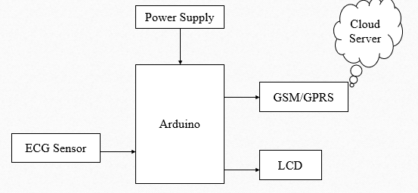

**Fig: block diagram of proposed method**

**Advantages:**

* Portable system.
* Save risk of heart attack as you can check it in home.
* Affordable system.
* Temperature and Heart beat monitoring by single device
* All Patient monitored by single person seating in Server room.
* This system also helps for Hospital monitoring system.

**Applications:**

* Very compatible it is very use full in medical camps.
* Useful in hospitals it reduces the heavy equipment.
* Very use full in taking care of disabled persons.

**Hardware Requirements:**

* Arduino
* Lcd
* ECG sensor
* GSM/GPRS Module
* Power supply
* Adapter 12v

**Software Requirements:**

* Arduino IDE
* Embedded C

**Learning outcomes:**

* Arduino pin diagram and architecture
* How to install Arduino IDE software
* Setting up and installation procedure for Arduino
* Introduction to Arduino IDE
* Basic coding in Arduino IDE
* Working of ECG sensor
* Interface ECG sensor with Arduino?
* Working of GSM module
* Interface GSM module with Arduino?
* Working of power supply
* Working of LCD
* Interface LCD with Arduino?
* About Project Development Life Cycle:
* Planning and Requirement Gathering (software’s, Tools, Hardware components, etc.,)
* Schematic preparation
* Code development and debugging
* Hardware development and debugging
* Development of the Project and Output testing
* Practical exposure to:
* Hardware and software tools.
* Solution providing for real time problems.
* Working with team/ individual.
* Work on Creative ideas.
* Project development Skills
* Problem analyzing skills
* Problem solving skills
* Creativity and imaginary skills
* Programming skills
* Deployment
* Testing skills
* Debugging skills
* Project presentation skills
* Thesis writing skills