Title

Contract Order NO: xxx (include if contract; otherwise delete)

Contract Reference NO: xxx (include if contract; otherwise delete)

*Grant NO: xxx (include if* agreement*; otherwise delete)*

*NPS Research Permit #: xxx*

Month Year

Prepared for:  
National Park Service, Washington Support Office WASO   
P.O. Box 25287 MS WCP  
Denver, CO 80225

Prepared by:  
Company Name  
Address line 1  
Address line 2

# Executive Summary (Style: Heading 1)

Brief context, project description and major take-aways.

# Introduction (Style: Heading 1)

Background, reason for inventory.

## Park Resource Management Issues (Style: Heading 2)

Describe the park resource management decisions or issues this project will inform (mostly taken from the Statement of Work). Include relevant ecology or natural history aspects that influence the study design, and the suitability of the results to address potential additional issues.

## Permits (Style: Heading 2)

Info on permits obtained (and put copies of permits in an Appendix).

# Methods (Style: Heading 1)

## Sample Design (Style: Heading 2)

Text describing sample design with enough detail that someone could repeat the work or see if the data from this project could be used to answer another question. Include any code/scripts used as file(s) in the deliverables.

## Survey Methods (Style: Heading 2)

Describe survey methods in detail, including when and how the work was done. Include relevant citations.

## Analysis Methods (Style: Heading 2)

Include enough detail so that someone could redo the analyses. Include any code used (R, python, etc.) as a separate file in the deliverables. Include relevant citations.

# Results (Style: Heading 1)

## Field Survey (Style: Heading 2)

Results described here. Create as many subheadings as needed to organize results. Include table and figure headers formatted to indicate the result set or sets used to produce them. Include relevant citations.

### Third order heading (Style: Heading 3)

Lorem ipsum aliquet tincidunt bibendum ultrices mi himenaeos, auctor elit justo consequat litora tempor, faucibus quis elementum platea quisque tristique sapien consectetur dictumst eu porta diam sodales platea.

#### Fourth order heading (Style: Heading 4)

Platea lacinia elementum lacus feugiat scelerisque cursus commodo, cras dui congue quisque blandit elit dolor tortor

##### Fifth order heading (Style: Heading 5)

Interdum auctor tempor aenean duis bibendum ipsum dapibus primis suscipit, est dictumst dui adipiscing aliquam adipiscing nec mi vitae (Appendix A).

# Conclusions

Report conclusions. Discuss how results inform park resource management needs.

Also include any lessons learned that might be of value for future related efforts.

# Works Cited

Use this format, ensuring all items cited in narrative are included:

DeVivo, J. C. 2019. Inventories 2.0: a plan for the next generation of NPS natural resource inventories. Natural Resource Report NPS/NRSS/NRR—2019/2007. National Park Service, Natural Resource Stewardship and Science, Fort Collins, Colorado. <https://irma.nps.gov/Datastore/Reference/Profile/2266646>.

Stevens, D. L., and A. R. Olsen. 2004. Spatially balanced sampling of natural resources. Journal of the American Statistical Association 99(465):262–278. <https://doi.org/10.1198/016214504000000250>.

# Appendix A

Figure and table examples

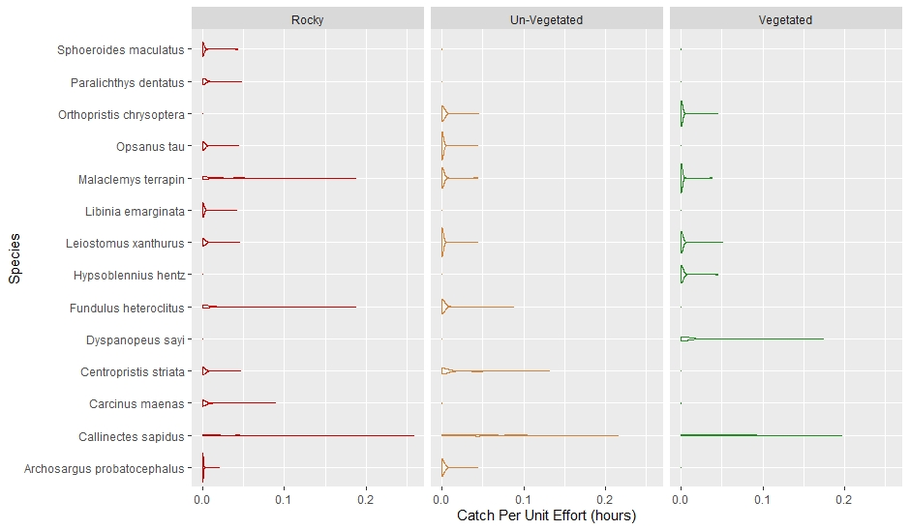

**Figure 1.** Style: Caption. Figure example. The figure itself should contain alternate text to adequately describe the image. Example of alt text: “Figure 1. A series left-to-right violin plots showing catch per effort (CPUE) for 14 species by habitat type. This same information is also presented in Table x above.” To edit alt text, right click the figure and select “Edit Alt Text.”

**Table 1**. Example of a basic table. (Style: Caption)

| Sample Unit | Site | Indicator | Source |
| --- | --- | --- | --- |
| Rocky | R01 | Vegetation | I&M Program |
| R02 | Deer | I&M Program |
| Unvegetated | U01 | Seedling density | I&M Program |
| U05 | Canopy cover | I&M Program |
| U06 | Rare plant species | I&M Program |
| Vegetated | V01 | Occurrence frequency | I&M Program |