

Faculty of Engineering Cairo University / Group 2

ICUFE
Software Design Specification (SDS)
Version: <1.0>
CM Identifier: G2_SDS_V_1

Revision History

Sl. No. | Prepared/  Modified by | E-mail | Version | Date | Approved by | Descriptions/  Remarks
1. | <Name(s) of the author(s)> | <e-mail> | <x.y> | <Mmm. dd, yyyy> | <Name of the approving authority> | <The action performed on the document. Include a link to the modified part>

Distribution list
Name | E-mail | Notes
Eng. Ali El Sedeek | alielseddeek@gmail.com | Approval needed

Table of Contents

1. Introduction 5
1.1 Purpose of this Document 5
1.2 Scope 5
1.3 Table of Acronyms and Definitions 5
1.4 References 5
1.5 Overview of Document 5
2. System Architecture 6
2.1 Design Patterns Description 6
2.1.1 MVC 6
3. Design Models 7
3.1 Class Diagrams 7
3.1.1 Model Diagram 7
3.1.2 Controller Diagram 7
3.2 Interaction Diagrams 8
3.2.1 Login Diagram 8
3.2.2 Change Password Diagram 9
3.2.3 Edit Profile Diagram 10
3.2.4 Add Project Diagram 11
3.2.5 View Project Diagram 12
3.3 Activity Diagrams 13
4. Data Models 14
5. System Deployment 15
6. Traceability to Requirements 15

List of Tables

Table 1 Traceability Matrix 15

List of Figures

Figure 1 System Architecture 6
Figure 2 Class Diagram 7
Figure 3.1: SD1 Login Sequence Diagram 8
Figure 3.2: SD2 Change Password Sequence Diagram 9
Figure 3.3: SD3 Edit Profile Sequence Diagram 10
Figure 3.4: SD4 Add Project Sequence Diagram 11
Figure 3.5: SD5View Project Sequence Diagram 12
Figure 4 Activity Diagram 13
Figure 5 ER Diagram 14
Figure 6 System Deployment diagram 15

Introduction

Purpose of this Document
The purpose of this document is to visualize, specify and construct models for the system and to show different aspects of the design processes.

Scope
The website is for CUFE students to use as communication platform. A user shall be able to Login to the personal page that is customized to view information he/she selects, and shall be able to add projects and show projects details.

Table of Acronyms and Definitions

Term | Definition
CUFE | Cairo University Faculty of Engineering

References

[1] The Object Primer 3rd Edition: Agile Model Driven Development with UML 2.
[2] Unified Modeling Language, Superstructure, V2.1.2

Overview of Document

The document shows the system architecture of our web app, then the different design models that explain how our system works (Sequence Diagrams and Class Diagram). After this ,The document shows the deployment diagrams which model how the system will be deployed, and finally the requirements traceability methodology which help of matrices design to keep track of user stories and designed elements.

System Architecture
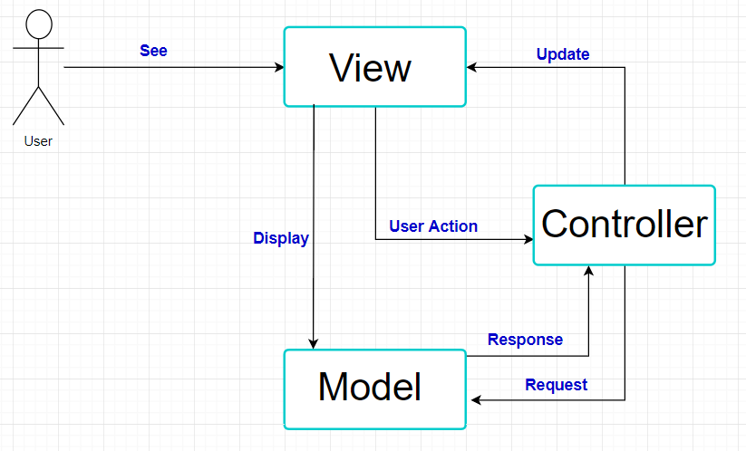
Figure 1 System Architecture

Design Patterns Description

MVC
The website is being developed using Laravel which is MVC framework. The project is separated to 3 sections, models that deal with the database, views that is the UI (User Interface), and controllers that retrieve the inputs and connect the models with the views.

Design Models

Class Diagrams
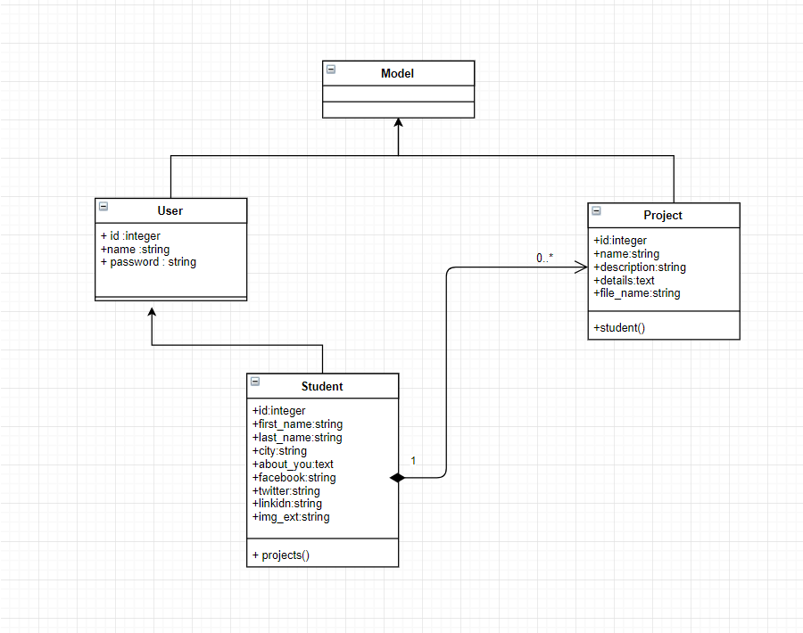
Figure 2.1 Model Class Diagram

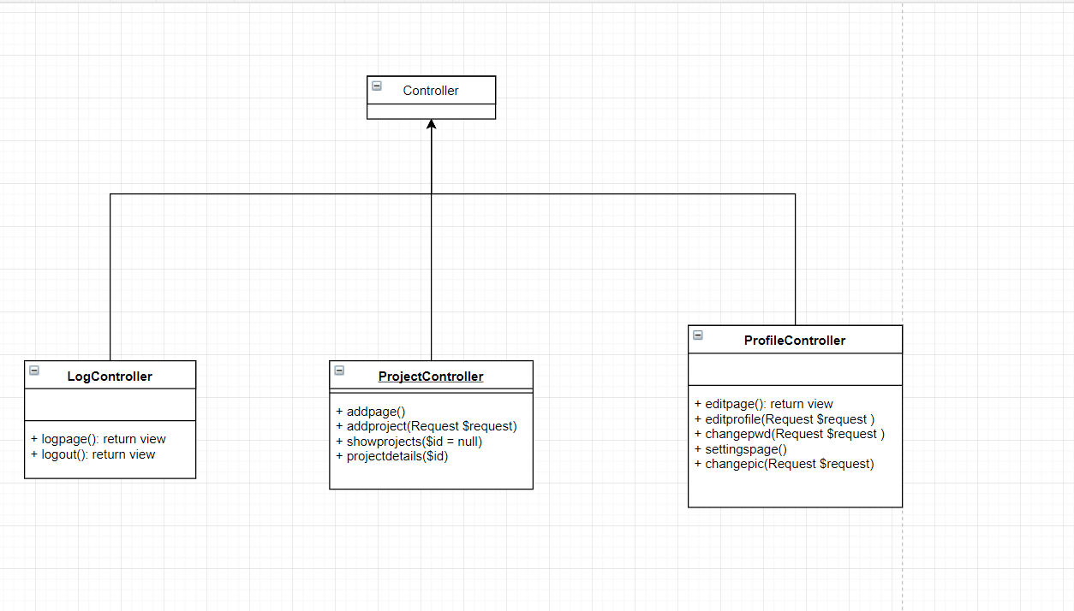
Figure 2.2 Controller Class Diagram

Interaction Diagrams

Login Diagram
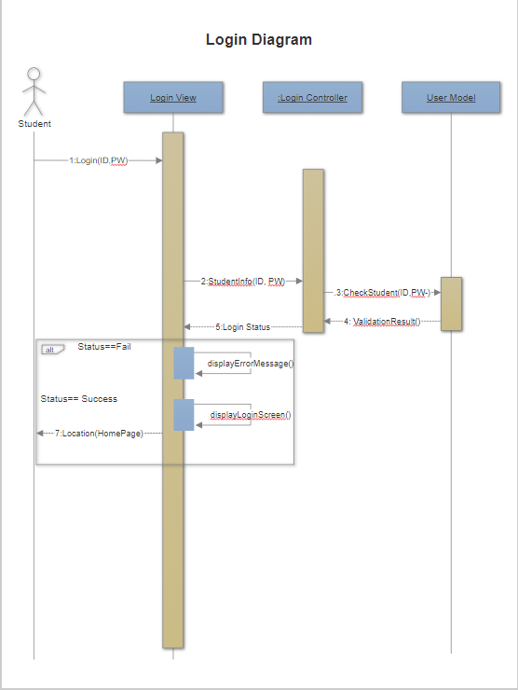

Figure 3.1: SD1 Login Sequence Diagram

Change Password Diagram
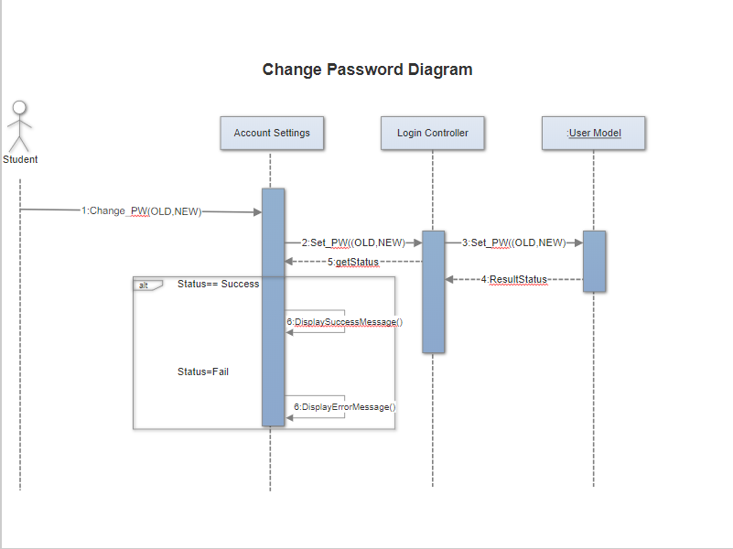
Figure 3.2: SD2 Change Password Sequence Diagram

Edit Profile Diagram
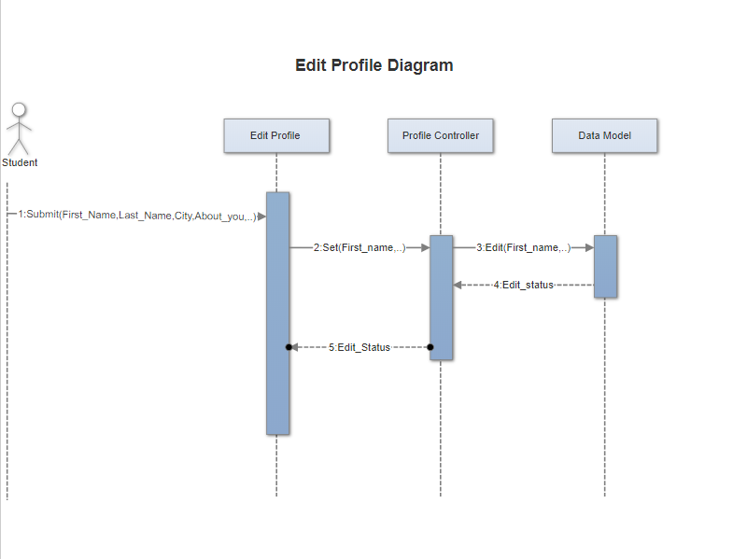

Figure 3.3: SD3 Edit Profile Sequence Diagram

2.3.4 Add Project Diagram
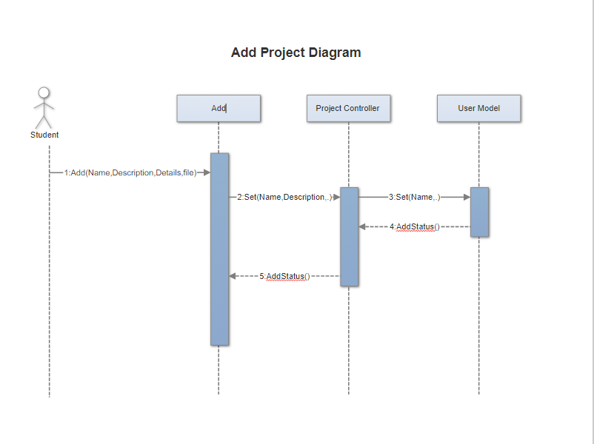
Figure 3.4: SD4 Add Project Sequence Diagram

2.3.5 View Project Diagram
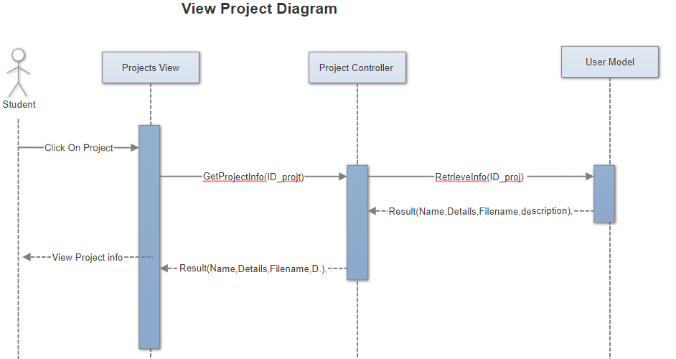

Figure 3.5: SD5 View Project Diagram

Activity Diagrams

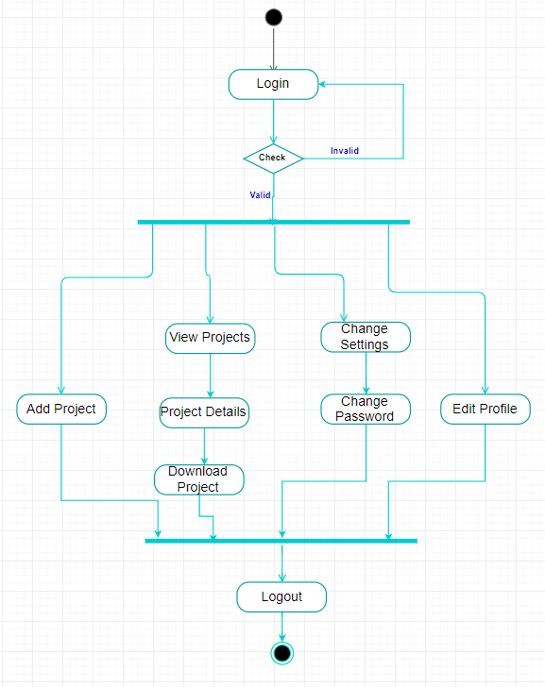

Figure 4 Activity Diagram

Data Models

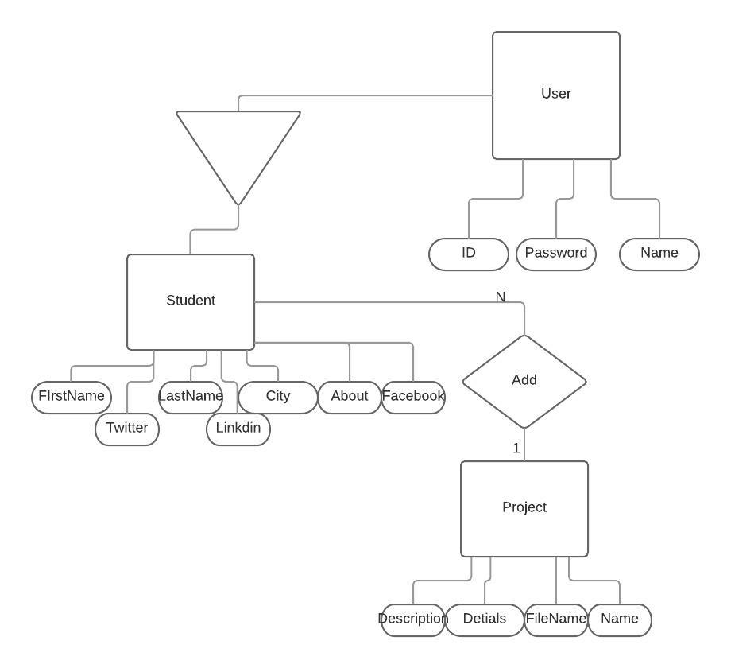
Figure 5 ER Diagram

System Deployment

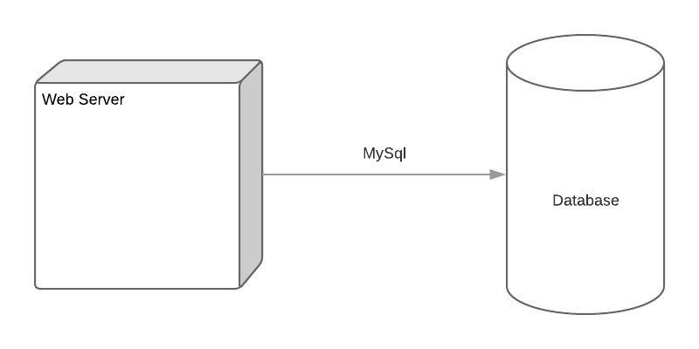
Figure 6 System Deployment

Traceability to Requirements

 | SD1 | SD2 | SD3 | SD4 | SD5
US1
US2 | ✓
US3
US4
US5
US6
US7
US8
US9
US10
US11
US12
US13
US14 |  | ✓
US15 |  |  | ✓
US16 |  |  |  | ✓ | ✓

