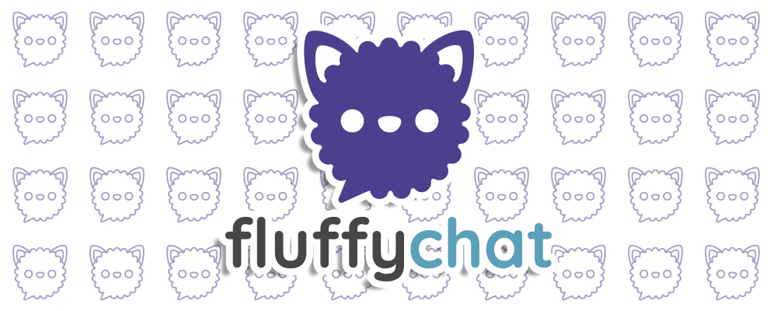
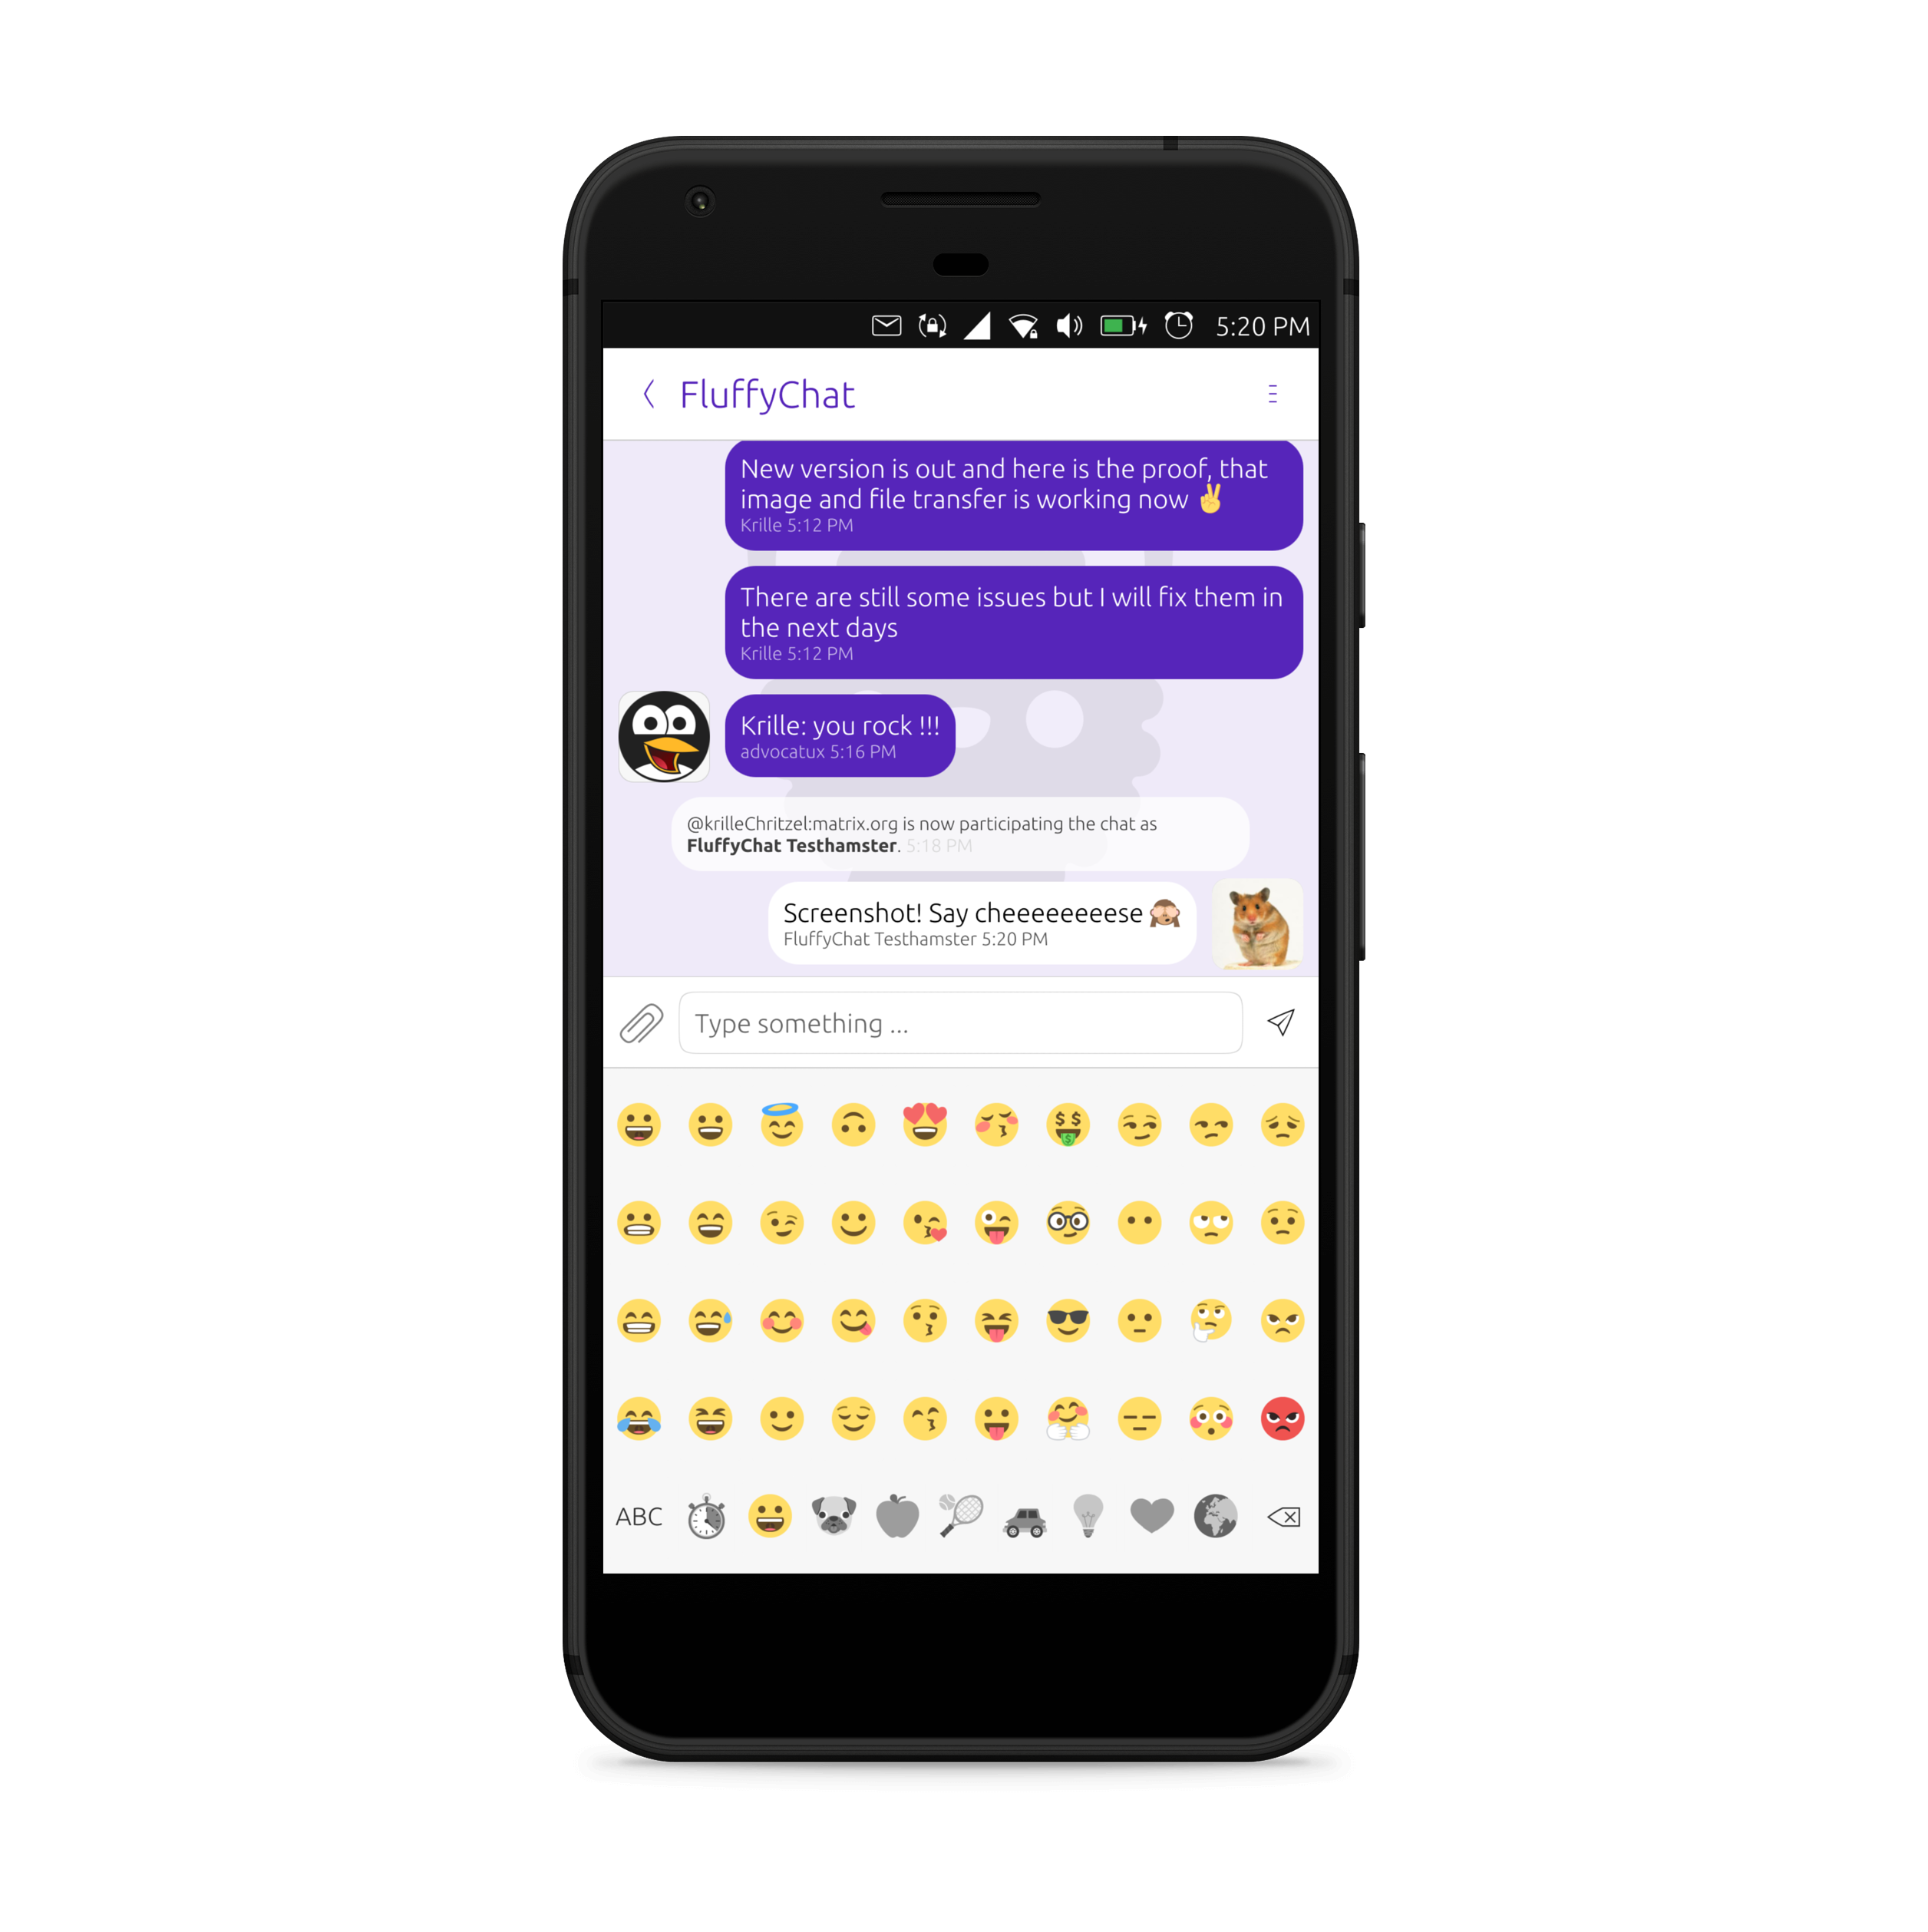

Open. Nonprofit. Cute ♥
Chat with your friends from Ubuntu Touch.


  Open  Opensource and open development where everyone can join. |   Nonprofit  Fluffychat is donations funded. |   Cute ♥  Cute design and much theme settings including a dark mode.
  Direct- and groupchats  Unlimited groups and direct chats. |   Easy  Fluffychat is made as simple to use as possible. |   Free  Free to use for everyone without ads.
  Connective  Fluffychat can use your addressbook to find your friends. |   Decentralized  There is no „fluffychat server“ which can track you. |   Compatible  Compatible with Riot, Fractal, Nekho and all matrix messengers.


Fluffychat came with a dream
Imagine a world where everyone can choose the messenger he likes and is still able to chat with all of his/her friends.
A world where is no single company which tracks all selfies you send to your love.
And a world where apps are made for fluffyness and not for profit. ♥

