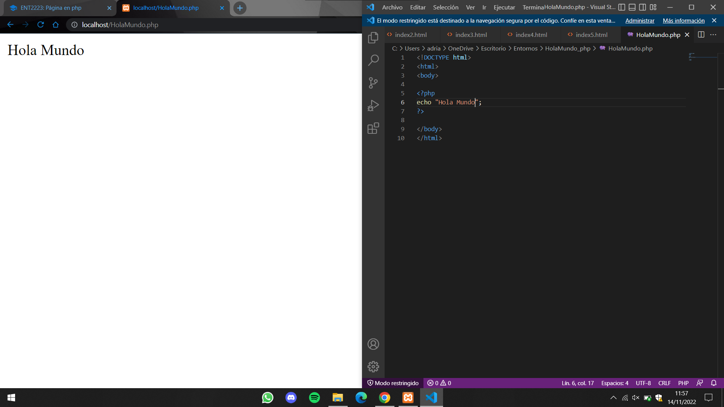**HOLAMUNDO.PHP**