AeroLab Studio
Aerogel-fibre analysis workbench

User guide · version 1.0.0

Made by Ezzeldien Yousef · ezz.yousef@mail.utoronto.ca
MPML — Microcellular Plastics Manufacturing Laboratory
Department of Mechanical & Industrial Engineering, University of Toronto
September 2026

Contents
1. What AeroLab Studio does
2. Installing and starting
3. The window
4. Quick start with the demo data
5. Importing data
6. Measurements
7. The Calculator
8. Plots — overlaying runs
9. Exporting
10. Validation
11. Settings
12. Sessions, undo and shortcuts
13. If something goes wrong
14. About

1. What AeroLab Studio does
Everything in the three source papers on aerogel fibres (Omranpour et al.) is either an equation or a measurement, and the application is built around that split:
- An equation takes a few numbers and returns one — porosity from two densities, the Knudsen correction, the SWT parameter. You work these on the Calculator page.
- A measurement takes columns of instrument data and returns many numbers plus graphs — a tensile pull gives a modulus, UTS, elongation, toughness and a stress–strain curve. These live on the Data and Measurements pages.
Both halves feed the same exports: a formatted Excel workbook, a styled OriginLab project and publication figures.

2. Installing and starting

Installer (recommended)
1. Run dist\AeroLabStudio-Setup-1.0.0.exe and follow the wizard (it creates a Start-menu shortcut and, if you tick it, a desktop shortcut; it can be removed from Windows Settings › Apps).
2. Start the application from the Start menu. A splash screen shows while it loads.

Portable copy (no installation)
Unzip dist\AeroLabStudio-1.0.0-portable.zip anywhere and run AeroLabStudio.exe inside the folder. Keep the whole folder together — the exe needs every file next to it.

From source (developers)
With Python 3.11 or newer: pip install -r requirements.txt, then python main.py. python main.py data.csv … starts and imports those files.
Tip python main.py --selftest (or the exe with --selftest) exercises the whole application without opening a window and prints PASSED or FAILED — useful after installing on a new PC. --version prints the version.

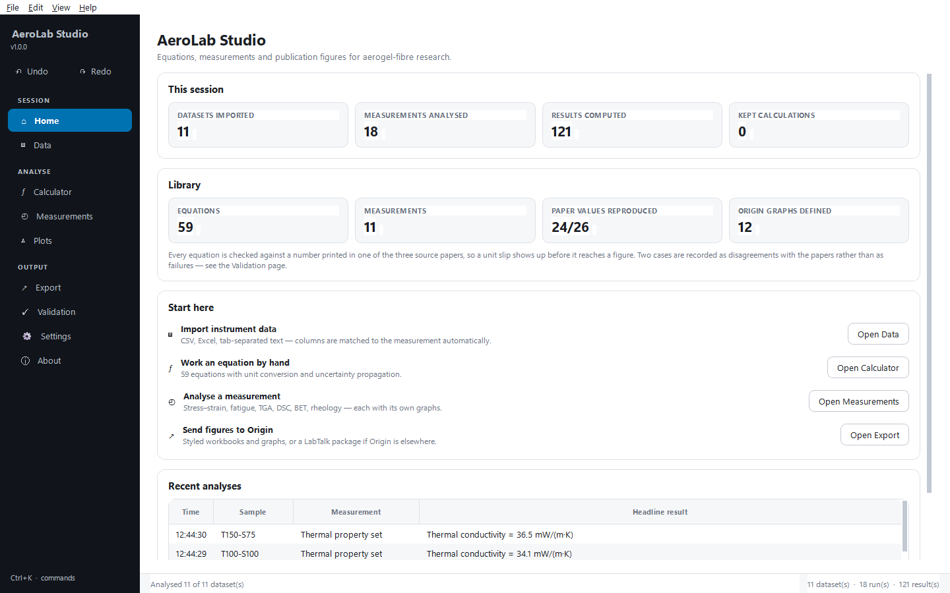
Figure 1. The Home page: session tiles, the library, where to start and recent analyses.

3. The window
Every page is one click away on the dark navigation rail on the left, grouped as follows:
Rail group | Pages
Session | Home, Data
Analyse | Calculator, Measurements, Plots
Output | Export, Validation, Settings, About

- Undo / Redo buttons sit at the top of the rail (also Ctrl+Z / Ctrl+Y and the Edit menu). Their tooltips name the action that will be undone.
- Status bar (bottom): the last action, and on the right a count or the plot coordinates under the mouse.
- Notifications appear briefly in the bottom-right corner and never block your work; anything that needs a decision opens a dialog instead.
- Command palette — press Ctrl+K and type part of any action or page name, then Enter.
- Light / dark theme — Ctrl+T or View › Toggle light / dark theme. Plots follow the theme on screen; exported figures are always light.
- Ctrl+1 … Ctrl+9 jump straight to the pages in rail order.
The status bar on the right counts datasets, runs and results in the session.

4. Quick start with the demo data
1. Press Ctrl+D (or Data › Load demo data). Eleven demo datasets are imported — one for each kind of measurement.
2. On the Data page, click a dataset to see its preview, the measurement the application guessed and the column mapping.
3. Click Analyse all imported. The application opens Measurements with one run per dataset.
4. Click a run and look at its Results, Graph and Settings tabs.
5. Open Export and click Export to Excel… or Export to Origin….
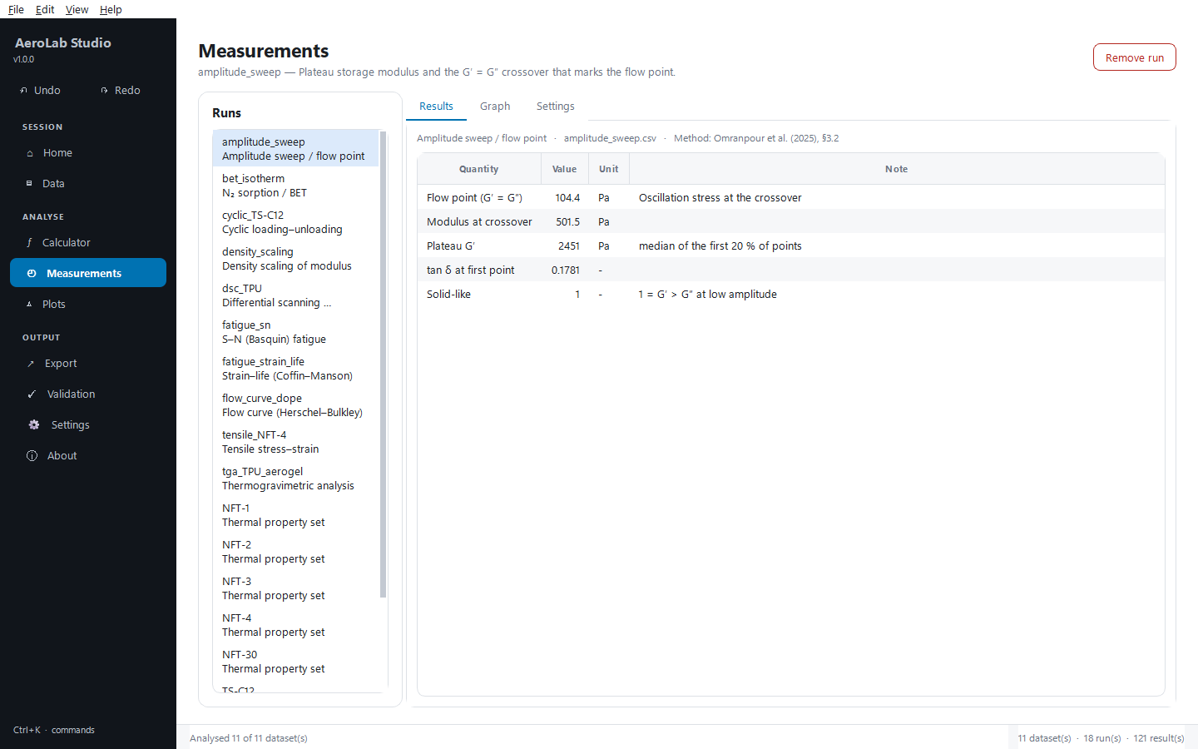
Figure 2. Measurements after analysing the demo data: runs on the left, results on the right.

5. Importing data
Use Import files… (Ctrl+O) on the Data page, or drag files onto the drop zone. Dropping a folder imports every readable file in it. Understood formats: .csv .tsv .txt .dat .asc .prn .xlsx .xlsm .xls .json .npz.
Real instrument exports are messy, and the importer expects that:
What the file does | What happens
Twenty lines of instrument metadata before the header | Detected and skipped; shown in the preview
Units on a second header row (Origin's layout) | Read as units, not as data
Stress (MPa) in one header cell | Split into a name and a unit
k (mW/(m·K)) — nested brackets | Split correctly
1,234 meaning 1.234 (European locale) | Detected by counting patterns across the file
Semicolons, tabs or runs of spaces as separators | Sniffed
A multi-sheet workbook | One dataset per sheet that holds numbers
A text column such as a sample name | Kept as labels

Check before you analyse
Selecting a dataset shows its Preview; the Analyse card beneath it shows the measurement the application guessed and the column mapping. A pill says whether every required column was matched. Nothing is analysed until you press a button, and every guess is a drop-down you can change.
- Analyse this dataset runs the measurement shown.
- Analyse all imported guesses for every dataset, runs the confident ones and reports how many succeeded.
- Remove and Clear all take datasets out of the session (undoable).
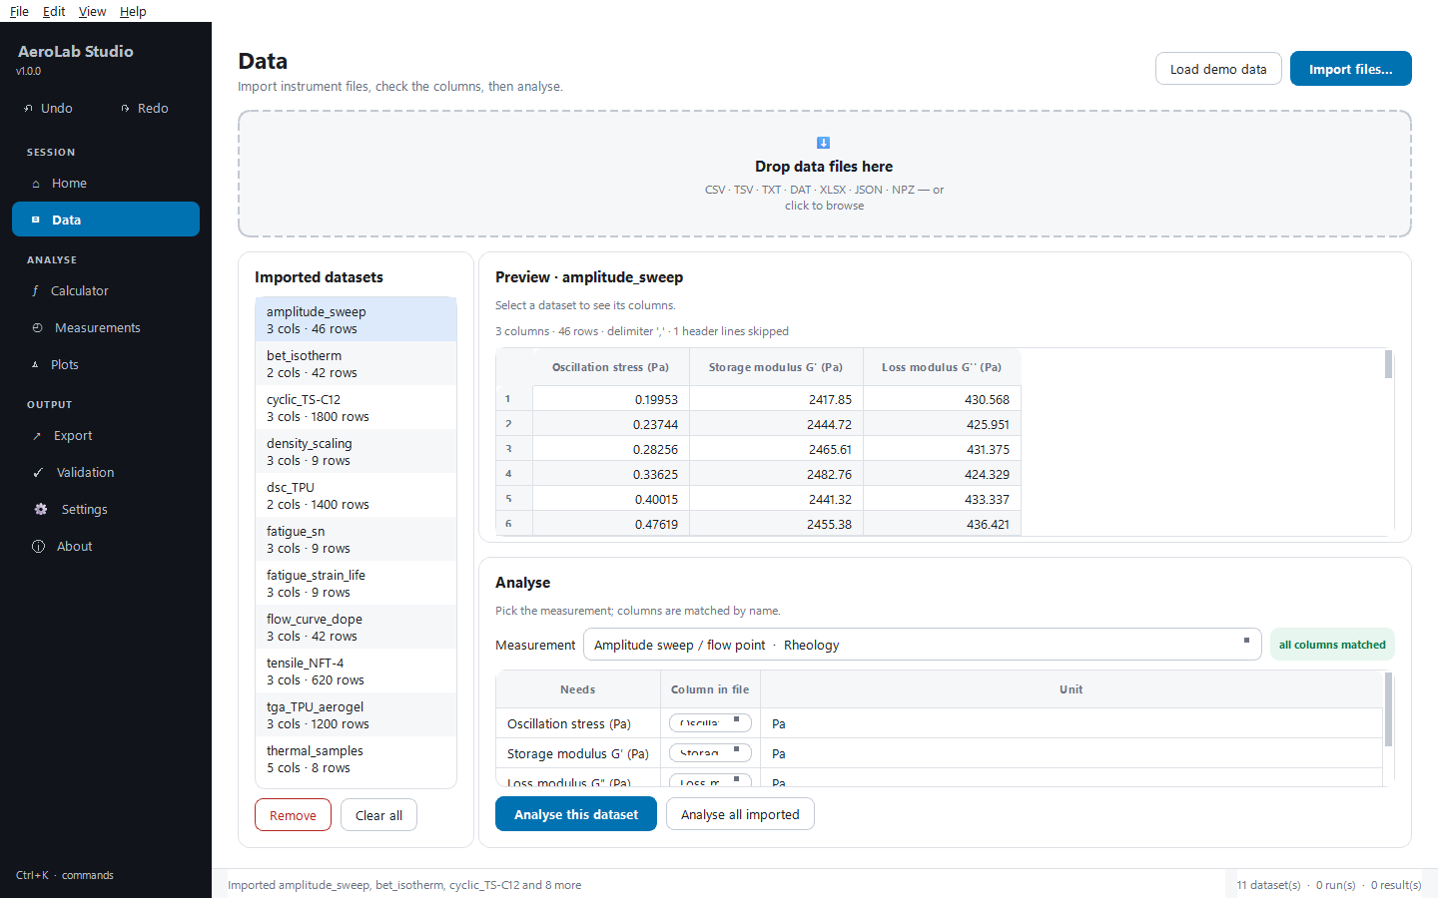
Figure 3. The Data page: imported datasets, the preview, and the measurement and column mapping.

6. Measurements
One row per analysed dataset in the Runs list. Three tabs on the right:
- Results — every computed quantity with its unit and, where it matters, a note saying how it was obtained.
- Graph — the graphs the measurement defines, with a results box placed where the data leaves room. Save image… writes PNG, PDF, SVG or TIFF.
- Settings — the analyser's options (the BET window, the DSC heating rate, the offset-yield strain…). Change them and click Re-run with these settings; the original data is untouched and Ctrl+Z puts the previous result back.
Remove run (top right) deletes the selected run.
Measurement | Needs | Gives
Tensile stress–strain | strain %, stress MPa | E, UTS, strain at UTS, elongation at break, toughness, offset yield, resilience
Cyclic loading–unloading | strain %, stress MPa | cycles, permanent set, hysteresis energy, stress softening, ratcheting
S–N (Basquin) | Nf, stress amplitude | σ′f, b, R², predicted life
Strain–life | Nf, elastic and plastic amplitudes | b, c, ε′f, σ′f, transition life
Density scaling | density, modulus | scaling exponent with confidence interval, against Gibson–Ashby
TGA | temperature, weight % | T at each loss threshold, onset, residue, DTG peaks
DSC | temperature, heat flow | each transition with its baseline and enthalpy, Tg estimate
Thermal property set | k, ρ, cp, (thickness) | diffusivity, effusivity, volumetric heat capacity, R-value, clo
N₂ sorption / BET | p/p₀, adsorbed volume | BET area, Vm, C, pore volume, mean pore diameter, R²
Flow curve | shear rate, shear stress | τy, K, n, R², apparent viscosity at 1 s⁻¹
Amplitude sweep | stress, G′, G″ | plateau G′, flow point, modulus at crossover, tan δ

7. The Calculator
Every equation, searchable. Pick one and it shows the formula, its source, and an input for each variable.
- Units — each input has its own unit selector; type 211 kg/m³ where the equation wants g/cm³ and the conversion happens on the way in. The result has a unit selector too.
- Uncertainty — the narrow ± box beside an input is optional. Fill in one or more and the result carries a propagated uncertainty (central differences, no linearity assumption).
- Lists — equations such as the rule of mixtures take several comma-separated values.
- Keep result adds the evaluation to Kept results, which is written to the Calculations sheet on export; Clear kept empties it.
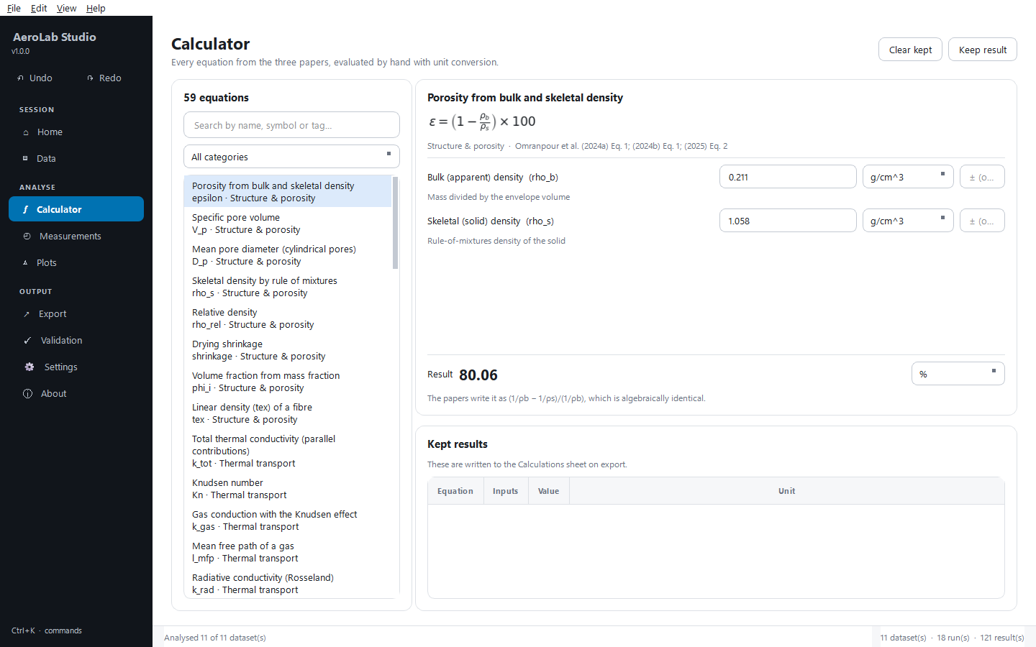
Figure 4. The Calculator: searchable equations, units, uncertainty and kept results.

8. Plots — overlaying runs
Overlays several runs of the same measurement on one pair of axes — for example four fibre grades on one stress–strain plot. In Choose runs, tick the runs (only runs of the same measurement can share axes; Select all / Select none help), choose the graph, set Show fits and Legend, then Draw. Save image… exports the figure. Neighbouring series never share a symbol, and a fit always takes the colour of its data.
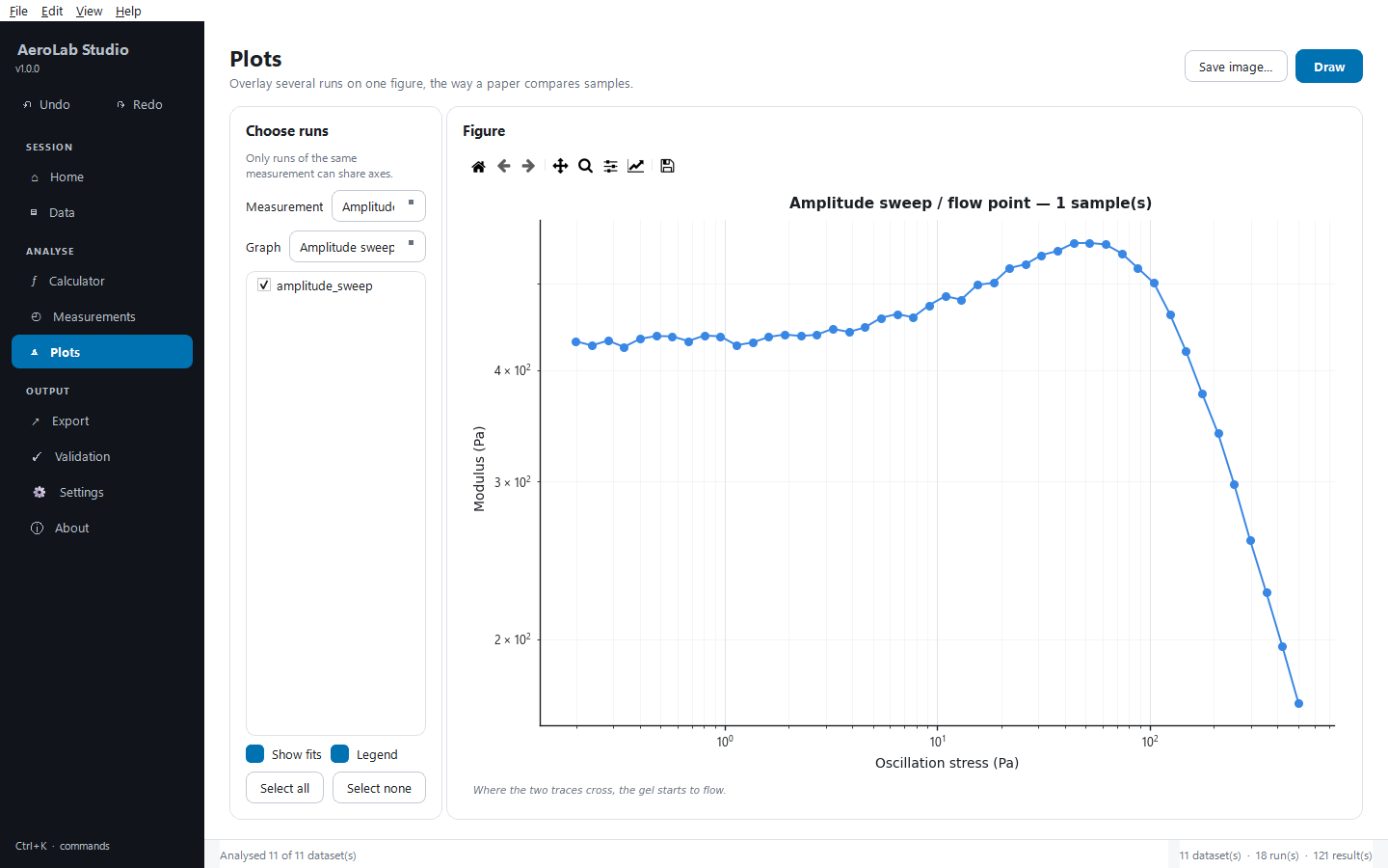
Figure 5. Plots: several runs of one measurement on shared axes.

9. Exporting

What will be exported
The first card on the Export page lists the runs; tick the ones to include (Select all / Select none).

Excel workbook
Options Include raw curves, Include native charts and Include validation sheet, then Export to Excel… (Ctrl+E). The workbook contains a Summary of every result, Calculations (kept equations), Validation, one sheet per dataset (results, settings used, raw and derived curves), native editable Charts, and Provenance (versions, source files, settings, timestamp).

OriginLab
1. Open the Export page and tick the runs to send.
2. Choose the options: Export PNG of each graph, Show Origin while it works, Leave Origin open afterwards.
3. Click Export to Origin… (Ctrl+R) and choose where to save the project. Origin takes 10–20 seconds to start; the export runs on a worker thread so the window stays responsive.
4. Each dataset becomes a workbook whose columns carry Long Name, Units and Comments, plus every graph the measurement defines — publication palette, filled/open symbols, dashed fits in their data's colour, log axes where appropriate — saved as an .opju project (and PNGs if ticked).
Tip No Origin on this PC? Click Write LabTalk package…. You get Origin-ready CSV files plus AeroLab_build.ogs; copy the folder to a PC with Origin and run the script to rebuild the whole project with the same styling.

Figure set
Export figures… writes every graph as PNG, PDF, SVG, TIFF or EPS at single-column (85 mm), double-column (175 mm), square or presentation size, at 110, 300 or 600 dpi.
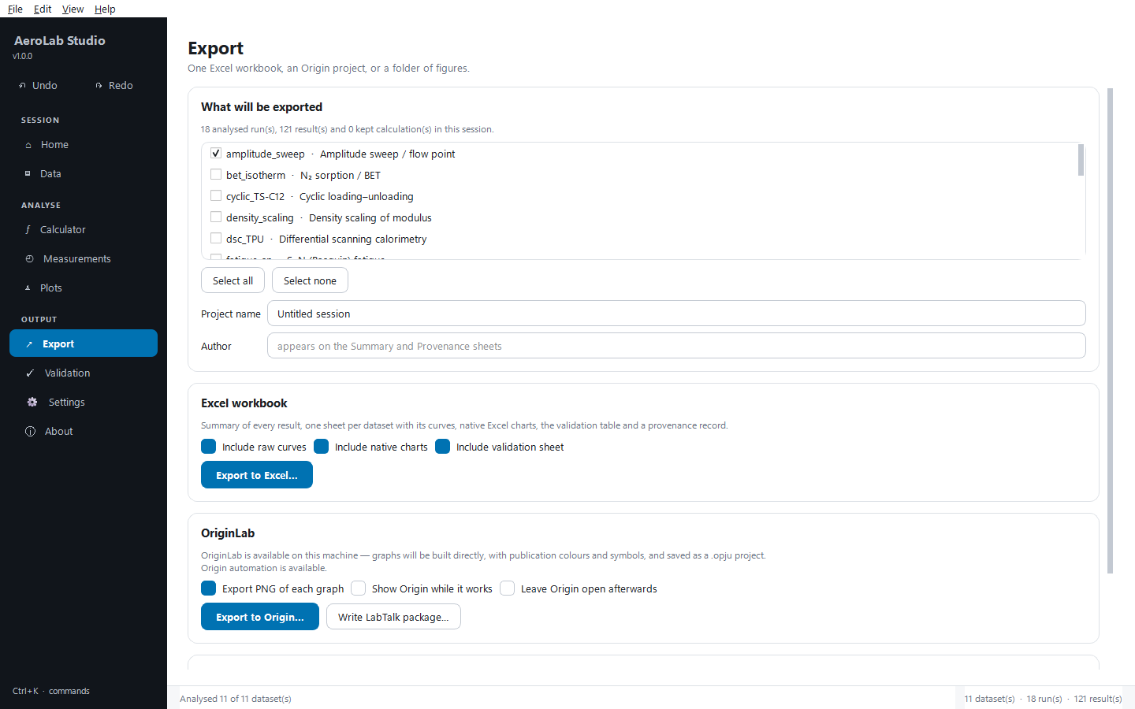
Figure 6. The Export page: scope, Excel workbook, OriginLab and figure set.

10. Validation
Twenty-six cases recompute a number printed in one of the papers. Re-run checks runs them again.
- reproduced — the equation returns the published value within tolerance.
- documented — it could not be reproduced and the comment explains why (two cases, described in the README; recorded disagreements with the source, not bugs).
- FAILED — should never appear; it would mean a real error in the equation library.
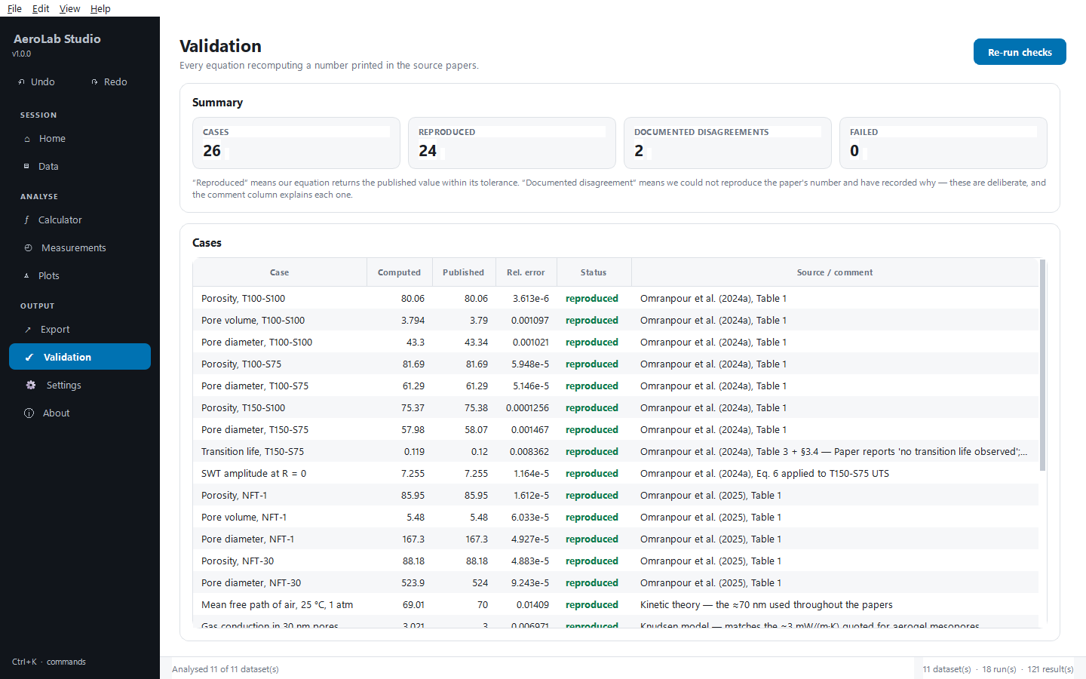
Figure 7. Validation: every case, its published and computed value, and its status.

11. Settings
- Appearance — theme and related options.
- Figure defaults — the default figure size and resolution for exports.
- Report details — project and author written into exports.
- Environment — what this build can reach (OriginLab, Excel writer…); Re-check after installing something.

12. Sessions, undo and shortcuts
File › Save session writes a .aerolab file holding every result and curve (not the raw imports, which stay where they are); reopening it restores the analyses. Undo and redo cover importing, analysing, re-running with new settings, removing and clearing; fifty steps are kept.
Keys | Action
Ctrl+K or Ctrl+P | Command palette — every action, searchable
Ctrl+Z / Ctrl+Y | Undo / redo
Ctrl+1 … Ctrl+9 | Jump to a page
Ctrl+O | Import data
Ctrl+D | Load the demo datasets
Ctrl+S | Save session
Ctrl+E | Export to Excel
Ctrl+R | Export to Origin
Ctrl+T | Toggle light / dark

13. If something goes wrong
Symptom | What to do
“no columns matched” | The headers don't look like anything the measurement expects. Set the mapping by hand in the drop-downs — matching is a convenience, not a requirement.
A number looks wrong | Open the Graph tab: most surprises are visible (a modulus fitted over the wrong window, a DSC peak running into its neighbour). The Settings tab usually has the option that fixes it.
Origin export failed | Check Settings › Environment. If Origin is unavailable, use the LabTalk package. If it is available, tick Show Origin while it works and run again to watch where it stops.
DSC glass transition looks wrong | It is an estimate from the steepest baseline step below the first peak; a Tg buried under a large melt cannot be found this way — read it off the graph.

14. About
The About page (also Help › About) shows the author and laboratory, what the program contains, the three papers it implements, and the versions of everything it runs on — useful when reporting a problem.
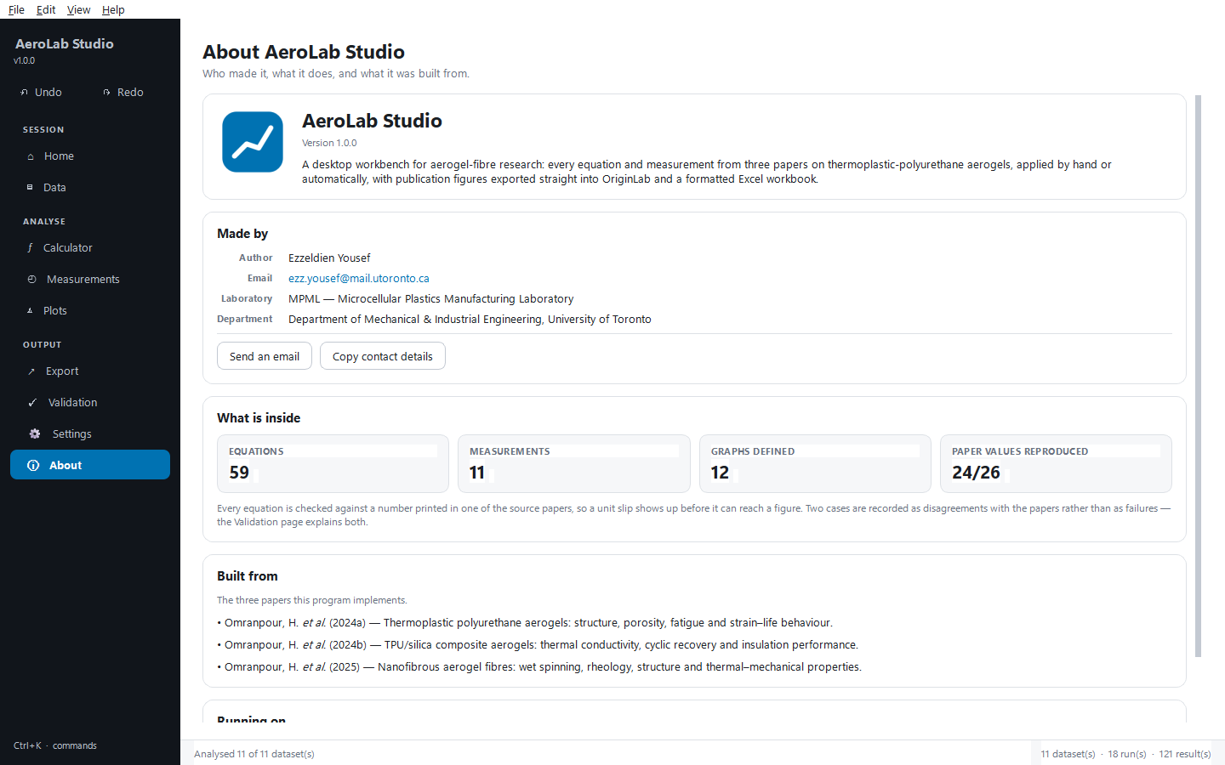
Figure 8. The About page.

