

FTIR & XRD Analysis Toolkit
FTIR spectra and X-ray diffraction patterns, analysed and exported

User guide · version 3.0.0

Made by Ezzeldien Yousef · ezzyousef@aucegypt.edu
EML — Energy Materials Laboratory
September 2026

Contents
1. What the toolkit does
2. Installing and starting
3. The window
4. Analysing FTIR spectra
5. Analysing XRD patterns
6. Exporting
7. Sessions, undo and recent files
8. Reference database and sources
9. Keyboard shortcuts
10. Troubleshooting
11. About

1. What the toolkit does
- FTIR — overlay several spectra; smooth, baseline-correct, ATR-correct, differentiate and normalize; detect peaks (with optional shoulder resolution); screen them against a reference database of 224 materials and 99 functional-group correlations; fit Gaussian, Lorentzian or pseudo-Voigt profiles; calculate %T ↔ absorbance, peak area, FWHM and Beer–Lambert concentration.
- XRD — read common diffractometer formats; detect peaks; d-spacing (Bragg), Scherrer crystallite size, Williamson–Hall size and strain, % crystallinity, SNIP background subtraction, 2θ/d/Q conversion, a single-peak cubic lattice parameter, and peak fitting.
- Exports — styled OriginLab graphs, an Excel workbook, PDF reports, CSV files, vector graphs and sessions.
Tip Phase identification against XRD reference cards is out of scope: use your diffractometer's search/match software, then bring the pattern here for the quantitative work.

2. Installing and starting

Installer (recommended)
1. Run installer\output\FTIR_XRD_ToolkitSetup-3.0.0.exe and follow the wizard (it creates a Start-menu shortcut and, if you tick it, a desktop shortcut; it can be removed from Windows Settings › Apps).
2. Start the application from the Start menu. A splash screen shows while it loads.

Portable copy (no installation)
Unzip dist\FTIR_XRD_Toolkit-3.0.0-portable.zip anywhere and run FTIR_XRD_Toolkit.exe inside the folder. Keep the whole folder together — the exe needs every file next to it.

From source (developers)
With Python 3.11 or newer: pip install -r requirements.txt, then python main.py. python main.py spectrum.csv pattern.xrdml starts and opens those files on the right pages.
Tip python main.py --selftest (or the exe with --selftest) exercises the whole application without opening a window and prints PASSED or FAILED — useful after installing on a new PC. --version prints the version.

3. The window
Every page is one click away on the dark navigation rail on the left, grouped as follows:
Rail group | Pages
Analyse | FTIR spectra, XRD patterns
Library | Reference database, Sources & references
Help | About

- Undo / Redo buttons sit at the top of the rail (also Ctrl+Z / Ctrl+Y and the Edit menu). Their tooltips name the action that will be undone.
- Status bar (bottom): the last action, and on the right a count or the plot coordinates under the mouse.
- Notifications appear briefly in the bottom-right corner and never block your work; anything that needs a decision opens a dialog instead.
- Command palette — press Ctrl+K and type part of any action or page name, then Enter.
- Light / dark theme — Ctrl+T or View › Toggle light / dark theme. Plots follow the theme on screen; exported figures are always light.
- Ctrl+1 … Ctrl+9 jump straight to the pages in rail order.
Menus: File (open files, Open recent, sessions and every export), Tools (FTIR reference database, sources), Edit (undo, redo) and View. While the mouse is over a plot, the status bar shows its x and y.

Layout of the FTIR and XRD pages
- Left — the controls, in cards from top to bottom in the order you use them. The ⓘ button beside a tool shows its equation and literature source.
- Loaded traces (top card) — Load spectra… / Load patterns… (Ctrl+O), or drop one or more files anywhere on the page. Click a row to make that trace active (the one every tool works on); untick Show to hide a trace; Remove and Clear all.
- Right — the plot (toolbar: zoom, pan, save) with Send to Origin, Export to Excel… and Save figures… beneath it, and the results tabs at the bottom. Drag the dividers to resize.
- Matching and fitting run in the background: a progress bar shows, and the window stays usable.

4. Analysing FTIR spectra
1. Load spectra… — .csv .txt .dat .xy .dpt .jdx .dx files with wavenumber and intensity. Load several to overlay them.
2. Mode & peak detection — choose Absorbance (peaks up) or %Transmittance (peaks down), set Peak sensitivity (prominence) and click Detect peaks. Tick Resolve shoulder bands (2nd derivative) for overlapping bands.
3. Processing — Smooth (Savitzky–Golay)…, Baseline correct (linear), ATR correction…, 1st / 2nd derivative…, Apply normalization (max, minmax, area or vector); Revert to raw data undoes all processing of the active trace. Detect peaks again after processing.
4. Database identification — set the Tolerance (±) and, if you know roughly what the sample is, Restrict search to a category; click Match to database.
5. Peak fitting — choose the Peak shape and Fit window (±) and click Fit all detected peaks. The fitted peaks are drawn as one dashed model line in the spectrum's colour.
6. Calculations — %T ↔ absorbance, peak area over a range, FWHM of the nearest peak, Beer–Lambert concentration.

Results tabs
Tab | Contents
Peaks | Position, intensity and prominence of every detected peak.
Database matches | Candidate materials ranked by corroborating peaks and coverage. Click a row to overlay its reference bands on the plot (orange) and list every band as MATCHED or not found; Export reference peaks (CSV)… and Clear overlay.
Functional groups | Each peak's functional-group assignments with the expected range and source.
Peak fits | Seed, fitted centre, FWHM, height, area and R² of each fitted peak.

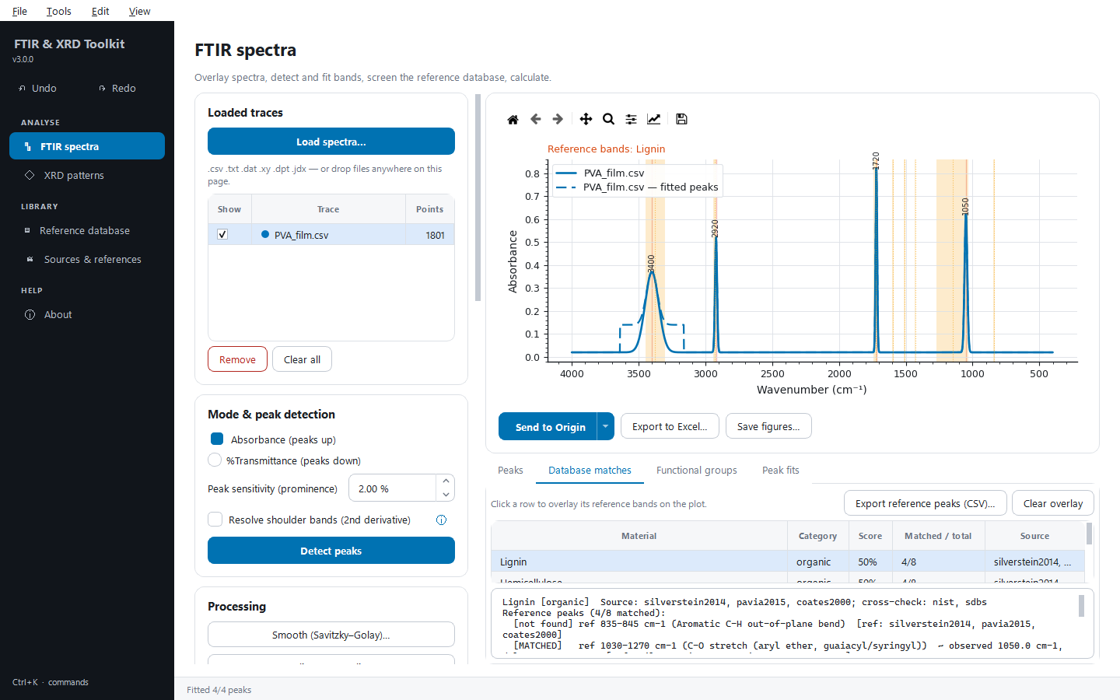
Figure 1. An FTIR spectrum with detected peaks, database matches and the reference bands of the selected match.
Important Database matching is heuristic screening, not identification. Confirm anything consequential against a certified reference spectrum (for example NIST WebBook or SDBS) or an expert. If many candidates come back, restrict the category and reduce the tolerance.

5. Analysing XRD patterns
1. Load patterns… — the format is detected from the extension (table below).
2. Wavelength & peak detection — choose the X-ray wavelength (or Custom... to type one), set the sensitivity and Detect peaks. Smooth (Savitzky–Golay)… and Subtract background (SNIP) are here too.
3. Calculations — d-spacing + Scherrer size (all peaks) fills the Peaks table; Williamson–Hall (size + strain) needs three or more peaks with a resolvable FWHM; % crystallinity (select regions)… asks for crystalline and amorphous 2θ regions written like 18-24,26-28; Cubic lattice parameter (single peak)… and the 2θ / d-spacing / Q converter… use the current wavelength.
4. Peak fitting — shape and Fit window (± 2θ), then Fit all detected peaks.
Results tabs: Peaks (2θ, intensity, FWHM, d-spacing, crystallite size), Williamson–Hall (size, microstrain and the linear fit, with a warning if the strain came out negative) and Peak fits.
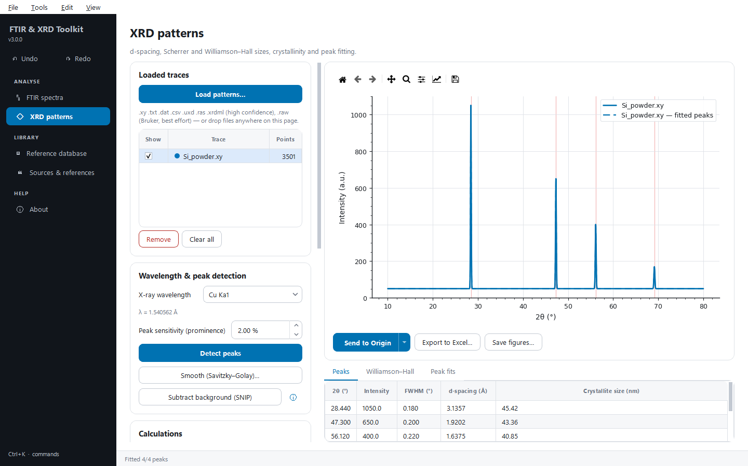
Figure 2. An XRD pattern with d-spacings and Scherrer sizes calculated.
Extension | Format | Confidence
.xy .txt .dat .csv | Generic two-column ASCII | high
.uxd | Siemens / Bruker text | high
.ras | Rigaku text | high
.xrdml | PANalytical / Malvern XML | high
.raw | Legacy Bruker binary (undocumented format) | best effort — export ASCII if it fails

Important Scherrer and Williamson–Hall sizes are apparent sizes from peak broadening, not corrected for instrumental broadening. % crystallinity depends on the regions chosen — report them with the number.

6. Exporting
The Send to Origin button under the plot on both analysis pages is a split button: click it to send, or click its arrow for more.
Action | What it does
Send to Origin | Starts OriginLab (10–20 s the first time) and builds a workbook — every trace in its own X/Y column pair with Long Name, Units and Comments, the results on a Results sheet — and a styled graph. Every later send adds to the same Origin project.
Save Origin project… | Saves that project as an .opju file.
Close Origin | Closes the Origin session the application started (this application stays open).
Write LabTalk package (no Origin needed)… | Writes Origin-ready CSV files plus the script AeroLab_build.ogs to a folder. Copy the folder to a PC with Origin and run the script there (drag it into Origin); it rebuilds the same workbooks and graphs. The folder's README explains the details.

Graphs use the lab's colour-blind-safe palette, draw fits in the colour of the data they belong to, carry axis titles with units, and place the legend in the emptiest corner of the plot. Origin work runs on its own thread, so the window stays responsive while Origin starts.
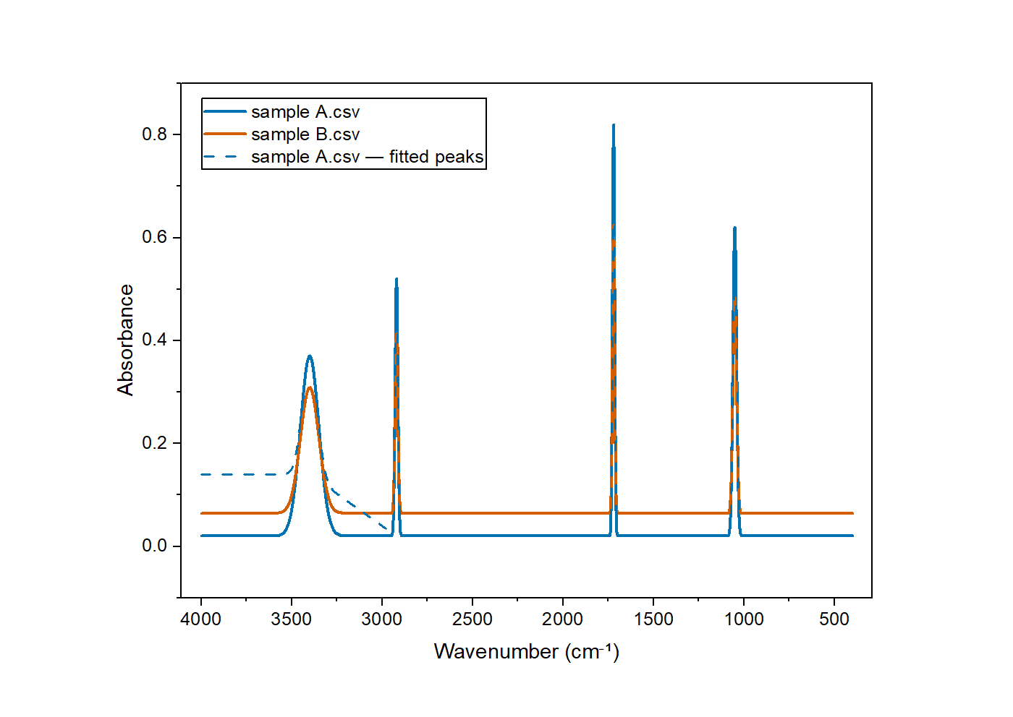
Figure 3. Two FTIR spectra and a fitted-peak model as built in OriginLab — the wavenumber axis runs high to low.
Export | Where | Result
Export to Excel… | under the plot, Ctrl+Shift+E | Summary, one sheet and native chart per trace, match and fit tables, provenance
Save figures… | under the plot | the plot as a 300 dpi PNG
Export PDF report… | Files & session card, Ctrl+E | plot, peak table, matches or Williamson–Hall, disclaimer
Export peak list (CSV)… | Files & session card | the active trace's peaks
Export for OriginLab (CSV)… | Files & session card | every trace as X/Y columns with Long Name and Units rows, for Origin's Import Wizard
Export graph (SVG/EPS/PDF/PNG)… | Files & session card | vector or 300 dpi raster graph

7. Sessions, undo and recent files
- Save session… (Ctrl+S) writes the page's traces, peaks, matches, fits and settings to a .ftirxrd file; Load session… (Ctrl+L) restores it. Open a session on the page it was saved from (FTIR or XRD) — the other page says so. Sessions from earlier versions still load.
- Undo / redo (Ctrl+Z / Ctrl+Y) cover loading, removing and hiding traces, processing, peak detection, database matching, fitting and the XRD calculations, on both pages.
- File › Open recent lists the last ten files.

8. Reference database and sources
Library › Reference database (Ctrl+D) lists every material with its category, number of bands and source. Search by name, filter by category, and click a material to see its bands with their assignments. Library › Sources & references gives the database note and the full bibliography.
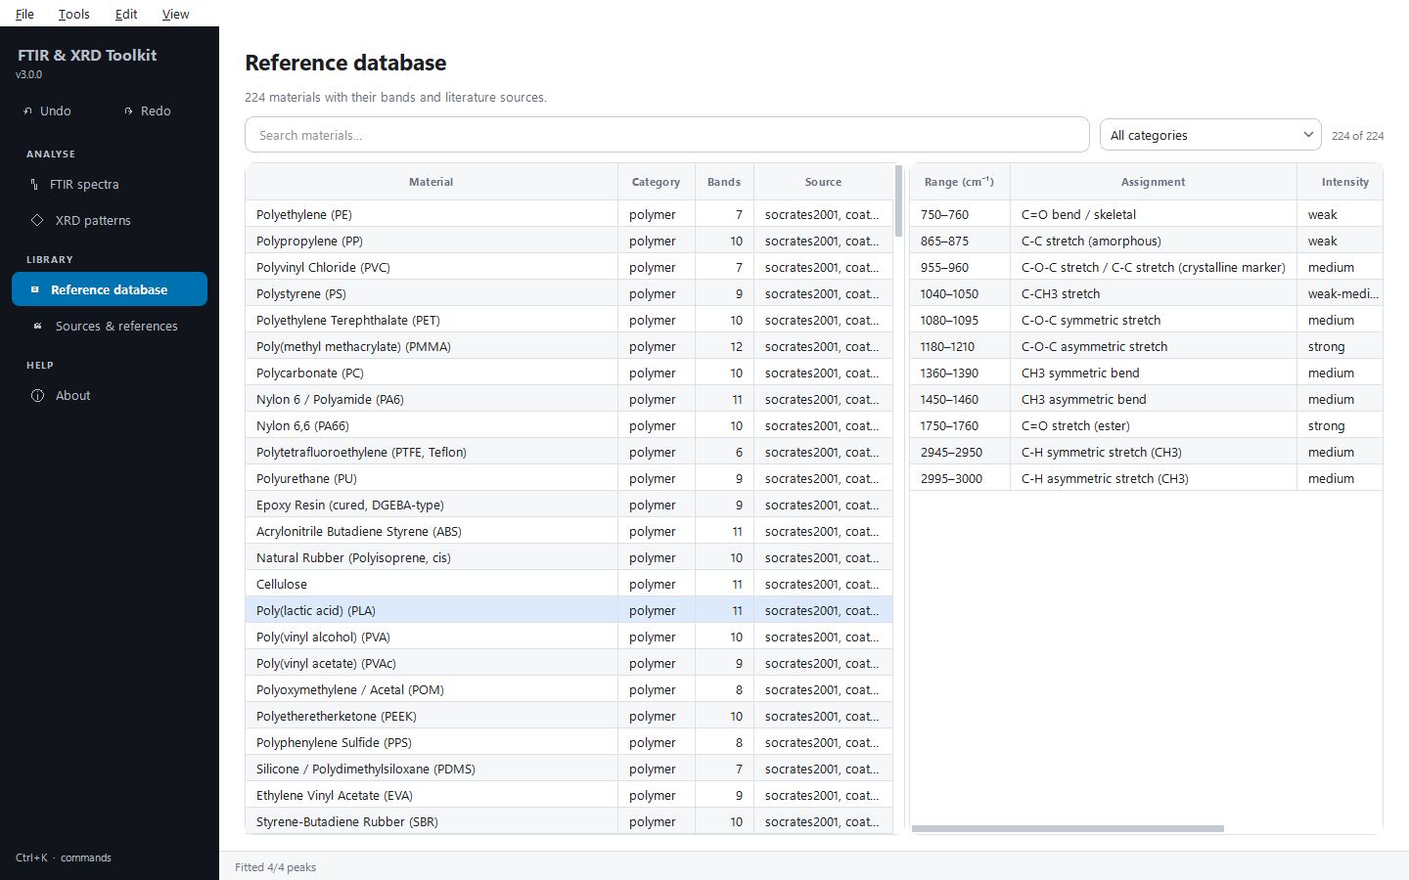
Figure 4. The reference database with a material's bands shown.
You can extend the database by editing database/ftir_reference_db.json in the application folder — no code changes are needed.

9. Keyboard shortcuts
Keys | Action
Ctrl+O | Open data files
Ctrl+Z / Ctrl+Y | Undo / redo
Ctrl+S / Ctrl+L | Save / load session
Ctrl+E | PDF report
Ctrl+Shift+O | Send to Origin
Ctrl+Shift+E | Export to Excel
Ctrl+D | Reference database
Ctrl+K | Command palette
Ctrl+T | Light / dark theme
Ctrl+1 … Ctrl+5 | Go to a page
Ctrl+Q | Quit

10. Troubleshooting
Symptom | What to do
“Could not load file” | The file isn't a two-column spectrum/pattern in a supported format. Export ASCII (x, y) from the instrument software and load that.
“LOW-CONFIDENCE parse” | Best-effort binary reading (for example Bruker .raw). Cross-check against an ASCII export before trusting it.
Too many peaks | Raise the peak sensitivity (prominence) and detect again; smoothing first also helps.
A fitted peak looks like a box | The fit window is narrower than the band — increase Fit window (±) and fit again.
Hundreds of database candidates | Restrict the search to a category and reduce the tolerance.
Excel or PDF export fails | The file is open in another program — close it and export again.

11. About
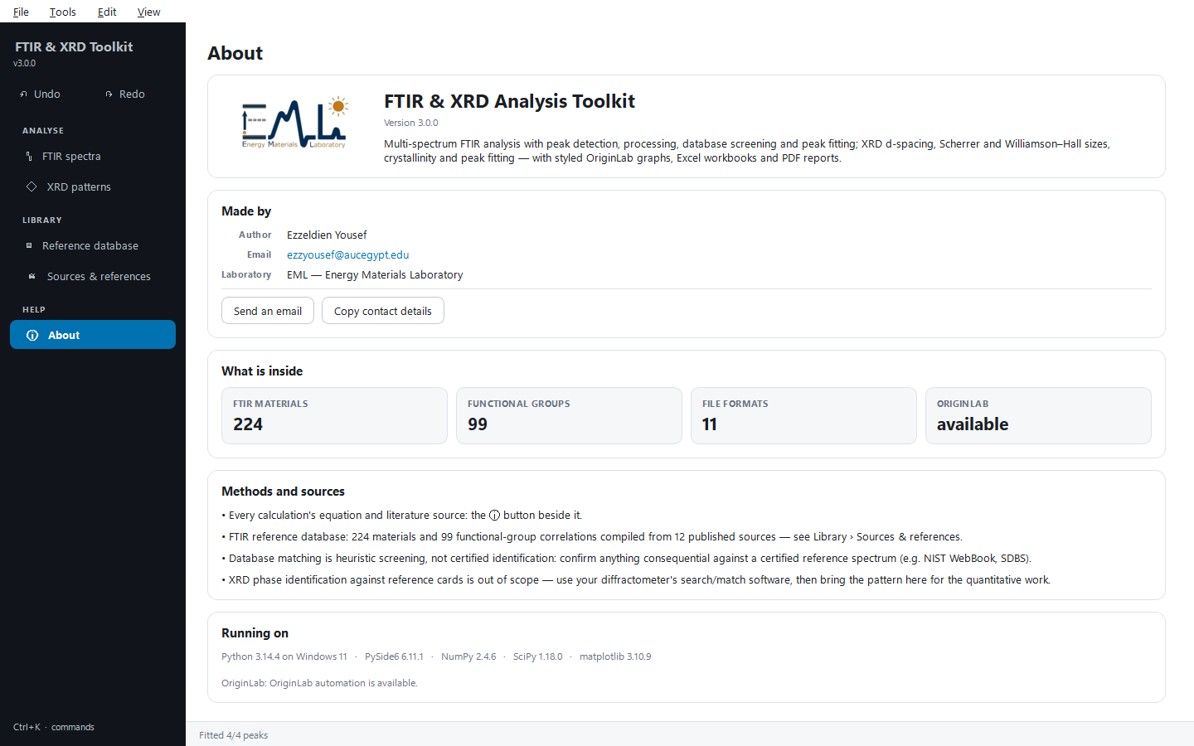
Figure 5. The About page: author, laboratory, database contents and environment.

