

Brookfield DV1 Viscosity Logger
Logging, plotting and analysis of DV1 viscometer readings

User guide · version 2.0.0

Made by Ezzeldien Yousef · ezzyousef2@aucegypt.edu
EML — Energy Materials Laboratory
September 2026

Contents
1. What the application does
2. Installing and starting
3. The window
4. Before you measure
5. The Dashboard
6. Choosing the spindle and speed
7. Taking a reading
8. Reviewing the data
9. Sessions and exports
10. The Serial page (protocol discovery)
11. Keyboard shortcuts
12. Troubleshooting
13. About

1. What the application does
The DV1 Logger records viscosity readings from a Brookfield AMETEK DV1 digital viscometer, calculates the full-scale range and shear rate from the manual's spindle constants, plots and summarises the readings (including a power-law fit for shear-thinning gels), and exports them to Excel, OriginLab, CSV and publication figures.
Important The DV1 has no publicly documented command set for live logging (it is designed to talk to Brookfield's own Wingather SQ software). Readings are therefore entered by hand: you read the value off the DV1 display and type it in. Everything else — plots, statistics, exports — works from those readings. The Serial page is a raw terminal for protocol discovery only.

2. Installing and starting

Installer (recommended)
1. Run installer_output\DV1Logger-Setup-2.0.0.exe and follow the wizard (it creates a Start-menu shortcut and, if you tick it, a desktop shortcut; it can be removed from Windows Settings › Apps).
2. Start the application from the Start menu. A splash screen shows while it loads.

Portable copy (no installation)
Unzip dist\DV1Logger-2.0.0-portable.zip anywhere and run DV1Logger.exe inside the folder. Keep the whole folder together — the exe needs every file next to it.

From source (developers)
With Python 3.11 or newer: pip install -r requirements.txt, then python main.py.
Tip python main.py --selftest (or the exe with --selftest) exercises the whole application without opening a window and prints PASSED or FAILED — useful after installing on a new PC. --version prints the version.

3. The window
Every page is one click away on the dark navigation rail on the left, grouped as follows:
Rail group | Pages
Measure | Dashboard, Data table
Analyse | Plots, Statistics
Instrument | Serial
Help | About

- Undo / Redo buttons sit at the top of the rail (also Ctrl+Z / Ctrl+Y and the Edit menu). Their tooltips name the action that will be undone.
- Status bar (bottom): the last action, and on the right a count or the plot coordinates under the mouse.
- Notifications appear briefly in the bottom-right corner and never block your work; anything that needs a decision opens a dialog instead.
- Command palette — press Ctrl+K and type part of any action or page name, then Enter.
- Light / dark theme — Ctrl+T or View › Toggle light / dark theme. Plots follow the theme on screen; exported figures are always light.
- Ctrl+1 … Ctrl+9 jump straight to the pages in rail order.
Menus: File (sessions and exports), Measure (add a reading, start and stop a timed run), Edit (undo, redo) and View (pages, theme, command palette). The status bar shows how many readings the session holds.

4. Before you measure

Equipment checklist
- The DV1 viscometer, powered, on a stable and level bench.
- The right spindle(s) for the expected viscosity range (section 6).
- Sample containers wide enough that the spindle stays about one spindle diameter from the wall.
- Temperature control (a water bath) — strongly recommended for polymer gels, whose viscosity is very temperature-sensitive.
- The guard leg, if you have one; a USB-B cable only if you plan to use the Serial page.

Preparing the sample
1. Bring the sample to the target temperature and keep it there; note the temperature for each reading.
2. Fill the container so the spindle sits at the correct immersion depth with clearance on all sides and below.
3. Remove trapped air bubbles near the spindle — they read as artificially low torque and viscosity.
4. For a concentration series of gels, expect viscosity to change by orders of magnitude: re-select the spindle and speed for each concentration, or hold them constant across the series if you want the shear rate to stay comparable.

Mounting the spindle
1. With the motor off, screw the spindle onto the coupling by hand — Brookfield couplings are left-hand threaded (turn counter-clockwise to tighten).
2. Lower the spindle until the liquid surface sits exactly at the immersion groove on the shaft. Under-immersion is one of the most common causes of bad readings.
3. Attach the guard leg, centred around the spindle, if you have one.

5. The Dashboard
The Dashboard is the page you use for every measurement. From top to bottom:
Area | What it holds
Current reading | Viscosity, speed, torque, shear stress, shear rate and temperature of the latest reading.
Viscometer | Port (Search refreshes the list), Connect, Baud, Model and Spindle. The pill shows the connection state.
Test setup and status | Test parameters (Data interval mm:ss, Number of data points), Sample (Product name, Batch, Sample notes) and Run (▶ Run / ■ Stop), with tiles for Elapsed time, Readings taken, Next reading in and Program status.
Manual reading entry | Viscosity (cP), % Torque, Temperature (°C) and Speed (RPM), with a live preview of the full-scale range and shear rate, and Add reading (Ctrl+Enter).
Spindle / speed advisor | Suggests spindle and speed combinations before you take a reading.
Data | The readings of this session and the live plot.

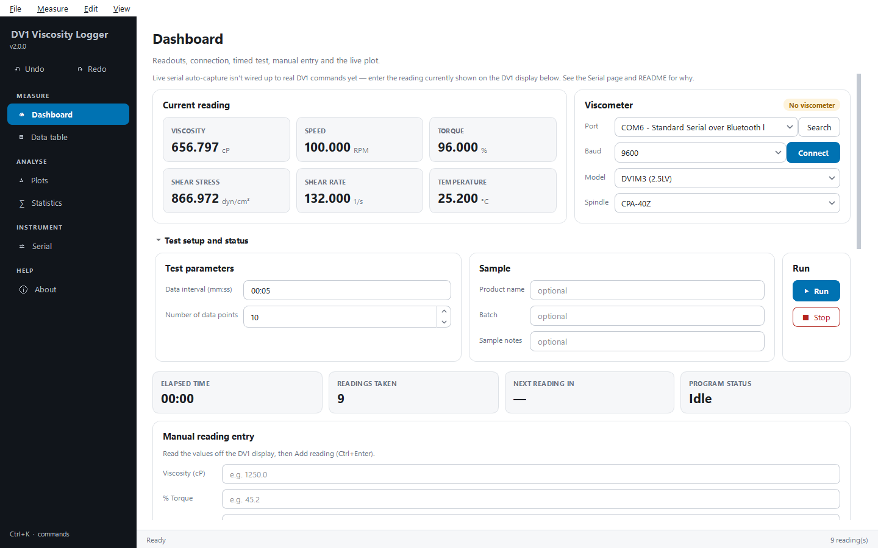
Figure 1. The Dashboard with a shear-rate sweep of a PVA hydrogel logged.

6. Choosing the spindle and speed

With the advisor (recommended)
1. In Viscometer, set Model to your DV1 variant.
2. Open Spindle / speed advisor, type your best estimate of the sample's viscosity in Expected viscosity (cP) (from a spec sheet, a previous batch or a guess) and click Suggest spindle & speed.
3. The table lists spindle/speed combinations predicted to land in Brookfield's recommended 10–100 % torque window, ranked closest to 50 % (the most accurate part of the range). Double-click a suggestion to copy its spindle and speed into the form.

By trial and error (no viscosity estimate)
1. Start with a mid-sized spindle (for example LV2 or RV3) at a moderate speed (about 30–60 RPM), and select the same on the DV1.
2. Take a reading and check % Torque.
3. Torque under 10 % → larger spindle number or slower speed; over 100 % → smaller spindle number or faster speed. Repeat until torque is within 10–100 %.

7. Taking a reading
1. On the DV1, select the spindle and speed, start the motor and let the reading stabilise (several full rotations; longer for viscous gels).
2. Read the viscosity (cP), % torque and temperature from the DV1 display (or the bath thermometer).
3. In Manual reading entry, type those values and check that Speed (RPM) matches the instrument.
4. Optionally fill in Product name and Batch so the reading is tagged with its sample.
5. Click Add reading or press Ctrl+Enter. The reading appears in the tiles, the table and the live plot.
Important If the torque is outside 10–100 %, the application warns you straight away — the reading is kept but is not reliable. Re-select the spindle or speed and take it again; Ctrl+Z removes the bad reading.

A full data set
- One reading per sample — repeat the steps above for each sample.
- Shear-rate sweep (recommended for gels) — same spindle and sample, several speeds. The power-law fit needs at least two points with a shear rate; more is better.
- Timed run — set Data interval (mm:ss) and Number of data points, then ▶ Run (F5). A notification says Reading due now at every interval; enter the reading each time. The run stops by itself once the number of points is reached, or press ■ Stop (Shift+F5).

8. Reviewing the data

Data table
Every reading of the session with all derived columns. Select rows and click Delete selected to remove bad points; Clear session removes everything. Both can be undone with Ctrl+Z. The Export card on this page holds the Origin, Excel and figure buttons (section 9).
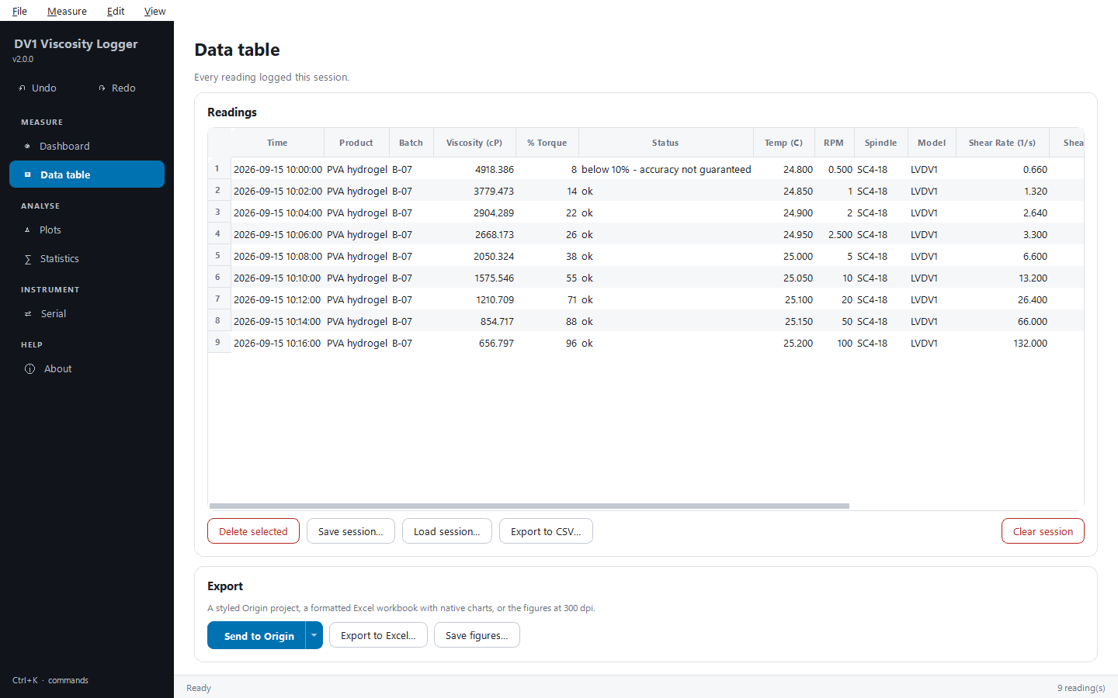
Figure 2. The Data table page with its session and export controls.

Plots
Choose the Plot: Viscosity vs Time, Viscosity vs Shear Rate (log–log, with the power-law fit drawn in the data's colour and n, K and R² in a results box), % Torque vs Time (10 % and 100 % limits marked) or Temperature vs Time. The toolbar above the plot zooms, pans and saves the image.
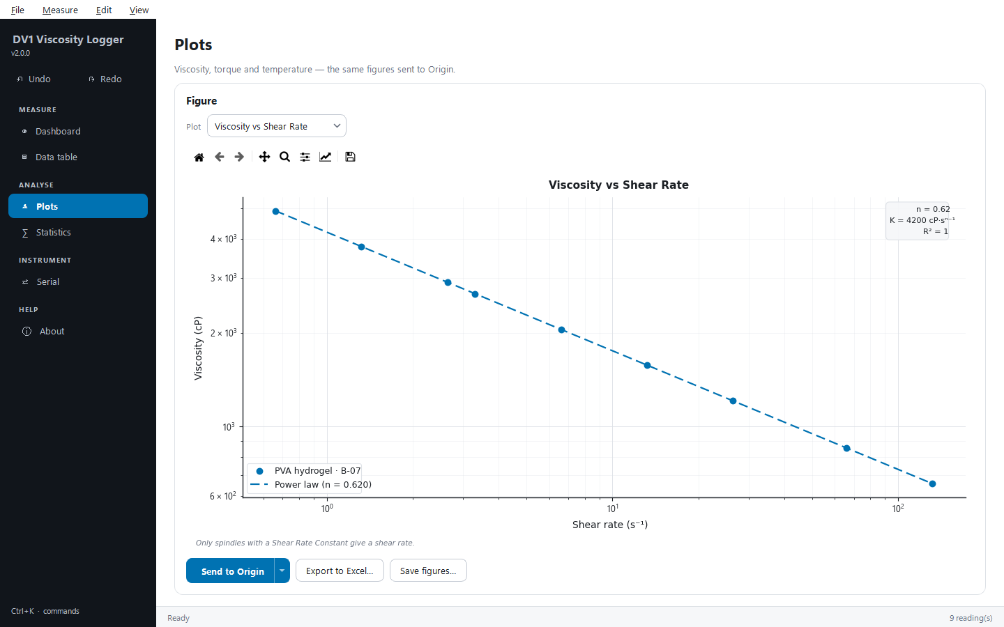
Figure 3. Viscosity against shear rate with the power-law fit.
Tip Only spindles with a Shear Rate Constant (for example the SC4 series, LV-2C/LV-3C, ULA) give a shear rate. Readings taken with RV/HA/HB spindles cannot appear on the shear-rate plot or in the fit.

Statistics
Tiles for the number of readings, mean viscosity, the flow behaviour index n and the count of out-of-range torque readings, and a Summary table of mean, standard deviation, minimum and maximum for each quantity, torque flags and the power-law fit. Statistics update as soon as readings change.
Flow index n | Meaning
n < 1 | shear-thinning (pseudoplastic) — typical of polymer solutions and gels
n ≈ 1 | approximately Newtonian
n > 1 | shear-thickening (dilatant)

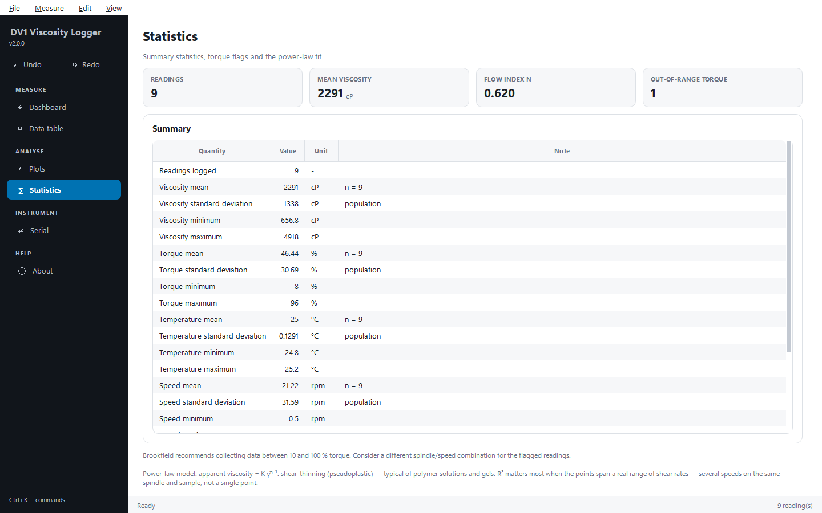
Figure 4. The Statistics page.

9. Sessions and exports
- File › Save session… (Ctrl+S) writes every reading to a JSON file; Load session… (Ctrl+O) reopens it — use this to pause a long run.
- Export to Excel… (Ctrl+E) — a Summary sheet, the readings with every derived column, the results, native Excel charts of all four plots, and a Provenance sheet.
- Export to CSV… — the raw readings.
- Save figures… — all four plots as 300 dpi PNG files.
- Send to Origin (Ctrl+Shift+O) — see below.
The Send to Origin button under the plot on the Plots and Data table pages is a split button: click it to send, or click its arrow for more.
Action | What it does
Send to Origin | Starts OriginLab (10–20 s the first time) and builds a workbook — every trace in its own X/Y column pair with Long Name, Units and Comments, the results on a Results sheet — and a styled graph. Every later send adds to the same Origin project.
Save Origin project… | Saves that project as an .opju file.
Close Origin | Closes the Origin session the application started (this application stays open).
Write LabTalk package (no Origin needed)… | Writes Origin-ready CSV files plus the script AeroLab_build.ogs to a folder. Copy the folder to a PC with Origin and run the script there (drag it into Origin); it rebuilds the same workbooks and graphs. The folder's README explains the details.

Graphs use the lab's colour-blind-safe palette, draw fits in the colour of the data they belong to, carry axis titles with units, and place the legend in the emptiest corner of the plot. Origin work runs on its own thread, so the window stays responsive while Origin starts.
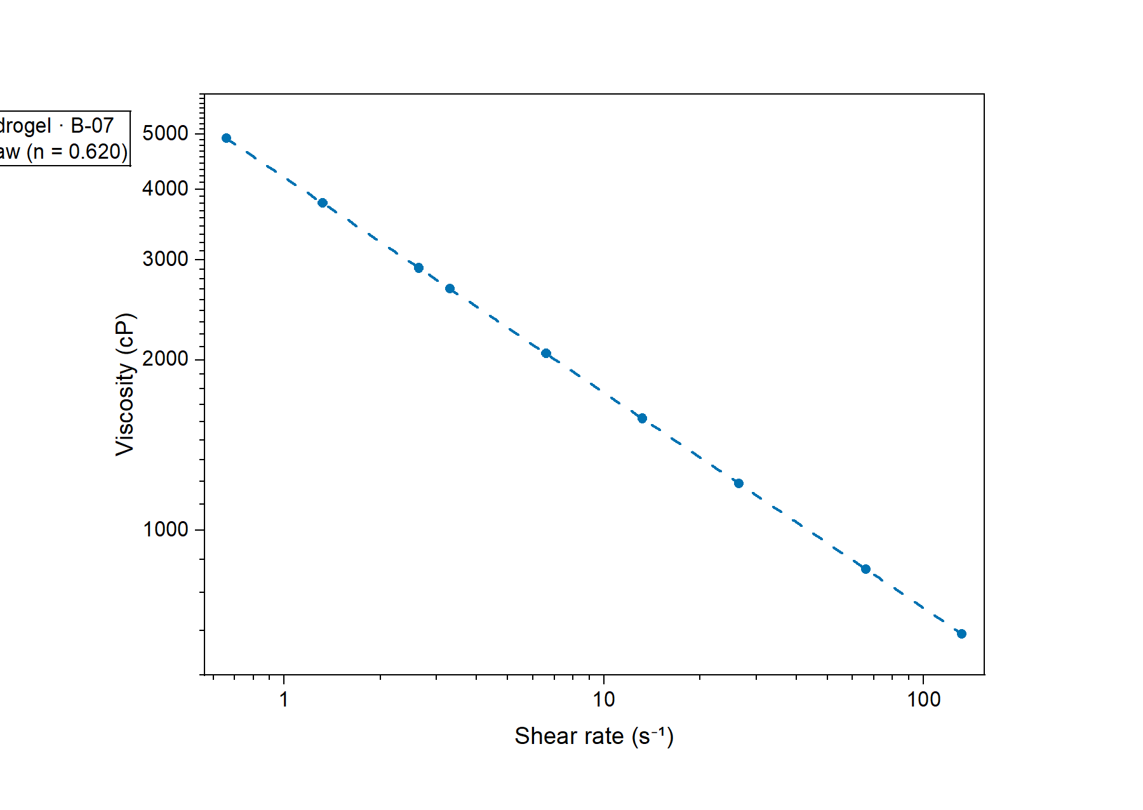
Figure 5. Viscosity against shear rate as built in OriginLab.

10. The Serial page (protocol discovery)
A raw, protocol-agnostic serial connection for experimenting once you have the DV1 interface command reference, or for instruments with a documented ASCII protocol. Connect from the Dashboard's Viscometer card (plug the DV1's USB-B PC port — not the other USB port — into the computer, Search, choose the port, Baud 9600, Connect).
- Auto-capture — Start auto-capture records everything the instrument sends; Export raw capture to CSV… saves it.
- Terminal — type bytes to send (sent as UTF-8 plus CR LF), Send, and Read now.
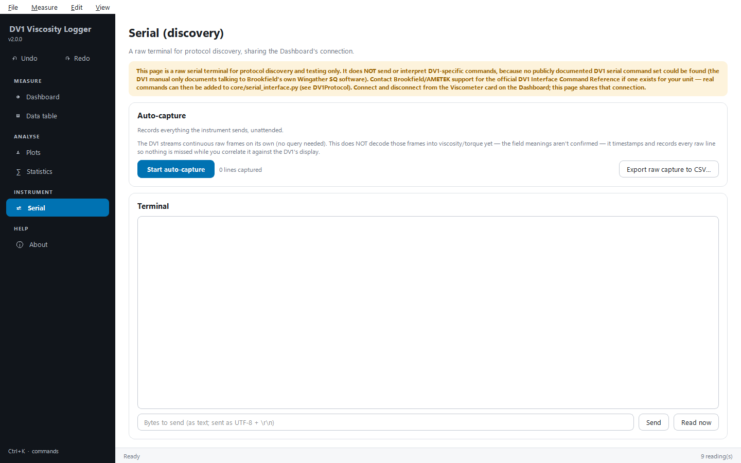
Figure 6. The Serial page: auto-capture and terminal.

11. Keyboard shortcuts
Keys | Action
Ctrl+Enter | Add reading
F5 / Shift+F5 | Start / stop a timed run
Ctrl+Z / Ctrl+Y | Undo / redo (add, delete, load, clear)
Ctrl+O / Ctrl+S | Load / save session
Ctrl+E | Export to Excel
Ctrl+Shift+O | Send to Origin
Ctrl+K | Command palette
Ctrl+T | Light / dark theme
Ctrl+1 … Ctrl+6 | Go to a page
Ctrl+Q | Quit

12. Troubleshooting
Symptom | What to do
Torque out of the recommended range | Re-select spindle or speed (section 6) and retake the reading; readings outside 10–100 % are not reliable.
Viscosity and torque don't fill in automatically | Expected — the DV1's command set is not public. Enter readings by hand; the Serial page can capture the raw stream but does not decode it.
Speed cannot be set from the application | Deliberate: the application will not send unverified commands that drive the motor.
No shear-rate plot or power-law fit | The spindle has no Shear Rate Constant, or fewer than two readings have one.
The COM port is missing | Check Device Manager after plugging in the DV1's USB-B PC port; click Search again.
Excel export fails | The workbook is open in Excel — close it and export again.

Spindle and model constants and the full-scale range and shear-rate formulas come from the Brookfield DV1 Operating Instructions (M14-023-A0416), Appendix D. The detailed sample-preparation manual is docs/MANUAL.md in the application folder.

13. About
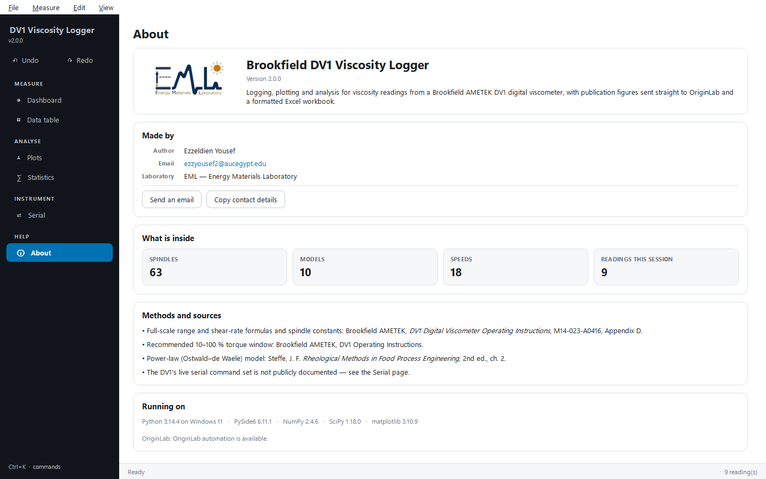
Figure 7. The About page: author, laboratory, sources and environment.

