

Supercapacitor & DSC Analysis Suite
Electrochemical and thermal analysis for supercapacitors and gel electrolytes

User guide · version 2.1.0

Made by Ezzeldien Yousef · ezzyousef2@aucegypt.edu
EML — Energy Materials Laboratory
September 2026

Contents
1. What the suite does
2. Installing and starting
3. The window
4. How every tool works
5. Manual calculator
6. Charge / discharge (GCD)
7. Cycling stability
8. Cyclic voltammetry
9. Rate study
10. Impedance (EIS)
11. Relaxation times (DRT)
12. DSC
13. Recording and comparing results
14. Exporting
15. Shortcuts
16. Accuracy and sources

1. What the suite does
Tool | What it calculates
Manual calculator | GCD/CV capacitance, energy and power density, ionic conductivity, 2-/3-electrode conversions and DSC enthalpy from numbers you already have
Charge / discharge (GCD) | Linear or integral capacitance (chosen from the discharge shape), ESR, energy and power density
Cycling stability | Capacitance retention and coulombic efficiency over many cycles
Cyclic voltammetry | Specific capacitance or capacity by cycle integration
Rate study | Capacitance vs scan rate or current density, b-value, Dunn's and Trasatti's methods, Randles–Ševčík diffusion coefficient, Ragone plot
Impedance (EIS) | Nyquist/Bode plots, Kramers–Kronig check, equivalent-circuit fitting, low-frequency capacitance, ionic conductivity
Relaxation times (DRT) | Distribution of relaxation times with peak interpretation
DSC | Peak integration and enthalpy; free / freezable-bound / non-freezable water in gel electrolytes

2. Installing and starting

Installer (recommended)
1. Run installer\output\SupercapSuiteSetup.exe and follow the wizard (it creates a Start-menu shortcut and, if you tick it, a desktop shortcut; it can be removed from Windows Settings › Apps).
2. Start the application from the Start menu. A splash screen shows while it loads.

Portable copy (no installation)
Unzip dist\SupercapSuite-2.1.0-portable.zip anywhere and run SupercapSuite.exe inside the folder. Keep the whole folder together — the exe needs every file next to it.

From source (developers)
With Python 3.11 or newer: pip install -r requirements.txt, then python main.py. docs/BEGINNER_SETUP_VSCODE.md walks through a first Python setup step by step.
Tip python main.py --selftest (or the exe with --selftest) exercises the whole application without opening a window and prints PASSED or FAILED — useful after installing on a new PC. --version prints the version.

3. The window
Every page is one click away on the dark navigation rail on the left, grouped as follows:
Rail group | Pages
Calculate | Manual calculator
Charge storage | Charge / discharge, Cycling stability, Cyclic voltammetry, Rate study
Impedance | Impedance (EIS), Relaxation times (DRT)
Thermal | DSC
Help | How to use, About

- Status bar (bottom): the last action, and on the right a count or the plot coordinates under the mouse.
- Notifications appear briefly in the bottom-right corner and never block your work; anything that needs a decision opens a dialog instead.
- Command palette — press Ctrl+K and type part of any action or page name, then Enter.
- Light / dark theme — Ctrl+T or View › Toggle light / dark theme. Plots follow the theme on screen; exported figures are always light.
- Ctrl+1 … Ctrl+9 jump straight to the pages in rail order.
The File menu opens a data file for the tool on screen (Ctrl+O), opens its export menu (Ctrl+E), and saves or closes the Origin session. Undo and redo work inside each table and results log (section 12).
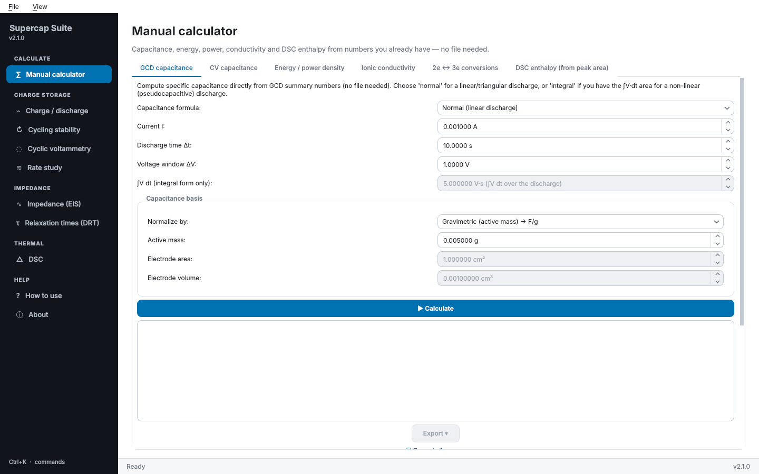
Figure 1. The suite with the Manual calculator open.

4. How every tool works
Every analysis tool follows the same three steps, top to bottom on its left-hand panel:
1. 1) Data — open a file with the 📂 Open … file button (Excel, CSV or EC-Lab .mpt; .mpr where noted), choose the Sheet for a workbook, and check the Column mapping (guessed from common EC-Lab names, always editable). Many tools also import several files at once (📚 Import multiple … files (batch)…).
2. 2) Configure — mass or area basis, windows, thresholds, cell configuration. Options you rarely need sit in collapsed Advanced sections.
3. Analyze — the blue ▶ button runs the calculation. The headline result appears in a card above the plot, with every secondary value and any warnings, and a ⓘ Formula & source link showing the exact equation and citation.
- The right-hand side holds the Plot (toolbar: zoom, pan, save image), Results summary and Data table. Each pane can be collapsed by its header or closed with ✕ — right-click the results area to bring a closed pane back. ⇔ Maximize results hides the settings panel.
- Drag the divider between the two panels to resize them; a horizontal scrollbar appears if a panel is narrower than its content.
- The Export ▾ button is enabled once a result exists (section 13).

5. Manual calculator
Sub-tabs: GCD capacitance, CV capacitance, Energy / power density, Ionic conductivity, 2e ↔ 3e conversions and DSC enthalpy (from peak area). Type the known values (each with its unit) and click ▶ Calculate. Results can be recorded and exported like any other tool's.

6. Charge / discharge (GCD)
1. 📂 Open GCD file (Excel / CSV / .mpt)… and check Column mapping (time, voltage, optional current).
2. In Discharge segment (row range, 0-indexed) click Auto-detect charge/discharge segments, pick the discharge you want (or set the rows by hand) and Preview segment on plot to confirm it is the discharge.
3. In 2) Configure › Test parameters choose the current source (a current column with its unit, or a manual current), then the Capacitance basis (mass, area or volume) and the Cell configuration (3-electrode, symmetric or asymmetric 2-electrode).
4. Leave 3) Advanced: capacitance formula override on auto-detect to let the app choose the linear or integral formula from the R² of the discharge, or force one.
5. Click ▶ Analyze discharge segment — capacitance, ESR, energy and power density, with the method and R² always shown. The IR drop is excluded from ΔV by default, ESR uses ΔV_IR / 2I when the discharge follows charging directly, and energy and power are not given for a three-electrode measurement.
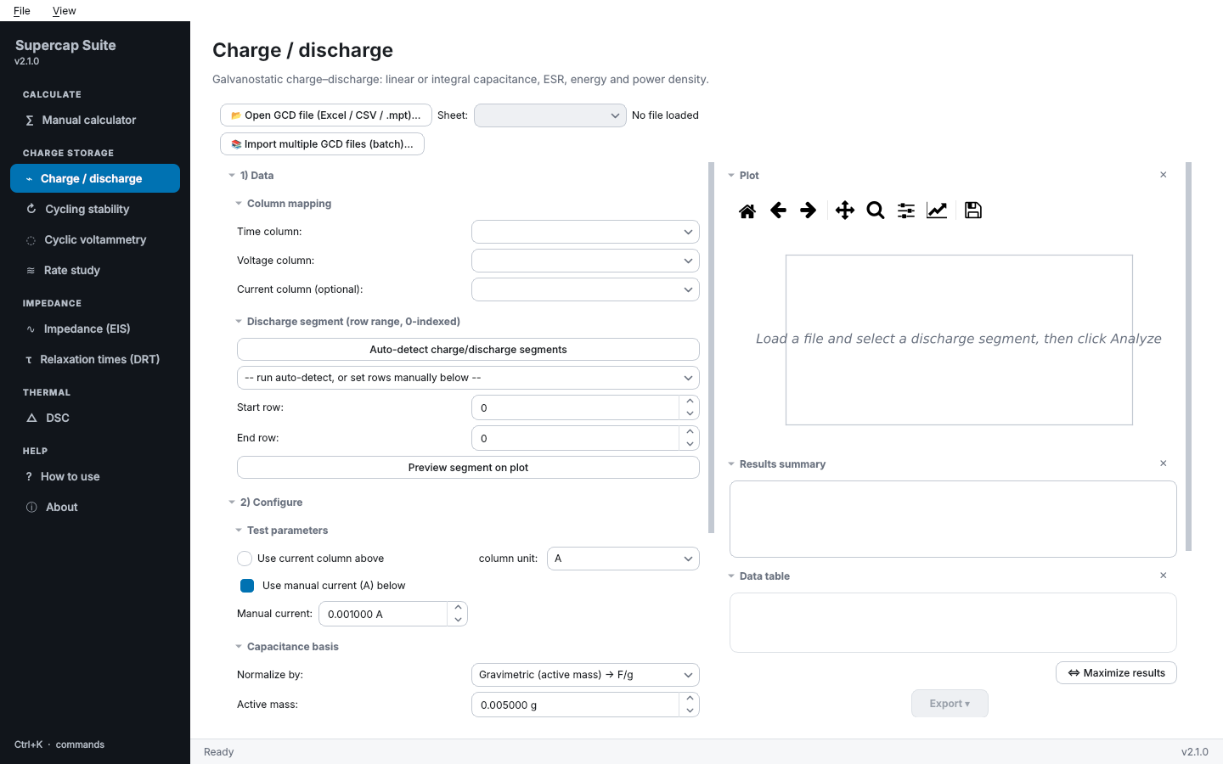
Figure 2. The Charge / discharge tool before a file is loaded.

7. Cycling stability
📂 Open multi-cycle GCD file (Excel / CSV / .mpt / .mpr)…, map the columns, set Test parameters and click ▶ Analyze cycling stability. For very long files, 3) Downsample table / plot / export keeps every n-th cycle (Always keep the last cycle, Also apply to the plot markers, Apply downsampling, Reset (show all cycles)).

8. Cyclic voltammetry
📂 Open CV file (Excel / CSV / .mpt)…, map the columns, choose One CV cycle (row range) and Preview cycle (I vs V). Set the scan rate and mass in Parameters, the Capacitance basis and Report as (specific capacitance F/g, or specific capacity C/g for battery-type materials), then ▶ Analyze CV cycle. If a file stacks several cycles, pick the cycle to analyse — the app warns before mixing cycles.

9. Rate study

CV vs. scan rate (Dunn's / Trasatti's / b-value)
- Fill the tables from files (📂 Import from summary file… or 📂 Import multiple raw CV files (one per scan rate)…) or type rows (+ Add row), with the units of each column.
- ▶ Run Trasatti's method — outer, inner and total capacitance, both extrapolations drawn side by side.
- ▶ Run b-value analysis and ▶ Run capacitive/diffusive split (Dunn's method).
- Randles-Sevcik parameters then ▶ Compute diffusion coefficient D.

GCD vs. current density (rate capability)
1. 📂 Open GCD file…, Auto-detect charge/discharge segments, then add one discharge per current with + Add this segment to the rate study.
2. Click ▶ Run rate-capability analysis — capacitance, energy, power and retention against current density. Tick Show as Ragone plot for energy against power on log–log axes.
3. Remove selected segment takes a segment out; ↶ Undo remove segment / ↷ Redo remove segment reverse it.
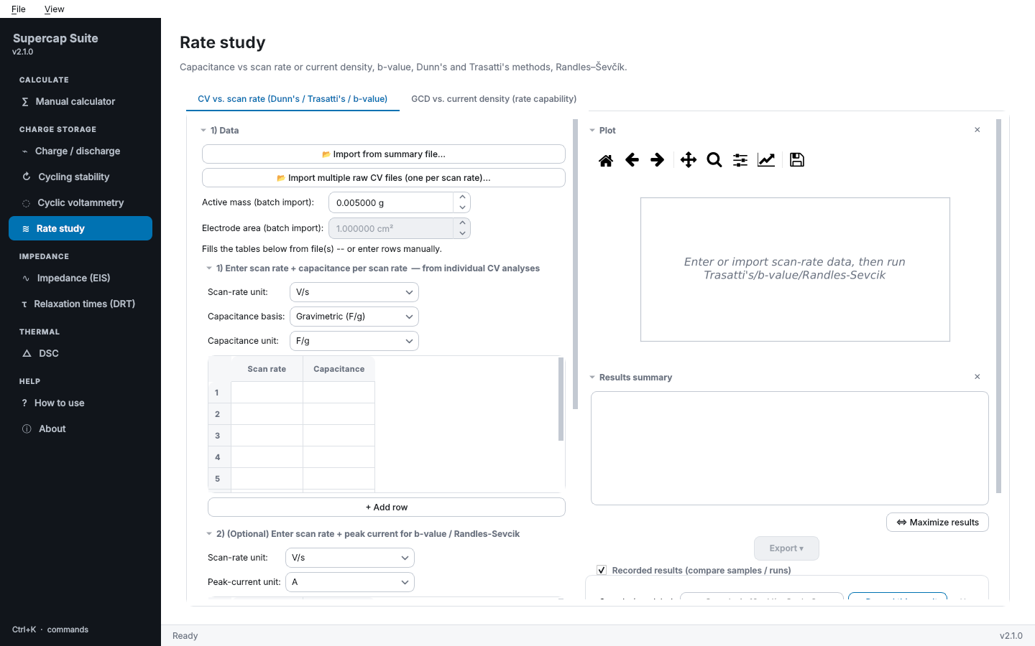
Figure 3. The Rate study tool.
Important The b-value and Dunn's-method split carry a documented literature critique (Pervez & Stallard, Small, 2023). Treat them as indicative, not definitive.

10. Impedance (EIS)
1. 📂 Open EIS file (Excel / CSV / .mpt)…, map Z real, Z imaginary and frequency, choose the Im(Z) sign convention and, for stacked spectra, the cycle to analyse.
2. Click Load & preview spectrum. Tick Show as Bode plot for |Z| and phase against frequency.
3. Optional: Inductive loop removal drops the high-frequency points below the real axis; ▶ Run Kramers-Kronig validity test checks the data is self-consistent before fitting. It also warns when the residuals follow a smooth trend with frequency (drift during the sweep), even if they pass.
4. Low-frequency capacitance — enter the active mass, ▶ Compute C from lowest-frequency point.
5. Ionic conductivity (2-electrode ion-blocking cell) — enter thickness and electrode area, Compute σ from bulk resistance (Nyquist intercept).
6. Equivalent circuit fit — choose a Category (start with Supercapacitor (recommended)) and a Circuit, then ▶ Fit this circuit. The fit is overlaid on the data, the circuit diagram is drawn (Show fitted values on diagram, ⬇ Export circuit diagram as image…) and parameters are listed with the fit quality as an RMS residual in % of |Z|. Auto-detect ranks circuits by AICc, so a more complex circuit has to earn its extra parameters.
Outlier points can be removed from the table with 🗑 Remove selected row(s) & redraw (and restored with ↶ Undo row removal). 📚 Import multiple EIS files (batch fit)… fits a whole set.
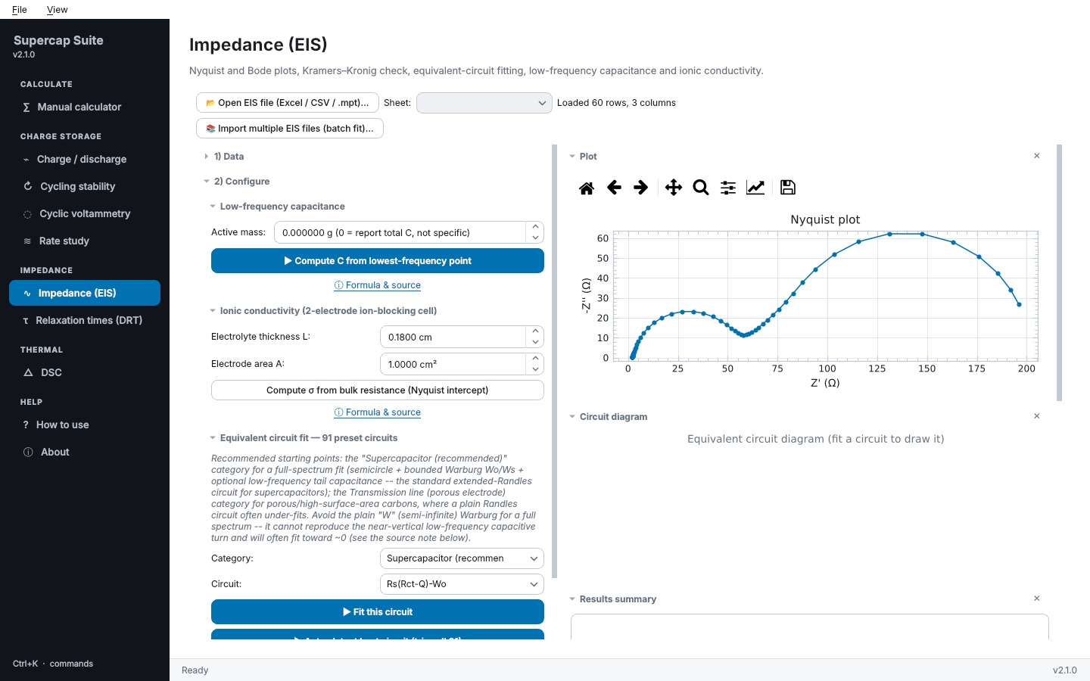
Figure 4. An impedance spectrum previewed as a Nyquist plot.

11. Relaxation times (DRT)
📂 Open EIS file…, map the columns, optionally remove the inductive loop, set the options in DRT / DCT deconvolution and click ▶ Run analysis. Peaks are interpreted by frequency region; the tool cross-checks its warnings with the DCT.

12. DSC

Raw curve → peak area / enthalpy
1. 📂 Open DSC file (Excel / CSV / PDF)… and map the time or temperature and heat-flow columns.
2. Auto-detect peak (position, value & enthalpy), or set Peak region (row range) by hand, and Preview peak + baseline.
3. Configure the sample mass and, if wanted, Water-type auto-calculation (optional).
4. ▶ Integrate peak (linear baseline) — peak area (J) and specific enthalpy (J/g). Send peak area (J) to Water-type tool → passes the area on.

Water-type classification (free / bound)
Enter the water and dry masses and the melting-peak area(s), then ▶ Classify water content for free, freezable-bound and non-freezable-bound water. The heat-of-fusion constant is under Advanced.
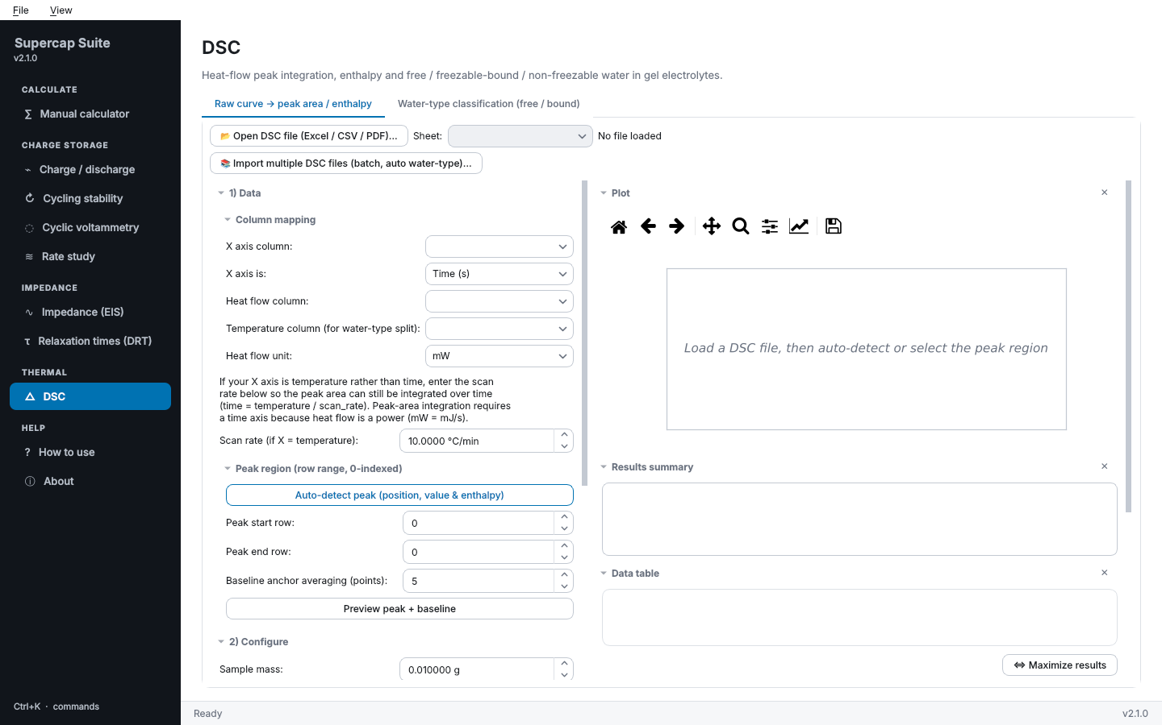
Figure 5. The DSC tool.

13. Recording and comparing results
Under each tool's results, Recorded results (compare samples / runs) collects results from several runs into one table:
1. After an analysis, type a Sample / run label (for example Sample A, 10 mV/s) and click + Record this result.
2. Repeat for each sample or condition — each becomes a row, parameters as columns.
3. ⬇ Export log to Excel… adds the table to an existing workbook; ⬇ Save log as Excel… writes a new one. Remove selected row and Clear log tidy it; ↶ Undo / ↷ Redo (or Ctrl+X / Ctrl+Y while the log has focus) reverse those.

14. Exporting
The Export ▾ button of a tool (or Ctrl+E) opens its destinations:
Menu item | What it does
📊 Export to Excel (existing workbook)… | Adds the results and data as a new sheet of a workbook you already have (or appends to a sheet you name).
💾 Save as new Excel workbook… | Writes a new workbook.
🔬 Send to OriginLab (data + graph) | Pushes the data and results into a worksheet of the running Origin session and builds a styled graph: data as symbols, fits as lines in their data's colour, axis titles with units (Z′, −Z″, 1/√v…), legend clear of the data. Each send adds to the same project.
💾 Save Origin project… | Saves the Origin project (.opju).
✕ Close Origin session (keeps this app open) | Closes Origin cleanly.

Important Origin cannot be closed with its own window button while this application controls it — use ✕ Close Origin session (or File › Close Origin session) instead. The suite explains this the first time Origin starts.

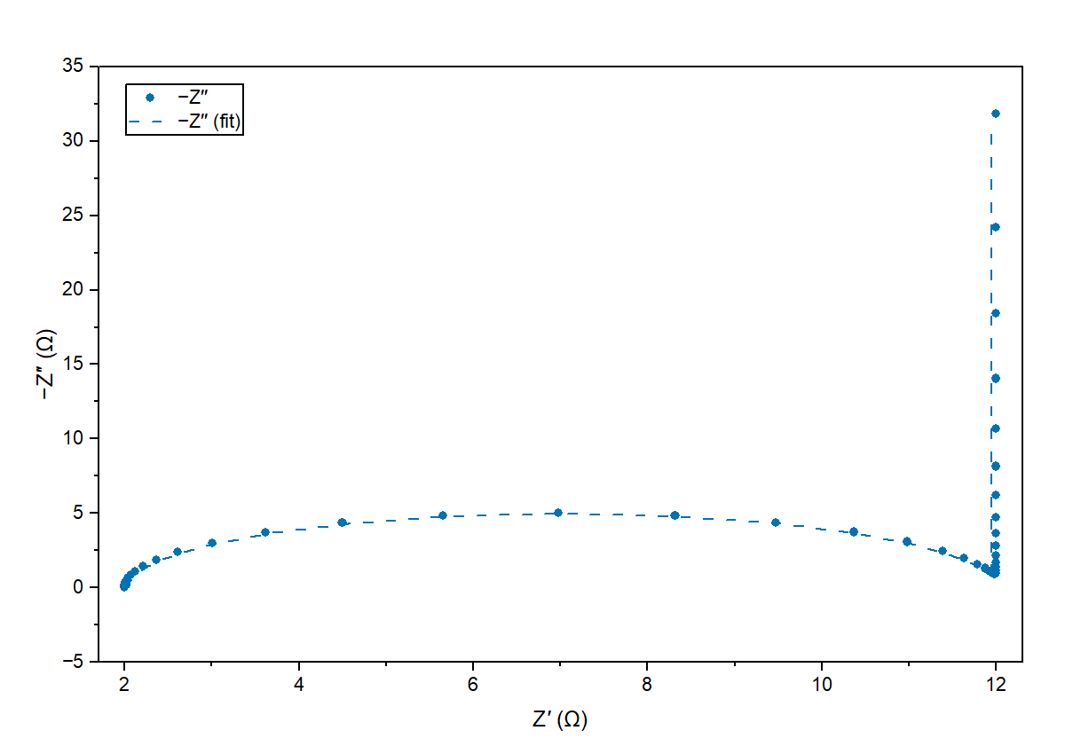
Figure 6. An impedance spectrum and its circuit fit as built in OriginLab.

15. Shortcuts
Keys | Action
Ctrl+O | Open a data file in the tool on screen
Ctrl+E | Open that tool's export menu
Ctrl+X / Ctrl+Y | Undo / redo inside a data table or the recorded-results log
Ctrl+K | Command palette
Ctrl+T | Light / dark theme
Ctrl+1 … Ctrl+9 | Go to a tool
Ctrl+Q | Quit

16. Accuracy and sources
All formulas are standard literature conventions with known caveats — mass basis, IR-drop handling, the heat-of-fusion reference value, b-value and Dunn's-method limitations. docs/EQUATIONS.md in the application folder lists every formula, its source and its assumptions, and every result's ⓘ Formula & source link shows the same one click away. The application cannot decide for you which convention is right for your system.
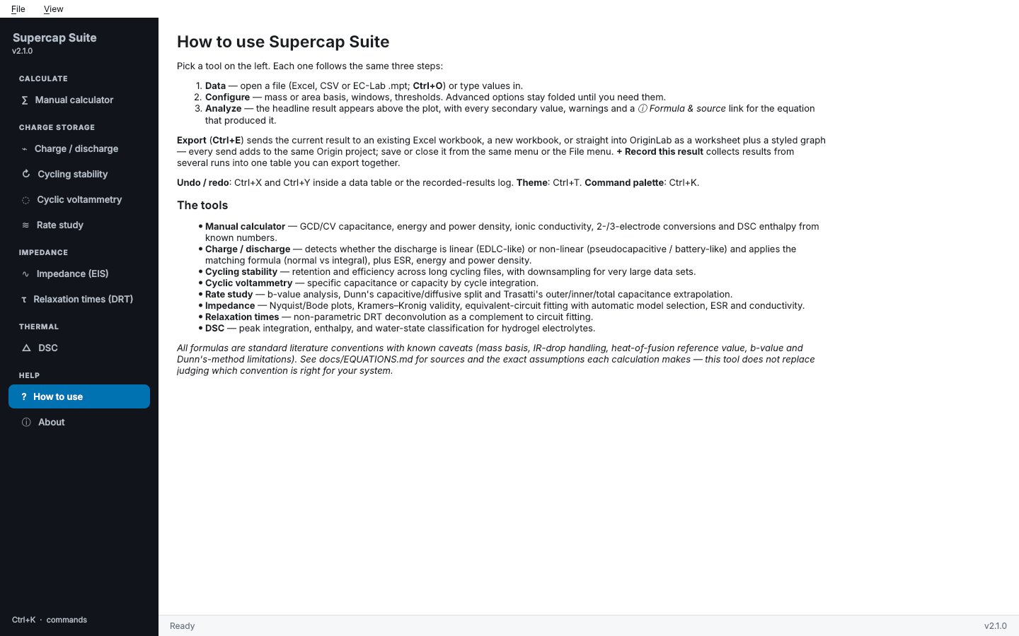
Figure 7. The built-in How to use page.
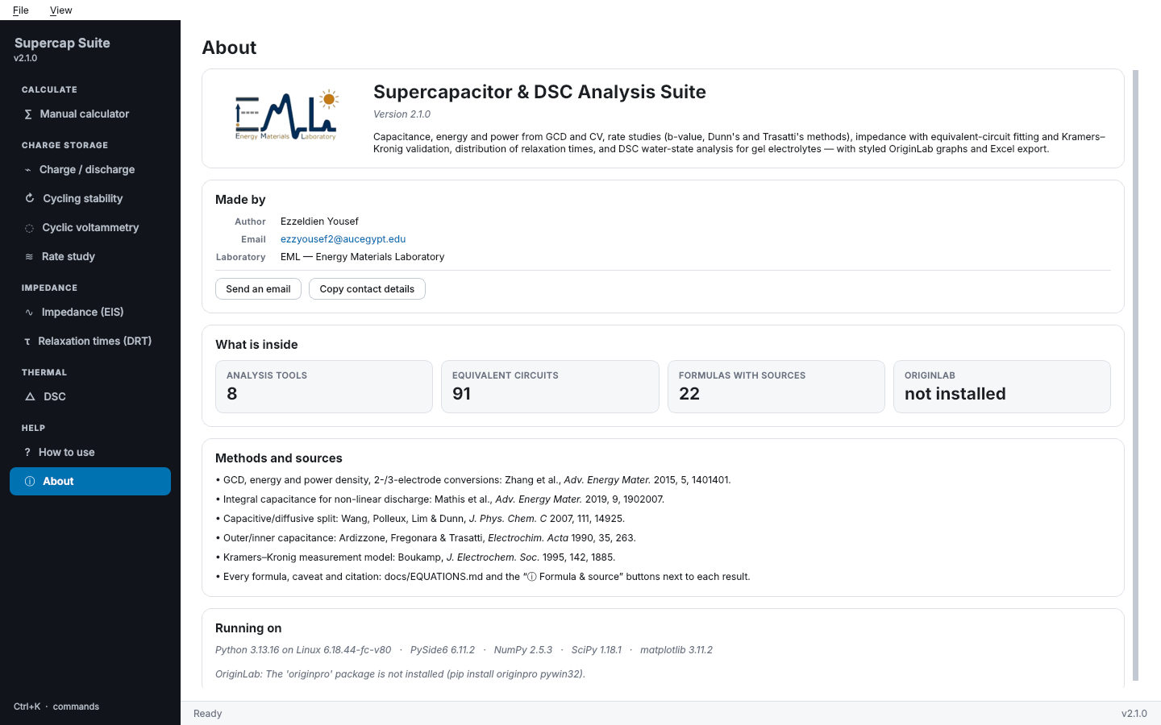
Figure 8. The About page.

What's new in version 2.1.0
Changes after independent science, code and usability reviews; docs/REVIEW_LOG.md lists every finding and what was done.
- GCD — the integral formula now measures V from the end-of-discharge voltage, so it agrees with the linear formula for any window; the IR drop is excluded from ΔV and Δt.
- Cycling — coulombic efficiency is computed from charge (Q) when the file has a current column; retention can be relative to the mean of the first N cycles.
- CV — a warning appears when the selected rows contain more than one cycle (their charge would add up).
- EIS fitting — points are weighted by their relative error, the classic Randles circuit Rs + Cdl‖(Rct+W) was added, capacitances above 10 F are allowed, and interchangeable stages are reported fastest first.
- Kramers–Kronig — a series capacitor and inductor are included, so a valid supercapacitor spectrum with its capacitive tail passes; smooth drift is flagged.
- DRT — λ can be chosen from the data by real/imaginary cross-validation.
- DSC — the heat-flow unit is read from the header (W, mW, µW, W/g, mW/mg); overlapping peaks in one window are reported separately; graphs use temperature when the X axis is temperature.
- Reliability — loading a file clears the previous result; a fit still running on old data is discarded; closing the window during a fit no longer crashes.

