A simple Cosmological Model

Fernando Alonso Vendrell
(July 18th – Dec 31st , 2017)

I propose a simple cosmological model to be used as a visual aid to understand apparently incompatible characteristics of the universe. This model is compatible with global properties of the universe, mainly because those properties are used to define it, yet the predictions of this model have not been observed. These predictions are also easy to understand so they can be compared with existing measurement, and can be used to introduce refinements due to theoretical background based on General Relativity, altering the model to account for them, and then visualize them with more accurate diagrams.

I. GLOBAL PROPERTIES

Based on observations, a majority of scientific community agrees on a set of properties that the universe has. These are well detailed in Ned Wright's Cosmology Tutorial [1] and they will serve as base for this cosmological model. This properties are:

- Isotropic Universe

- Homogeneous Universe

- Expansion of the universe, the farther an object is the fastest objects are receding from us

- There is an Background, it is isotropic and homogeneous

- Finite time since the beginning of the universe (Big Bang)

II.- GLOBAL ASUMPTIONS

The following are assumptions presented in the cosmological principle and assumptions that apply to other scientific theories:

- There is no privileged view of the universe, the physical laws apply the same independent of the place and time of the universe.

- There is a speed limit to which information can be sent from one place to another, so there can not be faster information exchange or any sort of instant communication.

- There is a proper Time defined based on time since the big bang.

III. SIMPLE COSMOLOGICAL MODEL PROPERTIES

Additionally to the previous properties and assumptions this simple cosmology model makes additional assumptions:

- All information is exchanged at the maximum speed

- Observers and observed events have very low velocities in comparison with the expansion of universe and are considered still in the same position

- Observers and observed events have very low interaction in comparison with the space time changing and are considered not influenced by any sort of field

- Universe has a finite description (closed)

- Universe is limited in spacial dimensions, 1, 2 or 3 and there is always a time dimension

- Universe has the simplest topological spacial description.
- Universe expands spatially linearly with time

IV.- ONE SPACIAL DIMENSION SIMPLE COSMOLOGICAL MODEL

The first approach is to have a model in which there is 1 spacial dimension and 1 time dimension, given the previous constrains the model is represented by a circumference:

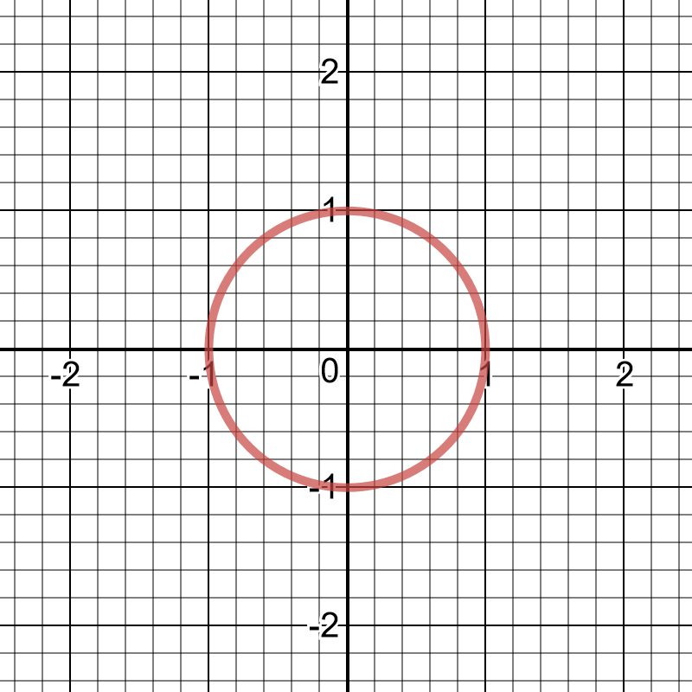Figure 1

In this case this universe it is closed but there is not a representation of time in it. In this simple model the universe is expanding from the (0,0) point (t0, t1, t2, t3,t4, and t_{now})

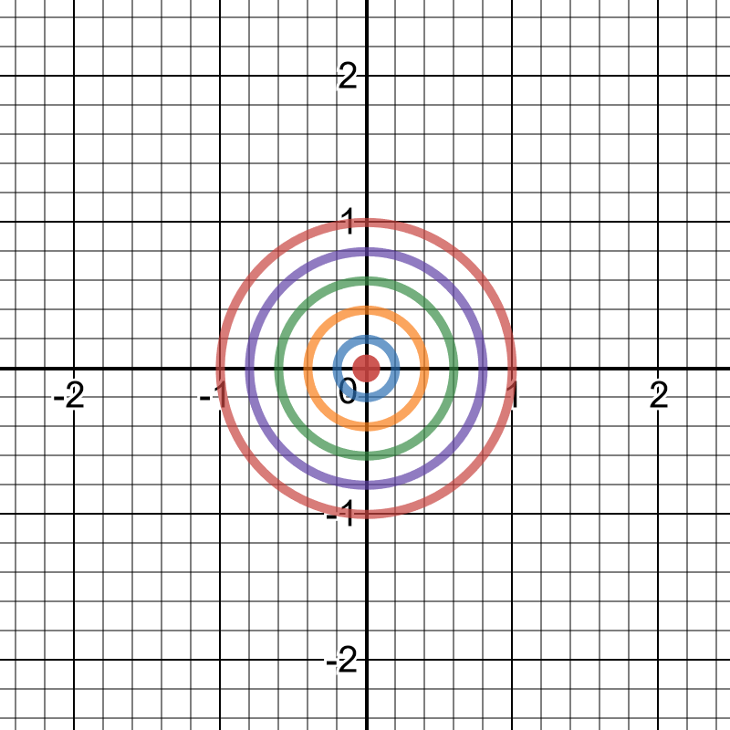Figure 2
From now on the point (1,0) represents our place in the universe now (t_{now}) although the descriptions and predictions do not change if the position or time is changed.

If we zoom into this point and plot current universe and the universe as it was in the near past we see that lines approach to straight lines

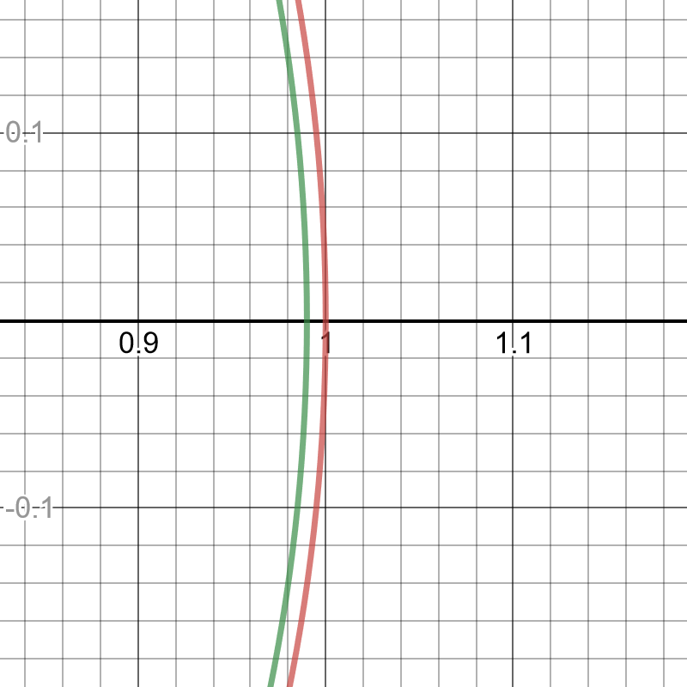Figure 3
Lets visualize the exchange of information (information line) between an object close to us and our place in the universe.

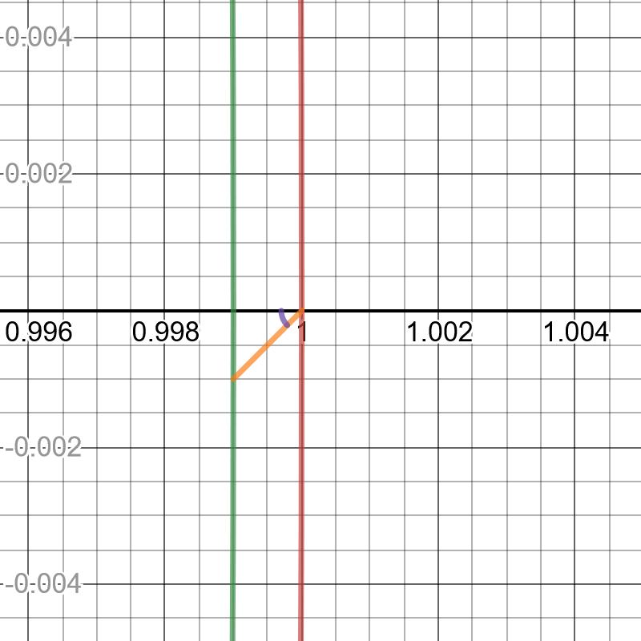Figure 4
Here we see that the object some time ago sent a signal toward us, this signal is moving at a constant speed while the universe has been expanding (visible in the zoom as the universe moving to the right, although this is just local perception due to the level of zoom), so we can represent it as a line (almost straight) from the object in the past towards us in the present. This information line forms an angle with the line representing the time or the space depending on the speed of the information traveling through space compared with the speed of the expanding universe.

The differentiating assumption in this model is that that angle (denoted by letter φ )does not change at any time or place, so that speed is constant. If that is the case, any information line will be a curve called logarithmic spiral.

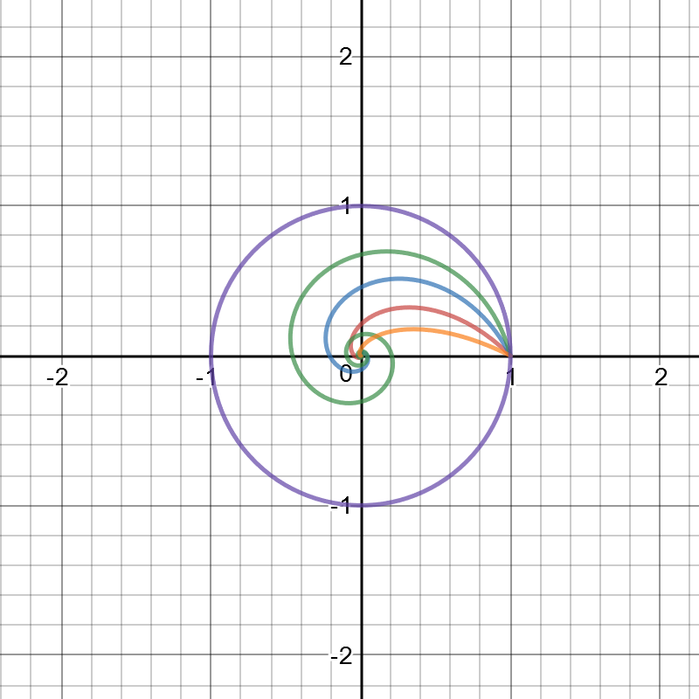Figure 5
In this figure 4 different non zero, finite information speed are represented for different values of φ.

One of the features of these curves is that they go around the origin an infinite number of times, if we zoom in a hundred time the same 4 curves we see:

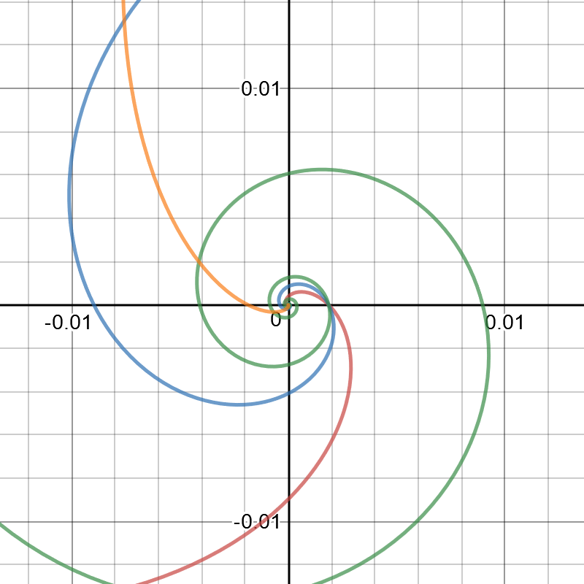Figure 6
Yet the length of these curves is finite, as a logarithmic spiral, the length of information line since origin is

From this point on we will use a high velocity of information, (high φ) in order to visualize this "spiral" condition of the information lines, but later on we will adjust φ to match observed data.

V.- DISTANCE BETWEEN OBJECTS

Now lets assume a distant object B sent some information that is received by us (A) now. This is shown in the following diagram. B can be described as a point in the circumference separated from us by an angle θ
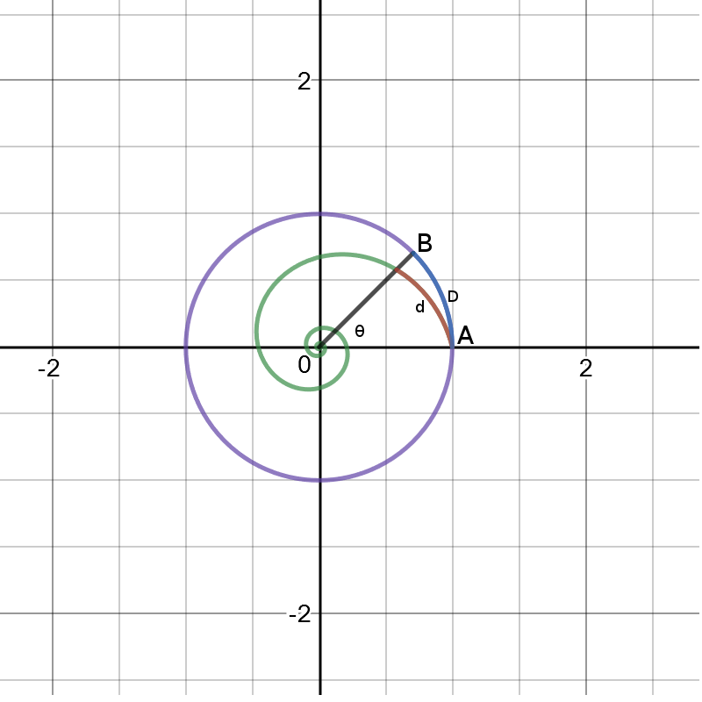Figure 7

Based on this angle θ we can define 2 distances:

- D is the distance from A to B if the universe was not expanding and can be calculated as:

- d is the distance from A to B that the information has traveled and takes into account the expansion of the universe. It can be calculated as:

R_{A} = Radius A now
R_{B} = Radius B then

so finally we have:

Notice that in this model B has sent many (an infinite amount in fact) interactions that are received by us, so these distances should be actually defined as:

and

so whilst d is limited D can be as big as we want.

V.- VELOCITY BETWEEN OBJECTS

Now we can measure how these distances change as time passes and the universe expands. One of the assumptions is that universe expands linearly with time from an original situation, therefore we can say that

where K and R0 are constants and R0 can be zero

For D we can calculate its Velocity V as:

or written in terms of D if R0 is sufficiently small:

So for any given moment in time this Velocity is proportional to the Distance, since the Distance can be as big as we want, so can the Velocity, being even greater than the velocity of information travel.

For d we can calculate its velocity v as:
or written in terms of d if R0 is sufficiently small doing the same

since d is limited to the length of the curve

and assuming R0 is very small we have that

which is finite but the actual value depends on the relation between the speed of universe expansion and the speed of information travel.

VI.- AVAILABLE MEASURES

Up to now, all measurements have been done assuming we could identify “point B” within the universe. One way to identify point B (distance and therefore velocity as seen from A) can be derived if point B generates a signal with certain periodicity. Let's assume that B generates such a signal so it repeats every T_{B} and we can check if that signal arrives at A with a different period (T_{A}), related to the distance of B.

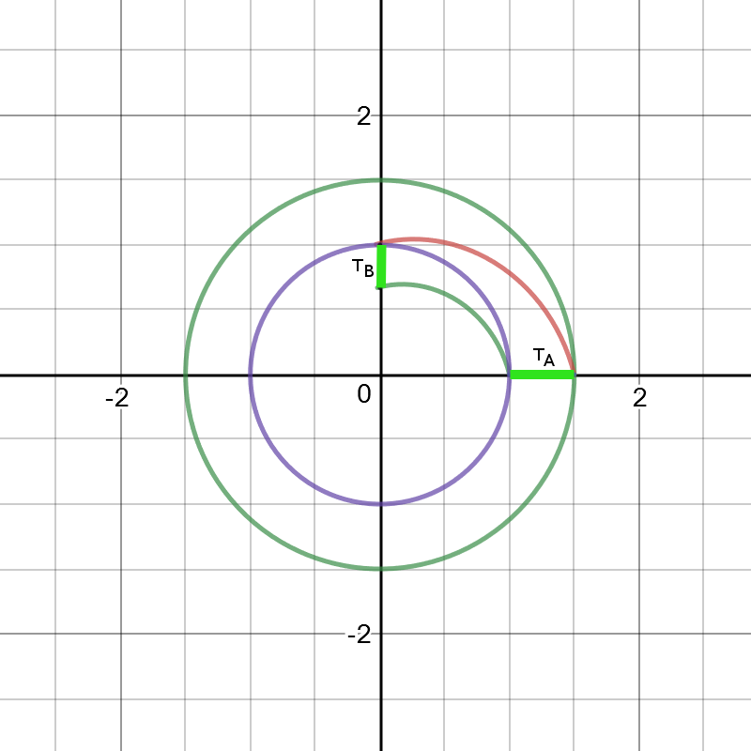Figure 8

Since we assume that signal moves at maximum speed we can calculate the original T_{B} based on T_{A} measured and the position θ of B.

So the received period is larger than the original period. If instead of period we use frequency we get a higher frequency emitted than the one observed:

From it we can calculate a “redshift” z parameter as:

or z+1 as:

Another measure could be the decrease of observed intensity of certain emitted quantity from point B as this is spread on N-1 spacial dimension.

In the case of one spacial dimension there is no such spread, as the intensity is constant with distance from B, but in the case of more spacial dimensions the decrease of intensity is 1/distance (for 2 spacial dimensions) and 1/distance² (for 3 spacial dimensions).

VII.- CORRELATED OBSERVATIONS

We have already noticed that we can observe B at different moments in time, so if the object has not changed in time we will observe several versions of it. If we had a description on how the object changes through time we could also correlate them based on their evolution.

Additionally since we are in a one spacial dimension universe, we have two directions to look at and if we plot the information lines we see that they cross multiple (infinite) number of times, so if we look to opposite directions we will see the same object at certain distances, being these objects ourselves in the past, and the objects located at the opposite side of the universe.

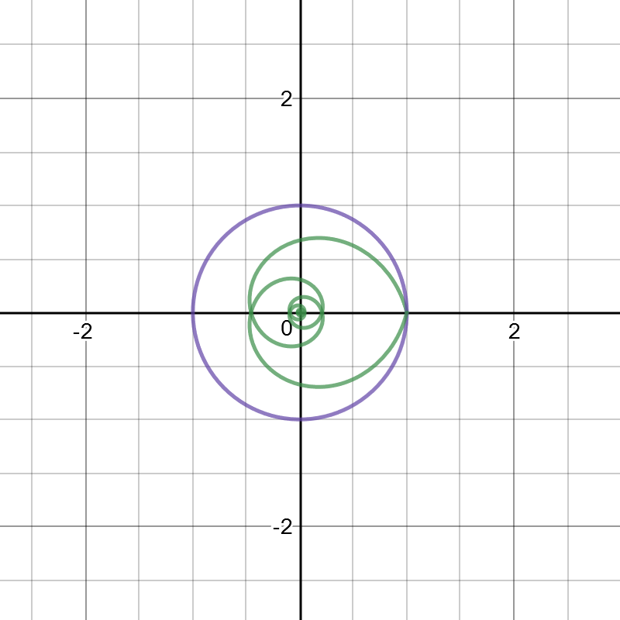Figure 9

VIII.- TWO SPACIAL DIMENSIONS SIMPLE COSMOLOGICAL MODEL

We can extend this model to 2 spacial dimensions, keeping the assumptions of simplicity and closed description. Now instead of an expanding circumference we have an expanding sphere.

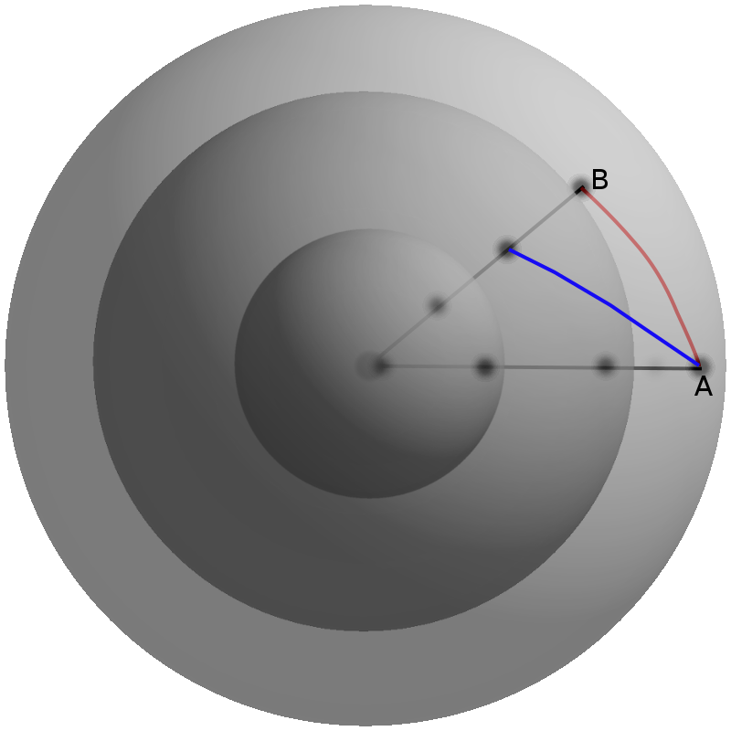Figure 10

Since for any A-B pair of objects we can slice this universe into a circumference all the properties and predictions from the 1D universe still apply for this universe

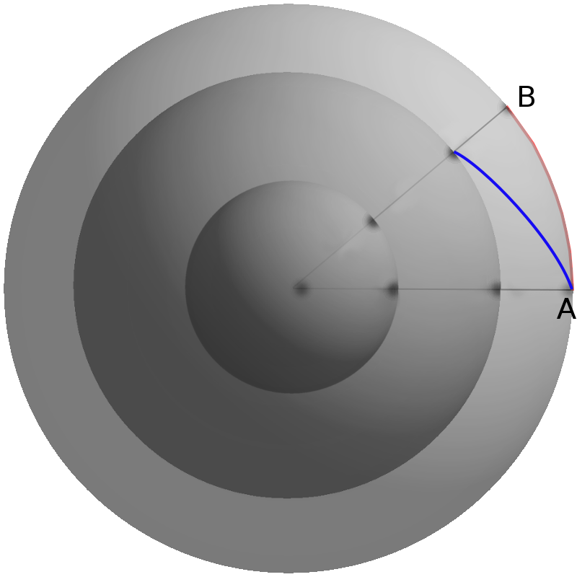Figure 11

IX.- DENSITY OF CONSERVED CUANTITY

Now lets assume there is certain property that is uniformly distributed in the universe and that the quantity of it is conserved through time. Let's call this quantity Q₀.

We can define the density of this property as the relation of this quantity and the size of the universe. As the universe expands this density will be lower.

In the case of one spacial dimension, the size of the universe is:

And the density (ρ) at a given time where universe had radius R is:

In the universe of one spacial dimension all the visual field that we had was a point, so in case we could measure a small interval of the past universe at R , say from R-ΔR to R+ ΔR we would be measuring the density of the universe directly.

In the case of two spacial dimensions, the size of the universe is:

And the density (ρ) at a given time where universe had radius R is:

Now the visual field can be defined by an angle (α), so it defines a section of the universe we can see at a given past time
This section increases as the two information lines that define α are further apart and decreases as the information lines get closer.
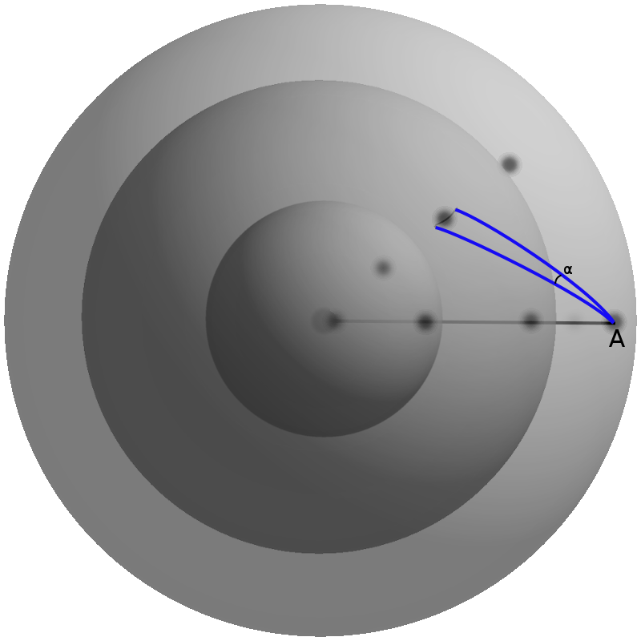Figure 12

In a flat universe (not curved) these lines would diverge and the section observed gets greater the further we observe.

In our simple universe information lines initially diverge, but they later converge and cross again at the angles θ=π, 2π, 3π... Nπ an infinite number of times.
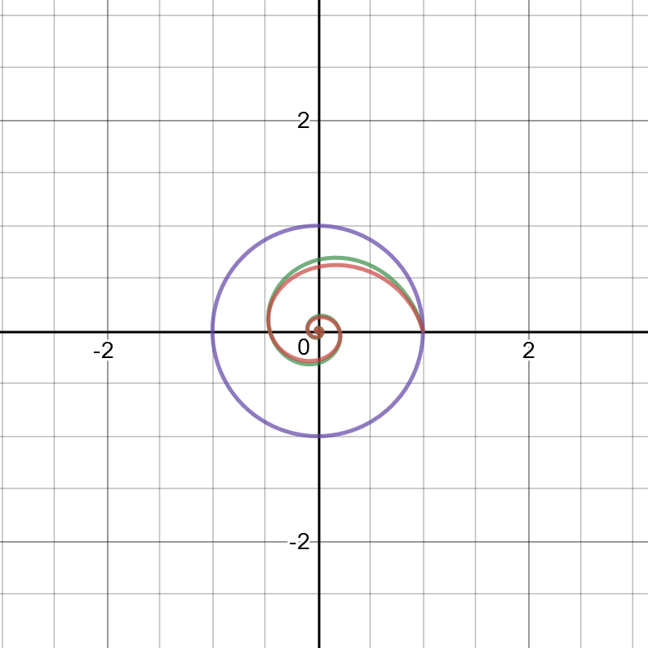Figure 13
In this figure we are seeing a section of a two spatially dimensional simple universe in which the two information lines separated at A by angle α are plotted. Keep in mind that both lines always keep the same angle φ with the radius at any point, and they appear different because of the section used.
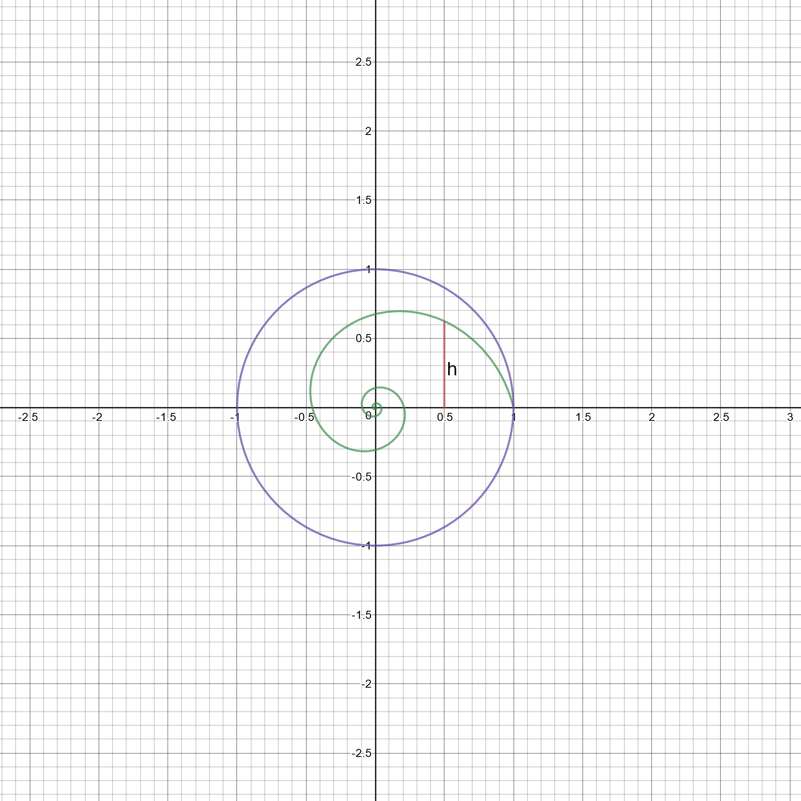Figure 14
This separation depends on the value h, and the angle α, so the visual field is:

we can calculate the value based on the radius at a given θ:

and h is then:

so the visual field is:

and the quantity observed is:

which has maximum where theta meets:

So for a given visual field there are maximums of density, being the first one at:
θ= π-φ
and the first minimum at:
θ= π

X.- THREE SPACIAL DIMENSIONS SIMPLE COSMOLOGICAL MODEL

In three spacial dimensions the visual field depends with the angle α, in steradian, and h, same as in the two spacial dimensional example now the visual field is:

we can calculate the value based on the radius at a given θ:

In the case of three spacial dimensions, the size of the universe is:

And the density (ρ) at a given time where universe had radius R is:

and the quantity observed is:

which has maximum where theta meets:

XI.- SETTING SIMPLE COSMOLOGICAL MODEL PARAMETERS

In all the presented models the free parameters to set are:

Parameter | Short Description
K | Constant of expansion
T | Age of Universe
R₀ | Starting radius of universe
φ | Angle between information line and radius (relation of speed of expansion to speed of information exchange)

We can then, set them to match age of universe, huble constant and

Age of the universe: 13.799+-0.021 Gy
Huble constant: 67.5 km/s/Mpc=0.069c/Gly
Observable universe: 46.5 Gly
CMB redshift (z): 1089

Since our simple cosmological universe relates directly the age with velocity between objects we can deduce T as:

T=1/H₀ => T = 14.49 Gy

In order to keep it simple we can set R₀ = 0, K = 1 and φ=45 degrees.

In this case we get first correlation at

which is 0.63 Gy respect to T providing an estimate that it happened at:

T₁=14.49-0.63=13.86Gy as the time of first correlation (somehow close to the reference age of the universe 13.79 Gy).

Note that observable universe in this model is all universe, so we can see as many Gly as we want, but we can define the vision of unique objects, we can think of it as (being K=1 and φ=45degrees)::

πT = 45.52 Gly (also close to current estimates of observable universe).

In this model although there is only one Big Bang there are infinite "potentially observed" big bangs and the different epochs take time over large periods, additionally all universe is causally connected.

We can calculate redshift z for first and second Big Bang.

which are far from expected CMB redshift of 1089. Of course we could modify φ so we can match redshift with observed big bang N. eg. If φ is 0.42 radians or 24 degrees then first big bang is the one generating the CMB. In this case R₁ is 0.01329Gy.

Of course we could play around with φ, R₀, T to match better observed data, but that is not the purpose of this model, rather to provide an initial step into understanding the meaning of a curved finite universe and a linear expansion.

Additionally this model could serve to introduce tools to provide more accurate concepts than “distance” like metrics or pseudo metrics, or how to measure curvature in a three spacial universe.

XII. CONCLUSION:

I have presented a very simple cosmological model which can be used to visualize universe evolution and to compare with observed data.

This model only contains constant speed of information exchange (speed of light) respect to expansion rate as physical constrain, and doesn't account for General Relativity making it just a mathematical approximation to most accurate models, on the other hand provides some sort of beauty due to the logarithmic spiral.

XIII. ACKNOLEDGEMENTS AND DISCLAIMER

Although this model is quite simple and I have derived myself from a couple of assumptions, I have only found a similar reference in Les Hardison book “More Light on the expanding universe” in “The exponential spiral model” chapter.

Nevertheless, it is very likely that this model has already be presented before this presentation, should that be the case, I recognize credit of it to whoever did it before me and I present apologies to not referencing it in this version.

Additionally, I have based the model on a limited set of information (mostly Wikipedia, Ned Wright's Cosmology tutorial and John Baez General Relativity tutorial), I would like to thank all the authors for the time taken to provide such useful information.

I would also like to thank my wife for her patience when I dedicate time for these ideas and my daughters for the notebook where I started sketching this model.

XIV. - REFERENCES

http://www.astro.ucla.edu/~wright/cosmo_01.htm

https://en.wikipedia.org/wiki/Big_Bang

https://en.wikipedia.org/wiki/Logarithmic_spiral

https://es.wikipedia.org/wiki/Esfera#Esferas_en_dimensiones_superiores

https://en.wikipedia.org/wiki/Hubble's_law

https://books.google.es/books?id=iCC9CwAAQBAJ&pg=PT80&lpg=PT80&dq=Les+Hardison+exponential+spiral+model&source=bl&ots=ikAF7qaKWZ&sig=hHlPD0YYa45wwjf-3CBmsr7D1JE&hl=es&sa=X&ved=0ahUKEwjy_viX0LTYAhWDNxQKHaMvDo0Q6AEIIDAF

http://math.ucr.edu/home/baez/gr/gr.html

