|  |
| --- |
| 3-30-2020 |

|  |
| --- |
| Distributed Applications |
| Student Transcript Application |
| [ Farah Aly, Vasilica Androsca, Ieaun Roberts] |

Contents

Introduction 2

How is this report structured? 2

1. Application Specification and Functionality 0

Application domain 0

Student User 0

University instructor user 1

Organization user 1

User Stories 2

Basic threat model 3

2. Overall logical and physical architecture 3

3. Domain object model 3

4. Stored data model and the mapping between the two models 5

Data Model and Data Access 5

5. Critical appraisal 0

Vasilica Androsca 0

Farah Aly 0

Ieaun Roberts 0

6. Prototype Related 0

References 1

Appendix 0

1) Initial UI design 0

2) User Flow Diagram 2

3) Page Navigation Diagram 3

# Introduction

[0% +- 100 words]

According to Wager (2018), “accepting transcripts directly from the student should be avoided. This approach opens the possibility of fraudulent representation of the record. A common approach is for the originating school to place the original record in a sealed envelope, enabling the student to deliver to document to the employer. Sometimes the document is marked “issued to student”. Regardless, this approach is at best marginally more secure and the fundamental possibility of fraud remains.” With the growing advance in technology, a method to authenticate the student transcripts has been offered with our project TRS.

TRS is a Transcript Repository System: a web-based application prototype built using the ASP.NET MVC framework. TRS allows the university to manage and hold eTranscripts for the students through the years. It will also be granting access for organizations to view the transcripts of their future employees in the recruitment process directly from the university’s system.

Proper user scenarios were divided in order for the system to be useful to be functional for every type of user that can come across TRS.

## How is this report structured?

The report is broken down into 5 distinct sections with each focusing on either requirement scoping and system design, data storage modelling or reflection and appraisal. The 5 sections are as follows:

1. Application Specification and Functionality
2. Overall logical and physical architecture
3. Domain object model
4. Stored data model and the mapping between the two models
5. Critical appraisal

A section about the prototype development is then included to conclude this report. This is then followed by reference and an appendix including UML diagrams to demonstrate TRS’s functionalities.

# 1. Application Specification and Functionality

[20% +- 1100 words]

A system is required to act as a university transcript repository to be helpful to students and employers. The specification set by the team is as follow: this system will be utilized by 3 end users: the university instructors, the students and organizations. University instructors are responsible for creating the transcripts. They act as the ‘admin’ users where they have full access to all the systems functionalities. The student can view their transcripts and can approve or deny the organizations requests to access their transcripts.

The students and university instructors would be able to log in with their university user ID or email along with their website. The organizations do not require log in credentials. They are given a shareable link by student. When they require a transcript, the organization sends a request for the transcript via the TRS link and the student can approve or deny their request.

Each type of users has a different set of functionalities which gives them different rights of access. These are explained further below.

## Application domain

### Student User

When conducting research further into the application domain the initial stages were spent inspecting a system many of us in our group had prior experience with that performed a few of the functions we would need in our enterprise prototype. This system was of course the E-vision portal made use of by the university to distribute official student results to all enrolled on a specific degree.

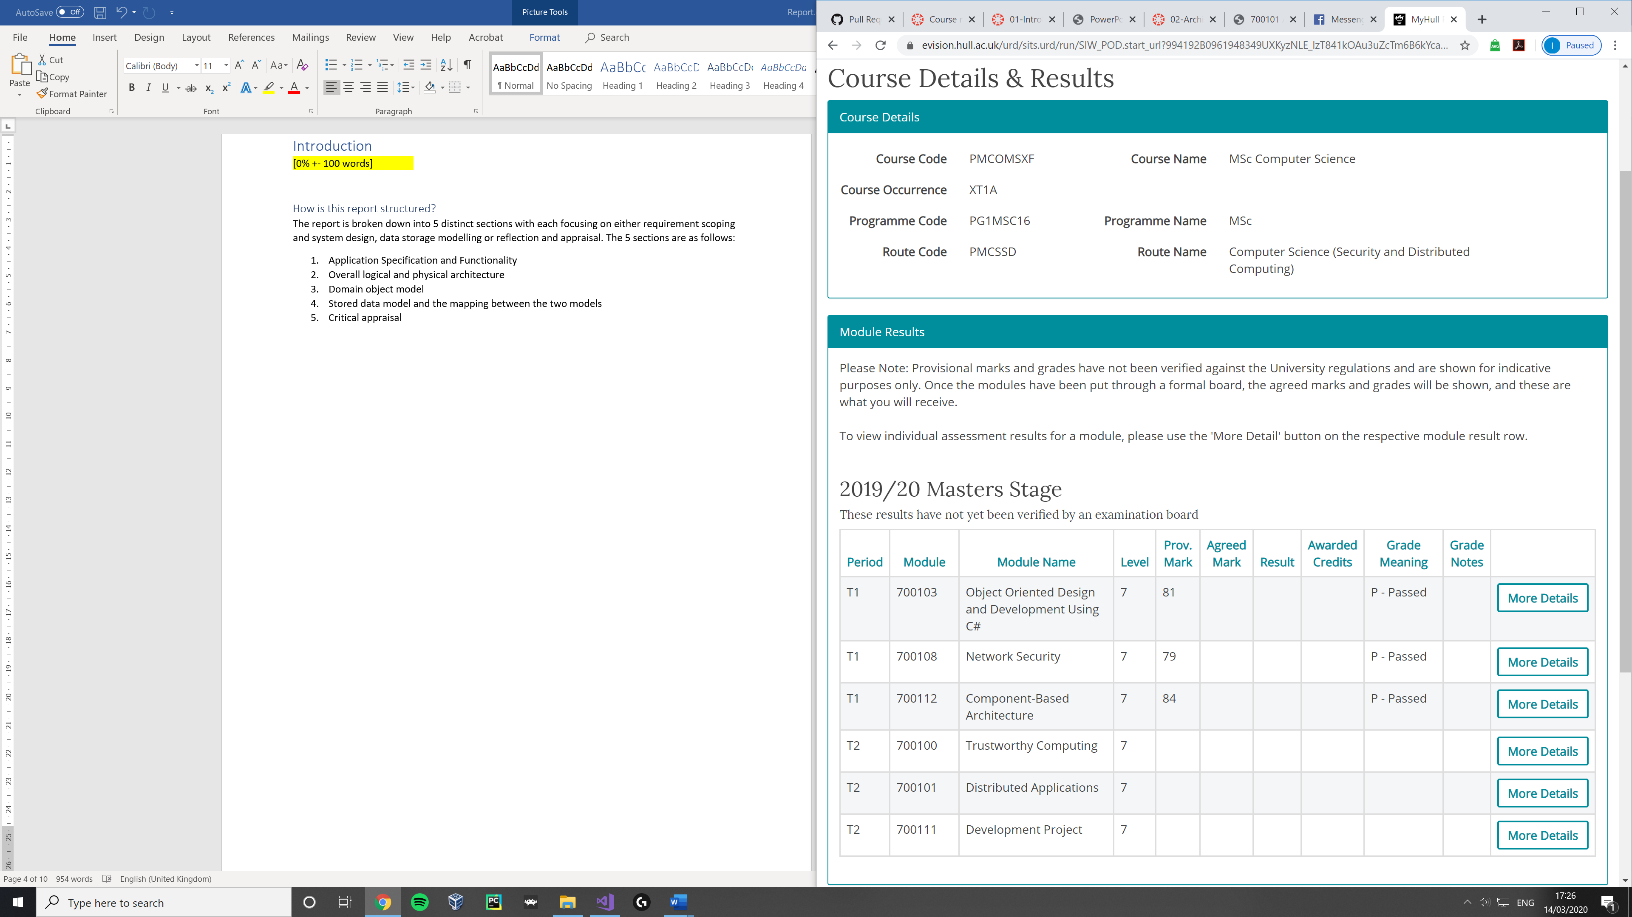

[Figure 1, E-vision Course details and results page (evision, 2020)]

Many requirements were revealed through this investigation, most notably the necessity to store several tables for numerous students across multiple universities. Using E-Vision as reference meant it was also possible to know exactly what fields we would need to prioritize and store in our data structure (Module id, Overall grade, Enrolled course ID, Semesters)

One possible security vulnerability that was found while accessing the E-Vision sight was in the form of ease of access. As all that is required to enter the site is a simple username – password method it would be possible for a malicious user with a keylogger to obtain further detailed information about a student with which they could use to commit fraud.

One way to add a further layer of security on top of the login design would be a 2-factor authentication system that would prompt a user to enter a produced 8-digit pin sent to their university email address whenever they successfully enter their username and password. This would serve as both another door to hide personal data behind and also a notification system that someone is attempting to access your account. It is acknowledged that this improvement would be at the cost of ease of access. Another security improvement would be further verification when using a new device to access the site.

#### Student User main Functionality

* Login
* View transcripts
* Manage access

### University instructor user

As with the E-Vision system, staff will need to have the ability to upload transcripts to the repository. This can be either by the instructor entering the data manually within the web application or possibly submitting a pdf. It is however assumed that the process of entering individual results and transferring them to numerous systems is automated from the stage of an examiner submitting a result on canvas to the student receiving it on the E-Vision site 3 months later with little to no human interaction with the data in-between, so an automation friendly system will be needed that can process data in a standard format (e.g xml) generated from another system.

Transcripts submitted by instructors will need to be verified and cross referenced with university records of the student attending and completing that course to prevent fraudulent transcripts from being uploaded.

#### University instructors main Functionality

* Login
* Upload transcripts manually, via pdf or via data storage methods such as e.g. xml files, databases
* Create, edit and delete courses.
* Create, edit and delete modules.
* Create, edit and delete transcripts.

### Organization user

To get a better understanding of what recruiters and organizations alike desire from a system where academic accomplishments can be displayed in a verified environment, research was conducted on “LinkedIn Talent Solutions”. On their site it is clear that there is a heavy emphasis on reaching a “unique audience”, obtaining “qualified candidates” and easily managing selected applicants. (Linkedin, 2020)

Through this research, a lot of functionality was birthed such as organization users being able to search for all students currently enrolled on a specific degree and requesting to view their profile as well as Student Users allowing the organization to further their hiring process by requesting the students email to contact them to discuss available positions.

#### Organization user main Functionality

* Login
* Request to view a student’s transcript

The repository application has been designed with three key user types in mind, they are

1. **University instructors** who upload completed transcript into the repository system for other users
2. **Students** making use of the program to view / share their transcript with 3rd parties.
3. **Organizations** who receive invitations and request to view other users’ transcripts.

## User Stories

As a **student** making use of the repository system, I want to be able to:

* Login.
* View my transcript when I need to.
* Trust the security of the system and be assured that my transcript will not be made public to any 3rd party unless I authorize it.
* View who has access to my transcripts as well as when they accessed it, along with the ability to revoke access to my transcript from a trusted company when I deem necessary.
* Have an option to make my transcript completely private (revoke all access from other users)
* Have an option to make my transcript public (anyone with a link can view my transcript and should I chose so, a link to my transcript will be returned to organizations searching for students in my field)

As an **organization / employer** making use of the repository system I want to be able to:

* Create a profile and login.
* Request to view or download a copy of a future employee’s (students) transcript.
* Trust that the transcript has been validated and is from an official educational institution.
* Search for student transcripts that match my criterial.
* Request further contact details if a transcript is satisfactory.

As an **educational institution** making use of the repository system, I want to be able to:

* Create a profile and login.
* Upload and store student transcripts to the repository system in a simple concise manner.
* Update / delete uploaded transcripts if necessary.
* Not worry about the security of the system.
* Not worry about any limitations in storage size. (Upload as many transcripts as I want).
* Automate the process of transcript uploading.

## Basic threat model

# 2. Overall logical and physical architecture

[%10 +- 450 words]

“explain the motivation or justification for the choices made”

“Discuss and justify the choice of any design patterns”

“In Section 2. Overall logical and physical architecture, estimate the performance requirements and discuss the ability of the design to achieve the required performance.”

# 3. Domain object model

[%10 +- 450 words]

“explain the motivation or justification for the choices made”

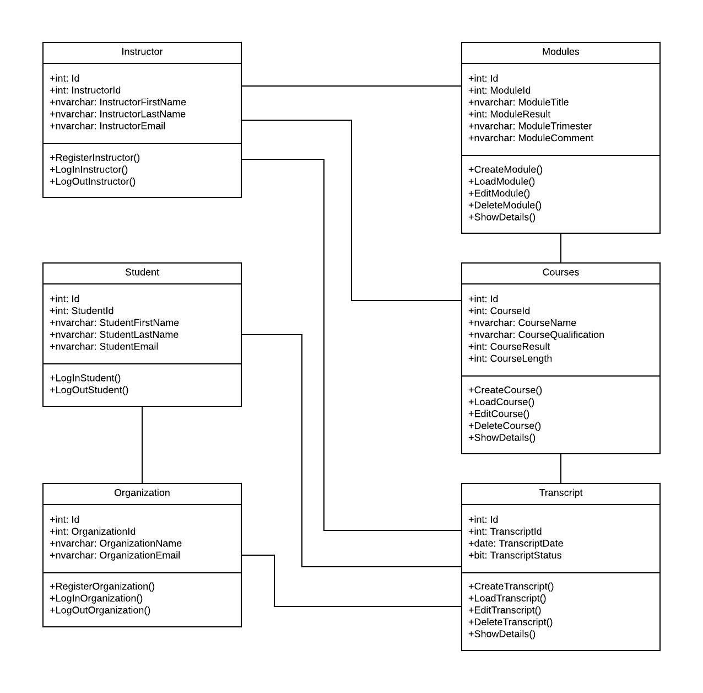

*

1

1

1

1

*

*

*

*

1

*

*

*

*

*

1

# 4. Stored data model and the mapping between the two models

[%10 +- 450 words]

“explain the motivation or justification for the choices made”

## Data Model and Data Access

“You are required to design the appropriate business objects and database structures using suitable design patterns.”

# 5. Critical appraisal

[25% +- 1500 words (500 each)]

“explain the motivation or justification for the choices made”

“You are also required to consider your design with respect to performance and scalability.”

“In Section 5. Critical Appraisal, each member of the group must, as an individual piece of work, write a critical appraisal of the application. Each individual critical appraisal should have as a heading the name of the student author. The appraisal should identify the strengths and weakness of the application. Discuss the areas where the application is well-designed and the areas where the design is not ideal. Where weakness are identified, discuss how they might be overcome.”

## Vasilica Androsca

[+-500 words]

---------------------------------------------------------------

## Farah Aly

[+-500 words]

----------------------------------------------------------------

## Ieaun Roberts

[+-500 words]

# Prototype Development

“The prototype should be able to 1. carry out selected functions, and 2. illustrate an overall user interface design.”

“In implementing the prototype, it is necessary to consider the architecture of the full application and all of the classes required by the design but not all of them need to be present or fully functional. Implement sufficient functionality to illustrate a few core functions and to give an overall impression of the design, i.e. a proof of concept. For many classes it may be sufficient to define the properties of the classes and the signatures of methods and to have these throw NotImplementedExceptions to show that they require implementation. Development of the prototype software is a minor part of this assignment, note the proportion of marks awarded for the software in the mark scheme. The majority of the assignment marks are awarded for the specification, design, the justifications of the design decisions, and the critical appraisal. Demonstration of the prototype, will be timetabled during a laboratory session and the software must run on a laboratory machine

# References

evision, 2020. *https://evision.hull.ac.uk.* [Online]   
Available at: https://evision.hull.ac.uk/urd/sits.urd/run/siw_lgn  
[Accessed 1 March 2020].

Linkedin, 2020. *https://business.linkedin.com/talent-solutions/.* [Online]   
Available at: https://business.linkedin.com/talent-solutions/cx/2016/11/jobs-dual-cta-2?&src=go-pa&trk=google_job-mktg_s_cid_1420546284_tid_kwd-316000194951_k_linkedin%20for%20recruiters_dev_c_crid_274143584308&veh=google_job-mktg_s_cid_1420546284_tid_kwd-316000194951_  
[Accessed 14 March 2020].

Wager J., 2018. *The Future Of The Academic Transcript – Do Employers Ask For Your Transcript?*. [online] Available at: <https://www.credentialssolutions.net/newsroom/blog/credentials-blog/2018/06/11/the-future-of-the-academic-transcript-do-employers-ask-for-your-transcript> [Accessed 24 May 2020].

# Appendix

## Initial UI Wireframe

[<https://whimsical.com/MzcxPfSASXPNdhWru59LFu>]

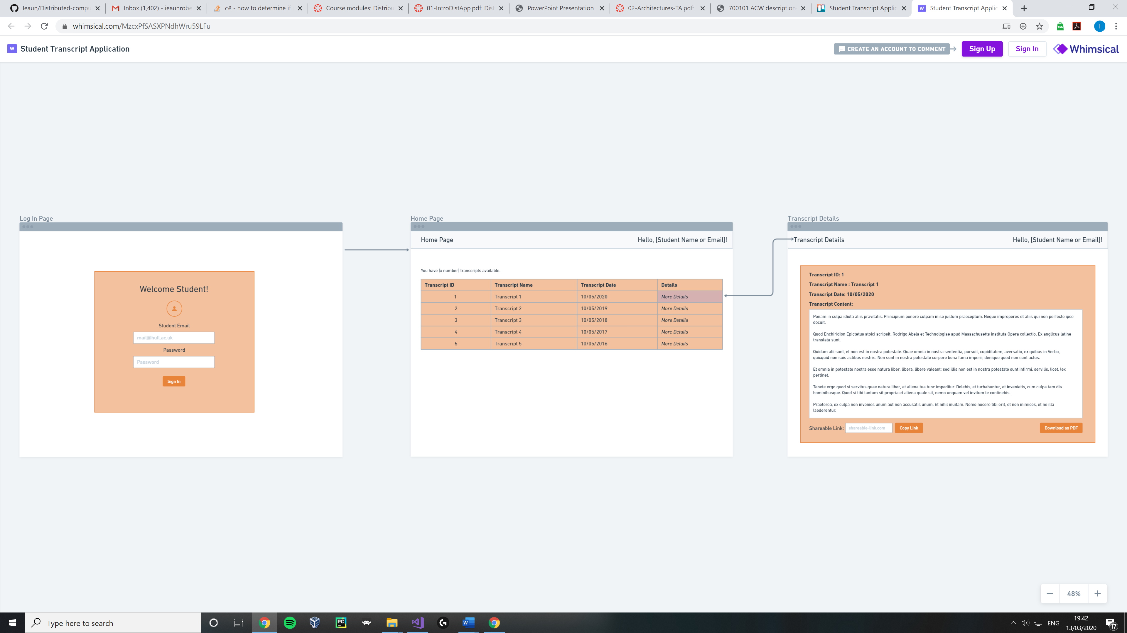



## User Flow Diagram

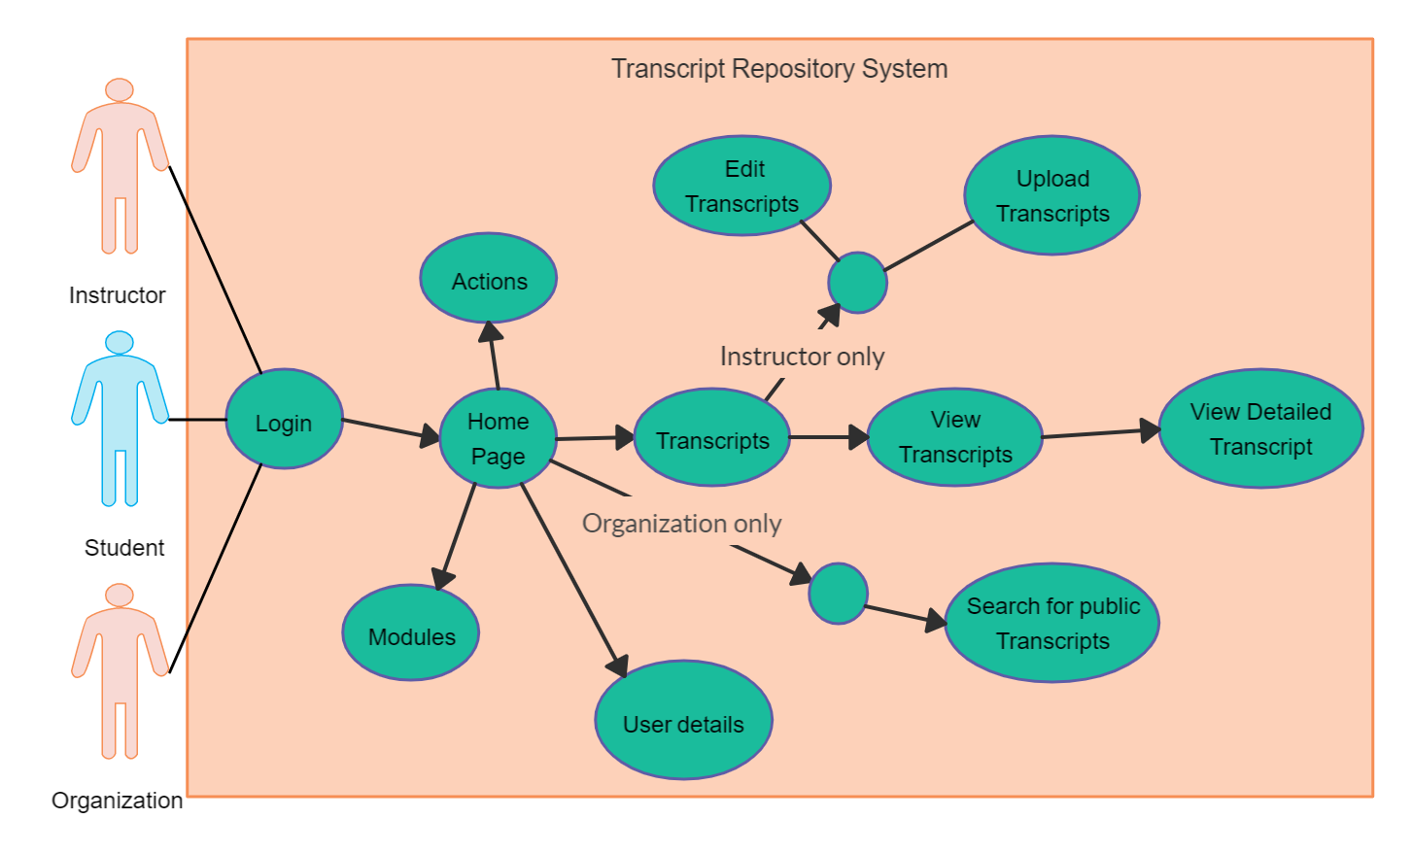

## Page Navigation Diagram

