The Effect of Climate Variability on Colombian Coffee Productivity: A Dynamic Panel Model Approach

Abstract

Coffee is one of the trademarks of Colombia. Currently, up to a half million Colombian families depend directly on coffee production for their livelihoods. As such, there has been increasing concerns about how coffee productivity will react to changing climate conditions and how coffee growers could adapt their production practices. This paper is one of the first to estimate the production function of Colombian coffee at the municipal level and to make projections about its future productivity. Using a panel dataset measured across municipalities over 2007-2013, we find that productivity depends on altitude as well as on March temperature and precipitation. We estimate projections based on the 2.6, 4.5, and 6.0 Representative Concentration Pathways derived from Global Circulation Models to find out that productivity over 2041-2060 is expected to increase by 7.6% on average. However, we find that this forecast varies greatly according to altitude. Indeed, municipalities above median elevation will increase their productivity by 16%, while those below the median will experience a 8.1% decrease in productivity. This result implies that place-tailored strategies for coffee production in Colombia are required to adapt to changing climate conditions in the future.

**Keywords:** Production function, altitude, Global Circulation Models, prediction.

# 1. Introduction

Coffee is one of the major crops produced in Colombia. This country is the world’s third largest producer of coffee after Brazil and Vietnam. Currently, up to 550,000 families depend directly on coffee production for their livelihoods (Federacion Nacional de Cafeteros de Colombia, 2017). Many more depend on it indirectly. Due to changing climate conditions, there has been increasing concern about the future quantity and quality of the coffee yield in the decades to come. Following a surge of crop production functions that propose to forecast the yield of crops such as corn (Burke and Emerick, 2016), soybeans (Fodor et al., 2017) and rice (Shrestha et al., 2016), some studies have also offered their forecast on coffee (Gay et al., 2006; Sachs et al., 2015; Schroth et al., 2009). They conclude that coffee is one of the crops that will suffer the most under unpredictable weather, with estimates of productivity losses of up to 34% for Mexico and 20% for Brazil. When it comes to Colombia, they forecast an increase between 4 and 24% in yields (Sachs et al., 2015). However, these studies restrict themselves to estimates at the national level (Sachs et al., 2015; Schroth et al., 2009), or to a geographic region within a country (Gay et al., 2006). With more than 500 municipalities producing coffee in Colombia, one cannot assume that each of them will be affected in the same way. As a result, this paper builds on the existing literature and offers the first estimates and forecasts of the impact of climate variability at the municipal level.

Crop production estimation efforts that rely on cross-sectional data, such as the ones conducted by Gay et al. (2006) and Schroth et al. (2009) explicitly estimate the effect of varying weather conditions on coffee productivity. However, they face a number of challenges: first, the availability of data on labor and capital inputs is often limited, and model selection is therefore constrained by the variables present in the data set. Ensuing models are highly discretionary in their choice of variables and functional form and could suffer from omitted variable bias if relevant variables are not explicitly modeled. Furthermore, the reliance on particular sets of data available at the regional level limits their external validity as the variables used in each particular model are not always present in other contexts and other datasets.

One alternative for modeling coffee distribution that implicitly addresses these issues is the use of Maximum Entropy (MaxEnt) algorithms. These models rely on presence-only data to predict distribution of crops, under the assumption that the absence of records from an area provides a meaningful signal on the suitability of unobserved conditions for the cultivation of the crop (for an in-depth explanation of MaxEnt algorithms, see Elith et al., 2011). Furthermore, by only considering the relation between the exogenous weather conditions and productivity, this model offers a high flexibility for estimation in various settings. For instance, MaxEnt models on coffee have been estimated at the global scale by Bunn et al. (2015) and Magrach and Ghazoul (2015), leading them to conclude that the largest future losses will happen in areas located at elevations below 1,000 meters above sea level (henceforth, m.a.s.l), and particularly in the coffee-growing regions of Brazil and Southeast Asia. At the regional scale, similar models have been estimated in the case of Nicaragua (Läderach et al., 2017) where suitability for coffee cultivation is expected to decrease in 90% of the current growing areas, with decreases of at least 25% in areas located between 500 and 800 m.a.s.l. A potential shortcoming of MaxEnt models is that, contrary to econometric estimations of crop production functions, they do not explicitly model changes in productivity. Additionally, the accuracy of the predictions on the probability of presence is highly dependent on the quality of the presence-only data (Elith et al., 2011).

The strengths and shortcomings of both approaches imply trade-offs that are not easy to optimize. For instance, modeling for unobservable conditions strengthens predictions on highly heterogeneous settings, but the interpretability of the model is diminished. Similarly, explicit estimation of the effect of weather conditions on productivity is highly desirable, but it comes at the cost of discretionary model selection, which can lead to misspecification. A step towards bridging this gap is proposed by Sachs et al. (2015). By using panel data methods, both time-variant and time-invariant unobserved characteristics can be implicitly modeled through the use of fixed effects models, hence improving the accuracy of estimations of marginal effects (Wooldridge, 2002). Furthermore, parting from the basic model with only weather conditions as regressors, these models can be enriched to suit the availability of data. In their paper, the authors estimate a highly heterogeneous future with decreases of yield of up to 70% in countries like Guatemala and Kenya, and increases of up to 60% in countries such as Nigeria and Gabon.

This paper posits a further refinement of the panel data estimation of the effects of climate variability on coffee productivity in Colombia. Its first contribution is the estimation of the panel model at the municipal level using yield and planted area data published by the Ministry of Agriculture of Colombia for the years 2007 to 2013. We believe this is a crucial endeavor as nationwide estimates might be misleading for policy-making decisions at the local level. In particular, the forecasts by Sachs et al. (2015) point to an increase in productivity of at least 4% for Colombia. However, the works of Bunn et al. (2015), Magrach and Ghazoul (2015), and Läderach et al. (2017) suggest that a uniform increase in productivity is unlikely, with some municipalities experiencing a boost in productivity while others should undergo a contraction. By offering estimates at the local level, we hope to guide policy-making decisions that fit the conditions of the municipalities.

Another contribution of this paper addresses the issue of model selection. Econometric analysis is susceptible to misspecification if the variables and functional form are not properly selected given the available data. Even though previous work in this topic has drawn from agronomic literature to guide the model selection process, we believe that greater efforts should be made to harmonize the understanding of biological processes related to crop production and the estimation of the effect of climate variability via econometric analysis. One notable exception is the work by Rahn et al. (2018); however, our work relies on secondary data, as opposed to experimental data. We dedicate a Subsection to the design and interpretation of a simplified agronomic model, from which we derive expectations of the functional form and direction of marginal effects. By construction, these models are a crass representation of biological processes; however, we believe that they provide us with better tools to guide, interpret, and verify the output of our models.

This paper is outlined as follows. Section 2 presents the materials and methods. Subsection 2.1 is devoted to adapting a coffee physiology model to the Colombian case in order to derive testable hypotheses for the econometric analysis. Subsection 2.2 builds the econometric model around these testable hypotheses, drawing from the previous literature on coffee physiology models and coffee production functions. Finally, Subsection 2.3 is devoted to the description of the data. Section 3 presents and discusses the results, including forecasts across different global climate models and representative concentration paths. Finally, section 4 summarizes our main findings and offers some concluding remarks.

# 2. Data and methods

## 2.1 Data

Our data set comprises 521 coffee-producing municipalities that continuously registered at least one hectare of Arabica coffee (*Coffea arabica*) from 2007 to 2013. Some municipalities registered planted hectares but no production, which means these hectares are likely newly planted and have not started producing. Municipalities that had records of coffee cultivation for a subset of the years studied were excluded. The yield data as well as planted area were obtained from the Municipal Agricultural evaluations performed by the Colombian Ministry of Agriculture.

Developing countries such as Colombia have a very limited network of weather stations. For instance, the National Center for Coffee Research in Colombia manages a network of 56 weather stations in 36 distinct municipalities that comprise only 6% of Colombia’s coffee production areas. The limited extent of the network leaves us with three options: i) rely on a small sample, ii) interpolate the missing observations through spatial krigging (Calderón, 2009; Chun and Griffith, 2013; Park et al., 2019), or iii) use calculated temperature data. Since solutions i and ii would lead to severely biased and/or inconsistent estimates, we focus our efforts on the third option. It can be dealt with either remotely sensed data or through data from a regional and global climate model.

Remotely sensed data offers great flexibility and availability, as it is continuously generated at various spatial and temporal resolutions. Improvements in quality have also led to its increased use in economic analysis (Donaldson and Storeygard, 2016). Satellite imagery is often available at resolutions of 0.25° to 1° (Karger et al., 2017), with some images at the 0.05° resolution (Peres et al., n.d.). Building on remotely sensed data, a number of global climate models have further refined it with the addition of weather modeling results and ground and radiosonde observations (Fick and Hijmans, 2017; Karger et al., 2017). They offer a finer resolution than raw satellite imagery (up to 30 arc seconds or ~1 km at the Equator) with the potential downside of limited availability. For instance, WorldClim data is only available from 1970 to 2000 and CHELSA Version 1.2 is available from 1979 to 2013. Given the time frame of this study, CHELSA V.1.2 (Karger et al., 2017) is suitable for the analysis and is used for the estimations.

Table 1 presents the descriptive statistics individually for high and low altitude municipalities (above and below the mean altitude of 1518 m.a.s.l.). Temperature is, on average, nearly 6°C lower in the first compared to the second group. Our results, displayed in the next section, will indicate that the altitude plays a significant role on coffee productivity. The choice of August and March as the months of observation of temperature and precipitation is explained in the next Subsection.

Table 1. Descriptive statistics of main variables by altitude group

|  |  |  |  |  |  |  |  |  |
| --- | --- | --- | --- | --- | --- | --- | --- | --- |
|  | **Low altitude municipalities** | | | | **High altitude municipalities** | | | |
|  | **Mean** | **S.D.** | **Min.** | **Max** | **Mean** | **S.D.** | **Min.** | **Max** |
| **2007-2013** | | | | | | | | |
| **Productivity (ton/ha)** | 0.72 | 0.52 | 0.00 | 8.97 | 0.71 | 0.36 | 0.00 | 8.79 |
| **Area planted (ha)** | 1291.85 | 1453.32 | 2.00 | 10073.00 | 1968.49 | 2498.03 | 3.00 | 20465.00 |
| **March precipitation (mm)** | 118.47 | 66.57 | 7.73 | 481.95 | 126.61 | 61.70 | 6.72 | 394.90 |
| **March temperature (°C)** | 22.29 | 2.09 | 17.66 | 28.52 | 16.90 | 2.28 | 10.11 | 22.55 |
| **August precipitation (mm)** | 109.81 | 85.30 | 1.68 | 491.66 | 109.22 | 84.69 | 1.95 | 434.23 |
| **August temperature (°C)** | 22.30 | 2.02 | 17.54 | 27.92 | 16.83 | 2.26 | 9.98 | 21.47 |
| **Altitude (m.a.s.l.)** | 1189.19 | 380.76 | 195.56 | 1758.01 | 2341.21 | 437.67 | 1765.42 | 3542.46 |
| **RCP 2.6 2041-2060** | | | | | | | | |
| **March precipitation (mm)** | 162 | 117 | 2.6 | 766 | 166.85 | 36.68 | 73.59 | 252.16 |
| **August precipitation (mm)** | 226 | 127 | 19 | 850 | 157.26 | 67.83 | 41.69 | 326.72 |
| **March temperature (°C)** | 24.1 | 2.26 | 17.10 | 46.2 | 15.46 | 2.72 | 7.59 | 20.59 |
| **August temperature (°C)** | 25.3 | 2.29 | 16.22 | 27.16 | 14.90 | 2.68 | 7.38 | 20.03 |
| **RCP 4.5 2041-2060** | | | | | | | | |
| **March precipitation (mm)** | 153 | 124 | 3.3 | 865 | 146 | 56 | 27 | 467 |
| **August precipitation (mm)** | 180 | 134 | 3.3 | 886 | 143 | 73 | 34 | 460 |
| **March temperature (°C)** | 26.1 | 2.33 | 20 | 29.7 | 16.6 | 3.3 | 3.5 | 34.9 |
| **August temperature (°C)** | 25.9 | 2.28 | 19.9 | 31.1 | 17.04 | 3.11 | 8.03 | 23.56 |
| **RCP 6.0 2041-2060** | | | | | | | | |
| **March precipitation (mm)** | 138 | 113 | 2.5 | 663 | 135 | 78 | 27 | 402 |
| **August precipitation (mm)** | 223 | 136 | 19 | 851 | 139 | 55 | 34 | 460 |
| **March temperature (°C)** | 25.8 | 2.3 | 19.9 | 29.6 | 16.9 | 2.95 | 8.4 | 22.3 |
| **August temperature (°C)** | 25.6 | 2.3 | 19.5 | 30.8 | 16.7 | 3.12 | 7.8 | 23.1 |

* Source: altitude data were obtained from the Shuttle radar topography mission (SRTM) (Werner, 2001), yield data were obtained from the National Agricultural Evaluations performed by the Colombian Ministry of Agriculture (see for example, Villalobos and Cifuentes, 2002), weather data were obtained from the CHELSA V.1.2 (Karger et al., 2017); ** Statistics for 2041-2060 are averaged over the 8 GCM models employed in this paper: BCC-CSM2-MR, CNRM-CM6-1, CNRM-ESM2-1, CanESM5, IPSL-CM6A-LR, MIROC-ES2L, MIROC6, and MRI-ESM2-0.

In this paper, we use future climate projections that rely on Global Circulation Models (GCMs) driven by three Representative Concentration Scenarios (RCP): 2.6, 4.5, and 6.0, described in the IPCC 5th Assessment Report (Stocker, 2013). Each prediction is retrieved from the CHELSA Future CMIP5 database at the 2.5-minute resolution. The local values for 2041 to 2060 are obtained from the GCMs: the Beijing Climate Center Climate System Model (BCC-CSM1), the Centre National de Recherches Météorologiques Circulation (CNRM-CM5, not available for the RCP 6.0), the Canadian Earth System Model version 2 (CanESM2 , not available for the RCP 6.0 scenario), the Institut Pierre-Simon Laplace Circulation Model 5A (IPSL-CM5A-LR), the Model for Interdisciplinary Research on Climate, Earth System (MIROC-ESM), the Earth System and Circulation Model (MIROC5) and the Meteorological Research Institute Earth System (MRI-CGCM3). On average, temperature and precipitation are expected to increase in Colombia’s coffee-growing region; the increase in precipitation in August is especially noteworthy, as it traditionally corresponds to a dry period.

A La Niña phenomenon was experienced at varying intensities between 2008 and 2011, increasing the prevalence of coffee leaf rust (*Hemileia vastatrix,* Henceforth CLR) in Colombia and Central America (Avelino et al., 2015). This event, aggravated by diminished flowering, resulted in a depression of coffee production and exports from Colombia (Bastianin et al., 2018). Figure 1 presents the time trends of temperature, precipitation, and yield for the years 2007 to 2013:

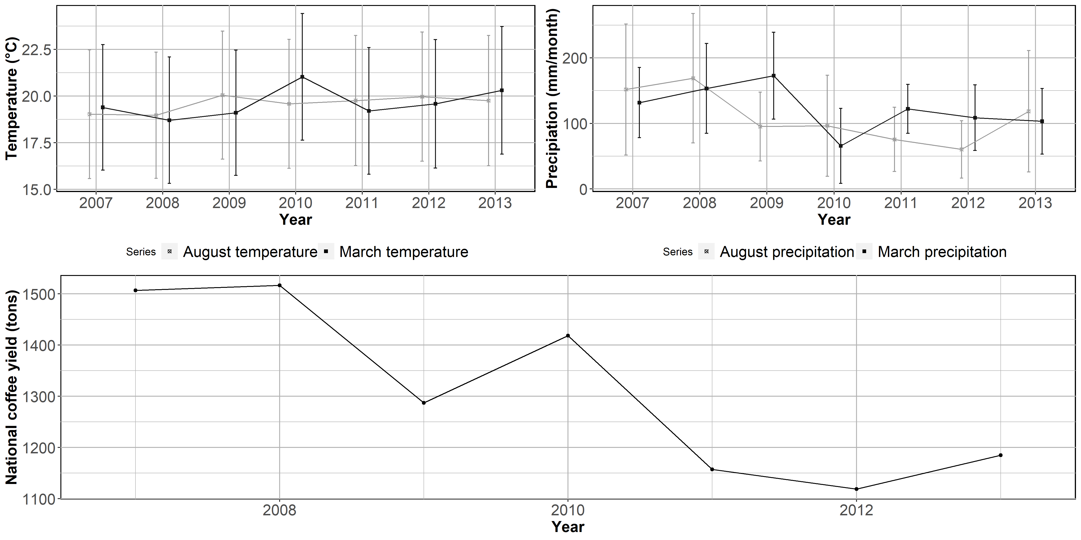

Figure 1. Time trends of : temperature (top left), precipitation (bottom left), and national yields bottom.

The graph shows a spike in precipitation, beginning in March 2008 and carrying on until March 2009. It was accompanied by a dip in total output of coffee in 2009, with a brief recovery in 2010 when precipitation decreased and mean temperature in March was high. This provides further evidence of the sensitivity of coffee productivity to varying weather conditions.

## 2.2 Theoretical framework

Changes in weather can have direct and indirect effects on coffee productivity. The direct effects refer to changes that modify the physiological processes of the plant and have an impact on the productivity realizations, which include induction of flowering and pollination as a result of short periods of hydric stress (Ramírez et al., 2014) or induction of vegetative growth as a result of extended rainy seasons (Carr, 2001). The indirect effects of changes in weather refer to changes in incidence of diseases, which include the CLR (Bastianin et al., 2018), and the distribution and reproduction patterns of both pests and pollinators. The latter include changes in the reproductive cycle of the Coffee Berry Borer (*Hypothenemus hampei*, Henceforth CBB) (Atallah et al., 2018; Iscaro, 2014; Jaramillo et al., 2010; Magina et al., 2007) and diminishing bee populations (Imbach et al., 2017).

We follow the example of Van Oijen et al. (2010) in considering that the complexity of models should be adjusted to the availability of data. We propose a simplified model for coffee production where the observable inputs of water and temperature have direct and indirect effects on five biological Submodels. Figure 2 presents the model’s structure:

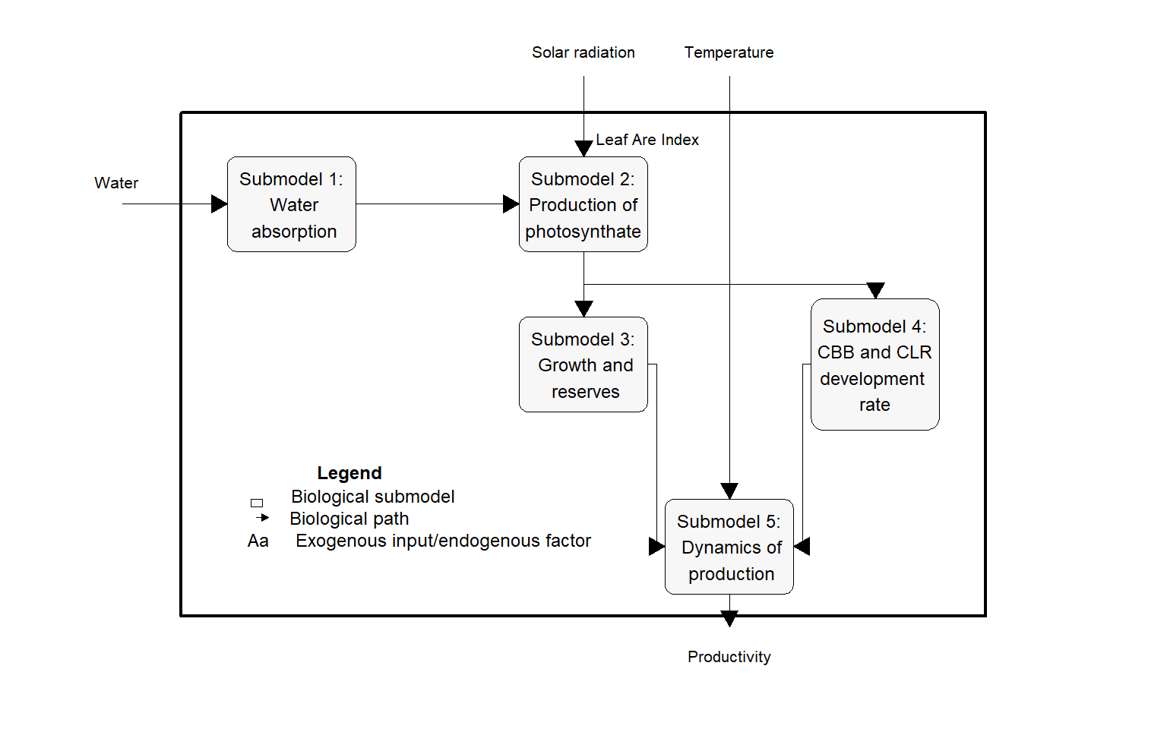

*Figure 2. Proposed model for coffee productivity: relationship between coffee productivity, temperature, and precipitation*

The general model aims to demonstrate how one output, coffee yield, results from the dynamics of three exogenous inputs: water, photosynthetically active radiation (noted Io), and temperature, and one endogenous factor: Leaf Area Index (LAI). Five Submodels have been developed by Rodríguez et al. (2011) and Rodríguez et al. (2013) to describe the physiological processes of water absorption, production of photosynthate, growth and reserves, CBB and CLR development rate and dynamics of production. We take LAI and Io as constant due to our inability to observe them in our data. The first Submodel, water availability and absorption, is almost exclusively dependent on precipitation as there is very little irrigated coffee cultivation. The water that is absorbed is broken apart in the photosynthetic process that transforms the carbon dioxide into photosynthate (Submodel 2). The photosynthate that is produced and is the focus of the second Submodel can be egested, respired, accumulated in reserves, or used in growth. Of the share of photosynthate accumulated in reserves or used in growth, a fraction of it is used for reproduction and is directly related to productivity realization (Submodel 3).

Temperature is present in three Submodels. First, it has a direct effect on respiratory rates that occur at the expense of greater accumulation of reserves and growth as well as on the increment of age due to the accumulation of thermic units (Submodel 3). Second, it has a direct effect on the increment of age of CBB due to accumulation of thermal units and on the infestation rate of CLR (model 4 in Appendix 1). In turn, this has an effect on the dynamics of production (model 5) as CBB is the leading cause of loss due to herbivory (parasitism) and CLR has been found to severely affect yield realizations. In the latter case, there has been evidence of severe impacts of the la Niña phenomenon which took place between 2008 and 2011 and is potentially affecting our results (Avelino et al., 2015). Additional details as well as the derivation of each model are presented in Appendix 1.

Based on this model, we make inferences on three aspects of our econometric specification: i) $Y=f(T,T^{2},P,P^{2},T*P)$, where T and P stand for temperature and precipitation, ii) the observation of weather in March and August, and iii) the choice of a dynamic model specification to account for the effect of past productivity realizations on present yield. The choice of quadratic forms of temperature and precipitation considers two facts: degree-days measurements are not feasible with the data we are working on, which has a monthly temporal resolution, and temperatures above the upper bound of coffee growth (35°C) are rare in Colombia’s coffee-growing region. Therefore, we favor a simpler functional form that assumes quadratic forms of temperature and precipitation to account for potential non-linear relationships between temperature, precipitation and yield.

One of the main challenges of the econometric modeling of production functions is the incongruence of the temporal scale of the variables as indicated in Blanc and Schlenker (2017). Productivity data is usually available at yearly intervals, whereas weather data is observed at any given time resolution from days to months. Furthermore, the inclusion of sequential observations of weather as regressors leads to an issue of multicollinearity, which can severely affect the efficiency of the estimators. We bridge this gap by building on the crop phenology literature: for any given crop, there exists a set of critical periods in which adverse environmental conditions can lead to a significant drop in yield (Zhao et al., 2013). Even though these periods do not preclude the importance of favorable weather conditions at other times during the production cycle, their predictive power over yield realizations outweighs that of other periods. In the case of coffee, DaMatta and Ramalho (2006) and DaMatta et al. (2007) identify the flowering and bean formation period as critically susceptible to adverse weather conditions. High temperatures during blossoming, especially if associated with a prolonged dry spell, may cause abortion of flowers. Prolonged dry spells can also lead to fruit drop, notably in the endosperm formation phase of bean filling (DaMatta et al., 2007). For the case of Colombia, Ramírez et al. (2014) identify March and August as the periods of most intense flowering, with the largest coffee producing areas flowering in March. We adopt these two periods for the observation of temperature and precipitation, as flowers forming in March depend on weather conditions of that month (for blossoming) and on August conditions for bean filling and vice versa.

Finally, we choose to model the dynamic nature of productivity to account for the fact that coffee is a perennial crop (DaMatta et al., 2007). The effect of past productivity realizations can be either positive or negative. If higher profits are invested in improved fertilization and pest control practices, farmers can expect better yields in the coming years. However, productivity can be affected when those investments are not made. Photosynthate reserves are exhausted after a heavy crop load, as described in Submodel 5. If they are not replenished, the number of fertilized flowers will be lower the next flowering season (DaMatta et al., 2007). This process is known as biennality of coffee productivity. We devote the next Subsection to the description of the econometric model to adequately capture the inferences described in this section.

## 2.3 Econometric model

The reduced form model for our econometric estimation is presented in equation (1). The dynamic process of yearly productivity is captured by regressing current productivity realizations $y_{it }$ in tons/ha on last year’s productivity realization $y_{it-1}$, on a set of weather variables $X=(T,T^{2},P,P^{2},T*P)$ and on $c_{i}$ and $μ_{t}$ that stand for spatial and time fixed effects respectively:

$y_{it}=θy_{it-1}+X_{it}β+c_{i}+μ_{t}+ε_{it} with ε_{it}∼N(0,σ_{ε}^{2})$, (1)

It is expected that estimating this dynamic model using Least Squares Dummy Variable (LSDV) will yield a downward biased $θ$ (Nickell, 1981). The reason is that the mean of the lagged dependent variable contains observations from time 0 to t-1 on y. The mean of the error captures the residuals from time 0 to t. Since $y_{it-1}$ depends on $ε_{it-1}$ and so does $ε_{it}$, the latter and $y_{it-1}$ are not orthogonal, hence $θ$ is biased. In ubsection 3.1. below, we will consider two alternatives to address this endogeneity. The first one is the Difference Generalized Method of Moments (GMM) proposed by Arellano and Bond (1991). It estimates a model based on the first differences of equation (1). This transformation expunges the time-invariant fixed effects $c_{i}$ yet still suffers from endogeneity due to the dependence between $y_{it-1}$ and $ε_{it-1}$. It is addressed through the use of previous realizations of the dependent variable as instruments for the first lag. The second alternative is the System GMM proposed by Arellano and Bover (1995) and Blundell and Bond (1998) where the lagged dependent variable in equation (1) is instrumented using the first differences as instruments. Compared to difference GMM, system GMM has the advantage of allowing more instruments to be introduced and of increasing the efficiency of the estimates. Arellano and Bover (1995) have demonstrated the latter point is especially true for panels with few time periods. This model requires the further assumption that the first difference instruments are uncorrelated with $c_{i}$.

Four conditions are necessary for the correct identification of a dynamic panel model by either of the two GMM methods above (Blundell et al., 2000): i) the test of first order serial autocorrelation must be significant; ii) the test of second order autocorrelation must be non-significant; iii) the Hansen/Sargan test of over-identifying restrictions must be insignificant so that the null hypothesis of validity of the instruments is not rejected; iv) the coefficient of the lagged variable must fall within a credible range (Roodman, 2009).We work with the STATA Statistical Package version 15.1 (StataCorp, 2017). The static models are estimated using the xtreg command, whereas we employ the xtdpdgmm command to estimate the GMM models (Kripfganz, 2019).

# 3. Results and discussion

## 3.1 Model fit

Table 2 below presents the results of the model described in equation (1). Column (1) presents the LSDV results of the quadratic static panel model without the time lag of the dependent variable. While this specification is akin to the specifications in Gay *et al.* (2006) and Sachs (2015), it is reported for information purpose only as the absence of $y_{it-1}$ leads to an omitted variable bias (Chamberlain, 1978).

Table 2. Dynamic panel model estimation results

|  |  |  |  |  |  |  |
| --- | --- | --- | --- | --- | --- | --- |
|  | (1) | (2) | | (3) | (4) | (5) |
| VARIABLES | LSDV | Difference GMM | | System GMM | System GMM | Long-run  System GMMi |
|  |  |  | |  |  |  |
| (Lag of) coffee productivity |  | 0.094*** | | 0.572*** | 0.535*** |  |
|  | (0.022) | | (0.062) | (0.059) |  |
| Mean temperature in March | 0.083 | 0.190*** | | 0.108* | 0.414** | 0.890** |
| (0.0548) | (0.0615) | | (0.0583) | (0.186) | (0.390) |
| Mean temperature in March sq. | -2.76×10-3** | -4.42×10-3*** | | -1.67×10-3 | -8.3×10-3** | -0.018** |
| (1.31×10-3) | (1.61×10-3) | | (1.23×10-3) | (3.87×10-3) | (8.1×10-3) |
| Mean temperature in August | -0.168* | 0.181 | | 0.411* | 0.099 | 0.214 |
| (0.092) | (0.211) | | (0.239) | (0.317) | (0.680) |
| Mean temperature in August sq. | 1.3×10-3 | -9.3×10-3* | | -0.0153** | -8.35×10-3 | -0.018 |
| (2.28×10-3) | (5.6×10-3) | | (6.2×10-3) | (7.65×10-3) | (0.016) |
| Precipitation in March | -0.00126*** | -1.3×10-3* | | -8.02×104 | 4.74×10-3 | 0.010 |
|  | (4.6×104) | (6.73×104) | | (7.88×104) | (3.23×10-3) | (6.8×10-3) |
| Precipitation in March sq. | 3.52×10-6*** | 6.96×10-6*** | | 3.63×10-6** | 4.16×10-6** | 8.96×10-6** |
| (1.24×10-6) | (1.70×10-6) | | (1.85×10-6) | (1.74×10-6) | (6.39×10-6) |
| Precipitation in August | 2.5×10-3*** | 1.7×10-3*** | | 1×10-3 | -2.6×10-3 | -5.6×10-3 |
|  | (3.45×10-4) | (5.31×10-4) | | (6.8×10-4) | (2.2×10-3) | (4.64×10-3) |
| Precipitation in August sq. | -5.8×10-6 *** | -4.09×10-6*** | | -1.67×10-6 | -6.18×10-7 | -1.33×10-6 |
| (8.06×10-7) | (1.11×10-6) | | (1.58×10-6) | (1.74×10-6) | (3.74×10-6) |
| Precipitation in March × Mean temperature in March |  |  | |  | -2.7×10-4* | -5.8×10-4* |
|  |  | |  | (1.42×10-4) | (3.01×10-4) |
| Precipitation in August × Mean temperature in August |  |  | |  | 1.52×10-4* | 3.27×10-4* |
|  |  | |  | (9.07×10-5) | (1.9×10-4) |
| Mean altitude |  |  | | -7.4×10-4*** | -8.1×10-4*** | -1.7×10-3 *** |
|  |  |  | | (2.25×10-4) | (2.28×10-4) | (3.53×10-4) |
| Constant | 2.885*** | 0.384 | | -2.029 | -1.927 | -4.144 |
|  | (0.974) | (2.214) | | (2.038) | (1.785) | (3.846) |
| Observations | 3,646 | 3,125 | | 3,125 | 3,125 | 3,125 |
| Adj. R-squared | 0.212 |  |
| R*ii |  | 0.289 | | 0.148 | 0.152 | 0.152 |
| Out-of-sample RMSEiii | 0.639 | 0.830 | | 0.508 | 0.474 | 0.474 |
| Hansen-Sargan test |  | 0.000 | | 0.161 | 0.198 | 0.198 |
| AR(1), p-value |  | 0.000 | | 0.000 | 0.000 | 0.000 |
| AR(2), p-value |  | 0.373 | | 0.813 | 0.798 | 0.798 |

Notes:

Standard errors in parentheses; *** p<0.01, ** p<0.05, * p<0.1;

i: Column (5) reports the long-run coefficients of the $(1-θ)$ convergence estimation of the System GMM results displayed in column (4).

ii: R*, or squared correlation coefficient, is estimated as the correlation between the predicted and observed values of the dependent variable ( ${Corr(\hat{y},y)}^{2}).$ It is akin to the estimation of R-squared in maximum likelihood estimators and it is conventionally reported in GMM models. See Bloom et al. (2001) for further details.

iii: Out-of-sample root mean squared error: out-of-sample estimations are completed by iteratively fitting each model on a subset of the sample that excludes one year. The fitted model is used to predict the productivity for the excluded year. The difference between the predicted and observed value (residual) is squared and averaged. The value reported corresponds to the square root of that value.

Columns (2) to (5) account for the perennial nature of the coffee plant and the fact that previous productivity realizations can be a good predictor of current productivity (DaMatta et al., 2007). The literature has demonstrated that including the time lag of the dependent variable requires a GMM approach to control for unobserved heterogeneity and avoid biased estimates (Nickell, 1981). As a result, we report the estimates based on difference GMM in column (2) (Arellano and Bond, 1991) and the estimates based on system GMM in columns (3) to (5) (Arellano and Bover 1995; Blundell and Bond 1998). Column (5) reports the long-run coefficients of column (4) and will be discussed further below.

Difference GMM transforms all the regressors by using their difference between t and t-1, hence individual fixed effects $c_{i}$ disappear as noted earlier. The tests for serial correlation reported at the bottom of table 3 show that there is serial correlation of order one (AR(1), p-value = 0.000), but not of order two (AR(2), p-value = 0.373), hence the yield of only the previous year matters. However, the Hansen-Sargan test result is significant, suggesting that the lagged levels of the endogenous and exogenous variables are not adequate instruments. Arellano and Bover (1995) and Blundell and Bover (1998) argue that in panel settings spanning over a short time period, difference GMM estimates can be inefficient and therefore they suggest the system GMM. The results of columns (3) and (4) validate this hypothesis as both the model with weather interactions and the one without them comply with the necessary conditions of a correctly identified GMM model (significant AR(1) test and non-significant Hansen-Sargan test). In terms of fit, the squared correlation coefficient (R*) of the system GMM models is a bit below the adjusted R-squared of the LSDV model given that GMM, unlike LSDV, is not an estimation strategy based on minimizing the residuals (Cameron and Trivedi, 2009). Yet, when we calculate the out-of-sample root mean squared error (RMSE) to test the predictive power of each model, our results show that the system GMM with weather interactions has the lowest RMSE. It indicates it is the most suitable option for the forecasting exercise undertaken in the next Subsection.

The results of column (4) highlight the importance of accounting for the dynamic nature of coffee production. The coefficient on the lagged dependent variable $θ$ is positive and significant. We hypothesize that it comes from better yields resulting in higher profits. They are re-invested in crop production in the form of better fertilization and pest control which, in turn, lead to better yields in the following years (Chávez and Ridley, 2001). We also find a negative and significant coefficient associated to altitude. It captures the slower rate of accumulation of thermal units due to cooler temperature at higher altitudes, which results in lower accumulation of photosynthate (Arcila et al., 2007). Furthermore, the results of column (5) meet the expectations of the theoretical framework. Indeed, the statistically significant evidence of diminishing returns to temperature in March indicates that high or very high temperature is harmful for coffee during the flowering season as stated by DaMatta et al. (2007). We also find that the effect of precipitation in March is positive and statistically significant. In line with the expectations derived in Submodel 2, coffee plants react favorably to increased water availability during the flowering period. We further argue that the monotonic relationship between March precipitation and coffee productivity observed in our model captures the fact that hydric excess and waterlogging is a rare occurrence in Colombia as coffee is planted in hilly areas, which results in significant surface runoff and in porous soils with adequate hydric conductivity (Poveda Jaramillo et al., 2002). Usually, excess rainfall is associated with a decrease in productivity (Ramírez et al., 2010) as the lack of a dry spell during the quiescent growth phase (about 2 to 4 months before flowering) stimulates flowering and results in scattered harvests (DaMatta et al., 2007). One limitation of this study is that we do not observe temperature and precipitation during the quiescent growth phase.

We also find that the results show no significant effect of temperature and precipitation in August. We believe this captures the fact that the main blooming season in Colombia’s largest coffee-growing regions takes place during the first semester with a peak in March (Ramírez et al., 2014; Vélez et al., 2000). Weather conditions in August have a smaller impact on productivity as the largest share of the yearly harvest is already at bean-filling stage, where beans are much more resilient to adverse weather conditions than flowers (DaMatta and Ramalho, 2006). Given the spatial and temporal resolution of our data, we fail to capture the smaller effect of weather during the sturdier bean-filling stage; however, these results do not rule out the importance of favorable weather during that stage.

It is also interesting to note a similar magnitude and opposing directions of the coefficients on the interaction between temperature and precipitation for each month. While high temperature and precipitation in March impact productivity negatively, the opposite is true for August. A possible explanation relates to the dynamics of CBB infestation. As described in Submodel 5, the number of CCB cohorts increases as temperature and precipitation increase. The impact of CBB on coffee productivity is also time-sensitive. If infestation occurs within the first two months after pollination, more than 50% of the berries are aborted; if it happens after the third month, that value drops to 23.5% (Bustillo Pardey, 2006). We believe that our model is capturing the opposing directions of the effect of the joint effect of temperature and precipitation on coffee productivity. Both the coffee plant and CBB develop optimally at temperature ranges of 20°C to 25°C and benefit from soil and air humidity (Bustillo, 2007). When these favorable conditions coincide with pollination and initial bean formation, the damaging effect of greater CBB infestation outweighs the positive impact on vegetative and reproductive development of the coffee plant. However, when those same optimal conditions happen at the latest stages of the reproduction process, CBB causes less losses and bean filling is positively impacted by favorable temperature and precipitation. Given that the largest coffee-producing areas in Colombia flower in March, we argue that these results correctly reflect this fact. A similar effect has been observed for CLR (Avelino et al., 2015). In addition, note that the negative and significant coefficient for the interaction between temperature and precipitation in March can also relate to the importance of a hydric stress period that stimulates flowering (DaMatta et al., 2007).

The GMM coefficients reported in columns (2) to (4) correspond to the short-run marginal effects of the matrix of independent variables on the dependent variable (Arellano and Bond, 1991). The estimation of long-run effects is made possible by dividing the short-run estimates of the coefficients by the convergence rate $(1-θ)$. We estimate the long-run coefficients of our preferred specification and present them in column (5). They will be used for the forecasting exercise of Subsection 3.2. However, before we proceed, we present further evidence of the validity of this estimation strategy. For that purpose, we run an exercise of productivity maximization at varying March temperatures. The optimal March temperature under the dynamic panel model is 19.5°C, which is within the optimal range for coffee production estimated by Mosquera Sánchez et al. (2005) and DaMatta et al. (2007). Figure 3 plots the marginal effects of temperature, precipitation and associated productivity based on estimates from column (5). We plot separate curves for each altitude subset (above or below the median altitude) and evaluate the other covariates at their median value.

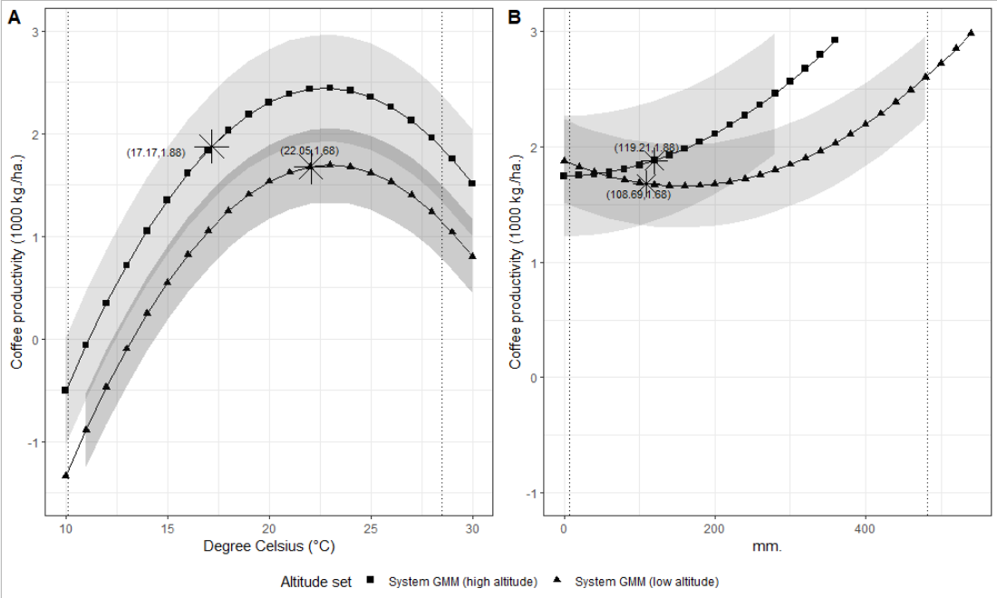

Figure 3. Marginal effects of (A) mean March temperature and (B) mean March precipitation by altitude group.

The stars in both curves represent the expected productivity evaluated at the median value of the corresponding weather variable for the period 2007 to 2013. It is interesting to note that, despite average productivity being lower at higher altitudes, the expectation of an increase in temperature in the future would have opposite effects for each group. Indeed, for an average increase of 1° to 2°C by 2050 as estimated by the National Institute of Hydrology, Meteorology and Environmental Studies of Colombia (IDEAM) (Ballesteros and Aristizabal, 2007), the high-altitude municipalities would see their productivity increase. In theory, they would move towards the optimum productivity level of temperature. On the other hand, low-altitude municipalities would experience a decrease in their median productivity as they already are at the optimum mean temperature level (figure 3A). Similarly, high-altitude municipalities would benefit from higher precipitation in March whereas low-altitude municipalities would benefit from a decrease (or a large increase) in precipitation (figure 3B). As a result, we expect that future weather conditions will reduce the productivity gap between high and low-altitude municipalities, potentially reshaping the landscape of Colombia’s coffee-growing regions.

In the case of our sample, the average increase in temperature forecasted by the GCM models is above the 2°C increment forecasted by IDEAM (See table 1). More precisely, they suggest an increase of 4°C for the average temperature between 2041 and 2060. Under this scenario the mean March temperature in high altitude municipalities would be 27.27°C, which is well above the optimum level of 19.5°C found in our estimations. On the other hand, the projected temperature for high altitude municipalities is 20.78°C, which is very close to the aforementioned optimum. Furthermore, the 56 mm projected increase in precipitation in the low-altitude municipalities will accentuate the negative impact on their productivity while the 40 mm increase in the high-altitude municipalities is expected to boost their productivity.

## 3.2 Forecasting

In the case of the dynamic model proposed in equation (1), the first approximation to the predictor at future time $K=T+r$ is the expectation of $y_{i,K}$ conditional on the information set $I_{K}(y_{i,K-1},X_{i,K},c_{i},ε_{i,K})$:

$y_{i,K}=E[y_{i,T+r}|I_{K}]=E[θy_{i,K-1}+βX_{i,K}+c_{i}+ε_{i,K}]$, (2)

$y_{i,K}=θy_{i,K-1}+βX_{i,K}+c_{i}$, (3)

Because the expectation of future shocks of the idiosyncratic error term $ε_{i,K}$ is assumed zero, it is expunged through the conditional expectation. However, both $y_{i,K-1}$ and the time invariant fixed effects $c_{i}$ remain. $y_{i,K-1}$ is incorporated through the $(1-θ)$ convergence transformation of the coefficients. $c_{i}$ is the group-specific average of all the residuals. The predictions of future temperature and precipitation are extracted from the GCMs listed in section 2.1. Figure 4 reports the predicted average coffee productivity by 2041-2060 (dot) and the associated 95% confidence interval (whiskers).

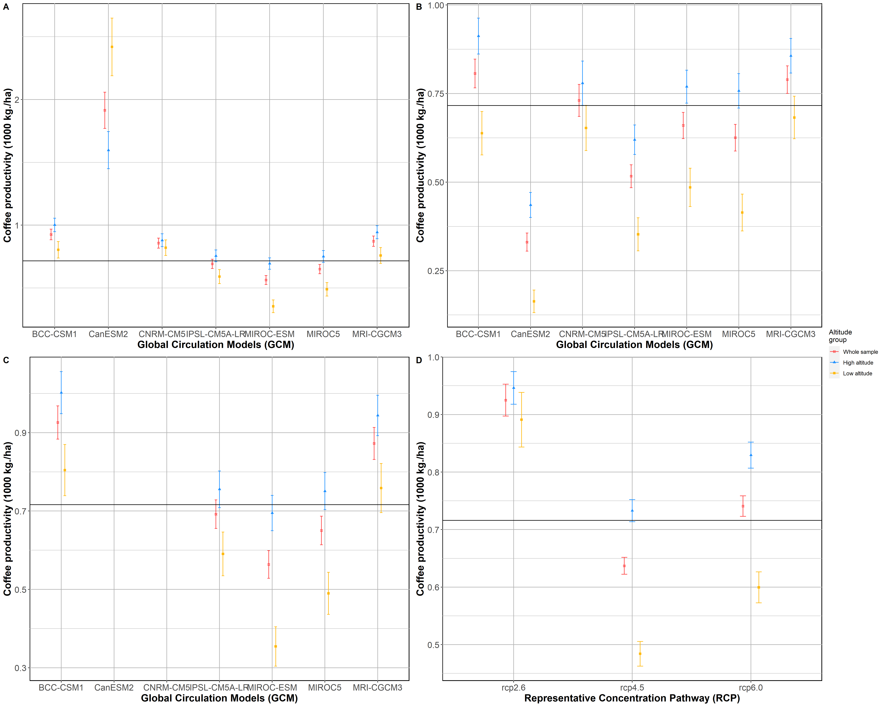

Figure 4. Projected coffee productivity in 2041-2060 for selected municipalities. The whiskers represent the 95% confidence interval of the mean. Whole sample: 521 municipalities; high altitude: 262 municipalities; low altitude: 259 municipalities. (A) Representative Concentration Path (RCP) 2.6, (B) RCP 4.5, (C) RCP 6.0, and (D) average prediction by RCP scenario.

The solid black line is the 2007 mean of coffee productivity which stands at about 716 kg of coffee per hectare. The RCP 2.6 scenario, which predicts a likely increase in global temperature between 0.3°C and 1.7°C (Pachauri et al., 2014), suggests that the average coffee productivity will increase by 29% (confidence interval: [24.4, 34.9]). In this scenario, both the high- and low-altitude municipalities will experience an increase in average productivity (32% and 24% increase for high and low altitude municipalities respectively). However, this result does not rule out a negative impact for a set of municipalities. Panel A of figure 5 shows the geographic distribution of change in productivity where the municipalities adjacent to the intra-Andean valleys and in the northeastern region are expected to experience a decrease in productivity.

RCP scenario 4.5 (figure 4B) assumes that global warming will range between 1.4°C and 3.1°C (Pachauri et al., 2014). Its results suggest a more heterogeneous impact of global warming. In this scenario, the productivity is expected to decrease by 11% (confidence interval: [13.1, 8.9]). The impact differs across altitude groups: high altitude municipalities are expected to increase their productivity by 2.3% (confidence interval: [-0.4, 5.1]) and low altitude municipalities are expected to decrease their productivity by 32.3% (confidence interval: [35.4, 29.4]).

Finally, under the RCP scenario 6.0, which predicts an increase in temperature between 2.6°C and 4.8°C (Pachauri et al., 2014), coffee production will increase by 4.46% on average (confidence interval: [0.97, 5.87]). Productivity in high altitude municipalities will also increase by 16% (confidence interval: [12.6, 18.9]). The opposite is expected to happen in low altitude municipalities with a decrease in average productivity of 16.2% (confidence interval: [-20.4, 12.5]). We aim to show all scenarios in order to contribute to policy-making discussions therefore we offer our municipal-level predictions for all three scenarios in Appendix 3.

Figure 5 maps the expected change (positive or negative) at the municipality level for each of the three RCPs. The results indicate that Colombia’s unique topography acts as a buffer that can mitigate most of the effects of climate variability on coffee productivity. Indeed, these findings indicate that negative impacts expected by low-altitude municipalities can be offset by increased productivity in high-altitude municipalities. The capacity of this shift in coffee cultivation to take place efficiently is highlighted by the area of coffee cultivation in high-altitude municipalities being already larger than in low-altitude municipalities (558,296 hectares vs. 352,114 hectares). Our findings suggest that this asymmetry will be accentuated in the future. As such, careful consideration and understanding of the large degree of spatial heterogeneity present in the country because of very different altitude levels is necessary. Any policy-making endeavors aiming to protect the livelihoods of Colombian coffee farmers will require place-tailored solutions.

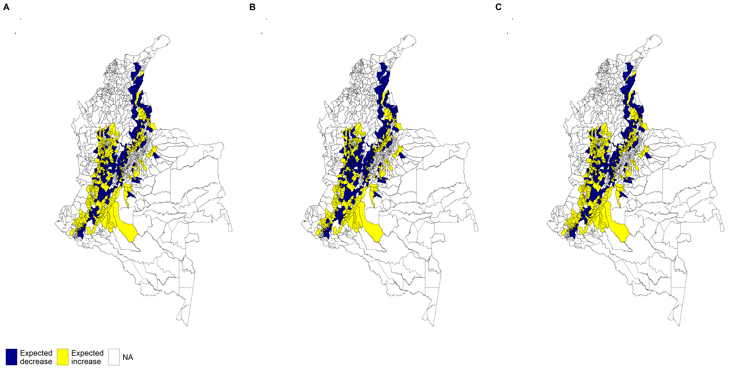

Figure 5. Expected changes in productivity across municipalities in 2041-2060 with respect to mean productivity from 2007-2013. (A) RCP 2.6, (B) RCP 4.5, and (C) RCP 6.0

Our set of predictions is subject to a couple of limitations. First, our model is not sensitive to the various types of adaptation strategies farmers can undertake that would mitigate the magnitude of our predictions. These options have been documented in the literature and include shading (Jaramillo et al., 2011; Schroth et al., 2009), crop diversification (Rahn et al., 2014) irrigation and fertilization (Fares et al. 2016; DaMatta et al. 2018), and eventually shifting crop to more resistant species such as *Coffea canephora* or other crops better suited to the new conditions (Kabubo-Mariara and Karanja, 2007; Krishnan, 2017). If the data were available, we believe they would enrich our estimates and foreacast. Finally, our model ignores the technological progress that could make coffee plants more resilient to future weather conditions. One such example is the development and diffusion of CLR resistant varieties that have decreased the susceptibility of Arabica coffee to the pathogen (Alvarado, et al., 2013). Even though the effort to develop a CBB-resistant variety has yet to be successful, some avenues of research suggest this might be possible in the future (Romero et al., 2015). Similar efforts have been conducted to develop drought-resilient coffee plants (Silva et al., 2018). In the absence of information on adaptation and technological progress, we believe our estimates provide coffee growers and policymakers with meaningful and accurate insights on the consequences of not addressing the challenges posed by future climate conditions.

# 4. Conclusions

This paper uses a panel data approach and a novel data set to measure the effect of climate variability in the framework of a crop production function built on elements from the crop physiology literature (Rodríguez et al., 2011, 2013). This approach allows us to go further than previous key references on the analysis of coffee yield realizations (Gay et al., 2006; Sachs et al., 2015) as we include the biennial productivity of coffee and provide results at the municipal, instead of only national, level. Since most policy-making institutions in Colombia operate at the sub-national level, it is important to produce estimates and forecasts at the local level to adequately address the magnitude and the spatial variability of the challenges that arise from climate change. Furthermore, this paper makes use of high-resolution global climate models. This approach is increasingly popular when focusing on climate variability in developing countries where the network of field weather stations is limited and accurate surface weather data is scarce (Bunn et al., 2015; Läderach et al., 2017; Magrach and Ghazoul, 2015).

A key finding of our study relates to the importance of accounting for the dynamic component of coffee productivity, in which the lagged productivity realizations have a positive and significant predictive power on current productivity realizations. We relate this finding to the perennial nature of the coffee plant and argue that positive yields in the previous year improve the economic conditions of the farmer. As a result, it leads to more investments in fertilizers and pest control in the current year. Modeling this process allows us to increase the accuracy of our estimates (measured by the out-of-sample RMSE) and to offer more appropriate recommendations than past approaches that ignored the dynamic nature of coffee productivity.

Based on estimates calibrated over the past and data from eight global climate models and three representative concentration scenarios, we also forecast coffee productivity by 2041-2060. These results show that Colombia’s unique topography is a buffer that can mitigate most of the effects of climate variability on coffee productivity. Indeed, our findings indicate that the negative impacts expected in low-altitude municipalities could be offset by increased productivity in high-altitude municipalities. In addition, these results display an even greater heterogeneity when calculated at the local level. As such, any policy-making endeavors aiming to protect the livelihoods of Colombian coffee farmers will require solutions that differ across municipalities.

Future research will focus on lifting a set of limitations that are common in the crop production function literature (Gay et al., 2006) and that we have adopted here too. For instance, the use of a constant technology and the assumption of linear climate adaptation strategies deserve to be challenged. Huffman et al. (2018) and Caetano et al. (2018) provide recent efforts in this direction on the corn and soybean productions respectively. In the case of Colombia, we believe that novel adaptation strategies could support coffee production on land parcels which are so far identified as unsuitable hence not included in our estimation (Cavatte et al., 2012; Jaramillo et al., 2011; Schroth et al., 2009). In addition, improvements in technology such as drought resistant cultivars could help keep some cropland productive (Romero et al., 2015) and so does the development of more efficient methods for irrigation and fertilization (Fares et al. 2016; DaMatta et al. 2018). These recent advances provide the foundations for some exciting avenues of research for the years to come.

# References

Acevedo, K.M., Bornacelly, I.D., 2014. Panel municipal del CEDE. Universidad de los Andes-CEDE.

Andrews, D. W., & Lu, B. (2001). Consistent model and moment selection procedures for GMM estimation with application to dynamic panel data models. *Journal of econometrics*, *101*(1), 123-164.

Alvarado, G., Posada, H. E., & Cortina, H. A. (2013). *Castillo: Nueva variedad de café con resistencia a la roya*. Centro Nacional de Investigaciones de Café (Cenicafé).

Arcila, J., FARFAN, F., Moreno, A., Salazar, L.F., Hincapié, E., 2007. Sistemas de producción de café en Colombia. Centro Nacional de Investigaciones de Café (Cenicafé).

Arellano, M., Bond, S., 1991. Some tests of specification for panel data: Monte Carlo evidence and an application to employment equations. The Review of Economic Studies 58, 277–297.

Arellano, M., Bover, O., 1995. Another look at the instrumental variable estimation of error-components models. Journal of Econometrics 68, 29–51.

Atallah, S.S., Gómez, M.I., Jaramillo, J., 2018. A bioeconomic model of ecosystem services provision: Coffee berry borer and shade-grown coffee in Colombia. Ecological Economics 144, 129–138.

Avelino, J., Cristancho, M., Georgiou, S., Imbach, P., Aguilar, L., Bornemann, G., Läderach, P., Anzueto, F., Hruska, A.J., Morales, C., 2015. The coffee rust crises in Colombia and Central America (2008–2013): Impacts, plausible causes and proposed solutions. Food Security 7, 303–321.

Ballesteros, H.B., Aristizabal, G.L., 2007. Información técnica sobre gases de efecto invernadero y el cambio climático. Bogotá DC: nota técnica del IDEAM.

Bastianin, A., Lanza, A., Manera, M., 2018. Economic impacts of el Niño southern oscillation: Evidence from the Colombian coffee market. Agricultural economics 49, 623–633.

Blanc, E., Schlenker, W., 2017. The use of panel models in assessments of climate impacts on agriculture. Review of Environmental Economics and Policy 11, 258–279.

Bloom, N., Bond, S. R., & Van Reenen, J. (2001). The dynamics of investment under uncertainty. Working paper.

Blundell, R., Bond, S., 1998. Initial conditions and moment restrictions in dynamic panel data models. Journal of Econometrics 87, 115–143.

Blundell, R., Bond, S., Windmeijer, F., 2000. Estimation in dynamic panel data models: Improving on the performance of the standard GMM estimator. The Institute for Fiscal Studies.

Bunn, C., Läderach, P., Rivera, O.O., Kirschke, D., 2015. A bitter cup: Climate change profile of global production of arabica and robusta coffee. Climatic Change 129, 89–101.

Burke, M., Emerick, K., 2016. Adaptation to climate change: Evidence from US agriculture. American Economic Journal: Economic Policy 8, 106–40.

Bustillo, A., 2007. El manejo de cafetales y su relación con el control de la broca del café en Colombia.

Bustillo Pardey, A.E., 2006. A review of the coffee berry borer, *Hypothenemus hampei* (coleoptera: Curculionidae: Scolytinae), in Colombia. Revista Colombiana de Entomología 32, 101–116.

Caetano, J.M., Tessarolo, G., Oliveira, G. de, Souza, K. da S. e, Diniz-Filho, J.A.F., Nabout, J.C., 2018. Geographical patterns in climate and agricultural technology drive soybean productivity in Brazil. PloS one 13.

Calderón, G.F.-A., 2009. Spatial regression analysis vs. Kriging methods for spatial estimation. International Advances in Economic Research 15, 44–58.

Cameron, A. C., & Trivedi, P. K. (2009). *Microeconometrics using stata* (Vol. 5, p. 706). College Station, TX: Stata press.

Carr, M., 2001. The water relations and irrigation requirements of coffee. Experimental Agriculture 37, 1–36.

Cavatte, P.C., Oliveira, Á.A., Morais, L.E., Martins, S.C., Sanglard, L.M., DaMatta, F.M., 2012. Could shading reduce the negative impacts of drought on coffee? A morphophysiological analysis. Physiologia plantarum 144, 111–122.

Chamberlain, G., 1978. Omitted Variable Bias in Panel Data: Estimating the Returns to Schooling. Annales de L’Insee, 30/31, 49–82.

Chaves, B., & Riley, J. (2001). Determination of factors influencing integrated pest management adoption in coffee berry borer in Colombian farms. *Agriculture, ecosystems & environment*, *87*(2), 159-177.

Chun, Y., Griffith, D.A., 2013. Spatial statistics and geostatistics: Theory and applications for geographic information science and technology. Sage.

DaMatta, F.M., Ramalho, J.D.C., 2006. Impacts of drought and temperature stress on coffee physiology and production: A review. Brazilian Journal of Plant Physiology 18, 55–81.

DaMatta, F.M., Ronchi, C.P., Maestri, M., Barros, R.S., 2007. Ecophysiology of coffee growth and production. Brazilian journal of plant physiology 19, 485–510.

DaMatta, F. M., Avila, R. T., Cardoso, A. A., Martins, S. C., & Ramalho, J. C. (2018). Physiological and agronomic performance of the coffee crop in the context of climate change and global warming: A review. *Journal of agricultural and food chemistry*, *66*(21), 5264-5274.

Donaldson, D., Storeygard, A., 2016. The view from above: Applications of satellite data in economics. Journal of Economic Perspectives 30, 171–98.

Elith, J., Phillips, S.J., Hastie, T., Dudík, M., Chee, Y.E., Yates, C.J., 2011. A statistical explanation of MaxEnt for ecologists. Diversity and distributions 17, 43–57.

Fares, A., Awal, R., Fares, S., Johnson, A. B., & Valenzuela, H. (2016). Irrigation water requirements for seed corn and coffee under potential climate change scenarios. *Journal of Water and Climate Change*, *7*(1), 39-51.

Federacion Nacional de Cafeteros de Colombia, 2017. FNC en Cifras. Federacion Nacional de Cafeteros de Colombia.

Fick, S.E., Hijmans, R.J., 2017. WorldClim 2: New 1-km spatial resolution climate surfaces for global land areas. International journal of climatology 37, 4302–4315.

Fodor, N., Challinor, A., Droutsas, I., Ramirez-Villegas, J., Zabel, F., Koehler, A.-K., Foyer, C.H., 2017. Integrating plant science and crop modeling: Assessment of the impact of climate change on soybean and maize production. Plant and Cell Physiology 58, 1833–1847.

Gay, C., Estrada, F., Conde, C., Eakin, H., Villers, L., 2006. Potential impacts of climate change on agriculture: A case of study of coffee production in Veracruz, Mexico. Climatic Change 79, 259–288.

Huffman, W.E., Jin, Y., Xu, Z., 2018. The economic impacts of technology and climate change: New evidence from US corn yields. Agricultural Economics 49, 463–479.

Imbach, P., Fung, E., Hannah, L., Navarro-Racines, C.E., Roubik, D.W., Ricketts, T.H., Harvey, C.A., Donatti, C.I., Läderach, P., Locatelli, B., others, 2017. Coupling of pollination services and coffee suitability under climate change. Proceedings of the National Academy of Sciences 114, 10438–10442.

Iscaro, J., 2014. The impact of climate change on coffee production in Colombia and Ethiopia. Global Majority E-Journal 5, 33–43.

Jaramillo, J., Chabi-Olaye, A., Borgemeister, C., 2010. Temperature-dependent development and emergence pattern of *Hypothenemus hampei* (coleoptera: Curculionidae: Scolytinae) from coffee berries. Journal of economic entomology 103, 1159–1165.

Jaramillo, J., Muchugu, E., Vega, F.E., Davis, A., Borgemeister, C., Chabi-Olaye, A., 2011. Some like it hot: The influence and implications of climate change on coffee berry borer (hypothenemus hampei) and coffee production in east Africa. PloS one 6.

Kabubo-Mariara, J., Karanja, F.K., 2007. The economic impact of climate change on Kenyan crop agriculture: A Ricardian approach. The World Bank.

Karger, D.N., Conrad, O., Böhner, J., Kawohl, T., Kreft, H., Soria-Auza, R.W., Zimmermann, N.E., Linder, H.P., Kessler, M., 2017. Climatologies at high resolution for the Earth’s land surface areas. Scientific data 4, 170122.

Klein, W.E., Hammons, G.A., 1975. Maximum/minimum temperature forecasts based on model output statistics. Monthly Weather Review 103, 796–806.

Kripfganz, S., 2019. XTDPDGMM: Stata module to perform generalized method of moments estimation of linear dynamic panel data models, [Statistical Software Components](https://ideas.repec.org/s/boc/bocode.html) S458395, Boston College Department of Economics, Discussion Paper.

Krishnan, S. (2017). Sustainable coffee production. In *Oxford Research Encyclopedia of Environmental Science*.

Läderach, P., Ramirez–Villegas, J., Navarro-Racines, C., Zelaya, C., Martinez–Valle, A., Jarvis, A., 2017. Climate change adaptation of coffee production in space and time. Climatic Change 141, 47–62.

Magina, F., Makundi, R., Maerere, A., Maro, G., Teri, J., 2007. Temporal variations in the abundance of three important insect pests of coffee in Kilimanjaro region, Tanzania.

Magrach, A., Ghazoul, J., 2015. Climate and pest-driven geographic shifts in global coffee production: Implications for forest cover, biodiversity and carbon storage. PloS one 10.

Mosquera Sánchez, L.P., Riaño Herrera, N.M., López Forero, Y., Arcila Pulgarín, J., 2005. Net photosynthesis and co2 compensation concentration in three coffee (coffea sp.) genotypes, bean and maize under three temperatures. Revista Facultad Nacional de Agronomía Medellín 58, 2827–2838.

Nakicenvoic, N., others, 2000. IPCC special report on emissions scenarios. Cambridge, uk, and new york, ny.

Nickell, S., 1981. Biases in dynamic models with fixed effects. Econometrica: Journal of the Econometric Society 1417–1426.

Pachauri, R. K., Allen, M. R., Barros, V. R., Broome, J., Cramer, W., Christ, R., ... & Dubash, N. K. (2014). *Climate change 2014: synthesis report. Contribution of Working Groups I, II and III to the fifth assessment report of the Intergovernmental Panel on Climate Change* (p. 151). Ipcc.

Park, E., Brorsen, B.W., Harri, A., 2019. Using Bayesian kriging for spatial smoothing in crop insurance rating. American Journal of Agricultural Economics 101, 330–351.

Poveda Jaramillo, G., Ramírez Osorio, J.M., Jaramillo Robledo, A., others, 2002. Un modelo estocástico para la humedad del suelo bajo diferentes coberturas vegetales en la región cafetera de Colombia. Avances en recursos hidraulicos 47–56.

Rahn, E., Läderach, P., Baca, M., Cressy, C., Schroth, G., Malin, D., Rikxoort, H. van, Shriver, J., 2014. Climate change adaptation, mitigation and livelihood benefits in coffee production: Where are the synergies? Mitigation and Adaptation Strategies for Global Change 19, 1119–1137.

Rahn, E., Vaast, P., Läderach, P., Asten, P. van, Jassogne, L., Ghazoul, J., 2018. Exploring adaptation strategies of coffee production to climate change using a process-based model. Ecological Modelling 371, 76–89.

Ramírez, V.H., Arcila, J., Jaramillo, A., Rendón, J.R., Cuesta, G., Menza, H., MEJIA, C., Montoya, D., MEJIA, J., TORRES, J., others, 2014. Floración del café en Colombia y su relación con la disponibilidad hídrica térmica y de brillo solar.

Ramírez, V., Jaramillo, A., Arcila, J., 2010. Índices para evaluar el estado hídrico en los cafetales.

Rodríguez, D., Cure, J.R., Cotes, J.M., Gutierrez, A.P., Cantor, F., 2011. A coffee agroecosystem model: I. Growth and development of the coffee plant. Ecological Modelling 222, 3626–3639.

Rodríguez, D., Cure, J.R., Gutierrez, A.P., Cotes, J.M., Cantor, F., 2013. A coffee agroecosystem model: II. Dynamics of coffee berry borer. Ecological Modelling 248, 203–214.

Romero, J.V., BUSTAMANTE, L., CORTINA, H., MONCADA, M., others, 2015. Evaluación por resistencia a *Hypothenemus hampei* ferrari en poblaciones derivadas de cruces entre caturra e introducciones etíopes.

Roodman, D. (2009). How to do xtabond2: An introduction to difference and system GMM in Stata. *The stata journal*, *9*(1), 86-136.

Sachs, J., Rising, J., Foreman, T., Simmons, J., Brahm, M., 2015. Champter 5: Empirics of production. The Earth Institute. Columbia University.

Schroth, G., Laderach, P., Dempewolf, J., Philpott, S., Haggar, J., Eakin, H., Castillejos, T., Moreno, J.G., Pinto, L.S., Hernandez, R. and Eitzinger, A., 2009. Towards a climate change adaptation strategy for coffee communities and ecosystems in the Sierra Madre de Chiapas, Mexico. *Mitigation and adaptation strategies for global change*, *14*(7), pp.605-625.

Shrestha, S., Deb, P., Bui, T.T.T., 2016. Adaptation strategies for rice cultivation under climate change in central Vietnam. Mitigation and Adaptation Strategies for Global Change 21, 15–37.

Silva, V.A., Prado, F.M., Antunes, W.C., Paiva, R.M.C., Ferrão, M.A.G., Andrade, A.C., Di Mascio, P., Loureiro, M.E., DaMatta, F.M., Almeida, A.M., 2018. Reciprocal grafting between clones with contrasting drought tolerance suggests a key role of abscisic acid in coffee acclimation to drought stress. Plant Growth Regulation 85, 221–229.

StataCorp. 2017. Stata Statistical Software: Release15. College Station, TX: StataCorp LLC.

Stocker, T.F., Qin, D., Plattner, G.K., Tignor, M., Allen, S.K., Boschung, J., Nauels, A., Xia, Y., Bex, V. and Midgley, P.M., 2013. Climate change 2013: The physical science basis. *Contribution of working group I to the fifth assessment report of the intergovernmental panel on climate change*, *1535*.

Vélez, B., Jaramillo, A., Chaves, B., Franco, M., 2000. Distribución de la floración y la cosecha de café en tres altitudes. Centro Nacional de Investigaciones de Café (Cenicafé).

Villalobos Palacios, R. and Reyes Cifuentes, G.A., 2002. *Evaluaciones agropecuarias 2002* (No. Doc. 21328) CO-BAC, Bogotá).

Werner, M., 2001. Shuttle radar topography mission (SRTM) mission overview. *Frequenz*, *55*(3-4), 75-79.

Wooldridge, J.M., 2002. Econometric analysis of cross section and panel data. MIT press. Cambridge, MA 108.

Zhao, M., Peng, C., Xiang, W., Deng, X., Tian, D., Zhou, X., Yu, G., He, H., Zhao, Z., 2013. Plant phenological modeling and its application in global climate change research: Overview and future challenges. Environmental Reviews 21, 1–14.