Crop shifting in Colombia’s lower marginal coffee-producing region due to climate change

Federico Ceballos Sierra

September 4, 2019

# Introduction and motivation

Changes in weather conditions, exemplified by a significant warming trend and the increase in extreme weather events, are now at the forefront of the economic agendas of developed and developing countries, and are highly relevant in any policy-making endeavors (Eriksen et al, 2015). Agriculture, the economic sector most sensitive to weather conditions, will be greatly affected by such changes regardless of geographical region (Citations). The particular case of coffee is of great interest; not only it is the second most traded commodity by volume worldwide (Torok citation), it directly provides livelihoods for 25 million coffee producers and indirectly to upwards of 100 million people that are in someway linked to the industry (Caswell citation). A stream of economic literature has attempted to quantify the effect of climate variability on coffee yields (Citations for different countries). However, a more in-depth analysis of the dynamics of adaptation to climate change in general, and crop shifting strategies to cope with adverse weather conditions is so far lacking, to the knowledge of the author. This research proposal aims at tackling this.

Changes in weather conditions, exemplified by a significant warming trend and the increase in extreme weather events, are now at the forefront of the economic agendas of developed and developing countries, and are highly relevant in any policy-making endeavors (Eriksen et al, 2015). Agriculture, the economic sector most sensitive to weather conditions, will be greatly affected by such changes regardless of geographical region (Citations). The particular case of coffee is of great interest; not only it is the second most traded commodity by volume worldwide (Torok citation), it directly provides livelihoods for 25 million coffee producers and indirectly to upwards of 100 million people that are in someway linked to the industry (Caswell citation). A stream of economic literature has attempted to quantify the effect of climate variability on coffee yields (Citations for different countries). However, a more in-depth analysis of the dynamics of adaptation to climate change in general, and crop shifting strategies to cope with adverse weather conditions is so far lacking, to the knowledge of the author. This research proposal aims at tackling this.

# Research questions and objectives

# Research method

# Timeline for work

# Roles and capacities

## Student

## Mentor

## Advisor

# Budget

# Budget justification

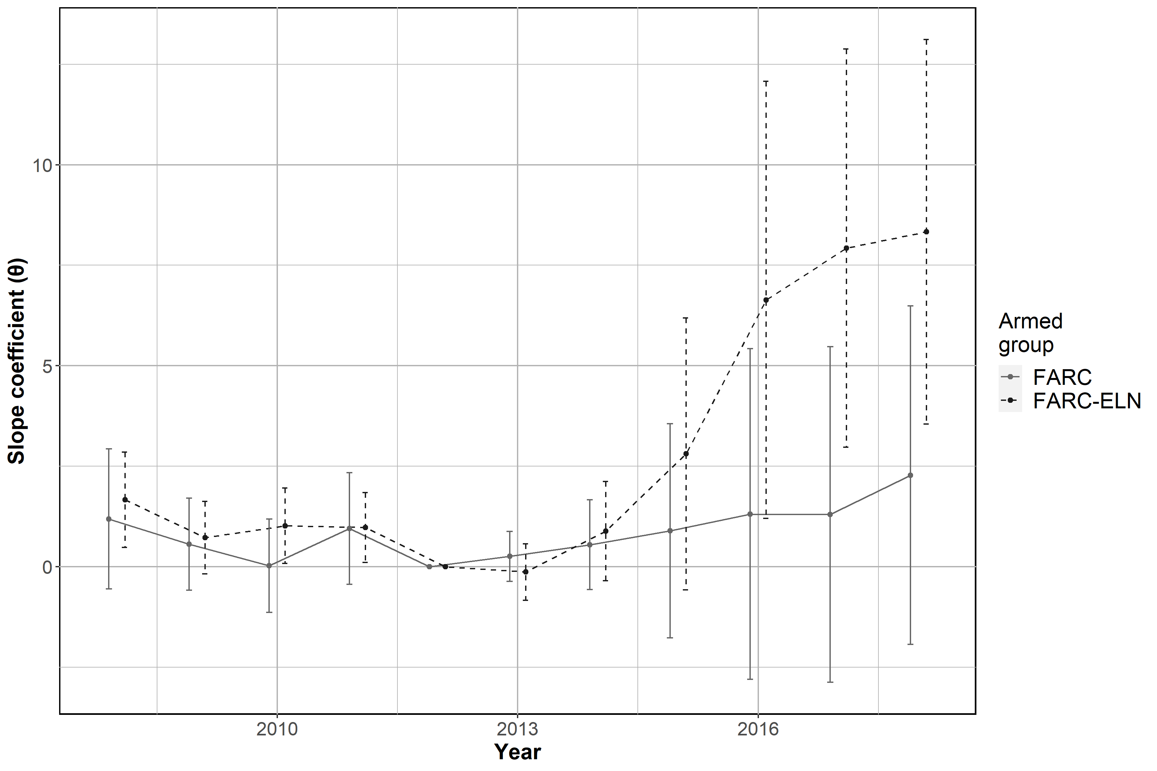

Figure 4. Configuration of armed group and coca cultivation. The figure traces the slope of the relationship between the year and intensity of coca cultivation for each configuration of armed group presence. 2012 and sole ELN municipalities are the omitted categories so all slope coefficients, Θ, capture the change in number of violent incidents in FARC or FARC_ELN municipalities with respect to 2012 versus the change in number of violent incidents in ELN municipalities with respect to 2012

References

Angrist, Joshua D, and Adriana D Kugler. 2008. “Rural Windfall or a New Resource Curse? Coca, Income, and Civil Conflict in Colombia.” *The Review of Economics and Statistics* 90 (2): 191–215.