**Technology Diffusion Within Families: Experimental Evidence from Nicaragua**

**Federico Ceballos Sierra**

**Corresponding Author**

[**fc3@illinois.edu**](mailto:fc3@illinois.edu)

**65 Mumford Hall, 1301 W. Gregory, Urbana, Illinois 61801**

**Ph.D. Student, Department of Agricultural and Consumer Economics**

**University of Illinois at Urbana-Champaign**

**Urbana, Illinois, USA**

**Mary Paula Arends-Kuenning**

**Co-author**

[**marends@illinois.edu**](mailto:marends@illinois.edu)

**408 Mumford Hall, 1301 W. Gregory, Urbana, Illinois 61801**

**Associate Professor, Department of Agricultural and Consumer Economics**

**University of Illinois at Urbana-Champaign**

**Urbana, Illinois, USA**

**Anina Hewey**

**Co-Author**

[**ahewey@fabretto.org**](mailto:ahewey@fabretto.org)

**Puma Ministerio del Trabajo, 500 mts abajo, Managua, Nicaragua**

**Director of Programs**

**Fabretto Foundation**

**Managua, Nicaragua**

**Declaration of Interest:**

1. Anina Hewey is an employee of Fabretto Foundation. Her involvement in this study was limited to the writing of the grant submitted to Tinker Foundation and the coordination of the field staff in Nicaragua. She was not involved in the empirical evaluation or the writing of the paper.
2. Federico Ceballos Sierra and Dr. Mary Paula Arends-Kuenning have no personal or professional ties with Fabretto Foundation.

**Funding Source Declaration:**

This study was funded through the Tinker Institutional Grant titled “Enhancing and Evaluating Tutorial Learning System’s (SAT) Impact on Rural Nicaraguan Youth and Communities”, awarded to Fabretto Foundation in 2018.

# Technology Diffusion Within Families: Experimental Evidence from Nicaragua

# Abstract

Farmer adoption of new agricultural technologies requires reliable and persuasive information as well as clarity regarding the technology's suitability to local conditions. Often, these standards are not met in developing countries due to the scarcity of local research facilities and a sparse and over-burdened network of extension agents. Different forms of social learning have been explored to act as complements to conventional extension services. This paper explores a new possibility: vocational training to high school students. We conduct a randomized control trial in nine communities in rural Nicaragua and evaluate changes in the knowledge of agricultural technologies, access to credit markets, and technology adoption for parents and students. Our results show improvements in knowledge-based outcomes for students and parents, and increased access to credit markets and adoption of agricultural technologies by parents. Given the increase in schooling across developing countries, our results suggest that programs designed around within-family information diffusion can complement more conventional forms of agricultural extension.

**Keywords:** Technology adoption, randomized control trial, social learning, agricultural extension, credit markets.

JEL: I250; O330; Q160; Q140

# 1. Introduction

Farmers’ adoption of new agricultural technologies is a risky endeavor that requires reliable and persuasive information, clarity about the technology’s suitability to local conditions, and careful instruction to be successful (BenYishay and Mobarak 2019). Often, these standards are not met in developing countries due to the scarcity of local research facilities where these technologies can be tested and the scarcity of agricultural extension services that transfer those technologies to farmers. Moreover, the imperfections of credit markets, insurance markets, land rights, output markets, and limited literacy are also significant deterrents of technology adoption in poor rural communities (Jack 2013; Mittal and Kumar 2000). This results in chronically low adoption rates of technologies that could significantly improve the quality of life of farmers across the developing world (Birkhaeuser, Evenson, and Feder 1991).

A stream of literature has focused on ways to cost-efficiently improve technology adoption by leveraging different channels of social learning, which have been shown to match (Krishnan and Patnam 2014) and even outperform (Vasilaky and Leonard 2018) traditional extension services. The first attempts focused on “passive” forms of social learning in which farmers are assumed to costlessly observe the technology being applied by their social network and make the decision to adopt based on the updated expected profitability of the technology (Munshi 2004; Bandiera and Rasul 2006). More recent research explored hybrid arrangements in which trained extension agents (EAs) create a network of farmers who are expected to learn from them and transmit this knowledge to the farmers in their own network (Niu and Ragasa 2018; BenYishay and Mobarak 2019; Shikuku 2019).

The training of farmers close to the targeted population as promoters increases access to technology on the extensive and intensive margins, at the potential cost of accuracy in the information as it is passed through the links (Niu and Ragasa 2018). On the extensive margin, it allows the sparsely populated network of EAs to expand and reach previously unserved farmers through the trained promoters. On the intensive margin, it increases the exposure of farmers to the technology, because the promoter is a member of the community with more frequent interactions with the community (Kondylis, Mueller, and Zhu 2014). However, these extension models are not free of complications; for instance, inadequate selection of promoters can hinder adoption if the target population does not have confidence in them (Hunecke et al. 2017; BenYishay and Mobarak 2019). Furthermore, it implies costly efforts from farmers (promoters and others) as they have to interrupt agricultural activities to be trained, which can limit the effectiveness of these extension models.

Our study explores whether we can overcome these limitations by leveraging a different channel of information diffusion: high school students undergoing vocational training. In essence, this model borrows from the public health literature, whose findings suggest that this channel is an effective way to transmit information from public health agents to parents (Magalhães et al. 2009). In line with the farmer-promoter models, this model maximizes exposure on the extensive and intensive margins, yet reduces the costs of training because farmers do not have to interrupt their activities to be trained. As such, the question is not whether the high school vocational training model can replace either conventional extension models or the recently developed social learning models, but whether it can complement either one of those strategies to bolster adoption.

In order to test the validity of this hypothesis, we conduct a randomized control trial (RCT) in the setting of the Tutorial Learning System (SAT) (Stifel 1982) implemented by the Fabretto Foundation in Northern Nicaragua. This program offers vocational training to high school students in poor rural communities on topics related to agricultural production. Aside from increasing the human capital of students, it also encourages them to remain in their communities, either through their insertion in the local labor market or through ventures of their own. We follow the first cohort of the SAT program in the Nueva Segovia department in the treatment group and a suitable control group that were chosen randomly from a pool of schools suggested to Fabretto by the Ministry of Education of Nicaragua.

For each group we monitor changes in key outcomes of both parents and students that fall into three broad categories: knowledge of the material covered, adoption of technologies that relate to that material, and income and access to credit markets. These outcomes capture the comprehensive nature of the SAT intervention, through which students are trained in relevant agricultural and accounting practices and encouraged to share their knowledge with their families. If the message was reliably transmitted to the household decision-maker, the expectation is that the adoption of those technologies covered will increase. Foreseeing that the adoption of technology might be constrained by availability of capital, Fabretto also offered a loan program to SAT participants and opened up market opportunities to the affiliated farmers through their commercial branch. This holistic approach is an innovation of its own, and therefore worth studying.

Our results show that the aforementioned intervention pipeline has had positive effects on knowledge-based outcomes, adoption of technology, and access to credit. Technical and accounting test scores increased for students and parents in the treatment group with respect to the control group; however, the results point to a larger increase in students’ scores compared to parents, suggesting information loss as knowledge passes through this link. This result is in line with the findings of Niu and Ragasa (2018), in which information loss occurs as knowledge is transferred from promoters to farmers. Similarly, the SAT intervention increased parents’ access to credit for treated students and parents, respectively compared to the control group. Finally, we observe that adoption of a new agricultural technology among parents (decision makers) was higher in the treatment group than in the control group, and that the new technologies adopted match those covered in the SAT module.

The contribution of the current paper is framed in the social learning and technology diffusion literature (Niu and Ragasa 2018; BenYishay and Mobarak 2019; Shikuku 2019). Instead of asking whether we can find more a more efficient extension model, we posit a complementary channel of technology diffusion and test whether it improves the same outcomes targeted by more conventional technology diffusion channels. Given the increase in schooling across developing countries, our positive results suggest promising returns to programs designed around within-family technology diffusion that can make adoption more effective and efficient. In the case of remote areas where school systems precede extension systems, the scheme proposed here can work as a primer for technology diffusion over which more refined extension services can be built. Furthermore, these results highlight the importance of comprehensive instruction programs that, in addition to delivering useful information, bolster technology adoption by alleviating illiteracy and economic constraints.

This paper also provides meaningful insights for Nicaragua, the second poorest country in the western hemisphere[1] with a large vulnerable rural population (Carte et al. 2019). Providing education, either traditional or vocational, has been a challenge for the Nicaraguan Government (Lindenberg et al. 2016; Schiller et al. 2020), and the design and implementation of cost-effective technology diffusion models, such as the one presented here, can help alleviate poverty in underserved rural communities.

The outline of the paper is as follows: Section 2 of this paper describes the background concerning the SAT program and its implementation in rural Nicaragua. Section 3 describes the data set and empirical strategy. Section 4 presents the results for the transfer of knowledge from SATec tutors to students and from students to parents (Subsection 4.1), its impact on technology adoption decisions and access to credit markets (Subsection 4.2), and the heterogeneous treatment effects with respect to student gender and parents landholding (Subsection 4.3). Section 5 offers conclusions and a discussion on policy implications of the study and states the limitations of this study.

# 2. Background: Tutorial Learning System (SAT)

SAT was created in 1974 by the Foundation for the Application and Teaching of Science (FUNDAEC), for rural communities in Colombia (Stifel 1982). Later, it was implemented in Honduras, Guatemala (active until 2005), Ecuador, Brazil, and Nicaragua. A total of more than 300,000 students have benefited from it (Kwauk and Perlman Robinson 2016). SAT is an alternative rural education program that provides access to secondary, technical, and vocational education to rural youth, their families, and members of their communities. At the same time, it prepares them to start new entrepreneurial business ventures, continue their agricultural activities with improved climate adaptation measures and increased productivity, or pursue higher education.

Since 2007, Fabretto has implemented the Tutorial Learning System (SAT) in Nicaragua, serving more than 1,500 rural young people from over 50 communities and training 40 tutors in this methodology. A total of over 1,000 young people have completed their middle school education, and over 400 young people have completed five years of high school and obtained their diplomas. The young participants are usually selected through information and coordination meetings with community leaders and parents. For the current study, they were selected randomly. To enroll, students only are required to presentdocuments verifying that they have completed primary education and written expressions of their interest in taking part in the program. Enrollment is open to men and women, regardless of their social, economic, ethnic, religious, or other status.

Several international organizations, including the Brookings Institution through its “Millions Learning” initiative, have recognized the SAT as an effective model that could be explored further because of its extended reach and adaptation to various countries, its proven impact, and its cost-effectiveness compared with other alternative secondary education programs (Marshall et al. 2014). In 2012, the University of Pennsylvania evaluated the SAT in Nicaragua and found that it has a 100% graduation rate for students who reach the last year, and that 80% of SAT’s graduates work, start their own business, or continue studying. It also found that 67% of students who took the college entrance exam were admitted. In addition, the study showed that the SAT stands out as a method to provide education about values, morals, self-esteem, respect, responsibility, and other influential positive character traits to students, teachers, families, and field staff (University of Pennsylvania Graduate School of Education 2012). Additional studies have highlighted its potential to promote community unity, citizen participation, environmental awareness, public health, community safety, and gender equity (Murphy-Graham 2008, 2012; Honeyman 2010).

## 2.1 Innovations to SAT in Nicaragua

In 2016, Fabretto began to introduce innovations to SAT, drawing from its experiences with the program in rural communities and aligned with global education trends and national public policy. With support from donors like the IDB and Tinker Foundation, Fabretto is executing an ambitious project that intends to increase SAT’s sustainability and strengthen its focus on youth entrepreneurship and “learning by earning,” while contributing to the development of resilience in rural families. The SAT methodology is currently implemented through two programs: (1) the traditional 5-year rural high school program, leading to a high school diploma certified by MINED, and (2) technical training courses certified by the National Technological Institute (INATEC).

In response to the need for a more flexible training modality, Fabretto adjusted the traditional SAT program to include the technical training courses, called “SATec.” SATec provides 6- to 9-month technical courses in topics like sustainable farm management and agricultural skills, while preserving the personal development, service learning, and soft skills development aspects of SAT, as well as the learning-by-doing methodology. SATec courses are designed in response to community interests and potential market opportunities. For example, in the northern highlands, Fabretto offers SATec courses specifically designed to help youth develop the skills needed to strengthen coffee production on the family farm and the entrepreneurial and business knowledge to link to markets to sell high quality coffee. In addition to developing technical skills and practical, hands-on experience with production, youth are also exposed to the SAT methodology and curriculum to foster strong values, a spirit of service and entrepreneurship.

## 2.2 SATec in Nueva Segovia Department

Fabretto implemented “hybrid SATec” model as an innovation aligned with the national secondary education strategy, which focuses on universalizing basic secondary education and technical-vocational training for young people and adults. In order to achieve broader coverage in rural areas, where geographic dispersion is an issue, the Government of Nicaragua implements a Distance Rural Education program. Students in this program only attend classes for one day during the weekend (generally on Saturday), and work or receive vocational training during the week. Fabretto recognized the opportunity of working with young people who choose the Distance Rural Education program and offered them technical-vocational training. Five vocational modules were endorsed by INATEC: Comprehensive Agricultural Production Management (MIPA), Small Ruminant Production, Production Processes for Small Agricultural Units, Sustainable Rural Production systems, and Artisanal Food Production. We study the first cohort that received the MIPA module.

The department of Nueva Segovia was selected for the expansion of the program. For the period of implementation of the project - funded by IDB - nine communities were selected for treatment under a roll-out scheme. Three schools, located in the communities of El Jobo, Estancia and Macaralí, were randomly chosen to receive the MIPA module starting April of 2018, the remaining six communities were surveyed, but did not receive the program until November of 2018 or July 2019. This configuration of treatment allowed us to compared the three communities that received the SATec program to a suitable control group comprising the remaining six communities.

# 3. Data and empirical strategy

## 3.1 Data

This research is based on two main sources of data: a knowledge-based test, and an individual survey administered to students and parents of the selected schools. Three treatment and six control schools were randomly selected from a pool of suitable schools within the Department of Nueva Segovia provided by the Ministry of Education of Nicaragua (MinEd). Although the program was initially offered to the three treatment communities during this study, the remaining six communities received the program after the end of the evaluation.. Within each school, a call for expresion of interest was made to all enrolled high school students (last two years of schooling). 25 students students and their parents were selected randomly from the pool of interested individuals to be part of the study, conditional on giving their consent to participate under the terms of the protocol #19560 of the University of Illinois' Institutional Review Board. A first round was conducted in March of 2019 prior to the start of the first SAT course in the treatment municipalities, and the follow up round was conducted in October of 2019 when the six-month SAT course was over.

The knowledge-based test was constructed based on the material used in the first module of SATec titled Comprehensive Agricultural Production Management (MIPA). The test is split into two sections: technical knowledge, and accounting knowledge. For the technical knowledge section, we selected four dimensions that comprise the key technology-related concepts that were taught during the MIPA module, in consultation with the Fabretto field team. Those four dimensions included questions about i) planting distance and density of corn, ii) preparation of organic fertilizers used in corn, iii) use of synthetic fertilizers in corn, and iv) forecasting corn yields. The accounting knowledge section included an accounting exercise using farm-related transactions analogous to the ones covered in the MIPA module. Each section was graded separately with maximum scores of 26 and 10, respectively. The tests can be found in appendix 1.

The questionnaire for the individual surveys of students and parents included modules on household characteristics, assets and income, access to extension services and technology adoption, access to financial markets, and social networks. Particularly relevant for the variables used as dependent variables were the questions about i) access to financial products in the past 6 months (and the amounts), and ii) adoption of a new technology in the past 6 months and which technology was adopted. To produce a credible assessment, we included questions within these broad categories that would act as counterfactuals in the sense that they covered outcomes that were not targeted by SAT (see apendix 1). For instance, we asked about adoption of technologies in livestock, marketing, and natural resource management, which were not part of the SAT module. Similarly, we asked about access to savings products, also not a part of Fabretto’s holistic program. Significantly larger effects on either of these outcomes would raise a red flag about the quality of the data and the results. The questionnaires for students and parents can be found in appendix 2 and 3. Table 1 presents the baseline summary statistics.

Table 1. Baseline summary statistics

|  |  |  |  |  |  |  |
| --- | --- | --- | --- | --- | --- | --- |
|  | **Students** | | | **Parents** | | |
|  | **Treatment** | **Control** | **P-value** | **Treatment** | **Control** | **P-value** |
| **Economic attributes** |  |  |  |  |  |  |
| Access to credit | 0.027 | 0.025 | 0.94 | 0.286 | 0.308 | 0.843 |
| Credit amount | 68.493 | 20 | 0.499 | 47863.158 | 9937.5 | 0.253 |
| Access to savings | 0.082 | 0.025 | 0.165 |  |  |  |
| Savings amount | 376.027 | 250 | 0.707 |  |  |  |
| Income |  |  |  | 4788.819 | 3966.542 | 0.602 |
| Farmland area |  |  |  | 5.387 | 4.867 | 0.664 |
| **Technology diffusion** |  |  |  |  |  |  |
| Adoption of technology: Agriculture | 0.151 | 0.225 | 0.35 | 0.094 | 0.08 | 0.835 |
| Adoption of  technology:  Livestock | 0.027 | 0.075 | 0.309 | 0.037 | 0.037 | 1 |
| Adoption of  technology:  Marketing | 0.041 | 0.05 | 0.833 | 0.074 | 0.111 | 0.606 |
| Adoption of  technology:  Natural resources | 0.219 | 0.2 | 0.812 | 0.164 | 0.037 | 0.046 |
| **Knowledge** |  |  |  |  |  |  |
| MIPA technical knowledge score | 10.184 | 10.8 | 0.839 | 8.28 | 10.6 | 0.219 |
| MIPA accounting  score | 2.872 | 2.429 | 0.499 | 2.643 | 2.571 | 0.896 |
| **Household characteristics and parent’s attributes** |  |  |  |  |  |  |
| Household size | 4.301 | 4.4 | 0.792 |  |  |  |
| Male-headed household | 0.575 | 0.7 | 0.187 |  |  |  |
| Age of parent |  |  |  | 40.548 | 41.533 | 0.626 |
| Educational level of parent |  |  |  | 1.581 | 1.767 | 0.65 |
| **N** | 40 | 73 |  | 30 | 62 |  |

We perform a balance test between our treatment and control municipalities to validate the randomization strategy. The last column presents p-values from t-tests for differences in these means. Both groups are statistically identical at the mean, but for the exception of the adoption of natural resource management technologies in parents. We believe that this minor imbalance does not compromise the success of our randomization.

A source of concern with our sample is the attrition rate of nearly 50%. Prominent among the reasons for such a high rate was the wave of civil unrest that engulfed the country starting in 2018, which widely overlapped with our study. The fact that this was an exogenous shock, compounded with the fact that the attrition rates were similar in the treatment and control groups, leads us to believe that attrition bias is not an issue. To test this belief we regress a binary variable that takes value of 0 if the individual wasn’t interviewed in the follow-up and 1 otherwise, on the type of municipality (treatment or control) and the observed variables. Our results show that the type of group (treatment or control) has no relation with missed follow-up interviews. Similarly, the test of joint significance fails to reject the null hypothesis that all coefficients are equal to zero (p-value = 0.2267). Because the attrition showed no pattern by observable characteristics, we assume this is also true for unobservable characteristics.

In general, technology adoption is low in our sample, regardless of the area. The largest adoption rates are seen in natural resource management, with as much as 21.9% of students in the treatment group having adopted one such technology in the past 6 months. We believe this result is driven by the widespread recycling campaigns such as the “Nicaragua Toda Dulce” (Nicaragua All Sweet)[2]. Similar rates of adoption are seen for agricultural technologies in students (15.1% and 22.5% for treatment and control groups respectively), yet much lower rates for parents (9.4% and 8%). Unsurprisingly, access to credit is lower for students than parents, the latter having had access to loans in the past 6 months in about 30% of the cases. Finally, scores for MIPA technical and accounting knowledge are low and very similar across all groups averaging about 10/26 and 2.5/10, respectively.

## 3.2 Empirical strategy

Our baseline specification is a simple comparison of means between treated and control individuals:

$y_{i,t=1}=α+βT_{i}+γy_{i,t=0}+ρX_{i,t=0}+ε_{it=1}$, (1)

where $y_{i,t=1}$ is the outcome (access to credit, adoption of agricultural technology, agricultural knowledge score, or accounting knowledge score) for individual i at time t = 1. $T_{i}$ is a binary variable that takes value of 1 if the individual was part of a community that was part of the SAT program, and 0 otherwise. We further control for baseline outcomes, $y_{i,t=0}$ and a set of individual and household-level characteristics, $X_{it}$, which include the age, sex, educational level, household size, and a dichotomous variable for whether the head of the household is male. The coefficient $β$ captures the average treatment effect (ATE) of exposure to the first module of the SAT program. Standard errors are clustered at the school level to account for possible correlation of the error terms.

In addition we estimate a difference-in-difference specification considering the possibility that, although our balance test suggests that the randomization was performed correctly, our samples differ in some characteristics that we are unable to observe. While these unobserved differences should not be correlated with the selection into treatment and control, they could still increase the variance of the error term, so that the difference-in-differences approach allows us to increase the precision of our estimates.

$y_{it}=α+β_{1}T_{i}+β_{2}t_{t}+β_{3}T_{i}⋅t_{t}+v_{s}+ε_{it}$, (2)

Where the coefficient of interest, $β_{3}$, captures the differential impact of the SAT on the outcomes of interest. The expectation is for the direction and significance of the coefficients of both estimations to match, further backing the claim that the randomization was successful and that our estimates are robust. Standard errors are clustered at the school-level.

# 4. Results

## 4.1 Knowledge transfer

As explained in section 3, we identify the causal effect of the SATec program on the outcome variables using data from a randomized control trial of 113 students and their respective (92) parents in nine randomly selected rural schools, which we observed at a baseline in March 2019 and an endline in October 2019. Figure 1 shows the changes in the test scores for students in both areas of knowledge. The left panel shows that changes in the accounting knowledge scores indicate a downward trend, which is more pronounced for control municipalities. The right panel plots the changes in scores for the agricultural knowledge test, with a different trend: both groups experienced increases in their scores, however the increase was more pronounced in the treatment group, for whom the average score increased by almost ten points compared to a more modest increase of three points in the control group.

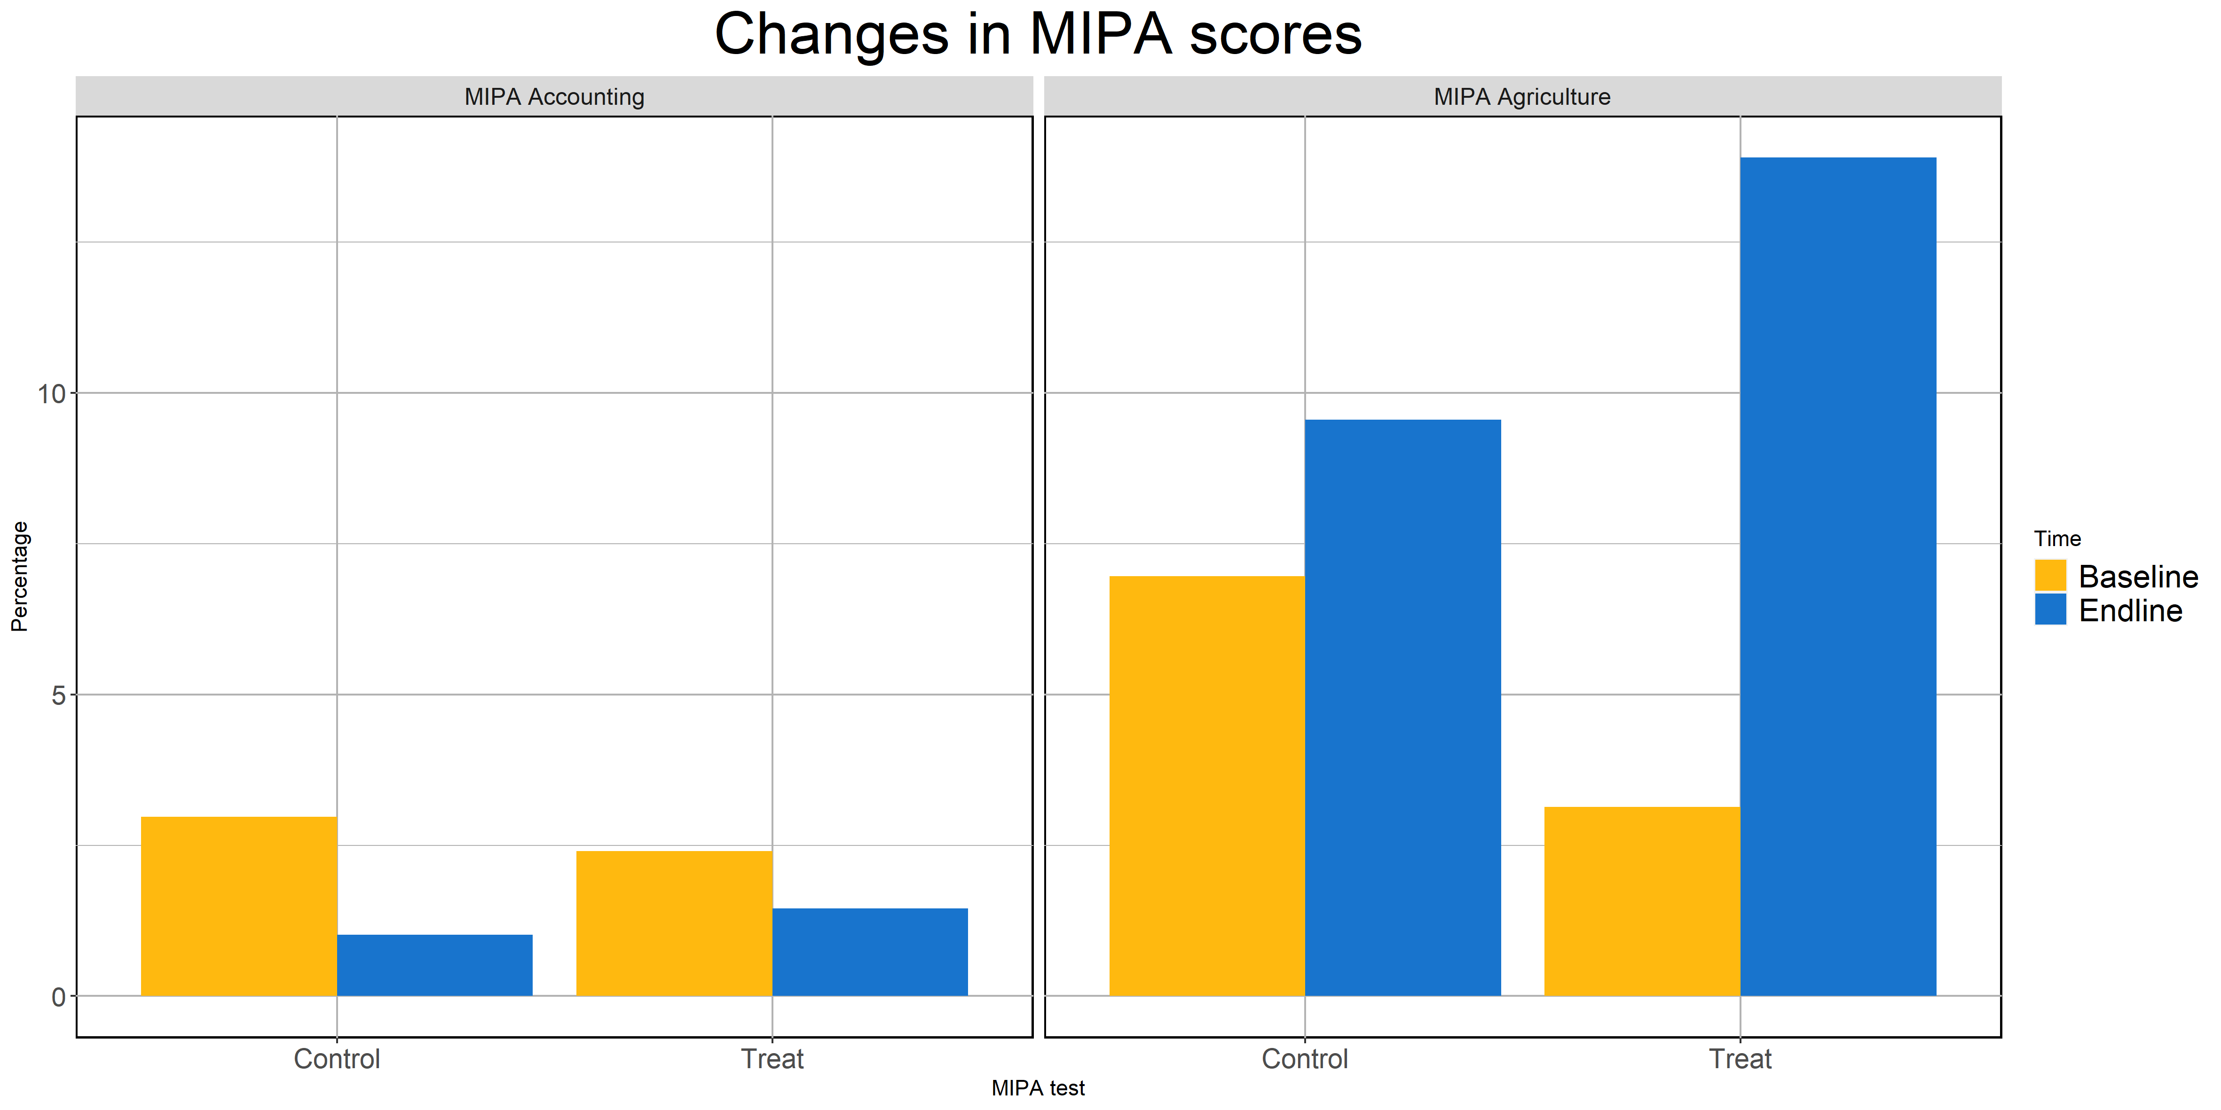

Figure 1. Changes in test scores for accounting knowledge (left) and agricultural knowledge (right): students

A similar situation is seen in Figure 2 for the case of parents: a decrease in the accounting scores, which is more acute for the control group and an increase in the scores of the agricultural knowledge test across both groups, but more pronounced in the treatment group.

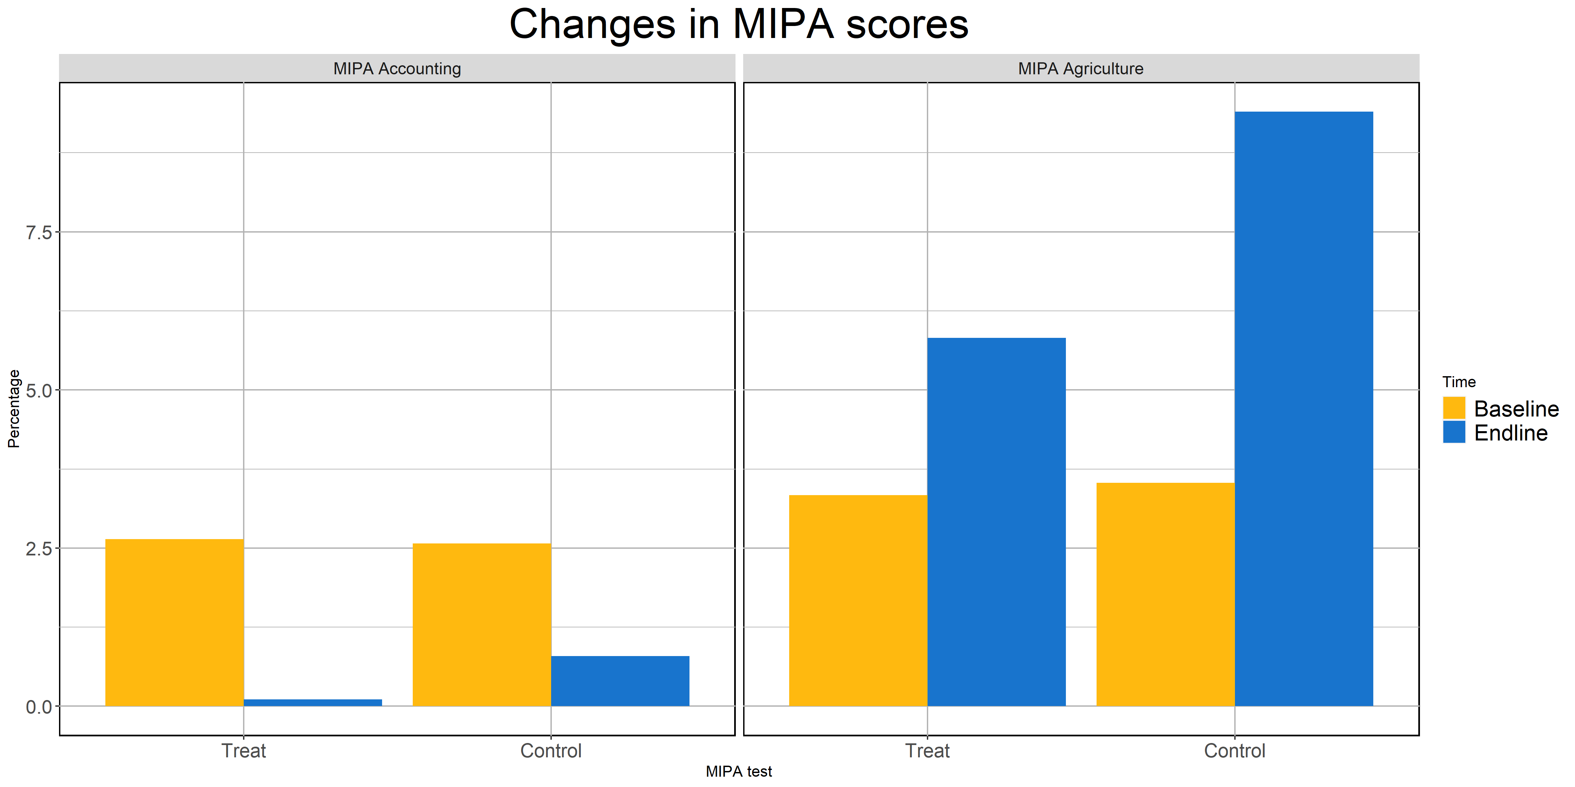

Figure 2. Changes in test scores for accounting knowledge (left) and agricultural knowledge (right): parents

Although we cannot empirically identify the cause for the decrease in accounting scores, the consistency of this trend suggests an underlying mechanism with impact across both groups. A possible explanation can be the selective attention model (Schwartzstein 2014; Niu and Ragasa 2018) in which farmers choose to attend to limited dimensions of knowledge. We believe that in the second exposure of farmers to the agricultural and accounting knowledge test, they singled out the agricultural section as that with more potential for improvement, and considered the accounting section too complex and time draining to devote too much effort. Even so, the fact that the dip in scores is smaller in treatment municipalities suggests a positive impact of the SATec program that could have acted as a buffer against knowledge loss. The consistent increases in agricultural knowledge scores in treatment municipalities, contrasted to smaller gains or even decreases in control municipalities also point to a positive effect of the SATec program, suggesting the agricultural information flowed from tutors to students and from students to parents. This claim is backed by the empirical results of estimating equations (1) and (2) on the MIPA scores outcomes:

Table 2. Changes in MIPA scores for students and parents. Comparison of means and difference-in-difference estimates

|  |  |  |  |  |
| --- | --- | --- | --- | --- |
|  | Students | | Parents | |
|  | MIPA technical knowledge score | MIPA accounting knowledge score | MIPA technical knowledge score | MIPA accounting knowledge score |
| 1. *Comparison of means* | | | | |
| Treat | 5.24 **  (2.48) | 0.20  (0.32) | 2.53 **  (1.15) | 0.40 **  (0.18) |
| Observations | 226 | 226 | 184 | 184 |
| 1. *Difference-in-differences* | | | | |
| Treat x time | 7.19 ***  (2.32) | 1.12 ***  (0.38) | 3.84 **  (1.94) | 0.77 **  (0.38) |
| Treat | 0.98  (2.45) | -0.16  (0.29) | -0.52  (2.45) | -0.56 *  (0.32) |
| Time | -0.93  (2.52) | -0.40  (0.44) | 2.72 ***  (1.01) | -0.38 *  (0.20) |
| Observations | 226 | 226 | 184 | 184 |

Source: Authors’ calculations from surveys and tests. Notes: Each column and panel correspond to separate OLS regressions that control for individual- and household level attributes (gender, age, schooling, household size and male-headed household). Standard errors clustered at the school level in parenthesis; *** p < 0.01; ** p < 0.05; * p < 0.1.

Table 2 presents the comparison of means (panel A) and difference-in-differences (panel B) estimates using the agricultural and accounting scores as outcome variable. The results from either specification are similar with the difference-in-difference estimates displaying lower standard errors, and the additional significance of the ATE on the accounting knowledge score in students. We will use the difference-in-difference results for our discussion, as we believe that the modeling of unobserved characteristics through this specification reduces the variance of the error term and increases the precision of our estimates.

The empirical evidence presented in Table 2 points to the suitability of the tutor-student-parent channel for information transfer; however, the results also suggest that there is information loss between students and parents. In the case of agricultural knowledge, students in the treatment group outperformed their control counterparts by 7.19 points (95% confidence interval: [2.631041, 11.7589]), whereas parents of the treatment group had a 3.84-point difference compared to treatment parents (95% confidence interval: [0.008732742, 7.667964]). In the case of accounting knowledge, students in the treatment group outperformed their control counterparts by 1.12 points (95% confidence interval: [0.3642986, 1.867765]), whereas parents in the treatment group outperformed their control counterparts by 0.77 (95% confidence interval: [0.02381303, 1.520775]). The information loss is consistent with previous work on social learning and technology diffusion, which identified selective attention (Niu and Ragasa 2018) and distrust (Hunecke et al. 2017; BenYishay and Mobarak 2019) as potential causes. However, we are careful about the interpretation of these results because we cannot reject that either pair of coefficients is statistically different.

## 4.2 Technology adoption and access to markets

We move on to analyze the effect that the information transfer discussed in the previous subsection had on technology adoption decisions and access to credit markets. Table 3 displays the results of employing the empirical strategy outlined in equations (1) and (2) on the binary outcomes adoption of agricultural technology in the previous six months and access to credit markets in the previous six months. No statistically significant difference was observed for students for either outcome, which can be attributable to the fact that students are not the decision maker in farm-related endeavors and that due to their young age are not suitable recipients of loans.

Table 3. Changes in adoption of agricultural technologies and access to credit markets for students and parents. Comparison of means and difference-in-difference estimates

|  |  |  |  |  |
| --- | --- | --- | --- | --- |
|  | Students | | Parents | |
|  | Access to credit | Adoption of technology: agriculture | Access to credit | Adoption of technology: agriculture |
| 1. *Comparison of means* | | | | |
| Treat | 0.09  (0.06) | 0.12  (0.09) | -0.01  (0.13) | 0.02  (0.13) |
| Observations | 226 | 226 | 184 | 184 |
| 1. *Difference-in-differences* | | | | |
| Treat x time | 0.08  (0.06) | -0.01  (0.10) | 0.26 **  (0.13) | 0.19 **  (0.09) |
| Treat | 0.06  (0.06) | 0.34 ***  (0.11) | -0.34 ***  (0.09) | -0.08  (0.10) |
| Time | -0.07 *  (0.04) | 0.03  (0.10) | -0.16 **  (0.07) | 0.01  (0.04) |
| Observations | 226 | 226 | 184 | 184 |

Source: Authors’ calculations from surveys and tests. Notes: Each column and panel correspond to separate OLS regressions that control for individual- and household level attributes (gender, age, schooling, household size and male-headed household). Standard errors clustered at the school level in parenthesis; *** p < 0.01; ** p < 0.05; * p < 0.1.

A different story is true for parents: our difference-in-differences estimates show that the adoption of new agricultural technologies was higher in our treatment group compared to the control group after the implementation of the SATec program. According to our endline survey, these new technologies closely match the topics covered in the MIPA module including, but not restricted to contour planting, planting distance, live barriers, improved seed, seed selection, chemical and organic fertilizers, and pest control. Further evidence of the relationship between Fabretto’s SATec program can be seen in panel A of Figure 3, where we plot the frequency of agricultural advice disaggregated by source for the control (left) and treatment (right) groups. It shows that a large share of the positive change in agricultural advice in the treatment group can be traced back to SATec tutors and students.

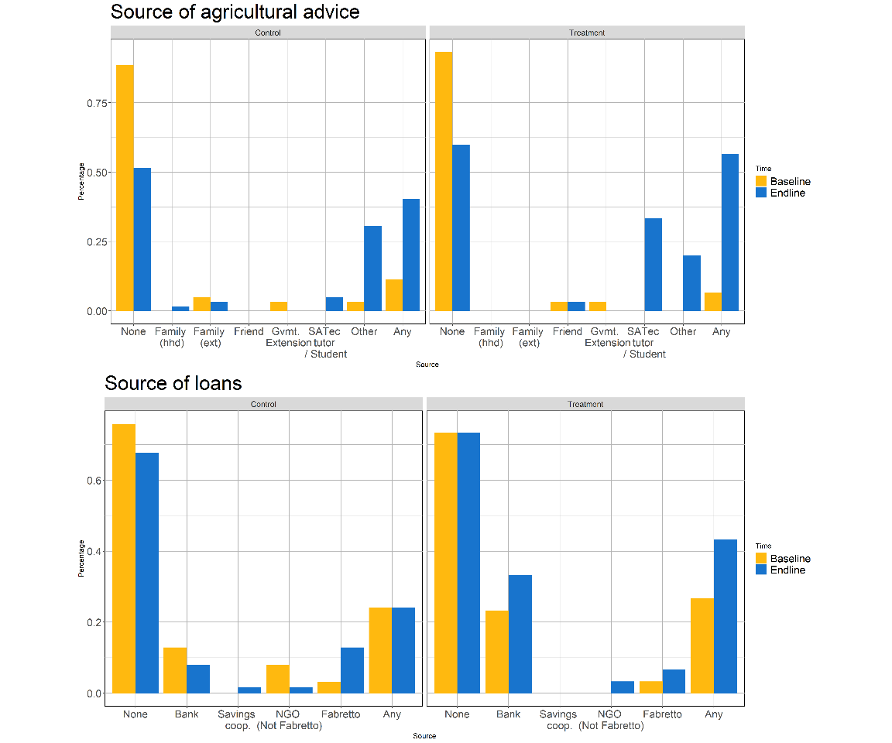

Main source of agricultural advice (top) and access to credit markets disaggregated by source (bottom)

Similarly, we observe a positive and statistically significant difference in access to credit markets among parents of the treatment group (Column 4 Table 3) compared to their control counterparts. However, contrary to the case of technology adoption, parents were using credit sources other than those offered by Fabretto, particularly favoring banks (Panel B, Figure 3). This is by no means a contradicting result; Fabretto offered a very flexible loan scheme that was, however, tied to the investment in ventures that aligned with their commercial branch goals and expertise in cash crops such as coffee and quinoa. The fact that farmers were willing to take loans from outside sources of credit attests to the confidence they derived from their new knowledge and ensuing ventures.

## 4.3 Heterogeneous treatment effects of gender and landholding

Finally, we conduct an analysis of the heterogeneity of the results presented in the previous two subsections focusing on two sources of heterogeneity: the gender of the student and the amount of land that parents have using a triple difference approach. Table 4 presents the results of this estimation, with panel A displaying the results of heterogeneity in student gender and heterogeneity in landholding in panel B:

Table 4. Heterogeneous effect of SATec by student gender and parent landholding

|  |  |  |  |  |  |
| --- | --- | --- | --- | --- | --- |
|  | *Dependent variable:* | | | | |
|  | Access to credit | Adoption of technology:  Agriculture | | MIPA technical knowledge | MIPA accounting knowledge |
| 1. *Heterogeneity in students: gender* | | | | | |
| Treat x time | 0.07  (0.08) | 0.00  (0.14) | | 9.85 ***  (3.23) | 1.90 ***  (0.49) |
| Treat x time x female (female = 1) | -0.00  (0.14) | -0.05  (0.21) | | -5.36  (4.76) | -1.57 **  (0.73) |
| Observations | 226 | | 226 | 226 | 226 |
| 1. *Heterogeneity in Parents: landholding* | | | | | |
| Treat x time | 0.67 ***  (0.22) | 0.14  (0.21) | | 9.98 **  (4.37) | 1.01  (0.81) |
| Treat x time x low area (<median area = 1) | -0.58 **  (0.26) | 0.08  (0.23) | | -7.93  (4.84) | -0.35  (0.88) |
| Observations | 184 | 184 | | 184 | 184 |

Source: Authors’ calculations from surveys and tests. Notes: Each column and panel correspond to separate OLS regressions that control for individual- and household level attributes (gender, age, schooling, household size and male-headed household). Standard errors clustered at the school level in parenthesis; *** p < 0.01; ** p < 0.05; * p < 0.1.

Panel A shows no statistically significant difference in ATE between male and female students in terms of access to credit, adoption of agricultural technology, and agricultural knowledge scores. However, there is a statistically significant difference in accounting knowledge scores. Unfortunately, we do not conduct any qualitative analysis that could help us understand this result better. However, this result could be an indication that the message is not reaching males and females equally and that tutors and Fabretto staff shoul pay attention to gender discrepancy. Furthermore, it could be evidence of disparity in the selective attention between genders and an interesting question for future research.

Due to the constraint of the sample size, we limit our analysis to a split of our sample between above median and below median size of the farm. Panel B shows a statistically significant difference in the ATE of the SATec program in access to credit markets, with below median farmers being less likely to receive loans over the previous six months. This result would be in line with the expectation that poorer farmers - who have fewer assets to use as collateral - are less likely to receive loans from credit institutions. As the program is expanded in Nicaragua and other countries, the credit constraints of the poorer household should be taken into account, as lack of access to credit programs among the poorest individuals in the program can curtail adoption of technology and ultimately dampen the success of the program.

# 5. Conclusion

This paper presents an experimental evaluation of the effect of a vocational training program - Tutorial Learning System (SATec) - on agricultural technology diffusion and adoption in vulnerable rural communities in Northern Nicaragua. We approach the question of its impact through the comprehensive nature of the program, which supersedes the traditional vocational training program objective of improving human capital to offer a more comprehensive scheme that encourages information transfer to farmers and alleviates credit and literacy constraints. Similar SAT programs have been implemented in numerous developing countries including Colombia, Honduras, Guatemala, Ecuador, and Brazil; however, none of these programs have embraced the comprehensive nature of SATec. As such, this study provides novel experimental evidence on the impact of the SATec program in rural communities and its potential to close the technological gap of poor farmers across the developing world.

The results of our analysis indicate two key findings. First, we show that the tutor-student-parent channel is an effective means of information transfer. SATec students improved their knowledge in the accounting and agricultural topics that were taught during the Comprehensive Agricultural Production Management (MIPA) module. Their parents also improved their scores, albeit to a lesser extent. Second, we show that the increased exposure to new technologies through the tutor-student-parent channel led to an increase in adoption of technology and access to credit markets. To the knowledge of the authors, this is the first study to provide empirical evidence of within-family technology diffusion and measurable increases in technology adoption. In line with other forms of social learning, the within-family channel increases exposure to new technologies on the extensive and intensive margins, without entailing the costs of displacement and interruption of activities that are common in the farmer-promoter system.

These findings have significant policy implications for extension programs targeting unserved and underserved rural communities. In the case of the former - and particularly in Latin America, schooling systems often created by the Catholic Church precede many of the other institutions of Government, including extension networks (Gill 2008). Organizations fostering technology adoption can leverage this channel, which builds on the educational system, and is therefore less taxing in terms of capital and time. In the case of the latter, the channel we posit can act as a complement of established extension systems and reinforce the message delivered by more conventional channels of technology diffusion.

Our study is subject to a number of limitations. First, our study was impacted by the civil unrest that swept through Nicaragua between 2018 and 2020, and the 2020 COVID-19 pandemic. The former was identified as one of the leading causes for the high attrition rate, and smaller than planned sample size. Nevertheless, we show that the significant results we provide here are robust, given their consistency across specifications; however, we might have missed identifying other significant effects due to our diminished predictive power. Regarding the COVID-19 pandemic, it impeded the execution of an additional round of surveys which was designed to test the cumulative effect of exposure to SATec. Therefore, the hypothesis of increasing returns to instruction remains untested and is left for future research. Finally, we lack qualitative data that could enrich the interpretation of the results presented in this paper.

# References

Bandiera, Oriana, and Imran Rasul. 2006. “Social Networks and Technology Adoption in Northern Mozambique.” *The Economic Journal* 116 (514): 869–902.

BenYishay, Ariel, and A Mushfiq Mobarak. 2019. “Social Learning and Incentives for Experimentation and Communication.” *The Review of Economic Studies* 86 (3): 976–1009.

Birkhaeuser, Dean, Robert E Evenson, and Gershon Feder. 1991. “The Economic Impact of Agricultural Extension: A Review.” *Economic Development and Cultural Change* 39 (3): 607–50.

Carte, Lindsey, Birgit Schmook, Claudia Radel, and Richard Johnson. 2019. “The Slow Displacement of Smallholder Farming Families: Land, Hunger, and Labor Migration in Nicaragua and Guatemala.” *Land* 8 (6): 89.

Gill, Anthony. 2008. *Rendering Unto Caesar: The Catholic Church and the State in Latin America*. University of Chicago Press.

Honeyman, Catherine A. 2010. “Social Responsibility and Community Development: Lessons from the Sistema de Aprendizaje Tutorial in Honduras.” *International Journal of Educational Development* 30 (6): 599–613.

Hunecke, Claudia, Alejandra Engler, Roberto Jara-Rojas, and P Marijn Poortvliet. 2017. “Understanding the Role of Social Capital in Adoption Decisions: An Application to Irrigation Technology.” *Agricultural Systems* 153: 221–31.

Jack, B Kelsey. 2013. “Constraints on the Adoption of Agricultural Technologies in Developing Countries.” *White Paper, Agricultural Technology Adoption Initiative, Boston: J-PAL (MIT) and Berkeley: CEGA (UC Berkeley)*.

Kondylis, Florence, Valerie Mueller, and Siyao Zhu. 2014. *Seeing Is Believing? Evidence from an Extension Network Experiment*. The World Bank.

Krishnan, Pramila, and Manasa Patnam. 2014. “Neighbors and Extension Agents in Ethiopia: Who Matters More for Technology Adoption?” *American Journal of Agricultural Economics* 96 (1): 308–27.

Kwauk, Christina, and Jenny Perlman Robinson. 2016. “Sistema de Aprendizaje Tutorial-Sat: Replanteando La Educación Secundaria Rural En América Latina.”

Lindenberg, Anni, Kathryn I Henderson, Leah Dur, and others. 2016. “Using Technology and Mentorship to Improve Teacher Pedagogy and Educational Opportunities in Rural Nicaragua.” *Global Education Review* 3 (1).

Magalhães, Danielle Ferreira de, José Ailton da Silva, João Paulo Amaral Haddad, Elvio Carlos Moreira, Maria Isabel Magalhães Fonseca, Marina Lúcia Lima de Ornelas, Barbara Kellen Antunes Borges, and Zélia Maria Profeta da Luz. 2009. “Dissemination of Information on Visceral Leishmaniasis from Schoolchildren to Their Families: A Sustainable Model for Controlling the Disease.” *Cadernos de Saúde Pública* 25 (7): 1642–6.

Marshall, Jeffery H, Claudia R Aguilar, Mario Alas, Renán Rápalo Castellanos, Levi Castro, Ramón Enamorado, and Esther Fonseca. 2014. “Alternative Education Programmes and Middle School Dropout in Honduras.” *International Review of Education* 60 (1): 51–77.

Mittal, Surabhi, and Praduman Kumar. 2000. “Literacy, Technology Adoption, Factor Demand and Productivity: An Econometric Analysis.” *Indian Journal of Agricultural Economics* 55 (3): 490–99.

Munshi, Kaivan. 2004. “Social Learning in a Heterogeneous Population: Technology Diffusion in the Indian Green Revolution.” *Journal of Development Economics* 73 (1): 185–213.

Murphy-Graham, Erin. 2008. “Opening the Black Box: Women’s Empowerment and Innovative Secondary Education in Honduras.” *Gender and Education* 20 (1): 31–50.

———. 2012. *Opening Minds, Improving Lives: Education and Women’s Empowerment in Honduras*. Vanderbilt University Press.

Niu, Chiyu, and Catherine Ragasa. 2018. “Selective Attention and Information Loss in the Lab-to-Farm Knowledge Chain: The Case of Malawian Agricultural Extension Programs.” *Agricultural Systems* 165: 147–63.

Schiller, Katharina JF, Laurens Klerkx, P Marijn Poortvliet, and Wendy Godek. 2020. “Exploring Barriers to the Agroecological Transition in Nicaragua: A Technological Innovation Systems Approach.” *Agroecology and Sustainable Food Systems* 44 (1): 88–132.

Schwartzstein, Joshua. 2014. “Selective Attention and Learning.” *Journal of the European Economic Association* 12 (6): 1423–52.

Shikuku, Kelvin Mashisia. 2019. “Information Exchange Links, Knowledge Exposure, and Adoption of Agricultural Technologies in Northern Uganda.” *World Development* 115: 94–106.

Stifel, Laurence D. 1982. “University for Rural Development: An Alternative Approach in Colombia.” *The Journal of Developing Areas* 16 (4): 511–22.

University of Pennsylvania Graduate School of Education. 2012. “Action-Based Evaluation of Sistema de Aprendizaje Tutorial (Sat) Program.” University of Pennsylvania.

Vasilaky, Kathryn N, and Kenneth L Leonard. 2018. “As Good as the Networks They Keep? Improving Outcomes Through Weak Ties in Rural Uganda.” *Economic Development and Cultural Change* 66 (4): 755–92.

1. <https://data.worldbank.org/indicator/NY.GDP.PCAP.CD>
2. <https://www.el19digital.com/articulos/ver/titulo:104251-nicaragua-presenta-plan-de-trabajo-y-perspectivas-de-turismo-a-ong-nacionales-e-internacionales>. Also see industry-led initiatives by Claro Mobile (<https://www.elnuevodiario.com.ni/economia/empresas/490697-claro-ambiente-basura-reciclaje/>), and Raleigh International (<https://raleighnicaragua.ong/sobre-raleigh/sinplastico/campana/>)