Code Organization for Chapter 16

There are two folders in Chapter_16 folder: “fdtd_2d_with_cuda” and “fdtd_2d_cuda_code”.

The folder “fdtd_2d_with_cuda” includes a modified version of the two-dimensional FDTD code that has been presented in Chapter 8. This code is organized such that problem definitions, initializations, and results post processing is done in Matlab as usual, while the program launches an executable, named as “fdtd2d.exe”, that runs the time marching loop on a graphics card. A parameter, named as computation_platform, is added to define_problem_space_parameters_2d subroutine to set the computation platform. If this parameter is set as 1, the program will run as usual in Matlab. If the parameter is set as 2 or 3, then the “fdtd2d.exe” will be launched. If the parameter is 2, the executable will perform FDTD computations on CPU, otherwise on GPU.

The executable “fdtd2d.exe” is generated by compiling and linking the C/CUDA source code that is in the “fdtd_2d_cuda_code” folder. The Microsoft Visual Studio project file of this code is named as fdtd2d.vcproj. This project is developed and tested using Microsoft Visual Studio 2008. The project is tested on a system with CUDA Toolkit 6.0.

Additional Considerations
The following paths are defined in the fdtd2d.vcproj project:
- Open “fdtd2d.vcproj” project in MSVC 2008.
- Right click on the project name fdtd2d in the Solution Explorer panel shown in Figure 1.
- Click on Properties in the pop-up menu. This opens the “fdtd2d property pages window” as shown in Fig. 2.
- “Configuration properties->C/C++->general->additional include directories” has the following two paths defined:
  - $(CUDA_PATH)/include
  - $(CUDA_SAMPLES_PATH)/common/inc
- “Configuration properties->Linker>general->additional library directories” has the following two paths defined:
  - $(CUDA_PATH)/lib/$(PlatformName)
  - $(CUDA_SAMPLES_PATH)/common/lib/$(PlatformName)
- “Configuration properties->CUDA Runtime API>general” has the following two paths defined as shown in Fig. 3:
  - $(CUDA_PATH)\bin\nvcc.exe
  - $(CUDA_PATH)\include
  - $(CUDA_SAMPLES_PATH)/common/inc

- CUDA_PATH and CUDA_SAMPLES_PATH are two environment variables that need to be added to “Environment Variables” list of the operating system. In Microsoft Windows 7, this list is accessed through “Start->control panel->system->advanced system settings->advanced->environment variables”. Figure 4 shows the “Environment Variables” window. Here, the environment variables CUDA_PATH and CUDA_SAMPLES_PATH are defined similar to as follows:
- CUDA_PATH : C:\Program Files\NVIDIA GPU Computing Toolkit\CUDA\v6.0
- CUDA_SAMPLES_PATH: C:\ProgramData\NVIDIA Corporation\CUDA Samples\v6.0

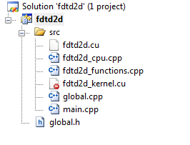
Figure 1. Solution Explorer panel.

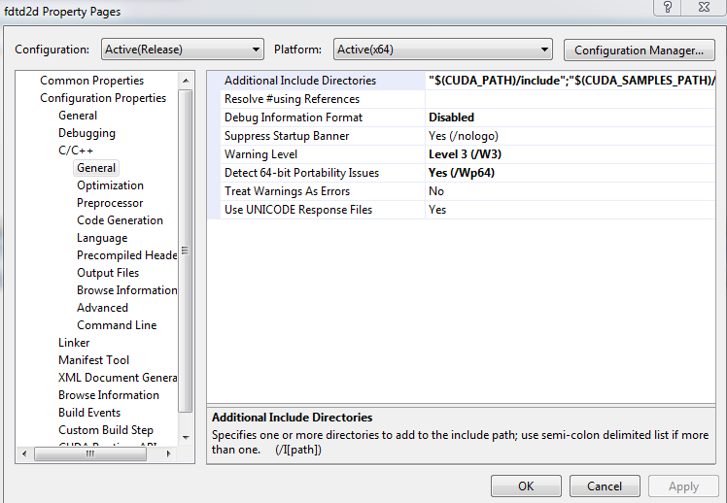

Figure 2. fdtd2d property pages window, C/C++ selected.

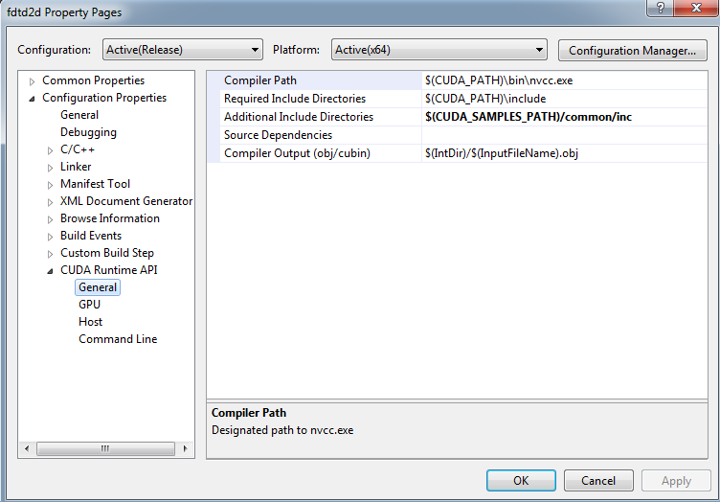
Figure 3. fdtd2d property pages window, CUDA Runtime API selected.

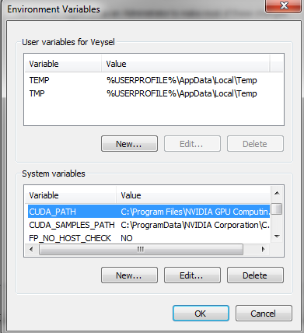

Figure 4. Environment Variables window.

