RELIEFSYNC Z
Detailed Project Summary and Technical Design
IBM Z Datathon 2026 | Real-Time AI for Critical Decisions
One-sentence pitch
ReliefSync Z is a hybrid-AI disaster logistics decision-support system that monitors relief convoys in real time, estimates route disruption risk, recommends the safest operational response, and explains that decision to a human dispatcher while running key workloads on LinuxONE.

1. Project Purpose
ReliefSync Z addresses a time-critical humanitarian logistics problem: during floods, storms, road closures, and other sudden disasters, relief convoys can continue toward dangerous or blocked routes because conditions change faster than conventional batch-updated logistics systems react.
The project therefore focuses on one operational question: “Given the convoy’s live state and the hazards ahead, should the vehicle continue, hold, reroute, or divert?”
The original application frames the problem around flooded transit corridors, port closures, regional demand spikes, delayed route-risk updates, and preventable losses of life and resources. The revised design keeps that core problem but strengthens the technical architecture, explainability, LinuxONE integration, and hybrid-AI elements to match the judging criteria.
2. Target Users and Community Value
- Humanitarian and disaster-relief organisations managing food, medical supplies, and essential equipment during emergencies.
- Government emergency-management agencies coordinating multi-agency responses and regional logistics.
- Third-party logistics and fleet managers operating vehicles through high-risk disaster zones.
- Human dispatchers who need a fast, transparent recommendation rather than an opaque autonomous decision.
The prototype should quantify value wherever possible. Example demo metrics include reduction in predicted route risk, additional detour time, and whether high-priority cargo is kept away from a hazard zone.
3. Revised System Architecture
The updated architecture uses structured predictive models for risk and action recommendation, a routing layer based on OpenStreetMap road data, and a Granite explanation layer. The LLM is not responsible for the safety decision; it explains the outputs of the predictive and decision models.
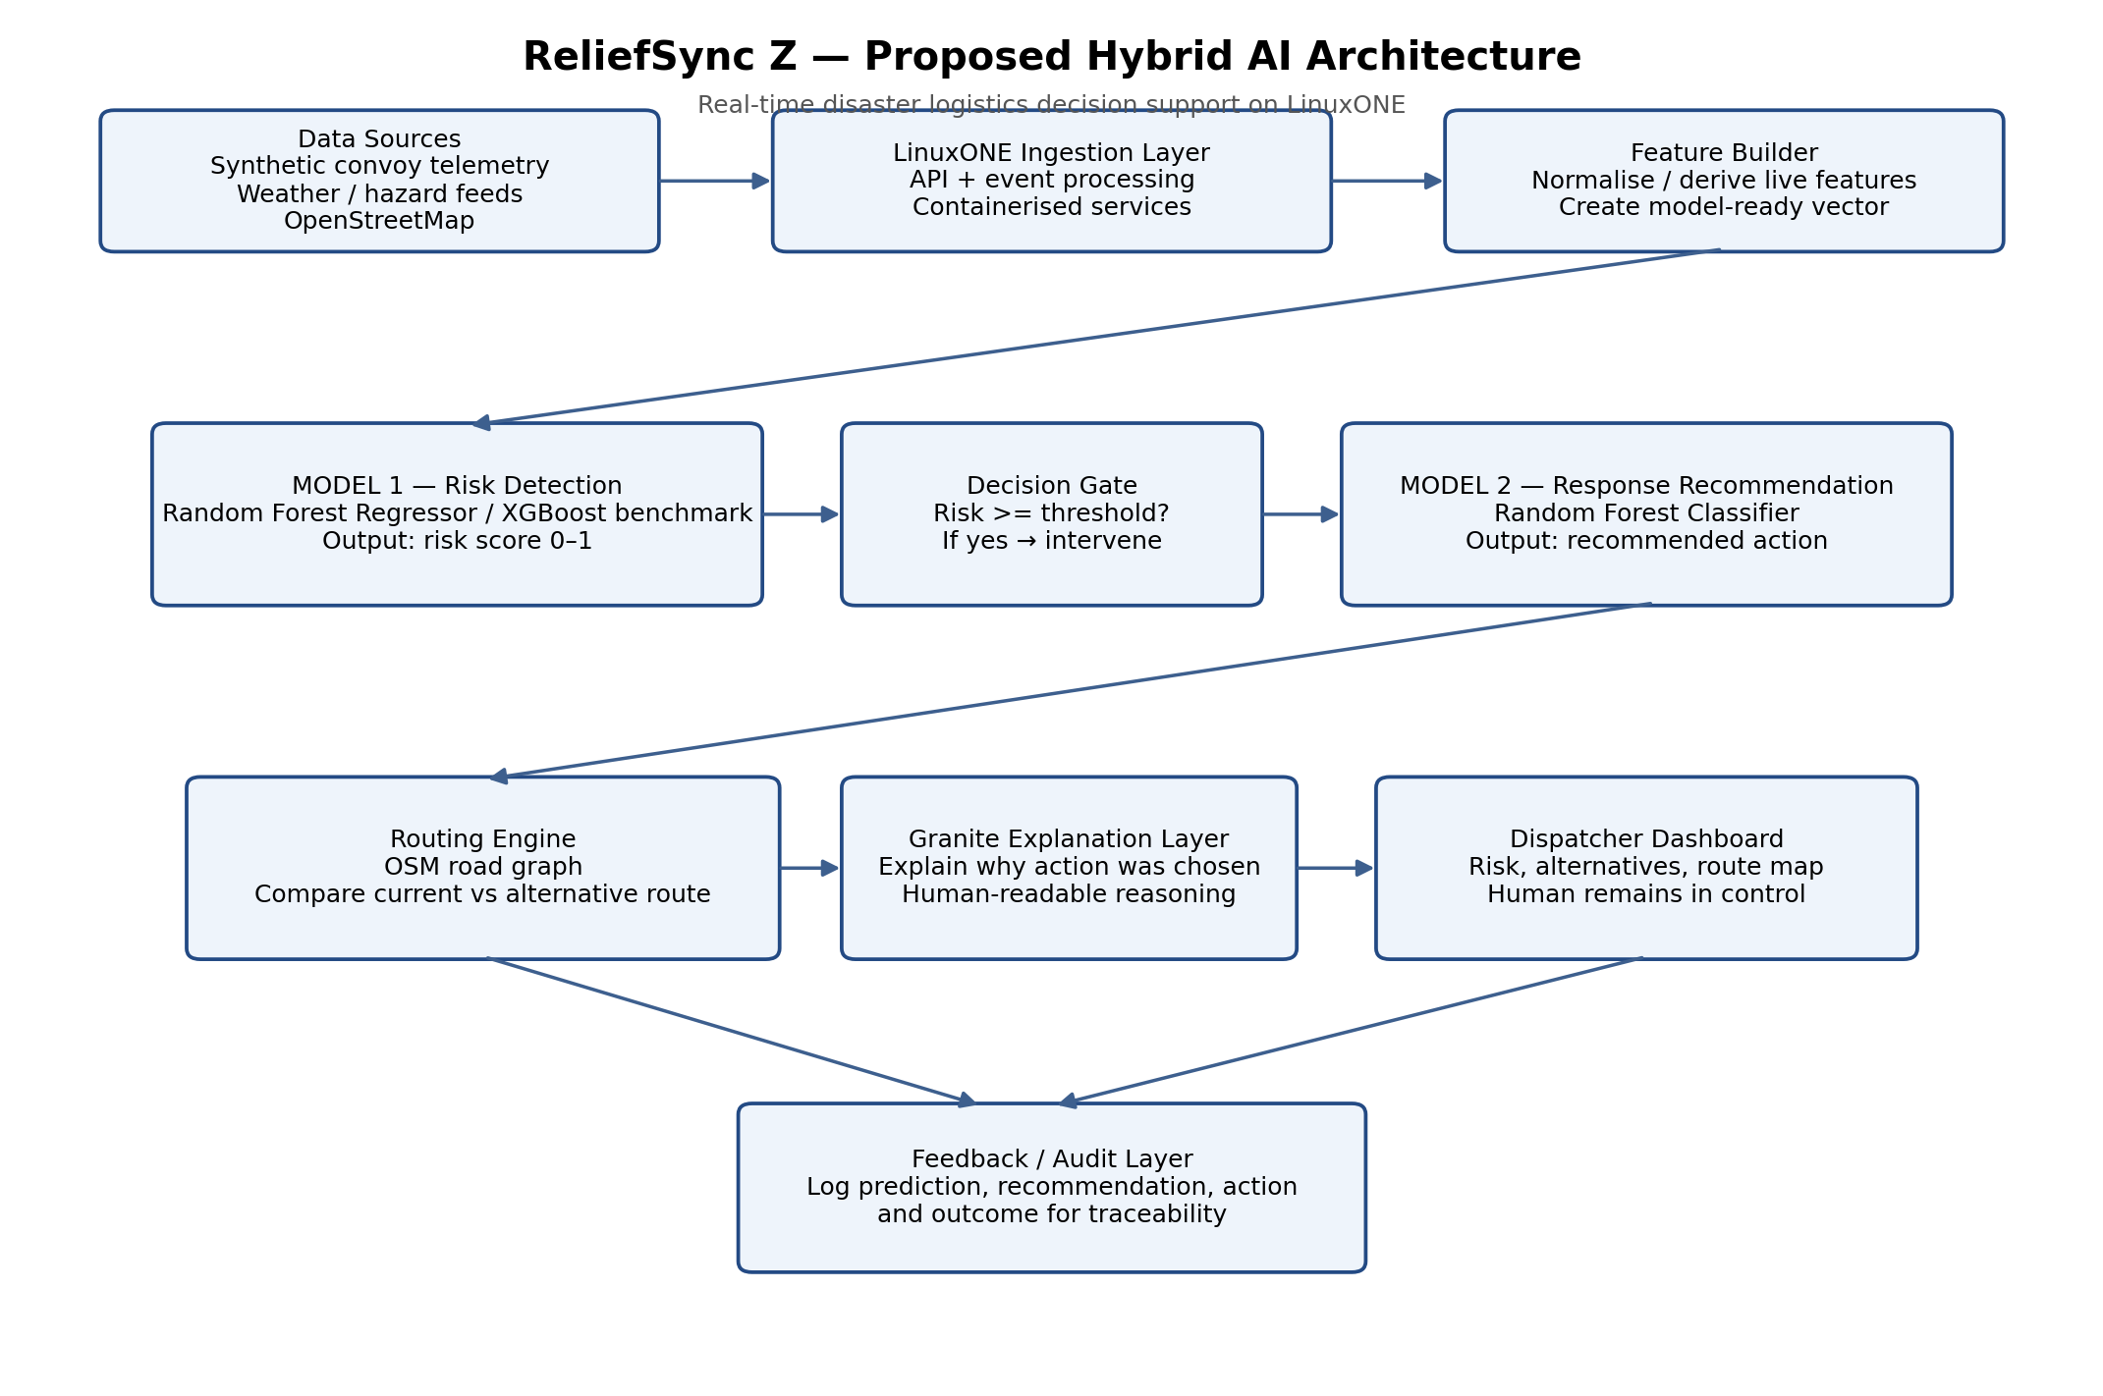
Figure 1. Proposed ReliefSync Z hybrid-AI architecture.
4. Data Sources
Data source | What it provides | How ReliefSync Z uses it
Synthetic convoy telemetry | Truck ID, GPS position, speed, fuel, cargo type, cargo priority, timestamps | Creates the continuous stream of moving relief vehicles required for the live demo.
Weather and hazard feeds | Rainfall, wind, weather alerts, flood indicators, regional hazard context | Provides real-world environmental context for Model 1 risk estimation.
OpenStreetMap road network | Road nodes, road links, intersections, route graph | Provides the graph used by the routing component to calculate alternative routes.
Synthetic labelled training scenarios | Model-ready rows with hazard, route and vehicle features plus synthetic targets | Allows both ML models to be trained when labelled humanitarian convoy data is unavailable.
Important implementation principle: OpenStreetMap supplies road-network data; a routing algorithm or routing library computes the alternate route. OSM itself is not the ML model.
5. Model 1 — Real-Time Route Risk Estimation
Question answered by Model 1
How risky is the convoy’s current route under the present vehicle, weather, flood, congestion and road conditions?

Model type
Primary choice: Random Forest Regressor, because the desired output is a continuous risk score from 0 to 1. XGBoost can be trained as a second benchmark to satisfy the judging emphasis on multiple open-source AI frameworks and to compare performance.
Model 1 features
Feature | Type / range | Meaning
speed_kmh | continuous | Current vehicle speed. Sudden low speed may reflect congestion or hazard response.
fuel_level_pct | 0–100 | Operational ability to continue or detour.
rainfall_mm_per_hr | continuous | Current rainfall intensity.
wind_speed_kmh | continuous | Severe-weather intensity.
flood_risk | 0–1 | Synthetic or API-derived flood exposure indicator.
traffic_congestion | 0–1 | Current route congestion level.
distance_to_hazard_km | continuous | How close the convoy is to the nearest identified hazard.
route_delay_minutes | continuous | Existing route degradation/delay.
road_closure_nearby | 0/1 | Whether a nearby closure is present.
Model 1 target and output
Target during training: risk_score, a continuous synthetic score in the range 0–1 generated from domain-informed relationships among hazards, congestion, route delay and road closures, with added stochastic noise.
Operational output: a number such as 0.87. This is interpreted as a high-risk route state within the prototype’s 0–1 risk scale.
The model does not decide the action. It only estimates risk.
Intervention threshold
The prototype may use an operational threshold such as 0.75 to decide when Model 2 should be invoked. The threshold is not claimed as a universal scientific standard. In a production system, it would be calibrated against real historical outcomes and the operational cost of missed hazards versus unnecessary diversions.
Model 1 evaluation
Because Model 1 is a regression model in the revised design, appropriate metrics include MAE, RMSE and R². A simple baseline or second classifier can still be retained for comparison if the team wants to discuss disruption/no-disruption classification.
6. Model 2 — Operational Response Recommendation
Question answered by Model 2
Given the current risk and the available operational alternatives, what should the convoy do next?

Model type
Random Forest Classifier. This is a multiclass classification problem because the output is one of several discrete operational responses.
Model 2 features
Feature | Type / example | Purpose
disruption_type | FLOOD / SEVERE_WEATHER / ROAD_CLOSURE / TRAFFIC_INCIDENT | Describes the type of operational disruption.
disruption_severity | 0–1 | Severity of the current event.
current_route_risk | 0–1 | Risk score produced by Model 1.
alternative_route_available | 0/1 | Whether a viable alternative route exists.
alternative_route_risk | 0–1 | Estimated risk of the alternative route.
extra_detour_minutes | continuous | Time cost of taking the alternative route.
fuel_level_pct | 0–100 | Whether the convoy can safely take a longer route.
cargo_priority | 1–5 | Urgency of the cargo, from low to critical.
estimated_hazard_duration_min | continuous | Expected duration of the hazard or blockage.
backup_hub_available | 0/1 | Whether a safe diversion hub is available.
Model 2 target / output classes
- CONTINUE_MONITORING
- HOLD_POSITION
- REROUTE
- DIVERT_TO_BACKUP_HUB
Example: if current route risk is 0.87, an alternative route exists with risk 0.18, the detour adds only 22 minutes, fuel is sufficient, and the cargo is critical, Model 2 should learn to recommend REROUTE.
7. Routing and Decision Layer
When Model 2 recommends REROUTE, the routing engine uses the OpenStreetMap road graph to compute a feasible alternate path. The system should compare the current route and candidate route in terms of risk and travel-time cost.
Option | Example output
Continue | Risk 0.87; no additional delay
Hold | Risk reduced after waiting, but +45 minutes
Reroute | Risk 0.21; +18 minutes
Divert to hub | Risk 0.14; +52 minutes
This comparison is intentionally visible to the dispatcher so the recommendation is not presented as an unexplained black-box command.
8. Granite Explanation Layer
To match the hybrid-AI judging criterion, Granite is used as a reasoning/explanation layer after the structured models have already made their predictions. It should receive structured outputs such as risk, contributing hazards, available routes and the selected action, then produce a concise human-readable explanation.
Example explanation
“Flood risk has increased sharply and the current route passes close to the hazard zone. A lower-risk alternative route is available with only a small increase in travel time. Because the convoy carries high-priority medical cargo, rerouting is recommended.”

Granite should not be allowed to override the safety model or independently invent a route. This separation makes the system easier to explain, audit and defend ethically.
9. Explainability and Ethical AI
The dashboard should explicitly show why a convoy was flagged and why an action was recommended. Human dispatchers remain in control.
- Display the current risk score and risk category.
- Display the most influential risk factors (for example flood risk, rainfall, road closure and hazard proximity).
- Show alternative actions and their predicted trade-offs.
- Show the Granite explanation separately from the numerical model output.
- Log the prediction, recommendation and operator action for traceability.
- State clearly that synthetic data is used for prototype training and that production deployment would require real operational validation.
10. LinuxONE / IBM Z Technical Design
LinuxONE should be central to the live demo, not an afterthought. The judging sheet specifically rewards live workload evidence, multiple open-source AI frameworks, containerised deployment, and use of platform capabilities.
- Run the backend API and live event-processing service on LinuxONE Community Cloud.
- Load and run Model 1 and Model 2 inference on LinuxONE.
- Use at least two open-source AI/ML frameworks meaningfully, for example scikit-learn Random Forest plus XGBoost benchmark or secondary model.
- Containerise the backend with Docker or Podman.
- Capture screenshots/video showing the containers, running processes, API calls and model inference on LinuxONE.
- If available and practical, demonstrate or discuss LinuxONE security / acceleration features without overstating what was actually implemented.
11. Backend API Contract
A simple implementation can expose one analysis endpoint so the web application does not need to understand the internal model details.
Example request fields: convoy telemetry + environmental context + route context. Example response:
Example API response
risk_score: 0.87
risk_level: HIGH
recommended_action: REROUTE
alternative_route_risk: 0.21
extra_detour_minutes: 18
explanation: “Rerouting is recommended because…”

12. Live Demo Scenario
- A relief convoy is travelling normally and the dashboard shows low route risk.
- A flash-flood or severe-weather event is injected or received from the hazard feed.
- The live feature vector updates immediately.
- Model 1 raises the route risk, for example from 0.18 to 0.86.
- The intervention threshold is crossed.
- The routing layer evaluates an alternative route.
- Model 2 recommends REROUTE.
- The system shows the new route risk, additional travel time and risk reduction.
- Granite explains the recommendation in plain language.
- The human dispatcher retains final control and can accept or reject the recommendation.
13. Quantified Demo Value
The prototype should display at least one measurable benefit rather than merely saying that the system “helps”.
Metric | Example
Current route risk | 0.86
Alternative route risk | 0.19
Relative risk reduction | 77.9%
Additional travel time | +18 minutes
Cargo priority | Critical medical supplies
These are simulation outputs for the prototype and should be labelled as such.
14. Judging-Criteria Alignment
Category | How the revised project addresses it
Technical Design | Live LinuxONE workloads, containerised services, structured ML, multiple open-source frameworks, visible deployment evidence.
Novelty & Originality | Hybrid AI: structured predictive models + route optimisation + Granite explanation, built end-to-end during the event.
Pitch & Delivery | A short, interactive demonstration in which a hazard appears, risk rises, rerouting is recommended, and reasoning is shown.
Community Value | Specific humanitarian logistics users; clear AI-for-Good framing; quantifiable risk reduction; human-in-the-loop and transparent reasoning.
15. Minimum Viable Product vs Stretch Goals
MVP — must work | Stretch — only if MVP is stable
Synthetic live convoy stream | Multiple simultaneous convoys
Weather/hazard values | Fully live external feeds
Model 1 risk score | XGBoost comparison and model selection
Model 2 response classification | More sophisticated action scoring
One reroute scenario | Several hazard types
LinuxONE-hosted backend | Advanced security / acceleration demonstrations
Dashboard with risk + action | Feature-attribution visualisation
Granite explanation | Feedback learning from operator outcomes
16. Final Project Definition
Final definition
ReliefSync Z is a LinuxONE-hosted hybrid-AI decision-support platform for disaster logistics. It combines live convoy telemetry, weather and hazard context, a real-time route-risk model, a response-recommendation model, road-network rerouting and Granite-based explanation so humanitarian dispatchers can react to dangerous route changes quickly, transparently and with measurable risk reduction.

