**Wiener Moderne - Kaffeehauskultur (the social networks of the fin de siècle)**

**Project Documentation**

**What physical or conceptual objects (node types, tables) are you working with?**

We are working with a graph database (specifically Neo4J).   
Our database will consist of nodes which are:

* Kaffeehaus
* Person
* Work
* Association

**What kind of properties (columns) do those objects have?**

The first property for “Kaffeehaus” is the identifier, which stands for their name, nickname or their colloquial calling – the identifier does not necessarily correspond to the official name of the respective Kaffeehaus, instead it functions as a short or more practical denominator. The second property is the address. Another property is “alias”, which accounts for name changes over time of a given Kaffeehaus. In some instances one Kaffeehaus also underwent several name changes, in which case we opted for a separate column for each name change.

The “Person” node contains all types of persons who frequented the Kaffeehäuser. Their properties are “name”, “born”, “died”, “profession”, and “alias”. All the properties except “name” are optional. In case of unretrievable dates, we would leave “born” and/or “died” properties blank. For partly unretrievable dates we also added the properties “born_original” and “died_original”, containing the approximate data. “Alias” is also an optional property in case of an existing pen name for a particular artist.

The “Work” node’s properties are “title” and “date”. “Work” could refer to different kinds of creations which might be of artistic, academical or journalistic quality. The date is non-essential. If we wanted to import the database in for instance SQL, we would add NA-values instead of leaving the unknown dates blank.

The “Association” node has the properties “identifier” and “type”. Identifier property functions in the same way as the identifier for a Kaffeehaus. The type specifies its category. It groups different kinds of institutions, artistic collectives, journals, work places, and academic circles as an entity for more tightly knitted groupings of people. The decision for the separation between “Association” and “Kaffeehaus” stems from the distinction between publicly accessible places and those which are reserved for their specific members (for example academics or journalists).

**What relationships do those objects have with each other?  If you're working with a graph: in what direction do these relationships flow?**

FREQUENTED (between a Person and a Kaffeehaus) denotes a person’s habitual presence at a given Kaffeehaus.

CONTRIBUTED_TO (between a Person and a Work) defines a unique cognitive achievement of one or more Persons. We will only consider achievements that have concrete physical properties and are passed down. The type of the contribution can be further specified.

REFERENCES (between a Work and either a Kaffeehaus, a Person or an Association) denotes an allusion or connection to a specific other entity in the network. The property “note” can denote the specific kind of reference, its connotation and potentially the section holding the reference.

ASSOCIATED_WITH (between a Person and an Association) defines the connection of a Person with a specific Association. The property “function” defines the role the person played in the Association.

AFFILIATED (between a Person and another Person) stands for an intimate connection or one of kinship.

As the current plan for this project is to not convert the final database into a linked open data format, we decided to keep the current properties of the relationships and not set them as different nodes.

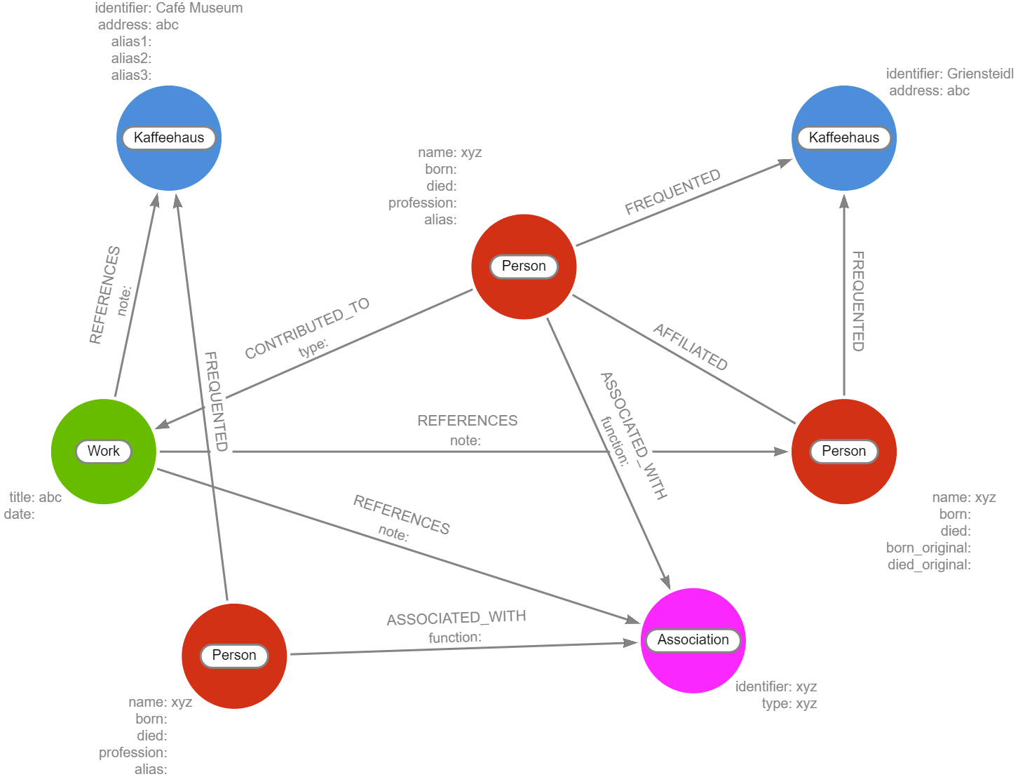

**What decisions are you making in your modelling?**

What are you including and how will you use it?   
What are you simplifying, or excluding, from your source material?

Even though there might be other relevant hotspots, our main focus will be on the Kaffeehäuser around the Fin de Siècle. However, some of the other hotspots will still be included as Associations to make sure their connections to and impacts on the Kaffeehäuser do not get lost. Mainly we want to use (digital) monographies and secondary readings about this period. The collected data will be made available on a website with an interactive map where entries will be collected in groupings and intersections of people and places. This might be of interest for the general population/tourists in terms of displaying certain networks. Our functional model will be available on the website to get further insight in the interconnected web to enhance the presentation. The website might also be of interest for an academic audience in terms of providing a new, more connected representation of data, which is already available as plain text.

What decisions do you think you will have to make, that you haven't made yet, about the model?

At first, we will have to decide which sources we want to use, since we cannot cover all of the available information. Therefore, we might choose only some significant persons of interest. Furthermore, our collection of works is – as it stands right now – not very exhaustive, given the fact that a lot of the texts in question are not available in digital format and therefore would require a lot more time and resources to search them for relevant data. Our approach of also including institutions turned out to be not as fruitful as expected, mainly because their references were for the most part scant and selective.

**Preliminary structure of the graph database:**

MERGE (n6:Person {name: "xyz", born: "", died: "", profession: "", alias: ""})-[:FREQUENTED]->(:Kaffeehaus {identifier: "Café Museum", address: "abc", alias1: "", alias2: "", alias3: ""})<-[:REFERENCES {note: ""}]-(n4:Work {title: "abc", date: ""})<-[:CONTRIBUTED_TO {type: ""}]-(n2:Person {name: "xyz", born: "", died: "", profession: "", alias: ""})-[:FREQUENTED]->(:Kaffeehaus {identifier: "Griensteidl", address: "abc"})<-[:FREQUENTED]-(n3:Person {name: "xyz", born: "", died: "", born_original: "", died_original: ""})<-[:REFERENCES {note: ""}]-(n4)-[:REFERENCES {note: ""}]->(n5:Association {identifier: "xyz", type: "xyz"})

MERGE (n3)<-[:AFFILIATED]-(n2)-[:ASSOCIATED_WITH {function: ""}]->(n5)<-[:ASSOCIATED_WITH {function: ""}]-(n6)