REPORT

Design Specification

• Clearly defines the design problem.

In this modern days, where technology is affecting the world, even in the automotive sector where every modern cars were equipped with technology such as cruise control, Engine Control Unit, Sensors but there is still an increase of automotive theft happening everyday. Majority of cars and bikes were equipped with front and rear dash cam, alarm system but there is lots of car/bikes theft where people know how to disarm the vehicle’s main alarm.

• Clearly articulates the proposed design solution.

Our Solution to the problem is to have a Pressure sensor with separate alarm system installed in motorcycle or car seat.

The pressure sensor will be located in the seats which will trigger the alarm when the sensor sense a certain amount of weight in the car/bike seats when the main alarm system or immobilizer is engage.

• Clearly specifies design requirements.

The design of this system required a spring loaded sensor which will triggered only when a certain pressure is loaded on the sensor. The standard weight to trigger the system is 30kg.

There will be a relay which will connect to the sensor and to our vehicle’s immobilizer or the alarm system so when the immobilizer is switch on, the sensor will go live. In order to disengage the sensor is to put the key into the ignition. The system have additional wiring which is made specially for cars that is connected to their existing car alarm system. Whenever the alarm system is disengage, the sensor will automatically disengage. The system is built in such a way to prevent people from seating on the seats while the vehicle is in parking mode and to attract bystanders attention when such happens.

• Concisely outlines the proposed technologies that will be used to develop the prototype or application.

The technologies used will be an pressure sensor which is invented and created by us. It is then connected to the vehicle battery source and attached to a relay which act as a switch that trigger the other components such as alarm.

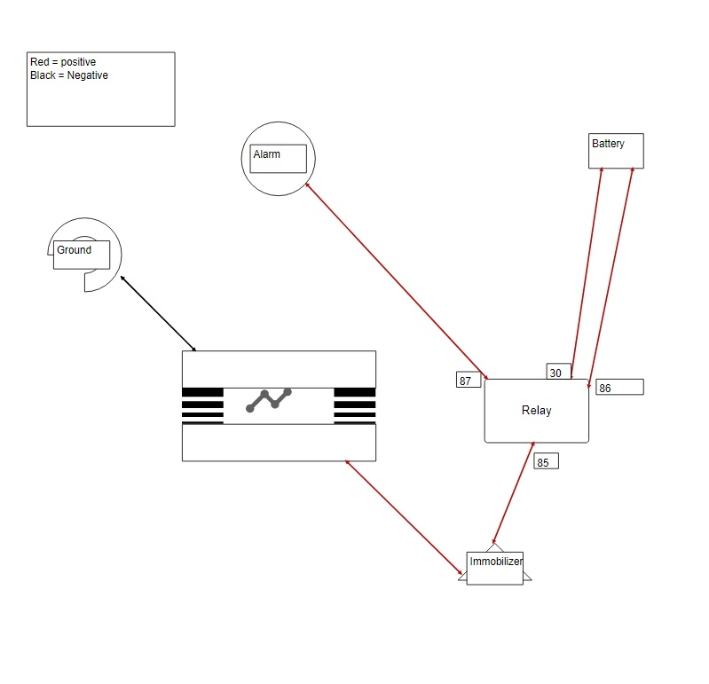

• Professionally presented and formatted digital report. PDF