Laboratory for Maritime Transport

**Optimization of small autonomous vessels' functionality**

Ports and intermodal transport

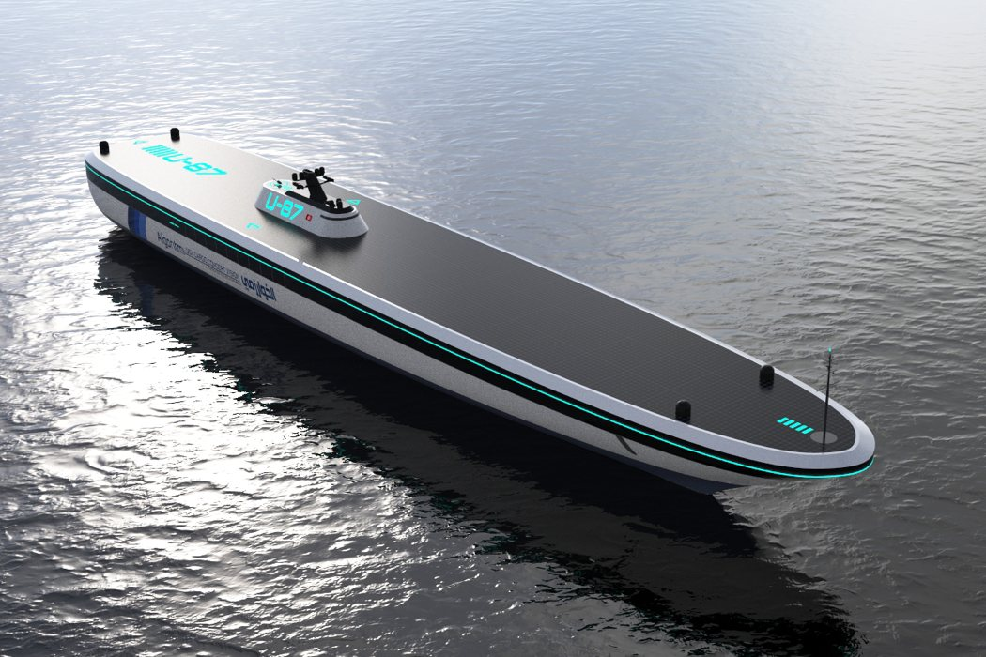

**Authors:**

Dimitris Tsoumpelis, N.A.M.E (NTUA)

Nikolaos Kougiatsos, N.A.M.E (NTUA)

**June 2019**

**ABSTRACT**

# **Optimization of small autonomous vessels' functionality: The case of autonomous rescue boats**

**Nikolaos Kougiatsos and Dimitris Tsoumpelis**

**School of Naval Architecture and Marine Engineering**

**National Technical University of Athens, Greece**

In this paper, proceedings of small autonomous vessels integration in today’s maritime industry are discussed. Not to be omitted, the role of modern ports is of huge importance on that matter and will be presented thoroughly in the following paragraphs. In this era of automation and big data, sea operations with conventional ships are beginning to look a bit obsolete and without any future prospects. This could not apply more to rescue vessels where the minimization of operational errors is crucial in preventing human losses at sea. Thus, one algorithm of path planning will be presented addressing the huge delays that the human factor imposes in today’s sea rescue missions.

**INTRODUCTION**

In the last 10-15 years, engineers found themselves with a huge pile of available resources, computational tools and operational data from existing structures. This situation slowly started to pave the way for automation and operation optimization in all sectors and especially in the field of manufacturing, the automotive industry and robotics.

The maritime sector is nowadays also finding itself confused with the integration of autonomous vessels as well as ROV’s and AUV’S in sea operations. Two of the biggest companies involved in this matter are Kongsberg Maritime and Rolls Royce, both trying to bring forth the era of all-autonomous ships. In particular, Kongsberg’s new breakthrough Yara Birkeland is destined to be the world’s first fully-electric and fully automated containership, thus having a huge impact on the future of maritime industry.

It is needless to say that with all these big changes coming in the following years, ports will also have to change both their operation and their resources, in order to be able to accommodate the needs of tomorrow’s vessels. UK ports have already begun to grasp the matter and are currently reviewing their options so as to remain competitive. Aside from the port’s personal gain and competitiveness, it is now more urgent than ever to review the intermodal trading routes role as a whole and how the world would benefit from all-autonomous transportation of goods. Therefore the challenges arising will have to be addressed by the transportation systems as a whole with the port at their core, as maritime transport is nowadays the key to people’s and industries’ collaboration in exchanging goods and services.

**What is autonomy?**

Autonomous vessels have been present at sea operations already for the last seven years. In all this time, the industry has come a long way, specifically in achieving autonomy on even bigger ship lengths. Nevertheless, the progress of today’s technology made sure of that, as more and more companies enter the banquet leading in a rise of competition to ensure dominance. When speaking about autonomous vessels, one must first define the level of attained autonomy. In this regard, multiple organizations nowadays try to define both the number and the context of those levels.

According to IMO [18], there is a total of four degrees of attained autonomy:

* Degree one: Ship with automated processes and decision support: Seafarers are on board to operate and control shipboard systems and functions. Some operations may be automated and at times be unsupervised but with seafarers on board ready to take control.
* Degree two: Remotely controlled ship with seafarers on board: The ship is controlled and operated from another location. Seafarers are available on board to take control and to operate the shipboard systems and functions.
* Degree three: Remotely controlled ship without seafarers on board: The ship is controlled and operated from another location. There are no seafarers on board.
* Degree four: Fully autonomous ship: The operating system of the ship is able to make decisions and determine actions by itself.

On the other side, Lloyd’s Register defines six degrees of ship autonomy [19]:

* AL0 (**No access**)
* AL1 **(Manual access)**
* AL2 (**Cyber access for autonomous/remote monitoring**)
* AL3 (**Cyber access for autonomous/remote monitoring and control, onboard permission is required, onboard override is possible**)
* AL4 (**Cyber access for autonomous/remote monitoring and control, onboard permission is not required, onboard override is possible**)
* AL5 (**Cyber access for autonomous/remote monitoring and control (onboard permission is not required, onboard override is not possible**)

However vast and complex these definitions seem, there are two main levels of autonomy that the maritime industry is now working towards: remote control and full-autonomy.

Ships belonging in the first category, are designed with inbuilt cameras and sensors receiving human orders from shore or another point of control and providing haptic feedback from the field of operation. Thus the human factor still remains partially in the process. This solution is seen as an intermediary stage to full autonomy and a lot of companies have started pouring their resources to develop both remote control stations and remotely operated vessels. Specific examples are discussed in the next paragraph.

On the contrary, ships of the second category also have control systems designed, able to process the sensor feedback on their own and determine an appropriate course of action. As a result, many theorize it as the final stage of autonomy implementation in the maritime sector.

Both categories, have their notable drawbacks. Remotely operated vessels have slower response time and still rely in a certain regard on the human factor. On the other hand, the existing technology cannot yet provide credible full autonomous solutions.

As seen in figure 1, the maritime industry’s goals up to 2050 start with projects using remote operation. Full autonomy is expected to arrive gradually as materials become cheaper, control systems get more widely implemented, classifications societies and IMO start including rules for autonomous ships and as the infrastructures adapt to the new needs.

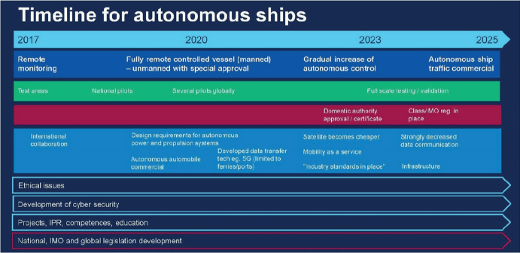

Fig.10 Autonomous shipping timeline [One Sea’s eight-year roadmap]

**BREAKTHROUTHS IN AUTONOMOUS SHIPPING**

In 2016, the American company Vigor Industrial made a move on the market by releasing Sea Hunter, a 40 m long trimaran powered by 2 Diesel Engines capable of self-piloting reaching a maximum speed of 27 knots.

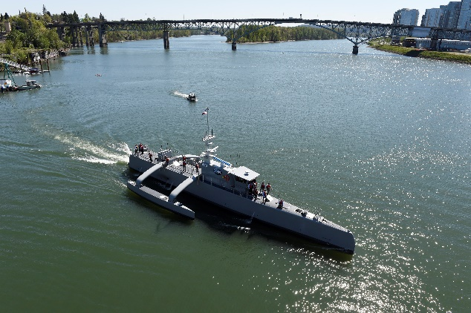

Fig.1 Vigor Industrial’s Sea Hunter (2016)

Then, in the first semester of 2018 a British company named L3 ASV released its own autonomous solution under the name of C-Worker 7. The vessel is 7.2 m long, powered by 2 Diesel engines as well and its main purpose is positioning, surveying and environmental monitoring without the need of a ship on station or sea-bed anchoring. It can eventually reach the speed of 6.5 knots.

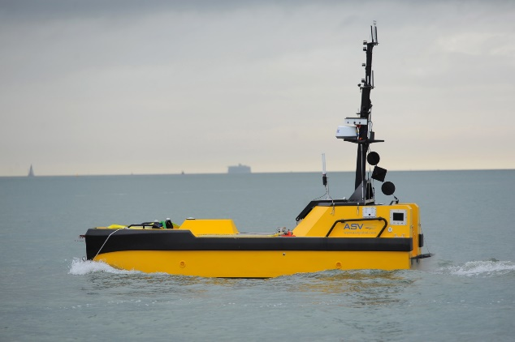

Fig.2 L3 ASV’s C-Worker 7 (2016)

In the case of autonomous tugboats, Rotortug developed RT Borkum. The vessel has the ability of remote operation from on shore stations as well as the ability to autonomously connect the towline, an indispensable feature regarding the ship’s type. RT Borkum remote control feature has already been tested in the International Tug, Salvage & OSV Convention and Exhibition (ITS) ITS in Marseille, while the vessel was sailing in Rotterdam.

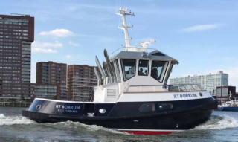

Fig.3 Rotortug’s RT Borkum (2017)

Going further, nowadays there are 3 major companies trying to overtake the market: Rolls Royce, Kongsberg and Port-Liner.

Rolls Royce started thinking ahead since 2016. One of its more promising and expected projects is the Future Shore Control Center, a solution which will eventually enable the remote control of ships from shore without the need for an active crew onboard. In 2018, the company started to discuss a possible partnership with Intel in order to produce the next generation of autonomous vessels.

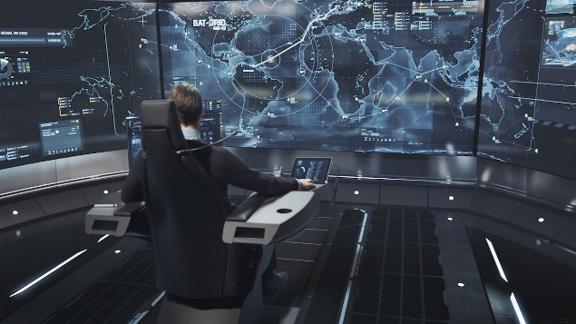

Fig.4 Rolls Royce Shore Control Centre

Kongsberg maritime has also come a long way in the recent years. The Norwegian giant started gathering expertise making ROV’s and AUV’s since 2007. The company entered into a partnership with UK’s Automated Ships Ltd in 2017 to develop Hrönn, an offshore utility autonomous ship. The ship will be working for some time through remote-control and will eventually pass in the full-autonomy specter. Future possible uses of Hrönn include sea survey, firefighting assistance and light intermodal cargo delivery/ delivery to offshore installations. Hrönn started operating in 2018.

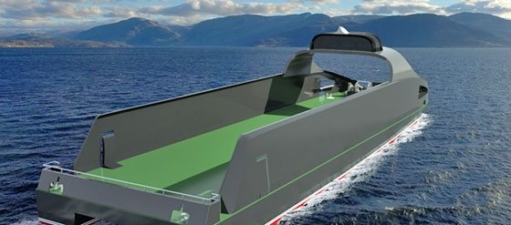

Fig.5 Kongsberg Hrönn Project (2018)

RALamander 2000 is also one of Kongsberg’s major future projects, featuring design by Robert Allan LTD., an American company with massive expertise on fireboat design. The vessel will be used for port safety operations in case of a fire breakout. Remote control of those ships will ensure the safety of port personnel, who will then be able to offer better assistance in manning tugs for search and rescue operations. The vessel’s release date is yet unknown.

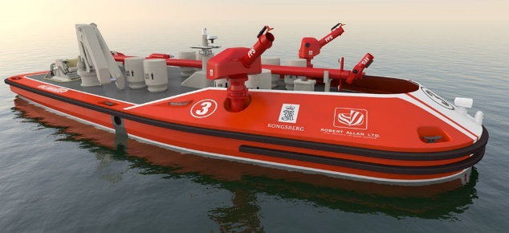

Fig.6 Kongsberg RALamander 2000 Project (2020)

Inspired by the revolution of batteries technology derived from Ellon Musk’s Tesla’s huge success, the Dutch company Port-Liner is currently building two large all-electric barges. Namely, Tesla ships are expected to make a huge impact on inter-European sea transports. In the first stage, the ports of Amsterdam, Antwerp, and Rotterdam are going to welcome Tesla ships in the cycle of their operations as of fall 2019. The company has also prepared a battery pack system solution that enables retrofitting to other existing barges.

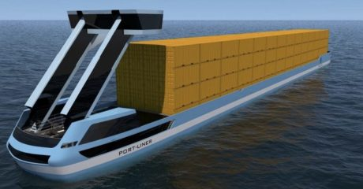

Fig.7 Port-Liner Tesla ships Project (2019)

Last but not least, autonomy is also beginning to reach vessels for search and rescue missions. Sea Machines SM300 control system kit allows retrofitting to existing survey vessels, patrol boats, ferries and other small boats rendering them autonomous. Subsystems present introduce features such as obstacle and traffic avoidance, real time data logging, satellite communication, 4G, pilot-by-wire propulsion and steering control, modern user interface etc. SM300 is already in progress of being used in Hike Metal’s vessels, an American workboats manufacturer. Sea trials will eventually begin this summer on Lake Erie.

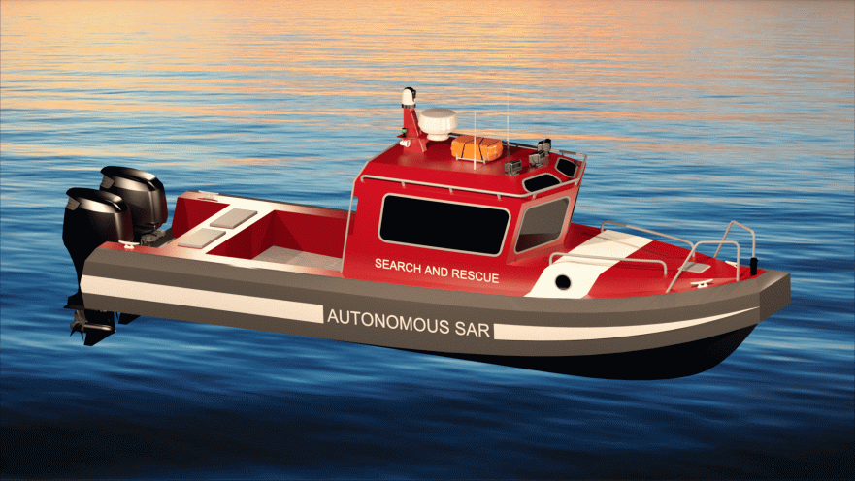

Fig.8 Hike Metal’s Search and Rescue Vessels to be used with SM300 (2019)

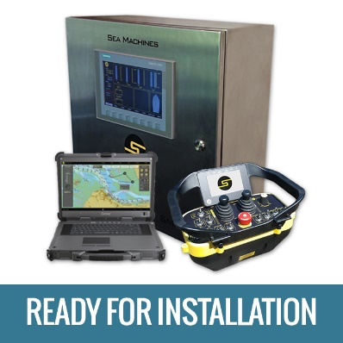

Fig.9 Sea Machines SM300 kit

**RESCUE VESSELS TECHNOLOGY & RESCUE EQUIPMENT**

Human safety on sea has undoubtedly turned for the better in the last fifteen years. The experience of severe accidents nearly in all ship types which took severe tolls on human life led the entire world to reconsider the safety measures applied to the entirety of sea vessels. Risk assessment theory has also greatly contributed in monitoring the situation and in the application of mathematical tools to solve the arising problems. Moreover, the adoption and review of SOLAS convention by the IMO in 1974, set without a doubt a solid minimum of safety measures and procedures, forcing into compliance each and every vessel’s crew.

We can distinguish two types of rescue craft, the ones readily available on ship and the ones coming from port and other shore locations. The advantage of the first type is their presence on site. Although, in many cases, due to systems’ malfunction, the possibility of slow crew response time and inadequate service, these boats fail to launch with grave repercussions. On the other hand, crafts coming from shore are most punctual on service and have almost no launch issues. In this case, the problems lie on slow response time due to human factor and the distance that must be covered to reach the wreck and also on the fact that their presence on site heavily relies on current sea conditions.

According to SOLAS, each passenger ship is obliged to have life boats on each side with available capacity no less than 37.5% of the people onboard (crew+passengers) on international sails. Plus, life rafts must be available for at least 50% of people onboard, each serviceable by at least one davit.

When a passenger vessel is used in national sails or in short international sails, the above boundaries can be modified as follows: 30% of life boats available capacity on each side and 75% life rafts for the remaining passengers.

In most cases, today’s rescue crafts are following the closed on top design as seen in the following figure 9. Although, if the climate conditions allow for it, open designs can also be used. Whilst on rescue, a person must be both on the ship in emergency and on each rescue craft, having taken into consideration that not every person onboard is a sailor or knows how to react.

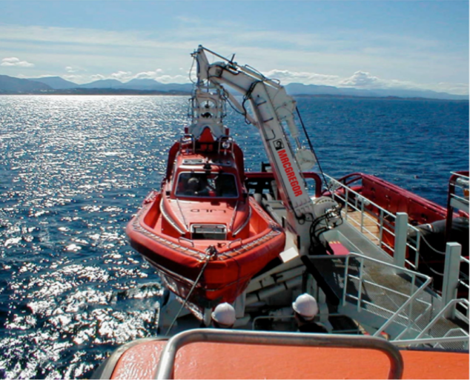

Fig.11 Man overboard rescue craft and davit [McGreggor]

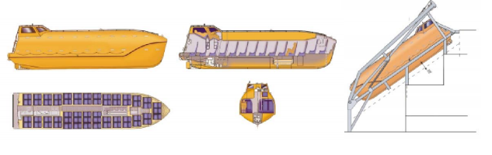

Fig.12 On-ship rescue craft and launch mechanism [5]

Search and Rescue Transponders are Radar based emergency transmitter attached to life rafts or life jackets. According to [15], the transponder emits a radio distress signal on nearby vessels, in the form of a series of 12 dots pointing to the victim’s location. Sensors available on these devices include: radar, gps. Part of their features is a standard of waterproof ability up to 10 m sea depth and their compact design. Up to this point in time, SARTs must be manually activated by a human in order to emit the distress signal.

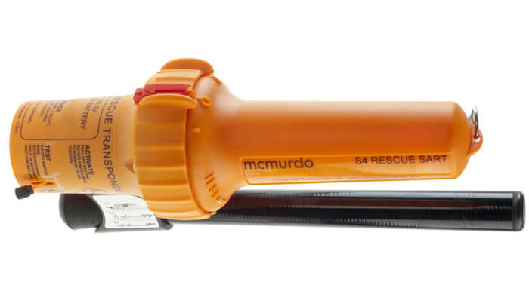

Fig.13 Search and Rescue Transponder (SART) [15]

Life jackets are of absolute importance on sea rescues. According to SOLAS, all life preserving equipment including life jackets must have reflective tape for easy recognition by incoming rescue crafts. Protective and thermal insulation suits must also be available on a number determined by other parameters to cover for the possibility of accidents occurring in cold weather conditions.

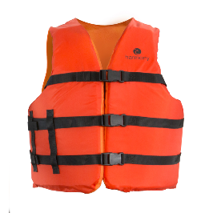

Fig.14 Modern Life jacket

Rescue cradles consist an absolute necessity for modern rescue crafts. Due to their form, they can be used to retrieve unconscious people in a certain radius from the rescue boat’s side. Autonomous ships can also make use of these cradles by automating ballistics using sensor and camera data to calculate the distance from target, assess the sea state and make precise movements to save the person in danger.

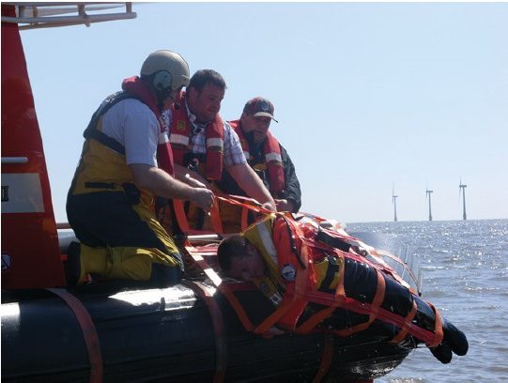

Fig.15 Rescue cradle system [13]

Control systems can also give a push to improving rescue missions. The thruster system shown in figure 14 can be used to dynamically position the rescue vessel, thus providing steadiness throughout the whole operation. As there is no propeller, people in danger cannot sustain injuries and the thruster system can be coordinated to accurately pinpoint a selected course.

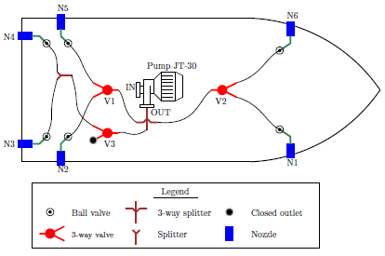

Fig.16 Dynamic Positioning using Thrusters [14]

**PATH PLANNING FOR RESCUE MISSIONS**

Path planning algorithms have been around for ages. Most of them are applied in daily basis for land transport by location providers such as Google (GMaps). The main advantage of using a specific path planning algorithm versus a Monte Carlo simulation is the time needed both for computation and application.

**PROBLEM FORMULATION**

Let’s suppose a wreck case nearby a port. We define “nearby” as in a maximum distance of 8 n.m. The coordinates of the wreck are set to (0, 0), although any other coordinate system can be used as well. Positive x coordinates are on the right half plane and positive y coordinates lie on the upward half plane. The port’s (P) coordinates (x, y) can then be written in reference to the wreck point (W). Let’s also suppose a known number of people in danger, whose locations are given by the equipped transponder module. However, in order to apply the algorithm for already occurred disasters, normally distributed points in a radius of 500 m are used.

The search and rescue vessels considered in this paper consist of Norsafe’s Maya 850 and Matrix 450 as well as Fast Rescue Craft’s FRC 1204. Though not autonomous by factory, autonomy can be achieved in these ships with the use of retrofitting solutions such as the SM300 mentioned above. The vessels’ main dimensions and properties are given in the following table.

Having read the problem setup as it is described above, one can think of three major optimization problems arising, each connected with the others.

1. Given a set of points (people in danger), a specific amount of each ship available on port and a rescue sequence, meaning the order of the ships deployment, what is the optimum route that must be followed to save as many people as possible?
2. Given a set of points (people in danger), a route connecting through all points and a deployment sequence, what is the optimum distribution of ships on-demand so as to save as many people as possible?
3. Given a set of points (people in danger), a specific ships distribution and a path connecting all points, what is the optimum deployment sequence so as to save as many people as possible?

It is obvious that the truly globally optimum solution lies in optimizing all these sub-problems at the same time. However, most times this task can be almost impossible as different people are entangled with each sub-task. For example, the type and amount of rescue vessels owned by port is mostly dependent on the techno economical study of the port finance office. At the same time, the optimum path and the deployment sequence concerns mostly the operators or the vessel itself if autonomous ships are in discussion.

This paper will mostly focus in the optimization of the first sub-problem. In addition, results regarding the second problem will also be discussed as the number of ships in each category is an integer random number in the interval [1,10].

As a matter of fact, the first optimization subproblem can be classified as a Travelling Salesman Problem (TSP) [21]:

“The goal is to find the shortest path for a salesperson that leaves a city, visits N other cities and goes back to the initial city, without repeating any city.”

Given that the time complexity of TSP is in general O(N!) with a brute force approach, it is logical to resort in other algorithms such as dynamic programming, heuristic algorithms or even genetic algorithms. Not all approaches provide the global optimum solution but all of them provide at least local optimum solutions.

After the final optimum path connecting all nodes (people at sea and port) has been determined by the algorithm, one can make use of the following theorem [17]:

**Theorem**  Given a weighted, directed graph G = (V, E) with weight function w : E → R, let p =< v1, v2, . . . , vk > be a shortest path from vertex v1 to vertex vk and, for any i and j such that 1 ≤ i ≤ j ≤ k, let pij =< vi, vi+1, . . . , vj > be the subpath of p from vertex vi to vertex vj. Then, pij is a shortest path from vi to vj. ▄

As a result, the vessels used can be ranked and get sent in the achieved ranking order to consecutive subpaths of the final path which are also optimal. The product of each vessel’s speed and capacity is used as the ranking variable. The lowest ranked ships are sent first on the path due to the closer distance to the port.

**ALGORITHM**

In order to apply the suggested path planning algorithms, Python was used as the programming language. The algorithms applied were mainly two: 2-Opt and a genetic algorithm.

2-Opt algorithm

2-Opt classifies as a heuristic algorithm. Though it can can not find the optimum solution, it is very good at providing a local optimal solution. The algorithm goes as follows:

1. Given a total of N points, construct the paths connecting all points. These paths in our case are random in each run as the point placement is also random.
2. Take four random points from the set and rank the distances from smallest to largest between each pair of points.
3. Delete the connection with the largest distance.
4. Continue with steps (3) and (4) until the total route (total distance of path that passes through all points) ceases to improve by one more iteration.

The main advantages of the algorithm is that it inherently rejects crossing paths and can provide a quick solution. However, the divergence of the solution from the global optimum is unknown. To tackle this problem, the algorithm must be used in conjunction with a genetic algorithm or against other similar algorithms like 3-Opt.

The reader can find all the code and input data used on the authors’ GitHub repo referenced on [8].

Genetic Algorithm

The genetic algorithm is also used to find close to optimal solutions and , as the name suggests, it is mimicking the way species evolve in order to adapt to their physical environment as good as possible. The general idea, for our problem of TSP, is that in each step we have a “generation”- a collection- of possible routes through the points. The generation in order each time to produce each member of the next one, uses the effective characteristics of two of its members . This procedure is called Cross Over. After the new member is created there is a process of altering, by a small amount, of its characteristics through a process called Mutation. This process ensures that a level of “gene” diversity is maintained. Following this procedure the next generation is created with equal amount of members as the previous one. Lastly, in order for this process to have a starting generation we create a first random one.

**CASE STUDIES**

Through the course of history, one can find a lot of accidents on passenger vessels that occurred near a port. This paper will examine one in particular, the Express Samina accident near Paros’s port in Greece (26/9/2000).

Express Samina

Express Samina was a RoPax ferry built in 1966 for Compagnie Générale Transatlantique. Along her life, she had many names: while in France the ship was known as Corse (1966-1982), from the moment she was sold to the Greek company Stability Maritime the name changed to Golden Vergina (1982-1999). Its final holder and the one who changed the name to Express Samina was Agapitos Bros Company (1999-2000). At this time, the vessel was operating in the route connecting Piraeus port with a handful of Greek islands of Aegean Sea, including Paros. As referenced by [10], when the ship was approaching Paros’s port she had a collision with the rocky islet Portes just 3 n.m outside the port. The vessel’s starboard’s stabilizer impact was the cause of the creation of an opening in the hull. As she continued to sail, water progressively started to flood the main engine room first and then all other buoyant spaces.

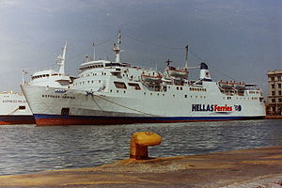

Fig.16 Express Samina in Piraeus

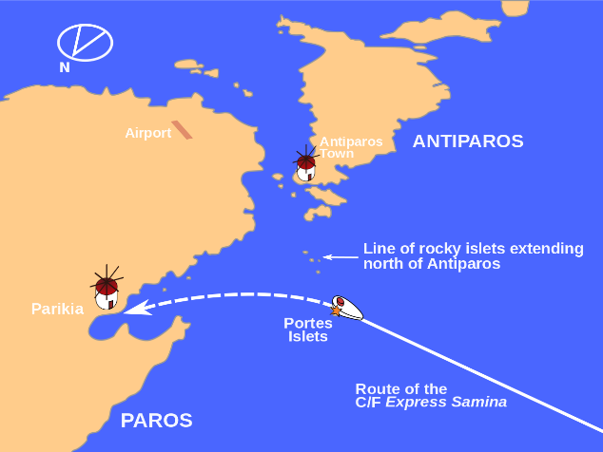

Fig.17 Express Samina wreck map location (Wikipedia)

The ship’s sinking lasted about half an hour. Of the 533 passengers and crewmembers, 80 people lost their lives that day. The sail’s conditions included an average speed of 18.5 knots and moderate weather conditions (5-6 Bf). According to Professor A. Papanikolaou and his team, the most probable scenario for the cause of sinking was that 9 out of 10 compartment watertight doors were left open and thus water could easily move from one compartment to another. In reality, only one of the doors was impossible to close due to the malfunction of its mechanism caused directly by the collision and the fin penetration. If all the other doors remained closed, the ship would most probably survive without any human loses.

The reader can find the complete analysis of the disaster and further conclusions at reference [10].

During sinking, only 3 out of 8 lifeboats were deployed.

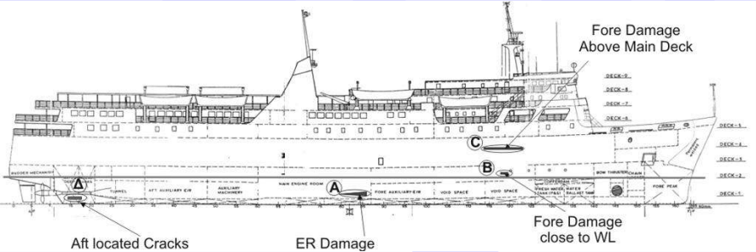

Fig.18 Express Samina damages [10]

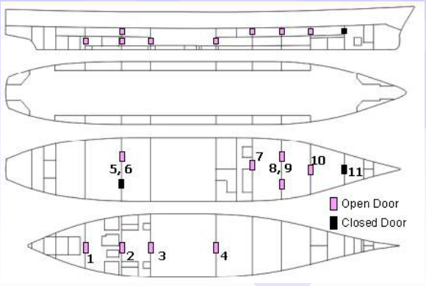

Fig.19 Express Samina compartment doors state during collision, flooding and sinking [10]

|  |  |  |
| --- | --- | --- |
| Express Samina Case Study | | |
| People on board | 533 | (A) |
| Total lifeboats | 8 | (B) |
| Dispatched lifeboats | 3 | (C) |
| Capacity (people) | 1500 | (D) |
| Lifeboats required capacity [6] | 900 | (E)=0.6*(D) |
| Lifeboat required capacity | 113 | (F)=(E)/(B) |
| People on lifeboats | 339 | (G)=(F)*(C) |
| People at sea | 194 | (H)=(A)-(G) |
| Lives lost | 80 |  |
| Port x [m] | 4611251.25 | [20] |
| Port y [m] | 2164911.79 | [20] |
| Wreck x [m] | 4613976.03 | [20] |
| Wreck y [m] | 2160695.14 | [20] |
| Port x (from wreck) [m] | -2,724.78 | port_x-wreck_x |
| Port y (from wreck) [m] | 4,216.65 | port_y-wreck_y |
| Weather | Warm [23 ‘C] | Microsoft Historical Data |

Table 1. Express Samina Case Study Input Data [16]

SS Admiral Nakhimov

SS Admiral Nakhimov was a German originated passenger vessel that was launched in 1925. The ship’s former name was SS Berlin until it was sold to the Soviet Union in 1949. It had a length of 174 m, a beam of 21.02 m and could carry a maximum of 1455 passengers.

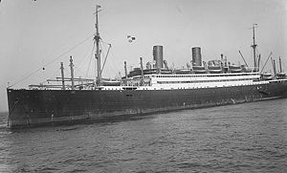

Fig.20 SS Admiral Nakhimov [11]

In 31 August 1986, the vessel collided with Pyotr Vasev, a Soviet Bulk carrier resulting in it sinking 8 miles outside the port of Novorossiysk and 2 miles from shore. At first, a power failure occurred as a result of the collision, thus leading to the use of the emergency generator. However, power was cut down again in just a few minutes causing terror to the passengers who could not in many cases find a route out of the sinking ship. Due to the fast pace of events, there was little to no time to launch the existing lifeboats and the majority of passengers dived into the water, trying to survive with the use of lifejackets, barrels and other solid objects.

The sinking took place in under seven minutes and sixty-four rescue ships were dispatched to the wreck location just 10 minutes after the event. Out of the total 1.234 passengers, 423 lives were lost. From those who survived, 836 were pulled from the water.

|  |  |  |
| --- | --- | --- |
| SS Admiral Nakhimov Case Study | | |
| People on board | 1234 | (A) |
| Total lifeboats | - | (B) |
| Dispatched lifeboats | 0 | (C) |
| Capacity (people) | 1455 | (D) |
| Lifeboats required capacity [6] | 873 | (E)=0.6*(D) |
| People on lifeboats | 0 |  |
| People at sea | 1234 | [16] |
| Lives lost | 423 | [16] |
| Port x [m] | 3585398.11 | [20] |
| Port y [m] | 2785546.98 | [20] |
| Wreck x [m] | 3590369.11 | [20] |
| Wreck y [m] | 2792650.65 | [20] |
| Port x (from wreck) [m] | -4,971 | port_x-wreck_x |
| Port y (from wreck) [m] | -7,103.67 | port_y-wreck_y |
| Weather | Warm [19-23 ‘C] | Microsoft Historical Data |

Table 2. SS Admiral Nakhimov Case Study Input Data [16]

**RESULTS**

**CONCLUSION**

**REFERENCES**

[1] Rolls Royce, *Autonomous ships: The next step*

[2] Forbes, Rolls Royce's Autonomous Ship Gives Us a peek into the future of sea transport

[3] Kongsberg Maritime, ROBERT ALLAN LTD. AND KONGSBERG MARITIME TO DEVELOP REMOTELY-OPERATED FIREBOATS FOR PORTS

[4] Kongsberg Maritime, *AUTOMATED SHIPS LTD AND KONGSBERG TO BUILD FIRST UNMANNED AND FULLY AUTONOMOUS SHIP FOR OFFSHORE OPERATIONS*

[5] K. Spyrou, *Ship Study and Design II*, NTUA, Athens, 2017

[6] IMO, *SOLAS Convention*, 2002

[7] Witn.com, How Long Can You Survive In Freezing Water?

[8] N. Kougiatsos D. Tsoumpelis, [Sea Rescue Mission GitHub repository](https://github.com/Jakendarth/Autonomous_Ship)

[9] Marine Traffic

[10] Prof. Apostolos Papanikolaou, NTUA-SDL, *Investigation into the Sinking of the Ro-Ro Passenger Ferry EXPRESS SAMINA*, 2015

[11] European Union civil protection team, *REPORT: Observation mission Giglio Island COSTA CONCORDIA*, 26-29 January 2012

[12] MINISTRY OF INFRASTRUCTURES AND TRANSPORTS, *Marine Casualties Investigative Body: Cruise Ship COSTA CONCORDIA*

[13] Frederick Hunter, Autonomous Man Overboard Rescue Equipment, WORCESTER POLYTECHNIC INSTITUTE

[14] Nikolaos Kouretas, Development of a Dynamic Positioning System for an Emergency Recovery and Rescue Vessel, LME NTUA 2018

[15] Orolia Maritime SART

[16] Wikipedia

[17]Columbia University, *Analysis of Algorithms I*: Course material

[18] IMO, *IMO takes first steps to address autonomous ships*

[19] LR*, Cyber-enabled ships ShipRight procedure*

[20] Apsalin.com [GPS Coordinates Converter to Cartesian plane]

[21] *Heuristics and Local Search*, Jose Fernando Oliveira, Maria Antonia Carravilla – FEUP, Version 2 2009