Laboratory for Maritime Transport

**Optimization of small autonomous vessels' functionality**

Ports and intermodal transport

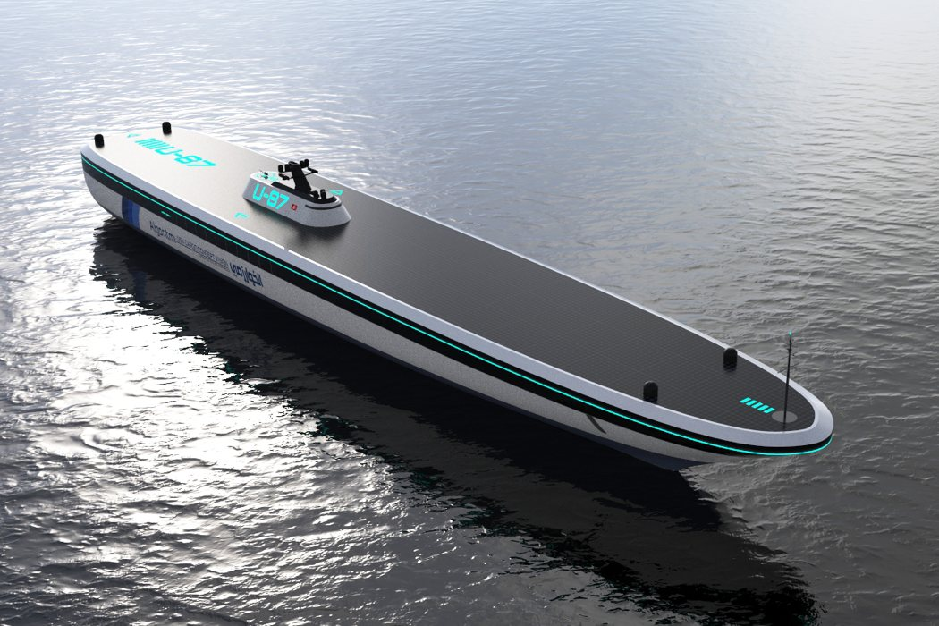

**Authors:**

Dimitris Tsoumpelis, N.A.M.E (NTUA)

Nikolaos Kougiatsos, N.A.M.E (NTUA)

**June 2019**

**ABSTRACT**

# **Optimization of small autonomous vessels' functionality: The case of autonomous rescue boats**

**Nikolaos Kougiatsos and Dimitris Tsoumpelis**

**School of Naval Architecture and Marine Engineering**

**National Technical University of Athens, Greece**

In this paper, proceedings of small autonomous vessels integration in today’s maritime industry are discussed. Not to be omitted, the role of modern ports is of huge importance on that matter and will be presented thoroughly in the following paragraphs. In this era of automation and big data, sea operations with conventional ships are beginning to look a bit obsolete and without any future prospects. This could not apply more to rescue vessels where the minimization of operational errors is crucial in preventing human losses at sea. Thus, one algorithm of path planning will be presented addressing the huge delays that the human factor imposes in today’s sea rescue missions.

**INTRODUCTION**

In the last 10-15 years, engineers found themselves with a huge pile of available resources, computational tools and operational data from existing structures. This situation slowly started to pave the way for automation and operation optimization in all sectors and especially in the field of manufacturing, the automotive industry and robotics.

The maritime sector is nowadays also finding itself confused with the integration of autonomous vessels as well as ROV’s and AUV’S in sea operations. Two of the biggest companies involved in this matter are Kongsberg Maritime and Rolls Royce, both trying to bring forth the era of all-autonomous ships. In particular, Kongsberg’s new breakthrough Yara Birkeland is destined to be the world’s first fully-electric and fully automated containership, thus having a huge impact on the future of maritime industry.

It is needless to say that with all these big changes coming in the following years, ports will also have to change both their operation and their resources, in order to be able to accommodate the needs of tomorrow’s vessels. UK ports have already begun to grasp the matter and are currently reviewing their options so as to remain competitive. Aside from the port’s personal gain and competitiveness, it is now more urgent than ever to review the intermodal trading routes role as a whole and how the world would benefit from all-autonomous transportation of goods. Therefore the challenges arising will have to be addressed by the transportation systems as a whole with the port at their core, as maritime transport is nowadays the key to people’s and industries’ collaboration in exchanging goods and services.

**BREAKTHROUTHS IN AUTONOMOUS SHIPPING**

Autonomous vessels have been present at sea operations already for the last seven years. In all this time, the industry has come a long way, specifically in achieving autonomy on even bigger ship lengths. Nevertheless, the progress of today’s technology made sure of that, as more and more companies enter the banquet leading in a rise of competition to ensure dominance. When speaking about autonomous vessels, one must first define the level of attained autonomy. Speaking on these terms, there are mainly two levels of automation: remote control and full-autonomy. Ships belonging in the first category, are designed with inbuilt cameras and sensors receiving human orders from shore or another point of control and providing haptic feedback from the field of operation. Thus the human factor still remains partially in the process. On the contrary, ships of the second category tend to also have control systems designed, able to process the sensor feedback on their own and determine a course of action. Both categories, have their notable drawbacks, the first’s being the slower response time and the maintenance of the risk level due to the human factor involved and the second’s being the lower credibility and the possible ship loss in case of system malfunction.

In 2016, the American company Vigor Industrial made a move on the market by releasing Sea Hunter, a 40 m long trimaran powered by 2 Diesel Engines capable of self-piloting reaching a maximum speed of 27 knots.

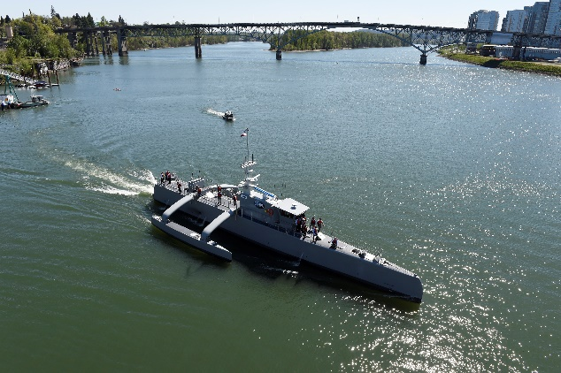

Fig.1 Vigor Industrial’s Sea Hunter (2016)

Then, in the first semester of 2018 a British company named L3 ASV released its own autonomous solution under the name of C-Worker 7. The vessel is 7.2 m long, powered by 2 Diesel engines as well and its main purpose is positioning, surveying and environmental monitoring without the need of a ship on station or sea-bed anchoring. It can eventually reach the speed of 6.5 knots.

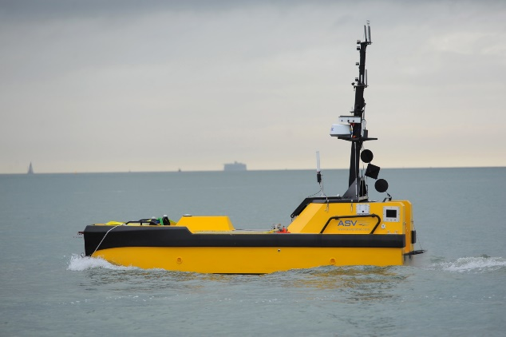

Fig.2 L3 ASV’s C-Worker 7 (2016)

Going further, nowadays there are 3 major companies trying to overtake the market: Rolls Royce, Kongsberg and Port-Liner.

Rolls Royce started thinking ahead since 2016. One of its more promising and expected projects is the Future Shore Control Center, a solution which will eventually enable the remote control of ships from shore without the need for an active crew onboard. In 2018, the company started to discuss a possible partnership with Intel in order to produce the next generation of autonomous vessels. Lastly, in 2019 the British company lent a hand to the Finnish ferry line Finferries fully automating the first 178 m ferry named Falco.

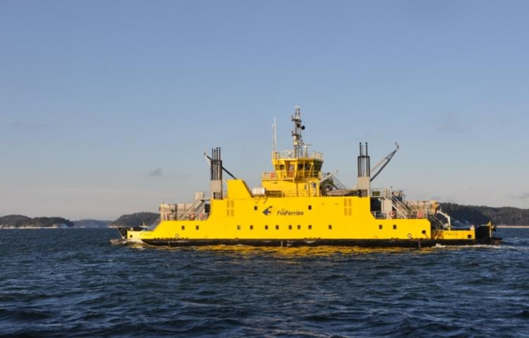

Fig.3 Rolls Royce Falco Project (2019)

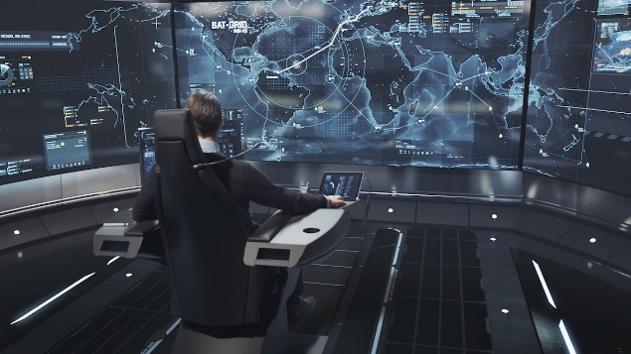

Fig.4 Rolls Royce Shore Control Centre

Kongsberg maritime has also come a long way in the recent years. The Norwegian giant started gathering expertise making ROV’s and AUV’s since 2007. The company entered into a partnership with UK’s Automated Ships Ltd in 2017 to develop Hrönn, an offshore utility autonomous ship. The ship will be working for some time through remote-control and will eventually pass in the full-autonomy specter. Future possible uses of Hrönn include sea survey, firefighting assistance and light intermodal cargo delivery/ delivery to offshore installations. Hrönn started operating in 2018. Yara Birkeland is another one of Kongsberg’s most anticipated projects and the world’s first all-electric and fully autonomous containership starting operations at 2020.

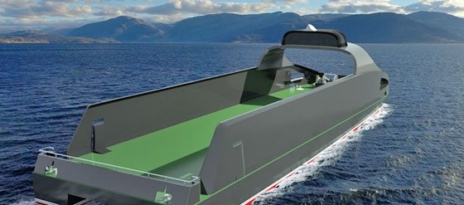

Fig.5 Kongsberg Hrönn Project (2018)

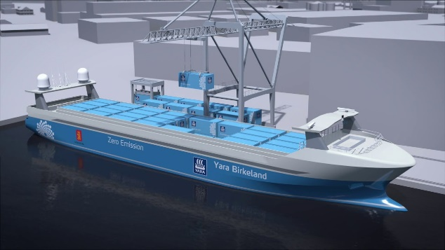

Fig.6 Kongsberg Yara Birkeland Project (2020)

Last but not least the Dutch company Port-Liner, inspired by the revolution of batteries technology derived from Elon Musk’s Tesla’s huge success , is currently building two large all-electric barges. Namely, Tesla ships are expected to make a huge impact on inter-European sea transports. In the first stage, the ports of Amsterdam, Antwerp, and Rotterdam are going to welcome Tesla ships in the cycle of their operations as of fall 2019. The company has also prepared a battery pack system solution that enables retrofitting to other existing barges.

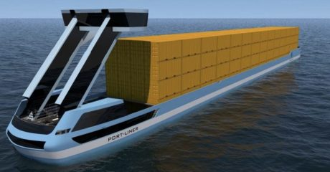

Fig.7 Port-Liner Tesla ships Project (2019)

Fig.8 Autonomous shipping timeline

**RESCUE VESSELS TECHNOLOGY & RESCUE EQUIPMENT**

Human safety on sea has undoubtedly turned for the better in the last fifteen years. The experience of severe accidents nearly in all ship types which took severe tolls on human life led the entire world to reconsider the safety measures applied to the entirety of sea vessels. Risk assessment theory has also greatly contributed in monitoring the situation and in the application of mathematical tools to solve the arising problems. Moreover, the adoption and review of SOLAS convention by the IMO in 1974, set without a doubt a solid minimum of safety measures and procedures, forcing into compliance each and every vessel’s crew.

We can distinguish two types of rescue craft, the ones readily available on ship and the ones coming from port and other shore locations. The advantage of the first type is their presence on site. Although, in many cases, due to systems’ malfunction, the possibility of slow crew response time and inadequate service, these boats fail to launch with grave repercussions. On the other hand, crafts coming from shore are most punctual on service and have almost no launch issues. In this case, the problems lie on slow response time due to human factor and the distance that must be covered to reach the wreck and also on the fact that their presence on site heavily relies on current sea conditions.

According to SOLAS, each passenger ship is obliged to have life boats on each side with available capacity no less than 37.5% of the people onboard (crew+passengers) on international sails. Plus, life rafts must be available for at least 50% of people onboard, each serviceable by at least one davit.

When a passenger vessel is used in national sails or in short international sails, the above boundaries can be modified as follows: 30% of life boats available capacity on each side and 75% life rafts for the remaining passengers.

In most cases, today’s rescue crafts are following the closed on top design as seen in the following figure 9. Although, if the climate conditions allow for it, open designs can also be used. Whilst on rescue, a person must be both on the ship in emergency and on each rescue craft, having taken into consideration that not every person onboard is a sailor or knows how to react.

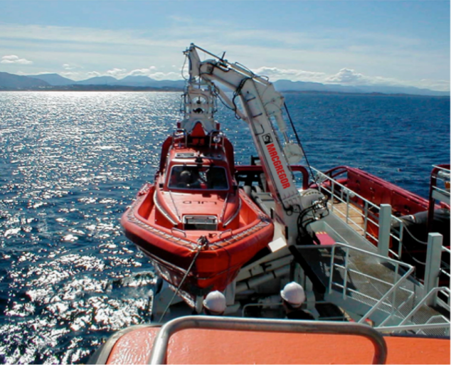

Fig.9 Man overboard rescue craft and davit

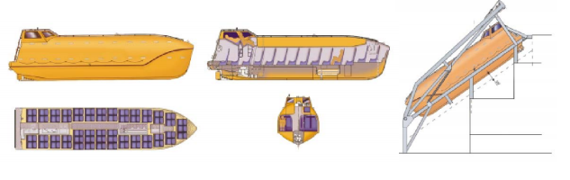

Fig.10 On-ship rescue craft and launch mechanism [5]

Search and Rescue Transponders are Radar based emergency transmitter attached to life rafts or life jackets. According to [15], the transponder emits a radio distress signal on nearby vessels, in the form of a series of 12 dots pointing to the victim’s location. Sensors available on these devices include: radar, gps. Part of their features is a standard of waterproof ability up to 10 m sea depth and their compact design. Up to this point in time, SARTs must be manually activated by a human in order to emit the distress signal.

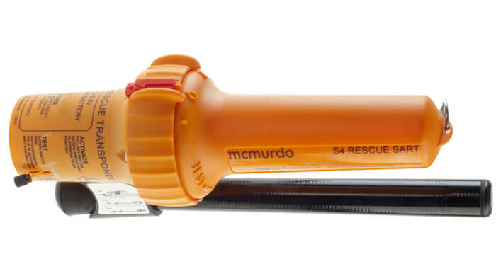

Fig.11 Search and Rescue Transponder (SART) [15]

Life jackets are of absolute importance on sea rescues. According to SOLAS, all life preserving equipment including life jackets must have reflective tape for easy recognition by incoming rescue crafts. Protective and thermal insulation suits must also be available on a number determined by other parameters to cover for the possibility of accidents occurring in cold weather conditions.

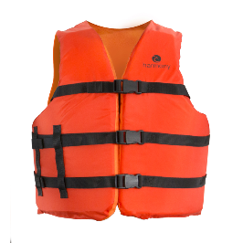

Fig.12 Modern Life jacket

Rescue cradles consist an absolute necessity for modern rescue crafts. Due to their form, they can be used to retrieve unconscious people in a certain radius from the rescue boat’s side.

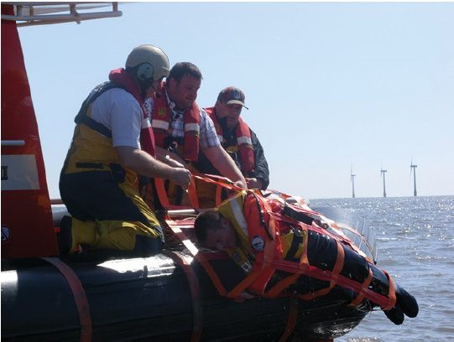

Fig.13 Rescue cradle system [13]

Control systems can also give a push to improving rescue missions. The thruster system shown in figure 14 can be used to dynamically position the rescue vessel, thus providing steadiness throughout the whole operation. As there is no propeller, people in danger cannot sustain injuries and the thruster system can be coordinated to accurately pinpoint a selected course.

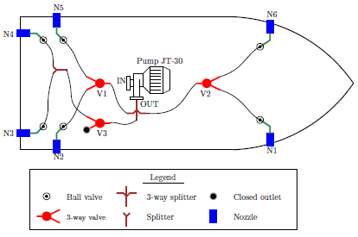

Fig.14 Dynamic Positioning using Thrusters [14]

**PATH PLANNING FOR RESCUE MISSIONS**

Path planning algorithms have been around for ages. Most of them are applied for land transport and by location providers such as Google (GMaps). The main advantage of using a specific path planning algorithm versus taking a random route through points or running a Monte Carlo simulation is the time needed both for computation and application. Thus, in rescue missions, where time is of absolute importance, it is logical to say the least to consider applying such algorithms so as to be able to save at least one more life. This could not be truer in tomorrow’s autonomous rescue vessels that need the ability to make complex decisions referring to the course they must follow in the shortest possible time.

In this paper, Dijkstra’s algorithm is discussed in particular. The algorithm goes like this:

1. Let’s suppose a number of six nodes 1-6 (see fig.15)
2. The algorithm starts by considering node number 1 (starting node) having a cost of 0 and all other unvisited nodes having a cost of Infinity
3. Compute the cost from current node to each visitable neighbor node. The cost consist of the accumulated cost up to the current point plus the cost of the route to each other point
4. If the cost to get to a specific point turns out less than the already assigned cost, swap them and keep the last point of the route from which the cost is minimum
5. Determine the minimum of all costs in each step and select the next destination
6. Repeat the procedure C-D-E until all nodes are visited
7. Determine all available short routes starting from a point a tracing the way back to node 1 (start node)
8. Choose the one with minimum overall cost



Fig.15 Dijkstra’s shortest path algorithm

**PROBLEM FORMULATION**

Let’s suppose a wreck case nearby a port. We define “nearby” as in a maximum distance of 5 n.m. The coordinates of the wreck are set to (0,0), although any other coordinate system can be used as well. Positive x coordinates are on the right half plane and positive y coordinates lie on the downward half plane. The port’s coordinates (x,y) can then be written in reference to the Wreck point. Let’s also suppose a known number of people in danger that are normally distributed in a radius of 500 m. Each person is equipped with a life jacket and a transponder and thus we know the position of all passengers.

**ALGORITHM**

In order to apply the suggested path planning algorithm, Python was used as the programming language. The reader can find all the code and input data used on the authors’ GitHub repo referenced on [8].

**CASE STUDIES**

Through the course of history, one can find a lot of accidents on passenger vessels that occurred near a port. This paper will examine two in particular, the Express Samina accident near Paros’s port in Greece (26/9/2000) and the more recent Costa Concordia accident near Giglio’s port (13/1/2012).

Express Samina

Express Samina was a RoPax ferry built in 1966 for Compagnie Générale Transatlantique. Along her life, she had many names: while in France the ship was known as Corse (1966-1982), from the moment she was sold to the Greek company Stability Maritime the name changed to Golden Vergina (1982-1999). Its final holder and the one who changed the name to Express Samina was Agapitos Bros Company (1999-2000). At this time, the vessel was operating in the route connecting Piraeus port with a handful of Greek islands of Aegean Sea, including Paros. As referenced by [10], when the ship was approaching Paros’s port she had a collision with the rocky islet Portes just 3 n.m outside the port. The vessel’s starboard’s stabilizer impact was the cause of the creation of an opening in the hull. As she continued to sail, water progressively started to flood the main engine room first and then all other buoyant spaces.

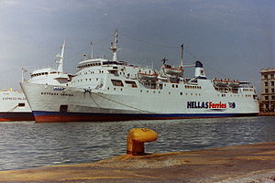

Fig.16 Express Samina in Piraeus

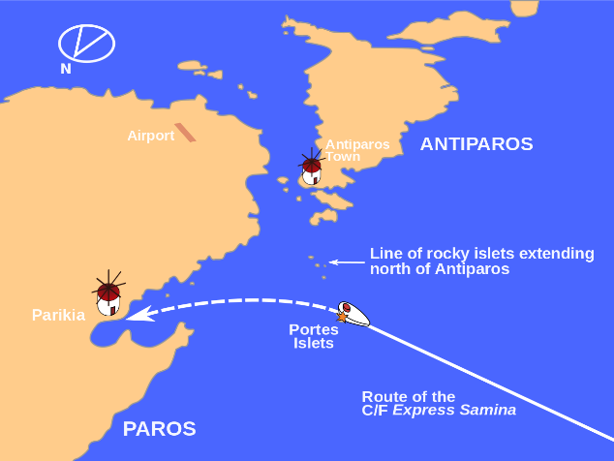

Fig.17 Express Samina wreck map location (Wikipedia)

The ship’s sinking lasted about half an hour. Of the 533 passengers and crewmembers, 80 people lost their lives that day. The sail’s conditions included an average speed of 18.5 knots and moderate weather conditions (5-6 Bf). According to Professor A. Papanikolaou and his team, the most probable scenario for the cause of sinking was that 9 out of 10 compartment watertight doors were left open and thus water could easily move from one compartment to another. In reality, only one of the doors was impossible to close due to the malfunction of its mechanism caused directly by the collision and the fin penetration. If all the other doors remained closed, the ship would most probably survive without any human loses.

The reader can find the complete analysis and conclusions at reference [10].

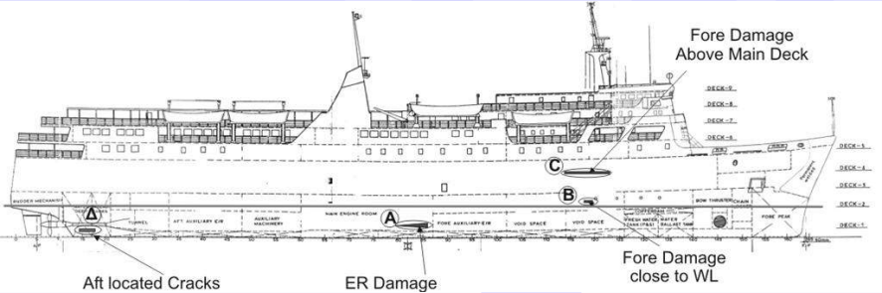

Fig.18 Express Samina damages [10]

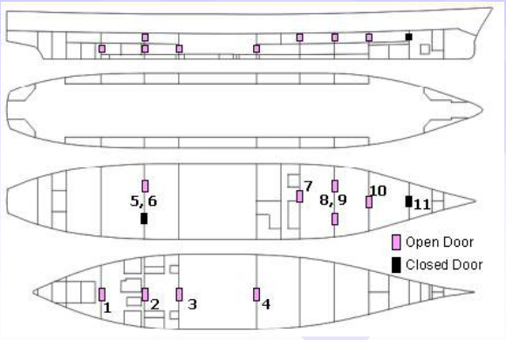

Fig.19 Express Samina compartment doors state during collision, flooding and sinking [10]

Costa Concordia

Costa Concordia was an Italian cruise ship initially constructed in 2004 by Fincantieri yards for the Carnival Corporation. She was delivered to Costa, a subsidiary of Carnival Corporation, on 2006. The vessel’s route was circular, starting and ending at the port of Savona and with the ports of call being Toulon, Barcelona, Palma de Mallorca, Cagliari-Palermo and Civitavecchia as referenced in [12].

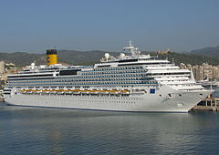

Fig.20 MS Costa Concordia

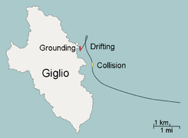

Fig.21 Costa Concordia wreck map location (MarineTraffic)

On 13/1/2012, she was struck by a rock just off the eastern shore of Isola del Giglio near Giglio Port. The collision marked an opening of considerable size which later caused a temporary black-out on the ship and a loss of engine power. The ship continued a course of around 1 n.m making a 180 degree turn to its starboard size, making once again contact with the solid bottom before capsizing. As seen in figure 22, the accident could have been prevented should the ship had maintained its course further from the shore. As a result of the accident, out of 4252 passengers and crewmembers 32 died, 64 sustained non-fatal injuries.

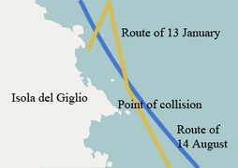

Fig.22 Costa Concordia route comparison

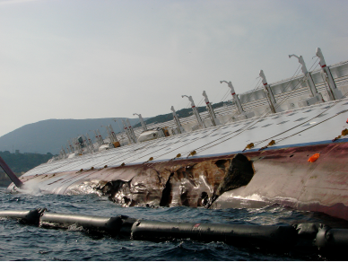

Fig.23 Costa Concordia damage [11]

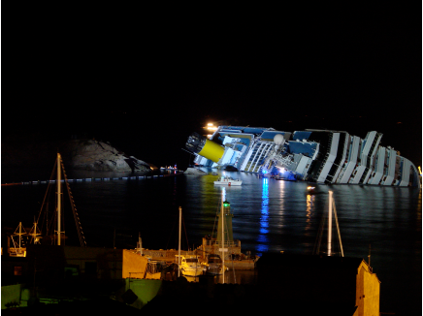

Fig.24 Costa Concordia final position (capsized) [11]

**RESULTS**

**CONCLUSION**

**REFERENCES**

[1] Rolls Royce, *Autonomous ships: The next step*

[2] Forbes, Rolls Royce's Autonomous Ship Gives Us a peek into the future of sea transport

[3] Kongsberg Maritime, *YARA AND KONGSBERG ENTER INTO PARTNERSHIP TO BUILD WORLD'S FIRST AUTONOMOUS AND ZERO EMISSIONS SHIP*

[4] Kongsberg Maritime, *AUTOMATED SHIPS LTD AND KONGSBERG TO BUILD FIRST UNMANNED AND FULLY AUTONOMOUS SHIP FOR OFFSHORE OPERATIONS*

[5] K. Spyrou, *Ship Study and Design II*, NTUA, Athens, 2017

[6] IMO, *SOLAS Convention*, 2002

[7] Witn.com, How Long Can You Survive In Freezing Water?

[8] N. Kougiatsos D. Tsoumpelis, [Sea Rescue Mission GitHub repository](https://github.com/Jakendarth/Autonomous_Ship)

[9] Marine Traffic

[10] Prof. Apostolos Papanikolaou, NTUA-SDL, *Investigation into the Sinking of the Ro-Ro Passenger Ferry EXPRESS SAMINA*, 2015

[11] European Union civil protection team, *REPORT: Observation mission Giglio Island COSTA CONCORDIA*, 26-29 January 2012

[12] MINISTRY OF INFRASTRUCTURES AND TRANSPORTS, *Marine Casualties Investigative Body: Cruise Ship COSTA CONCORDIA*

[13] Frederick Hunter, Autonomous Man Overboard Rescue Equipment, WORCESTER POLYTECHNIC INSTITUTE

[14] Nikolaos Kouretas, Development of a Dynamic Positioning System for an Emergency Recovery and Rescue Vessel, LME NTUA 2018

[15] Orolia Maritime SART

[16] Wikipedia