**Installing R for use with ArcGIS Toolboxes and Scripts**

1. **Make sure that you have installed ArcGIS 10 or ArcGIS 10.1 and Python (2.6 or 2.7, respectively)**
   1. Note that Python should be installed by default when you install ArcGIS
   2. Check for the location of several important directories, which are installed to C:\Program Files or C:\Program Files (x86) depending on your operating system. The directories you should be able to locate include:
      1. …\ArcGIS\Desktop10.0\bin
      2. …\ArcGIS\Desktop10.0\arcpy
      3. …\ArcGIS\Desktop\ArcToolbox\Scripts
      4. …\Python26\ArcGIS10.0
   3. When you install ArcGIS and Python the above directories should be added automatically to your Python Path (an environment variable, which you will learn how to set in the next set of steps)
      1. To make sure that these directories were added to your Path environment variable automatically, open ArcMap, open the Python Window (from the Geoprocessing Dropdown), and type the following

>>> import sys

>>> print sys.path

* + 1. The output should include the following (the exact output will be different, but should include the pathnames listed above in i-iii)

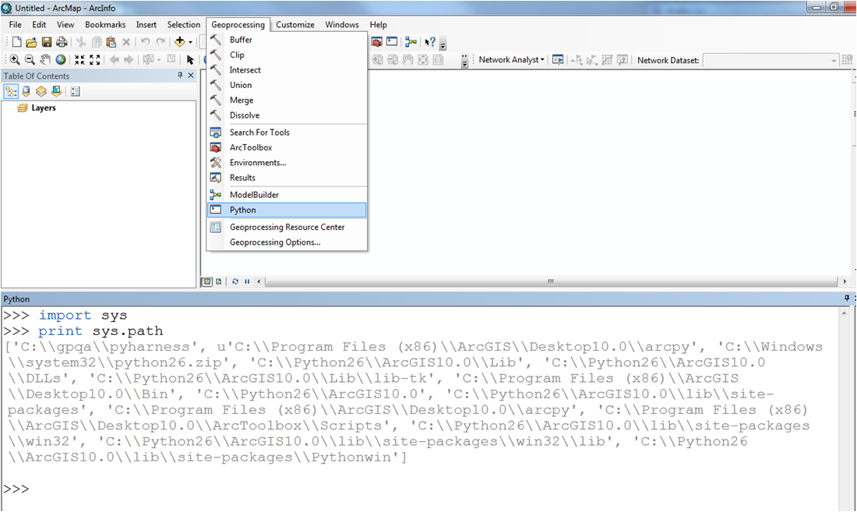

* + 1. If you do not see the directories listed (which is unlikely), add them when you do step 3 below
    2. Close ArcMap

1. **Install R**
   1. Go to the R homepage (<http://www.r-project.org>) and download the most recent version (**NOTE: the tool has been successfully tested in R 2.15.0**) by clicking the “Download R” link in the Getting Started section, and then choosing the location that is closest to you
      1. Choose to Download and Install R (NOT the Source Code for all Platforms), choose the appropriate operating system, choose to download the Base install, and then choose to Download R (this will be the most recent version of R)
   2. Follow the standard steps for installation
      1. IMPORTANT: Take note of the directory where you choose to install R and write it here (or on a separate piece of paper so that you don’t forget…you will need it to add the directory to the Path environment variable)

__________________________________________________________

* + 1. Accept all of the defaults, and run the installation

1. **Add the R Bin directory to your Path environment variable (CRUCIAL STEP…without this the tool will not work!!)**
   1. Navigate to the location of the R install on your computer (that you wrote on the line above) and open the folder labeled Bin
   2. Copy the full path location of the bin folder (by default it would install here: C:\Program Files\R\R-2.15.0\bin)
   3. Go to your Start Menu, find the My Computer icon (or just Computer icon, depending on what operating system you are using), right click on it, and choose the Properties option

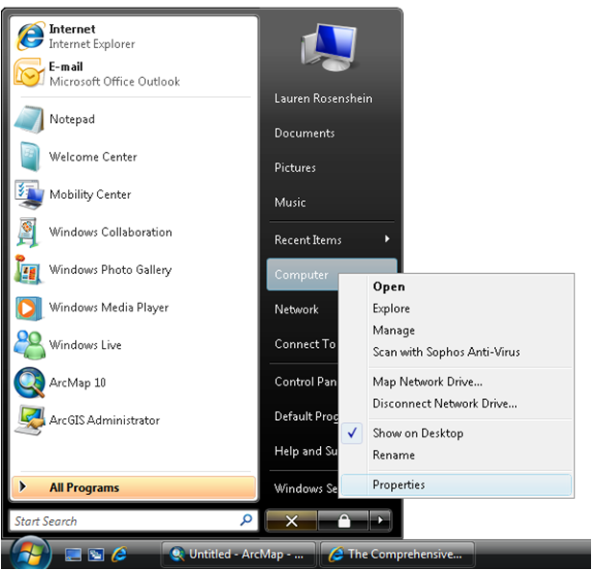

* 1. For both Windows Vista and Windows 7, this will open a dialog where you will then click the Advanced System Settings link on the left side (highlighted in red). For Windows XP, this will open the System Properties dialog box, from which you will choose the Advanced tab (highlighted in red in)

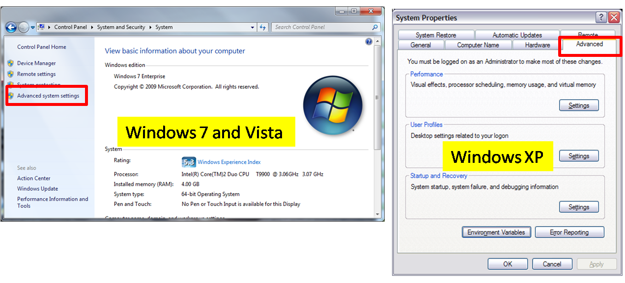

* 1. The next window will have a button on the bottom that says Environment Variables, click it and the following dialog will appear

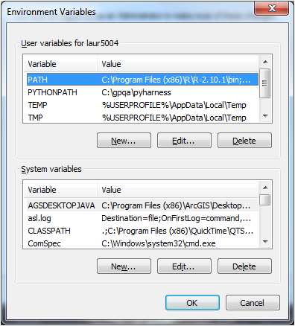

* 1. Find the environment variable called Path (or PATH). This may be in the User Variables, and it may be in the System Variables. If you are the only person that uses your machine, this distinction should not matter. If your machine is shared, and you use the Path variable that is a user variable, then you will be the only person impacted by the change. If you want your changes to be shared by all users, make sure to use the System Variable.
  2. Select the Path variable, and click Edit.

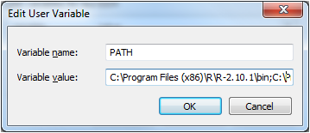

* 1. At the end of the list of directories, add a semi-colon (;) with NO space after it, and then paste in the R Bin directory that you copied earlier (should look something like this: C:\Program Files\R\R-2.15.0\bin\x64 or C:\Program Files (x86)\R\R-2.15.0\bin\x64 depending on your operating system). **NOTE**: if you are using the 32-bit version then it should be i386 instead of x64
  2. Click OK
  3. Your R Bin directory should be successfully added to your Path environment variable
     1. You can follow these same steps to add ArcGIS directories to your path if they did not appear in step 1c.

1. **Install the necessary R Libraries (ismev, raster, rgdal,** and **spatstat)**
   1. Open R, either from the desktop shortcut that was created (if you chose to create one), or from the Start menu
   2. Type .libPaths() and check which one is the default path where R will automatically save all the libraries you install. If the path is not the one you want, change it using the command: .libPaths() <- “TYPE_PATH_TO_A_FOLDER_YOU_WANT”
   3. Go to the default or chosen library path and once you are in that folder make sure you do not have any version of the packages ‘rgdal’ or ‘raster’ already there. If so, you can manually delete them and re-install them within R. All this because the packages need to be at the most current version (at least version 2.0-31 for ‘raster’ and version 0.8-5 for ‘rgdal’).
   4. Go back to R and to the Packages menu, then choose to Install Packages, then choose the location closest to you for download
   5. Find **ismev, raster, rgdal,** and **spatstat** in the list of packages and select them both (you can select multiple packages using the Ctrl key), and click OK
   6. Close R, without saving the workspace image
   7. You are now ready to run the ArcGIS Sample R Scripts in ArcMap
2. **Add the R Tools toolbox and start using it**
   1. Open ArcMap
   2. Open ArcToolbox: from the Geoprocessing Window select ArcToolbox
   3. Right click inside of ArcToolbox, and choose Add Toolbox
   4. Navigate to the location where you saved the zipped folder with the Gridded Extremes tool file and unzipped everything, and choose **Gridded Extremes.tbx**
   5. Double-click on the Gridded Extremes tool, and fill out of the necessary parameters
      1. This tool takes folders as input and output workspace (AT THE CURRENT VERSION, THIS TOOL **ONLY** ACCEPTS FOLDERS WITH **.img** RASTER FORMAT…I will soon add a new feature to select some pre-defined formats to choose from), and can take values manually typed in as return periods (one or more in a list). You can also check or uncheck a few options at the bottom of the tool. The output will be saved as a raster (.img) file and as .shp Shapefile if you checked the option to calculate and save a table with all model coefficients
   6. Run the tool
      1. By default the tool will run in the back, like any other toolboxes in ArcGIS, thus you can keep working on other things while the tool runs. Keep an eye for possible warnings or error messages, should they pop up during the execution (see figure below).

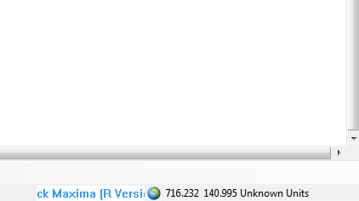

If you DO NOT wish to run the tool in the back and, instead, run it in foreground then right click on the tool script, then click properties (see figure below) and check the “Always run in foreground” option.

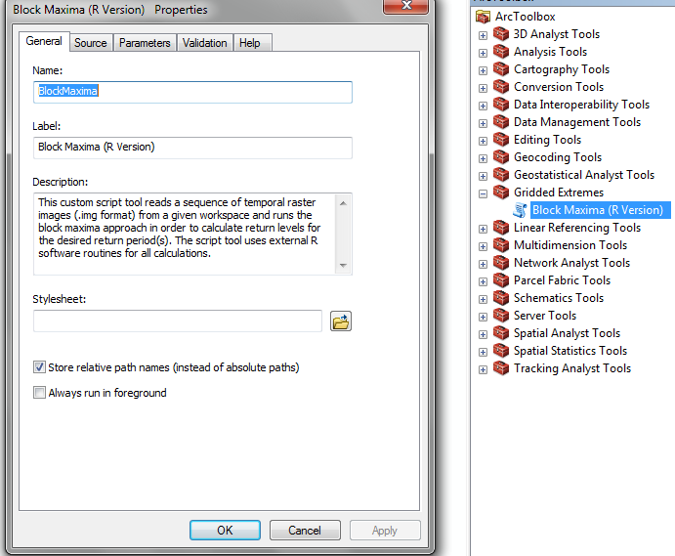

In this case, a message window will pop up while running and look like this:

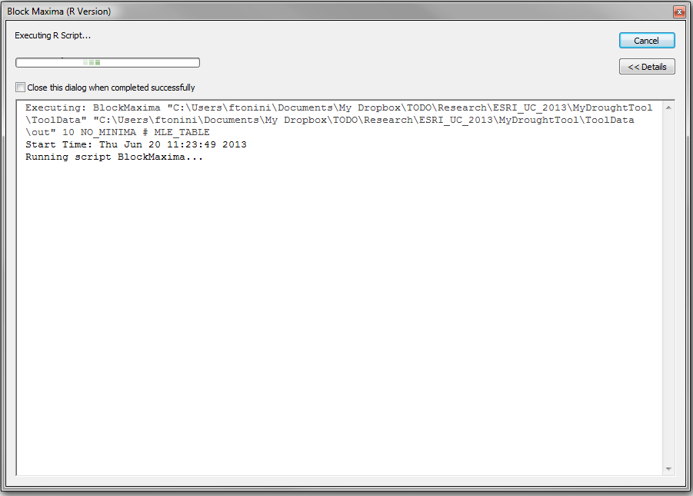

* + 1. If the tool runs successfully (the larger the area, the longer the tool will take to run…on my laptop with medium-high specs it takes about 2 minutes using the test data coming with the tool) at the end you should see the following:
       - 1. Run in background (default):

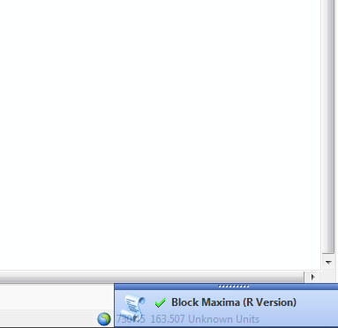

* + - * 1. Run in foreground:

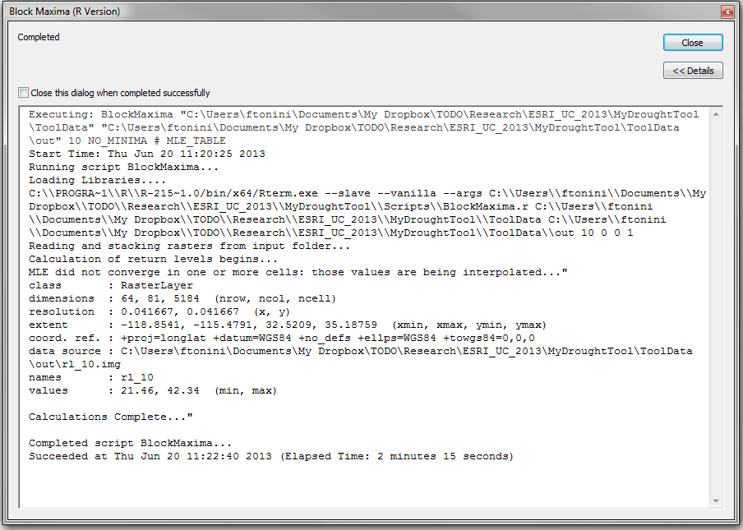

1. **Check the output!**
   1. Go to the folder you selected as output workspace. You should find a number of rasters equal to the number of return periods you chose in the list. If you checked confidence intervals then you should also have 2 (upper and lower) raster files with confidence intervals for each one of the return level rasters. Finally, if you checked the coefficient table option, you should also find a .shp file (see figure below).

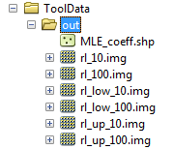

Lower confidence intervals rl_low_XX

Upper confidence intervals rl_up_XX

Return Levels

rl_XX

.shp with all MLE coefficients for each pixel

THE END!!

**THE END!!!**

If you have any questions or cannot get the tool to run properly, please contact me at:

f_tonini@hotmail.com