The “SmallEdit 2.0” code is based on the sample software written by Sean O'Rourke.
(to be compiled with the free Lcc-Win32 compiler written by Jacob Navia).

It has been completely corrected to support UNICODE. It saves and loads in Unicode format and incorporates bi-directional text support for Arabic or Hebrew languages (RightToLeft).

1) Multi-lingual and Unicode support in edit windows and controls.

The code has been re-written to be Unicode compatible, in the edit window and all edit boxes. Foreign languages entry using IMM (Input Management Method) are supported (Arabic, Chinese Big5, Greek, Japanese (Kata), Hebrew, Russian).

File write and read functions are supporting Unicode UTF-16 little endian format.

2) Bidirectional text support (BIDI)

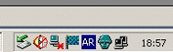

In Arabic or Hebrew, the bidi facility (RightToLeft writing) is automatically
switched and follows the "Keyboard layout" (AR or HE blue box on the system tray).
It works in the main Edit Window and in the Edit boxes.

When Arabic or Hebrew text is loaded from file, select all, then click on the text switches bidi or select the right language on the system tray.

Jacques Laporte
laporte.j@wanadoo.fr
10/31/2002
Works on Win2K and WinXP.
Multilingual support must be installed for the desired languages.
Free software given "as is".

Sample Arabic and Hebrew texts.

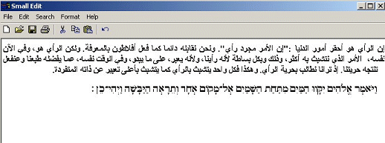

Poem of Parmenides : on nature.

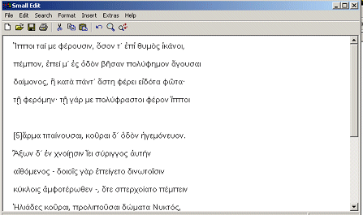

Extracts from Yahoo China

