UyCare Diploma Project Proposal
  - Development of a Digital Platform for Coordinating Repair and Maintenance Services for Residential Complexes and Private Homes
First pre-defense analysis and design package
21 October 2026
UyCare will connect residential customers in Kazakhstan with independent service providers through repair requests, competing offers and explicit customer selection. This report defines the proposed scope, evidence base, requirements, architecture, interaction design and evaluation approach.

Project team
Member | Role
Akhmetov Kazbek | Frontend and backend
Uranov Daryn | Machine learning and backend
Tazhibayev Marsel | Team lead

Supervisor: Elvira Aitmukhambetovna

Current readiness
The analysis, specification, editable diagrams, prototype and planning materials are prepared for review. Real user discussions, substantive supervisor feedback, a live YouTrack project and progressive individual contribution evidence remain required. The prototype does not represent a completed backend, Flutter application or trained model.

Contents
1. Project proposal and scope
2. Evidence of relevance and user discovery
3. Literature review
4. Existing system comparison
5. Technology comparison and decisions
6. Requirements specification
7. Architecture and diagrams
8. UX and prototype
9. Verification and evaluation plan
10. Project management and risks
11. Supervisor feedback and revision record
12. References and source register
Appendix A. Required architecture diagram exports
Appendix B. Requirements traceability
Appendix C. Repository and submission obligations

Companion materials
The UyCare repository package contains editable Markdown documents, .drawio diagram sources, SVG exports, a portable interactive prototype, the proposed YouTrack backlog, interview and feedback forms, and planned acceptance tests. The accompanying presentation summarises the project for the committee.

Project proposal and scope

Project identity
UyCare is a proposed service marketplace for residential repair and maintenance in Kazakhstan. Its formal diploma title is Development of a Digital Platform for Coordinating Repair and Maintenance Services for Residential Complexes and Private Homes.
The project team comprises Akhmetov Kazbek (frontend and backend), Uranov Daryn (machine learning and backend), and Tazhibayev Marsel (team lead). The supervisor is Elvira Aitmukhambetovna, using the name supplied by the team. This package supports the 24 October pre-defense requirement; 2026 is the planning assumption. The final defense date remains to be confirmed.

Problem statement
The team reports that people often use personal recommendations to find repair specialists and have difficulty judging unfamiliar providers. This is an initial stakeholder assertion, not a measured finding. The proposed problem is fragmented coordination: a customer needs to describe a repair, compare prices and availability, assess previous work, select a provider, and retain a record of the agreement and outcome.
Existing marketplaces already address parts of this workflow [S11–S13]. UyCare therefore makes no claim that Kazakhstan has no services for finding specialists. Its engineering contribution is an integrated, testable implementation of the request-and-offer workflow for private property and residential shared areas, with transparent selection and assisted request categorisation. Its local usefulness must be validated through user research and task-based evaluation.

Target users
- Apartment residents and private homeowners who commission repairs to their own property.
- Authorised OSI/KSK representatives who publish requests for shared areas of a residential complex. OSI/KSK are the local organisation types named by the team; the system does not determine legal spending authority.
- Independent service providers who maintain profiles, submit offers and complete jobs.
- Platform moderators who handle reports and record moderation decisions.
A person may hold both customer and provider roles. Organisation membership is separate from personal ownership. A provider must not bid on their own request.

Aim and objectives
The aim is to design, implement and evaluate a digital platform that helps residential customers in Kazakhstan publish repair requests, compare providers' offers, choose a provider and coordinate service delivery, with an ML component suggesting work categories from request descriptions.
O1. Establish requirements from 3–5 user discussions and a documented analysis of related systems and publications.
O2. Design a shared backend and data model that preserve ownership, offer history, one-provider assignment and valid job-state transitions.
O3. Implement the essential customer and provider journeys in a web interface and a shared Flutter application for iOS and Android.
O4. Compare a keyword baseline, TF-IDF with a linear classifier, and a multilingual encoder-based approach on a separately held-out labelled dataset.
O5. Evaluate usability, functional correctness, access control and response times against explicit criteria and a manual coordination baseline.
O6. Maintain traceable tasks, individual contributions, reviews and tagged submissions in the same repository.

Scope
The final MVP includes authentication, customer/provider roles, organisation membership, requests with photos, category and approximate location, provider profiles and portfolios, competing offers, explicit selection, chat, contact sharing with consent, status history, completion confirmation, reviews linked to completed jobs, reports and basic moderation. Prices use KZT. A request budget is indicative; the accepted offer becomes the recorded agreement.
Flutter is a fixed team choice. The proposed web stack is Next.js with TypeScript. The proposed backend is Django REST Framework with PostgreSQL and Django Channels. English is the documentation and prototype language. Russian and Kazakh are provisional languages for request-text evaluation, pending team confirmation and sufficient data. They are not claimed as validated model capabilities.
The initial repair taxonomy contains plumbing, electrical work, heating and ventilation, appliance repair, furniture and carpentry, and finishing work. Unclear, mixed or unsupported work receives a manual-choice fallback. Multi-trade jobs may be split by the customer; automatic multi-label routing is outside the first model.
Payments in the MVP occur directly between the parties. The platform records a declared payment method without processing, holding or verifying funds. In-app payments, escrow, insurance, identity-document verification, emergency dispatch, automatic price estimation, live worker tracking, subscriptions and scheduled preventive maintenance are deferred. No payment gateway appears as an active dependency in the initial architecture.

Engineering complexity
The difficult parts are consistent state across several clients, authorization for personal and organisation-owned requests, transactional acceptance of one offer under concurrent clicks, duplicate-safe operations, private chat and media access, review eligibility, and reproducible ML evaluation under limited data. Each is tied to a requirement and a test instead of adding infrastructure only to make the system look complex.

Expected outcomes
At the first pre-defense, the deliverables are this analysis and design package, editable diagrams, a browser prototype, a verification plan and a prioritised backlog. The prototype uses demonstration data and does not prove a working backend, trained ML model or mobile application.
At final evaluation, the expected outputs are runnable web and Flutter clients, a shared API, database migrations, tests, an evaluated category model or documented baseline fallback, and reproducible setup instructions. These remain planned outcomes, not completed implementation claims.

Evidence of relevance and user discovery

Evidence currently available
E01. The project team supplied a marketplace concept, target country, team roles and the Flutter constraint in the project discussion on 21 October 2026. This establishes project intent, not demand or usability.
E02. Official product descriptions show that request posting, price comparison, reviews and direct selection already exist in relevant systems [S11–S13]. This supports the feasibility of the interaction pattern and the need for a careful comparison. It does not establish a competitive advantage for UyCare.
E03. Research on platform governance and scams motivates explicit responsibilities, review rules and moderation [S01, S02]. Transfer to local repair services is a design inference that needs local validation.
No user interviews, client agreement, observations of a real repair process, or local usage statistics have yet been supplied. The committee requirement for 3–5 discussions or a substantive client agreement remains open. Planned discussions must never be presented as conducted interviews.

Assumptions to validate
H1. Customers have difficulty comparing repair offers because scope, materials and timing are not recorded consistently. Validate with accounts of recent repair jobs and examples of how quotes were compared.
H2. Portfolios and completed-job reviews affect selection alongside price. Ask participants to rank and explain choices between neutral sample profiles.
H3. Providers will respond to a visible request with their own price and schedule. Ask how they currently find work, what information they need and why they decline jobs.
H4. OSI/KSK representatives need shared-area request ownership and a visible decision history. Validate with an actual representative, including how authority to commission work is established.
H5. Category suggestions reduce confusion without hiding suitable providers. Observe manual category choice and correction of intentionally wrong suggestions.
H6. Customers and providers want in-app communication. Compare their preferences for phone and chat rather than assuming that chat is sufficient.

Recruitment and protocol
Target five discussions: two residential customers, two providers from different trades, and one OSI/KSK representative. Three is the minimum if all three perspectives are represented. This is a purposive discovery sample, not statistically representative market research. Marsel coordinates recruitment; Kazbek interviews customers and the representative; Daryn interviews providers and records category vocabulary. Recruitment and participation are not yet confirmed.
Each discussion lasts approximately 20–30 minutes. Explain the student project and obtain permission to take notes. Recording requires separate consent. Use participant codes P01–P05. Keep phone numbers, addresses and recordings outside the public repository. Participants may decline a question or withdraw their material before analysis.
Begin with the participant's most recent real repair experience before showing the concept. Ask neutral questions, record counterexamples, and distinguish exact quotations from paraphrases. After discovery, use the prototype for a separate usability exercise. Do not merge the two forms of evidence.

Interview guide
- Describe the last time you needed a repair or accepted a repair job. What happened from start to finish?
- Where did you find the customer or provider, and which alternatives did you consider?
- What information was missing when you first discussed the work?
- How were the price, materials, travel cost and timing agreed? What changed later?
- What helped you trust the other person? What evidence would not be useful?
- How did you compare alternatives? Describe a case where the cheapest option was not selected.
- How did you communicate and record completion? Did any misunderstanding occur?
- What would make you refuse a request or decline to use an online platform?
- For OSI/KSK representatives: who can publish, select and approve work, and how is that authority recorded?
- After seeing the prototype: which step matches your process least well, and what would need to change?

Analysis and acceptance
For each discussion, retain date, participant role, consent status, interviewer, evidence reference, observed workflow, difficulties, counterexamples and proposed requirement changes. Summarise themes with participant codes and frequencies only within the actual sample. A statement such as 3 of 5 participants is descriptive of the sample, not of Kazakhstan.
Each requirement influenced by research receives a link to its evidence code. Marsel and another member review the interpretation. Mandatory requirements are revised when findings contradict assumptions. The evidence component is complete only when at least three real records or a substantive client agreement exist and the resulting design decisions are documented.
The unfilled record form is in research/interview-record-template.md. The evidence register is in research/evidence-register.json. Blank forms and interview questions are preparation materials and do not satisfy the interview requirement.

Literature review

Review scope and selection
This focused review connects marketplace governance, multilingual text classification, dataset quality and evaluation to UyCare decisions. Searches used publisher pages, ACL Anthology and author preprints on 21 October 2026. Search concepts included online labour platform governance, platform scams, Kazakh NLP resources, few-shot classification, sentence embeddings and data leakage. This is a focused engineering review, not an exhaustive systematic review.
The core scientific set contains eight published journal/conference/workshop papers [S01–S08], supplemented by two explicitly identified research preprints/technical reports [S09–S10]. Eight of these ten sources date from 2021–2025. The 2019 Sentence-BERT and 2020 XLM-R papers are retained as foundations for the candidate representations. Official product and technical sources [S11–S23] are used for design/comparison, not counted as scientific publications.
Sources were included when their method or finding changed a requirement, comparison, data procedure or evaluation decision. Generic application-project descriptions without a clear evaluation method were excluded. Author/publisher abstracts and accessible text support the synthesis; no numeric result is transferred to UyCare, and this package does not claim to have reproduced the cited experiments.

Critical synthesis
Platform governance is part of system design. Immonen distinguishes platform models with different degrees of control [S01], while Ticona shows that trust mechanisms can coexist with harmful interactions and disputed responsibility [S02]. UyCare therefore makes provider selection explicit, limits verification claims, and provides reporting with a recorded moderator decision. Their settings differ from Kazakhstan housing repairs, so local interviews must determine which concerns and policies are relevant.
Text classification needs an appropriate representation and an evaluation set. Sentence-BERT and XLM-R establish useful foundations [S07, S08], while SetFit and multilingual E5 supply later alternatives [S09, S10]. None removes the need for labelled repair requests. A small TF-IDF model is an intentional comparator because it is cheap to train, inspect and serve. A more complex encoder is justified only if measured gains outweigh latency and maintenance costs.
The Central Asian language survey highlights resource limitations [S05]. MTEB demonstrates why broad embedding rankings cannot identify a universal winner [S06]. For UyCare, evaluation must separate Russian, Kazakh and mixed-language requests where the data support such analysis. News, sentiment or general retrieval datasets may help investigate tools, but they cannot be relabelled as a repair-request test set without a valid annotation process.
Dataset documentation and leakage prevention are complementary. Gebru et al. motivate recording provenance, intended use and limitations [S03]. Kapoor and Narayanan motivate a separate test set and explicit leakage checks [S04]. UyCare will group duplicates and paraphrases before splitting, fit the text vectorizer only on training data, and keep synthetic examples identifiable. Performance on generated examples alone will not establish real-user performance.
The resulting research gap is practical and bounded: can a coherent request-and-offer workflow and an optional category suggestion improve defined user tasks for the recruited target users? The project does not claim a new marketplace algorithm or a new language model. Its evaluation will establish the extent and limits of the implementation's benefit.

Structured scientific analysis
Source | Approach | Finding relevant to UyCare | Limitation | Design consequence
S01 Jere Immonen (2023) | Comparative platform analysis distinguishes intermediary models and degrees of managerial control. | Platform governance differs across business models; a marketplace must state who selects and directs work. | The study is not a Kazakhstan home-repair evaluation. | Customer selection and provider-defined offers; explicit moderator role. FR-05, FR-07, FR-15.
S02 Julia Ticona (2022) | Ethnography, platform observations and interviews with 42 careworkers. | Trust signals coexist with scams and conflicting expectations of platform responsibility. | Carework in US cities differs from residential repair in Kazakhstan. | Report/appeal workflow, clear verification labels and restricted contact access. FR-14, FR-15.
S03 Timnit Gebru et al. (2021) | A structured documentation framework for dataset provenance and use. | Dataset composition, collection, intended use and limitations should be documented. | Documentation alone cannot make a dataset representative or remove label errors. | Dataset card, consent/source fields and per-language coverage. NFR-10.
S04 Sayash Kapoor and Arvind Narayanan (2023) | Review of leakage problems and a reproducibility case study. | Leakage can make model comparisons overly optimistic. | Scientific prediction settings differ from production request classification. | Group near-duplicates before splitting; fit preprocessing on train only; freeze test data. NFR-10.
S05 Yana Veitsman and Mareike Hartmann (2025) | Survey of language resources and NLP methods for Central Asian Turkic languages. | Data scarcity and language-specific characteristics limit direct transfer of general NLP results. | The survey supplies no repair-request benchmark. | Evaluate Kazakh separately; document mixed-language and transliteration cases. FR-12, NFR-10.
S06 Niklas Muennighoff, Nouamane Tazi, Loic Magne and Nils Reimers (2023) | Benchmark spanning multiple embedding tasks and datasets. | No evaluated embedding method dominates every task. | General benchmarks do not establish UyCare domain quality. | Choose the model using local classification and latency evaluation. NFR-09.
S07 Alexis Conneau et al. (2020) | Large-scale multilingual masked-language pretraining and transfer evaluation. | Multilingual representations support cross-language transfer. | Pretraining scale does not guarantee reliable small-domain or mixed-language classification. | Transformer alternative, evaluated against a simpler baseline. ADR-004.
S08 Nils Reimers and Iryna Gurevych (2019) | Siamese/triplet training produces reusable sentence embeddings. | Sentence embeddings provide a practical representation for downstream similarity and classification. | The original work does not validate Kazakh repair categories. | Foundation for embedding-based alternatives; not evidence of local accuracy. ADR-004.
S09 Lewis Tunstall et al. (2022) | Contrastive sentence-transformer fine-tuning followed by a classifier. | SetFit offers a prompt-free approach when labelled examples are scarce. | Results depend on datasets and encoder; no UyCare performance claim follows. | Candidate low-data experiment after a reliable labelled set exists. ADR-004.
S10 Liang Wang et al. (2024) | Multilingual contrastive embedding training with several model sizes. | Model size offers a quality versus inference-cost choice. | An embedding model is not a ready-made repair-category classifier. | Candidate multilingual encoder with a trained classification head. ADR-004.

Supporting sources
Sources | Purpose | How used
S11–S13 | Official product descriptions | Comparison of posting, offers, selection, communication and payment.
S14–S22 | Official technical documentation | Backend, storage and interaction alternatives and their constraints.
S23 | Official YouTrack documentation | Feasible import route and explicit distinction between prepared and live tasks.

Full bibliographic references and verified URLs are in docs/12-references.md.

Existing system comparison

Method and relevance
Three systems are compared against ten consistent criteria. Profi.kz is a local-market comparator with direct overlap in specialist selection. Airtasker is an international request-and-offer comparator. Taskrabbit provides a contrasting provider-booking model. The comparison uses the official pages [S11–S13], accessed on 21 October 2026, rather than anonymous reviews or assumptions about hidden features.
Yes means the reviewed page explicitly describes the capability. Not established means that this review did not verify it; it never means the product lacks it. UyCare entries are proposed requirements, not implemented capabilities. Country availability, commercial terms and feature details require verification before making a market-entry claim.
Criterion | Profi.kz | Taskrabbit | Airtasker AU | UyCare target
C1 Request publication | Yes [S11] | Task description before booking [S12] | Yes [S13] | Required
C2 Competing provider offers | Yes [S11] | Booking from provider list; bidding not evidenced [S12] | Yes [S13] | Required
C3 Customer selects provider | Yes [S11] | Yes [S12] | Yes [S13] | Required
C4 Visible price model | Provider-proposed price [S11] | Displayed hourly rates [S12] | Task budget and offers [S13] | KZT offer, scope and availability
C5 Reviews or ratings | Reviews advertised [S11] | Customer reviews [S12] | Ratings, reviews and completion rate [S13] | Completed-job reviews with count
C6 Portfolio evidence | Not established by reviewed page | Skills shown; portfolio not established [S12] | Portfolio explicitly described [S13] | Labelled provider-uploaded work
C7 In-app communication | Not established by reviewed page | Chat [S12] | Private messaging after acceptance [S13] | Chat attached to an offer/job
C8 Payment coordination | Not established by reviewed page | In-app card payment [S12] | Held funds and later release [S13] | Direct settlement; no held funds
C9 Kazakhstan applicability | Kazakhstan domain [S11] | Not established by reviewed page | Australian page only [S13] | Target market by project scope
C10 OSI/KSK ownership and category ML | Not established | Not established | Not established | Proposed ownership; category suggestion

Implications
The basic request-and-offer pattern is not novel. UyCare must demonstrate the quality of its implementation and the usefulness of its residential workflow, rather than claiming to be the first marketplace. Organisation-owned requests, recorded selection and a category suggestion are candidate differentiators; the reviewed sources do not prove that competitors lack them.
Profi.kz is the most relevant local comparator, so the next validation step is a scenario walkthrough with potential users. Taskrabbit helps test whether customers prefer direct booking. Airtasker provides a useful comparison for offer selection and payment coordination. UyCare's initial direct-payment scope reduces implementation effort but provides no escrow or platform payment protection.
This is a documented feature review, not a hands-on product audit. No composite winner score is calculated: the criteria have not been weighted by actual users. Screenshots or dated field observations can supplement the source register after authorized walkthroughs.

Technology comparison and decisions

Decision method
Choices are assessed against the actual requirements: a shared mobile/web API, transactional provider selection, private chat, moderation, small-team delivery and Python-based ML. The assessments below are engineering judgements informed by official documentation. They are not performance measurements. Exact package versions and lockfiles will be fixed when implementation begins.

Server platform
Alternative | Fit | Cost or limitation | Decision
Django with DRF [S14] | Python integration; ORM and admin ecosystem support records and moderation | Domain permissions and async chat still need explicit implementation | Selected
FastAPI [S17] | Python types and API tooling suit a compact service | Need to assemble ORM, admin and account workflows | Viable alternative
NestJS [S18] | TypeScript modules align with web development | Python ML usually adds a boundary or separate runtime | Viable if team expertise changes

ADR-001 selects Django with DRF because the project has many related records, an administrative workflow and a Python ML component. Django admin is for restricted staff use; it is not the customer interface. Revisit if a short implementation spike reveals a major team skill mismatch.

Persistent storage
Alternative | Fit | Cost or limitation | Decision
PostgreSQL [S15] | Foreign keys, unique constraints, transactions and row locks fit orders/offers/reviews | Schema changes require reviewed migrations | Selected
MySQL with InnoDB [S19] | Also supports transactional relational data | No measured reason it cannot satisfy this project | Viable alternative
MongoDB [S20] | Flexible documents and supported multidocument transactions | Linked permissions and assignment invariants require careful modelling | Not selected for the primary store

ADR-002 selects PostgreSQL. Accepting an offer locks the request row and creates a unique assignment in one transaction. Database constraints complement application checks. PostgreSQL is a fit decision, not a claim that competing databases lack transactions.

Component interaction
Alternative | Fit | Cost or limitation | Decision
REST/JSON with WebSocket chat [S14, S16] | Straightforward resource API for Flutter and web; chat receives events | Two transports need consistent authorization and reconnect handling | Selected
GraphQL with subscriptions [S21] | Clients choose fields through a typed schema | Resolver permissions, query costs and subscription operations add decisions | Not selected initially
gRPC with browser adaptation [S22] | Generated typed contracts and efficient RPC | Browser adaptation and operational tooling add complexity | Reserved for a future internal service

ADR-003 selects versioned REST resources under /api/v1 and authenticated WebSocket chat. Messages are stored before broadcast, and reconnecting clients retrieve history through REST. Redis is optional runtime infrastructure for a multi-process Channels deployment; it is not the authoritative message store. HTTP errors use documented 400/401/403/404/409 semantics.

Category classification
Alternative | Fit | Cost or limitation | Decision
Keyword rules | Deterministic, inspectable and cheap | Limited synonyms, negation and mixed-language handling | Required baseline
Word/character TF-IDF with logistic regression | Fast CPU inference; practical with a modest labelled corpus | Needs domain labels; weak semantic transfer | Initial ML candidate
Multilingual encoder with classifier, optionally SetFit [S07–S10] | Can exploit semantic and multilingual representations | Larger model, inference cost and possible overfitting | Experimental challenger

ADR-004 selects the simplest candidate that meets the evaluation criteria. Train only after creating a documented dataset. A larger model is adopted only if held-out macro-F1 improves by at least 0.03 over TF-IDF while meeting latency and language-specific checks. This is a proposed decision threshold, not an achieved result. Any candidate that fails the quality gate remains experimental; manual selection stays available.

Client and deployment boundaries
Flutter is fixed by the team. Next.js with TypeScript is the proposed web client. Both call the same backend, and business rules stay on the server. Object storage holds photos behind access-controlled URLs; provider portfolios and private request attachments have different visibility rules. Docker Compose is the planned local deployment method. A separate ML service, Kubernetes and a message broker are not initial requirements.
The pre-defense prototype is intentionally a portable HTML/CSS/JavaScript interaction model. It validates navigation and wording before the production clients are implemented; it is not claimed as a Flutter or Next.js build.

Requirements specification

Baseline and priorities
This is the initial proposed requirements baseline for team and supervisor review. Must items define the final MVP release gate. Should items are planned but may be deferred with a recorded decision. Proposed numerical thresholds are targets, not observed results. The first pre-defense requires the specification and prototype, not implementation of every item.
The prototype demonstrates selected interactions. Server authorization, concurrency, backups, trained ML and Flutter compatibility require later implementation tests. A working prototype control is not evidence that the corresponding production requirement is satisfied.

Functional requirements

FR 01 Accounts and roles
Priority: Must. Component: Accounts.
Customer and provider roles are stored independently; staff permissions are separate.
Acceptance: Given an unauthenticated user, protected writes return 401. Given a provider without staff permission, moderation returns 403. Switching a UI role never grants a server permission.

FR 02 Create and edit a request
Priority: Must. Component: Requests.
An owner supplies title, description, category, property type, city/district, desired date and optional KZT budget.
Acceptance: A valid request publishes once with an ID. Missing title/description/category or a past desired date is rejected. Once offers exist, a material edit invalidates active offers and requests resubmission.

FR 03 Request photos
Priority: Must. Component: Media.
An owner can attach up to five JPEG/PNG images, each no larger than 5 MB.
Acceptance: Unsupported content and oversized files are rejected server-side. Another customer cannot retrieve a private attachment by guessing its URL.

FR 04 Browse eligible requests
Priority: Must. Component: Requests.
Providers filter open requests by city and category; exact address and contact are withheld.
Acceptance: A city/category query excludes nonmatching and assigned/cancelled requests. A provider cannot see their own request as a bidding opportunity.

FR 05 Submit and revise an offer
Priority: Must. Component: Offers.
A provider proposes a positive KZT price, availability, scope and materials/travel inclusions.
Acceptance: One active offer per provider/request is maintained. Negative price, own-request bidding and bidding on a closed request are rejected. Revised offers retain an audit event.

FR 06 Compare providers
Priority: Must. Component: Profiles.
A customer compares price, schedule, portfolio and review count; sorting is explicit.
Acceptance: All active offers on the owned request are shown. Price sort is numeric. A provider without reviews displays No reviews yet instead of a fabricated rating.

FR 07 Accept exactly one offer
Priority: Must. Component: Orders.
Only the request owner or authorised organisation member can select an active offer.
Acceptance: Two simultaneous acceptance attempts produce exactly one assignment. A losing attempt returns 409. Repeating a successful request with the same idempotency key returns the same result.

FR 08 Coordinate progress
Priority: Must. Component: Orders.
The assigned provider starts work and marks it ready for confirmation; the customer confirms completion.
Acceptance: Only Assigned to In progress to Awaiting confirmation to Completed is accepted. An unrelated user or invalid transition is rejected and no history changes.

FR 09 Handle cancellation
Priority: Must. Component: Orders.
Before assignment the owner can cancel; after assignment either party requests cancellation and the other confirms.
Acceptance: Cancellation records actor, reason and time. A disputed cancellation stays pending for moderator review. Cancelled work cannot receive a completed-job review.

FR 10 Private messaging
Priority: Must. Component: Messaging.
A chat belongs to a request/offer pair and is accessible to the customer and that provider.
Acceptance: A third party cannot read or send messages. After reconnect, the same ordered persisted history appears. Duplicate client message IDs do not create duplicates.

FR 11 Contact sharing and notifications
Priority: Should. Component: Messaging.
A user may explicitly share a phone contact; essential events appear in an in-app inbox.
Acceptance: Phone contact is absent before opt-in and visible only to the intended participant after sharing. The inbox records offer, acceptance and completion events without exposing private content to others.

FR 12 Suggest a category
Priority: Must. Component: Classification.
The service suggests a category from text and allows confirmation, correction or manual selection.
Acceptance: Blank/unsupported text has no forced category. Service failure leaves request creation usable. The final category, suggested category and model version are stored separately.

FR 13 Completed job reviews
Priority: Must. Component: Reviews.
Only the commissioning customer can leave one 1–5 rating and comment for the completed job.
Acceptance: Uncompleted, cancelled, unrelated and duplicate reviews are rejected. The displayed mean and count match eligible published reviews. Moderation removals recalculate them.

FR 14 Manage a provider profile
Priority: Must. Component: Profiles.
Providers describe skills, service areas and self-uploaded portfolio work.
Acceptance: Providers edit only their own profile. Self-declared experience is labelled as such. Uploading a photo never grants a verified-identity badge.

FR 15 Reports and moderation
Priority: Must. Component: Moderation.
Users report requests, profiles, messages or reviews; staff record decisions and reasons.
Acceptance: Only staff can resolve a report or suspend an account. Resolution retains an audit record and allows an appeal record without deleting original evidence.

FR 16 Organisation owned requests
Priority: Must. Component: Organisations.
An approved member may act for an organisation; ownership survives a member leaving.
Acceptance: A member from organisation B cannot edit organisation A requests. Revoked membership immediately blocks new actions. Staff approval records the membership basis without claiming legal certification.

FR 17 Agreement history
Priority: Must. Component: Orders.
The accepted offer snapshot and subsequent agreed changes remain available to both parties.
Acceptance: Changing a profile or other offer cannot change the accepted price/scope snapshot. A proposed job change takes effect only after the other party accepts it.

FR 18 Direct payment declaration
Priority: Should. Component: Orders.
Parties may record that payment will occur directly outside the platform.
Acceptance: No card number or payment credential is requested. A user declaration is labelled unverified and cannot trigger a platform-paid or escrow status.

Nonfunctional requirements

NFR 01 Authorization
Priority: Must.
All record and media operations enforce ownership/membership on the server.
Acceptance: Pass the complete cross-role and cross-organisation access matrix, including direct IDs and WebSocket sessions.

NFR 02 Data integrity
Priority: Must.
Acceptance, status changes and review creation preserve database invariants.
Acceptance: Run concurrent acceptance and repeated-command tests against PostgreSQL; exactly one assignment and at most one customer review per job remain.

NFR 03 Response time
Priority: Must.
Under the defined pilot load, ordinary reads remain responsive.
Acceptance: On a documented 2 vCPU/4 GB test server with 10,000 requests and 25 concurrent clients, warm API p95 is at most 800 ms and error rate below 1% over 10 minutes, excluding uploads and ML.

NFR 04 Usability
Priority: Must.
Core web journeys work at mobile and desktop widths with keyboard navigation.
Acceptance: At 390 and 1440 px, no horizontal overflow; all key controls have visible focus and labels. At least 80% of 5–8 recruited users finish the core task without intervention.

NFR 05 Privacy and secret handling
Priority: Must.
Private contacts, exact addresses and credentials are not public data.
Acceptance: No secrets or real personal research data are committed. Logs redact tokens and private message text. Public request responses omit exact addresses and phone numbers.

NFR 06 Recoverability
Priority: Must.
Backups can restore a consistent pilot dataset.
Acceptance: Restore an encrypted backup to a clean environment and verify representative records and attachment references. Proposed pilot RPO 24 h and RTO 4 h are demonstrated, not assumed.

NFR 07 Transport and sessions
Priority: Must.
Deployed authenticated traffic uses TLS and bounded sessions.
Acceptance: HTTP redirects to HTTPS, expired/revoked sessions fail, repeated login attempts are limited, and state-changing cookie requests require CSRF protection.

NFR 08 Compatibility
Priority: Must.
The core workflow operates across the planned clients.
Acceptance: Run the same acceptance scenario in a named desktop browser, Android emulator/device and iOS simulator/device; record OS/app versions. Mobile success remains untested until Flutter exists.

NFR 09 ML quality and latency
Priority: Must.
Category suggestions are optional and must pass a defined release gate.
Acceptance: On a frozen domain test set, macro-F1 is at least 0.80, at least 0.05 above keyword rules, and each evaluated language macro-F1 is at least 0.70. CPU warm p95 prediction time is at most 1 s. Otherwise keep manual selection and report failure.

NFR 10 ML reproducibility
Priority: Must.
Dataset provenance, grouped split, preprocessing and model version are reproducible.
Acceptance: A second team member reproduces metrics within 0.01 macro-F1 using the same data hash, split IDs, seed and locked environment. Test data never tune thresholds or vocabulary.

NFR 11 Maintainability and traceability
Priority: Must.
Mandatory requirements map to components, tasks and tests.
Acceptance: Every Must requirement has an acceptance record; reviewed changes pass appropriate checks and link to a real YouTrack ID after project setup.

NFR 12 Observability
Priority: Should.
Failures and critical lifecycle actions are diagnosable without private content.
Acceptance: A failed acceptance and failed notification can be traced by correlation ID; audit records contain actor, action, target and time, not secrets.

Important business rules
The lowest price never automatically wins. The customer selects a provider. A displayed rating includes its review count and is not a guarantee of quality. A profile without completed jobs remains eligible to respond. A budget, offer, accepted price and payment declaration are separate fields.
An accepted offer creates one job and freezes the agreement. Changes require a separate proposal and consent. A job may return from Awaiting confirmation to In progress if the customer requests corrections with a reason. Reopening a cancelled job is not implicit; publish a new request with a reference if needed.
An organisation request belongs to the organisation, with a recorded acting member. This platform workflow does not certify the member's statutory authority. Membership approval and revocation are administrative actions with evidence retained privately.

Architecture and diagrams

System boundary
UyCare is a modular backend with a web client and a Flutter client. Customer, provider and moderator interactions enter through authenticated interfaces. External object storage holds media. Optional delivery services may later deliver push/email notifications. Direct payment and telephone conversations happen outside the system. In-app payments are not an active component.
The required editable diagrams and readable exports are in diagrams: system-context.drawio and .svg, use-cases.drawio and .svg, and components.drawio and .svg. An additional lifecycle diagram records job states. The drawio files open in diagrams.net and preserve individual shapes and connectors. The SVG files are readable without a diagram editor.

Component responsibilities
Accounts owns login, roles and session lifecycle. Organisations owns membership and organisation-scoped authorization. Requests owns the initial description, category and location visibility. Offers owns price/schedule proposals and revisions. Orders alone accepts an offer and changes the job lifecycle. Profiles owns provider descriptions and portfolios. Reviews owns review eligibility and published aggregates. Messaging owns participant-bound conversations and history. Moderation owns reports and decisions. Classification owns model inference behind a replaceable Python interface. Media authorizes uploads/downloads, and Audit records critical actions.
All durable business data lives in PostgreSQL. Private request attachments are distinct from public portfolio media. The backend stores media metadata, not raw file bytes. The classifier is a local backend module initially; training runs offline and produces a versioned model artifact. This avoids a mandatory network dependency during request creation.

Logical data model
Entity | Key fields | Integrity rule
User | id, roles, account status | Staff permission is separate from customer/provider roles
Organisation / Membership | organisation_id, user_id, role, status | Only active authorised membership grants organisation actions
ProviderProfile / PortfolioItem | user_id, skills, service area, media_id | One profile per provider; self-declared work is labelled
ServiceRequest | owner_user_id or organisation_id, creator_id, category, location, status | Exactly one ownership mode; public and private location fields separated
Offer | request_id, provider_id, price_kzt, scope, availability, state, revision | One active offer per provider/request; positive price
Job | request_id, accepted_offer_id, agreed_snapshot, state, version | Unique request_id; accepted offer belongs to request
AgreementChange | job_id, proposed_by, proposal, state | Both-party consent before snapshot replacement; history retained
Conversation / Message | request_id, provider_id, sender_id, client_message_id | Participants match request customer/provider; duplicate-safe IDs
Review | job_id, customer_id, provider_id, rating, moderation_state | One commissioning-customer review per completed job; rating 1–5
Report / AuditEvent | actor_id, target, reason, decision, timestamp | Restricted access; append-only application history
ClassificationRecord | request_id, predicted_category, final_category, model_version | Prediction never overwrites the confirmed category silently

Offer acceptance transaction
Authenticate the actor and authorize ownership. Begin a transaction and lock the request row. Check that the request is Open and the offer is active and belongs to it. Create the unique Job, copy the accepted offer into its agreement snapshot, set the request to Assigned, accept the chosen offer and close competing offers. Commit. Repeated idempotency keys return the prior result, and conflicting selections return 409. Persist notification work in an outbox in the transaction; a retryable worker delivers it after commit. A failed notification must not undo or duplicate the job.

Lifecycle and cancellation
Request states are Draft, Open, Assigned and Cancelled. A Job exists only after assignment and moves through Assigned, In progress, Awaiting confirmation and Completed. The customer may request corrections, returning the job to In progress. Either party may request cancellation before completion. The other party confirms it, or a moderator records a decision if disputed. Pending cancellation does not silently count as completion. Completed-job reviews follow confirmation, never only a provider's completion claim.

API contract outline
Endpoint | Purpose | Important response
POST /api/v1/requests | Publish a validated request | 201; 400 for invalid input
GET /api/v1/requests?city=&category= | Browse eligible public summaries | 200; paginated and privacy-filtered
POST /api/v1/requests/{id}/offers | Submit an offer | 201; 403 own-request; 409 closed request
POST /api/v1/offers/{id}/accept | Create one assignment | 201 or replayed result; 409 conflict
POST /api/v1/jobs/{id}/transitions | Apply an authorized lifecycle command | 200; 403 wrong actor; 409 stale state
GET/POST /api/v1/conversations/{id}/messages | Read/send persisted chat | 200/201; 403 nonparticipant
POST /api/v1/categories/suggest | Return a suggestion or abstention | 200; manual selection works on failure
POST /api/v1/jobs/{id}/reviews | Review completed work | 201; 409 ineligible/duplicate

The full implementation will generate OpenAPI documentation. These are design contracts, not live endpoints. Page-level UI visibility is not a security control: every operation requires server-side permission checks.

Deployment and failure handling
A pilot deployment consists of a web service, Django ASGI service, PostgreSQL, private/public media buckets, and optional Redis for Channels. TLS terminates at the deployment edge. Secrets come from environment or a secret manager. Database migrations run as a controlled release step. Backups and restore tests are required before real-user operation.
If inference fails, the user selects a category manually. If WebSocket delivery fails, saved messages remain retrievable and the client reconnects. If two clients act on stale data, the server returns a conflict and the UI refreshes the current state. Exact addresses become visible only to the selected provider; telephone contact requires explicit consent.

UX and prototype

Prototype purpose
The portable prototype in prototype/index.html demonstrates the core marketplace flow with fictional people, offers and reviews. It runs in a browser without installation. All state is local to that browser; there is no real authentication, server, payment processor, trained ML model or external messaging. The visible demo notice remains present throughout the experience.
Private hosted preview: https://uycare-repair-prototype.sunnychime6.chatgpt.site. This is an owner-private preview, not an unrestricted committee link. The portable files provide a demonstration route independent of hosted sharing settings. Deployment and domain checks passed; full browser walkthrough and mobile viewport inspection remain manual verification items.

Key scenarios
UC-01 Publish a request. A customer describes a repair, chooses a property context, supplies a city/district, reviews a category suggestion, enters a budget and publishes. Validation explains missing fields. The exact street address is intentionally absent from the public view.
UC-02 Compare offers. A customer opens a request and compares three fictional offers by total price, availability, portfolio and rating count. Sorting by price or rating changes the order. Opening a profile reveals clearly labelled demonstration portfolio material and reviews. Selection requires an explicit confirmation.
UC-03 Respond as a provider. The role switch opens a provider view. A provider inspects an open request and submits a price, schedule and scope. The new offer appears when returning to the customer view. This role switch is a demo control, not account authorization.
UC-04 Coordinate and complete. After acceptance, the customer can send local chat messages. The provider starts the work and marks it ready. The customer confirms completion and submits one review. The screen shows the job state and retained agreement.
UC-05 Handle exceptional states. A customer can cancel an open request; an assigned job supports a cancellation request and confirmation by the other demo role. Empty filters, invalid amounts, missing descriptions and duplicate reviews have explicit responses. A low-information category suggestion returns manual choice.

Interaction decisions
Offers show scope inclusions so a lower quoted amount is not presented as automatically preferable. A review count accompanies ratings. Price and rating sorts are user-controlled. Category suggestions never submit a request or choose a provider automatically. Organisation-owned requests visibly show that context. English labels support the pre-defense discussion; production localisation remains a separate requirement decision.

Demonstration script
Reset the demo. Inspect the sample request, open a provider profile and sort offers. Create a new request, switch to provider mode and send an offer, then switch back and accept it. Send a chat message. Switch to provider mode to start and mark the work ready, then return as customer to confirm and review. Demonstrate cancellation on a second request. Repeat the core screens at a mobile width.
The prototype is evidence of interaction design only. Its client-side restrictions do not satisfy server security requirements, and its rule-based category demo does not satisfy the ML quality gate. tests/prototype-checklist.md records what to inspect before a presentation.

Verification and evaluation plan

Evaluation questions
RQ1. Can target users complete request creation, offer comparison and provider selection with fewer coordination errors than a manual message-based baseline?
RQ2. Can a category classifier improve macro-F1 over keyword rules while keeping CPU latency and language-specific quality within the stated targets?
RQ3. Does the implementation preserve authorization and data integrity under invalid actions, duplicate submissions and concurrent acceptance?

Functional verification
Each Must requirement has an acceptance test in tests/acceptance-cases.md and a row in docs/traceability.md. Unit tests cover validation and lifecycle rules. Integration tests use PostgreSQL for acceptance transactions, review uniqueness and permission checks. API tests include negative ownership and organisation cases. End-to-end tests execute the main customer/provider journey in web and Flutter clients. Security checks include direct object identifiers, private media, expired sessions, WebSocket participation and upload validation.
Mocking the database cannot establish transaction correctness. A concurrent test must issue two real acceptance operations and inspect persistent outcomes. Network reconnect tests verify saved message history rather than only a visible toast.

User evaluation and baseline
Recruit 5–8 consenting participants from the target roles after the discovery discussions. Use two comparable fictional repair scenarios and the same three provider offers. In one condition participants coordinate using a prepared message thread and unstructured profile information; in the other they use UyCare. Alternate condition order across participants to reduce learning effects. This is a controlled manual-coordination baseline, not a claim to reproduce every person's WhatsApp behaviour.
Define the task before testing: create an adequate request, identify an offer meeting a specified availability and scope constraint, select it, and explain the recorded agreement. Measure independent completion, elapsed time, wrong or missing fields, wrong-provider selections and post-task confidence. Record interventions separately. Report individual outcomes and medians; with this sample size, avoid population-level or causal claims beyond the test conditions.
Proposed targets are at least 80% independent completion and at least 20% lower median task time than the manual condition without an increased error rate. These are evaluation targets, not promised results. If improvement is absent, report it and identify the design change or scope revision. No invented time savings appear in the proposal.

ML data and experimental design
Start with the six-category taxonomy in the proposal. Aim to collect at least 900 labelled domain examples across Russian and Kazakh, with at least 30 held-out examples per category overall and transparent language counts. At a 20% test split, 900 balanced examples permit 180 test examples, or 30 per category; collect more if grouping or imbalance reduces coverage. The number is a collection target; no dataset currently exists. If representative data cannot be obtained, narrow the experimental claim and retain manual classification in the product.
Collect consented descriptions or use lawfully reusable data with documented provenance. Remove names, telephone numbers and exact addresses. Two annotators independently label at least 20% of examples and resolve disagreements with a written guide. Track mixed and out-of-scope cases. Synthetic paraphrases may supplement training but must be flagged and grouped with their source; the main test set must contain independently sourced human descriptions.
Group duplicate descriptions, paraphrases and the same underlying job before making a 60/20/20 train/validation/test split, stratified as far as groups permit. Preserve group IDs and the data hash. Fit vocabulary and scaling on training data only. Choose confidence thresholds and hyperparameters on validation data only. Freeze the test set before the final comparison.
Compare keyword rules, word/character TF-IDF plus logistic regression, and a multilingual encoder with a classification head. Use the same splits and labels. Report macro-F1, per-class precision/recall/F1, confusion matrix, per-language results, abstention coverage, conditional error among shown suggestions, warm CPU p50/p95 latency and model size. Do not report high conditional accuracy without its coverage. Run training with three seeds where stochasticity applies and disclose variation.
The release gate is NFR-09. The experimental challenger replaces TF-IDF only if the predeclared quality/latency rule in ADR-004 is met. Blank, mixed-trade and unknown-category inputs test fallback behaviour separately. A failed model experiment is still a valid research finding; it must not be relabelled as a successful deployment.

Performance conditions
For the proposed API test, use 2 vCPU and 4 GB RAM, 10,000 requests, realistic offers/messages, 25 concurrent clients and a 10-minute steady-state measurement after warm-up. Record host, database version, dataset size, network placement and exact commit. Use a mix of list, detail and write operations and report its proportions. API p95 must be at most 800 ms with less than 1% errors, excluding uploads and classifier calls, which have separate measurements.

Reporting and completion gate
Each result records requirement, environment, commit, input/fixture, expected outcome, actual outcome, tester, date and evidence link. Results use Not run, Passed, Failed or Blocked. A plan or prototype walkthrough cannot be marked as a production test pass. The final gate requires passing all Must acceptance criteria or a supervisor-reviewed scope change, no unresolved critical access/integrity defect, and reproducible ML results or an explicitly documented fallback.

Project management and risks

Working arrangements
The repository is https://github.com/f0nce/UyCare and must remain the same throughout the diploma. The team has not yet created a YouTrack project. management/youtrack-backlog.csv contains a prepared backlog, not live issues. UCPLAN identifiers are local planning references and must be mapped to the real YouTrack IDs before implementation branches claim tracker linkage.
The dates below are a proposed schedule beginning 21 October 2026. The 24 October milestone comes from the supplied rubric; its year and the final defense date need confirmation. Dates after the first pre-defense are planning targets and must be revised to the official academic calendar.

Responsibility allocation
Member | Primary responsibility | Concrete review contribution
Akhmetov Kazbek | Web and Flutter clients, request/profile APIs, prototype | Review API contracts and independently reproduce ML evaluation
Uranov Daryn | Data model, offers/orders backend, classifier and data preparation | Review frontend/API integration and correctness tests
Tazhibayev Marsel | Coordination, requirements, moderation/audit integration, QA and releases | Review scope, acceptance evidence, risk changes and submission readiness

This is a proposed detailed allocation based on the roles provided by the team. Team-lead work includes inspectable engineering deliverables, not only assigning others. No commits or reviews are attributed to members who did not perform them.

Milestones
Milestone | Target | Exit criterion
M1 Analysis and design submission | 24 October 2026 assumed | Documents, diagrams, prototype, actual user/supervisor evidence, tracker and reviewed tag
M2 Request and assignment backend | 20 November 2026 proposed | Accounts, requests and concurrent offer acceptance tested
M3 Core workflow and ML experiment | 18 December 2026 proposed | Web journey, chat, reviews and initial domain evaluation
M4 Mobile and deployment | 8 January 2027 proposed | Android/iOS journey, TLS and backup restoration evidence
M5 Evaluation and final preparation | 22 January 2027 proposed | User baseline study, load results and requirement closure; official date pending

Risks and dependencies
Risk | Likelihood / impact | Owner | Mitigation and trigger
No interview participants before pre-defense | High / High | Marsel | Recruit immediately; if fewer than three real discussions, mark evidence requirement unmet
Three clients and ML exceed team capacity | High / High | Kazbek | Share Flutter code and backend; prioritize essential journey and defer payments
Insufficient Kazakh domain labels | High / High | Daryn | Track coverage; narrow evaluated language claim and keep manual fallback
Concurrent acceptance creates two jobs | Medium / High | Daryn | Transactional lock plus unique constraint; real PostgreSQL concurrency test
Ratings or portfolio imply false verification | Medium / High | Marsel | Label self-declared content; only completed-job reviews; moderation with appeal
Exact locations or messages become public | Medium / High | Kazbek | Separate visibility, signed media access and negative permission tests
iOS build or signing access unavailable | Medium / Medium | Kazbek | Verify Mac/Xcode/simulator access early; device distribution is a separate dependency
GitHub write or tracker access missing | High / High | Marsel | Resolve member accounts/access before publishing or marking live tasks
Supervisor review arrives too late | Medium / High | Marsel | Send actual artifacts early and record decisions; do not invent sign-off
External product documentation changes | Medium / Low | Daryn | Record access date and recheck material claims before defense

Definition of done
A task is complete only when its acceptance criteria hold, relevant checks pass, its owner supplies evidence, another member reviews it, comments are resolved and the real YouTrack task links to the PR or commit. main is the reviewed baseline. Documentation changes follow the same review rule.
Use branches such as UYC-23-database-schema only after UYC-23 exists in YouTrack. Include the ID in the commit or PR description and link the change back from YouTrack. Every student uses their own identifiable account. Do not split or backdate one upload to simulate progressive contribution.
Tags pre-defense-1, pre-defense-2 and final-pre-defense identify exact reviewed submissions and must not be moved. Create pre-defense-1 only when the team selects the actual submitted commit. submission/checklist.md records unfinished obligations and submission metadata.

Supervisor feedback and revision record
Supervisor: Elvira Aitmukhambetovna. No substantive supervisor comments or approval have yet been supplied. This section is a review instrument, not evidence that supervision has occurred.

Review package
Provide the proposal and scope, evidence register, literature/comparison tables, mandatory requirements, diagrams, prototype, verification plan and schedule. Ask the supervisor to assess whether the scope is deliverable, whether the engineering complexity is sufficient, whether the ML data/evaluation plan is credible and whether the OSI/KSK scenario is appropriately bounded.

Decisions requiring review
- Confirm direct settlement outside the platform for the first MVP and defer integrated payments.
- Confirm a modular Django backend with shared web/Flutter interfaces.
- Confirm the six-category taxonomy, language scope and classification quality gate.
- Confirm which organisation actions require membership approval and how to demonstrate them.
- Agree the final defense calendar, checkpoint dates and selected significant PR reviews.

Feedback log
The unfilled form in management/supervisor-feedback-template.md records review date, artifact version, exact comment or approved paraphrase, decision, responsible member, due date, change link and verification. A comment is closed only when the reviewer can inspect the resulting change or a justified rejection. At least one substantive design improvement should be traceable when the supervisor identifies a needed revision.
No feedback rows are prefilled with invented comments. The committee evidence is the real dated review plus the changes it caused. The team must obtain and attach it before claiming completion of this rubric item.

References and source register
Sources accessed on 21 October 2026. S01–S08 are published scientific works. S09–S10 are additional research preprints/technical reports, explicitly distinguished from the published set. S11–S23 support product and technology decisions. The scientific synthesis uses paraphrases rather than copied passages.

S01
Jere Immonen (2023). HRM models of online labor platforms: Strategies of market and corporate logics. Frontiers in Sociology 7, 980301 (2022 volume; published 6 January 2023). Type: Journal article.
https://doi.org/10.3389/fsoc.2022.980301
Use in UyCare: Customer selection and provider-defined offers; explicit moderator role. FR-05, FR-07, FR-15.

S02
Julia Ticona (2022). Red flags, sob stories, and scams: The contested meaning of governance on carework labor platforms. New Media & Society 24(7), 1548–1566. Type: Journal article.
https://doi.org/10.1177/14614448221099233
Use in UyCare: Report/appeal workflow, clear verification labels and restricted contact access. FR-14, FR-15.

S03
Timnit Gebru et al. (2021). Datasheets for Datasets. Communications of the ACM 64(12), 86–92. Type: Journal article.
https://doi.org/10.1145/3458723
Use in UyCare: Dataset card, consent/source fields and per-language coverage. NFR-10.

S04
Sayash Kapoor and Arvind Narayanan (2023). Leakage and the reproducibility crisis in machine-learning-based science. Patterns 4(9), 100804. Type: Journal article.
https://doi.org/10.1016/j.patter.2023.100804
Use in UyCare: Group near-duplicates before splitting; fit preprocessing on train only; freeze test data. NFR-10.

S05
Yana Veitsman and Mareike Hartmann (2025). Recent Advancements and Challenges of Turkic Central Asian Language Processing. Proceedings of LoResLM 2025, 309–324. Type: Workshop paper.
https://aclanthology.org/2025.loreslm-1.25/
Use in UyCare: Evaluate Kazakh separately; document mixed-language and transliteration cases. FR-12, NFR-10.

S06
Niklas Muennighoff, Nouamane Tazi, Loic Magne and Nils Reimers (2023). MTEB: Massive Text Embedding Benchmark. EACL 2023, 2014–2037. Type: Conference paper.
https://aclanthology.org/2023.eacl-main.148/
Use in UyCare: Choose the model using local classification and latency evaluation. NFR-09.

S07
Alexis Conneau et al. (2020). Unsupervised Cross-lingual Representation Learning at Scale. ACL 2020, 8440–8451. Type: Conference paper.
https://aclanthology.org/2020.acl-main.747/
Use in UyCare: Transformer alternative, evaluated against a simpler baseline. ADR-004.

S08
Nils Reimers and Iryna Gurevych (2019). Sentence-BERT: Sentence Embeddings using Siamese BERT-Networks. EMNLP-IJCNLP 2019, 3982–3992. Type: Conference paper.
https://aclanthology.org/D19-1410/
Use in UyCare: Foundation for embedding-based alternatives; not evidence of local accuracy. ADR-004.

S09
Lewis Tunstall et al. (2022). Efficient Few-Shot Learning Without Prompts. arXiv:2209.11055. Type: Research preprint.
https://arxiv.org/abs/2209.11055
Use in UyCare: Candidate low-data experiment after a reliable labelled set exists. ADR-004.

S10
Liang Wang et al. (2024). Multilingual E5 Text Embeddings: A Technical Report. arXiv:2402.05672. Type: Technical research report.
https://arxiv.org/abs/2402.05672
Use in UyCare: Candidate multilingual encoder with a trained classification head. ADR-004.

S11
Profi.kz (2026 access). Service marketplace homepage. Official product page. Type: Product documentation.
https://profi.kz/
Use in UyCare: Existing-system comparison and removal of the unsupported no-competitors claim.

S12
Taskrabbit (2026 access). How Taskrabbit Works. Official product page. Type: Product documentation.
https://www.taskrabbit.com/how-it-works
Use in UyCare: Comparison of booking, pricing, communication and payment models.

S13
Airtasker (2026 access). How it works. Official Australian product page. Type: Product documentation.
https://www.airtasker.com/au/how-it-works/
Use in UyCare: Comparison and careful distinction between direct payment and platform-held funds.

S14
Django REST Framework maintainers (2026 access). Django REST framework. Official documentation. Type: Technical documentation.
https://www.django-rest-framework.org/
Use in UyCare: ADR-001 and API design.

S15
PostgreSQL Global Development Group (2026 access). About PostgreSQL. Official documentation. Type: Technical documentation.
https://www.postgresql.org/about/
Use in UyCare: ADR-002 and one-assignment invariant.

S16
Django Channels maintainers (2026 access). Django Channels. Official documentation. Type: Technical documentation.
https://channels.readthedocs.io/en/stable/
Use in UyCare: ADR-003 and persisted messages before notification.

S17
FastAPI maintainers (2026 access). FastAPI. Official documentation. Type: Technical documentation.
https://fastapi.tiangolo.com/
Use in UyCare: Backend technology comparison.

S18
NestJS maintainers (2026 access). NestJS documentation. Official documentation. Type: Technical documentation.
https://docs.nestjs.com/
Use in UyCare: Backend technology comparison.

S19
Oracle (2026 access). Introduction to InnoDB. MySQL 8.4 Reference Manual. Type: Technical documentation.
https://dev.mysql.com/doc/refman/8.4/en/innodb-introduction.html
Use in UyCare: Database technology comparison.

S20
MongoDB (2026 access). Transactions. Official documentation. Type: Technical documentation.
https://www.mongodb.com/docs/manual/core/transactions/
Use in UyCare: Database technology comparison.

S21
GraphQL Foundation (2026 access). Learn GraphQL. Official documentation. Type: Technical documentation.
https://graphql.org/learn/
Use in UyCare: Communication technology comparison.

S22
gRPC authors (2026 access). Introduction to gRPC. Official documentation. Type: Technical documentation.
https://grpc.io/docs/what-is-grpc/introduction/
Use in UyCare: Communication technology comparison.

S23
JetBrains (2026 access). Import from CSV. YouTrack Cloud documentation. Type: Technical documentation.
https://www.jetbrains.com/help/youtrack/cloud/import-from-csv.html
Use in UyCare: YouTrack setup and import instructions.

Accessible author versions
S02 author manuscript: https://par.nsf.gov/servlets/purl/10351600
S03 author manuscript, 2021 revision: https://arxiv.org/abs/1803.09010
S04 author preprint: https://arxiv.org/abs/2207.07048. The final 2023 article is the bibliographic reference; numerical counts from different versions are not mixed.

Review limits
Product claims come from public official descriptions, not independent feature testing. The literature synthesis uses accessible abstracts, publisher text and author versions. Detailed replication or a systematic review protocol is outside this pre-defense package. Where a page did not establish a product feature, the comparison records Not established.

Appendix A Architecture diagrams

System context and external boundaries
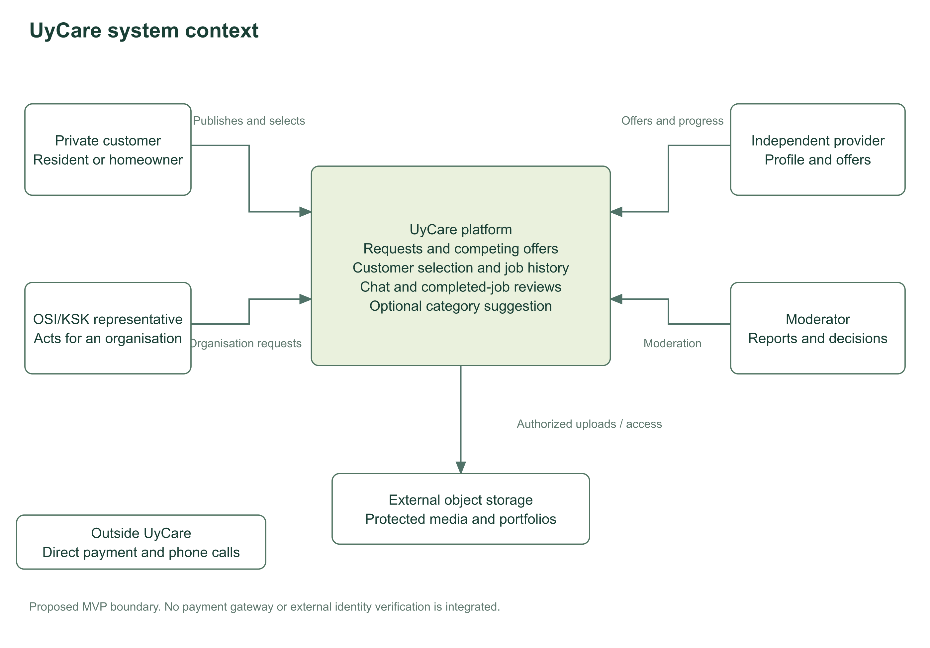
Editable source: diagrams/system-context.drawio. Readable export: diagrams/system-context.svg.

Actor participation in core use cases
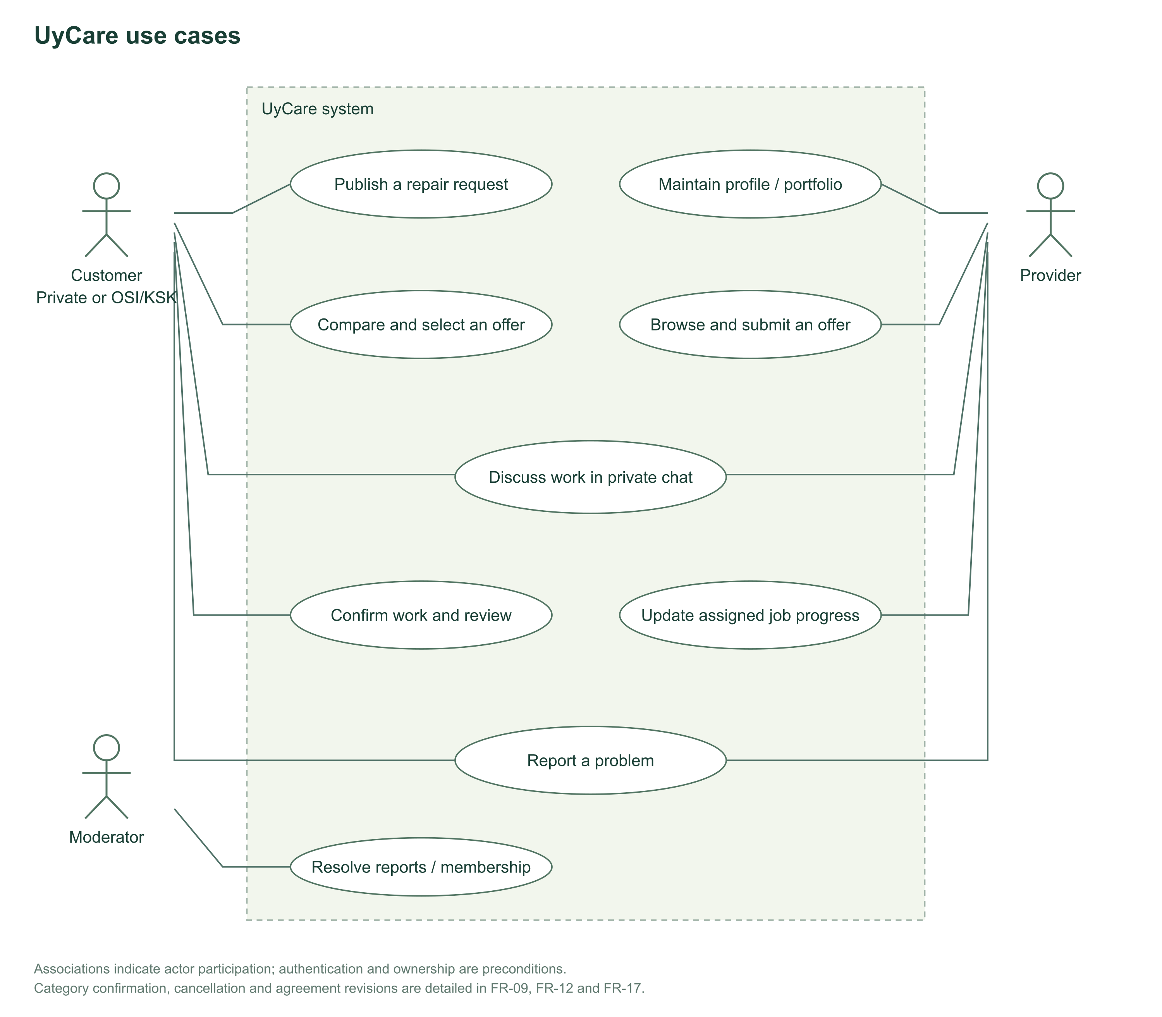
Editable source: diagrams/use-cases.drawio. Readable export: diagrams/use-cases.svg.

Proposed component responsibilities and storage
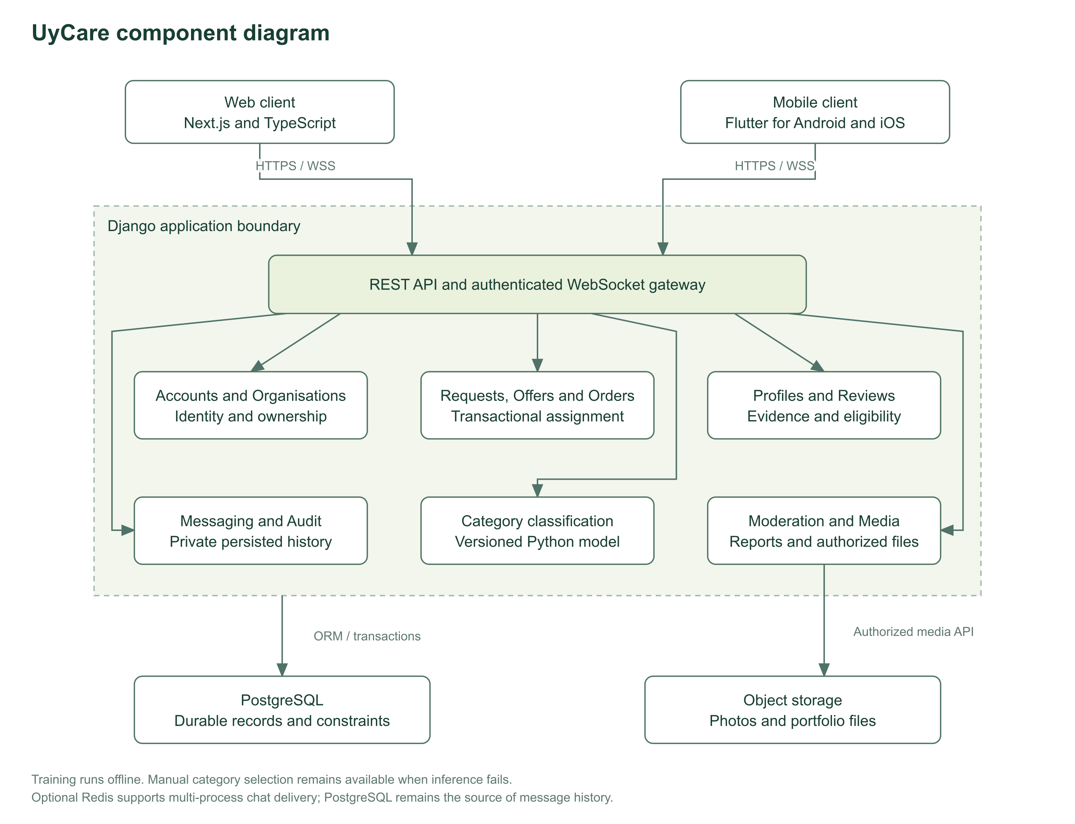
Editable source: diagrams/components.drawio. Readable export: diagrams/components.svg.

Job states and authorised transitions
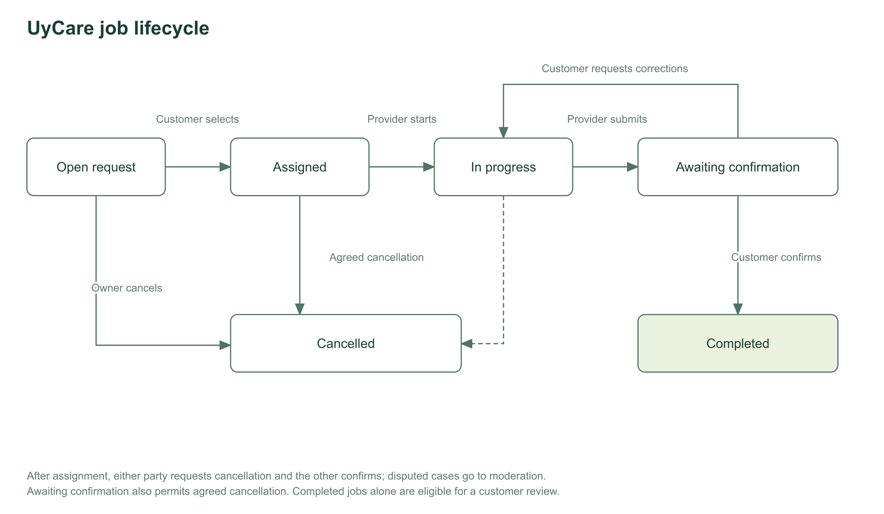
Editable source: diagrams/job-lifecycle.drawio. Readable export: diagrams/job-lifecycle.svg.

Appendix B Requirements traceability
All implementation verification is initially Not run. Prototype coverage is interaction evidence only.
Requirement | Component | Test | Planning task | Basis | Status
FR-01 | Accounts | AT-01 | UCPLAN-13 | Team scope; H1–H6 pending validation | Not run
FR-02 | Requests | AT-02 | UCPLAN-14 | Team scope; H1–H6 pending validation | Not run
FR-03 | Media | AT-03 | UCPLAN-14 | Team scope; H1–H6 pending validation | Not run
FR-04 | Requests | AT-04 | UCPLAN-14 | Team scope; H1–H6 pending validation | Not run
FR-05 | Offers | AT-05 | UCPLAN-15 | Team scope; H1–H6 pending validation | Not run
FR-06 | Profiles | AT-06 | UCPLAN-16 | Team scope; H1–H6 pending validation | Not run
FR-07 | Orders | AT-07 | UCPLAN-15 | Team scope; H1–H6 pending validation | Not run
FR-08 | Orders | AT-08 | UCPLAN-17 | Team scope; H1–H6 pending validation | Not run
FR-09 | Orders | AT-09 | UCPLAN-17 | Team scope; H1–H6 pending validation | Not run
FR-10 | Messaging | AT-10 | UCPLAN-18 | Team scope; H1–H6 pending validation | Not run
FR-11 | Messaging | AT-11 | UCPLAN-18 | Team scope; H1–H6 pending validation | Not run
FR-12 | Classification | AT-12 | UCPLAN-21 | Team scope; H1–H6 pending validation | Not run
FR-13 | Reviews | AT-13 | UCPLAN-16 | Team scope; H1–H6 pending validation | Not run
FR-14 | Profiles | AT-14 | UCPLAN-16 | Team scope; H1–H6 pending validation | Not run
FR-15 | Moderation | AT-15 | UCPLAN-19 | Team scope; H1–H6 pending validation | Not run
FR-16 | Organisations | AT-16 | UCPLAN-13 | Team scope; H1–H6 pending validation | Not run
FR-17 | Orders | AT-17 | UCPLAN-17 | Team scope; H1–H6 pending validation | Not run
FR-18 | Orders | AT-18 | UCPLAN-28 | Team scope; H1–H6 pending validation | Not run
NFR-01 | Cross-cutting | NT-01 | UCPLAN-13 | Engineering target; review pending | Not run
NFR-02 | Cross-cutting | NT-02 | UCPLAN-15 | Engineering target; review pending | Not run
NFR-03 | Cross-cutting | NT-03 | UCPLAN-25 | Engineering target; review pending | Not run
NFR-04 | Cross-cutting | NT-04 | UCPLAN-25 | Engineering target; review pending | Not run
NFR-05 | Cross-cutting | NT-05 | UCPLAN-24 | Engineering target; review pending | Not run
NFR-06 | Cross-cutting | NT-06 | UCPLAN-24 | Engineering target; review pending | Not run
NFR-07 | Cross-cutting | NT-07 | UCPLAN-24 | Engineering target; review pending | Not run
NFR-08 | Cross-cutting | NT-08 | UCPLAN-23 | Engineering target; review pending | Not run
NFR-09 | Cross-cutting | NT-09 | UCPLAN-21 | Engineering target; review pending | Not run
NFR-10 | Cross-cutting | NT-10 | UCPLAN-27 | Engineering target; review pending | Not run
NFR-11 | Cross-cutting | NT-11 | UCPLAN-07 | Engineering target; review pending | Not run
NFR-12 | Cross-cutting | NT-12 | UCPLAN-19 | Engineering target; review pending | Not run

Appendix C Repository and submission obligations
Submission date: 24 October, assumed 2026. Actual submission commit and tag: not yet selected. Repository: https://github.com/f0nce/UyCare. YouTrack: not created.

Prepared artifacts
- Project README, proposal, scope and team allocation.
- Focused literature review with eight published scientific sources, two additional research reports and official supporting sources.
- Three-system comparison using ten criteria and four technical decisions with three alternatives each.
- Eighteen functional and twelve nonfunctional requirements with acceptance criteria and traceability.
- Editable context, use-case, component and lifecycle diagrams with SVG exports.
- Portable browser prototype and demonstration instructions.
- Verification, user-baseline and ML evaluation plans.
- Twenty-eight prioritised planning tasks with owners, proposed deadlines and acceptance criteria.
- Supervisor feedback and interview instruments.

Obligations that remain external or unverified
- Conduct 3–5 real user discussions or obtain a substantive client agreement.
- Obtain substantive supervisor feedback and record resulting revisions.
- Create YouTrack, map actual accounts, import tasks and add its live link.
- Review the published preparation branch with another team member and address their comments.
- Demonstrate genuine progressive contributions from each student. A generated starting package does not meet this historical requirement.
- Confirm the academic calendar and language scope for ML.

Submission procedure
After peer review, merge the intended submission into main. Record its commit hash, completed work, limitations and outstanding tasks in submission/release-notes.md. Create the annotated pre-defense-1 tag on that exact commit and push it once. Do not move it later. Grant the supervisor and committee access before the presentation. Repeat with pre-defense-2 and final-pre-defense at the relevant stages.

Demonstration sequence
Show README and structure, then source history. Trace one actual YouTrack task to its branch, PR, reviewer comment, revision and artifact. Open an editable diagram and its export. Run the prototype and explain its limitations. Show the verification plan and open evidence items. Each member explains their real contribution. Do not present planned backend/mobile work as running software.

