Hattama
  - Development of a Platform for Automated Meeting Minutes Generation in Kazakh and Russian Using Neural Network Models
First pre-defense analysis and design package
23 October 2026
This report updates the existing diploma analysis and design package to match Hattama, the implemented local meeting-minutes application. It covers uploaded Kazakh and Russian audio, local speech recognition and speaker attribution, neural draft generation, editable review fields and saved DOCX export. Live meeting connection remains a planned extension. The eleven assessment areas distinguish implementation evidence, research findings and work still pending.

Project team
Member | Responsibility
Akhmetov Kazbek | Frontend and backend
Uranov Daryn | Machine learning and backend
Tazhibayev Marsel | Team lead and workflow coordination

Supervisor: Elvira Aitmukhambetovna

Submission status
Working hackathon baseline: github.com/f0nce/hattama, commit 13d2271. This documentation update preserves the application. Published research supports relevance; illustrative scenarios are labelled. The supervisor review is a draft for confirmation. The team reports an existing YouTrack project, but its URL, access and task mapping remain pending. Teammate review and a submission tag are still required.

Contents
1. Hattama project proposal and scope
2. Relevance and evidence of user needs
3. Literature review
4. Existing system comparison
5. Technology and model comparison
6. Requirements specification
7. Hattama architecture and data design
8. Working interface and demonstration
9. Verification and evaluation plan
10. Project management and risks
11. Supervisor review and response
12. References
Appendix A. Architecture diagrams
Appendix B. Requirements traceability
Appendix C. Remaining manual work

Companion package
The repository package contains English source documents, a 35-source register including eleven scientific publications, three-system comparison, seven technical decisions including four generation models, 21 functional and 13 nonfunctional requirements, four editable diagrams, the working application demo guide, an evaluation plan and 33 planning tasks. Historical hackathon measurements are explicitly separated from fresh checks and proposed targets.

Hattama project proposal and scope

Project identity
Development of a Platform for Automated Meeting Minutes Generation in Kazakh and Russian Using Neural Network Models
Hattama is an existing local meeting-minutes application developed during a hackathon. This diploma project extends and evaluates that application. A user uploads a recording, supplies meeting context, inspects the generated transcript and tasks, saves corrections and exports a DOCX. The first pre-defense submission combines the existing implementation with an updated research and engineering specification. Baseline source: commit 13d2271 [S35].
Member | Diploma responsibility
Akhmetov Kazbek | Frontend and backend integration, recording workflow, persisted review and exports
Uranov Daryn | Speech and language models, diarization, evaluation data and reproducible experiments
Tazhibayev Marsel | Team lead, shared contracts, scope, integration, review and submission coordination

Supervisor: Elvira Aitmukhambetovna. The team reports that the topic is agreed. University/programme details and the final defense date remain to be supplied. Individual Git accounts must be mapped to these real names by the team; this report does not infer identity from nicknames.

Problem and target users
Meeting coordinators and secretaries need to turn discussions into accurate summaries and actionable tasks. Code-switching, overlapping speech, uncertain names and relative dates can make automatic output unreliable. Published research establishes the relevance of evidence alignment and user correction [S06, S07, S28]. The repository records an omitted deadline and an incorrect summary in one model run [S35]. The prevalence and cost of these problems among Kazakhstan users remain to be established locally.
Primary users are coordinators, secretaries and project-team members who prepare minutes on a local computer. A human checks the resulting document before sharing it. The current application has no separate authenticated reviewer or administrator accounts. Local operating-system access is the security boundary; a shared web service is outside the delivered baseline.

Aim and objectives
The aim is to develop and evaluate an offline-capable platform that reduces active preparation effort while producing reviewable Kazakh and Russian meeting minutes.
1. Establish user needs using published evidence and actual user discussions, with assumptions explicitly separated.
2. Preserve and document the working recording-to-DOCX flow and its local processing boundary.
3. Evaluate Kazakh, Russian and mixed-speech transcription and speaker attribution on independently annotated data.
4. Compare the current generator with feasible local alternatives and an extractive baseline using the same meeting tasks.
5. Improve measured errors in task owners, deadlines, evidence references and summary faithfulness.
6. Explore live meeting ingestion only after an explicit feasibility gate; retain upload as the working baseline.

Implemented baseline and planned development
The baseline uses React/Vite with TypeScript, FastAPI, SQLite, local audio files and a separate Python worker. The bundled pipeline uses mixed-CTC speech recognition, sherpa-onnx speaker diarization and a 4-bit Qwen3-4B-Instruct-2507 checkpoint. Mac uses MLX; the Windows path executes the quantized checkpoint through a PyTorch adapter. Weights and hashes are pinned [S21, S33–S35].
Implemented input formats are WAV, MP3, M4A and FLAC with a default 100 MiB upload limit. The application preserves the machine result and the latest saved correction. Participants, tasks and summary are editable; transcript segments and source metadata are not editable in the current review API. Export uses one saved revision. This is a useful application, not a complete multiuser approval system.
Diploma extensions prioritise bilingual evaluation, error reduction, usable review and performance measurement. Live connection is planned research/development, not an implemented feature. The earlier 500 MB/60-minute specification is superseded by the actual baseline: 100 MiB; supported recording duration must be measured rather than claimed. Native mobile apps, several meeting providers and automatic external task execution remain outside the current scope.

Expected outcomes and engineering contribution
Expected outcomes are a reproducible Hattama release, a coherent English documentation package, editable diagrams, a traceable task/review history and a controlled evaluation of accuracy, performance and user effort. The diploma contribution builds on the hackathon baseline through documented research, verified improvements and evaluation; it must not present inherited code as newly developed work.
Engineering complexity includes process isolation, durable queued jobs, audio decoding, model orchestration, source-linked task extraction, schema validation, transactional review revisions and consistent DOCX export. Neither a larger model nor a passing interface test proves minutes quality. The first pre-defense may present implementation plus an evaluation plan without claiming completed final experiments.

Relevance and evidence of user needs

Evidence that is available
Three forms of evidence are kept separate: published studies, repository observations and direct user discovery. The topic agreement is reported by the team. No completed local interviews or client agreement have been supplied. The team reports permission to use constructed examples; such examples below are labelled illustrative and are not participant testimony. If the committee accepts an alternative to its written interview requirement, retain that explicit decision.
Evidence | Verified observation or author report | Project implication and limit
Meetalk 2025 [S28] | Authors describe ASR plus generated minutes adapted through user examples/corrections and report a user study in five meeting scenarios | Supports editable drafts and review cues; does not prove Kazakhstan user demand or Hattama quality
MeetingBank 2023 [S07] | Professional minutes are aligned with segments of public council meetings | Supports source-linked output and long-recording evaluation; language and setting differ
ExplainMeetSum 2023 [S06] | Meeting summaries are connected to supporting evidence | Motivates source references; a valid source ID alone does not establish truth
Hattama recorded Windows run [S35] | One synthetic Russian input produced an omitted relative deadline and an incorrect summary | Demonstrates an actual failure mode in this implementation; one run is not a prevalence estimate

Meetalk is used at the level supported by its published abstract; this package does not claim an independent replication. Literature supports the design rationale. Local efficiency gains, preferred output format and willingness to use the platform remain hypotheses.

Illustrative scenarios for requirements discussion
The following are constructed design scenarios, not interviews, quotations or measured observations.
1. A university coordinator reviews a mixed-language meeting. A task says that a document is needed by the following day, but the generator omits the date. The user checks the cited segment and supplies the verified deadline.
2. A project-team secretary sees a speaker label assigned to the wrong participant. The user remaps the label, verifies task owners and saves the correction before DOCX export.
3. A local administrator requires recording contents to remain on the workstation. Dependencies and model weights are prepared beforehand, and inference is tested with networking disabled.
These scenarios motivate FR-06, FR-08, FR-09 and NFR-05. They must not be counted as completed discussions or used to claim time savings.

Primary evidence still to collect
Recruit 3–5 distinct user representatives: two coordinators/secretaries, one meeting chair, one bilingual participant and, if available, an information owner. Discuss the most recent actual meeting before showing the interface. Ask how minutes were prepared, what was corrected, which languages were used, how deadlines were resolved and what sharing restrictions applied. Record actual dates, roles, consent and counterexamples.
Use the interview template and evidence register. Link each finding to a requirement change. A written exchange can provide useful evidence if substantive and accepted by the supervisor; the team must not assume that fictional scenarios meet the original rubric. If an alternative assessment route is permitted, record who authorised it and what evidence is required instead.

Hypotheses to test
Hypothesis | Evidence required | Decision affected
Review takes less active time than manual preparation | Paired user study with quality guardrail | NFR-07 usability benefit
Mixed speech increases correction effort | Annotated language spans and observed corrections | Model selection and evaluation strata
Users need traceable task sources | Actual disputed-task examples | FR-05 and FR-08 evidence workflow
Offline processing matters to the target setting | Stated data-handling constraints | Local deployment boundary

Literature review

Review method and boundaries
This focused design review uses eleven scientific publications published in 2021–2025 and official product and technology sources. Scientific records were checked on ACL Anthology, the ISCA archive and PMLR; product claims were checked against official help pages on 23 October 2026. Searches covered Kazakh ASR, long-form transcription, diarization, meeting summarization, evidence alignment and summary evaluation. The reference register contains 35 meaningfully used sources.
Inclusion required a clear connection to a pipeline component, evaluation method or design risk. Papers without a usable method or relevant limitation were excluded. This is a structured engineering review, not an exhaustive systematic review. No paper is evidence that the proposed platform already works on Kazakhstan meeting data. The core includes nine papers from 2022–2025. Two 2021 papers are retained for their meeting-benchmark and evaluation methods; they are outside the rolling five-year window.

Speech recognition and speaker attribution
KSC2 provides a substantial Kazakh speech resource that includes varied domains and code-switching [S01]. It is relevant to ASR development but does not provide the proposed meeting-minute annotations. Training or tuning on public speech cannot replace a held-out meeting evaluation. Dataset versions, access conditions and licenses must be checked for the exact files used.
Whisper supplies a multilingual neural transcription starting point [S02]. The platform must use original-language transcription rather than automatic translation to English, retain uncertain passages for review, and measure language-specific error. WhisperX motivates segmentation and alignment for long recordings [S03]. Word-level alignment for Kazakh is not assumed available; segment timestamps are the mandatory fallback. The pyannote pipeline illustrates speaker diarization as segmentation and clustering [S04]. A cluster label is not a verified personal identity, so names must be supplied or corrected by users.

Meeting summarization and evidence
QMSum frames a meeting as multiple discussions from which relevant evidence must be selected [S05]. ExplainMeetSum makes the relationship between summary statements and source evidence explicit [S06]. These motivate generation from selected segments, evidence IDs on each decision or action, and source navigation in the editor. A syntactically valid source ID does not demonstrate that the source actually supports the generated statement; human entailment review remains necessary.
MeetingBank connects long transcripts with professionally prepared minutes [S07]. Its domain and language differ from the target setting, so its value is methodological: chunk long inputs, preserve source references and evaluate a structured output. Chunking can split a proposal from its later rejection. The proposed pipeline therefore retains surrounding context and performs a cross-chunk consolidation pass that preserves disagreements and corrections.

Evaluation and unresolved limitations
SummEval supports combining automatic metrics with human assessment instead of equating lexical overlap with quality [S08]. Meeting-specific error analysis highlights omissions, attribution problems and unsupported statements [S09]. MESA explores automated quality estimation, but an LLM evaluator is not independent ground truth [S10]. The project will use two bilingual annotators, adjudicate disagreements and report both end-to-end and corrected-transcript results to separate ASR errors from generation errors.
The research gap addressed by this project is an evaluated, reviewable implementation for a defined Kazakh/Russian user setting. It is not a claim that bilingual transcription or meeting summarization is new. Local user benefit, mixed-language accuracy and hardware feasibility remain unanswered research questions.

Structured publication analysis
Source | Approach or finding | Limitation for this project | Design consequence
S01 KSC2, 2022 | Kazakh speech corpus with diverse sources | Not a meeting-minutes benchmark | Document data provenance; reserve in-domain meetings
S02 Whisper, 2023 | Multilingual weakly supervised ASR | Uneven language and domain performance | Measure WER/CER by language and noise condition
S03 WhisperX, 2023 | Long-audio segmentation and alignment | Alignment model coverage is language dependent | Require segment timestamps; test optional word alignment
S04 pyannote, 2023 | Neural diarization pipeline | Overlap and domain shift affect clustering | Anonymous labels, manual mapping and DER measurement
S05 QMSum, 2021 | Locate relevant discussion before summarizing | English benchmark and query-oriented task | Preserve context when selecting evidence
S06 ExplainMeetSum, 2023 | Evidence-aligned meeting summaries | Evidence IDs alone do not prove factuality | Human-check source support for every important item
S07 MeetingBank, 2023 | Long meetings aligned with professional minutes | Public council setting differs from project teams | Chunk and consolidate with traceable references
S08 SummEval, 2021 | Compares automatic and human evaluation | News summarization differs from meetings | Use task-level accuracy and human review
S09 What’s Wrong, 2025 | Identifies and refines meeting-summary errors | Refinement cannot guarantee correctness | Track omissions, invented content and wrong attribution
S10 MESA, 2025 | Multi-model estimation of summary quality | Judge models have their own errors | Use automated judges only as auxiliary diagnostics

Every source is used above to change a design or evaluation decision. Full bibliographic records and direct links appear in the references chapter and docs/sources.json.

User correction in meeting systems
Meetalk [S28] combines speech recognition with generated minutes informed by user examples and corrections. Its authors report benefits in five meeting scenarios. This supports studying a correction workflow, but the abstract does not establish Kazakh/Russian performance or justify adding personalization to the required scope. Hattama already preserves corrections and the original output; the diploma should measure whether this workflow reduces effort without losing factual quality.
Source | Approach | Limitation for Hattama | Design use
Meetalk 2025 S28 | Generation informed by examples and user corrections | Published abstract reviewed; local bilingual generalisation not established | Evaluate corrections and reviewer effort; keep personalization optional

Alignment with the implementation
Whisper and pyannote papers inform alternatives and evaluation rather than describing the active default stack. Hattama currently uses mixed-CTC ASR and sherpa-onnx diarization [S33, S34]. The model and technology comparison distinguishes this implemented baseline from untested alternatives.

Existing system comparison

Method
Three relevant meeting-assistant systems are compared using ten consistent criteria. Official documentation was reviewed on 23 October 2026. This is desk research, not hands-on benchmarking. Features and plan limits can change; no quality, speed or price rankings are inferred from marketing claims.
Documented means explicitly described in the cited page. Not listed means absent from the published source-language list, not an independently tested failure. Not established means the reviewed documents do not establish the capability. The Hattama column describes the current implementation; quality is not established by feature presence.
Criterion | Fireflies.ai | Notta | Otter.ai | Hattama baseline
1 Recording upload | Documented S12 | Documented S14 | Documented S18 | WAV, MP3, M4A, FLAC
2 Kazakh source transcription | Listed S11 | Not listed S13 | Not listed S17 | Implemented; quality evaluation pending
3 Russian source transcription | Listed S11 | Listed S13 | Not listed S17 | Implemented; quality evaluation pending
4 Kazakh–Russian mixed speech | Exact pair not established S11 | Kazakh not in bilingual source list S14 | Neither source language listed S17 | Required evaluation stratum
5 Summary and action items | Documented S12 | AI Notes and tasks S15 | Documented S19 | Structured draft with unknown fields
6 Editable generated content | Not established in reviewed pages | AI Notes editable S15 | Conversations editable S18 | Participants, tasks and summary
7 Export | Download documented S12 | Notes export S16 | Export documented S18 | DOCX export; JSON via API
8 Item-level source evidence | Not established | Not established | Not established | Task source IDs validated; summary support needs review
9 Revision and approval control | Not established | Not established | Not established | No formal approval; save conflict check
10 Self-managed inference deployment | Not established | Not established | Not established | Implemented local model stages

Notta's Kazakh translation target must not be confused with Kazakh audio transcription support [S13]. Fireflies already lists both target languages [S11]; therefore the title's language pair alone is not a defensible uniqueness claim. “Not established” cells must not be presented as missing product features.

Rationale for the proposed solution
The project combines task source links, unknown-value handling, a preserved machine original and local neural processing. A language-stratified evaluation will assess its practical value. Interviews must establish whether those priorities solve a meaningful local problem. A matched manual workflow is the feasible primary baseline; competitor benchmarking would require comparable access, consent and test conditions and is optional.
A follow-up product audit should record plan, product version, test recording, language mode and observed result. It should revisit undocumented cells before any claim of superiority is made. The system comparison is sufficient to motivate design choices, not to prove market demand.

Technology and model comparison

Decision basis
The working hackathon implementation is the starting point. Selection criteria are local processing, Kazakh/Russian accuracy, maintainability for three students, reproducibility and the measured hardware budget. Alternatives below are engineering comparisons, not benchmark rankings. The existing stack is retained until a controlled experiment justifies a change [S35].

Server platform
Alternative | Fit and tradeoff | Decision
FastAPI with Python | Existing typed API and direct Python pipeline integration; heavy work stays outside the API | Retain [S22, S35]
Django with DRF | Suitable if a broader account/admin product becomes necessary; migration adds work | Reserve for changed requirements
NestJS with TypeScript | Shares language with UI; still requires Python model integration | No demonstrated benefit over existing API

Data storage
Alternative | Fit and tradeoff | Decision
SQLite and local files | Embedded deployment, transactions and no database server; current single-worker boundary | Retain [S32, S35]
PostgreSQL and object storage | Better candidate for a networked multiuser deployment; introduces services and access design | Future scaling option [S24]
JSON files and local files | Simple for a disposable demo; application must implement safe concurrent updates and recovery | Reject for mutable queue/review state

SQLite is used with short transactions and WAL mode. The application uses a single worker and local files. This is a deliberate deployment boundary rather than a claim that SQLite meets arbitrary concurrent-server requirements.

Component interaction and jobs
Alternative | Fit and tradeoff | Decision
REST, UI polling and separate SQLite-backed worker | Existing persisted jobs and real stages; one machine, one worker | Retain
Celery with Redis and REST | Suitable for multiple workers but adds broker, deployment and recovery concerns | Reconsider only for scaling [S23]
In-process background task | Fewer processes but ties inference lifetime and resources to the web process | Reject for the core flow

The worker claims jobs transactionally, models run outside database transactions, and interrupted jobs become visible failures. This design must be evaluated as implemented; it does not use an outbox, SSE or distributed queue.

Speech recognition
Alternative | Evidence and limitation | Decision
Kazakh Russian mixed CTC checkpoint | Current bundled model; local evidence files exist; controlled bilingual quality is incomplete | Baseline [S34, S35]
Whisper large v3 turbo | Multilingual comparison path and recorded small-clip tests; same data/normalization needed | ASR challenger [S02, S20, S35]
Kazakh-tuned Whisper turbo | Repository pins a community variant; mixed/Russian robustness requires separate checking | Development challenger [S35]

The repository includes small synthetic-clip comparisons and real-audio timing records. Do not generalise those results to all meetings. Compare models on identical whole-meeting splits and report WER/CER separately by language. Public corpus studies such as KSC2 guide data design, not a guarantee for the current checkpoint [S01].

Speaker diarization
Alternative | Fit and limitation | Decision
sherpa onnx segmentation plus speaker embeddings | Current local pipeline with pinned assets | Retain and measure DER [S33, S35]
pyannote pipeline | Established alternative; exact model access, dependencies and license must be checked | Controlled comparison if feasible [S04]
Manual speaker assignment only | Low compute, high manual effort and no automatic grouping | Human baseline and correction fallback

Speaker clusters are not verified identities. Manual mapping to named participants remains necessary.

Language models for minutes
The exact candidates are Qwen3-4B-Instruct-2507, Llama-3.1-8B-Instruct, Gemma-3-12B-IT and NVIDIA-Nemotron-3-Nano-30B-A3B-BF16. The latter three are comparison candidates, not installed replacements. Card context limits describe model capabilities, not the configured Hattama runtime.
Model | Model scale and context | Language and resource consideration | Project decision
Qwen3 4B Instruct 2507 | 4B dense; upstream context 262144 tokens | Existing 4-bit local checkpoint; Windows application limits total context to 2048 and output to 512 tokens | Retain baseline; improve measured errors [S21, S35]
Llama 3.1 8B Instruct | 8B dense; 128K context | Its eight explicitly supported languages exclude Kazakh/Russian; custom Llama license and adaptation need review | Conditional research candidate, not a bilingual default [S29]
Gemma 3 12B IT | 12B class; 128K input context | Card describes 140+ languages; this is not a Kazakh minutes benchmark. Larger memory footprint; Gemma terms apply | Larger multilingual challenger if resources permit [S30]
Nemotron 3 Nano 30B A3B | Hybrid MoE; about 30B total and 3B active; up to 1M context | Listed supported languages do not establish Kazakh/Russian coverage; low active count does not remove total-weight storage cost | Resource-gated challenger; NVIDIA model license [S31]

A rough arithmetic check gives about 2, 4, 6 and 15 GB for weights alone at 4 bits per parameter for the nominal sizes above. These are estimates, not measured RAM/VRAM requirements; scales, embeddings, caches, activations and runtime overhead add memory. MoE still stores inactive experts. Neither Gemma 12B nor Nemotron 30B is promised to fit the recorded 4 GB GPU. Quantization or offloading changes the performance comparison and must be disclosed.
Run generation on the same corrected transcript set first to isolate generation quality. Compare source-supported task precision, task recall, owner/date correctness, summary errors, schema failures, processing time and memory. Use the same output schema and documented decoding settings; allow model-appropriate templates. Then measure the full ASR-to-DOCX pipeline. Qwen is retained for integration and resource evidence, not because an unperformed benchmark proved it best.

Live meeting development
Alternative | Dependency and limitation | Decision
Zoom RTMS | Authorised app, media scopes, events and credits; new adapter and streaming evaluation | First external-connector candidate, not implemented [S26]
Google Meet Media API | Current documented preview access restrictions | Defer and recheck availability [S27]
Local microphone capture | Suitable for an in-room meeting; does not guarantee remote participant audio | Separate possible local extension

The shipped baseline ingests uploaded recordings and keeps inference local. Adding a meeting-provider connection does not imply sending meeting content to a cloud AI service. A live feature requires a separately reviewed scope, permission model, buffer/reconnect behavior and latency measurements. The old 15-second live target is not a current performance claim.

Requirements specification

Priority and status
This revision replaces the earlier speculative cloud design with the Hattama baseline. Must denotes the local diploma acceptance baseline, not a claim that every quality target already passes. Should denotes an extension or secondary target. Implementation status is based on source inspection and recorded evidence; experiment targets remain provisional. The existing API contract remains unchanged.

Functional requirements

FR 01 Local access boundary
Priority: Must. Status: Baseline.
Acceptance: The documented launcher binds the API to loopback. The UI does not claim authenticated multiuser roles. Public deployment is excluded.
Responsible component: Launch/API. Verification: T01.

FR 02 Recording upload
Priority: Must. Status: Baseline.
Acceptance: Accept decodable WAV, MP3, M4A and FLAC with the configured default 100 MiB limit. Reject invalid input before inference; generated file paths must not use client path traversal.
Responsible component: API/audio. Verification: T02.

FR 03 Persistent job processing
Priority: Must. Status: Baseline.
Acceptance: A valid upload returns 202 and a persisted meeting ID. A separate worker moves queued to processing and then done or failed; status remains queryable.
Responsible component: Store/worker. Verification: T03.

FR 04 Original language transcription
Priority: Must. Status: Baseline.
Acceptance: Produce timestamped Kazakh/Russian source segments without translating all content into English. Measure linguistic quality under NFR-01; do not infer quality from schema validity.
Responsible component: ASR. Verification: T04.

FR 05 Task source navigation
Priority: Must. Status: Baseline.
Acceptance: Each task references existing source segment IDs. Selecting evidence displays the corresponding source text; a newly edited task must retain valid sources.
Responsible component: UI/validation. Verification: T05.

FR 06 Speaker mapping
Priority: Must. Status: Baseline.
Acceptance: Map anonymous speaker labels to supplied participants and reject duplicate ownership of one label. A label is not a verified identity.
Responsible component: Review. Verification: T06.

FR 07 Tasks and summary
Priority: Must. Status: Baseline.
Acceptance: Return schema-valid tasks and a summary. Missing owner or deadline remains null and requires review; empty tasks are valid when no commitment is supported.
Responsible component: Pipeline. Verification: T07.

FR 08 Result validation
Priority: Must. Status: Baseline.
Acceptance: Reject unknown sources/participants, invalid dates, duplicate IDs and invalid timestamps. Semantic support is checked by a human, not implied by validation.
Responsible component: Validation. Verification: T08.

FR 09 Persisted corrections
Priority: Must. Status: Baseline.
Acceptance: For a done meeting, save participants, tasks and summary, increment revision and preserve edits after restart. Segments and original metadata are not editable in this API.
Responsible component: Store/review. Verification: T09.

FR 10 Immutable machine original
Priority: Must. Status: Baseline.
Acceptance: GET original returns the unchanged machine output after any saved user correction. Store the latest correction separately; do not claim full edit history.
Responsible component: Store. Verification: T10.

FR 11 DOCX export
Priority: Must. Status: Baseline.
Acceptance: Export one consistent saved revision containing metadata, participants, tasks, summary and transcript. Unsaved UI edits block export; fixture output is visibly labelled.
Responsible component: Export/UI. Verification: T11.

FR 12 Meeting library
Priority: Must. Status: Baseline.
Acceptance: List saved meetings newest first and open their status/details after restart. Do not claim search or pagination absent from the API.
Responsible component: API/UI. Verification: T12.

FR 13 Retry failed jobs
Priority: Must. Status: Baseline.
Acceptance: Only failed meetings can be requeued. Retrying queued, processing or successful meetings returns a conflict and does not discard saved successful edits.
Responsible component: Store. Verification: T13.

FR 14 Deletion
Priority: Must. Status: Baseline.
Acceptance: Delete permitted non-processing meetings and associated audio. Reject processing deletion and do not return success if file removal fails.
Responsible component: Store/API. Verification: T14.

FR 15 Processing visibility
Priority: Must. Status: Baseline.
Acceptance: Show actual pipeline stages and safe errors. No invented percentage or silent fallback to synthetic output is displayed.
Responsible component: Worker/UI. Verification: T15.

FR 16 Meeting context
Priority: Must. Status: Baseline.
Acceptance: Validate title, actual meeting datetime with offset, IANA timezone and participant metadata. Reject invalid or ambiguous local datetime input in the UI.
Responsible component: API/UI. Verification: T16.

FR 17 Concurrent review protection
Priority: Must. Status: Baseline.
Acceptance: Save against expected_revision in a transaction. A stale edit returns 409 REVISION_CONFLICT and cannot overwrite a newer saved review.
Responsible component: Store. Verification: T17.

FR 18 Failure and fixture separation
Priority: Must. Status: Baseline.
Acceptance: A model failure yields failed status with safe details. Fixture mode is explicit configuration, visibly labelled and never an automatic error fallback.
Responsible component: Pipeline/API. Verification: T18.

FR 19 Live meeting ingestion
Priority: Should. Status: Planned extension.
Acceptance: Before implementation agree one authorised input mode. Demonstrate ordered incremental segments, visible gaps and a reconciled final result on controlled meetings.
Responsible component: Future connector. Verification: T19.

FR 20 Transcript editing and full revisions
Priority: Should. Status: Planned extension.
Acceptance: Persist all source/minutes revisions and invalidate derived content on a source edit. Requires a new contract; not supplied by the current latest-review store.
Responsible component: Future revisions. Verification: T20.

FR 21 Authenticated shared review
Priority: Should. Status: Planned extension.
Acceptance: If shared deployment is approved, enforce owner/editor/reviewer/viewer permissions and revision-bound approval. Cross-meeting access tests must pass.
Responsible component: Future identity. Verification: T21.

Nonfunctional requirements

NFR 01 Bilingual ASR quality
Priority: Must. Status: Evaluation pending.
Acceptance: Report WER/CER separately for Kazakh, Russian and mixed held-out meetings with fixed normalization. Provisional WER targets: 25%, 20% and 30%; confirm before final testing.
Verification: E01.

NFR 02 Minutes factuality
Priority: Must. Status: Evaluation pending.
Acceptance: Target at least 95% supported-task precision and task-tuple F1 at least 0.80 per stratum. Report omissions, incorrect owners/dates and summary errors; zero output is not perfect accuracy.
Verification: E02.

NFR 03 Measured performance
Priority: Must. Status: Partial historical evidence.
Acceptance: Record total/stage time and memory on a named host for 1-, 10- and 30-minute inputs where feasible. Report RTF without claiming real-time speed. Establish a duration target after a pilot.
Verification: E03.

NFR 04 API responsiveness
Priority: Must. Status: Evaluation pending.
Acceptance: During one active worker job, measure status/metadata p95 under five local clients for ten minutes; provisional target under one second excluding upload/inference.
Verification: E04.

NFR 05 Local content processing
Priority: Must. Status: Implemented controls; OS test pending.
Acceptance: Load local weights without cloud AI fallback. Test processing under OS network isolation; distinguish library offline flags and Python socket guards from proof of full isolation.
Verification: E05.

NFR 06 Recovery
Priority: Must. Status: Baseline tests available.
Acceptance: After interrupted processing and worker restart, interrupted jobs become visible failures and can be retried. Persisted successful reviews survive restart.
Verification: T03.

NFR 07 Usability benefit
Priority: Must. Status: Evaluation pending.
Acceptance: In a paired study of 6–8 users, target at least 80% unaided completion and 20% lower median active time than manual preparation without lower factual quality.
Verification: E06.

NFR 08 Usable bilingual interface
Priority: Must. Status: Evaluation pending.
Acceptance: Check keyboard reachability, labels, focus, small-screen layout and preservation of Kazakh characters in display and DOCX. Document accessibility gaps.
Verification: T22.

NFR 09 Reproducibility
Priority: Must. Status: Baseline manifests available.
Acceptance: Each experiment records code commit, model hashes, data IDs/split, prompt/settings, hardware and result files; another member repeats one case.
Verification: E07.

NFR 10 Recording retention
Priority: Should. Status: Policy pending.
Acceptance: Document storage location and an agreed cleanup/backup policy. Verify API deletion behavior and manual cleanup of crash remnants; no automatic 30-day backup expiry is claimed.
Verification: T14.

NFR 11 Untrusted content handling
Priority: Must. Status: Baseline validation; adversarial tests pending.
Acceptance: Treat transcript text as data. Generation cannot execute tasks. Check escaping and malformed results; valid schema alone does not prevent misleading content.
Verification: T23.

NFR 12 Speaker quality
Priority: Should. Status: Evaluation pending.
Acceptance: Measure DER with declared overlap treatment and a 0.25-second collar on 2–6-speaker references; proposed 20% target requires pilot review.
Verification: E08.

NFR 13 Live latency
Priority: Should. Status: Planned extension.
Acceptance: If live ingestion is built, report audio-chunk-close-to-visible-text p95, gaps and finalization delay. Set a hardware-specific target before acceptance.
Verification: E09.

Hattama architecture and data design

Current system boundary
The architecture describes source commit 13d2271. A local browser runs React/Vite and calls FastAPI on loopback. SQLite stores meetings, jobs and reviews; local files hold recordings. A separate Python worker calls ai.pipeline.run_pipeline(input_data, on_progress=None). Model stages run locally in child processes. There is no Redis, Celery, PostgreSQL, S3 service, SSE or live meeting connector in this baseline [S35].
The user uploads, reviews and exports on the same trusted workstation. Human review is a workflow action; it is not a separately authenticated approval role. Downloaded dependencies and prepared model weights are deployment inputs, not inference-time cloud services.

Components and processing
Component | Implemented responsibility
frontend | Recording/context form, meeting list, status polling, participant/task/summary review and export controls
backend/app.py | HTTP validation, upload limit, routes, safe errors and static frontend serving
backend/store.py | SQLite transactions, queued jobs, original/latest-review data and revision conflicts
backend/worker.py | Single worker ownership, recovery and calling the AI pipeline
ai | Audio preparation, ASR, diarization, alignment, task/summary extraction and validation
backend/export.py | DOCX from one saved review revision
scripts and model manifests | Installation, launch, pinned weight assembly and checks

A validated upload creates queued state. The worker claims work with BEGIN IMMEDIATE, then runs inference outside the database transaction. Progress stages are preparing_audio, transcribing, diarizing, aligning, extracting_tasks, summarizing and validating. Summary and tasks are generated together. Success becomes done; an exception becomes failed. On worker restart, abandoned processing records become failed instead of silently pretending completion.

Data and revisions
The default application directory is .local/app. The database holds meeting context, state, stage, safe error information, original_json, review_json and a revision number. Audio files use server-generated paths. Result objects contain participants, timestamped segments, tasks, summary and warnings. Each task has source_segment_ids; unknown owner/date values remain null.
PUT review replaces participants, tasks and summary for a done meeting. Source segments and meeting metadata are immutable in this endpoint. expected_revision is checked transactionally; a concurrent outdated edit receives 409. The machine original remains unchanged. Only the latest saved review is retained; a revision counter is not a full historical log. A formal approval state is not implemented.

API summary
Method and path | Behavior
POST /api/v1/meetings | Validate audio/context; persist a queued meeting; return 202
GET /api/v1/meetings | List summaries without full result content
GET /api/v1/meetings/{id} | Return current status and result when done
GET /api/v1/meetings/{id}/original | Return immutable machine output
PUT /api/v1/meetings/{id}/review | Save permitted fields with expected_revision
POST /api/v1/meetings/{id}/retry | Requeue failed only
DELETE /api/v1/meetings/{id} | Remove non-processing meeting/audio; reject processing deletion
GET /api/v1/meetings/{id}/export.docx | Export one consistent saved revision

The authoritative HTTP contract is contracts/API.md at repository root. This diploma document introduces no new routes or schema fields.

Reliability and local processing
Single-worker locking prevents concurrent consumers for one database. Each heavy AI stage is a child process, allowing memory release between stages. Recorded Windows behavior uses an MLX-format 4-bit checkpoint through the PyTorch adapter. Current context/output limits are application settings and are lower than the upstream Qwen maximum.
Offline flags, local-only FFmpeg protocols and Python socket guards reduce accidental network use. They do not replace an OS network-isolation test. The baseline has no public authentication or encrypted local storage. Keep deployment on loopback and document access/retention expectations. Recordings and protocol files inherited under data/ require permission review before public redistribution; no existing data is removed by this documentation update.

Planned extensions
Live ingestion, editable source transcripts with full revision history and authenticated shared approval are shown in the requirements as extensions, not inserted into current architecture diagrams. A future connector must preserve the local inference boundary and define buffering, gaps, ordering and final reconciliation. New contracts require explicit design and review before implementation.

Working interface and demonstration

Existing application
The repository contains the actual React interface integrated with FastAPI and the local worker. It supersedes the earlier stand-alone fictional prototype for the primary demonstration. No application rewrite is required. Use README.md at repository root for the operating-system-specific setup and launch steps.
The main journey is uploaded audio → actual processing stages → source-linked tasks and summary → saved corrections → DOCX. The meeting library retains records across restart. The current API permits editing participants, tasks and summary, not transcript text. There is no final approval button backed by a role model and no real-time meeting connection.

Demonstration script
1. Launch Hattama using the documented Mac or Windows profile and open the loopback interface.
2. Upload a short permitted recording; supply its actual date, time zone and participants. Select a language-appropriate example.
3. Show queued/processing and the actual pipeline stage. Explain that inference is local and timing depends on hardware.
4. Open a generated task and its source segment. Check speaker attribution, owner and date; explain unknown fields.
5. Correct the summary or task, save it and inspect the immutable original separately.
6. Download DOCX and confirm the saved correction and Kazakh characters. Reopen the meeting after restart.
7. State measured limitations, including errors observed in the recorded run and the absence of live connection.
Keep a preprocessed permitted example ready so a long model run does not consume the whole presentation. State clearly if a result was prepared before the demonstration. The fixture profile is useful for interface checks only; it must remain visibly labelled synthetic.

Interface evidence and checks
Interface area | User action | Verification
Upload/context | Select audio and meeting metadata | Invalid/oversized input rejected; no file-path trust
Processing | Follow real stages | Failure visible; no invented progress percentage
Review | Inspect sources and edit permitted fields | Original preserved; stale revision rejected
Library | Reopen saved meeting | Saved review survives restart
Export | Save and download DOCX | Export reflects saved revision; unsaved edits blocked

The repository includes historical browser/HTTP/export checks. The updated report identifies these as recorded evidence rather than claiming a new full-model demonstration in this editing session. A final rehearsal on the presentation machine remains necessary. The committee can view the existing application; an additional mock interface is unnecessary.

Verification and evaluation plan

Research questions and baselines
RQ1 asks how accurately candidate ASR models transcribe Kazakh, Russian and mixed meeting speech. Compare the current mixed-CTC model and the pinned Whisper turbo alternatives on exactly the same test recordings, then select an implementation candidate using quality and resource results [S01–S04, S20]. RQ2 asks whether source-linked neural minutes retain decisions and task tuples better than a deterministic extractive template. RQ3 asks whether the complete review workflow reduces active preparation time without reducing factual quality.
For the extractive baseline, freeze a bilingual cue list on development data, select complete segments containing agreed decision/action cues, retain the original text and evidence ID, and leave owner/date null unless explicitly annotated by the rule. This deliberately simple baseline measures the value and cost of neural abstraction. Do not change its cues after looking at the test set.

Data and experimental separation
Target a pilot collection of 30 consented meetings of 10–30 minutes: ten primarily Kazakh, ten primarily Russian and ten mixed. Allocate six to development, six to validation and eighteen to frozen testing, balanced as two/two/six within each stratum. This is a small feasibility sample, not a population estimate. If the target cannot be reached, report actual counts and narrow the claims.
Keep every recording, derivative chunk and duplicate in the same split. Prefer disjoint recurring teams and speakers across splits; if that is infeasible, document the overlap and resulting limitation. Do not split segments from one meeting between tuning and testing. Public corpora may support development but must not enter the test set if they have influenced prompts, model selection or tuning. Pretrained-model exposure to public data cannot be fully excluded, so the principal test should be newly recorded consented meetings.
Two bilingual annotators independently transcribe and annotate test decisions/actions. Adjudicate disagreements without seeing system identity. Record language spans, timestamps, speaker turns, important decisions and task tuples (action, owner or null, deadline or null, evidence). Define rules for suggestions versus accepted decisions, withdrawn commitments, ambiguous owners and relative dates before annotation. Report agreement before adjudication and use the adjudicated set as the reference. The repository contains hackathon recordings and small synthetic/real-audio checks. A consented, independently annotated diploma test set with frozen splits has not been supplied.

Measurement definitions
Measure | Definition and reporting rule
WER and CER | Levenshtein edits divided by reference words/characters; corpus totals plus per-meeting values. Unicode NFC, casefolding and punctuation normalization are fixed; preserve Kazakh letters. Report empty-reference insertions separately.
Mixed speech | Report whole-meeting WER and manually aligned language-span error; never assign languages only from the system hypothesis.
Supported-item precision | Supported generated decisions/actions divided by all generated decisions/actions; check recording and source transcript. Empty output is not scored as perfect.
Decision recall | Correctly retained reference decisions divided by annotated reference decisions; report omissions separately.
Task-tuple F1 | One-to-one matching of semantically equivalent actions with correct owner and deadline, including null; report precision, recall and F1 by stratum.
Unsupported owner/date rate | Incorrect filled owner/date fields divided by filled fields; separately report missing required fields.
DER | Missed speech, false alarm and speaker confusion divided by reference speaker time; 0.25-second collar and overlap included.
Real-time factor | Processing wall time divided by recording duration; report queue, upload and cold model load separately.
Human effort | Active minutes to create an accepted protocol, correction count, task completion and reviewer factual-quality score.

The repository includes ai/evaluate.py, ai/metrics.py and recorded evidence. Their exact metrics and input provenance must be checked for each experiment. Semantic support, task matching and DER require annotated data and the planned evaluation process. Unit tests of this utility are not model-quality results.

Conditions and targets
Provisional quality gates are WER at most 25% Kazakh, 20% Russian and 30% mixed; supported-item precision at least 95%; task-tuple F1 at least 0.80 per stratum; and no automatic approval. These thresholds are planning targets pending a pilot and supervisor review. Report decision recall alongside precision so an empty or overly conservative summary cannot appear successful. A high-risk false owner/deadline assignment requires review even if aggregate metrics pass.
Use a declared reference machine with a proposed single GPU of at least 16 GB VRAM, 32 GB system RAM and SSD, but confirm actual model memory fit before committing to these specifications. Run ASR and generation sequentially if needed. Record GPU/CPU model, memory, operating system, library versions, model hashes, quantization, decoding and prompt. Test 1-, 10- and 30-minute inputs where feasible, one active job, warm and cold runs separately, three runs per performance fixture, and report all failures. If no suitable GPU is available, use a smaller candidate and revise the latency target transparently. Report RTF; set a feasible acceptance target after the pilot. The recorded full-pipeline run is slower than real time, so RTF at most 1.0 is not a supported baseline promise.
For metadata APIs, run a five-minute warm-up followed by ten minutes at five local clients and a declared fixture meeting set; report p50/p95 and error rates. Inject worker termination, repeated job claims, database lock contention, invalid JSON, silent audio, wrong-language output, cross-meeting evidence IDs and concurrent review saves. Verify the state and access invariants, not merely HTTP success codes.

Usability study
Recruit 6–8 representative bilingual users, separate from annotators where possible. Each prepares minutes for two matched recordings: one with a manual audio player and text editor, one with the platform. Counterbalance order and recording assignment; do not give the same recording twice to one user. Keep the required minutes template and accuracy criteria identical. Measure active time separately from waiting time, independent task completion, correction effort and blinded reviewer quality.
Targets are at least 80% independent task completion and at least 20% lower median active preparation time without lower factual quality. With this small sample, report individual paired results and medians; bootstrap uncertainty by meeting or participant when appropriate. Do not claim statistical or population-level superiority from a small convenience sample.

Error analysis and release decision
Run generation both on ASR transcripts and on corrected reference transcripts to isolate error propagation. Compare no-evidence prompting with source-constrained prompting only on development/validation data before freezing the selected variant. Review failures by language, overlap, noise, proper names, omissions, unsupported statements and attribution [S05–S10]. Store raw result records and a reproducible experiment manifest; label unfinished experiments as not run.
A release requires passing mandatory functional tests, documented unresolved limitations and supervisor agreement on any unmet target. No benchmark table in this package contains invented measurements. The full diploma benchmark has not been run.

Live mode evaluation
This evaluation applies only if the planned live extension is implemented. Replay the same consented recordings through a controlled authorised meeting and compare the finalized live result with upload mode. Record chunk duration, overlap handling, event duplication, disconnect/reconnect, missing audio and late decision corrections. Measure p95 chunk-close-to-visible-text latency against a hardware-specific target agreed before testing; report provider and network delays separately. Verify that provisional minutes cannot be approved, that missing media is disclosed, and that final reconciliation removes duplicate text without erasing corrections. Use one active session for the first benchmark and state this capacity limit explicitly.

Model comparison experiment
Retain Qwen3-4B as the integrated baseline. Compare an extractive template and, subject to memory/language feasibility, Gemma 3 12B, Llama 3.1 8B and Nemotron 3 Nano 30B A3B. Use the same corrected transcripts and required output schema, record each exact checkpoint/template and compare factuality, recall, latency and memory. A candidate that cannot run within the declared budget is reported as infeasible rather than assigned an invented score. No head-to-head results for these three alternatives are supplied.

Preliminary evidence from the repository
Record | Observed result | Interpretation and limit
Windows original-model run | 20.7949 s synthetic Russian audio; 196.97 s full pipeline; 6 segments, 2 speakers and 2 tasks | Recorded end-to-end evidence; RTF about 9.47; omitted deadline and incorrect summary noted
Real 45-second excerpt | 62.371 s pipeline; 6 segments, 2 speaker tracks, 0 tasks | Timing/count evidence only; no supplied reference supports a task recall score
Synthetic mixed 5.879-second clip | WER 0.30 mixed-CTC; 0.50 base-turbo; 0.30 Kazakh-turbo on ten reference words | Small synthetic comparison; not representative bilingual meeting accuracy

These values are read from committed ai/evidence files at baseline 13d2271 [S35], not newly measured in this documentation update. The Windows evidence file reports an older 240-check collection including a legacy prototype; the current README reports 171 after layout consolidation. Counts refer to different scopes and must not be combined. Fresh validation results and limitations are recorded separately in submission/verification.md.

Project management and risks

Repository and inherited baseline
The project repository is https://github.com/f0nce/hattama. The hackathon baseline is commit 13d2271. History already contains contributions and references to PRs in the former BAITC-Hacks repository. Those messages do not prove that review comments are available in the new repository. Preserve history, retain accessible provenance links and identify the new diploma work explicitly.
The diploma documentation update is developed in a separate branch and submitted through a PR. main remains the reviewed baseline. Another team member should review before merge. No completed review, individual student authorship, YouTrack issue ID or submission tag is fabricated. Existing Git author identity is used transparently for the documentation contribution.
YouTrack has been created according to the team. Its URL and access are not available for this update. The local backlog remains a planning file until mapped to real issues. Do not treat PLAN IDs as live issue IDs or silently count this rubric item as complete.

Team and milestones
Member | Responsibility | Review contribution
Akhmetov Kazbek | UI, API, saved review and DOCX workflow | Review model-output integration
Uranov Daryn | Models, datasets, metrics and error analysis | Review bilingual evidence and experiments
Tazhibayev Marsel | Scope, shared contracts, integration and release | Coordinate cross-component review

Milestone | Proposed date | Exit condition
First pre-defense package | 24 October 2026 | Aligned report/deck, diagrams, task plan and honest evidence status
Discovery and evaluation protocol | 6 November 2026 | User findings or approved alternative, data permission, frozen definitions
Baseline evaluation | 27 November 2026 | Same-data ASR/generation results and documented failure cases
Measured improvements | 18 December 2026 | Reviewed fixes or model selection supported by comparisons
Usability and robustness | 22 January 2027 | Paired user study and reproducible system checks
Final defense | Not supplied | Confirm academic date and final acceptance scope

Dates are proposed and must be reconciled with the university calendar. Live integration starts only after its feasibility and acceptance scope are approved; it does not delay documentation of the working upload baseline.

Risks and dependencies
Risk | Owner | Likelihood and impact | Mitigation and trigger
Kazakh or mixed-speech errors | Daryn | High / high | Separate language strata; inspect corrections before changing models
Invented or omitted owner/date | Daryn | High / high | Source references, null fields and human review; measure both precision and recall
Larger model exceeds hardware | Daryn | High / medium | Resource gate; keep Qwen baseline and disclose infeasible candidates
Live mode expands scope | Marsel | Medium / high | One connector; explicit future status and feasibility decision
Conflicting review saves | Kazbek | Medium / high | expected_revision transaction and regression tests
Recorded meetings lack publication permission | Marsel | Unknown / high | Verify provenance and permitted use; do not assume hackathon access permits public reuse
Missing YouTrack access | Marsel | High / medium | Preserve backlog locally and map real issues when access returns
Missing user/supervisor evidence | Marsel | High / high | Clearly labelled draft materials; collect actual evidence or documented assessment exception
Demo environment differs | Kazbek | Medium / high | Rehearse on target host, keep a disclosed preprocessed example

Work traceability and submission
Every substantive item needs an owner, outcome, acceptance criteria and deadline. Once tracker access is available, create real issues and use their IDs in task branches/PRs. Link PRs back to tasks and record who checked each criterion. Do not backdate issues or divide generated files into artificial student contributions.
After peer review and merge, tag the exact accepted commit as pre-defense-1. Later tags must identify later exact versions without moving earlier tags. Provide URL, tag, completed work, limitations and outstanding tasks. A PR is reviewable work, not a completed peer review or final submission tag.

Supervisor review and response

Confirmed status
Supervisor: Elvira Aitmukhambetovna. The team reports that the topic has been agreed. No verbatim deliverable-specific review, signature or approval date has been supplied. The following is a prepared draft for the supervisor to edit or adopt, not a received endorsement. The team reports that drafting assistance is permitted; that permission does not establish that the supervisor has reviewed this version.

Draft review text for confirmation
The project addresses the preparation of meeting minutes in Kazakh and Russian and builds on a functioning local application. Its engineering scope includes speech recognition, speaker attribution, structured task extraction, persistent review and document export. The diploma should demonstrate a measurable contribution beyond the hackathon baseline through evaluation and justified improvements.
The report should distinguish implemented functionality from planned live-meeting integration. Model selection should be supported by bilingual experiments, with explicit attention to incorrect task owners, omitted deadlines and unsupported summaries. The requirements, architecture diagrams and demonstration should reflect the actual React, FastAPI, SQLite and local-worker implementation. The final evaluation should report limitations as well as successful cases.
Before submission, the team should complete its user-evidence route, connect work to the project tracker, document individual contributions and show peer review. Acceptance of the package should follow review of the final materials and the applicable university rubric.

Proposed response matrix
The items below are editorial recommendations prepared for review, not comments attributed to the supervisor.
Proposed review point | Change in this package | Confirmation still required
Align documents to working application | Current stack, API limits and local boundary replace the speculative cloud design | Supervisor/team checks this interpretation
Separate baseline and extensions | Live ingestion, full revisions and shared approval are explicitly planned | Confirm diploma scope and priorities
Justify model choice | Current Qwen compared with Llama, Gemma and Nemotron using documented criteria | Confirm feasible experiment budget
Separate evidence from examples | Published findings, recorded runs and illustrative scenarios are labelled | Confirm whether any rubric exception is granted
Demonstrate progression beyond hackathon | Baseline provenance, backlog and review workflow supplied | Record actual student changes and reviews

After actual review, fill planning/supervisor-feedback.md with date, reviewed version, comment, response, responsible member, PR/commit and verification. Replace this draft with the adopted text only when the supervisor confirms it. Do not invent a signature or date.

References
Sources were checked on 23 October 2026. The register contains 35 sources, including eleven scientific publications. S35 is project evidence, not an independent scientific study. Product/model cards describe documented capabilities rather than Hattama benchmark results.

S01
Mussakhojayeva, S., Khassanov, Y., and Varol, H. A. (2022). KSC2: An Industrial-Scale Open-Source Kazakh Speech Corpus. Interspeech 2022, 1367–1371.
https://www.isca-archive.org/interspeech_2022/mussakhojayeva22_interspeech.html
Use in this project: Kazakh speech and code-switching; informs ASR development data, not meeting-summary ground truth.

S02
Radford, A., et al. (2023). Robust Speech Recognition via Large-Scale Weak Supervision. ICML, PMLR 202, 28492–28518.
https://proceedings.mlr.press/v202/radford23a
Use in this project: Multilingual ASR starting point; local language and recording conditions still require measurement.

S03
Bain, M., Huh, J., Han, T., and Zisserman, A. (2023). WhisperX: Time-Accurate Speech Transcription of Long-Form Audio. Interspeech 2023.
https://www.isca-archive.org/interspeech_2023/bain23_interspeech.html
Use in this project: Long audio segmentation and alignment; Kazakh alignment availability must be checked.

S04
Bredin, H. (2023). pyannote.audio 2.1 speaker diarization pipeline: principle, benchmark, and recipe. Interspeech 2023, 1983–1987.
https://www.isca-archive.org/interspeech_2023/bredin23_interspeech.html
Use in this project: Speaker clustering motivates editable anonymous labels and a separate diarization evaluation.

S05
Zhong, M., et al. (2021). QMSum: A New Benchmark for Query-based Multi-domain Meeting Summarization. NAACL, 5905–5921.
https://aclanthology.org/2021.naacl-main.472/
Use in this project: Locate relevant discussion before summarization; English benchmark does not establish bilingual quality.

S06
Kim, H., Cho, M., and Na, S.-H. (2023). ExplainMeetSum: A Dataset for Explainable Meeting Summarization Aligned with Human Intent. ACL, 13079–13098.
https://aclanthology.org/2023.acl-long.731/
Use in this project: Evidence-aligned summaries motivate source segment links and review.

S07
Hu, Y., et al. (2023). MeetingBank: A Benchmark Dataset for Meeting Summarization. ACL, 16409–16423.
https://aclanthology.org/2023.acl-long.906/
Use in this project: Long meeting transcripts and professional minutes inform chunking and structured output.

S08
Fabbri, A. R., et al. (2021). SummEval: Re-evaluating Summarization Evaluation. TACL 9, 391–409.
https://aclanthology.org/2021.tacl-1.24/
Use in this project: Human evaluation complements automatic overlap metrics; news-domain findings need cautious transfer.

S09
Kirstein, F., Ruas, T., and Gipp, B. (2025). What’s Wrong? Refining Meeting Summaries with LLM Feedback. COLING, 2100–2120.
https://aclanthology.org/2025.coling-main.143/
Use in this project: Meeting error analysis motivates explicit checks for omissions, unsupported claims and wrong attribution.

S10
Kirstein, F., Ruas, T., and Gipp, B. (2025). Is my Meeting Summary Good? Estimating Quality with a Multi-LLM Evaluator. COLING Industry Track, 561–574.
https://aclanthology.org/2025.coling-industry.48/
Use in this project: Model-based evaluation is an auxiliary signal; bilingual human adjudication remains the reference.

S11
Fireflies.ai. Supported languages.
https://guide.fireflies.ai/articles/2973706448
Use in this project: Kazakh and Russian are listed for transcription and summaries; exact mixed-pair quality is unverified.

S12
Fireflies.ai. How to upload and transcribe audio or video files.
https://guide.fireflies.ai/articles/3893959957-how-to-upload-and-transcribe-audio-or-video-files-in-fireflies
Use in this project: Upload, transcript, summary and action-item workflow supports competitor comparison.

S13
Notta. What languages does Notta support?
https://support.notta.ai/hc/en-us/articles/4403155631131-What-languages-does-Notta-support
Use in this project: Russian appears in transcription lists; Kazakh appears as a translation target, which is not ASR support.

S14
Notta. Bilingual transcription and translation on the web.
https://support.notta.ai/hc/en-us/articles/23437010425755-Bilingual-transcription-translation-Web
Use in this project: Uploaded and live bilingual workflows; the listed source languages do not include Kazakh.

S15
Notta. Edit, regenerate or delete AI Notes.
https://support.notta.ai/hc/en-us/articles/37290499079835-Edit-Regenerate-or-Delete-AI-Notes
Use in this project: Editable AI notes and tasks inform comparison of correction workflows.

S16
Notta. Export AI summaries.
https://support.notta.ai/hc/en-us/articles/37290527491739-Export-AI-summaries
Use in this project: Documented notes export, subject to access and plan conditions.

S17
Otter.ai. Supported languages.
https://help.otter.ai/hc/en-us/articles/360047247414-Supported-languages
Use in this project: The published transcription list does not include Kazakh or Russian.

S18
Otter.ai. What is Otter?
https://help.otter.ai/hc/en-us/articles/360035266494-What-is-Otter
Use in this project: Import, editing, sharing and export workflows.

S19
Otter.ai. Meeting Summary Overview.
https://help.otter.ai/hc/en-us/articles/9156381229079-Meeting-Summary-Overview
Use in this project: Meeting summaries and action items are established competitor features.

S20
OpenAI. Whisper repository and model information.
https://github.com/openai/whisper
Use in this project: Multilingual transcription candidates; pin model revision and decoding settings.

S21
Qwen team. Qwen3-4B-Instruct-2507 model card.
https://huggingface.co/Qwen/Qwen3-4B-Instruct-2507
Use in this project: Upstream model for the current quantized local generator; model context is not the application context limit.

S22
FastAPI. Features.
https://fastapi.tiangolo.com/features/
Use in this project: Typed API schemas and documented interfaces for the Python model pipeline.

S23
Celery. Introduction.
https://docs.celeryq.dev/en/stable/getting-started/introduction.html
Use in this project: Dedicated background workers with a broker; application must enforce idempotency.

S24
PostgreSQL. Transaction isolation.
https://www.postgresql.org/docs/current/transaction-iso.html
Use in this project: Transactional revision and approval checks; concurrency policies require explicit design.

S25
JetBrains. Import from CSV in YouTrack Cloud.
https://www.jetbrains.com/help/youtrack/cloud/import-from-csv.html
Use in this project: Current CSV workflow uses Google Sheets as an intermediary; manual task creation is an alternative.

S26
Zoom. Add Realtime Media Streams to your app.
https://developers.zoom.us/docs/rtms/meetings/add-features/
Use in this project: Audio-only authorised live connector requires app scopes, events and Developer Pack credits.

S27
Google. Get started with Meet Media API.
https://developers.google.com/workspace/meet/media-api/guides/get-started
Use in this project: Current preview access constraints support deferring this connector.

S28
Chen, Z., Futian, J., Deng, Y., He, C., and Li, B. (2025). Meetalk: Retrieval-Augmented and Adaptively Personalized Meeting Summarization with Knowledge Learning from User Corrections. KnowFM.
https://aclanthology.org/2025.knowllm-1.9/
Use in this project: Published user-study rationale for correction and review; not interviews conducted by our team.

S29
Meta. Llama 3.1 8B Instruct model card.
https://huggingface.co/meta-llama/Llama-3.1-8B-Instruct
Use in this project: Comparison candidate; Kazakh and Russian are outside the explicitly supported language list.

S30
Google DeepMind. Gemma 3 12B IT model card.
https://huggingface.co/google/gemma-3-12b-it
Use in this project: Larger multilingual generation candidate; assess resource fit and bilingual minutes quality.

S31
NVIDIA. Nemotron 3 Nano 30B A3B BF16 model card.
https://huggingface.co/nvidia/NVIDIA-Nemotron-3-Nano-30B-A3B-BF16
Use in this project: MoE comparison candidate; active parameters do not equal stored model size.

S32
SQLite. Appropriate Uses For SQLite.
https://www.sqlite.org/whentouse.html
Use in this project: Supports embedded local storage; multiwriter server use changes the tradeoff.

S33
k2 fsa. sherpa onnx Speaker Diarization documentation.
https://k2-fsa.github.io/sherpa/onnx/speaker-diarization/index.html
Use in this project: Segmentation and embedding components used by the local speaker pipeline.

S34
Serikbay, A. Kazakh Russian Mixed STT model card.
https://huggingface.co/alibiserikbay/kazakh-russian-mixed-stt
Use in this project: Current CTC speech-model provenance; local evaluation is still required.

S35
Hattama team. Application source and recorded hackathon evidence. Baseline commit 13d2271.
https://github.com/f0nce/hattama/tree/13d2271e846f6566219d8899ac7bf3085865debd
Use in this project: Primary evidence for implemented behavior, architecture, runtime limits and historical measurements.

Appendix A Architecture diagrams

System context
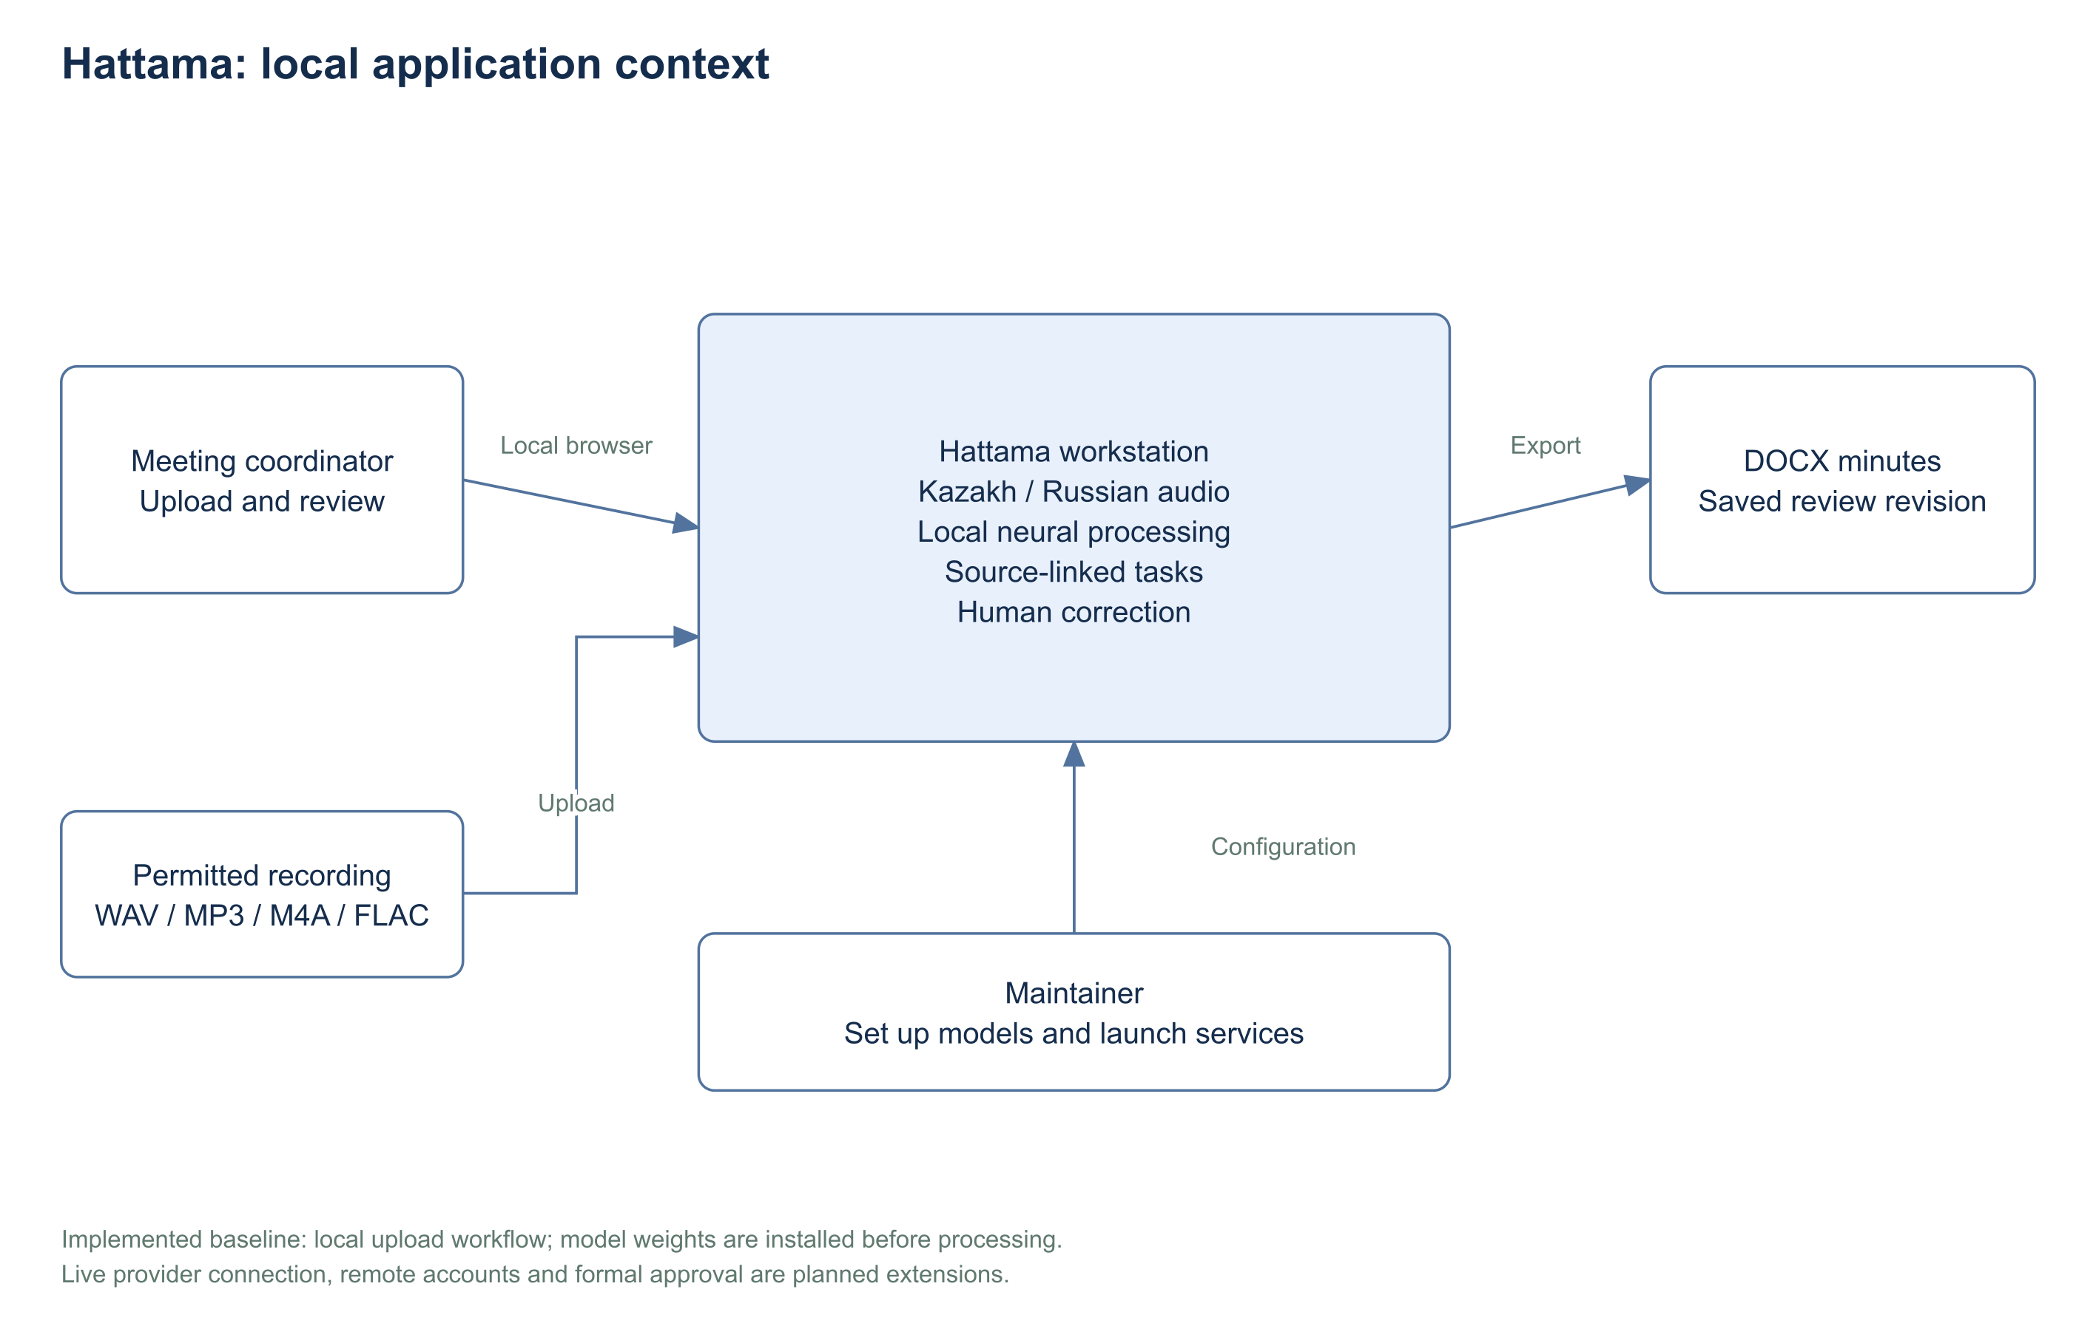
Editable source: diagrams/system-context.drawio. Readable export: diagrams/system-context.svg.

Implemented use cases
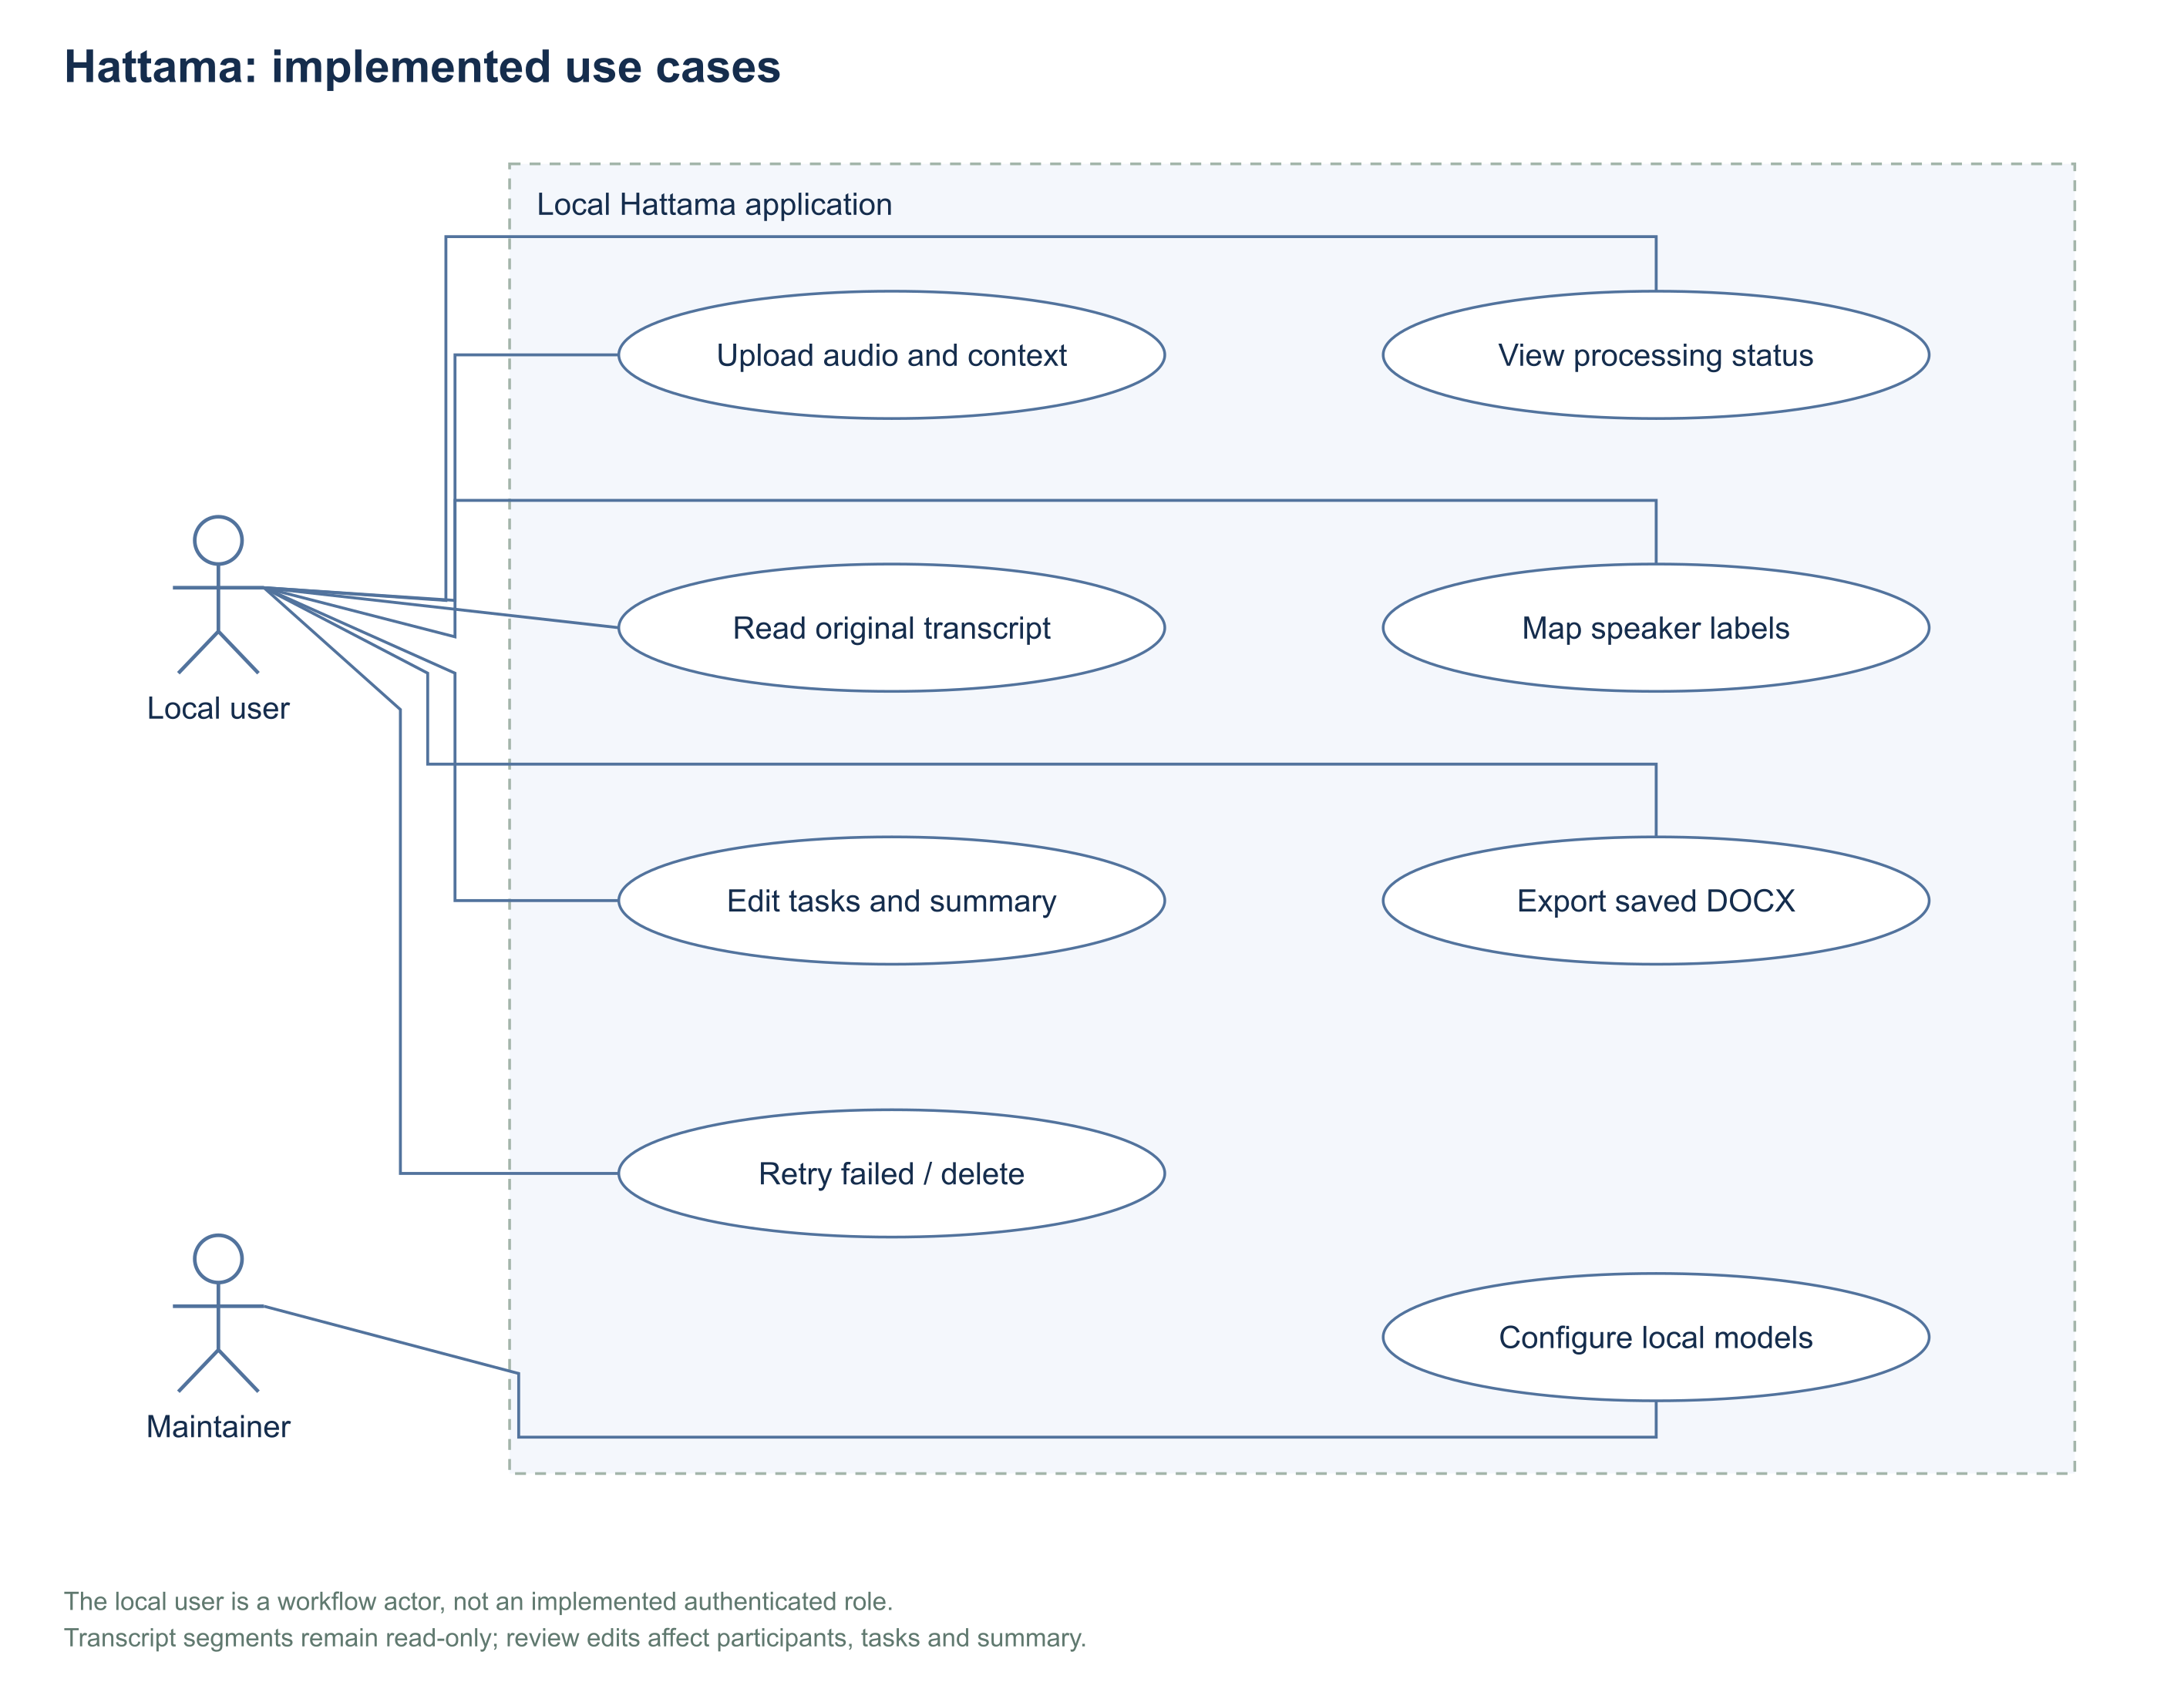
Editable source: diagrams/use-cases.drawio. Readable export: diagrams/use-cases.svg.

Component architecture
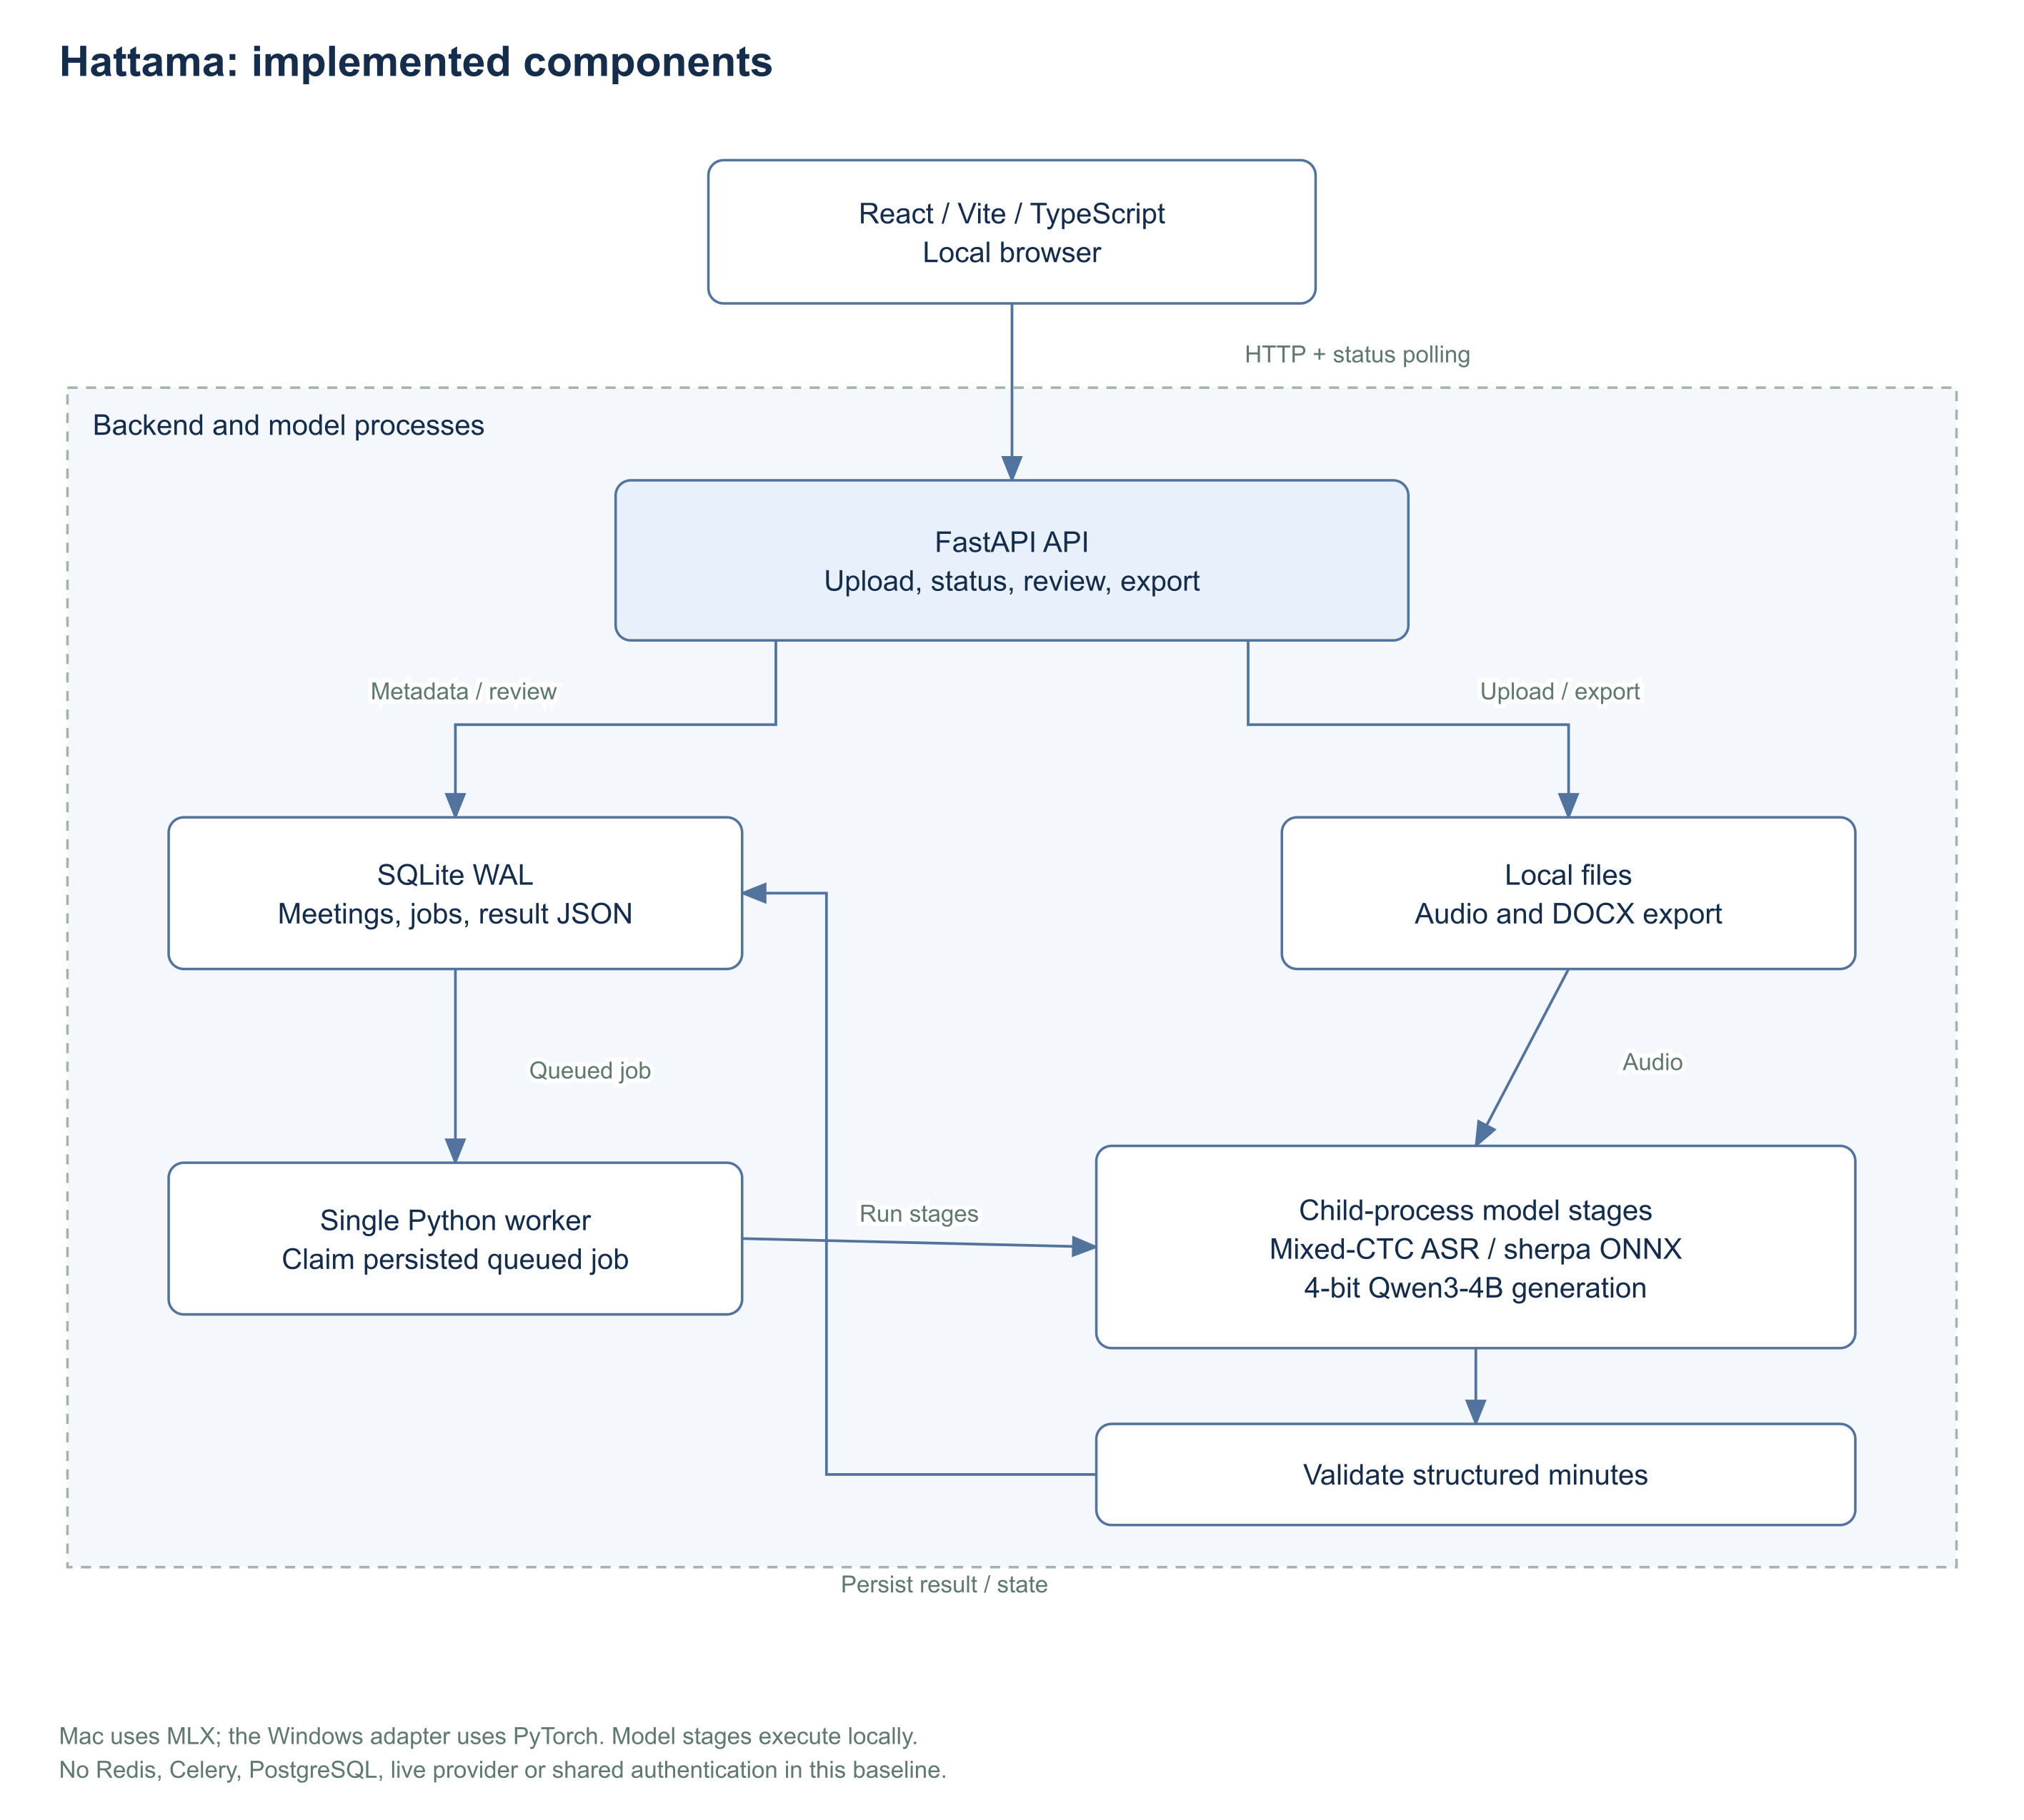
Editable source: diagrams/components.drawio. Readable export: diagrams/components.svg.

Processing and review lifecycle
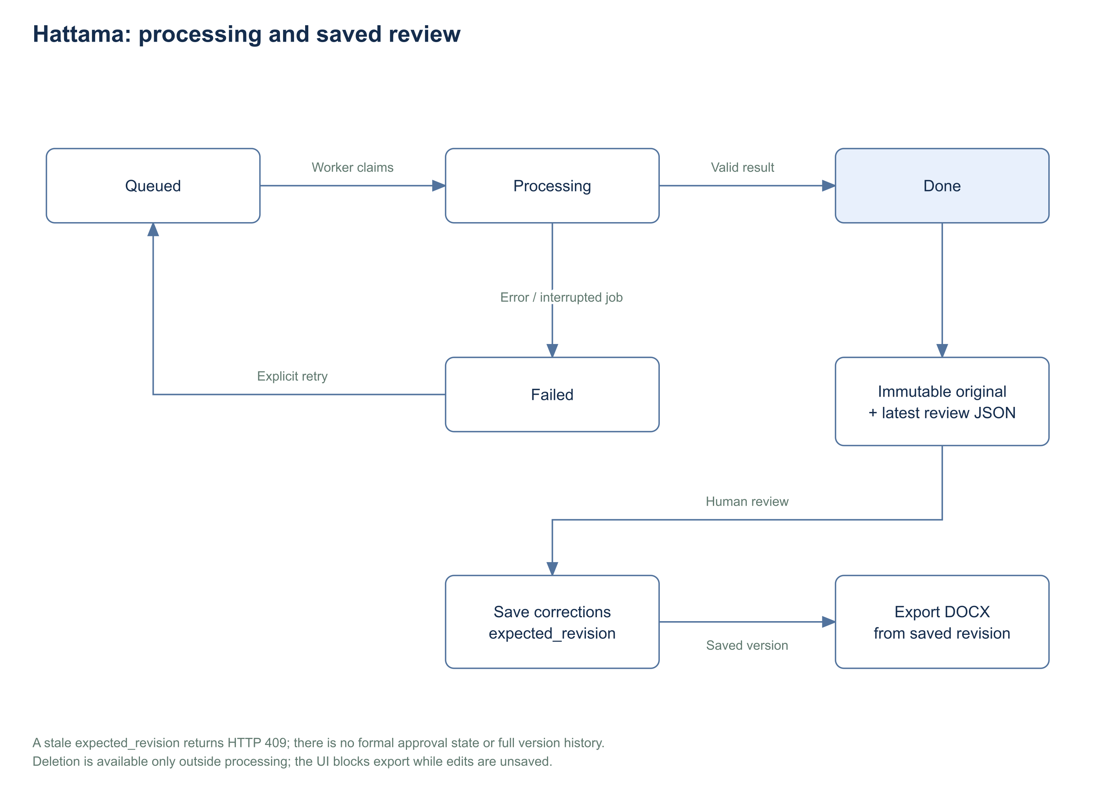
Editable source: diagrams/lifecycle.drawio. Readable export: diagrams/lifecycle.svg.

Appendix B Requirements traceability
PLAN identifiers are local placeholders until YouTrack access returns. Baseline test references are checks to execute, not automatic pass claims.
Requirement | Component or evaluation | Verification | Planning task
FR-01 | Launch/API | T01 | PLAN-14
FR-02 | API/audio | T02 | PLAN-15
FR-03 | Store/worker | T03 | PLAN-16
FR-04 | ASR | T04 | PLAN-17
FR-05 | UI/validation | T05 | PLAN-18
FR-06 | Review | T06 | PLAN-18
FR-07 | Pipeline | T07 | PLAN-20
FR-08 | Validation | T08 | PLAN-20
FR-09 | Store/review | T09 | PLAN-21
FR-10 | Store | T10 | PLAN-21
FR-11 | Export/UI | T11 | PLAN-22
FR-12 | API/UI | T12 | PLAN-23
FR-13 | Store | T13 | PLAN-16
FR-14 | Store/API | T14 | PLAN-24
FR-15 | Worker/UI | T15 | PLAN-23
FR-16 | API/UI | T16 | PLAN-15
FR-17 | Store | T17 | PLAN-21
FR-18 | Pipeline/API | T18 | PLAN-25
FR-19 | Future connector | T19 | PLAN-31
FR-20 | Future revisions | T20 | PLAN-33
FR-21 | Future identity | T21 | PLAN-33
NFR-01 | Bilingual ASR quality | E01 | PLAN-26
NFR-02 | Minutes factuality | E02 | PLAN-26
NFR-03 | Measured performance | E03 | PLAN-28
NFR-04 | API responsiveness | E04 | PLAN-28
NFR-05 | Local content processing | E05 | PLAN-14
NFR-06 | Recovery | T03 | PLAN-16
NFR-07 | Usability benefit | E06 | PLAN-27
NFR-08 | Usable bilingual interface | T22 | PLAN-28
NFR-09 | Reproducibility | E07 | PLAN-26
NFR-10 | Recording retention | T14 | PLAN-24
NFR-11 | Untrusted content handling | T23 | PLAN-25
NFR-12 | Speaker quality | E08 | PLAN-18
NFR-13 | Live latency | E09 | PLAN-32

Appendix C Remaining manual work

Before the first pre defense
1. Confirm university/programme details, actual submission/defense dates and the team account-to-name mapping. Topic agreement is already reported.
2. Have a teammate review this documentation PR and merge only after checks and substantive review. The application source is preserved; this update does not impersonate individual student contributions.
3. Confirm the supervisor review draft or replace it with actual comments. Retain the reviewed version, date and changes. No signature has been supplied.
4. Complete the real user-evidence route or obtain explicit confirmation that the illustrative/secondary-evidence alternative is accepted under the rubric. Published studies and constructed scenarios are labelled.
5. Restore YouTrack access, add its URL, invite members and map the 33 planning records to real assigned issues. YouTrack exists according to the team; task setup has not been verified.
6. Verify permission to publish and reuse the inherited recordings/protocols in data/. No data is removed or newly disclosed by this update.
7. Rehearse the current application and slides on the presentation machine. Use a short permitted recording and a disclosed preprocessed fallback. State live-mode and quality limitations.
8. Tag the exact reviewed submission commit as pre-defense-1; provide URL, tag, completed work and open obligations. Do not move earlier submission tags.

After the first pre defense
Collect and annotate the bilingual evaluation set, freeze splits and baselines, compare feasible models, measure error reduction and user effort, and document individual development. Implement live ingestion only after the feasibility gate. Full revision history and shared-role approval require separate contract decisions. Preserve the working upload flow while extending it.

Submission boundary
The package provides updated written materials and a real implementation baseline. It cannot itself establish actual user interviews, a received supervisor endorsement, configured YouTrack access, teammate review or measured model results that have not been supplied. Those statuses remain explicit so the committee can assess the work accurately.

