Java Bootcamp MyDay User Guide

Welcome to our blog. MyDay is yet another blog platform written in Java. What is a difference between MyDay and another popular blog platform? We are deleting all the data at midnight, so MyDay is representing actual information slice for last 24 hours.

As a guest, you can read all posts and comments. Also, you can use search to find some concrete information.

Search
Search bar is present on every page, so you can easely access it to search existing posts for some keyword or phrase. New posts are on top.
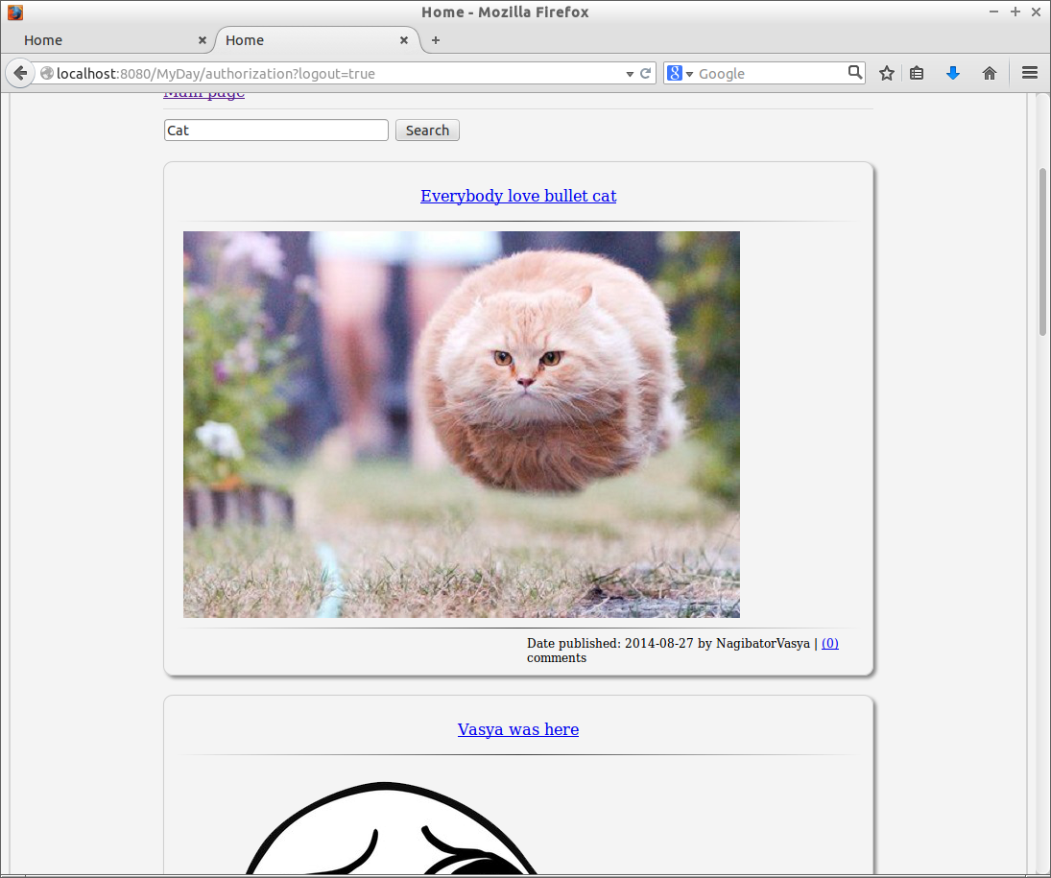

To be able to create posts and coment you have to register.
Registration
Link to a registration form also is visible in top right corner of the website. You have to take any nickname you wish, except for already used ones. It also shouldn’t be too short or too long etc
We store as minimum profile data as possible.
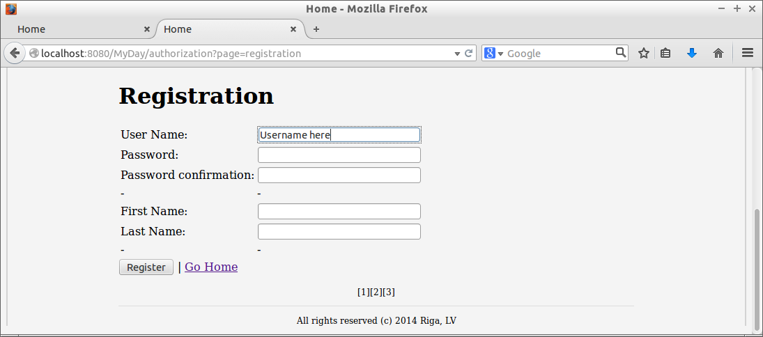

Authorization
After registration, you can log in using your username in password. After that you will be able to create you own posts and comments.
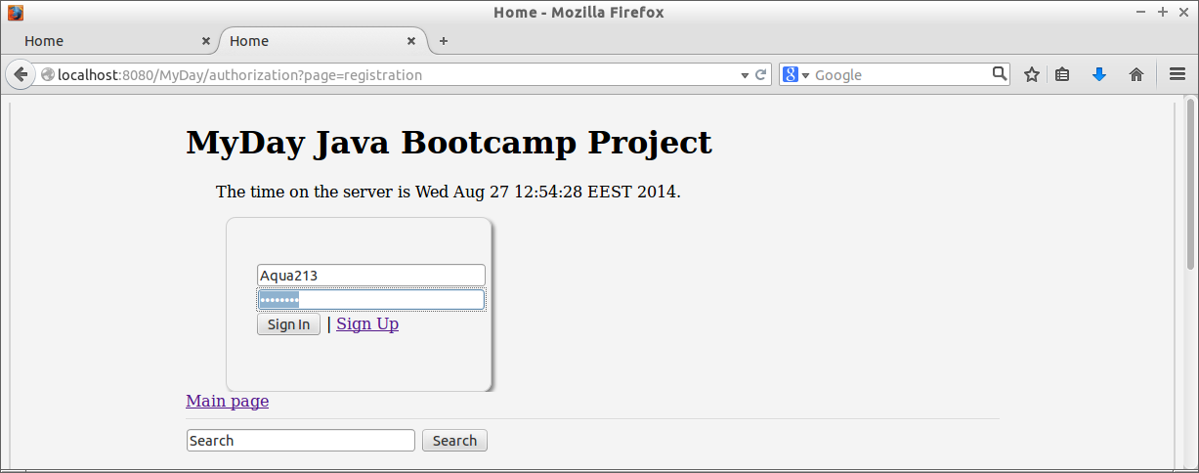

Creating a post
Creating post is quite easy. After authorization, link [New Post] will appear, just above the search bar.
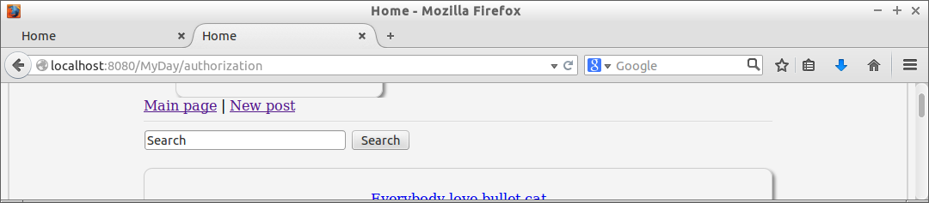
Link is leading you to the post creation form. Don’t forget to write a title and keep in mind that post length is limited to 1000 symbols.
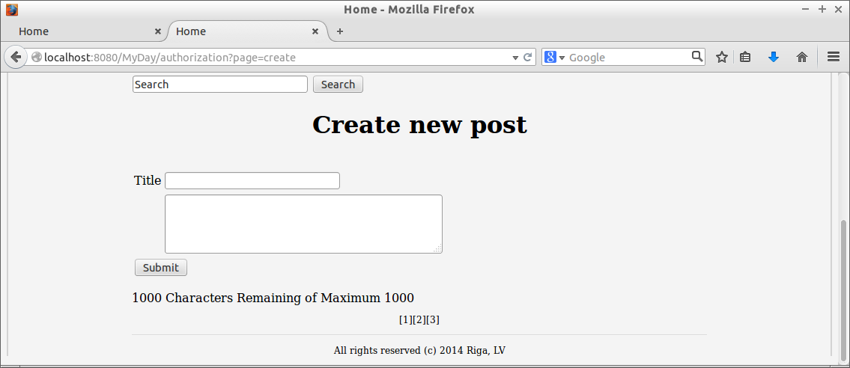

Commenting a post
Commenting a post is quite similar to creating a post. Open the post you want to comment by clicking on it’s header and you will see a form just below the last comment. Note that comment length is limited to 200 symbols
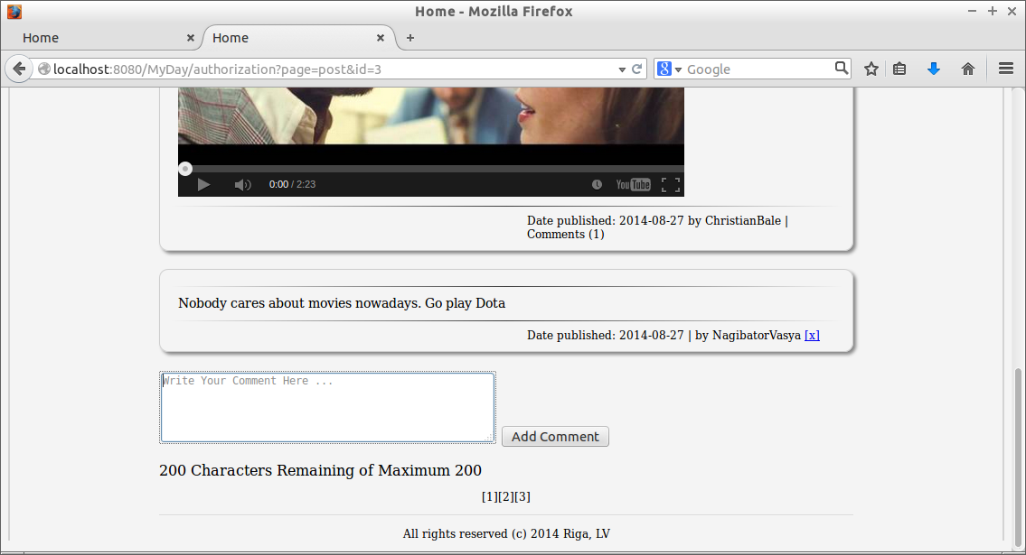

Adding pictures, links and video
Plain text post might be not enough for you. Luckly, you can format text and insert pictures, links and videos into posts and comments using standard html tags.
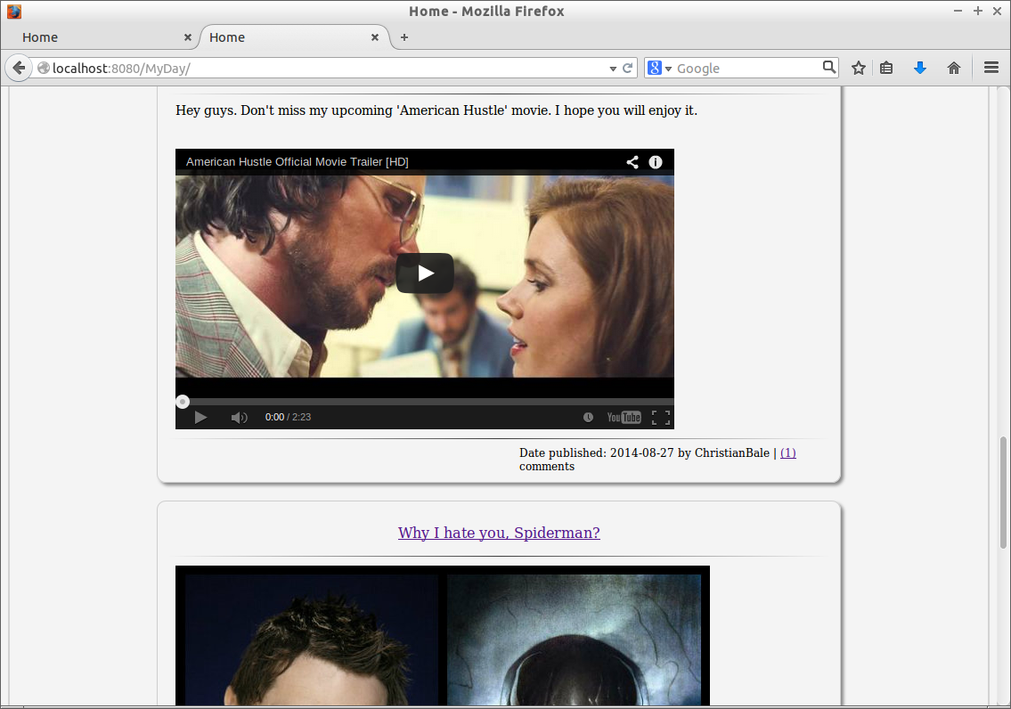

Editing post
You always can add some update or missing information to your post just by opening it and clicking ‘Edit post’ link on the top of your post. Note, that comments cannot be edited.
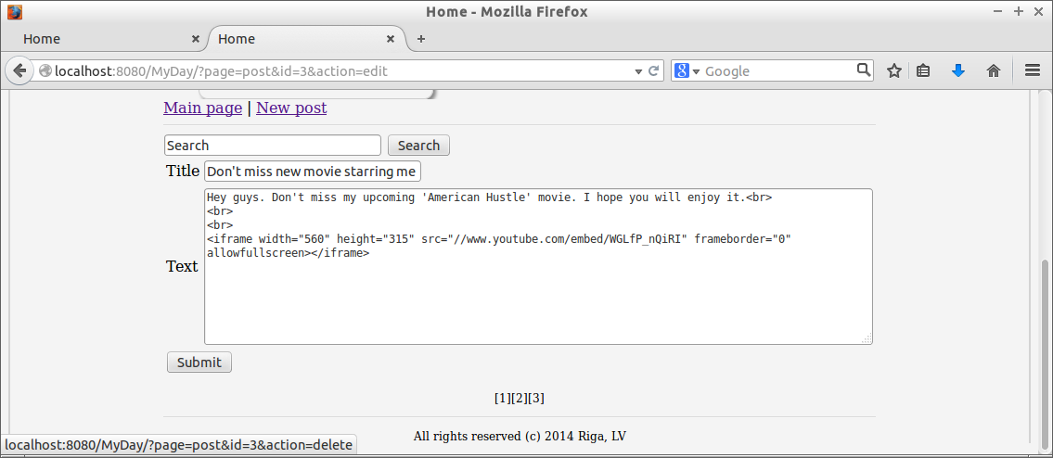

Deleting your post or comment
You always can removed your post or comment. To delete post, open it and click ‘Delete post’ link on the top of it. Keep in mind that all the post comments will be deleted too.
To delete a comment, click little [x] link on the right bottom side of it.

Thats all, folks



