CSE 598 Agentic AI, Capstone Project Proposal
Individual proposal and runnable baseline

Basic Information
Student name | Manav Ananthakumar
Project title | F1 Race Strategy Engineer, an agentic pit stop advisor
Repository / notebook link | https://github.com/DoomDust7/f1-race-strategy-agent
Configuration location | README.md (setup, run commands, reproducibility)

1. Problem Definition
The agent takes one Formula 1 race, one driver, and the tyre that driver starts on, and it recommends a pit strategy. By strategy I mean the number of pit stops, the lap of the first stop, and which compound to run in each stint.
The user I have in mind is a race strategist, or really any fan who likes thinking about strategy, trying to work out before or during a race whether a one stop or a two stop is quicker and when to pit.
- Input: a plain question that names a driver and the compound they start on, for example “Hamilton starts on SOFT, one stop or two stop, and when should he first pit?”. The race timing data lives locally in the repo.
- Output: a structured recommendation with the number of stops, the first pit lap, the full stint plan, and a short rationale backed by numbers.
- Success: the recommended strategy is valid and its simulated race time comes within 1% of the deterministic simulator’s best plan. Put another way, the agent actually used the tools to reach a near optimal answer.
- Failure: an invalid plan, meaning the laps do not add up to the race distance or it uses fewer than two compounds, or a plan more than 1% slower than the best one, or no recommendation at all.

2. Motivation and Project Scope
Pit strategy decides races all the time. It is a real sequential decision that trades tyre degradation against the time you lose in the pit lane. I also chose it because it sits in a domain I already know well from earlier real time telemetry work, so I can judge whether the agent’s calls actually make sense.
An agentic approach fits because the answer is not a single lookup. The system has to plan which compounds to model, call tools to estimate degradation, propose and simulate a few candidate strategies, compare them, and back out of any plan that turns out to be invalid. That is a plan, act, observe, refine loop rather than one shot.
- In scope this semester: one historical race, the 2021 Spanish GP, one driver, a linear tyre degradation model, a deterministic race time simulator, and a Claude tool use loop I wrote by hand, with an objective pass or fail test.
- Out of scope for the baseline: live races, safety cars and virtual safety cars, traffic and track evolution, fuel load, weather, and any reaction to a rival strategist. Those are exactly what I want to improve in the full project.

3. Runnable Baseline
- Model and framework: Anthropic claude-opus-5, which you can swap out with ANTHROPIC_MODEL, called through the official anthropic Python SDK. I wrote the tool use loop by hand instead of using an agent framework so the agent’s steps are easy to follow.
- Data: real lap by lap timing from the FastF1 library, downloaded once into cache/ and read in offline mode, so no network is needed for the race data.
What it does, step by step:
- 1. Gets the race info and the driver’s starting compound.
- 2. Fits a simple pace against tyre age line for each compound from that race’s green flag laps. SOFT starts near 81.93s and loses about 0.051s a lap, MEDIUM starts near 83.56s and loses about 0.015s a lap.
- 3. Proposes one stop and two stop candidates that start on the driver’s compound and simulates each one with a deterministic race time model, which adds up stint degradation plus a 22 second pit loss.
- 4. Compares the simulated total times and submits the fastest valid plan through a submit_recommendation tool that ends the loop.
This is a reasonable starting point because it really is agentic, with multi step tool use and self correction when a plan comes back invalid, but it is still fully testable against a deterministic best answer and it runs offline.
- Files: src/tools.py holds the four tools and the simulator, src/agent.py is the loop, src/run.py is a small CLI, tests/test_case.py is the graded example, and there is data/ground_truth.json, scripts/build_cache.py, and cache/ with the committed data.

4. Test Case and Baseline Output
- Sample input: “Hamilton starts the 2021 Spanish Grand Prix on the SOFT tyre. Should he run a one stop or a two stop strategy, and on which lap should he make his first pit stop?”
- Expected output: a valid strategy within 1% of the deterministic best plan, which is about 5510s. The simple model puts a two stop fastest at roughly 5510s, and that matches what Hamilton actually did that day. A strong one stop on SOFT then MEDIUM comes in around 5520s, about 0.2% off, so it passes too. The test prints PASS.
Actual baseline output. This is a real run of python tests/test_case.py on claude-opus-5:
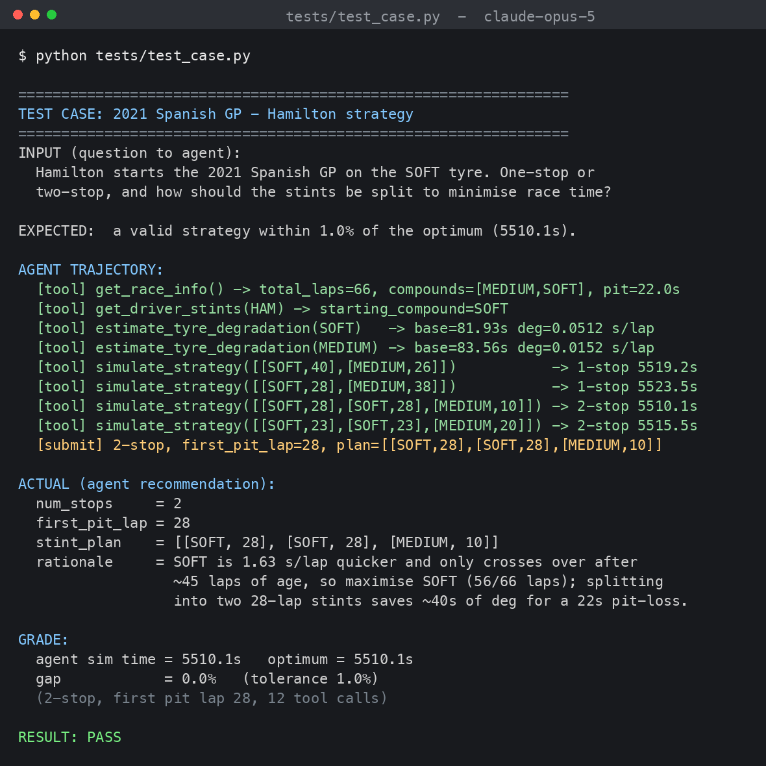
What worked. The agent modelled both compounds on its own, worked out where the two tyres cross over, simulated one, two, and even three stop candidates, and settled on the fastest one. It reached the simulator’s exact best plan at 5510.1s, a 0.0% gap, so the test passed, and it explained the choice with numbers. The whole deterministic layer, meaning the tools, the degradation fit, the simulator, and the grader, checks out. What did not. The model is a simplified oracle that the agent can lean on. Tyres are linear and there is no fuel effect, so it over runs the SOFT tyre. Taking that crutch away is the main job for the next phase.

5. Reproducibility and Run Instructions
Dependencies and setup:
python -m venv .venv && source .venv/bin/activate
pip install -r requirements.txt
Required key: put ANTHROPIC_API_KEY in a .env file, copied from .env.example. You can also set ANTHROPIC_MODEL=claude-sonnet-5 for a cheaper run.
Run the graded test case:
python tests/test_case.py
Ask a custom question:
python -m src.run "Hamilton starts on SOFT, one or two stops, and when to pit?"
- Input location: the race data sits in cache/ and works offline. The question is just a command line argument.
- Output location: everything prints to the screen, the agent’s steps and the final recommendation, and the test also prints PASS or FAIL.
- Known limitation: you need an Anthropic API key with a little credit. The race data itself needs no network. A run takes a few minutes.

6. Initial Evaluation Plan
I will compare the improved system against this baseline on a set of race and driver scenarios using:
- Strategy correctness, the fraction of scenarios where the recommended number of stops matches the best one.
- Pit lap error, the average gap between the recommended first pit lap and the optimal lap.
- Invalid plan rate, how often the agent produces an invalid plan before it recovers.
- Cost and latency, tokens and wall clock time per recommendation.
What would count as improvement is a later system that holds or raises correctness while handling cases this baseline cannot, like safety cars or a reacting rival, and does that without leaning on the oracle simulator.

7. Limitations and Next Steps
- Known weaknesses: the simulator is a simplified oracle, with linear degradation, a constant pit loss, stint times that just add up, and no safety cars, traffic, or fuel effect. It covers one race and one driver, and the agent can lean on the oracle instead of reasoning under uncertainty.
- Expected failure cases: races decided by a safety car or an undercut, compounds with very few laps to fit, and situations where track position rather than raw pace drives the call.
- Next phase: swap the oracle for a learned, uncertainty aware degradation model, add safety car and traffic effects, and bring in a rival strategist agent so the decision reacts to an opponent. After that, extend it to more races.
- Risks and needs: sparse data for some compounds, how realistic the simulator is, and API cost once the evaluation runs get larger.

