**ARTIFICIAL NEURAL NETWORK BASED CALCINER MODEL**

**Aditya Ranjan, Prateek Sharma, Rao**

**Abstract**

Ever increasing speed at which world is adopting Artificial Intelligence from phones to military drones. It is said that the new age of Industrial Revolution is at dawn with Artificial Intelligence being the major driver of industry 4.0 other drivers being automation, cloud computing, IOT etc. No major economy wants to miss out on the opportunity provided by Industry 4.0. India being one of those major economy is giving big push to infrastructure to attract businesses. These infrastructure projects require cement and steel with demand outpacing supply. AI can change that. AI offers a new mode of digital manufacturing process that can increase productivity by optimizing the use of assets at the fraction of cost. Calciner is one to the major component of a cement production plant which calcinates the Calcium Carbonate into Calcium oxide and Carbon Dioxide. An AI model of a calciner can provide valuable information which can implemented in real time. Since a model can implement conditions which otherwise might lead to loss in production or can damage equipment, and AI model on top provides us with predictions in consonance with real world as it learns from real world data. The AI based calciner model does the following as it is able to predict the outlet calciner temperature with high degree of accuracy (+/- 2% error) when validated against real world data. It input comprises of various parameters which are recorded in the daily log sheet of plants like calcium carbonate weight, kiln speed, fan speeds, pre heater temperature and draught, tertiary air and other correlated parameters). Initially the output of the model is outlet temperature of calciner however new outputs can be generated by training on relevant dataset. This model can be used by industries to estimate the outlet temperature by changing the input parameters as it is not based on the chemical and physical process taking place in the calciner but on real world historical data. Being trained on real world data, it innately provides the model with the ability to account for real world losses like heat loss, efficiency of the heaters etc. to provide with a prediction which is close to the true value. This models also helps us identify the parameters which are usually don’t associated with the process of calcination thus enabling better utilization of assets to increase productivity.

1. **Introduction**

The calciner is one of the major parts of a cement plant where the calcination of calcium carbonate form calcium oxide and carbon dioxide takes place. Several physical and chemical factors govern the process like thermodynamics and chemical kinetics of the reaction, mass transfer of carbon dioxide and heat transfer between the various phases (Zhang, 2011). The combination of these factors makes the modelling of calciner difficult. Machine learning algorithms learns by training on data generally on historical data to predict or make a decision without explicitly being programed to do so. Machine learning as shown itself to be a tool capable of forming complex relations between input parameters and desired output. This relationship can't be numerically established or are difficult to establish like that of a calciner. The model discussed in this paper is based on machine learning. Machine learning regression algorithms are powerful tools which are able to perform better on numerical data with one or more dependent variable and a series of independent variable. Feature were extracted and selected accordingly and exploratory data analysis was conducted. The parameter to be predicted/label was the output temperature of a calciner (P.C. O/T temp). Various machine learning regression algorithms were trained on the prepared dataset. Comparative analysis of the root mean squared error and R2 score of the algorithms on test dataset was conducted and the best among them was selected for the model namely artificial neural network.

1. **Experimental work**

The machine learning modeling process comprises of various operations performed from collection of raw data to the implementation of the algorithms to learn. The various sub-divisions are listed below:

• Collection of raw data

• Feature Extraction

• Feature Selection

• Exploratory Data analysis

• Data Visualization

• Feature extraction

• Implementation of ML regression algorithms

• Tuning of hyperparameters

• Comparing errors different regression algorithms on test dataset

The raw data was collected from the daily log sheets of a cement production plant. The features were selected which usually corresponds to the working of calciner. A dataset was prepared from these log sheets of 3 months with on an average 24hours entries which ended up being a sufficiently large to help identify outliers, increase accuracy of the model. Heat map correlation of the dataset was plotted to get a measure of correlation between the features and the label. The features which correlated with the label with a large magnitude were selected while rest were dropped from the feature set. The dataset was divided into training, validation and testing datasets. The training dataset consisted of 1200 entries and the validation and test set consisted of 150 data entries each. The following is a snippet of the dataset used (Fig1).

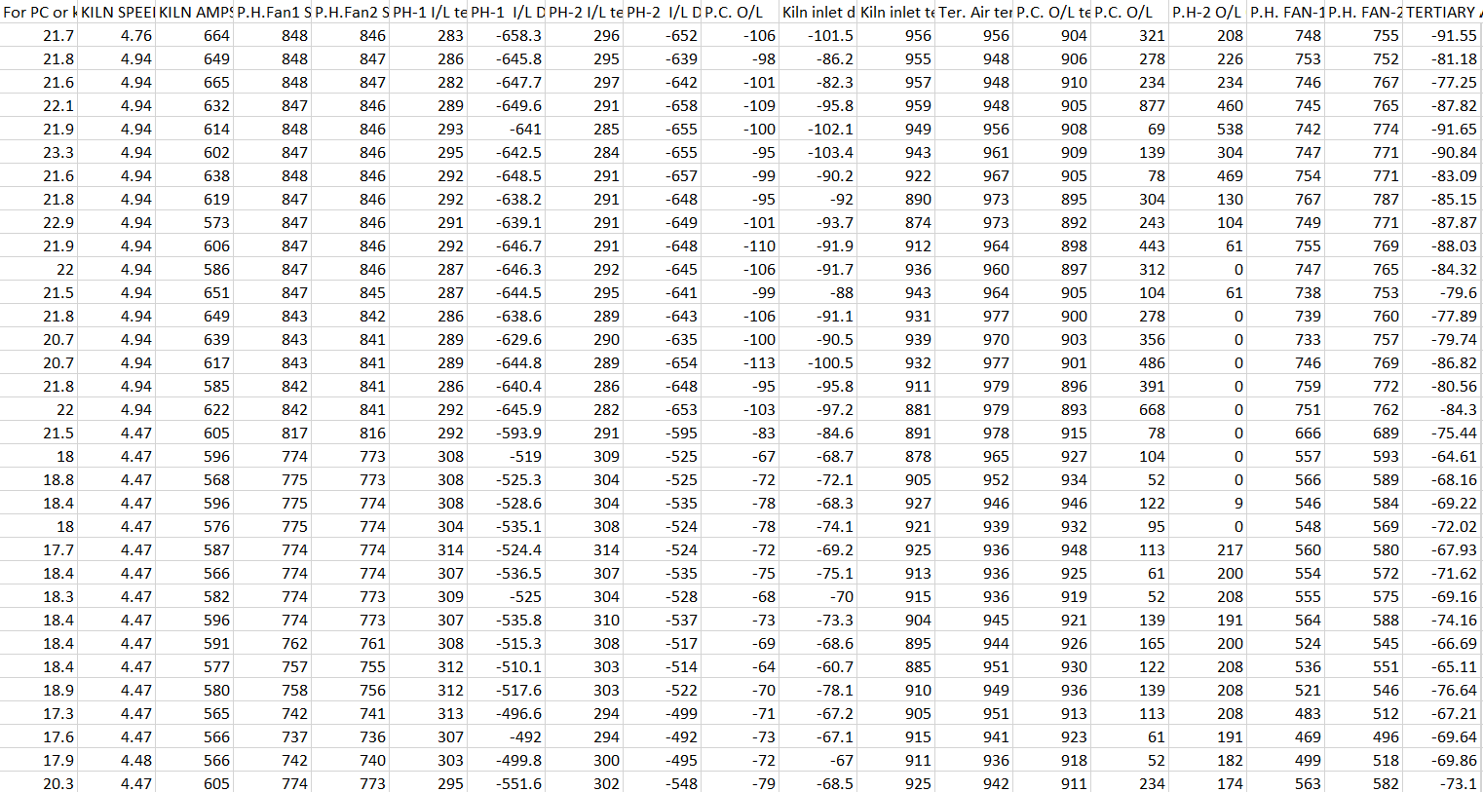

**Figure 1**:Snippet of the dataset.

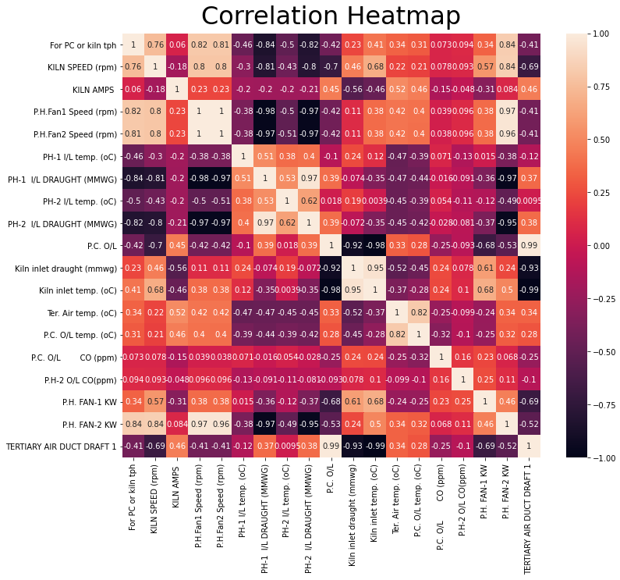

**Figure 2:** Correlation Heat Map of the dataset after removing features which correlation weakly with calciner outlet temperature.

Since, the log sheets were maintained by human various outliers, missing data points crept into the dataset. These outliers and missing datapoints made the dataset statistically skewed which in turn makes the prediction misleading. To find outliers interquartile method was employed and visualized using boxplot shown in figure3 on two features for example.

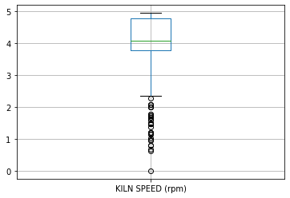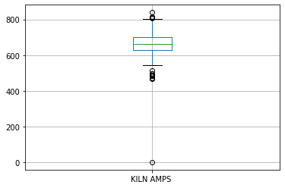

**Figure 3:** Boxplots of kiln speed and amperage depicting the presence of outliers.

The standard practice to deal with outliers is to either remove them or replace them with a central tendency. The latter was performed with central tendency being median. The fig4 shows the boxplots of kiln speed and amperage after outliers were replaced with median.

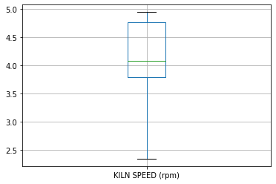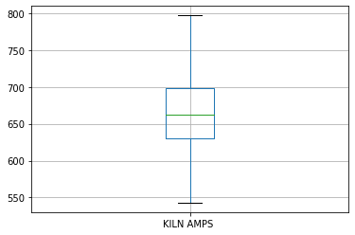

**Figure 4:** Boxplots of kiln speed and amperage after replacing outliers with median.

A correlation heat map was plotted again(fig5) visualize the effect of the operation described above.

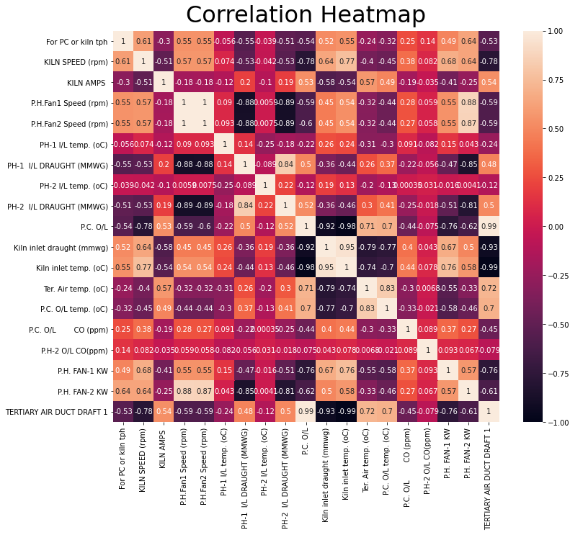

**Figure 5:** Correlation Heat map of the dataset after replacing outliers with median.

The heat map showed the increase in magnitude and change in nature of correlation between the features and label. The effects due to the presence of outliers in the dataset is established by the heat maps (Fig2 & Fig 5). The correlation of for example of the kiln speed changed its nature from directly related to inversely with correlation value changing from 0.21 to -0.45. Either of these changes were observed in most of the correlation of the features. Initially Kiln inlet carbon monoxide, Kiln raw meal feed rate were being used as a feature but its correlation was in the magnitude of 10-3 indicating weak correlation therefore, they were dropped from the data set. The regression algorithms were trained on the datasets with hyperparameters like batch size, number of epochs were tuned accordingly to minimize prediction errors on validation dataset.

1. **Results**

The algorithms implemented were tested on test dataset their root mean squared error and R2scores were calculated, tabulated (Table 1) and plotted as bar graph (Fig6).

|  |  |  |
| --- | --- | --- |
| Algorithms | RMSE | R2 Score |
| ANN | 15.65 | 0.87 |
| GB Decision Tree | 16.77 | 0.83 |
| XPGBoost | 18.24 | 0.81 |
| Linear Regression | 18.37 | 0.80 |
| Ridge Regression | 18.37 | 0.80 |
| Lasso Regression | 18.47 | 0.80 |
| Random Forest | 19.43 | 0.78 |
| Basic Decision Tree | 26.51 | 0.59 |

**Table 1:**Algorithms with their RMS error and R2 score

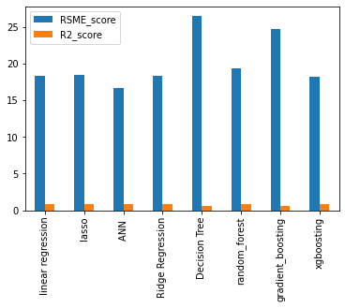

**Figure 6:** Bar graph of RMSE and R2 score of algorithms on test dataset

The neural network performed best among the algorithms. The table shows the calciner outlet temperature of the ANN(Table2).

|  |  |  |
| --- | --- | --- |
| Predictions (oC) | True Values(oC) | % Absolute Error |
| 975 | 973 | 0.28 |
| 895 | 892 | 0.33 |
| 978 | 976 | 0.50 |
| 946 | 950 | 0.33 |
| 897 | 903 | 0.50 |
| 894 | 910 | 1.66 |
| 886 | 889 | 0.26 |
| 1001 | 994 | 0.72 |
| 960 | 974 | 1.35 |

**Table 2:** Calciner outlet temperature predictions of ANN and the true values of test dataset and the absolute percentage error.

1. **Conclusion**

Modelling of Calciner through machine learning is possible. The model was able to predict the outlet temperature with high degree accuracy. The model was able to correlate parameters whose association can’t be established through the other models as of now. It can be used to provide an estimate for the plant as it is based on the actual data of a working plant. This model can be trained on relevant data to generate desired outputs. Machine learning can be used to simulate other processes in the cement plant which can give predictions in consonance with real world values. It can help design new plants considering data generated from the model for increased productivity.

**Acknowledgement**

**References**

<https://www.tensorflow.org/guide/keras/sequential_model>

<https://keras.io/guides/>

<https://www.geeksforgeeks.org/python-introduction-matplotlib/>