**Preparing for the next workshop**

To set up an Alert , you first create a saved search. To do this, you first need to register with the database. In the Friday, January 30 workshop on Alerts, we will use Web of Science for the saved search.

**Please register with Web of Science before Friday, January 30,** as this will save some time on Friday.

Note: If you have ever registered for EndNote Web, you have also registered for Web of Science.

Directions:

From the **library home page**: [http://library.boisestate.edu](http://library.boisestate.edu/)

Click the **Databases** tab

In the Top Databases list, click **Web of Science**

If you are not on a campus network, you'll need to sign in with your myBoisestate username and password

On the Web of Science page, on the upper right you'll see a **sign in** link-- click the link, then select **Register (see graphic below)**

Fill in the required information.

**Remember** which email address you used (it does not have to be the boisestate email) and your password!

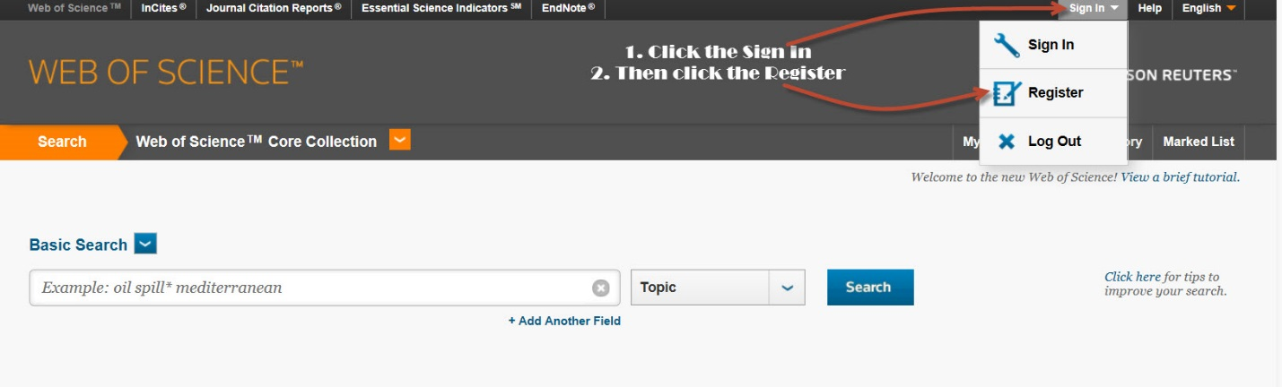

Also, be thinking about a search (or a topic) for which you would like to create a saved search. With a saved search alert, the database will periodically send you updates on new items that match your search terms.

Besides saved searches in Web of Science, we will also talk about journal table of contents alerts from Science Direct.

If you are interested in Table of Contents alerts from a journal on the ScienceDirect platform, you could also sign up with **ScienceDirect**. I don't expect everyone will want to do this, but if you do, here are the Directions:

From the **library home page**: [http://library.boisestate.edu](http://library.boisestate.edu/)

Click the **Databases** tab

Click the **S** under Databases by Name

Click **ScienceDirect**

On the ScienceDirect page, on the upper right you'll see a **sign in** link--click the link, then click the **Not Registered** link.

Fill in the required information.

**Remember** your Username and Password!