Midterm Examination

CS410/510

Date: 03/17/2014

Total Points: **200**

General instructions:

1. Create a new directory/folder in your onyx home folder  
   for example*, mkdir ~/cs410/midterm*
2. Create files  
    *touch A.sql*

*touch B1.sql, touch B2.sql,…., touch B5.sql*

1. Edit A.sql ,B1.sql, B2.sql,…. to represent your solutions
2. Upload the files using command  
    *submit vijaydialani cs410 midterm*

**Problem A**

**Points 80**

Write the DDL statements to create relational tables for the given ER diagram

* For all entities types being present (10 points)
* For all attributes correctly present (10 points)
* For all the primary key definitions (20 points)
* For all foreign keys being present (20 points)
* For proper choice of data types and length of arrays (20 points)

Hint: Use the attached notes on rules to convert the data model to relational schema

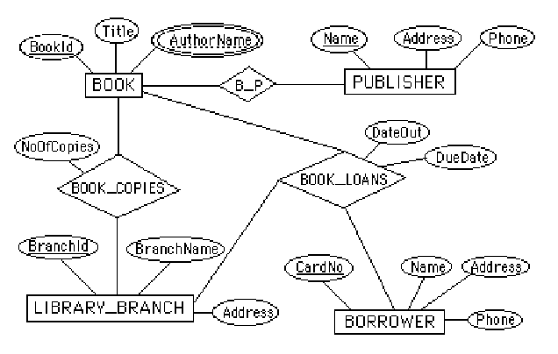

**Problem B**

**Points 120**

Instructions**:**

1. Create the database using the script ecommerce.sql
2. Modify the B1.sql to B5.sql to write the queries
3. Verify the results against B1.out,…,B5.out respectively

For the given “ecommerce” database, as described in the UML diagram attached below, write the queries:

1. For all shipped orders within USA determine the number of orders for each state, sort in descending by number of orders. **(10 points)**
2. Determine the type and the quantity of ‘motorcycles’ that have been shipped to customers. (Hint: Use Products.productLine='Motorcycles' with orders.status ='Shipped' ) … **(20 points)**
3. For the ‘Shipped’ orders how much revenue

(use ROUND(SUM(quantityOrdered*priceEach), 2) to calculate revenue) is from sales within USA and how much revenue is from sales outside USA (Hint: use orders.status=’Shipped’ and the customers.country to aggregate the revenue for USA and sum all the revenue from foreign countries. Use UNION ALL to merge the results for two queries) … **(30 points)**

1. Based on shipped orders, determine the sales in each product line by quantity of items ordered during the first quarter of 2004. Order results in descending order based on the quantities sold.   
   **(20 points)**
2. Based on the price of the shipped orders and payments received. Calculate the outstanding payment amount for each of the customers that have any outstanding payments. Order by outstanding payment in desc order. (Hint: use Round(number,0) to round off the amount to nearest whole number)  
   (**40 points**)

