Assignment #3
Turn in your work as a single file via Blackboard. Make sure your full name is included in the file name. Handwritten answers will not be accepted. Total points: 120.

- Cohesion
The following class is a bus management system, which deals with a number of school buses, drivers, and routes. How can you improve the design by using strong cohesion? (5 points)
public class SchoolBusManager {
private int busNumber;
private int busFee;
private String driver;
…

public int getBusNumber(){
…}

public void getBusRoute(String start, String end){
... }

public voir payBusFee(int amount) {
...}
…
}

Answer: we can create 4 different classes: Bus, BusDriver, BusFee and BusRoute with respective private fields and methods declared within these classes. Thus we can keep dependencies local. For example, Bus will store busNumber field and has a method to return that member variable. BusDriver can store information regarding bus driver. BusFee calculates the total bus fee. BusRoute represents and store route and has a method that show route based on start and end routes. We have a SchoolBusManager class which will have collection of these all these classes and corresponding methods. Thus, staying close to the Single Responsibility Principle i.e. each function/class should do only one thing will result high cohesive and reusable code.

- Inheritance
To solve this problem, you may choose an object-oriented language from Java, C#, or C++. In order to receive full credits, your code must not have any bugs. For (a) and (b), turn in your source code and screenshot of test execution.
- Write a pair of classes, Square1 and Rectangle1. Define Square1 as a subclass of Rectangle1. In addition to setters and getters, provide such methods as computeArea and computePerimeter. (8 points)
- Write a pair of classes, Square2 and Rectangle2. Define Rectangle2 as a subclass of Square2. In addition to setters and getters, provide such methods as computeArea and computePerimeter. (8 points)
- Compare (a) and (b) and describe their pros and cons. (9 points)

 | Pros | Cons
(a) | Every Square “is-a” Rectangle | Square does not need both length and  width member variables. Yet it will inherit them anyway. Clearly, this is wastage of memory size.  Square will inherit the setLength and setWidth functions which is not appropriate for Square as both are identical.
(b) | Every Rectangle “is not a” Square unless it’s all sides are equal. | To calculate Area of Rectangle and Perimeter of Rectangle we need to modify the source code which violates the Open-Closed Principle.  It Violates Liskov substitution principle (LSP) i.e. A subclass must fulfill the requirements of all its superclasses.

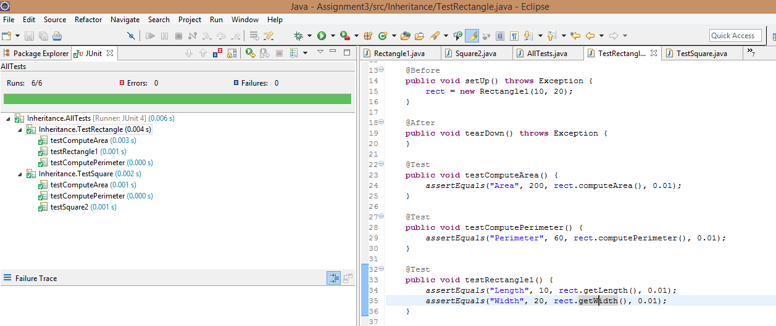

3. Testing
This problem is based on the given Java programs. Do not make any changes to the code. If you choose to use a different object-oriented language, it is your responsibility to translate the code correctly.

Download Triangle.zip and unzip it. The source code has seven Java packages: correct, bug1. bug2,…, and bug6. Each package contains a class Triangle.java. Triangle.java in the “correct” package is a correct program that reports the type (RIGHT, OBTUSE, ACUTE and NOTRIANGLE) of a triangle whose three angles are given as integers (angleA, angleB, angleC). Triangle.java in each bugX (X=1, …, 6) package has a bug.

- Complete the following table of equivalence classes. (15 points)

Condition | Valid classes | Invalid classes
angleA
angleB
angleC
angleA+angleB+angleC=180

- Complete the following table of boundary values. (15 points)

Variable | Boundary values from valid classes | Boundary values from invalid classes
angleA
angleB
angleC
angleA+angleB+angleC

- Complete the following table of test cases only based on the equivalence partitioning in (a) and boundary value analysis in (b). You should add new rows as needed. (15 points)

Test # | Test Input |  |  | Oracle Value  (expected result)
Test # | angleA | angleB | angleC | Oracle Value  (expected result)
1
2
3
4

- Write a Junit class TriangleTest.java in the “correct” package to implement all the test cases in (c). A sample test is given below. Run and debug TriangleTest.java in the “correct” package until there is no failure (if there is a failure, then something is wrong with your tests and you must fix it). Turn in your source code and include a screenshot of your test execution in this Word document. (15 points)
public void testAcuteTriangle () {
Triangle triangle = new Triangle(50, 60, 70);
assertTrue(triangle.reportTriangleType()==Triangle.TriangleType.ACUTE);
}
- Based on the test cases in (c), complete the following table about coverage of each conditional statement in the correct program (15 points).

Conditional statement | Is branch coverage achieved? |  | Is multi-condition coverage achieved?
Conditional statement | Yes/No | If yes, list the test cases that achieved the branch coverage | Yes/No | If yes, list the test cases that achieved the multi-condition coverage
if (angleA <= 0 || angleB <= 0 || angleC <=0)
if (angleA+angleB+angleC!= 180) |  |  | N/A | N/A
if(angleA== 90 || angleB == 90 || angleC == 90)
if(angleA > 90 || angleB > 90 || angleC > 90)

- Copy your TriangleTest.java in (d) to each bugX (X=1, 2, …, 6) package. Make sure the package statement in TriangleTest.java is correct so that you can test Triangle.java in the same package. Report your test results in the table below and include in this Word document a screenshot of test execution for each bugX package. (15 points)
Note: To get full credits for (a), (b), and (c), your tests must be able to find at least 4 of the bugs. These tests must result from the techniques in (a) and (b).

Bug Version | Test failure: Yes or No? | If Yes, list the tests that failed; If No, explain why
1
2
3
4
5
6

