IT department / Mutah university
Image processing lab 2

Problem 1: draw histogram for an image
Insert text box into your form
Read the value of channel from text box
int channel=Convert::ToInt16(textBox1->Text);
the call the following function:
Bitmap ^ drawhis(int channel ,Bitmap ^im1){
int nw=256;
int nh=128;
Bitmap ^ im2=gcnew Bitmap(nw,nh);
int w=im1->Width;
int h=im1->Height;
int Hist[256];
int x,y,i;
Color c;
for (x = 0 ;x<256;x++) {
Hist[x] = 0;
}
for (x = 0;x<w;x++) {
for (y = 0;y<h;y++) {
c = im1->GetPixel(x,y);
double Cb,Cr;
switch(channel){
case 1:
i=c.R;
break;
case 2:
i=c.G;
break;
case 3:
i=c.B;
break;
default://grey
i=(c.R+c.G+c.B)/3.0;
break;
}
Hist[i]++ ;
}
}
int maxHist = 0;
for (x = 0 ;x<256;x++) {
if (Hist[x] >maxHist)
maxHist=Hist[x];
}
int height;
Color cc;
switch (channel){
case 1:
cc=Color::Red;
break;
case 2:
cc=Color::Green;
break;

case 3:
cc=Color::Blue;
break;
default://grey
cc=Color::Black;
break;
}
for (x = 0 ;x<nw;x++) {
height = nh *(maxHist - Hist[x]) / maxHist;
for (y = nh-1;y>height;y-- ) {

im2->SetPixel(x,y,cc); //draw
} }
return im2; }

the previous code work for any chanel, make it to work for red histogram only, and green only and blue only and grey only.
==============================================================
Problem 2: show the red or green or blue shades of an image:
Red➔ keep the red components, and zeros for blue and green
Green➔ keep the Green components, and zeros for blue and red
Blue➔ keep the Blue components, and zeros for red and green
Example: this code for the red shades:

Bitmap ^ redImage(Bitmap ^ im1){
Bitmap ^im2=gcnew Bitmap(im1);
for (int x=0;x<im1->Width ;x++)
for (int y=0;y<im1->Height ;y++){
Color c1=im1->GetPixel(x,y);
int r=c1.R;int g=c1.G; int b=c1.B;
im2->SetPixel(x,y,Color::FromArgb(r,0,0));
}
return im2;}
do the same for green and blue shades.

=====================================================
Problem 3: image negative: the following code output the negative image for a grey image, change the code to work for color images (negate a color image)

Bitmap ^ inverse(Bitmap ^ im1){
Bitmap ^im2=gcnew Bitmap(im1);
for (int x=0;x<im1->Width ;x++)
for (int y=0;y<im1->Height ;y++){
Color c=im1->GetPixel(x,y);
int r=c.R;
r=255-r;
im2->SetPixel(x,y,Color::FromArgb(r,r,r));
}
return im2;
}
=========================================================
Problem 4: Piecewise Linear Gray Level transforms:

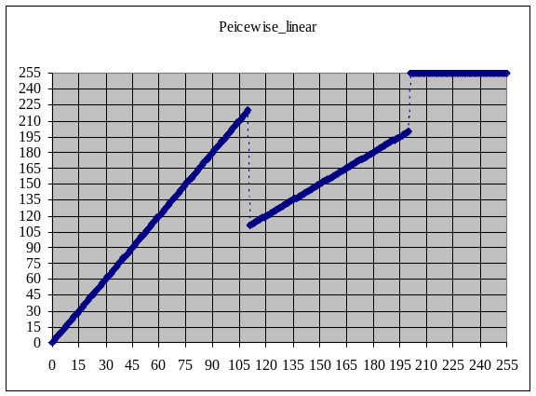

Run the following code which represent the previous piecewise transform.
Bitmap ^ Piecewise(Bitmap ^ im1){
Bitmap ^im2=gcnew Bitmap(im1);
for (int x=0;x<im1->Width ;x++)
for (int y=0;y<im1->Height ;y++){
Color c=im1->GetPixel(x,y);
if (c.R<110)
im2->SetPixel(x,y,Color::FromArgb(2*c.R,2*c.R,2*c.R));
else if (c.R>200)
im2->SetPixel(x,y,Color::FromArgb(255,255,255));
else
im2->SetPixel(x,y,Color::FromArgb(c.R,c.R,c.R));
} return im2;}

Change the previous code to follow the following transform:
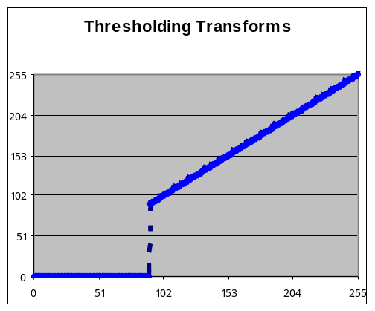

=========================================================
Problem 5: nonlinear log transforms:
Run the following log transform:
int threshold =Convert::ToInt16(textBox1->Text);
pictureBox1->Image= log(im1, threshold);

Bitmap ^ log(Bitmap ^ im1, int threshold){
Bitmap ^im2=gcnew Bitmap(im1);
for (int x=0;x<im1->Width ;x++)
for (int y=0;y<im1->Height ;y++){
Color c=im1->GetPixel(x,y);
int out=threshold*Math::Log(c.R+1,2);
if (out>255)
out=255;
im2->SetPixel(x,y,Color::FromArgb(out,out,out));
}
return im2;
}

Change the code to take the value of the threshold from a slide bar (insert slide bar)
===================================================================

Problem 6: nonlinear Gamma transforms:
Run the following log transform: after inserting another text box
int cc=Convert::ToInt16(textBox1->Text);
double r=Convert::ToDouble(textBox2->Text);
pictureBox1->Image= gamma(im1,cc,r);

Bitmap ^ gamma(Bitmap ^ im1, int cc , double r){
Bitmap ^im2=gcnew Bitmap(im1);
for (int x=0;x<im1->Width ;x++)
for (int y=0;y<im1->Height ;y++){
Color c=im1->GetPixel(x,y);
int out=cc*Math::Pow(c.R,r);
out*=255;
if (out>255)
out=255;
im2->SetPixel(x,y,Color::FromArgb(out,out,out));
}
return im2;
}
Change the previous code to take the value of r from a slide bar (insert slide bar)

Discuss the effects of the previous transforms with your peers.

Problem 7: Contrast stretching
write the code that strech the histogram of an image using the following transform;
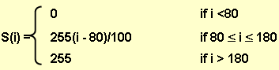

Change the code to strech any histogram after finding the minimum and the maximum color using the following equation:
s(i)= 255*(i-min)/(max-min)

Problem 8: Gray Level Slicing
Consider the following trnasform; write the code that highlights the specified color range. And write a code to binarize an image deppending on a specific threshold given by a text box.

