Make Windows Boot Directly into Your Front End
Created by Derek (aka d_sellers1)

(Note: This should be the last configuration in your installation. Get all your hardware and software working before doing this.)

This tutorial will show you how to make Windows boot directly into your front end of choice. You will not have to click on anything. This process can speed things up and save you a little bit of RAM. If you use your front end to hibernate or standby your machine, it should boot back up into the front end. This is primarily for cold boot setups.

Step 1: Click Start > Run > regedit
Step 2: Browse to HKEY_LOCAL_MACHINE \ SOFTWARE \ Microsoft \ Windows NT \ CurrentVersion \ Winlogon
Step 3: In the right pane, find and double-click Shell
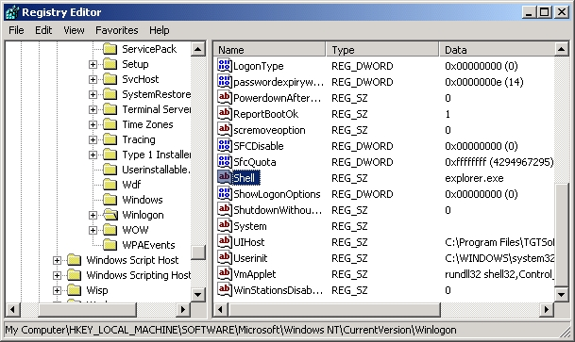

Step 4: Change explorer.exe to the complete path of your front end and hit OK. (Note: In this case for FrodoPlayer: C:\Program Files\Frodoplayer\Frodoplayer.exe. Also, note the quotation marks at the beginning and end up the path. These are used to allow long filenames.)
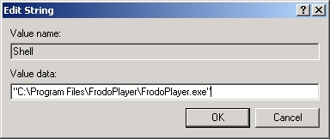

Technically, that’s all but we’re going to improve it a bit. We’re going to also set up Windows to Auto-Logon and not display any messages during boot-up and shutdown.

Disable Status Messages During Boot, Logon, Logoff, & Shutdown
Step 1: Click Start > Run > regedit
Step 2: Browse to HKEY_LOCAL_MACHINE \ SOFTWARE \ Microsoft \ Windows \ CurrentVersion \ policies \ system \
Step 3: In the right pane, find and double click DisableStatusMessages
Step 3b: If you do not have it, click Edit > New > DWord Value. Name the new DWord as DisableStatusMessages
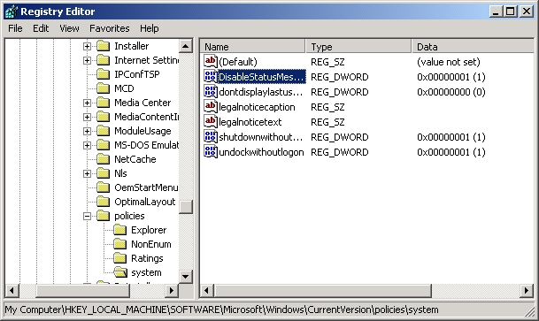

Step 4: Double click DisableStatusMessages and change the value to 1 and hit OK
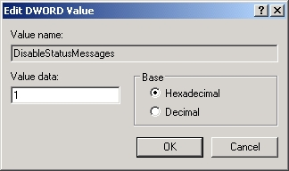

Auto Logon Windows
Step 1: Click Start > Control Panel > Display > Screensaver
Step 2: Uncheck On resume, password protect (if you have a screensaver set)
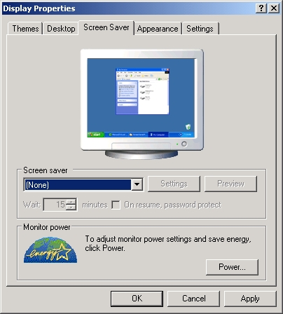

Step 3: Click the Power button followed by the Advanced tab
Step 4: Uncheck Prompt for password when computer resumes from standby
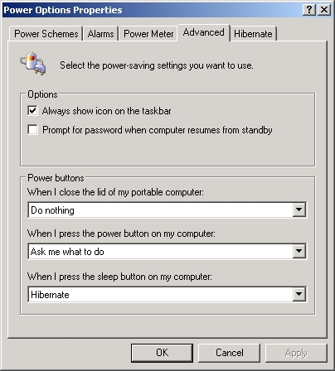
Step 5: Using the Microsoft Powertoy called Tweak UI, select Logon > AutoLogon
Step 6: Enter your username and password (if any) and hit OK
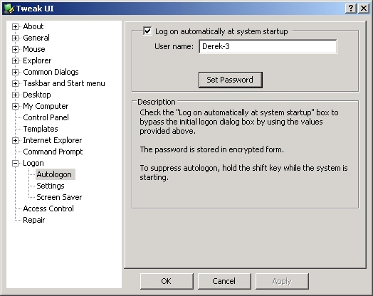

To Make the Logon Screen Black/Not Shown
Step 1: Click Start > Control Panel > Display > Desktop
Step 2: Change the wallpaper to None and select the color black
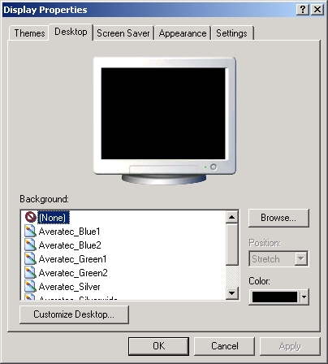

Step 3: Click Start > Control Panel > User Accounts > Change the way users log on or off
Step 4: Uncheck Use the Welcome screen
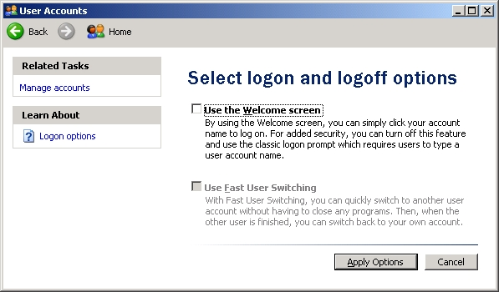

Step 6: Using the Microsoft Powertoy called Tweak UI, select Logon > Settings
Step 7: Check Colors & Wallpaper and hit Copy Now followed by OK twice
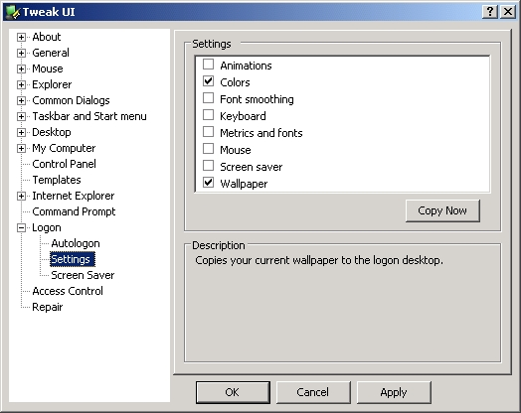

Note: If you change your login screen and do not uncheck Use the Welcome Screen, the login screen’s bitmap will still be shown. This could be beneficial but for the purpose of this tutorial, I am going to assume you have not changed your logon screen and am I going to tell you how. Search. This is what my current logon screen would look like with Use the Welcome Screen checked and Auto Logon set.


