TIC-TAC-TOE

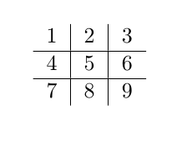

#Rules to be followed in our tic-tac-toe game:-

1. First move by each player not to be made on center (i.e. not 5 in first move)

2. Unless there is immediate win or loss condition, any player at the given time while making his move must follow this priority order
a. Corner (1,3,7,9)
b. Center (5)
c. Edge (2,4,6,8)

These simple rules limit the game to a certain extent but we get our required result while assuming both players to be intelligent, obviously. (i.e. both make moves to win). Anyone can lose!

The following is a FOL (First Order Logic) stating why the rules lead to a win for the first player every time :

A_{n}(X) -> Player A makes his n^{th} move on X numbered position.
B_{n}(X) -> Player B makes his n^{th} move on X numbered position.

A₁(Corner) & B₁(Corner) & A₂(Corner) & B₂(Forced Move) & A₃(Corner which is the last corner )
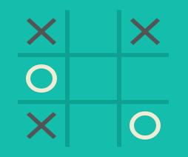
Now this leads to a condition as shown

*Here is some additional information that we discovered during our research:

For the following cases, we are not considering our previous rules and restrictions and generalizing the statements for any move that first player takes, we have a possibility of winning. And these winning conditions are demonstrated formally through cases and examples.

For first player to win:
Case I : If first Player makes a move on any corner, second player should move on any of the places other than center.
For example : If first player moves on 1, whenever second Player moves anywhere other than 5 first Player will always win.

Case II : If first Player moves on center, second player should move on the edges only.
For example: If first player move on 5, and second Player moves on any one of the edges, first Player will always win.

Case III : If first Player moves on edge(any, not considering the previous rules), second Player should move on any position other than the corresponding row or column.
For example: If first player moves on 2, and second player moves on any position other than 1, 3, 5, 8, first player will win.

On using the program, you are instructed to use ‘o’ i.e. the second Player and follow the rules mentioned above(not the cases).
Here, we made this program hereby declaring that it is intelligent enough to choose a move that will lead it to ‘win’ or ‘draw’. You are challenged to beat that ‘Bot’ or ‘Computer’ following our rules and we know that its not possible. Knock yourself out!

There is a prolog code given with this document along with its README file. All the instructions to run the program are given in the README. Please help yourself out.

Participants in this research are :
1. Hrishikesh Dahiya 2016A7PS0057G
2. Atul Rai ` 2016A7PS0724G
3. Satyajeet Jena 2016A7PS0054G
4. Mounil Memaya 2016A7PS0077G
5. Ayush Gupta 2016A7PS0024G
6. Bhavishya Singh 2016A7PS0726G

PS : We are most welcome for any criticism or questions about our research.

