Asma Azam
F2021065278
Software Engenring(W8)

Project Title: GroSwift App
GroSwift App – An Online Grocery Delivery System

Overview:
The GroSwift App is a modern online grocery delivery application designed for customers in Lahore, Pakistan. The app allows users to conveniently shop for fresh fruits, vegetables, everyday groceries, bakery items, beverages, and farm-fresh products from the comfort of their homes.
Users can sign up using their email, log in to their accounts, and manage their profiles with ease. The app offers an intuitive interface that includes a search bar for quick product searches, a favorites feature for saving preferred items, and an add-to-cart system for a smooth shopping experience.
The GroSwift App focuses on freshness, usability, and fast delivery, ensuring that customers receive their grocery items quickly and safely anywhere within Lahore.

Objectives:
To provide a user-friendly and reliable grocery shopping experience.
To ensure the delivery of fresh and high-quality grocery items to customers.
To enable users to browse, select, and purchase groceries online with ease.
To offer fast and efficient delivery services within Lahore.
To allow users to receive discounts and offers on selected items.
To minimize the hassle of physical grocery shopping through a digital platform.

Scope:
The scope of the GroSwift App includes:
User registration and login/logout system through email.
Product browsing, search bar, and favorite feature for better usability.
Add to cart and checkout system for a seamless shopping process.
Online payment and cash-on-delivery options for flexibility.
Customer offers and discounts, such as 10% off or buy-one-get-one-free deals.
Admin dashboard to manage products (add, update, delete) and offer discounts.

Core Functionalities (COP):
User Registration and Login/Logout
Product Browsing and Search Functionality
Favorites List for Preferred Items
Add to Cart
Online Payment and Cash on Delivery Options
Customer Offers and Discounts (10% off, BOGO, etc.)
Admin Panel for Product Management and Promotion

Problem Statement:
In today’s fast-paced lifestyle, people often struggle to find time for traditional grocery shopping. Visiting multiple stores, waiting in lines, and dealing with traffic in cities like Lahore can be time-consuming and inconvenient.
Moreover, customers face challenges in finding fresh and quality grocery items at reasonable prices all in one place. There is also a lack of digital platforms that provide fast delivery, secure payments, and user-friendly access to daily grocery needs.
Therefore, there is a need for a reliable online grocery delivery system that ensures freshness, fast service, and easy usability for customers in Lahore.

Proposed Solution:
The GroSwift App addresses these problems by offering a digital grocery shopping platform where users can:
Register easily using their email and location,
Search and browse a wide range of fresh grocery items,
Add items to their cart and complete purchases online,
Receive doorstep deliveries quickly within Lahore, and
Enjoy discounts and offers on various products.
This solution provides a convenient, time-saving, and efficient way for customers to shop for their daily groceries from the comfort of their homes.
Gantt Chart
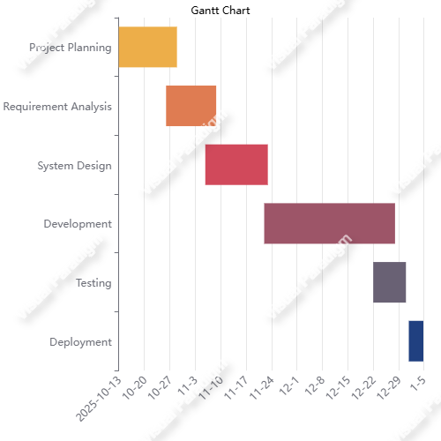

Work Breakdown Structure (WBS)
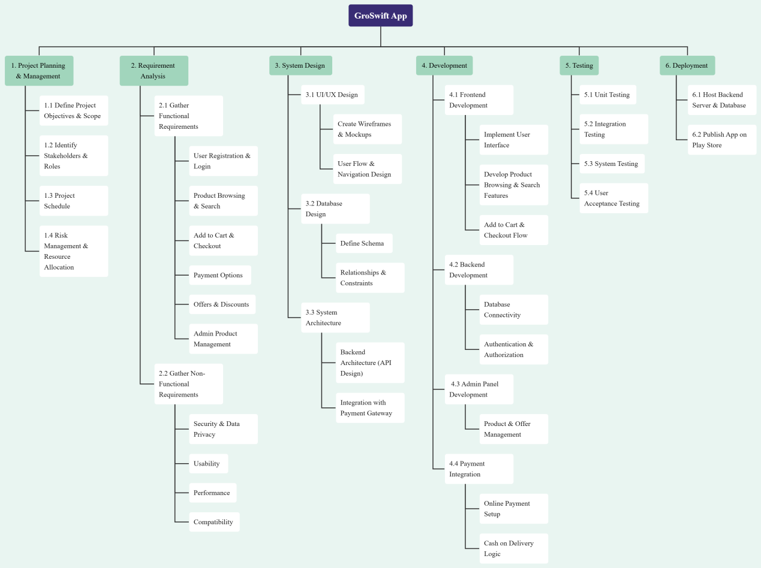

1. List of Actors

Primary Actor
Customer/User
Main user who registers, logs in, searches products, adds to cart, places orders, and tracks deliveries.

Secondary Actor
Admin
Helps manage product inventory, discounts, manage user data and customer orders.

External System Actor
Payment Gateway – Processes online payments (credit/debit cards, e-wallets).
Notification Service – Sends order updates and alerts.
Delivery Rider– Updates delivery progress and completes the delivery.

2. List of Use Cases

Customer Use Cases
Siggn Up Account
Login
Logout
Update Profile
Receive Notifications

Recover Password
View Product Details
Search Products
View Offers/Disscount
Add to Favorites
Remove from Favorites
Add to Cart
Remove Cart Item
Checkout
Make Payment
Track Order

Admin Use Cases
,Manage User Data
Add Product
Delete Product
Manage Discounts
View Customer Order
Update Order Status
View Analytics

External System Use Cases
Process Payment (Payment Gateway)
Send Notification (Notification Service)
Track Order (Location)
Use Case Diagram
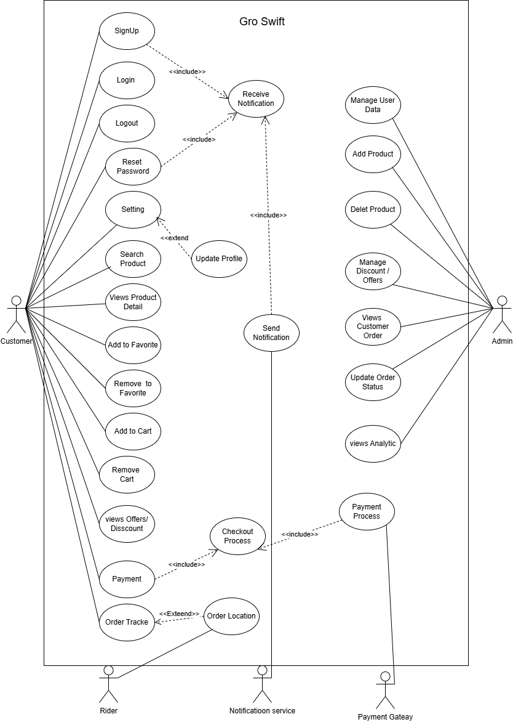

USE CASE 1 —Sign Up

 | SignUp Account
Use Case ID | UC-01
Primary Actor | Customer
Secondary Actors | None
Preconditions | – Customer must provide a valid email.  – Customer must open the Signup screen.
Postconditions | – Customer account is successfully created.  – Customer data is stored in the database.
Data Flow | Inputs: Email, Password, Name, Phone Number → System validation → Database storage  Outputs: Registration success message → Customer dashboard access
Main Flow | - Description:The customer wants to create a new account in the GroSwift App.  - Actor’s Actions:  - Customer opens the app and selects Signup.  - Customer enters email, password, name, and phone number.  - Customer submits the SignUp form.  - System’s Actions:  – System validates the entered information.  – System checks whether the email already exists.  – System saves the customer’s information into the database.  – System sends a confirmation message to the customer.
Alternate Flow | – If email already exists, system displays “Email already registered”.  – If required fields are missing, system shows validation errors.  – If network/server error occurs, registration cannot be completed.

USE CASE 2 — Login

Use Case Name | Login
Use Case ID | UC-02
Primary Actor | Customer
Secondary Actors | None
Preconditions | – Customer must be registered.  – Customer must enter valid email & password.
Postconditions | – User is logged into the system dashboard.
Data Flow | Inputs: Email, Password → System verifies credentials  Output: Login success / failure message
Main Flow | - Description:Customer wants to access their account  - Actor’s Actions:  – Customer opens login screen.  – Customer enters email and password.  – Customer clicks “Login”.  - System’s Actions:  – System checks if email exists.  – System verifies password.  – System grants access to dashboard.
Alternate Flow | – If password invalid → show error.  – If email not found → show “Account not found”.

USE CASE 3 — Logout

Use Case Name | Logout
Use Case ID | UC-03
Primary Actor | Customer
Secondary Actors | None
Preconditions | – User must be logged in.
Postconditions | – User session ends and they are returned to login screen.
Data Flow | Inputs: Logout request → System clears session  Output: Logged-out message
Main Flow | - Description:User wants to log out of the app.  - Actor’s Actions:  – User clicks “Logout”.  3. System’s Actions:  – System clears active session.  – System redirects user to login page.
Alternate Flow | – If system error occurs, logout fails temporarily.

USE CASE 4 — Update Profile

Use Case Name | Update Profile
Use Case ID | UC-04
Primary Actor | Customer
Secondary Actors | None
Preconditions | – Customer is logged in.
Postconditions | – Profile data updated in the database.
Data Flow | Inputs: Updated fields (name, address, phone) → System validates → Save to DB  Output: “Profile updated”
Main Flow | - Description: Customer wants to update their information.  - Actor’s Actions:  – Opens Setting.  – Updates Profile data.  – Clicks Save.  - System’s Actions:  – Validates new data.  – Stores updated profile info.
Alternate Flow | – Invalid phone/email → error message.

USE CASE 5 — Recover Password

Use Case Name | Recover Password
Use Case ID | UC-05
Primary Actor | Customer
Secondary Actors | None
Preconditions | – Customer must provide registered email.
Postconditions | – Password reset link sent to user email.
Data Flow | Inputs: Email → System checks database → Sends reset link  Output: “Reset email sent”
Main Flow | - Description: User wants to reset forgotten password.  - Actor’s Actions:  – Opens Forgot Password.  – Enters email  – Clicks Submit.  - System’s Actions:  – Checks if email exists.  – Sends reset link.
Alternate Flow | – Email not registered → error.

USE CASE 6 — View Product Details

Use Case Name | View Product Details
Use Case ID | UC-06
Primary Actor | Customer
Preconditions | – Customer must select a valid product.
Postconditions | – Product information displayed.
Data Flow | Inputs: Product ID → System retrieves details  Output: Product name, price, image, description
Main Flow | - Description: Customer wants to view details of a specific product.  - Actor’s Actions:– Clicks on a product.  3. System’s Actions:– Retrieves full product details.– Displays product page.
Alternate Flow | – If product not found → show error message.

USE CASE 7 — Search Products

Use Case Name | Search Products
Use Case ID | UC-07
Primary Actor | Customer
Preconditions | – Product database must be available.
Postconditions | – Search results displayed.
Data Flow | Inputs: Keyword → System filters product list  Output: Matching results
Main Flow | - Description: Customer searches for an item by name.  - Actor’s Actions:– Enters text in search bar.– Presses “Search”.  3. System’s Actions:– Filters products using keyword.– Displays matching items.
Alternate Flow | – If no results → Display “No items found”.

USE CASE 8 — Add to Favorites

Use Case Name | Add to Favorites
Use Case ID | UC-08
Primary Actor | Customer
Preconditions | – Customer must be logged in.
Postconditions | – Product added to favorite list.
Data Flow | Inputs: Product ID → System saves to user’s favorites  Output: “Added to Favorites”
Main Flow | - Description: Customer wants to save a product to favorites.  - Actor’s Actions:– Clicks heart/favorite icon.  3. System’s Actions:– Saves product to favorites list.
Alternate Flow | – If product already in favorites → show message.

USE CASE 9 — Remove from Favorites

Use Case Name | Remove from Favorites
Use Case ID | UC-9
Primary Actor | Customer
Preconditions | – Product must exist in favorites.
Postconditions | – Product removed from favorites.
Data Flow | Inputs: Remove request → System updates favorites list  Output: “Removed successfully”
Main Flow | - Description: Customer wants to remove a saved product.  - Actor’s Actions:– Opens favorites.– Clicks “Remove”.  3. System’s Actions:– Deletes product entry from favorites list.
Alternate Flow | – If product not found → show error.

USE CASE 10 — Add to Cart

Use Case Name | Add to Cart
Use Case ID | UC-10
Primary Actor | Customer
Preconditions | – Customer must be logged in.– Product must be available in stock.
Postconditions | – Selected product added to cart.
Data Flow | Inputs: Product ID, Quantity → System saves to cart  Output: “Item added to cart”
Main Flow | - Description: Customer wants to add an item to their shopping cart  - Actor’s Actions:– Selects product.– Clicks “Add to Cart”.  3. System’s Actions:– Verifies stock availability.– Adds product with quantity to cart.– Updates total cart amount.
Alternate Flow | – If item is out of stock → show error.

USE CASE 11 — Remove Cart Item

Use Case Name | Remove Cart Item
Use Case ID | UC-11
Primary Actor | Customer
Preconditions | – Item must exist in the cart.
Postconditions | – Item removed from cart.
Data Flow | Inputs: Remove request → System updates cart items Output: “Item removed”
Main Flow | - Description: Customer wants to delete an item from their cart.  - Actor’s Actions:– Opens cart.– Clicks “Remove” on an item.  3. System’s Actions:– Removes item from cart.– Recalculates cart total.
Alternate Flow | – If item is not found → show error.

USE CASE 12— Checkout

Use Case Name | Checkout
Use Case ID | UC-12
Primary Actor | Customer
Secondary Actors | Payment Gateway, Notification Service
Preconditions | – Cart must not be empty.  – Delivery address must be selected.
Postconditions | – Order successfully placed.
Data Flow | Inputs: Cart items + Address + Payment method → System processes order  Outputs: Order ID + Confirmation message
Main Flow | - Description: Customer wants to place an order and complete purchase.  - Actor’s Actions:– Opens cart.– Clicks “Checkout”.– Selects address.– Chooses payment method.  3. System’s Actions:– Verifies cart items.– Creates order in database.– Sends confirmation via notification.
Alternate Flow | – If payment fails → order not placed.  – If address missing → show error.

USE CASE 13 — Track Order

Use Case Name | Track Order
Use Case ID | UC-13
Primary Actor | Customer
Secondary Actors | None
Preconditions | – Customer must be logged in.  – Customer must have at least one active order.
Postconditions | – Order status is displayed to the customer.
Data Flow | Inputs: Order ID → System retrieves order status  Output: Status shown (Processing / Packed / Out for Delivery / Delivered)
Main Flow | - Description: Customer wants to check the status of their placed order.  - Actor’s Actions:– Customer opens “My Orders”.– Selects an order to view its status.  3. System’s Actions:– Fetches order details from the database.– Displays current status (e.g., Processing, Packed, Out for Delivery, Delivered).
Alternate Flow | – If order not found → show error message.  – If system cannot fetch data → show “Unable to load order status”.

Functional & Non-Functional Requirements

Section 1: Functional Requirements (FRs)
FR ID | Functional Requirement Description
FR-01 | The system shall allow new users to register using their email, password, and basic profile details.
FR-02 | The system shall verify user credentials during login.
FR-03 | The system shall allow users to log out securely.
FR-04 | The system shall allow users to update their profile information such as name, address, and phone number.
FR-05 | The system shall allow users to recover their password through email.
FR-06 | The system shall allow users to browse all available grocery products categorized by type.
FR-07 | The system shall display product details including name, image, price, description, and availability.
FR-08 | The system shall allow users to search for products using keywords.
FR-09 | The system shall allow users to add selected products to their favorites list.
FR-10 | The system shall allow users to remove items from their favorites list.
FR-11 | The system shall allow users to add products to the cart.
FR-12 | The system shall allow users to update item quantity inside the cart.
FR-13 | The system shall allow users to remove items from the cart.
FR-14 | The system shall calculate the total bill automatically based on selected products and quantity.
FR-15 | The system shall apply available discounts and promotional offers to items in the cart.
FR-16 | The system shall allow users to proceed to checkout from the cart.
FR-17 | The system shall allow users to enter or select a saved delivery address.
FR-18 | The system shall support multiple payment methods including online payment and COD.
FR-19 | The system shall allow users to track their order status.
FR-20 | The system shall notify users of order updates through in-app notifications.
FR-21 | The system shall display discounts such as 10% off, BOGO, etc.
FR-22 | The system shall automatically apply discounts to eligible products.
FR-23 | The system shall allow users to view all active offers in a separate offers section.
FR-24 | The system shall allow the admin to add new grocery products.
FR-25 | The system shall allow the admin to update product information.
FR-26 | The system shall allow the admin to delete products from the catalog.
FR-27 | The system shall allow the admin to manage and publish discounts.
FR-28 | The system shall allow the admin to view all customer orders and update their status.
FR-29 | The system shall allow the admin to view system analytics.

Section 2: Non-Functional Requirements (NFRs)
1 Performance Requirements
- Homepage loads within 3 seconds.
- Search results displayed within 2 seconds.
- Support at least 5000 concurrent users.
- Process order within 5 seconds after payment.
2 Usability Requirements
- Simple and intuitive interface.
- Readable icons and text on all screens.
- Follows standard UI/UX guidelines.
- First-time users can navigate without training.
3 Reliability Requirements:
- 99% uptime availability.
- Regular data backups.
- Accurate order information during failures.
- App recovers from crashes within 5 seconds.
4 Security Requirements
- Encrypt user passwords and sensitive data.
- Secure PCI-compliant payment gateway.
- Admin access only for authorized users.
5 Scalability Requirements
- Handle increasing users/data.
6 Maintainability Requirements
- Modular architecture for easy updates.
- Documented modules.
7 Compatibility Requirements
- Support Android and iOS.
- Compatibility: Work on all major mobile/tablet screens.

