Graphene Field Effect Transistors to develop Nanobiosensors for Viral Disease detection

Submitted in fullfillment
Of the requirement of
INSTR F266 (Study Oriented Project)

Submitted by

Deepanshu Jain (2022B2A81582P)

Under the supervision of
Prof. Dheerendra Singh



Certificate

This is to certify that the project report entitled, Graphene Field Effect Transistor to develop Nanobiosensors for Viral Disease detection, submitted to the Department of Electrical and Electronics Engineering, BITS Pilani, Pilani Campus, in fulfillment for project course, is a record of bonafide work being carried out by Deepanshu Jain (2022B2A81582P), under my supervision and guidance.

(Dr. Dheerendra Singh)
Professor
Department of EEE
Date: 28th November 2024 BITS Pilani

Acknowledgements

I would like to extend my heartfelt gratitude to my supervisor, Dr. Dheerendra Singh, for his invaluable guidance and continuous support throughout the course of this project. His insightful advice and constructive feedback were instrumental in shaping this research.
I would also like to thank Dr. Upendra Mohan Bhatt, and the research Scholar Mr. Pradeep Shukla, for their immense guidance throughout. I also appreciate the encouragement and academic environment provided by the Department of Electrical and Electronics Engineering at BITS Pilani, and CSIR-Central Electronics Engineering Research Institute (CSIR-CEERI), Pilani, which allowed me to explore the learning techniques in device fabrications. I would like to acknowledge the various research papers and TCAD Sentaurus that made this work possible.


Signature
Deepanshu Jain (2022B2A81582P)
B.E. Electronics and Instrumentation with M.Sc. Chemistry

Introduction

Biosensors, particularly those based on Field-Effect Transistor (FET) technology, have emerged as pivotal tools in modern healthcare and diagnostics. These devices leverage the intrinsic charge properties of biomolecules to achieve label-free detection, offering a paradigm shift from traditional optical-based methods. Over the past decade, FET-based biosensors have gained prominence due to their high sensitivity, miniaturization potential, and cost-effectiveness. However, challenges such as improving sensitivity, overcoming charge screening effects, and reliable fabrication persist. Addressing these issues has become a multidisciplinary effort combining materials science, computational modelling, and biomedical engineering.

Recent advances have highlighted the unique capabilities of graphene, a single-atomic-layer material with extraordinary electronic and mechanical properties, as a sensing channel in FET-based biosensors. Graphene-based FETs have demonstrated exceptional performance in detecting biomolecules such as DNA and nucleic acids, even at femtomolar and attomolar concentrations. The addition of nanoscale deformations in graphene channels further amplifies sensitivity, creating "electrical hot spots" that enhance charge detection by reducing Debye screening. This capability opens new possibilities for high-throughput, label-free analysis of genetic variations, disease biomarkers, and drug interactions.

This project explores the design and simulation of a graphene-based nanobiosensor using TCAD Sentaurus. By modelling critical parameters such as source-drain current and gate voltage characteristics, this study aims to understand the behaviour of graphene channels in biosensing applications. The project involved navigating the technical intricacies of Sentaurus, including defining material properties and creating microfluidic setups. Alongside the computational work, the experience was enriched by interactions with scientists and researchers in the field, offering practical insights into biosensor design and real-world challenges.

With the growing demand for precise and cost-effective diagnostic tools, this research highlights the potential of integrating graphene-based FETs into next-generation biosensor platforms. It also underscores the importance of bridging simulation studies with experimental findings to pave the way for scalable and reliable solutions in healthcare technology.

Discussion on related works

1.1 High-Sensitivity Detection of Nucleic Acids Using Deformed Graphene-Based Field-Effect Transistors (GFETs) [1]
This paper introduces a novel graphene-based field-effect transistor (GFET) design, which utilizes deformed monolayer graphene channels for ultrasensitive detection of nucleic acids. The research highlights the interplay between the device's structural innovations and its enhanced sensitivity, providing a robust framework for next-generation biosensing applications.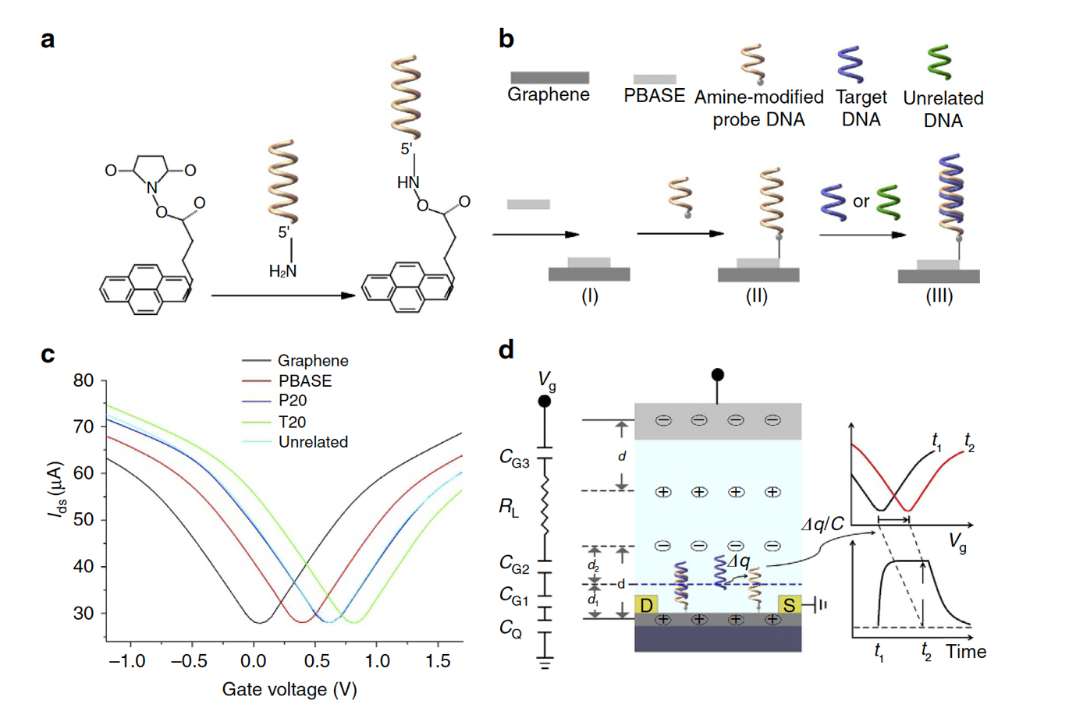
Figure 1 | Functionalization and properties of G-FETs.
Below are the detailed aspects of the study:
- Device Structure
The structural design of the GFET plays a pivotal role in its exceptional performance:
- Graphene Channel
  - A single-crystal graphene monolayer serves as the core sensing material. The channel length is specified as 10 µm, while the width extends to 5 mm, ensuring a sufficiently large active sensing area for nucleic acid interactions.
- Substrate and Insulating Layer
  - The graphene layer is transferred onto a Si/SiO2​ substrate. The SiO2​ layer has a thickness of 90 nm, acting as an insulating and supportive dielectric material.
- Contact Materials
  - The source and drain electrodes are fabricated using Gold (Au) with a Chromium (Cr) adhesion layer. This combination provides excellent conductivity and stable contact with the graphene.
- Electrical and Sensing Characteristics
The unique electrical properties of the GFET facilitate ultra-sensitive detection:
- Voltage Parameters
  - The device operates within a gate voltage range of -0.5 V to 0.5 V, with a fixed drain voltage of 50 mV. These parameters are optimized for reliable sensing of minimal charge variations.
- Ultrasensitive Detection
  - The GFET achieves remarkable detection limits of 600 zM (approximately 18 molecules) in buffer solutions and 20 aM (approximately 600 molecules) in human serum samples, surpassing conventional biosensors.
- Nanoscale Deformations
  - Introducing controlled deformations in the graphene layer creates "electrical hot spots" that amplify sensitivity. These regions enhance the detection of biomolecule charges by mitigating the effects of Debye screening.
- Functionalization with DNA Probes
The functionalization of graphene with DNA probes is a critical aspect of the device's operation:
- Probe Immobilization
  - DNA probes are immobilized on the graphene surface through π-π stacking interactions. This ensures selective and efficient hybridization with target nucleic acids.
- Simulation Insights
Computational simulations provide valuable insights into the behavior of the GFET:
- Charge Screening Reduction
  - The deformed graphene structure minimizes charge screening in the sensing region, particularly in concave areas, enhancing overall sensitivity.
- Electrical Hot Spots
  - Simulations reveal that these concave deformations act as localized regions of high sensitivity, crucial for detecting extremely low analyte concentrations.
- Applications and Implications
The GFET design holds promise for diverse applications in biomedical diagnostics:
- Biomarker Detection
  - The device enables real-time detection of nucleic acids, making it suitable for identifying disease biomarkers.
- Drug Discovery
  - The sensor's high sensitivity allows for efficient screening of potential drug candidates.

1.2 Cost-Effective DNA Hybridization Detection Using Graphene Nanowire Field-Effect Transistors (FETs) [2]
This paper discusses the development of graphene-based nanowire FETs for highly sensitive DNA hybridization detection. The study emphasizes the advantages of using graphene as a sensing material for label-free biomolecule detection, particularly in systems that require low-cost, high-throughput measurements. The unique properties of graphene, along with the use of a single-crystal domain patterned into multiple channels, enhance the device's ability to detect DNA hybridization kinetics and distinguish single-base mutations with high reliability.
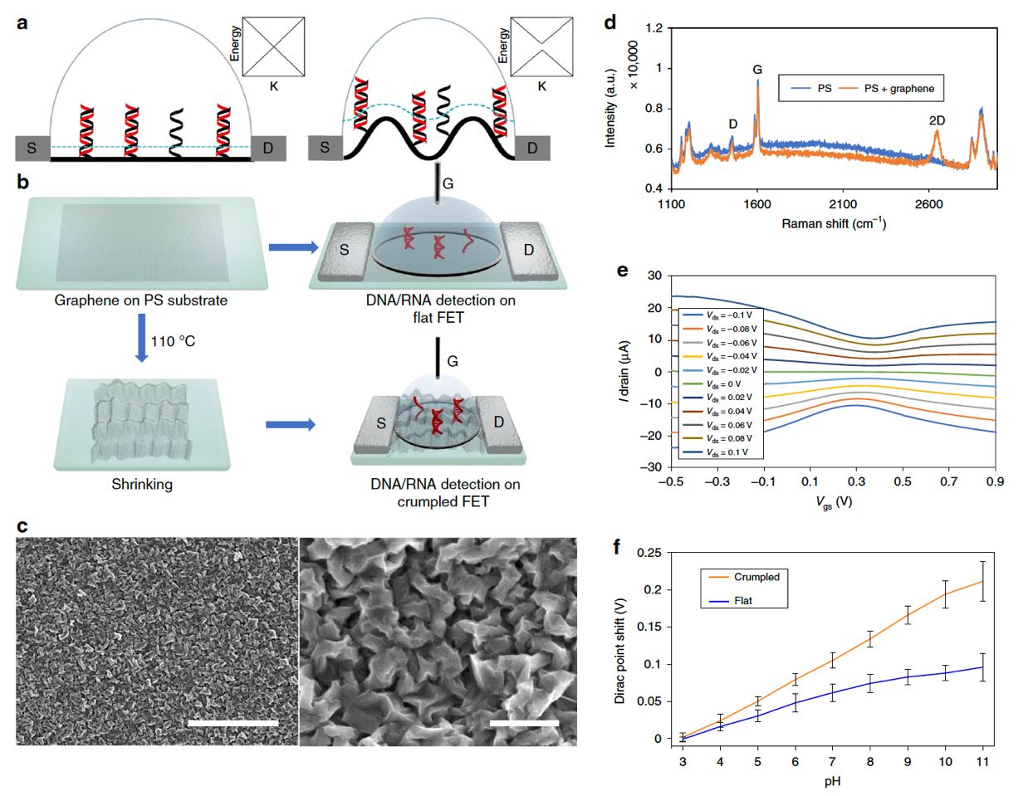
Figure 2 | Scheme and characterization of flat and crumpled graphene FET biosensor.
Below are the key elements of the research:
- Device Structure and Design
The design and structure of the graphene nanowire FET play a crucial role in enabling high-sensitivity detection of DNA hybridization:
- Graphene Channel Configuration
  - The device uses a graphene single-crystal domain that is patterned into multiple channels. The configuration of these channels contributes to improved signal response, especially for the real-time measurement of DNA hybridization kinetics and affinity.
- Substrate
  - The graphene channels are deposited onto a sapphire substrate, ensuring high mechanical stability and optimal electrical performance for sensing applications.
- Contact Materials
  - The source and drain contacts are made of Gold (Au), which provides high conductivity and durability for electrical measurements. The contact pads are precisely aligned with the graphene channels to enable efficient charge transfer.
- Sensing Mechanism and Sensitivity
The sensing mechanism relies on the intrinsic properties of graphene to detect the DNA hybridization events:
- Detection of DNA Hybridization
  - The graphene channels are functionalized with complementary DNA probes, allowing the detection of hybridization events when target DNA sequences bind to the probes.
- Sensitivity
  - The device achieves a remarkable detection limit of 10 pM for DNA, which corresponds to a high level of sensitivity, capable of detecting very small amounts of target DNA.
- Simulation and Computational Insights
Simulations provide a detailed understanding of the underlying mechanisms that contribute to the device’s high sensitivity:
- Charge Transport Modeling
  - Computational simulations reveal that the device's performance is influenced by the interaction between the DNA molecules and the graphene surface, as well as the overall charge transport through the graphene channels.
- Optimization of Probe Density
  - Simulations also offer insights into optimizing probe density on the graphene surface to maximize the device’s sensitivity and detection limit.
- Device Performance
  - The simulations suggest that the device’s performance can be fine-tuned by modifying the length and width of the graphene channels, as well as the gate voltage applied to the FET.

Simulation Framework and Results for Nanobiosensor

FET-based devices are semiconductor components that incorporate a metal-oxide-semiconductor (MOS) structure. When the potential applied to the metal (ψm) is varied, the induced electric field causes the semiconductor channel to undergo band bending. This results in changes to the carrier concentration in the channel, leading to phenomena such as accumulation, depletion, or inversion. In conventional MOSFETs, a gate voltage is applied to invert the channel (i.e., VG > Vth), thereby turning the transistor on. In a similar fashion, other factors, such as solution potential (e.g., pH) or the charge of biomolecules, can influence the gate potential. These factors affect the carrier state in the channel, shifting the current-voltage characteristics accordingly. The resulting shift is reflected in the threshold voltage difference. Thus, the change in threshold voltage (ΔVth) serves as a measure of the device's sensitivity.
To describe the behavior at the solid-liquid interface, the electrical double layer (EDL) model is employed. The Coulomb forces within the solution cause ions to form three distinct layers: the Stern layer, diffuse layer, and bulk solution.

Modelling the Device on Sentaurus Structure Editor (SDE)

Overview

The following section outlines the commands used to create the device structure in Sentaurus Structure Editor. The device design is based on the principles outlined in the referenced research papers; however, some material substitutions have been made due to technical constraints. Specifically, polysilicon has been used instead of graphene, SiO₂ has replaced PMMA, and Titanium has been chosen in place of Chromium.

These substitutions were made to overcome fabrication challenges, but the electrical properties of the selected materials closely resemble those of the original ones. For instance, polysilicon and graphene both exhibit similar electrical conductivity and carrier mobility, while SiO₂ and PMMA share comparable dielectric constants. Additionally, titanium and chromium demonstrate similar work functions and adhesion properties in this context, making them suitable replacements. Although these materials are not identical, their comparable electrical characteristics ensure the functionality of the device remains consistent with the original design.
The contacts (Source, Drain, Gate, Substrate) have also been set in the given SDE commands.
Additionally, the meshing strategy code is included to facilitate the simulation, and in the later section, the SDEVICE commands are provided to plot the graphs corresponding to the device's performance.

SDE Command File

(sdegeo:create-cuboid (position 0 0 0) (position 150 150 100) "Silicon" "region_1")
(sdegeo:create-cuboid (position 0 0 100) (position 150 150 100.3) "SiO2" "region_2")
(sdegeo:create-cuboid (position 30 48.5 100.3) (position 120 101.5 100.30035) "PolySilicon" "region_3")
(sdegeo:set-default-boolean "BAB")
"ABA"
(sdegeo:create-cuboid (position 0 0 100.3) (position 150 51 100.32) "Titanium" "region_1")
(sdegeo:create-cuboid (position 0 150 100.3) (position 150 99 100.32) "Titanium" "region_2")
(sdegeo:create-cuboid (position 0 0 100.32) (position 150 51 100.42) "Gold" "region_3")
(sdegeo:create-cuboid (position 0 150 100.32) (position 150 99 100.42) "Gold" "region_4")
(sdegeo:set-default-boolean "BAB")
"ABiA"
(sdegeo:create-cuboid (position 0 25 100.3) (position 150 52.5 100.5) "Si3N4" "region_2")
(sdegeo:create-cuboid (position 0 125 100.3) (position 150 97.5 100.5) "Si3N4" "region_1")
(sdegeo:create-cuboid (position 0 35 100.5) (position 150 45 110.5) "SiO2" "region_1")
(sdegeo:create-cuboid (position 0 105 100.5) (position 150 115 110.5) "SiO2" "region_2")
(sdedr:define-constant-profile "BoronDopingProfile" "BoronActiveConcentration" 1e18)
(sdedr:define-constant-profile-material "SisubstrateDoping" "BoronDopingProfile" "Silicon")
(render:rebuild)
(sdegeo:define-contact-set "source" 4 (color:rgb 1 0 0 ) "##")
(sdegeo:define-contact-set "drain" 4 (color:rgb 1 0 0 ) "##")
(sdegeo:define-contact-set "gate" 4 (color:rgb 1 0 0 ) "##")
(sdegeo:set-contact (list (car (find-face-id (position 75 137.5 100.42)))) "drain")
(render:rebuild)
(sdegeo:set-current-contact-set "source")
(sdegeo:set-contact (list (car (find-face-id (position 75 12.5 100.42)))) "source")
(render:rebuild)
(sdegeo:set-current-contact-set "gate")
(sdegeo:set-contact (list (car (find-face-id (position 135 75 100.3))) (car (find-face-id (position 75 75 100.30035))) (car (find-face-id (position 75 48.75 100.5))) (car (find-face-id (position 75 45 105.5))) (car (find-face-id (position 75 101.25 100.5))) (car (find-face-id (position 15 75 100.3))) (car (find-face-id (position 75 105 105.5))) (car (find-face-id (position 75 75 100.3)))) "gate")
(sdegeo:define-contact-set "substrate" 4 (color:rgb 1 0 0 ) "##")
(sdegeo:set-current-contact-set "substrate")
(sdegeo:set-contact (list (car (find-face-id (position 75 75 0)))) "substrate")
(render:rebuild)

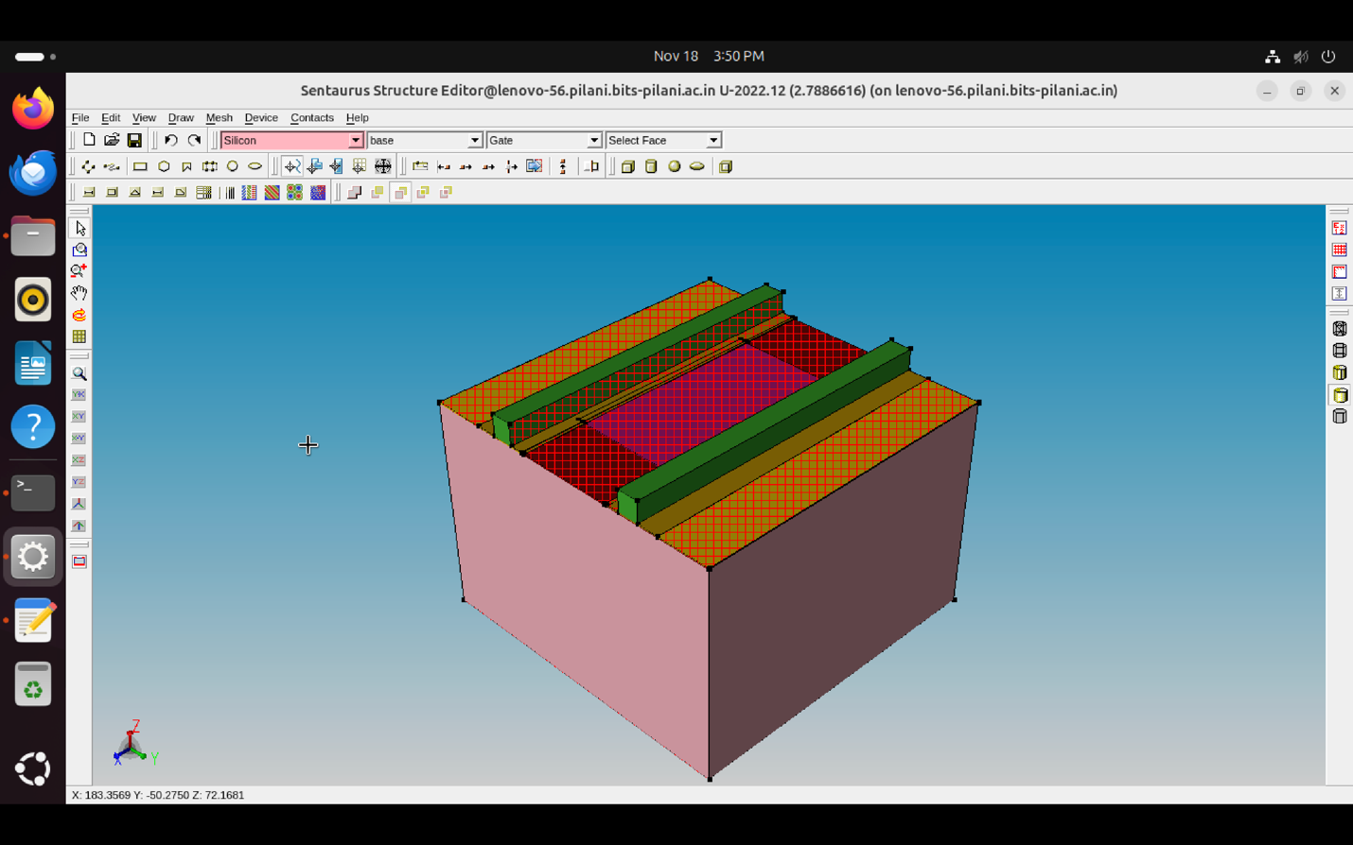
Figure 3 | Produced structure of the Field Effect Transistor on SDE.

In the following section, the meshing strategy commands has also been given, which has to be worked upon in the SDE scheme command file only.

SDE Meshing Strategy

(sdedr:define-refeval-window "RefEvalWin_1" "Cuboid" (position -50 -50 -50) (position 200 200 150))
(sdedr:define-refinement-size "RefDef.Global" 10 10 10 2.5 2.5 2.5 )
(sdedr:define-refinement-placement "Place.Global" "RefDef.Global" (list "window" "RefEvalWin_1" ) )
(sdedr:define-refinement-function "RefDef.Global" "MaxLenInt" "Silicon" "SiO2" 0.05 1.5)
(sdedr:define-refinement-size "RefDef.Global" 10 10 10 2.5 2.5 2.5 )
(sdedr:define-refinement-placement "Place.Global" "RefDef.Global" (list "window" "RefEvalWin_1" ) )
(sdedr:define-refinement-function "RefDef.Global" "MaxLenInt" "Silicon" "SiO2" 0.05 1.5)
(sde:build-mesh "n@node@")
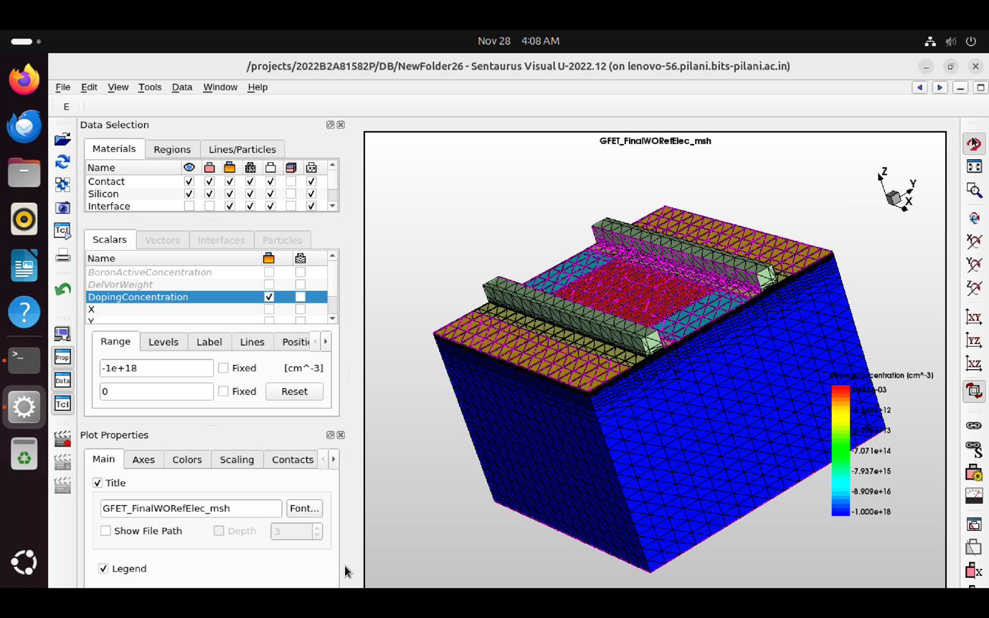
Figure 4 | Meshed structure on SVISUAL tool.

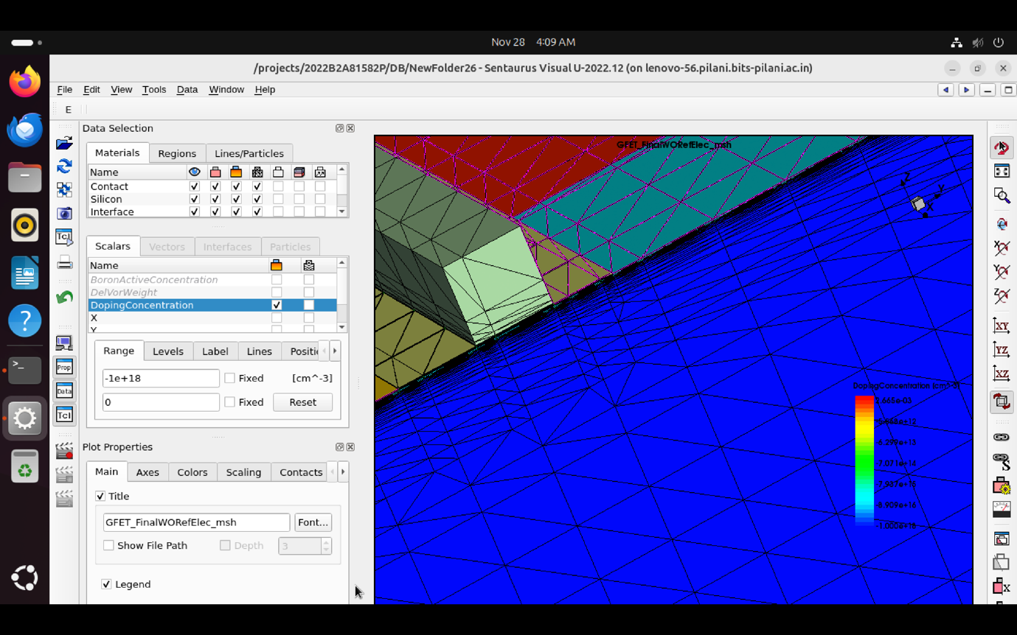
Figure 5 | Closeup of the mesh to show the correct mesh density for the electron channel

The following section shows the sdevice commands to be entered in the input command file from the Sentaurus Workbench (SWB) nodes.

SDEVICE Command File
File{
Grid = "@tdr@"
Plot = "@tdrdat@"
Parameter = "@parameter@"
Current = "@plot@"
Output = "@log@"
}
Electrode{
{ Name="source" Voltage=0.0 }
{ Name="drain" Voltage=0.0 }
{ Name="gate" Voltage=_Vginit_ }
{ Name="substrate" Voltage=0.0 }
}
Physics{
_Tmodel_
_QC_
Fermi
EffectiveIntrinsicDensity( OldSlotboom )
Mobility(
DopingDep
eHighFieldsaturation( _DF_ )
hHighFieldsaturation( GradQuasiFermi )
Enormal
)
Recombination(
SRH( DopingDep TempDependence )
)
}
Plot{
*--Density and Currents, etc
eDensity hDensity
TotalCurrent/Vector eCurrent/Vector hCurrent/Vector
eMobility hMobility
eVelocity hVelocity
eQuasiFermi hQuasiFermi
*--Temperature
eTemperature Temperature * hTemperature
*--Fields and charges
ElectricField/Vector Potential SpaceCharge
*--Doping Profiles
Doping DonorConcentration AcceptorConcentration
*--Generation/Recombination
SRH Band2Band * Auger
ImpactIonization eImpactIonization hImpactIonization
*--Driving forces
eGradQuasiFermi/Vector hGradQuasiFermi/Vector
eEparallel hEparallel eENormal hENormal
*--Band structure/Composition
BandGap
BandGapNarrowing
Affinity
ConductionBand ValenceBand
eQuantumPotential
}
Math {
Extrapolate
Iterations= 20
Notdamped= 100
Method= Blocked
SubMethod= Pardiso
}
Solve {
*- Build-up of initial solution:
NewCurrentPrefix="init_"
Coupled(Iterations=100){ Poisson _QC_ }
Coupled{ _EQUATIONSET_ _QC_ }
*- Bias drain to target bias
Quasistationary(
InitialStep=0.01 MinStep=1e-5 MaxStep=1
Goal{ Name="drain" Voltage= 0.1 }
) { Coupled { _EQUATIONSET_ _QC_ } }
*- gate voltage sweep
NewCurrentPrefix="IdVgs_"
Quasistationary(
InitialStep=1e-3 MinStep=1e-5 MaxStep=1
Goal{ Name="gate" Voltage= 5 }
) { Coupled { _EQUATIONSET_ _QC_ }
CurrentPlot(Time=(Range=(0 1) Intervals=20))
}
System("rm init_n@node@_des.plt")
}
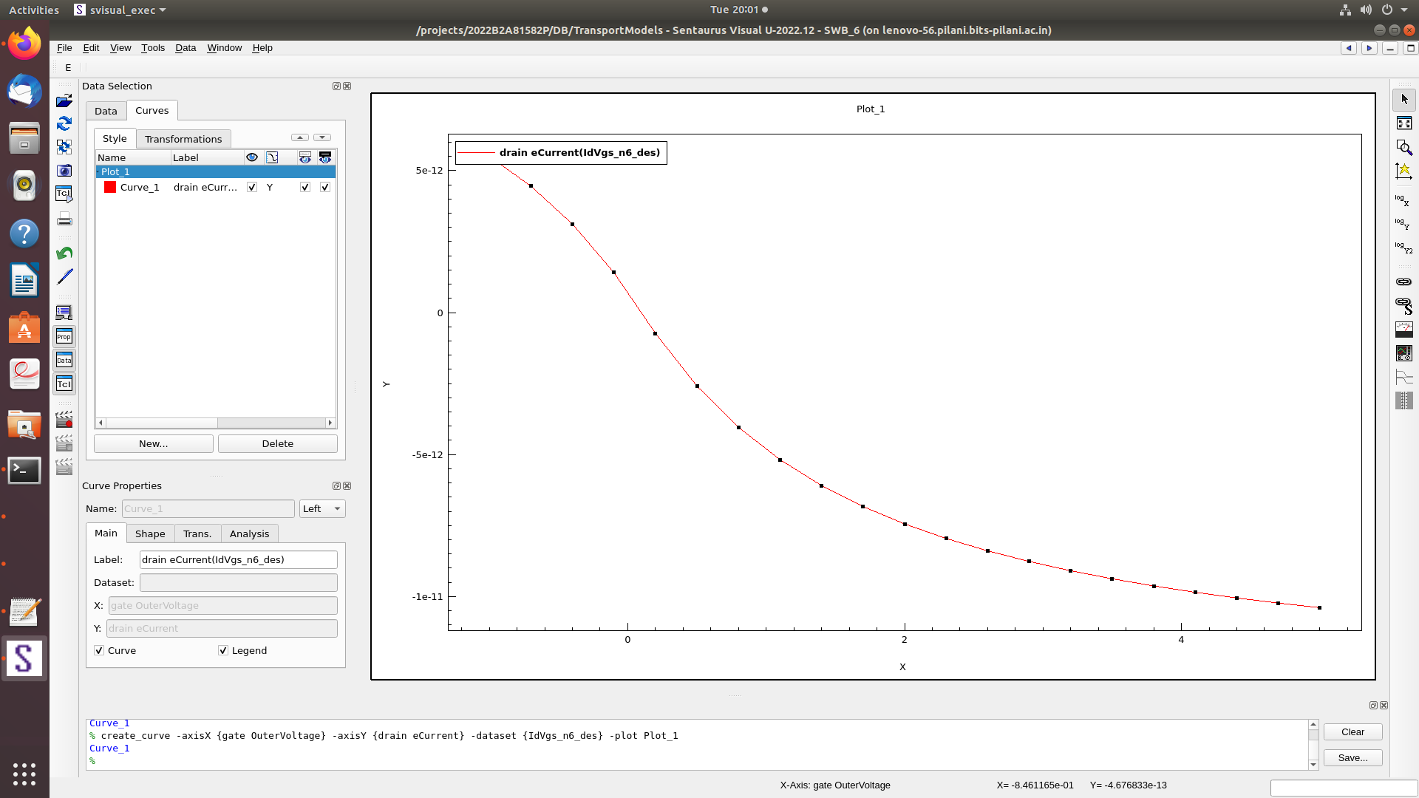
Figure 6 | Plotted graph on SVISUAL with Drain Current vs Gate Voltage (Constant Drain Voltage).

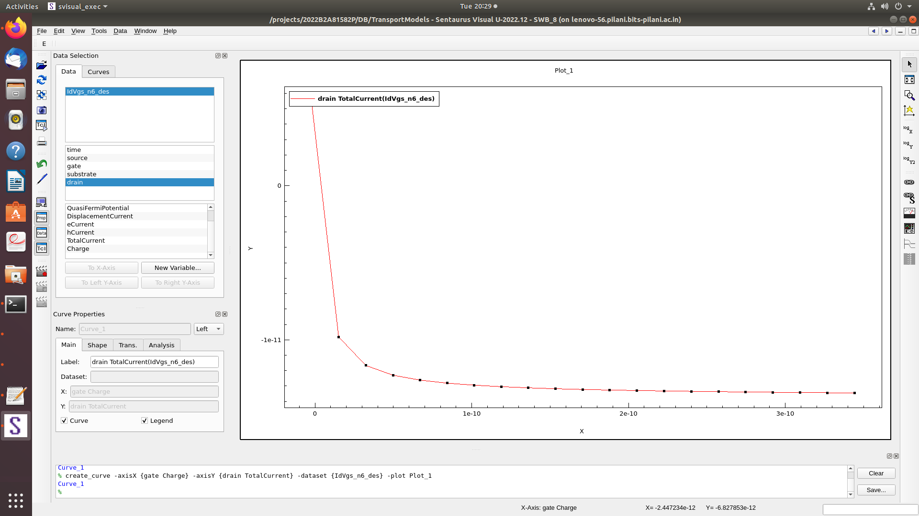
Figure 7 | Plotted graph with Drain Current vs Gate Charge

Disscussion

2.2 Overview

The structure in the Sentaurus TCAD file consists of several cuboid regions, each representing different materials used in the device. The dimensions of the cuboids for each material are as follows:

The Silicon region (Region 1) is a cuboid with a length of 150 µm, width of 150 µm, and height of 100 µm. It is positioned at the origin. The SiO₂ layer (Region 2) has the same length and width as Silicon, 150 µm and 150 µm, respectively, but the height is 0.3 µm. The SiO₂ layer is positioned directly above the Silicon region, starting at z = 100 µm and extending to z = 100.3 µm. Polysilicon layer (Graphene Alternate) (Region 3) is located at a height of 100.3 µm and extends to 100.30035 µm in the z-direction. It has a length of 90 µm and a width of 53 µm. The Titanium regions (Regions 1 and 2) are placed on top of the SiO₂ layer. The first Titanium region (Region 1) has a length of 150 µm, width of 51 µm, and a height of 0.02 µm . The second Titanium region (Region 2) has similar dimensions but is positioned along the y-axis. Gold regions (Regions 3 and 4) are located at a height of 100.32 µm to 100.42 µm and have the same length and width as the Titanium regions, with a length of 150 µm and a width of 51 µm for the first region, and similar for the second region, but positioned along the y-axis. Si₃N₄ layers (Regions 1 and 2) span the entire 150 µm x 51 µm area, with a height of 0.2 µm, and are positioned on top of the Titanium layer. The upper SiO₂ regions (Regions 1 and 2) are stacked above the Si₃N₄ and Titanium regions. Both layers have a length of 150 µm and a width of 50 µm, with a height ranging from z = 100.5 µm to z = 110.5 µm.

Doping Concentrations:
The Boron doping profile for the Silicon region is defined as a constant Boron active concentration of 1e18 cm⁻³, which directly influences the doping of the Silicon layer, enhancing the device's ability to conduct current and allowing for the controlled creation of p-type material.

Meshing Strategy:
The meshing strategy uses a refinement window (RefEvalWin_1) to ensure finer mesh resolution in critical regions. The window extends from (x = -50 µm, y = -50 µm, z = -50 µm) to (x = 200 µm, y = 200 µm, z = 150 µm). A global refinement size of 10 x 10 x 10 µm is applied to the entire structure, with a refinement factor of 2.5 µm in each direction for the materials, ensuring accurate results for the simulation.

Voltage Values:
Drain Voltage: The drain voltage is kept constant at 0.1 V throughout the simulation.
Gate Voltage: The gate voltage sweeps from 0 V to 5 V, with initial steps of 1e-3 V, minimum step size of 1e-5 V, and a maximum step size of 1 V.

These dimensions, doping profiles, and voltage settings were taken from the Nature journal paper referenced earlier, with material substitutions made due to technical constraints in the fabrication process. The key electrical properties such as conductivity, carrier mobility, and bandgap are similar to those in the original design to ensure comparable device performance.

2.2.1 Graph Analysis

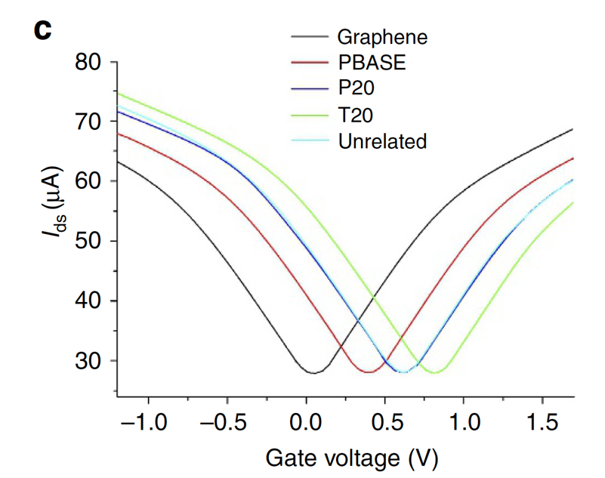
Figure 8 | Expected Graph wrt the Natural’s jounal research paper.

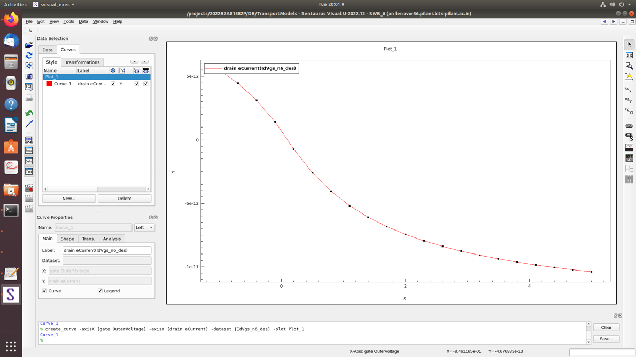
Figure 9 | Experimental Graph obtained on Sentaurus TCAD.

Key Differences:

Shape and Range
Expected Graph shows a clear symmetrical V-shape with a linear region around Vgs=0Vgs​=0.
Actual Graph displays an exponentially decaying curve without the characteristic symmetry.

Current Levels
Expected Graph has current levels in microampere (μA) range.
Actual Graph has current in picoampere (pA) range, suggesting significantly lower conduction.

Possible Causes:

Material Properties

Mismatch in Graphene Parameters:
Graphene has unique properties like zero bandgap, high carrier mobility, and a linear energy dispersion relationship. If these are not properly modeled, the simulation will not capture its behavior.
Parameters such as mobility, work function, and Fermi level should be carefully selected from experimental data.

Incorrect Inclusion of Defects:
Defects like grain boundaries or impurities can reduce the current dramatically. If these are modeled improperly, the simulation may underestimate current levels.

Device Structure

Improper Layer Thickness or Geometry:
Graphene is atomically thin, and any deviation from this assumption in the simulation (e.g., a thicker layer or 3D assumptions) can result in incorrect behavior.
Misalignment in the source, drain, or gate contacts could also change current flow.

Doping Profile:
Doping levels and gradients play a significant role in determining the device’s response to gate voltage. Improper doping (or lack of it) can lead to insufficient carriers for conduction, resulting in picoampere-level currents.

Boundary Conditions

Contact Properties:
The Schottky barrier height, contact resistance, and work function differences between the metal and graphene need to be accurately modeled. Improper values can suppress current significantly.
Gate Voltage Application:
Ensure the gate terminal voltage sweep matches the expected conditions. If the gate-source potential is not properly applied, the device may not operate in the desired region.

Simulation Parameters

Physical Models:
If the simulation does not include graphene-specific effects (e.g., ballistic transport, quantum tunneling), the output will differ. For low-dimensional materials like graphene, traditional drift-diffusion models may be insufficient.

Steps to Align Results:

Verifying the Simulation Setup:
Cross-check the physical models enabled in Sentaurus.
Enable graphene-specific models, such as ballistic transport, quantum corrections, or non-parabolic energy bands, if available.
Use the drift-diffusion model cautiously. For graphene devices, advanced models like Monte Carlo simulations or quantum transport may be necessary.
Confirm that the voltage sweep (gate voltage) matches the range and resolution of the expected graph.

Validate Material Parameters

Graphene Mobility:
Use literature values for graphene’s intrinsic mobility (up to 105 cm2/Vs105cm2/Vs) unless there are reasons to include defects or impurities.
Work Function:
Ensure the work function of the gate material and graphene are consistent with experimental setups.
Doping Concentrations:
Use lightly or undoped graphene for typical ambipolar behavior. If doped, verify the doping concentration aligns with experimental conditions.

Analyze Current Levels

Compare the absolute current levels. A current level mismatch may suggest:
Excessive resistance in the simulation setup.
Improper material properties (e.g., mobility too low).
Missing effects like tunneling or contact injection.

Test Simplified Configurations

Running the simulation under ideal conditions to isolate the issue.
Setting the contact resistance and defect density to zero.
Using an ideal gate dielectric material (e.g., SiO2SiO2​ or h-BNh-BN) with well-defined properties.
Gradually adding complexity (e.g., defect density, edge scattering) to see where the deviation begins.

Adjust Voltage Sweep

Confirm that the voltage sweep is symmetric (e.g., from −1.0 V−1.0V to 1.5 V1.5V) to capture the ambipolar behavior observed in the expected graph.

2.2.2 Biomolecule Approach

2.2.2.1 IgG Charge: Practical and Biological Implications [3]
Biosensors utilizing graphene-based field-effect transistors (GFETs) rely heavily on the electrostatic interaction between the sensing surface and the target analyte. The research presented in the paper provides a comprehensive analysis of the charge characteristics of Monoclonal antibodies (mAbs) and their fragments, highlighting their potential application in nanobiosensors.
These mAbs were analyzed under two key conditions:
- Formulation buffer at pH 5.0 (10 mM acetate, 50 mM NaCl): Simulating conditions often used in biotherapeutics.
- Physiological buffer at pH 7.4 (phosphate-buffered saline, PBS): Mimicking the native environment in the human body.
Measured Charge Characteristics
- Formulation Buffer (pH 5.0):
  - In the acidic buffer, all IgGs exhibit a net positive charge, consistent with the high concentration of H+H+ions in the solution.
  - Intact IgG charges varied significantly, with ZDHHZDHH​ values ranging from 1.4 ± 0.2 for IgG4 to 12.5 ± 0.1 for IgG1.
- Physiological Buffer (pH 7.4):
  - At physiological pH, the charge of most IgGs transitioned to weakly anionic states. For instance, IgG1 showed a ZDHHZDHH​ of -5.6 ± 0.1, while IgG4Pro exhibited a more negative charge of -13 ± 0.3.
Implications for GFET Biosensors
The study's findings are directly relevant to the design and optimization of GFET-based biosensors for nanobiosensing. GFETs rely on charge-induced modulation of the graphene channel's conductivity, making the charge characteristics of the sensing element (antibodies) critical.
- Charge-Induced Voltage Shifts:
  - At physiological pH (7.4), IgGs exhibit net negative charges, which induce a gating effect on the GFET when immobilized on its surface.
  - For example, an IgG4 molecule with ZDHH = −10.6ZDHH​= −10.6 to −13−13 corresponds to a charge of approximately −1.6×10−18 C−1.6×10−18C per molecule. When distributed across the sensor surface, this creates a measurable electrostatic potential, causing a shift in the GFET's Dirac point.
- Binding-Induced Charge Redistribution:
  - Antigen binding to immobilized antibodies further alters the net charge at the sensor interface. The study suggests that this interaction could shift the charge balance by a few Coulombs per molecule, translating to millivolt-scale changes in the GFET output.
Broader Applications and Design Considerations
- Specificity and Sensitivity:
  - The charge profiles of antibodies provide insights into their binding efficiency and surface interactions. For GFET sensors, using antibodies with higher ZDHHZDHH​ values at neutral pH could enhance signal-to-noise ratios by amplifying the gating effect.
Based on the paper's data, a single layer of IgG molecules could induce voltage shifts in the range of 10–50 mV, depending on the subclass and pH conditions. These shifts are well within the detectable range for modern GFETs, underscoring the feasibility of this approach.

2.2.2.2 Field Effect Transistor Biosensor Using Antigen Binding Fragment for Detecting Tumor Marker in Human Serum [4]
This paper investigates the use of antigen-binding fragments (Fab) in FET biosensors for detecting tumor markers, particularly alpha-fetoprotein (AFP), a critical biomarker for liver cancer diagnosis. The findings highlight how reducing the size of the probe molecule enhances sensitivity by mitigating ionic screening effects. FET biosensors offer a rapid, label-free alternative, capable of detecting low concentrations of target biomolecules by monitoring changes in surface charge near the gate electrode.
Key Findings on Sensitivity and Voltage Shifts
- Threshold Voltage Shifts (ΔVg):
  - When exposed to 1 μg/mL AFP, the Fab-immobilized FET exhibited a ΔVg of 111 mV, significantly greater than the 51 mV shift observed with the antibody-immobilized FET. This enhanced response is attributed to Fab's closer interaction with AFP molecules within the Debye length.
  - The Fab-immobilized FET achieved a detection limit of 100 pg/mL, a tenfold improvement over the 10 ng/mL detection limit of antibody-immobilized FETs.
Clinical Relevance and Rapid Detection
The Fab-immobilized FET demonstrated reliable detection of AFP in human serum within clinically relevant concentrations (1 ng/mL to 1 μg/mL). Notably, detection at 1 ng/mL in serum showed equivalent sensitivity to 100 pg/mL in buffer, despite the presence of serum proteins. This represents a significant advancement, with detection completed within 60 minutes, far surpassing the time required for ELISA (approximately 3 hours).
Implications for Future Biosensors
This work underscores the importance of probe molecule selection and surface modification in biosensor design. For graphene FETs, employing small, high-affinity receptors like Fab can significantly enhance sensitivity, specificity, and operational reliability. The use of Fab immobilization, combined with optimized blocking agents, provides a template for developing biosensors capable of detecting various biomarkers in clinical samples.

Conclusion

This report encapsulates the transformative potential of graphene-based field-effect transistors (GFETs) in advancing biosensing technology. The exploration of GFETs demonstrated their unparalleled sensitivity and versatility in detecting biomolecules, ranging from nucleic acids to protein biomarkers, such as monoclonal antibodies (IgG) and alpha-fetoprotein (AFP). The simulation studies conducted in TCAD Sentaurus provided insights into the nuanced behaviors of these devices under varying conditions, highlighting the influence of material properties, device geometry, and functionalization on performance.

Key findings from the literature emphasized the significance of probe molecule design, particularly the use of smaller, high-affinity receptors like antigen-binding fragments (Fab), in overcoming challenges such as Debye screening and enhancing sensitivity. This was evident in the detection of AFP, where Fab-immobilized FETs achieved a tenfold improvement in detection limits compared to antibody-immobilized counterparts. These insights were further validated by simulation results, which showcased how structural innovations like nanoscale deformations in graphene channels create electrical hotspots, amplifying sensitivity.

The integration of theoretical modeling with experimental findings underlines the importance of a multidisciplinary approach in biosensor development. By bridging computational design with practical implementation, this research paves the way for scalable, cost-effective diagnostic tools capable of detecting disease biomarkers at ultra-low concentrations. As GFETs evolve, their application in point-of-care diagnostics, drug discovery, and personalized medicine will undoubtedly expand, marking a significant leap forward in healthcare technology. This study lays a solid foundation for future innovations in nanobiosensing, reaffirming the promise of graphene as a cornerstone material in next-generation biosensors.

References
- Xu, S., Zhan, J., Man, B. et al. Real-time reliable determination of binding kinetics of DNA hybridization using a multi-channel graphene biosensor. Nat Commun 8, 14902 (2017). https://doi.org/10.1038/ncomms14902
- Hwang, M.T., Heiranian, M., Kim, Y. et al. Ultrasensitive detection of nucleic acids using deformed graphene channel field effect biosensors. Nat Commun 11, 1543 (2020). https://doi.org/10.1038/s41467-020-15330-9
- Yang, D., Kroe-Barrett, R., Singh, S., & Laue, T. (2019). IgG Charge: Practical and Biological Implications. Antibodies, 8(1), 24. https://doi.org/10.3390/antib8010024
- Cheng, S., Hotani, K., Hideshima, S., Kuroiwa, S., Nakanishi, T., Hashimoto, M., Mori, Y., & Osaka, T. (2014). Field Effect Transistor Biosensor Using Antigen Binding Fragment for Detecting Tumor Marker in Human Serum. Materials, 7(4), 2490-2500. https://doi.org/10.3390/ma7042490
- Liu H, Yang A, Song J, Wang N, Lam P, Li Y, Law HK, Yan F. Ultrafast, sensitive, and portable detection of COVID-19 IgG using flexible organic electrochemical transistors. Sci Adv. 2021 Sep 17;7(38):eabg8387. doi: 10.1126/sciadv.abg8387. Epub 2021 Sep 15. PMID: 34524851; PMCID: PMC8443172.
- Jana Brndiarova, Peter Siffalovic, Martin Hulman, Anna Kalosi, Michal Bodik, Viera Skakalova, Matej Micusik, Zoran Markovic, Eva Majkova, Karol Frohlich; Functionalized graphene transistor for ultrasensitive detection of carbon quantum dots. J. Appl. Phys. 7 December 2019; 126 (21): 214303. https://doi.org/10.1063/1.5120757

