TECHNICAL REPORT
Audience Response Analysis of YouTube Comments Using Natural Language Processing
Sentiment, Keyword, Topic and Engagement Analysis of the First 200 Comments on a YouTube Video
Case study video: “I tested the most Futuristic Tech - it scared me.” (Mrwhosetheboss)
Submitted by | ______________________________
Registration No. | ______________________________
Course | ______________________________
Submitted to | ______________________________
Date of submission | 18 October 2026

Table of Contents
Abstract 4
1. Introduction 4
1.1 Background 4
1.2 Problem Statement 5
1.3 Objectives 5
1.4 Scope 5
2. Theoretical Background 5
2.1 Sentiment Analysis 5
2.2 VADER 6
2.3 Term Frequency–Inverse Document Frequency (TF-IDF) 6
2.4 Topic Modelling with Latent Dirichlet Allocation 6
2.5 Spearman Rank Correlation 7
3. System Design and Tools 7
3.1 Overall Architecture 7
3.2 Development Environment and Libraries 8
3.3 Configuration Parameters 8
4. Data Collection 8
4.1 Obtaining Access to the YouTube Data API 8
4.2 API Endpoints and Request Parameters 9
4.3 The Case-Study Video 9
4.4 Description of the Collected Dataset 10
4.5 Ethical Considerations 10
5. Text Pre-processing 10
5.1 Normalisation Steps for Sentiment Analysis 10
5.2 Tokenisation, Stop-word Removal and Lemmatisation 11
5.3 Worked Examples 12
5.4 Effect of Pre-processing 12
6. Sentiment Analysis 12
6.1 Method 12
6.2 Domain Adaptation for YouTube Language 13
6.3 Results 14
7. Keyword and Phrase Analysis 15
7.1 Word Frequency 15
7.2 N-gram Analysis 16
7.3 TF-IDF Key Terms 16
7.4 Words that Distinguish Positive from Negative Comments 17
8. Topic Modelling 18
8.1 Method 18
8.2 Selecting the Number of Topics 18
8.3 Discovered Topics 19
9. Comment Categorisation 20
9.1 Rule-based Classification 20
9.2 Results 21
10. Engagement and Timeline Analysis 21
10.1 Distribution of Likes 21
10.2 Does Positive Sentiment Attract More Likes? 22
10.3 Comment Length 23
10.4 Video Timeline Analysis 23
11. Key Findings: Audience Response 24
11.1 Overall Response 24
11.2 What the Audience Liked 24
11.3 Concerns and Criticism 25
11.4 Requests and Questions 25
12. Recommendations 25
12.1 Future Video Ideas 25
12.2 How to Maintain a Good Audience Response 26
13. Output Files 26
14. Limitations 27
15. Conclusion and Future Work 28
References 29
Appendix A: How to Run the Program 29
Appendix B: Program Structure 30
Appendix C: Top 30 Keywords 30

Abstract
Comment sections are one of the richest sources of direct audience feedback available to online video creators, yet popular videos attract far more comments than a creator can read and interpret manually. This report documents the design, implementation and results of a Python-based analysis system that takes a single YouTube video, retrieves its first 200 top-level comments through the official YouTube Data API v3, and converts the unstructured text into a structured audience-response report delivered as CSV files. The system combines several established Natural Language Processing (NLP) techniques: text normalisation and lemmatisation, lexicon-based sentiment analysis using VADER (Valence Aware Dictionary and sEntiment Reasoner), word-frequency and n-gram analysis, Term Frequency–Inverse Document Frequency (TF-IDF) weighting, Latent Dirichlet Allocation (LDA) topic modelling with the number of topics chosen automatically by UMass coherence, rule-based comment categorisation and a timestamp-based analysis of which parts of the video viewers reacted to.
The system was applied to the video “I tested the most Futuristic Tech - it scared me.” published by the technology channel Mrwhosetheboss (15,465,044 views and 4,788 comments at the time of analysis). The audience response was found to be positive overall: 120 comments (60.0%) were positive, 47 (23.5%) neutral and 33 (16.5%) negative, with a mean VADER compound score of +0.279. Four discussion themes were identified: camera quality compared with the iPhone, electronic instruments and general futuristic technology, assistive and personal-care devices, and drones, robots and pop-culture references. A notable 60% of comments quoted a specific timestamp, which allowed the reaction to individual segments of the video to be measured. A domain adaptation step, which reinterprets laughter emoji and internet slang, corrected the sentiment label of 17 comments (8.5%). The report closes with data-driven recommendations for future video topics and for maintaining a positive audience response, together with a discussion of the method’s limitations.
Keywords: sentiment analysis, VADER, YouTube Data API, TF-IDF, topic modelling, LDA, audience analytics, NLP

1. Introduction

1.1 Background
YouTube is the largest video-sharing platform in the world, and its comment section acts as a public, continuously updated focus group for every video. Viewers use comments to praise, criticise, ask questions, joke, request new content and point to specific moments they found memorable. For a creator, this feedback is valuable because it is spontaneous and unprompted; for a researcher, it is a large, freely available corpus of opinionated short texts.
The difficulty lies in the volume. The case-study video in this report received 4,788 comments within eight days of publication. Reading every comment is slow, subjective and impossible to repeat consistently. Natural Language Processing offers a way to summarise such text automatically, measuring overall tone, surfacing the words and themes that recur most often, and isolating the comments that matter most.

1.2 Problem Statement
Creators need a quick, repeatable and explainable way to answer three practical questions about any video: How did the audience respond? What did they like and dislike? What should the next videos be about? Platform analytics such as views and likes measure how much people engaged, but not what they thought. This project addresses that gap by building a system that reads the comments and answers those questions in a structured format.

1.3 Objectives
- Retrieve the first 200 top-level comments of a given YouTube video, together with its metadata, using the official YouTube Data API v3.
- Clean and pre-process the comment text so that it is suitable for computational analysis.
- Measure the sentiment of every comment and of the audience as a whole.
- Identify the most important words, phrases and discussion themes.
- Classify comments into meaningful categories such as questions, criticism, requests and humour.
- Determine which moments of the video generated the strongest reaction.
- Generate recommendations for future video topics and for maintaining a good audience response.
- Export all results to CSV files and document the complete process in this report.

1.4 Scope
The analysis is limited to the first 200 top-level comments returned by the API in relevance order, which corresponds to the “Top comments” view on YouTube. Replies to comments are counted but not analysed. The language models used are designed for English text; non-English comments are detected and reported but not translated. The system is general-purpose: any public video link can be supplied, although this report presents the results for one case-study video.

2. Theoretical Background

2.1 Sentiment Analysis
Sentiment analysis (also called opinion mining) is the computational study of opinions, attitudes and emotions expressed in text (Liu, 2012). It is commonly framed as classifying a piece of text as positive, negative or neutral, or assigning it a continuous polarity score. Two broad families of approach exist:
- Machine-learning approaches train a classifier (for example Naive Bayes, Support Vector Machines or transformer models such as BERT) on a large set of texts that have already been labelled by humans. They can be very accurate, but they require labelled training data and behave as “black boxes” whose decisions are hard to explain.
- Lexicon-based approaches use a dictionary in which each word has a pre-assigned sentiment value, combined with grammatical rules for negation, intensifiers and punctuation. They require no training data, are fully transparent and are well suited to short informal text.
A lexicon-based method was chosen for this project because no labelled training set exists for this video, because every score can be traced back to the words that produced it, and because the chosen lexicon, VADER, was designed specifically for social-media text.

2.2 VADER
VADER (Hutto & Gilbert, 2014) is a rule-based sentiment model whose lexicon of roughly 7,500 words, emoticons, slang terms and acronyms was rated by human annotators on a scale from −4 (extremely negative) to +4 (extremely positive). On top of the lexicon, VADER applies five heuristics that capture how people actually write online:
- Punctuation: exclamation marks increase intensity (“great!!!” is stronger than “great”).
- Capitalisation: words written in capitals while the rest of the text is not are intensified (“GREAT”).
- Degree modifiers: words such as “extremely” or “kind of” raise or lower intensity.
- The contrastive conjunction “but”: sentiment after “but” is weighted more heavily than sentiment before it.
- Negation: a negation within the three preceding words (“not good”) flips and dampens the polarity.
The valence scores of all words in a comment are summed and normalised into a single compound score between −1 and +1 using the formula below, where x is the summed valence and α is a normalisation constant equal to 15:
compound = x / √(x² + α)
VADER also reports the proportion of the text that is positive, neutral and negative. Following the thresholds recommended by the original authors, a comment is labelled Positive if compound ≥ 0.05, Negative if compound ≤ −0.05 and Neutral otherwise.

2.3 Term Frequency–Inverse Document Frequency (TF-IDF)
Raw word counts favour words that are common everywhere. TF-IDF (Salton & Buckley, 1988) instead rewards words that are frequent within a comment but rare across the collection, which makes them more distinctive. For a term t in document d within a collection of N documents:
tf-idf(t, d) = tf(t, d) × [ ln((1 + N) / (1 + df(t))) + 1 ]
where tf(t, d) is the frequency of the term in the document and df(t) is the number of documents that contain it. This project uses sub-linear term frequency (1 + ln tf), unigrams and bigrams, and averages each term’s TF-IDF weight over all comments to rank the key terms of the whole comment section.

2.4 Topic Modelling with Latent Dirichlet Allocation
Latent Dirichlet Allocation (Blei, Ng & Jordan, 2003) is a probabilistic model that assumes every document is a mixture of a small number of hidden topics, and that every topic is a probability distribution over words. Given only the documents, LDA infers both the word distribution of each topic and the topic mixture of each document. The most probable words of a topic are then read by a human and given a meaningful label.
LDA requires the number of topics k to be fixed in advance. Instead of choosing k arbitrarily, this project trains a model for every k from 3 to 7 and selects the one with the highest UMass coherence (Mimno et al., 2011). For the top words of each topic, UMass coherence measures how often pairs of those words actually appear together in the same comments:
C_UMass = Σ (i < j) ln[ (D(w_i, w_j) + 1) / D(w_i) ]
where D(w_i) is the number of comments containing word w_i and D(w_i, w_j) the number containing both words. Values are negative; a value closer to zero indicates that the topic’s words genuinely co-occur and therefore form a more coherent, interpretable theme.

2.5 Spearman Rank Correlation
To test whether more positive comments receive more likes, the Spearman rank correlation coefficient (ρ) is used. Spearman’s ρ compares the rank order of two variables rather than their raw values, which makes it robust to the extremely skewed distribution of comment likes, where a handful of comments receive thousands of likes and most receive very few. ρ ranges from −1 to +1, with values near 0 indicating no monotonic relationship.

3. System Design and Tools

3.1 Overall Architecture
The system is implemented as a single Python program, youtube_comment_analyzer.py, organised as a linear pipeline. Each stage takes the output of the previous stage and adds new columns or results. Figure 1 shows the complete flow from the API request to the final output files.
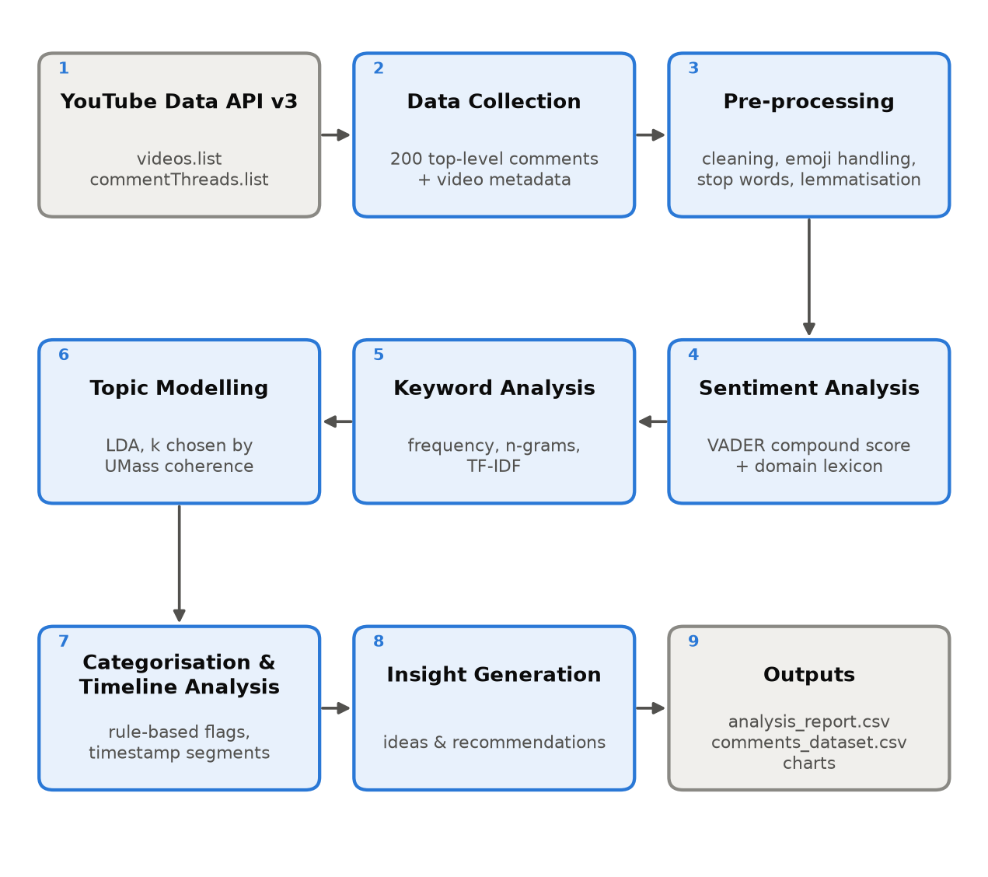
Figure 1: Processing pipeline of the YouTube comment analysis system

3.2 Development Environment and Libraries
The program was developed and executed on Windows 11 with Python 3.11.9. Table 1 lists the third-party libraries used and the role each one plays.
Table 1: Python libraries used and their purpose
Library | Version | Purpose in this project
requests | 2.32.5 | Sending HTTPS requests to the YouTube Data API v3
python-dotenv | 1.2.3 | Loading the API key from a private .env file so it never appears in the code
pandas | 2.3.3 | Storing the comments as a table and computing aggregate statistics
numpy | 1.26.4 | Numerical operations such as weighted averages
nltk | 3.10.3 | VADER sentiment analyser, English stop-word list and WordNet lemmatiser
scikit-learn | 1.9.1 | TF-IDF vectoriser, count vectoriser and LDA topic model
emoji | 2.16.0 | Detecting, counting and converting emoji into words
langdetect | 1.0.9 | Identifying the language of each comment
matplotlib | 3.11.2 | Producing the charts included in this report

3.3 Configuration Parameters
All important settings are defined as named constants at the top of the program so that the analysis can be repeated or adjusted without changing the logic. Table 2 lists them.
Table 2: Configuration parameters of the program
Parameter | Value | Meaning
VIDEO_URL | youtube.com/watch?v=nQdXp6HKKik | Default video; any link can be passed on the command line
MAX_COMMENTS | 200 | Number of top-level comments analysed
COMMENT_ORDER | relevance | YouTube’s “Top comments” ordering (alternative: time)
POSITIVE_THRESHOLD | 0.05 | Minimum compound score for a Positive label
NEGATIVE_THRESHOLD | −0.05 | Maximum compound score for a Negative label
TOPIC_RANGE | 3 to 7 | Candidate numbers of LDA topics
TOP_WORDS_PER_TOPIC | 8 | Words used to describe and score each topic
SEGMENT_MINUTES | 2 | Width of the video-timeline segments
RANDOM_STATE | 42 | Fixed random seed so the results are reproducible

4. Data Collection

4.1 Obtaining Access to the YouTube Data API
YouTube comments are retrieved through the official YouTube Data API v3 provided by Google. Using the official API rather than scraping the website ensures that data is collected in line with YouTube’s Terms of Service and is returned in a clean, structured JSON format. Access was set up as follows:
- A new project named YouTube Comment Analysis was created in the Google Cloud Console.
- The YouTube Data API v3 was enabled for that project from the API Library.
- An API key was generated under APIs & Services → Credentials.
- The key was restricted so that it can only be used with the YouTube Data API v3, limiting the damage if it were ever exposed.
- The key was stored in a local .env file (YOUTUBE_API_KEY=...) that is read by the program at run time. The key is therefore never written into the source code or this report.
The API is free to use within a daily quota of 10,000 units. Each request used in this project costs one unit, and the complete analysis requires only three requests (one for video details and two pages of 100 comments), so the cost of a full run is approximately 3 units, or 0.03% of the daily allowance.

4.2 API Endpoints and Request Parameters
Table 3: YouTube Data API endpoints used
Endpoint | Key parameters | Data returned
videos.list | part=snippet,statistics,contentDetails; id=<video ID> | Title, channel, publish date, duration, view count, like count, comment count, description
commentThreads.list | part=snippet; videoId; maxResults=100; order=relevance; textFormat=plainText; pageToken | Top-level comment text, author, like count, reply count, publish time

The commentThreads.list endpoint returns at most 100 comments per request. To collect 200 comments the program uses pagination: the first response contains a nextPageToken, which is sent with the second request to obtain the next 100 comments. The loop stops when 200 comments have been collected or when no further page exists. The parameter textFormat=plainText asks the API to return comments without HTML formatting, and order=relevance returns comments in the same order as YouTube’s “Top comments” view, which prioritises comments with high engagement.
The video ID is extracted from the link with regular expressions that support every common URL format (youtube.com/watch?v=, youtu.be/, /shorts/, /embed/ and /live/). The program also handles common API failures with clear messages, including disabled comments, an invalid video ID and an exhausted daily quota.

4.3 The Case-Study Video
Table 4: Metadata of the case-study video
Attribute | Value
Title | I tested the most Futuristic Tech - it scared me.
Channel | Mrwhosetheboss
Video ID | nQdXp6HKKik
Published | 2026-10-10 (8 days before analysis)
Duration | 24 minutes 32 seconds
Views | 15,465,044
Likes | 142,770 (like-to-view ratio 0.92%)
Total comments | 4,788 (comment-to-view ratio 0.031%)
Analysis date | 18 October 2026

The video is a review of experimental consumer gadgets marketed as “futuristic”, including automatic hair clippers, a solar-powered charging hat, an AI-assisted camera, an electronic guitar, the Augmental Mouthpad (a tongue-operated trackpad for hands-free computer control), drones and a robot vacuum with an arm. It suits this study well: it is recent, so the comment section is active; it has a large audience; and it covers many separate products, which gives the topic and timeline analyses something meaningful to separate.

4.4 Description of the Collected Dataset
Table 5: Summary of the collected comment dataset
Measure | Value
Comments collected | 200 top-level comments (4.2% of all comments on the video)
Unique authors | 195
Comment dates | 2026-10-10 to 2026-10-18
Total words | 3,250 (mean 16.2, median 12, longest 291 words)
Comments containing emoji | 54 (27%), 82 emoji in total
Total likes on these comments | 42,791 (most-liked comment: 12,192 likes)
Comments with replies | 85 (707 replies in total)
Comments quoting a video timestamp | 121 (60.5%)

Language detection with langdetect identified 186 comments as en, 13 comments as undetermined (too short), 1 comments as so. Because statistical language detectors are unreliable on very short text (for example “poor guy 😭” was initially detected as Spanish), comments with fewer than four alphabetic words are reported as undetermined rather than given a misleading label. A manual review confirmed that the dataset is effectively entirely English, so the English-language tools used in the following stages are appropriate.

4.5 Ethical Considerations
Only publicly visible comments were collected, through Google’s official API and within its usage terms. Author display names are stored in the dataset file only to allow duplicate detection and are not reproduced or analysed in this report. The analysis looks at the audience as a whole rather than at individuals, and comment texts quoted in this report are used only to illustrate the findings.

5. Text Pre-processing
YouTube comments are noisy: they contain timestamps, links, user mentions, emoji, repeated letters (“MAAAAAN”), slang (“ngl”, “ppl”) and inconsistent capitalisation. Pre-processing turns this raw text into a form the analysis algorithms can use. A key design decision was to produce two cleaned versions of every comment, because sentiment analysis and keyword analysis need different things:
- Normalised text (for sentiment and rule matching). VADER relies on capitalisation, punctuation and emoji to judge intensity, so these are kept. Only noise that carries no sentiment is removed.
- Token list (for keyword and topic analysis). Frequency-based methods need clean, comparable words, so the text is lower-cased, stripped of everything except letters and reduced to meaningful base words.

5.1 Normalisation Steps for Sentiment Analysis
- URL removal: links (http://..., www...) are deleted with a regular expression.
- Mention removal: @username references are deleted.
- Laughter-emoji mapping: the emoji 😂 🤣 😭 💀 ☠ 😆 😹 😅 are replaced with the word “haha” (explained in Section 6.2).
- Emoji to text: every remaining emoji is converted into its descriptive name (for example 🔥 becomes “fire” and 💔 becomes “broken heart”) so that VADER can score it.
- Elongation reduction: any character repeated three or more times is reduced to two (“sooooo” becomes “soo”, “!!!!!” becomes “!!”), which keeps the emphasis while making the word recognisable.
- Whitespace normalisation: repeated spaces and line breaks are collapsed into single spaces.

5.2 Tokenisation, Stop-word Removal and Lemmatisation
- Lower-casing so that “Camera” and “camera” are treated as one word.
- Removal of URLs, mentions, timestamps (e.g. 5:27) and emoji.
- Removal of non-letter characters (digits and punctuation), keeping apostrophes inside words.
- Slang expansion using a dictionary of 24 common informal spellings (Table 7).
- Tokenisation by splitting on whitespace.
- Stop-word removal using the NLTK English stop-word list combined with a custom list, giving 282 stop words in total.
- Length filter: tokens shorter than three letters are discarded.
- Lemmatisation with the WordNet lemmatiser, applied first as a noun and then as a verb, so that “cameras” becomes “camera” and “playing” becomes “play”.
Stop words are very common words such as “the”, “is” and “and” that carry little topical meaning. The standard NLTK list was extended with words that are extremely common in YouTube comments but say nothing about the content of this particular video. Table 6 lists this custom extension; the creator’s names (“arun”, “maini”, “mrwhosetheboss”) were also added, because a name is not a discussion topic and it dominated an early version of the topic model.
Table 6: Custom stop words added to the standard NLTK list
Custom stop words (84 words)
actually, also, always, anyone, back, bro, can't, cant, come, comment, comments, could, day, don't, dont, dude, even, ever, every, everyone, first, get, go, going, gonna, good, got, great, guy, guys, i'm, im, it's, know, let, like, lmao, lol, look, lot, made, make, man, much, need, next, oh, omg, one, people, really, said, say, see, someone, something, still, take, thank, thanks, that's, thing, things, think, though, time, two, u, us, use, video, videos, wanna, want, watch, watched, watching, way, well, would, yeah, year, years, yes

Table 7: Slang dictionary used during tokenisation
Informal form | Expanded form | Informal form | Expanded form
u | you | ur | your
pls / plz | please | thx / ty | thanks
bc / cuz / coz | because | tho | though
vid / vids | video / videos | ppl | people
im / ive | i'm / i've | dont / cant / wont | don't / can't / won't
didnt / doesnt / isnt | didn't / doesn't / isn't | idk | i don't know

5.3 Worked Examples
Table 8 shows how real comments from the dataset are transformed by the two cleaning paths.
Table 8: Examples of the two pre-processing paths applied to real comments
Original comment | Normalised text (sentiment) | Tokens (keywords and topics)
0:45 Just left the poor guy with half a haircut 😂 | 0:45 Just left the poor guy with half a haircut haha | leave poor half haircut
The mouth trackpad was crazy!!! (it will be good for ppl that can't use their hands) | The mouth trackpad was crazy!! (it will be good for ppl that can't use their hands) | mouth trackpad crazy hand
Ngl, as a bassist and sometimes guitarist, I can speak for a lot of musicians when I say, almost nobody likes these electronic instruments. Electro... | Ngl, as a bassist and sometimes guitarist, I can speak for a lot of musicians when I say, almost nobody likes these electronic instruments. Electro... | ngl bassist sometimes guitarist speak musician almost nobody electronic instrument electronic drum kit cool convenient give nature drum electronic...
4:45 MAAAAAN! I was hoping you would mention how bad their software looks. I’m an early adopter of that camera and it should not be marketed toward... | 4:45 MAAN! I was hoping you would mention how bad their software looks. I’m an early adopter of that camera and it should not be marketed towards t... | maan hop mention bad software early adopter camera market towards feature eye couple pro camera lens phone whole game software top complaint

5.4 Effect of Pre-processing
Across the 200 comments, pre-processing reduced the 3,250 raw words to 1,255 meaningful tokens, removing 61% of the text as stop words, noise or very short fragments. The remaining tokens form a vocabulary of 727 distinct lemmatised words. The large reduction is typical of social-media text, where a high share of words are function words, fillers and reactions rather than content words.

6. Sentiment Analysis

6.1 Method
Every normalised comment was passed to NLTK’s implementation of the VADER SentimentIntensityAnalyzer. For each comment the program stores four values: the positive, neutral and negative proportions and the compound score, and then assigns a label using the ±0.05 thresholds described in Section 2.2. Table 9 shows how VADER scored three representative comments.
Table 9: Examples of VADER scores for individual comments
Comment | Pos | Neu | Neg | Compound | Label
So many solutions in search of a problem. | 0.204 | 0.517 | 0.279 | -0.1832 | Negative
The mouth trackpad was crazy!!! (it will be good for ppl that can't use their hands) | 0.263 | 0.737 | 0.000 | +0.6103 | Positive
Surprised the Balmuda toaster wasn't in here with its futuristic bread taste! | 0.166 | 0.834 | 0.000 | +0.2942 | Positive

6.2 Domain Adaptation for YouTube Language
A first run of the unmodified VADER model revealed a systematic error. On YouTube, the emoji 😭 (“loudly crying face”) and 💀 (“skull”) are almost always used to mean “I am laughing so hard”, not sadness or death. Similarly, words such as “insane”, “crazy” and “sick” are compliments in informal speech (“those clippers are sick”), but VADER’s dictionary treats them as negative. Two corrections were therefore added:
- Laughter-emoji mapping: laughter emoji are replaced with the word “haha” before scoring.
- Slang lexicon update: the VADER dictionary is updated with the values in Table 10, which reflect the informal meaning of these words.
Table 10: Slang lexicon added to VADER (scale −4 to +4)
Term | New valence | Term | New valence | Term | New valence
insane | +1.5 | crazy | +0.5 | goat | +2.0
dope | +2.0 | lit | +1.5 | underrated | +1.5
fire | +1.0 | sick | +1.5 | haha | +1.5
ngl | 0.0

Table 11 compares the results before and after this adaptation. Overall, 17 comments (8.5%) changed label. Of these, 1 moved from Negative to Neutral, 14 moved from Negative to Positive, 2 moved from Neutral to Positive. All changed comments were inspected manually, and Table 12 lists the most-liked examples. In almost every case the adapted label matches the commenter’s evident intention far better. A few remain debatable: for example, a dark joke followed by 💀💀 moved from Negative to Positive, when Neutral would arguably fit better. Because the corrections are overwhelmingly improvements, the adapted model was used for all reported results.
Table 11: Sentiment distribution before and after domain adaptation
Label | Unmodified VADER | Adapted VADER | Change
Positive | 104 (52.0%) | 120 (60.0%) | +16
Neutral | 48 (24.0%) | 47 (23.5%) | -1
Negative | 48 (24.0%) | 33 (16.5%) | -15

Table 12: Comments whose label was corrected by the domain adaptation
Comment | Before | After
24:20 image your dog takes a dump and this robot vacuum is tryna grab it while it gets everywhere 😭 | Negative (-0.69) | Neutral (-0.03)
12:27 "DO ME" is crazy work😭 | Negative (-0.67) | Positive (+0.46)
That cliper was insane! | Negative (-0.46) | Positive (+0.42)
Dude those clippers are sick. | Negative (-0.51) | Positive (+0.36)
don't leave my boy josh like that 😭 | Negative (-0.12) | Positive (+0.63)
Here already 🔥🔥🔥 let's see the tech we won't buy | Negative (-0.74) | Positive (+0.61)

6.3 Results
Figure 2 shows the final sentiment distribution. 120 of the 200 comments (60.0%) are positive, 47 (23.5%) are neutral and 33 (16.5%) are negative, a positive-to-negative ratio of 3.64 to 1. The mean compound score is +0.279 and the median is +0.361.
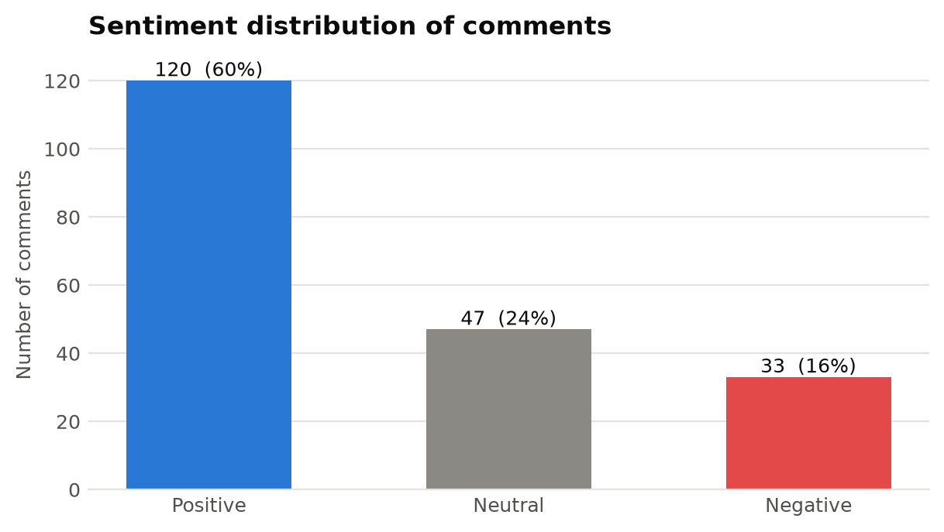
Figure 2: Sentiment distribution of the 200 analysed comments
Figure 3 shows the full distribution of compound scores. The tall grey bar at zero represents comments that contain no sentiment-bearing words at all, such as factual remarks (“8:03 everyone expected a different song”). Positive comments are spread widely between +0.3 and +0.9, showing that approval ranges from mild to very strong, whereas negative comments are fewer and mostly moderate.
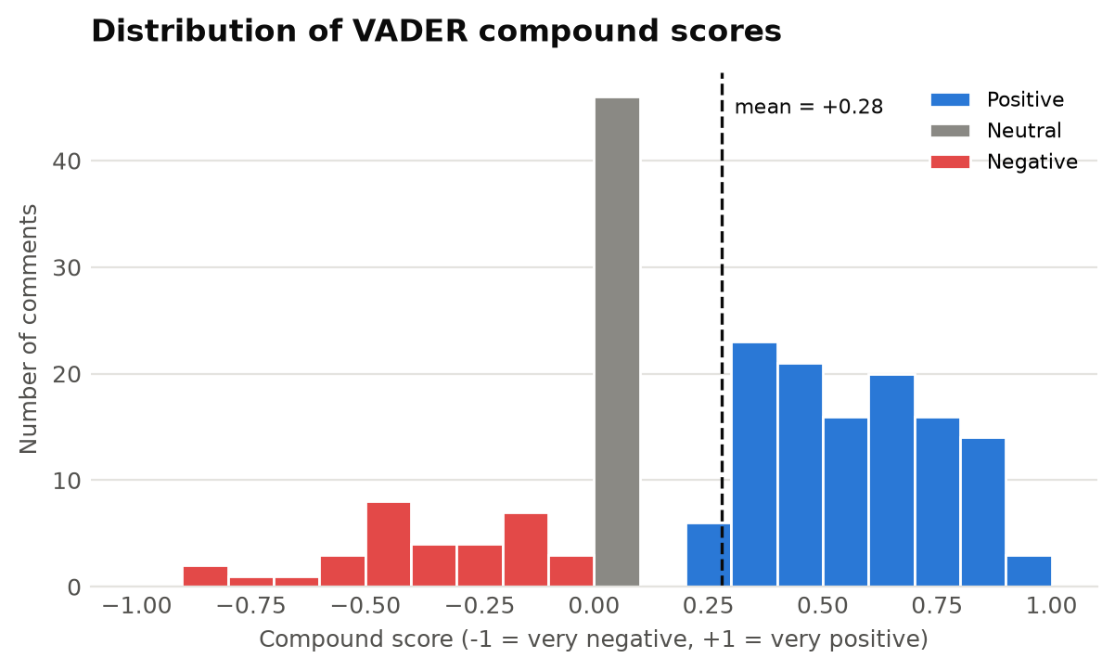
Figure 3: Distribution of VADER compound scores, coloured by sentiment label
Because some comments are endorsed by thousands of viewers and others by none, a like-weighted compound score was also calculated, in which each comment is weighted by ln(1 + likes) + 1. The weighted score of +0.281 is almost identical to the unweighted mean of +0.279, which shows that the overall positive tone is shared by the most popular comments and is not driven by a few unrepresentative ones. The ten most-liked comments have an even higher average score of +0.418.
Based on these results, the system’s automatic verdict is: “Positive - most viewers responded well, with limited criticism.”

7. Keyword and Phrase Analysis

7.1 Word Frequency
After pre-processing, the frequency of every token was counted across all comments. Figure 4 shows the 20 most frequent words. The list is dominated by the products in the video, namely camera, guitar, drone, hat and mouthpad, together with evaluative words (cool, better, bad, useful, love) and the video’s theme (tech, futuristic, future). The fact that iphone is the fifth most frequent word is notable for a video that is not about the iPhone at all: viewers repeatedly compared the AI camera’s footage with the iPhone footage that was shown alongside it.
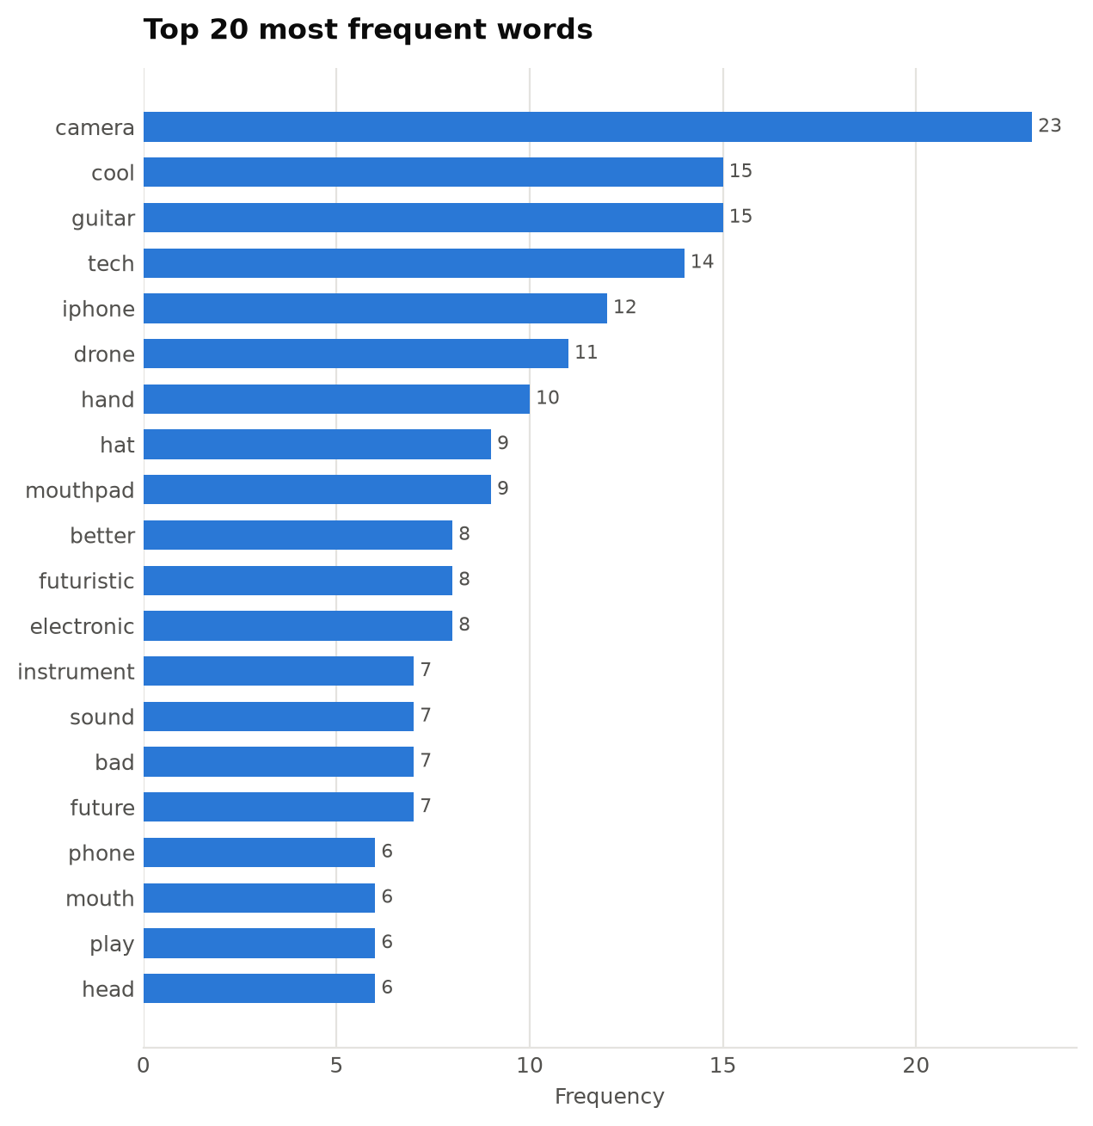
Figure 4: The 20 most frequent words after pre-processing

7.2 N-gram Analysis
Single words lose context, so consecutive word pairs (bigrams) and triples (trigrams) were also counted; only phrases appearing at least twice are reported. The top phrases in Figure 5, iphone better, iphone camera, prefer iphone and footage better, confirm the camera comparison as the single most discussed point. Other phrases point to clear sub-themes: electronic guitar and electronic instrument (the music segment), mouth trackpad and hand free (the Mouthpad), and robot vacuum. The recurring trigram remind diamond steal scene comes from several viewers comparing the robot-vacuum segment to a famous scene in the Bollywood film Dhoom 2, an example of shared cultural humour in the audience.
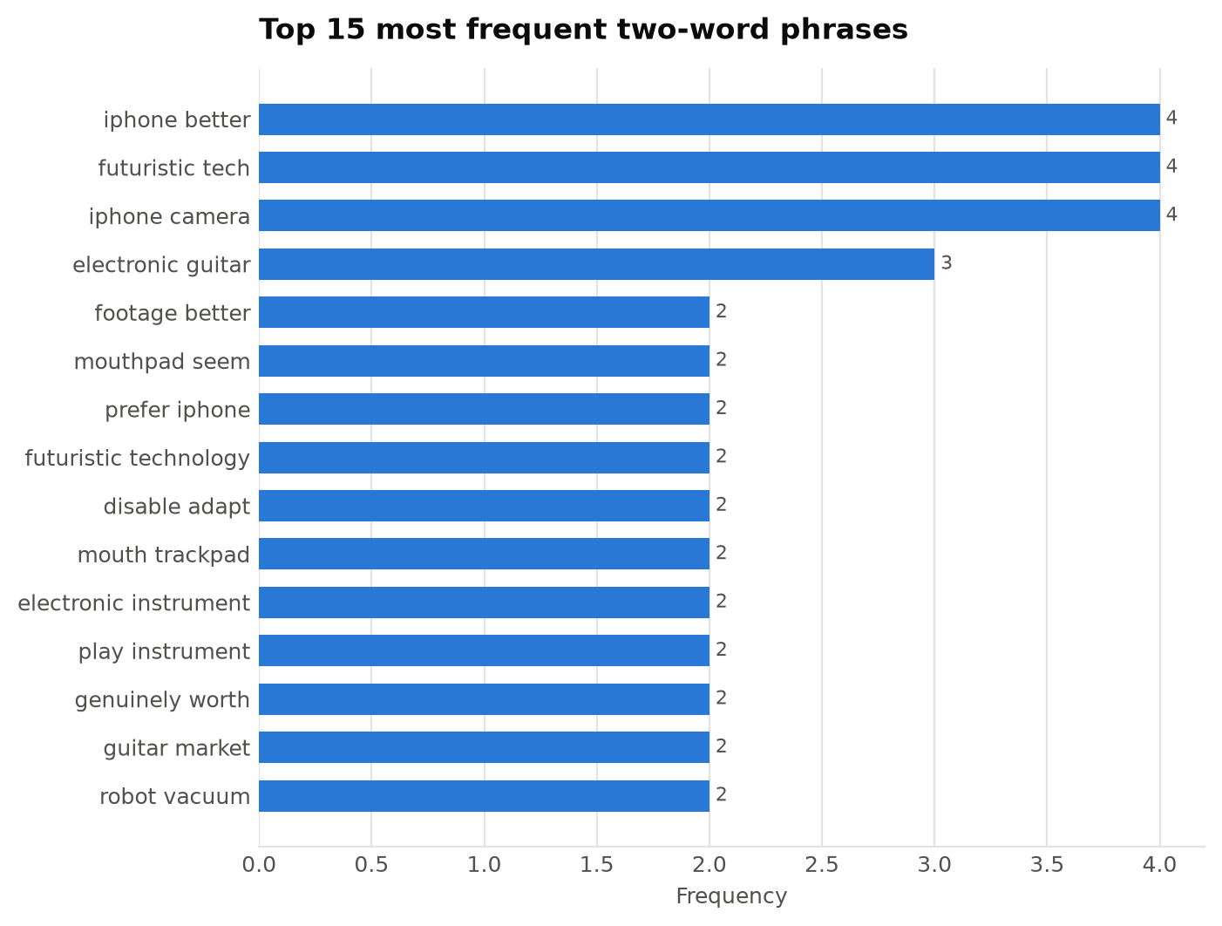
Figure 5: The 15 most frequent two-word phrases

7.3 TF-IDF Key Terms
Figure 6 ranks terms by their mean TF-IDF weight. The ranking is similar to raw frequency, which shows that the main terms are both frequent and concentrated in specific comments rather than spread thinly. TF-IDF also brings forward terms that frequency alone under-ranks, such as wear, head, product and the bigram iphone better, which describe the wearable gadgets and the comparison theme.
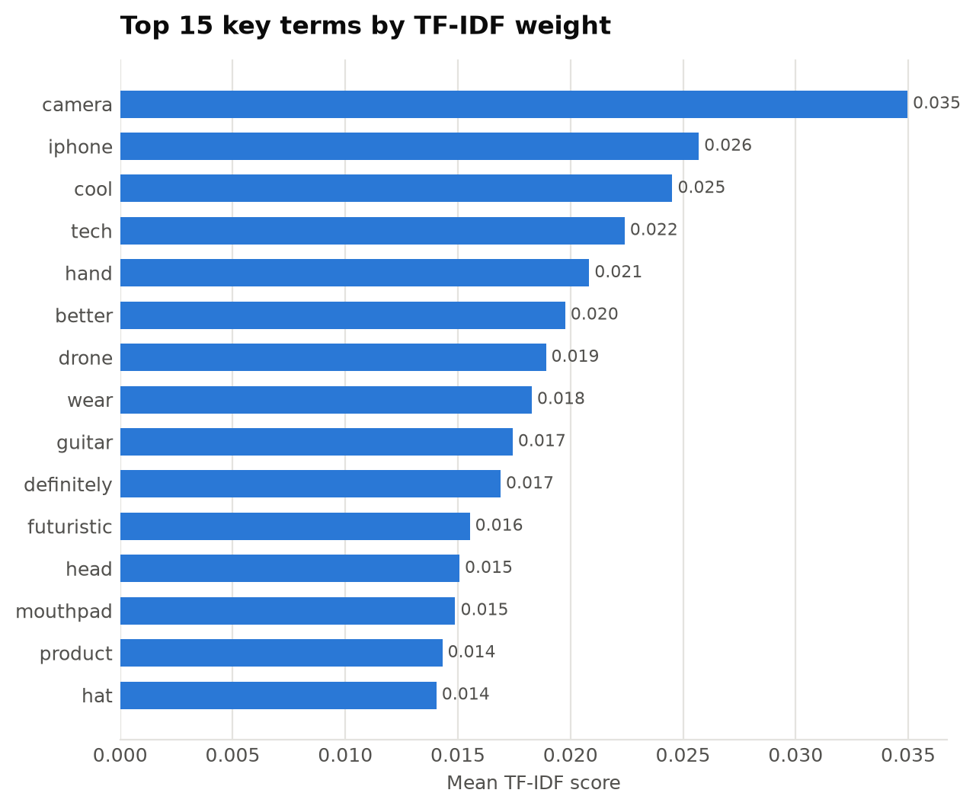
Figure 6: The 15 most important terms ranked by mean TF-IDF weight

7.4 Words that Distinguish Positive from Negative Comments
To understand why comments are positive or negative, the program compares word usage between the two groups using a smoothed log-ratio of relative frequencies. For each word w:
score(w) = ln[ (f_pos(w) + 1) / (N_pos + V) ] − ln[ (f_neg(w) + 1) / (N_neg + V) ]
where f is the word’s count in each group, N is the total number of tokens in each group and V is the vocabulary size. Adding one to every count prevents division by zero for words that appear in only one group.
Table 13: Words most characteristic of positive and negative comments
Group | Most distinctive words
Positive comments | cool, drone, hand, electronic, instrument, sound, future, definitely, futuristic, genuinely
Negative comments | poor, control, diamond, disguise, elden, hair, half, hit, low, many

Positive comments are characterised by the music segment (electronic, instrument, sound), the drone and hands-free control (drone, hand), and forward-looking appreciation (cool, future, futuristic, genuinely, definitely). The negative list contains both genuine and false signals. Poor, hair and half come from the joke about the half-finished haircut, and diamond and disguise from the robot-vacuum scene (“a bomb disposal robot disguised as a harmless puck”). However, elden, hit and control come from enthusiastic comments imagining “no-hit” Elden Ring speed-runs played with the Mouthpad; VADER scores them as negative only because of the word “hit”. This illustrates the domain-specific errors discussed in Section 14.

8. Topic Modelling

8.1 Method
The token lists were converted into a document–term matrix with scikit-learn’s CountVectorizer, keeping only words that appear in at least two comments (min_df = 2) and in no more than half of them (max_df = 0.5). This removes one-off words and words too common to separate topics. Comments left empty after pre-processing (four comments consisting only of emoji or stop words) were excluded from topic modelling. LDA models were trained with the parameters in Table 14.
Table 14: LDA training parameters
Parameter | Value | Reason
n_components (k) | 3 to 7 (best chosen) | Range suitable for a small corpus of short texts
learning_method | batch | More stable than online learning for small datasets
max_iter | 100 | Enough iterations for convergence
doc_topic_prior (α) | 0.1 | Low value: each short comment is expected to be about few topics
topic_word_prior (β) | 0.01 | Low value: each topic is expected to use a focused vocabulary
random_state | 42 | Reproducible results

8.2 Selecting the Number of Topics
Figure 7 shows the UMass coherence for each candidate number of topics. Coherence rises sharply from three to four topics and then falls as further topics are added, so k = 4 was selected automatically (coherence -40.768). With more topics, the model starts to split real themes into fragments whose words rarely appear together.
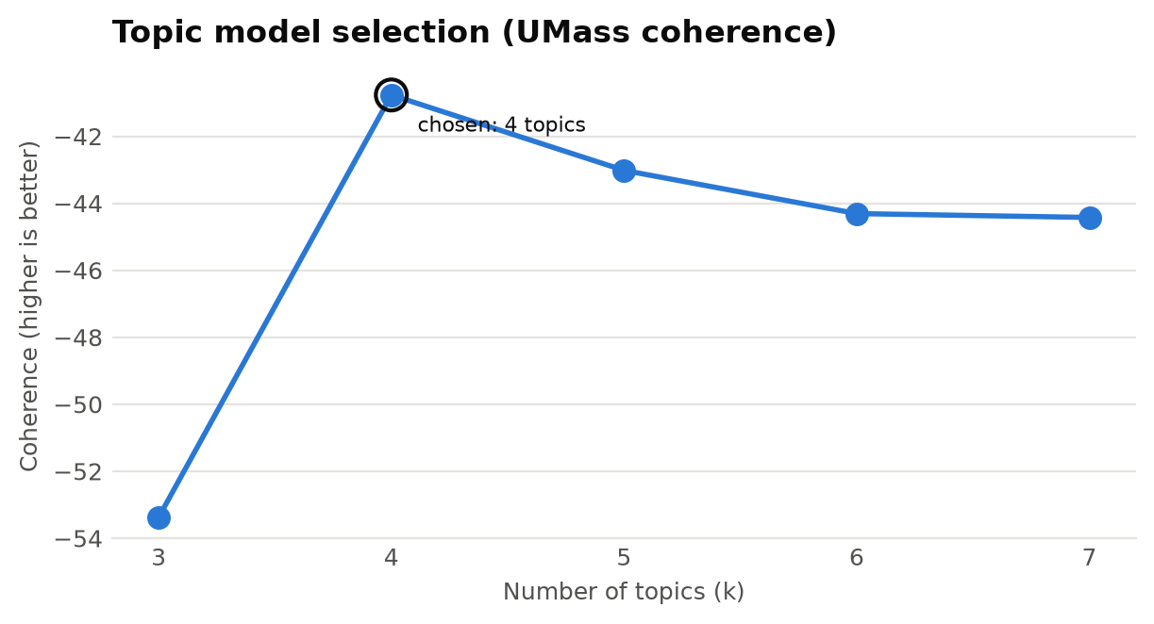
Figure 7: UMass coherence for each candidate number of topics

8.3 Discovered Topics
Table 15: Topics discovered by LDA, with interpreted labels
Topic | Interpreted label | Top words | Comments | Avg sent. | Positive | Avg likes
Topic 1 | Camera quality and comparison with the iPhone | camera, iphone, better, bad, wear, definitely, game, head | 66 comments (33%) | +0.24 | 61% positive | 311.2
Topic 2 | Electronic instruments and general futuristic-tech reactions | guitar, cool, tech, instrument, sound, play, futuristic, genuinely | 44 comments (22%) | +0.37 | 70% positive | 216.7
Topic 3 | Assistive and personal-care devices (Mouthpad, hair clippers, AI toothbrush) | mouthpad, leave, mind, clipper, toothbrush, poor, talk, camera | 39 comments (20%) | +0.19 | 56% positive | 158.6
Topic 4 | Drones, robots and pop-culture references | hand, drone, robot, product, imagine, dhoom, movie, futuristic | 47 comments (24%) | +0.32 | 53% positive | 136.1

The topic labels were assigned by reading the top words together with the comments most strongly assigned to each topic. Each comment was assigned to the topic with the highest probability in its topic mixture; the mean probability of the assigned topic was 0.81, which shows that most comments belong clearly to one theme.
- Topic 1, camera quality and comparison with the iPhone (largest theme). This theme contains the most-liked comment in the dataset (“The iPhone footage was so much better? 😂”, 12,192 likes). Viewers judged the dedicated AI camera to be worse than a smartphone. The theme has the highest average likes per comment, which makes it the audience’s main takeaway from the video.
- Topic 2, electronic instruments and futuristic-tech reactions (most positive theme). Driven by a highly liked comment from a musician explaining which electronic instruments musicians actually value, together with general reactions such as “cool” and “genuinely”. It has the highest average sentiment and the highest share of positive comments.
- Topic 3, assistive and personal-care devices. Combines the Mouthpad, which viewers praised as an accessibility device, with the automatic hair clippers (the half-finished haircut joke) and the AI toothbrush. It has the highest share of negative comments, mainly because of humorous remarks about the haircut and doubts about the toothbrush.
- Topic 4, drones, robots and pop-culture references. Covers the drone camera and the robot vacuum, including the Dhoom 2 comparisons, and broader observations such as “so many solutions in search of a problem”.
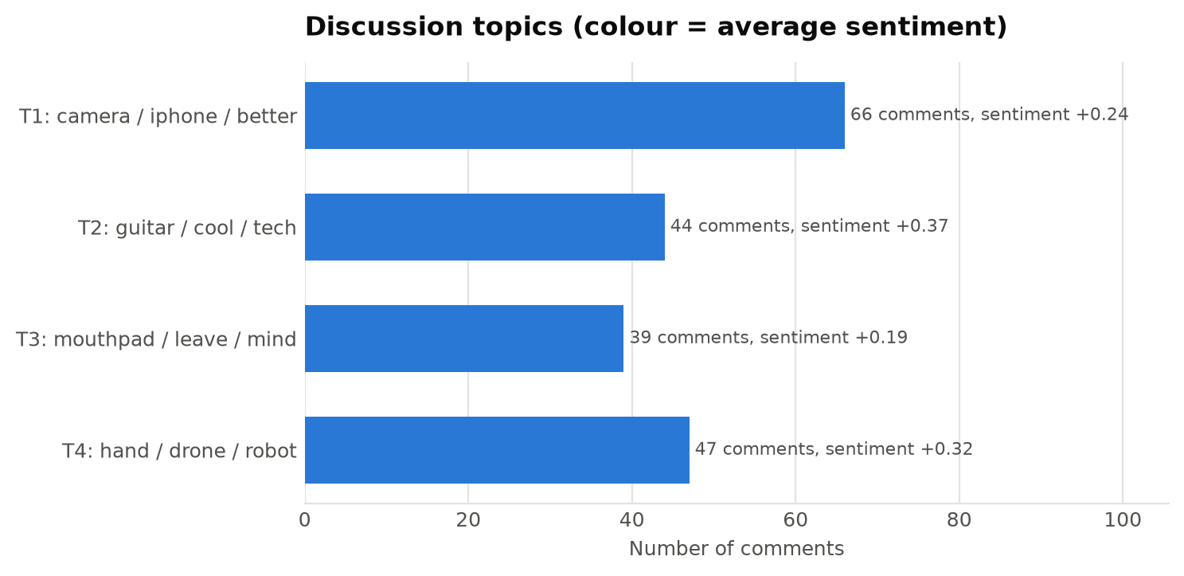
Figure 8: Number of comments and average sentiment per discovered topic

9. Comment Categorisation

9.1 Rule-based Classification
Sentiment shows how viewers feel, but not what kind of comment they are writing. A rule-based classifier built from regular expressions was therefore developed to flag the communicative purpose of each comment. Rules were chosen over a trained classifier because no labelled data was available and because rules are transparent and easy to audit. Each comment receives a true/false value for every flag in Table 16, so one comment can carry several flags.
Table 16: Rules used to flag the purpose of each comment
Flag | Detection rule (simplified)
Request / Suggestion | Patterns such as “make a video about …”, “please do …”, “can you review …”, “you should …”, “would love to see …”, “part 2”. The requested subject is extracted.
Purchase intent | “I want one”, “I need this”, “take my money”, “where can I buy”, “I would buy”, “just bought”
Question | Contains “?” or begins with who, what, when, where, why, how, which, is, are, can, does, etc.
Criticism / Concern | Critical vocabulary (clickbait, boring, misleading, waste, audio, fake, …) with compound < 0.3, or any Negative comment that is not a joke
Appreciation / Praise | Thanks, “love this”, “best video”, amazing, awesome, brilliant, underrated, helpful, etc.
Humour / Joke | lol, lmao, haha, funny, hilarious, “I’m dead”, or laughter emoji
Personal story | “I remember”, “when I was”, “my dad / mom / friend”, “growing up”, “I’m from”
Timestamp reference | Contains a time in the form m:ss or h:mm:ss

For summary charts each comment also receives a single primary category chosen by priority: Request, Purchase Intent, Criticism, Question, Personal Story, Appreciation, Humour and finally General Opinion. The priority puts the most actionable types of feedback first.

9.2 Results
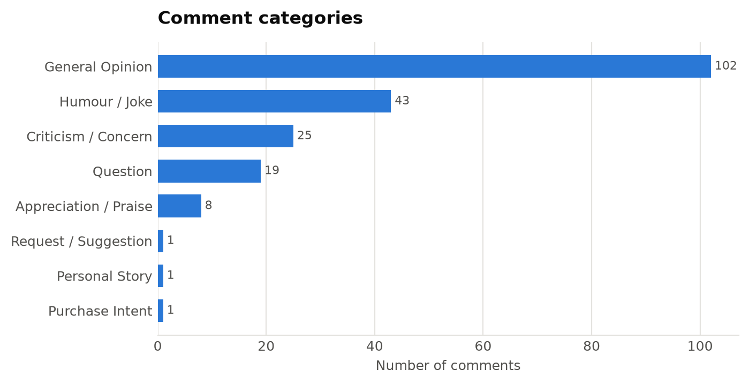
Figure 9: Primary category of each comment
Table 17: Number of comments carrying each flag (a comment can carry several)
Flag (overlapping) | Comments | Share
Contains a question | 22 | 11%
Contains a request | 1 | 0%
Expresses appreciation | 9 | 4%
Raises criticism | 26 | 13%
Shows purchase intent | 1 | 0%
Humour / laughter | 50 | 25%
Shares a personal story | 1 | 0%
References a timestamp | 121 | 60%

Half of the comments are general opinions about the products. The second-largest group is humour: 50 comments (25%) contain jokes or laughter, and the humour category has an average sentiment of +0.43. Joking is clearly a central part of how this audience engages. 26 comments raise genuine criticism or concerns and 22 contain questions, many of them rhetorical or humorous. Explicit content requests and purchase intent are rare, which matches a review video whose products are mostly experimental, expensive or not yet widely available. The most striking figure is that 121 comments (60%) quote a timestamp, a behaviour analysed in the next section.

10. Engagement and Timeline Analysis

10.1 Distribution of Likes
The 200 comments received 42,791 likes in total, but these are extremely unevenly distributed: the average is 214.0 likes per comment while the median is only 13, and the ten most-liked comments hold 84% of all likes. In practice, a handful of comments act as the “voice” of the audience, so they deserve special attention. Table 18 lists the ten most-liked comments.
Table 18: The ten most-liked comments
Likes | Sentiment | Comment
12192 | Positive | The iPhone footage was so much better? 😂
5240 | Positive | Ngl, as a bassist and sometimes guitarist, I can speak for a lot of musicians when I say, almost nobody likes these electronic instruments. Electro...
4835 | Negative | 0:45 Just left the poor guy with half a haircut 😂
4683 | Positive | 5:27 definitely prefer the iphone here
2612 | Positive | Surprised the Balmuda toaster wasn't in here with its futuristic bread taste!
2298 | Negative | So many solutions in search of a problem.
1429 | Positive | The hat is the ultimate zombie apocalypse tool lmao 40% in 2 hours means you can essentially make your phone last forever with a little bit of care...
1124 | Positive | The mouth trackpad was crazy!!! (it will be good for ppl that can't use their hands)
775 | Positive | 5:22 To be fair the iphone looked a lot better
578 | Neutral | I think Arun should emphasize that most of these "futuristic" technologies are designed for people with disabilities. They are not designed to be c...

10.2 Does Positive Sentiment Attract More Likes?
The Spearman correlation between compound score and like count is ρ = -0.001, which means there is no relationship between how positive a comment is and how many likes it receives. Figure 10 makes this visible: highly liked comments appear at both ends of the sentiment scale. The audience rewards comments that are funny, insightful or relatable, such as a sharp criticism (“So many solutions in search of a problem”, 2,298 likes) as much as a compliment. Positive and negative comments receive similar average likes (261.6 and 256.0), while neutral comments receive far fewer (62.7): comments that take a clear stance, in either direction, are the ones the audience endorses.
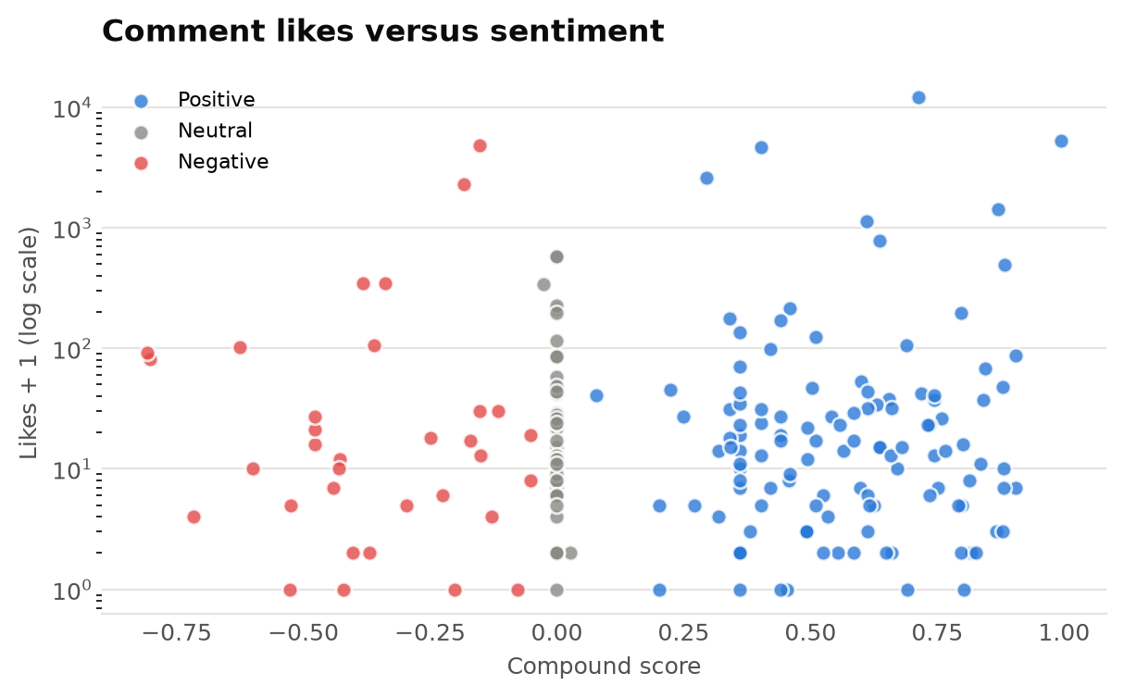
Figure 10: Comment likes plotted against sentiment (logarithmic scale)

10.3 Comment Length
Comments are short: the median length is 12 words, and most comments are under 25 words (Figure 11). A small number of long comments, the longest with 291 words, are typically detailed opinions, such as the musician’s explanation of electronic instruments, and they are among the most liked. The short typical length is one reason topic modelling on comments is harder than on longer documents (see Section 13).
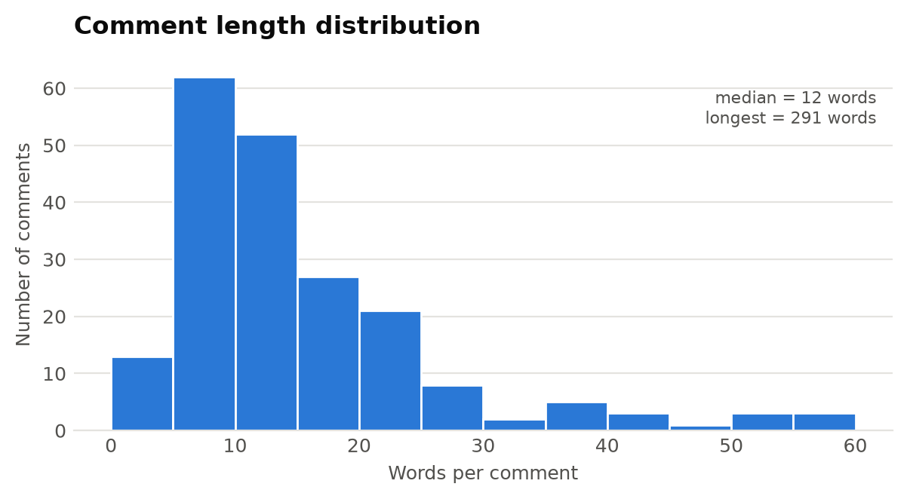
Figure 11: Distribution of comment length in words

10.4 Video Timeline Analysis
Because 60% of the comments begin with a timestamp, the comment section effectively labels the video with audience reactions. The program extracts the first timestamp of each such comment, converts it to seconds and groups comments into two-minute segments of the 24.5-minute video. For each segment it records the number of comments, their total likes, their average sentiment and their most frequent words (Figure 12 and Table 19).
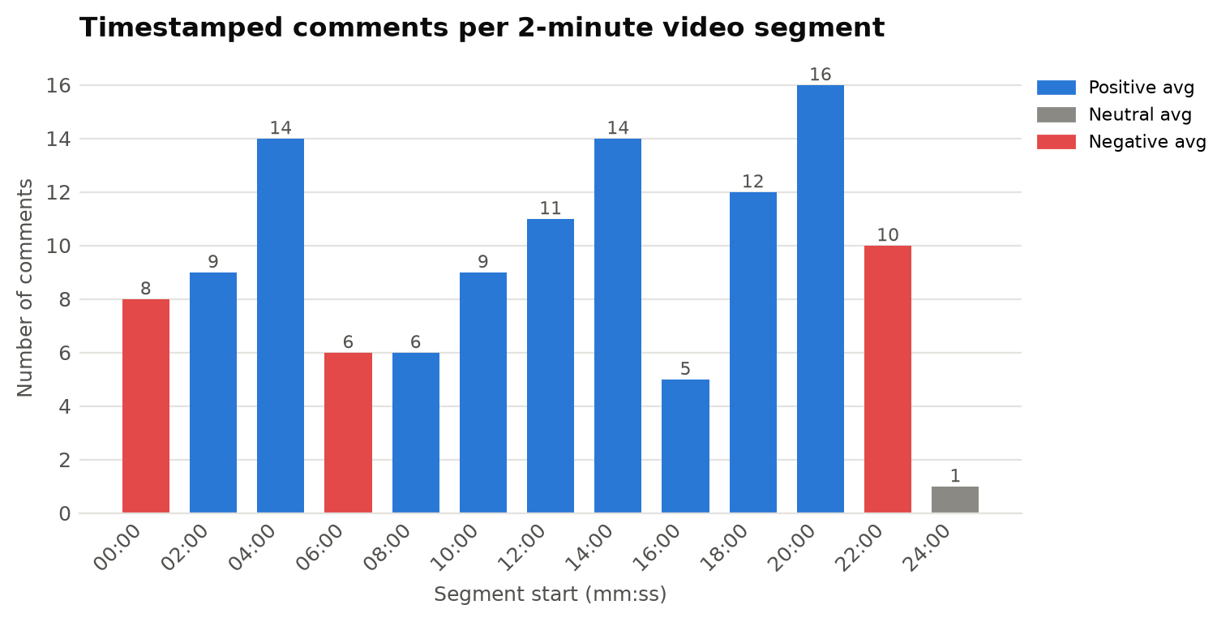
Figure 12: Number of timestamped comments per two-minute segment, coloured by average sentiment
Table 19: Audience reaction to each two-minute segment of the video
Segment | Comments | Likes | Avg sent. | Keywords
00:00-02:00 | 8 | 5095 | -0.05 | poor, leave, half, haircut, destroy
02:00-04:00 | 9 | 321 | +0.29 | pant, modular, charge, point, ayo
04:00-06:00 | 14 | 6865 | +0.26 | camera, iphone, better, bad, seem
06:00-08:00 | 6 | 495 | -0.13 | guitar, easily, understand, short, leather
08:00-10:00 | 6 | 217 | +0.44 | real, expect, play, different, song
10:00-12:00 | 9 | 230 | +0.09 | talk, human, soon, thermal, paste
12:00-14:00 | 11 | 450 | +0.30 | wear, unpack, crazy, work, hmm
14:00-16:00 | 14 | 283 | +0.33 | smaller, version, little, sure, leg
16:00-18:00 | 5 | 61 | +0.30 | physically, clean, fluid, ain't, water
18:00-20:00 | 12 | 747 | +0.58 | hand, minecraft, touchpad, love, play
20:00-22:00 | 16 | 440 | +0.16 | camera, dji, drone, ring, cool
22:00-24:00 | 10 | 230 | -0.08 | dhoom, steal, diamond, robot, remind
24:00-26:00 | 1 | 341 | -0.03 | image, dog, dump, robot, vacuum

Three segments stand out:
- 04:00–06:00 (AI camera), the most-liked segment with 6,865 likes across 14 comments. Viewers almost unanimously preferred the iPhone footage shown for comparison.
- 00:00–02:00 (automatic hair clippers), with 5,095 likes, driven by the 4,835-like joke about the half-finished haircut. Its average sentiment is slightly negative only because of the word “poor”; the reaction is humorous.
- 18:00–20:00 (Mouthpad and hands-free control), the most positive segment (average sentiment +0.58), where viewers praised the device’s value for people with disabilities and enjoyed the Minecraft demonstration.
The quietest segment was 16:00–18:00, with only five comments and 61 likes, which suggests that this part of the video held the least attention. The 22:00–24:00 robot-vacuum segment was the only substantial segment with a negative average, although its comments are mostly jokes rather than complaints.

11. Key Findings: Audience Response

11.1 Overall Response
The audience responded positively to the video. Six in ten comments are positive and fewer than one in five are negative, and the most-liked comments are, on average, even more positive than the rest. Combined with a like-to-view ratio of 0.92% and more than 15 million views in eight days, the evidence shows a video that was well received and widely watched.

11.2 What the Audience Liked
- The accessibility angle. The Mouthpad segment was the most positive part of the video, and one of the most-liked comments asked the creator to stress that many “futuristic” products are designed for people with disabilities.
- Honest comparisons. The most-liked comment in the whole dataset points out that the smartphone footage beat the dedicated camera. Viewers value the creator showing evidence rather than marketing claims.
- Humour and personality. A quarter of all comments joke along with the video, and humorous comments are among the most positive and most liked.
- Genuinely novel ideas. The solar charging hat (“the ultimate zombie apocalypse tool”, 1,429 likes), the drone camera and the Mouthpad drew excited, forward-looking reactions.

11.3 Concerns and Criticism
- Practicality. The most-liked critical comment, “So many solutions in search of a problem” (2,298 likes), reflects a wider feeling that several products are gimmicks.
- Product quality. Repeated statements that the AI camera’s image quality was poor, with one viewer even suspecting such products of being designed to attract investors rather than users.
- Value for money. Comments such as “expensive and totally useless” question whether the products are worth buying.
- Specific gadgets. Doubts about the AI toothbrush (“Who needs an AI toothbrush”) and the robot vacuum’s arm.
These criticisms are aimed at the products, not at the creator or the quality of the video itself. No comments complained about audio, editing, length or clickbait, which is a positive sign for the channel.

11.4 Requests and Questions
Only one explicit content request was detected: a viewer would like to see someone “someone try playing an fps game with the gyro sensors” using the Mouthpad. Most questions were rhetorical or humorous, but a few were genuine product questions, for example whether a device comes in a smaller size, or how a remotely controlled camera would behave in a public place.

12. Recommendations
The program automatically generates future video ideas and recommendations from the data (sections 19 and 20 of analysis_report.csv). This section presents those outputs, interpreted and expanded with the context gathered in the earlier analysis.

12.1 Future Video Ideas
Table 20: Recommended future video ideas and the evidence supporting them
# | Video idea | Evidence from the comment data
1 | Smartphone vs. dedicated “AI” cameras: a blind test | Topic 1 is the largest theme; the 04:00–06:00 segment drew 6,865 likes; the most-liked comment (12,192 likes) is about the iPhone footage being better.
2 | Technology that changes lives: an accessibility special | Most positive segment (18:00–20:00, +0.58); highly liked comments praise the Mouthpad for people with disabilities and ask for this angle to be emphasised.
3 | Musicians test futuristic instruments | Topic 2 is the most positive theme (70% positive); a 5,240-like comment from a musician explains which electronic instruments are actually valued.
4 | Useful or useless? A practicality ranking of futuristic gadgets | Directly addresses the most-liked criticism (“solutions in search of a problem”, 2,298 likes) and the value-for-money concerns.
5 | Viewer challenge: playing an FPS game with the Mouthpad’s gyro sensors | The only explicit request in the dataset; it reuses a product the audience already reacted to very positively.
6 | Long-term follow-up: do these gadgets survive a month of daily use? | Answers practicality doubts and gives the audience a reason to return to the topic.
7 | Short-form clips of the high-reaction moments | The haircut joke (0:45, 4,835 likes), the iPhone comparison (5:27, 4,683 likes) and the robot-vacuum scene (24:20) are natural YouTube Shorts.

12.2 How to Maintain a Good Audience Response
- Keep the honest side-by-side comparisons. Viewers reward the creator for showing that a product falls short. Comparisons with familiar devices such as the iPhone give them a reference point and provoke the most-liked reactions.
- Explain who each product is for. Framing gadgets by their intended users, as the audience asked for the Mouthpad, turns “useless gimmick” reactions into appreciation.
- Add a practicality verdict to each product. A short “would I actually use this?” score anticipates the most common criticism and shows the creator shares the audience’s scepticism.
- Keep the humour. Humorous comments make up a quarter of the section and are among the most positive and most liked; the light tone is part of the channel’s appeal.
- Add chapter markers to the description. 60% of comments quote timestamps, which shows viewers navigate and discuss the video by moment, yet the description contains no chapter list. Chapters would make the video easier to navigate and share.
- Engage in the comments. 85 of the 200 comments already have replies (707 in total). Answering the genuine product questions, or pinning a reply that addresses the camera-quality discussion, would strengthen this community.
- Tighten the weakest segment. The 16:00–18:00 segment drew the fewest reactions; shorter or more dynamic treatment of similar products could improve retention.
- Do not chase only positive comments. With ρ = -0.001 between sentiment and likes, the audience upvotes comments that are insightful or funny, positive or negative. Content that gives viewers something to react to matters more than purely positive content.

13. Output Files
Each run of the program creates the following files in the project folder:
Table 21: Files produced by the program
File | Contents
analysis_report.csv | The complete analysis report in 215 rows and four columns (Section, Item, Value, Details), organised into 20 sections.
comments_dataset.csv | All 200 comments, one per row, with the 29 columns of computed features described in Table 23.
charts/ (11 PNG files) | The figures reproduced in this report.

Table 22: Structure of the analysis report CSV file
Section of analysis_report.csv | Contents
1. Video Overview | Title, channel, publish date, duration, views, likes and comment count
2. Data Collection | API source, number of comments and requests, word and token counts, languages
3. Overall Audience Response | Verdict, sentiment counts and shares, mean, median and like-weighted compound score
4. Engagement Insights | Like statistics, concentration of likes, Spearman correlation
5. Top Keywords | Top 30 words with counts
6. Top Phrases | Frequent bigrams and trigrams
7. TF-IDF Key Terms | Top 25 TF-IDF terms
8. Discussion Topics (LDA) | Coherence per k and each topic's keywords, size, sentiment and example
9. Comment Categories | Primary categories and overlapping flags
10. Most Liked Comments | Ten most-liked comments
11. Most Positive Comments | Five most positive comments
12. Most Negative Comments | Most negative comments
13. What the Audience Loves | Words and examples that characterise positive comments
14. Concerns and Criticism | Words and examples that characterise criticism
15. Audience Requests | Extracted viewer requests
16. Audience Questions | Most-liked questions
17. Video Timeline Engagement | Two-minute video segments with comments, likes, sentiment and keywords
18. Purchase Intent | Comments showing purchase intent
19. Future Video Ideas | Automatically generated future video ideas with evidence
20. How to Maintain a Good Response | Automatically generated recommendations with evidence

Table 23: Data dictionary of comments_dataset.csv
Column(s) | Description
rank, comment_id | Position in the API response and YouTube’s unique comment ID
author, published_at | Display name and publication time (UTC)
like_count, reply_count | Likes and number of replies
text | Original comment text
clean_text | Pre-processed tokens joined with spaces
word_count, token_count, emoji_count | Length measures before and after cleaning, and number of emoji
language | Detected language code or “undetermined (too short)”
sent_positive, sent_neutral, sent_negative | VADER proportions of positive, neutral and negative text
compound, sentiment | VADER compound score and the resulting label
topic, topic_confidence | Assigned LDA topic (0 = too short to model) and its probability
category | Primary comment category
is_question … mentions_timestamp | Eight true/false flags from the rule-based classifier
timestamps, requests | Extracted timestamps and requested subjects

14. Limitations
- Sarcasm and irony. Lexicon-based models read words literally. “So a bad camera with no built-in display. Sign me up” contains a sarcastic “sign me up”, and “Who needs an AI toothbrush” is scored as neutral although it is dismissive.
- Domain vocabulary. Even after adaptation, gaming and product jargon is misread. A “no-hit Elden Ring run” is negative to VADER because of “hit”, and a comment calling a temperature-control wearable “a game changer” for someone with a “temperature control problem” is scored negative because of “problem”.
- Aspect-level sentiment. VADER assigns one score per comment. “The iPhone footage was so much better” is positive in wording, yet it is a criticism of the camera being reviewed. Aspect-based sentiment analysis would be needed to attribute sentiment to individual products.
- Sample size and selection. The 200 comments are about 4% of all comments, selected by YouTube’s undisclosed relevance algorithm, which favours highly engaged comments. During development, repeated runs returned slightly different comment sets as YouTube re-ranked comments on a recently published video. The final results in this report come from a single saved snapshot (comments_dataset.csv).
- Short documents for topic modelling. LDA was designed for longer documents; with a median of 12 words per comment, topics are less sharply separated than they would be in essays or articles. Topic labels also require human interpretation.
- Rule-based categories. The regular-expression rules are precise but cannot detect every phrasing; requests or purchase intent expressed in unusual words will be missed.
- Language. All tools are designed for English. The dataset was effectively entirely English, but other videos may need translation or multilingual models.
- Replies excluded. Only top-level comments were analysed; replies often contain discussion and disagreement that this study does not capture.

15. Conclusion and Future Work
This project designed and implemented a complete, reproducible pipeline that turns the comment section of a YouTube video into a structured audience-response report. Using the official YouTube Data API, the system collected 200 comments from a 15,465,044-view technology video and analysed them with established, explainable NLP techniques: VADER sentiment analysis adapted to YouTube language, frequency, n-gram and TF-IDF keyword analysis, coherence-optimised LDA topic modelling, rule-based categorisation and a timestamp-based timeline analysis.
The analysis showed a clearly positive audience response (60% positive, 16% negative), identified four discussion themes, and located the strongest reactions in the video’s timeline. It found that the audience’s main takeaway was the AI camera losing to an iPhone, that the accessibility segment was the most appreciated, and that criticism targeted the practicality of the products rather than the video itself. These findings were turned into concrete, evidence-based recommendations for future content.
Several extensions could improve the system in future:
- Replacing or complementing VADER with a transformer model fine-tuned on social-media text (for example a RoBERTa sentiment model) to better handle sarcasm.
- Adding aspect-based sentiment analysis to measure the audience’s opinion of each product separately.
- Analysing all comments and replies, and tracking how sentiment changes over the days after publication.
- Comparing several videos from the same channel to identify which formats consistently perform best.
- Presenting the results in an interactive dashboard.

References
Bird, S., Klein, E., & Loper, E. (2009). Natural Language Processing with Python. O’Reilly Media.
Blei, D. M., Ng, A. Y., & Jordan, M. I. (2003). Latent Dirichlet Allocation. Journal of Machine Learning Research, 3, 993–1022.
Google. (2026). YouTube Data API v3 Reference. Google for Developers. https://developers.google.com/youtube/v3/docs
Hutto, C. J., & Gilbert, E. (2014). VADER: A Parsimonious Rule-based Model for Sentiment Analysis of Social Media Text. Proceedings of the Eighth International AAAI Conference on Weblogs and Social Media (ICWSM-14), 216–225.
Liu, B. (2012). Sentiment Analysis and Opinion Mining. Morgan & Claypool Publishers.
Mimno, D., Wallach, H. M., Talley, E., Leenders, M., & McCallum, A. (2011). Optimizing Semantic Coherence in Topic Models. Proceedings of the 2011 Conference on Empirical Methods in Natural Language Processing, 262–272.
Pedregosa, F., et al. (2011). Scikit-learn: Machine Learning in Python. Journal of Machine Learning Research, 12, 2825–2830.
Salton, G., & Buckley, C. (1988). Term-weighting approaches in automatic text retrieval. Information Processing & Management, 24(5), 513–523.
Spearman, C. (1904). The Proof and Measurement of Association between Two Things. The American Journal of Psychology, 15(1), 72–101.

Appendix A: How to Run the Program
1. Install the required libraries:
pip install requests python-dotenv pandas numpy nltk scikit-learn matplotlib emoji langdetect
2. Download the NLTK resources (one time only):
python -c "import nltk; [nltk.download(p) for p in ['vader_lexicon','stopwords','wordnet']]"
3. Create a file named .env in the project folder containing the API key:
YOUTUBE_API_KEY=your_key_here
4. Run the analysis on the default video, or pass any other video link:
python youtube_comment_analyzer.py
python youtube_comment_analyzer.py "https://www.youtube.com/watch?v=VIDEO_ID"
The program prints its progress through seven stages and writes analysis_report.csv, comments_dataset.csv and the charts folder to the project directory.

Appendix B: Program Structure
Table 24: Main functions of youtube_comment_analyzer.py
Function | Stage | Responsibility
extract_video_id | Collection | Extracts the 11-character video ID from any YouTube link format
api_get | Collection | Sends an API request and converts API errors into readable messages
fetch_video_details | Collection | Retrieves the video’s metadata and statistics
fetch_comments | Collection | Retrieves comments page by page until 200 are collected
normalise_text | Pre-processing | Light cleaning for sentiment analysis (keeps emphasis and emoji meaning)
tokenize | Pre-processing | Heavy cleaning: slang expansion, stop words and lemmatisation
detect_language | Pre-processing | Language identification with a short-text safeguard
add_sentiment / label_sentiment | Sentiment | VADER scoring with domain lexicon, and threshold labelling
ngram_counts / tfidf_terms | Keywords | N-gram frequencies and mean TF-IDF ranking
distinctive_words | Keywords | Smoothed log-ratio comparison of positive and negative vocabulary
umass_coherence / run_topic_model | Topics | Trains LDA for k = 3–7 and keeps the most coherent model
categorise / extract_requests | Categories | Rule-based flags, primary category and request extraction
timeline_segments | Timeline | Groups timestamped comments into two-minute video segments
build_future_ideas / build_recommendations | Insights | Turns the measured results into ideas and recommendations
make_charts | Output | Produces the eleven figures
main | Control | Runs the full pipeline and writes the CSV files

Appendix C: Top 30 Keywords
Table 25: The 30 most frequent words after pre-processing
Rank | Word | Count | Rank | Word | Count
#1 | camera | 23 | #16 | future | 7
#2 | cool | 15 | #17 | phone | 6
#3 | guitar | 15 | #18 | mouth | 6
#4 | tech | 14 | #19 | play | 6
#5 | iphone | 12 | #20 | head | 6
#6 | drone | 11 | #21 | game | 6
#7 | hand | 10 | #22 | genuinely | 5
#8 | hat | 9 | #23 | seem | 5
#9 | mouthpad | 9 | #24 | definitely | 5
#10 | better | 8 | #25 | work | 5
#11 | futuristic | 8 | #26 | robot | 5
#12 | electronic | 8 | #27 | useful | 5
#13 | instrument | 7 | #28 | charge | 5
#14 | sound | 7 | #29 | wear | 5
#15 | bad | 7 | #30 | love | 5

