Login page:
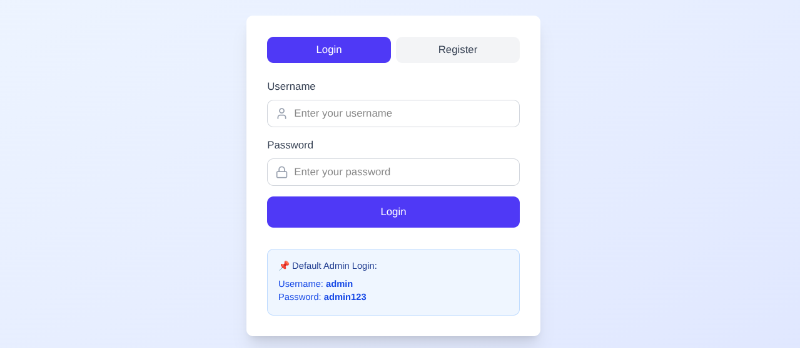

—-----------------------------------------------------------------------------------------------------------------------------------------------------------------------------------------------------------------------------------------------------------

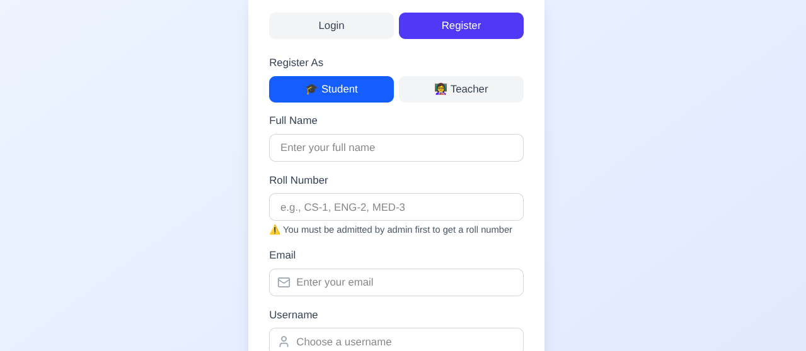

Admin portal:

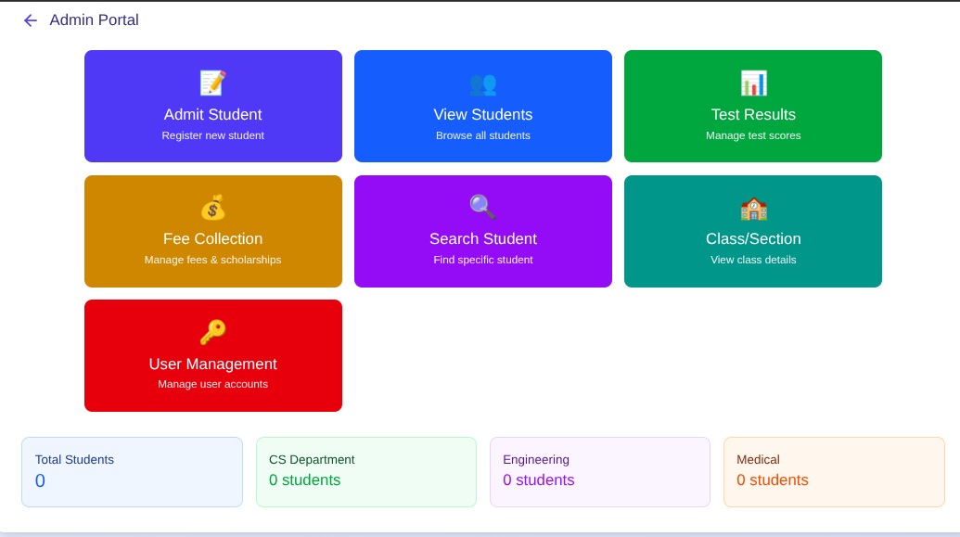

—-----------------------------------------------------------------------------------------------------------------------------------------------------------------------------------------------------------------------------------------------------------

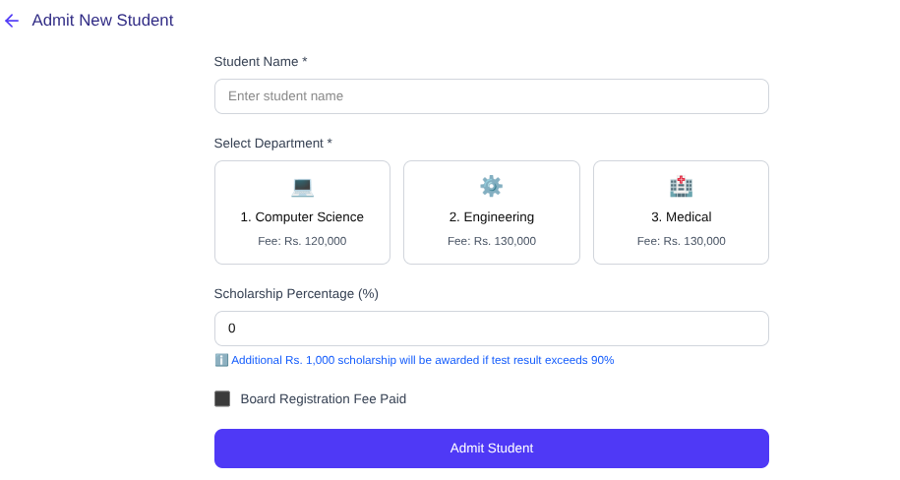

—-----------------------------------------------------------------------------------------------------------------------------------------------------------------------------------------------------------------------------------------------------------

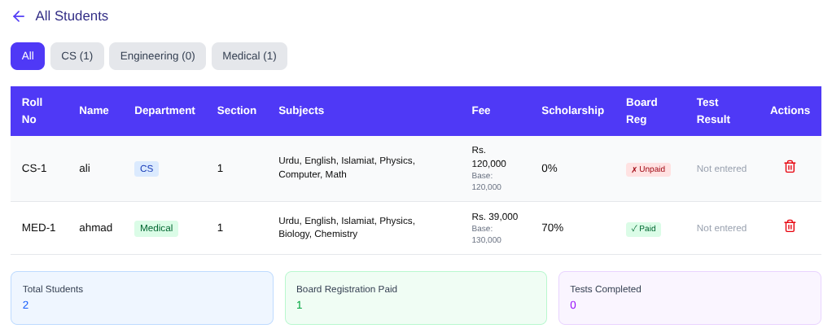

—-----------------------------------------------------------------------------------------------------------------------------------------------------------------------------------------------------------------------------------------------------------

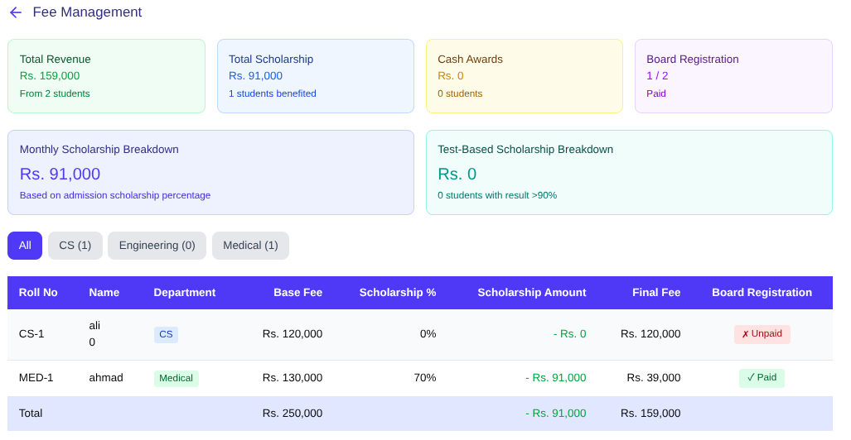

—-----------------------------------------------------------------------------------------------------------------------------------------------------------------------------------------------------------------------------------------------------------

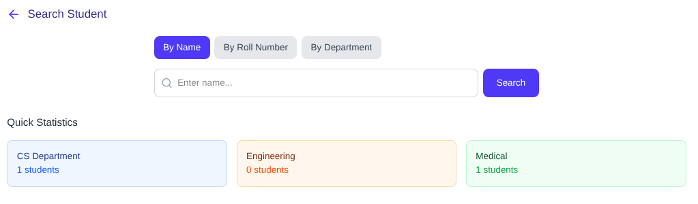
—-----------------------------------------------------------------------------------------------------------------------------------------------------------------------------------------------------------------------------------------------------------
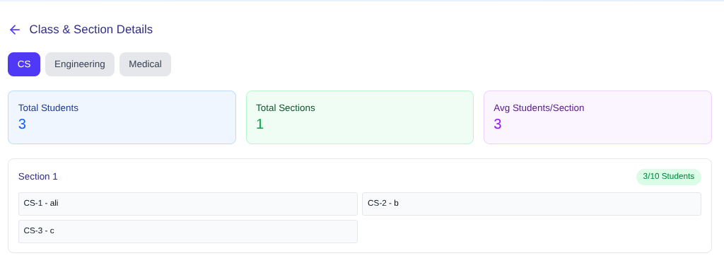
-------------------------------------------------------------------------------------------------------------------------------

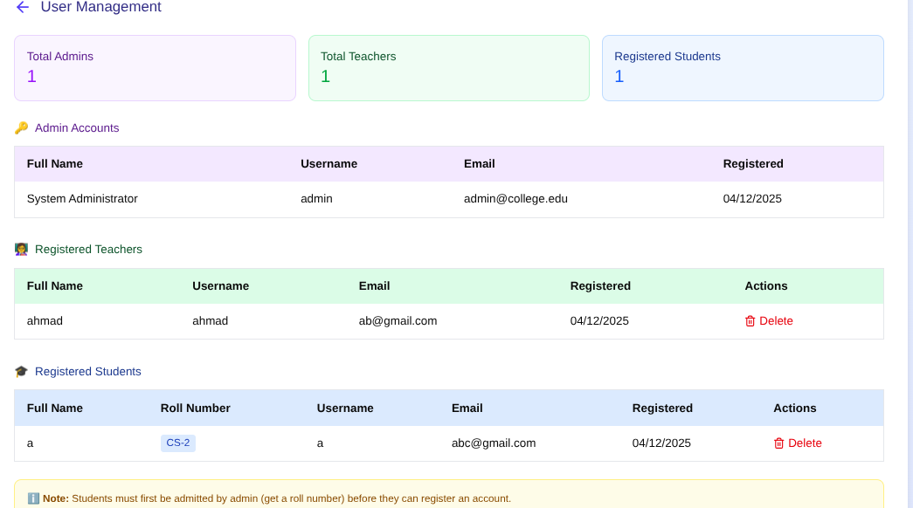

Teacher portal:
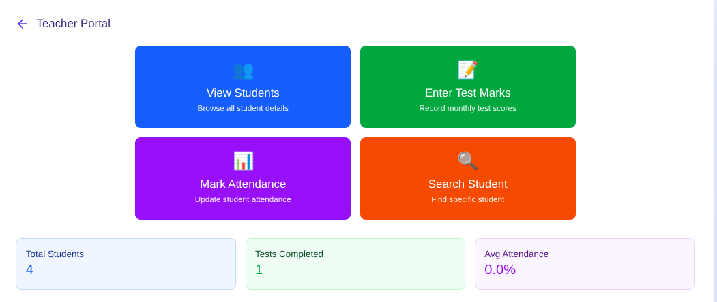

—-----------------------------------------------------------------------------------------------------------------------------------------------------------------------------------------------------------------------------------------------------------

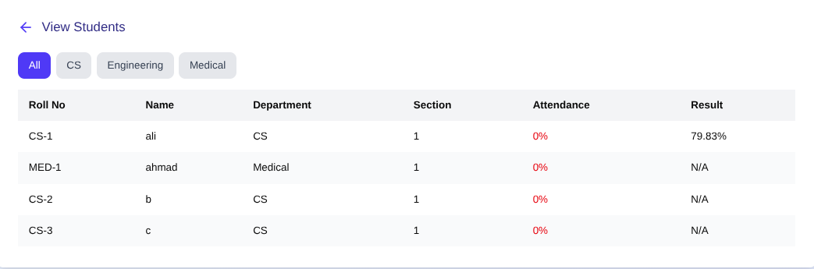

—-----------------------------------------------------------------------------------------------------------------------------------------------------------------------------------------------------------------------------------------------------------

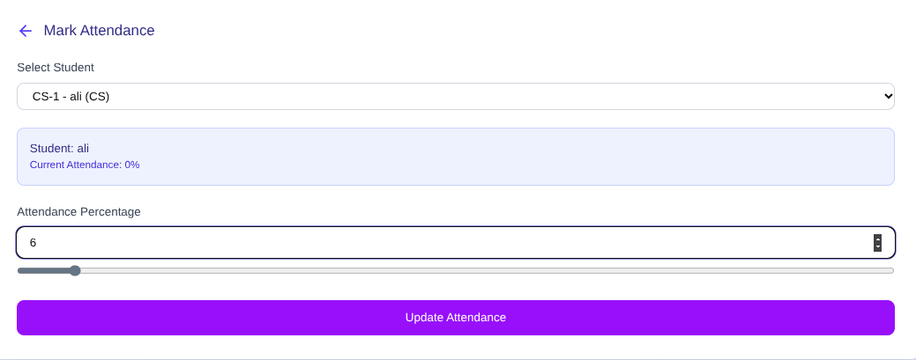

—-----------------------------------------------------------------------------------------------------------------------------------------------------------------------------------------------------------------------------------------------------------

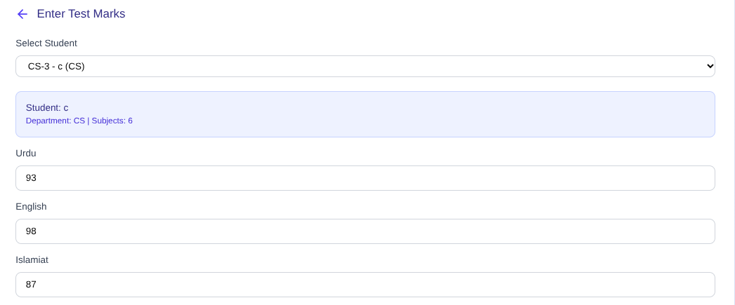
-------------------------------------------------------------------------------------------------------------------------------
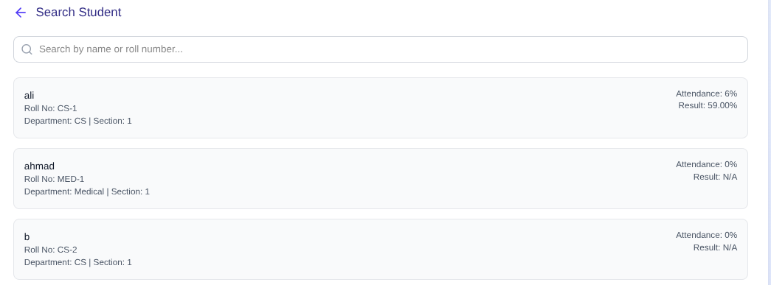

Student:
