University of management and Technology
Assignment 02
Sudoku Solver Game Project
Prototypes
Name: Gulshan Parveen | ID: F2024065265
Course: Software Engineering | Section: W8
Instructor: Ma’am KINZA SARDAR

3 Prototypes:
- Basic Prototype
- Medium Fidelity Prototype
- High Fidelity Prototype

1.Low Fidelity Prototype:
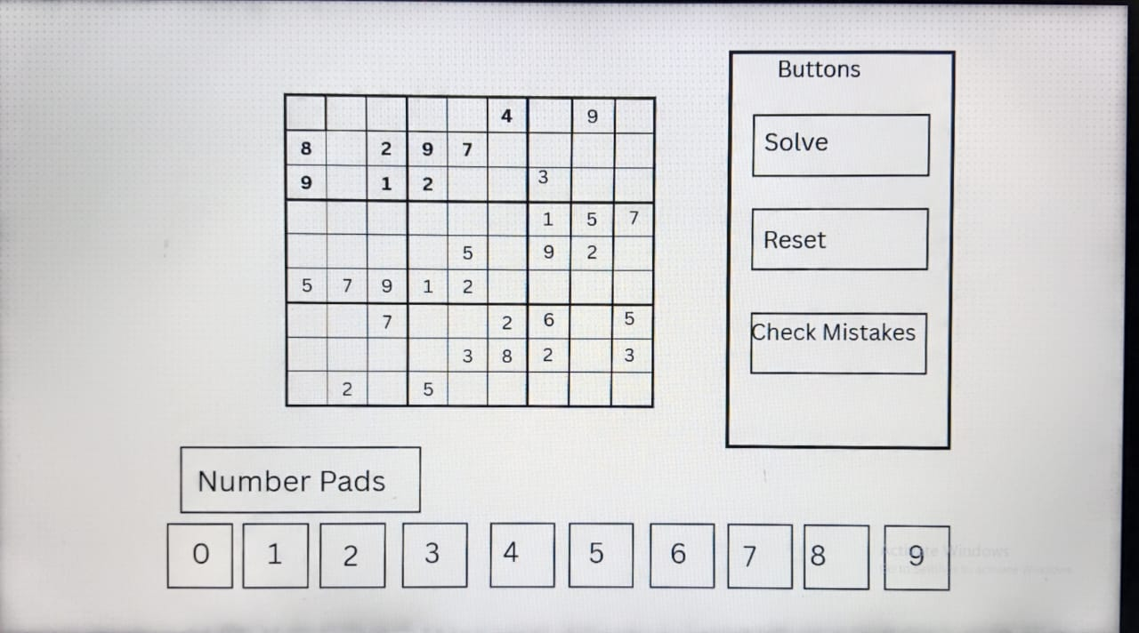

2.Medium Fidelity Prototype:

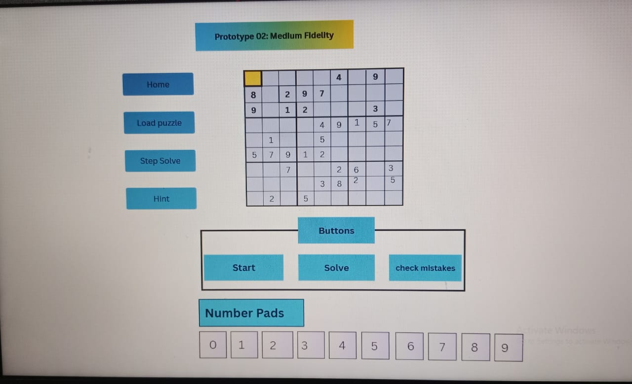

3.High Fidelity Prototype

