RESULTS REPORT
INT8 vs FP16 vs Posit8 3x3 Systolic Arrays
Accuracy, hardware utilization, power
Item | Detail
Scope | Matched 3x3 systolic arrays for INT8, FP16, and Posit(8,0) matrix multiplication
Benchmark control | Same topology, FSM, skew-feed schedule, int8 I/O boundary, and 8-cycle T_MAX
Evidence used | Python accuracy benchmark plots plus Vivado post-implementation utilization and power screenshots
Executive Summary
Main result
INT8 is the best area-efficiency point in this benchmark: it matches FP16 system-level SQNR at realistic magnitude while using 3% LUT utilization versus FP16's 20% LUT utilization and no DSP blocks.

The data does not support claiming that Posit8 reduced power versus FP16 in the current implementation. Vivado reports 0.185 W for Posit8 and 0.128 W for FP16, so FP16 is 30.8% lower in total vectorless on-chip power. The supported Posit8 benefit is area-related: 30.0% lower LUT utilization than FP16 and no DSP usage.
Format | Best supported benefit | Main cost / caveat
INT8 | Matches FP16 at 18.81 dB system SQNR with 85.0% lower LUT utilization. | Native precision is excellent, but final int8 output saturation dominates large values.
FP16 | Best accuracy-power point here: +9.52 dB SQNR vs Posit8 and 30.8% lower total power. | Uses the most LUTs and 4% DSP utilization.
Posit8 | 30.0% lower LUT utilization than FP16 and DSP-free in this implementation. | Accuracy drops sharply outside small magnitudes; power is higher in current vectorless report.

Accuracy Comparison
Native precision removes the shared int8 output bottleneck and compares internal arithmetic against a float64 reference. System-level precision includes the full pipeline and final int8 output saturation.
Native magnitude bound | Posit8 SQNR | INT8 SQNR | FP16 SQNR | Interpretation
|a|, |b| <= 1 | inf | inf | inf | All exact
|a|, |b| <= 2 | inf | inf | inf | All exact
|a|, |b| <= 4 | 20.44 dB | inf | inf | Posit8 starts losing precision
|a|, |b| <= 32 | 0.74 dB | inf | inf | INT8/FP16 remain exact
|a|, |b| <= 127 | 0.05 dB | inf | 73.81 dB | FP16 handles full int8 range far better
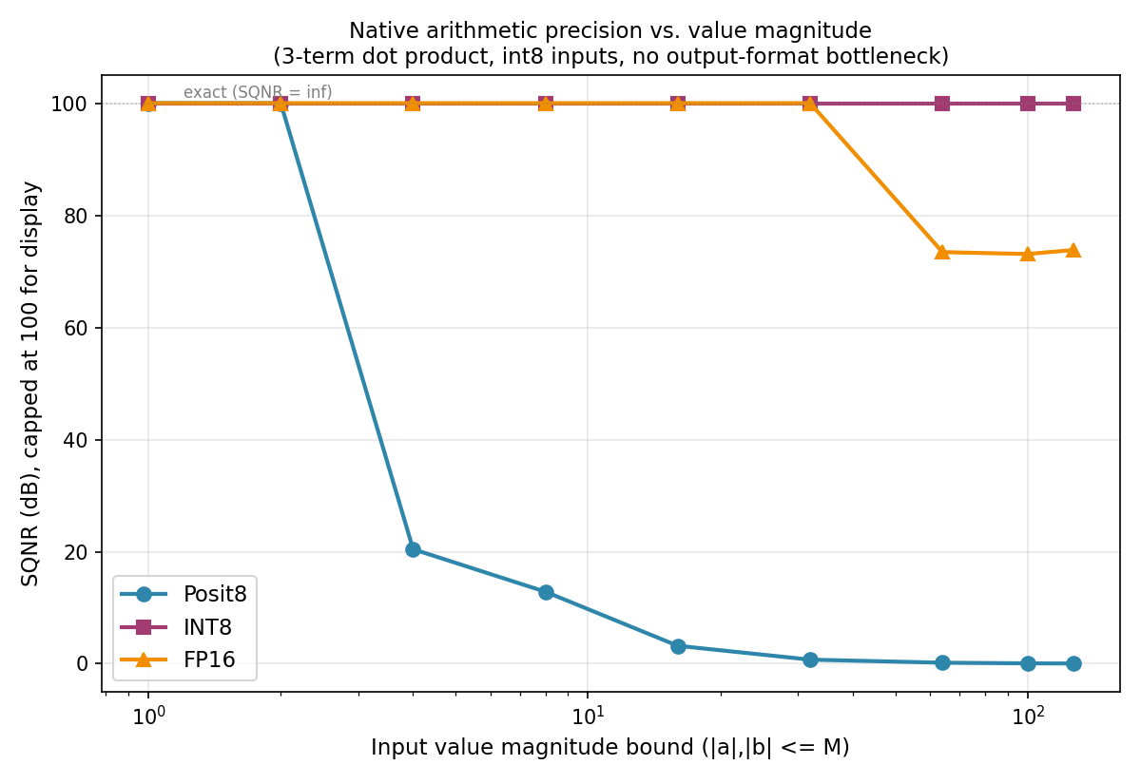
Figure 1. Native arithmetic SQNR vs input magnitude.
System-level workload | Posit8 | INT8 | FP16 | Result
Realistic magnitude, sigma=5 | 9.29 dB | 18.81 dB | 18.81 dB | INT8/FP16 are +9.52 dB over Posit8
Large magnitude, sigma=40 | 0.15 dB | 0.29 dB | 0.29 dB | Output saturation dominates all formats
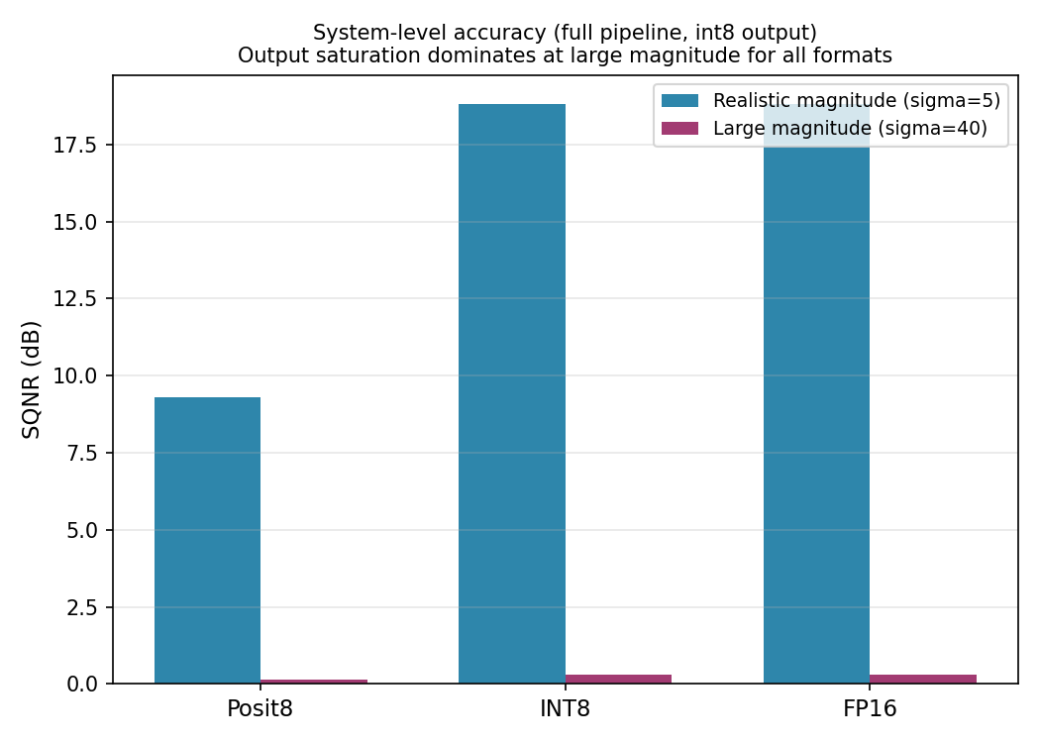
Figure 2. Full-pipeline accuracy with int8 output.

Hardware Utilization And Power
Utilization values are read from the post-implementation Vivado screenshots. Power values are vectorless Vivado estimates with low confidence, so they are useful as early comparative estimates but should be replaced by SAIF-based reports for final publication.
Metric | Posit8 | INT8 | FP16 | Winner
LUT utilization | 14% | 3% | 20% | INT8
FF utilization | 1% | 1% | 1% | Tie
DSP utilization | 0% | 0% | 4% | INT8 / Posit8
I/O utilization | 73% | 73% | 73% | Tie
BUFG utilization | 3% | 3% | 3% | Tie
Power metric | Posit8 | INT8 | FP16 | Winner
Total on-chip power | 0.185 W | 0.135 W | 0.128 W | FP16
Dynamic power | 0.104 W | 0.053 W | 0.046 W | FP16
Static power | 0.081 W | 0.081 W | 0.081 W | Tie
Clock power | 0.004 W | 0.003 W | 0.006 W | INT8
Signal power | 0.037 W | 0.005 W | 0.022 W | INT8
Logic power | 0.038 W | 0.005 W | 0.017 W | INT8
I/O power | 0.025 W | 0.040 W | 0.001 W | FP16
Supported Benefits
- INT8 matched FP16 system-level accuracy at realistic magnitude while reducing LUT utilization by 85.0% and using no DSP blocks.
- FP16 delivered the best accuracy-power point: +9.52 dB SQNR over Posit8 at sigma=5, 30.8% lower total vectorless power, and 55.8% lower dynamic power.
- Posit8 reduced LUT utilization by 30.0% compared with FP16 and removed DSP usage, but its tapered precision caused large accuracy loss outside the smallest magnitude range.
- All three formats collapse near 0 dB SQNR at sigma=40, proving that int8 output saturation is the dominant high-magnitude bottleneck.

Vivado Evidence: Posit8
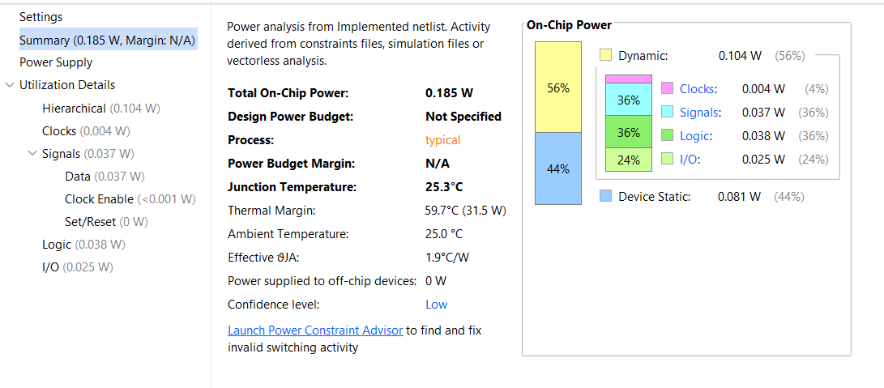
Figure 3. Posit8 Vivado vectorless power report: 0.185 W total, 0.104 W dynamic.
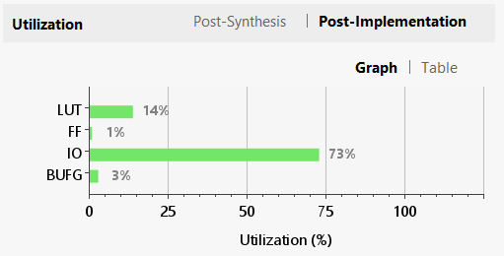
Figure 4. Posit8 post-implementation utilization: 14% LUT, 1% FF, 73% I/O, 3% BUFG.

Vivado Evidence: INT8
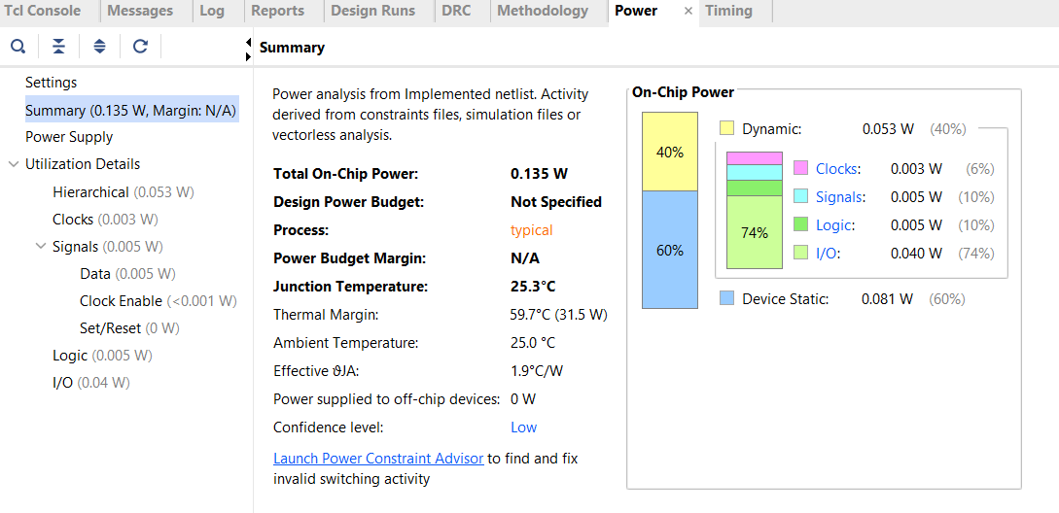
Figure 5. INT8 Vivado vectorless power report: 0.135 W total, 0.053 W dynamic.
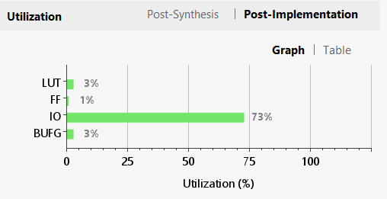
Figure 6. INT8 post-implementation utilization: 3% LUT, 1% FF, 73% I/O, 3% BUFG.

Vivado Evidence: FP16
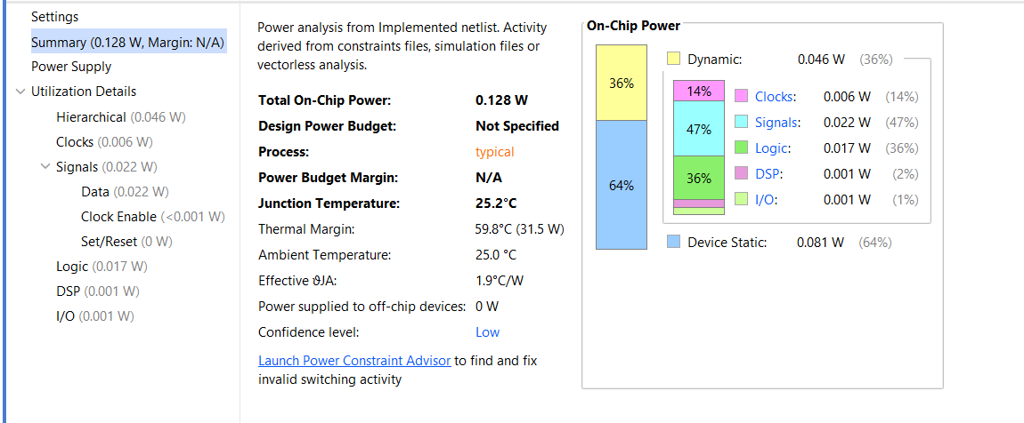
Figure 7. FP16 Vivado vectorless power report: 0.128 W total, 0.046 W dynamic.
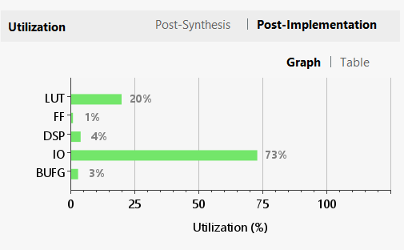
Figure 8. FP16 post-implementation utilization: 20% LUT, 1% FF, 4% DSP, 73% I/O, 3% BUFG.

