ChaturangZero: The Complete Project Explained
  - Everything we built, tried and found, from the first commit to the last game (CS F407)
November 2026
Table of Contents

How to read this document
This document explains the whole ChaturangZero project from the very beginning to the very end. It is written so that someone who has never seen the project, or who missed parts of it, can understand every step: what we built, why we built it that way, what every experiment was, what the results were, and what they mean.
It is much longer and more detailed than the formal report. The report is written to the required format for the professors; this document is the full story behind it, useful for preparing the presentation, answering questions, and keeping the team up to date.
The document is organized in the order things happened, with reference material at the end:
- The project in one page: the whole story in short.
- The basics, from zero: what machine learning, neural networks, GPUs, Git and tests are, and how we measure strength. Start here if the project is new to you.
- Background: the game of Chaturanga and how AlphaZero works.
- The course rules, milestones and team, and the timeline of every pull request.
- Building the system: how every part was built.
- Walkthroughs with real examples: real numbers followed through the system, from the board encoding to one training step.
- The first training runs, which did not work, and why.
- Making training about 11 times faster.
- The long run and the final model.
- Trying to make it even stronger: every later experiment.
- Playing against the AI, and the human games.
- The decision log, every training option, a tour of the code, and a guide to presenting the project.
- What it all means, limitations, and the key numbers.
- Reference: the repository file by file, how to run everything, questions the professors may ask, and a glossary.
A note on words used throughout: a ply is one move by one player (so 100 plies is 50 moves by each side). An iteration (also called a round) is one cycle of “play games against itself, then learn from them”. A checkpoint is the saved network after an iteration. A simulation is one step of the search the agent does before choosing a move.

1 The project in one page
Goal. Build an AlphaZero-style artificial intelligence for Chaturanga, the ancient Indian ancestor of chess, from scratch. The AI is given only the rules of the game. It gets no opening books, no piece values and no human games. It learns entirely by playing against itself.
What we built.
- A complete Chaturanga rules engine: the board, every piece’s moves, check, checkmate, stalemate and the draw rules, checked by unit tests.
- A neural network (a residual network with 4 blocks of 64 filters) that looks at a position and outputs two things: which moves look promising (the policy) and who is likely to win (the value).
- Monte Carlo Tree Search (MCTS), the look-ahead search that uses the network to decide which moves to explore and to judge positions.
- A self-play training loop: the AI plays thousands of games against itself, and the network learns from the results.
- An evaluation suite: fixed benchmarks against simple opponents, matches between versions of the AI, analysis of how games end, and a system for logging games against humans.
- A terminal game and a browser game to play against the AI.
- 127 automated tests that check every part.
What happened.
- The first training runs (400 games each, about 7 hours) did not make the AI any stronger. We investigated and found why: about 80% of games were draws, so the network almost never saw a win or a loss to learn from, and 400 games is far too little data for this method.
- We made training about 11 times faster without changing what it computes, and then ran a long training run: 540 more iterations, 54,000 games, about 144 hours on one laptop.
- The long run produced the final model (models/chaturangzero_final.pt). It beats the model it started from 27 wins to 0, beats a random player 16 to 0, and beats an untrained network 17 to 4. It still draws almost every game against a “greedy capture” player and rarely finishes games with checkmate.
- We tried many ways to make it stronger: a bigger network (twice), counting draws as slightly bad, resigning hopeless games, and even smaller learning steps. None of them made it stronger within the project rules. The one thing that clearly helps is letting it think longer when playing: with 800 search steps per move instead of 50, it beats its normal self 23 to 0.
- We moved self-play to the laptop’s GPU, making it about 2.2 to 2.4 times faster again.
- A team member new to chess played 10 games against the final model through the browser game: 5 human wins, 2 AI wins, 3 draws.
The main lesson. Within the project’s rules and the compute of one laptop, the model has reached about its limit. Its central weakness is that its “value” judgment does not know when a position is won or lost until the very end, because nearly all of its training games are draws. Every improvement we tried ran into this same problem.

2 The basics, from zero
This chapter assumes you know nothing about artificial intelligence, programming tools or this project. Everything later in the document builds on these ideas, so it is worth reading even if some parts feel obvious.

2.1 What “artificial intelligence” and “machine learning” mean here
A normal computer program follows rules a person wrote: “if this, do that”. A chess program written that way would need a person to write down how good every kind of position is, which pieces are worth how much, which openings are good, and so on. That is called hand-written knowledge or domain knowledge.
Machine learning is different. Instead of writing the rules of good play, we write a program that can adjust itself based on examples or experience. We give it a structure with millions of adjustable numbers, and a procedure that nudges those numbers so that the program does better and better at some task.
There are three main kinds of machine learning:
- Supervised learning: you give the program examples with the right answers (for example, photos labeled “cat” or “dog”), and it learns to produce the right answer.
- Unsupervised learning: you give it data without answers, and it finds patterns.
- Reinforcement learning: the program acts in some environment (here, a game), gets a reward or penalty at the end (win, loss or draw), and learns which actions lead to good rewards.
Our project is reinforcement learning. Nobody tells the program which moves are good. It plays, sees who won, and learns from that. The specific way we do it is called self-play: the program plays against itself, so it always has an opponent at exactly its own level.

2.2 What a neural network is
A neural network is the adjustable structure that does the learning. You can think of it as a very large mathematical function: numbers go in, numbers come out, and in between there are many layers of simple calculations.
A single “neuron” takes several input numbers, multiplies each by a weight (an adjustable number), adds them up, adds a bias (another adjustable number), and passes the result through a simple function. A common one is ReLU, which just turns negative numbers into 0 and leaves positive numbers as they are.
A layer is many neurons side by side, all looking at the same inputs. A deep network is many layers stacked, so the output of one layer is the input of the next. Early layers learn simple patterns; later layers combine them into more complex patterns.
The weights are what gets learned. At the start they are random, so the network’s outputs are meaningless. Training adjusts them. Our network has 836,359 of these adjustable numbers, which we call parameters.

2.3 How a neural network learns: loss, gradients and steps
Learning happens in small steps:
- Show the network an example input (for us, a board position).
- The network produces an output (its guess).
- Compare the guess with the target (what it should have said). The size of the mistake is measured by a number called the loss. A small loss means a good guess.
- Work out, for every weight, in which direction it should change to make the loss a bit smaller. This is done with calculus, and the result is called the gradient. The technique for computing it efficiently through all the layers is called backpropagation.
- Change every weight a tiny amount in that direction. How big the change is depends on the learning rate.
Repeat this thousands or millions of times on many examples, and the network gradually gets better at the task.
Some related words:
- Batch: instead of one example at a time, the network looks at a group of examples (for us, 64 or 256 positions) and averages the corrections. This is faster and steadier.
- Training step: one update of the weights using one batch.
- Optimizer: the exact rule for updating weights. We use Adam, the most common one, which adapts the step size for each weight automatically.
- Learning rate: the size of each step. Too big and the network jumps around and never settles. Too small and it learns very slowly. A common trick, which we used, is to start with a bigger rate and lower it later. Learning rates are written like 1e-3 (0.001), 1e-4 (0.0001), 3e-5 (0.00003) and 2e-5 (0.00002).
- Weight decay (L2 regularization): a small extra penalty that keeps the weights from growing too large, which helps the network generalize instead of memorizing.
- Overfitting: when a network memorizes its training examples instead of learning general patterns. A replay buffer of many varied positions helps avoid this.

2.4 Why the network uses “convolutions”
A board game position is a grid, like an image. A convolution is a kind of layer designed for grids. Instead of looking at the whole board at once, it slides a small window (we use 3x3 squares) across the board and applies the same small set of weights at every location. This means a pattern learned in one corner (for example, “a horse attacking a piece”) is automatically recognized everywhere else on the board.
A convolution layer has many filters, each looking for a different pattern. “64 filters” means each layer produces 64 different pattern maps of the board.
Batch normalization is a layer that rescales the numbers flowing through the network so they stay in a reasonable range, which makes training faster and more stable.
A residual block is two convolution layers plus a skip connection: the block’s input is added back to its output. This lets information flow easily through deep networks and makes them much easier to train. This design is called a ResNet and is what AlphaZero uses.

2.5 What a “tensor” is
A tensor is just a block of numbers with a shape. A single number is a tensor of shape [] , a list of 10 numbers has shape [10], a table of 8 rows and 8 columns has shape [8, 8], and a stack of 13 such tables has shape [13, 8, 8]. Our network takes a position as a [13, 8, 8] tensor and outputs a [4096] tensor (one score per possible move) and one number (the value).

2.6 What a GPU is and why it matters
A CPU (the computer’s main processor) is good at doing a few complicated things quickly, one after another. A GPU (graphics processor) is good at doing thousands of simple calculations at the same time. Neural networks are mostly huge numbers of simple multiplications, so they run much faster on a GPU, especially when you give it many inputs at once (a batch). Giving a GPU one position at a time wastes most of its power. This is why, later in the project, we rebuilt self-play so that many games send their positions to the GPU together.
Our laptop is an Apple machine with an A18 Pro chip: 2 fast “performance” CPU cores, 4 slower “efficiency” CPU cores, a built-in GPU, and 8 GB of memory. On Apple computers, PyTorch calls the GPU “mps”.

2.7 The tools we used
- Python: the programming language everything is written in.
- NumPy: a Python library for fast work with arrays of numbers.
- PyTorch (imported as torch): a Python library for building and training neural networks, on the CPU or the GPU.
- Matplotlib: a Python library for drawing graphs.
- pytest: a tool that runs all the automated tests.
- pandoc: a tool that converts the Markdown report into a Word document.
- The terminal: the text window where commands like python play_web.py are typed.

2.8 Git, GitHub and pull requests
The code lives in a Git repository, a folder whose full history of changes is recorded.
- A commit is one saved set of changes with a message describing them.
- A branch is a separate line of work, so changes can be made without disturbing the main version. The main version is the main branch.
- GitHub is the website that stores the shared copy of the repository (ours is https://github.com/f20241463-cmd/CS-F407-chaturanga).
- A pull request (PR) is a request to add a branch’s changes into main. Others can review it first. When it is accepted, it is merged.
- The team squash-merges: all commits of a pull request become one commit on main. Because of this, every new piece of work was started on a fresh branch from the latest main.
The project has 24 numbered pull requests, listed in the timeline.

2.9 Automated tests
A unit test is a small program that checks that one piece of code does what it should, for example “a horse on b1 can move to a3 and c3 and nowhere else” or “after checkmate, the result is a loss for the side to move”. Tests are run with python -m pytest -q. If someone changes code and breaks something, a test fails and shows exactly what broke. The project has 127 tests, and all of them pass.

2.10 Random seeds and reproducibility
Many parts of the project use randomness: the network’s starting weights, the noise added to the search, the sampling of moves in self-play. Computers produce “random” numbers from a starting value called a seed. With the same seed, the same “random” numbers come out every time. We seeded everything, so running the same command twice gives exactly the same games and results. This is important for science: anyone can reproduce our results.

2.11 How we measure strength: scores, margins and ranges
When two players play many games, we compute a score:
score = (wins + 0.5 x draws) / finished games
A score of 0.5 means the two are even. Above 0.5 means the first player is better; below 0.5 means worse. A draw counts as half a win.
Example (the final model against the starting model): 27 wins, 0 losses, 59 draws and 14 unfinished games (stopped at the 800-ply cap). The finished games are 27 + 0 + 59 = 86. The score is (27 + 0.5 x 59) / 86 = 56.5 / 86 = 0.657.
The margin (+/-). Any score from a limited number of games has some luck in it. The margin is a 95% range: if we played many more games, the true score would very likely be within that distance. We compute it from how much the individual game scores (1, 0.5 or 0) vary: margin = 1.96 x (standard deviation of the game scores) / sqrt(number of finished games). For the example above, that is about +/- 0.049, so the true score is very likely between about 0.61 and 0.71: clearly above 0.5.
Reading a result: if the score minus its margin is still above 0.5, the first player is clearly better. If 0.5 is inside the range, we cannot tell them apart.
The Wilson range is a more careful version of the same idea for very small numbers of games, like the human games. With only 10 games, the range is wide (for the AI against the human: 0.137 to 0.646), which honestly shows how uncertain a 10-game result is.
Why draws make this hard. When 85% of games are draws, wins and losses are rare, so you need many games to see a difference. That is why we moved from 20-game to 100-game and 200-game matches.

3 Background

3.1 Chaturanga, the game
Chaturanga is an Indian board game from around the 6th century. It is the ancestor of chess, shogi, xiangqi and makruk. It is played on the same 8x8 board as chess, with the same starting arrangement, but most pieces are weaker.
The pieces.
Piece | Chess equivalent | How it moves
Raja (king) | King | One square in any direction.
Mantri (counselor, minister) | Queen’s position, but much weaker | One square diagonally only.
Ratha (chariot) | Rook | Any number of squares in a straight line (horizontal or vertical).
Gaja (elephant) | Bishop’s position, but different | Exactly two squares diagonally, jumping over the square in between.
Ashva (horse) | Knight | An L-shaped jump, exactly like a knight.
Padati (foot soldier) | Pawn | One square forward; captures one square diagonally forward; becomes a Mantri on reaching the last rank.
Starting position. Each side has, on its back rank from left to right: Ratha, Ashva, Gaja, Raja, Mantri, Gaja, Ashva, Ratha, and eight Padati on the rank in front. (Historical sources differ on where exactly the kings go; we used the chess-like layout because it is simple and unambiguous, and documented this choice in the code.)
Rules that differ from modern chess.
- There is no castling, no pawn double step and no en passant.
- A soldier that reaches the last rank always becomes a Mantri.
How a game ends.
- Checkmate wins: the side to move is in check and has no legal move.
- Stalemate is a draw: the side to move is not in check but has no legal move.
- The no-progress rule: 100 plies (50 moves each) with no capture and no soldier move is a draw.
- Threefold repetition: the same position with the same side to move occurring three times is a draw.
Why this matters for learning. Because the Mantri and Gaja are short-range pieces, it is much harder to turn a material advantage into checkmate than in chess. You can be several pieces ahead and still be unable to force mate. This made a huge difference to our results: most games end in draws, often by the no-progress rule, and a learning system gets very little win or loss signal from drawn games.

3.2 The idea behind AlphaZero
AlphaZero (DeepMind, 2017 and 2018) learned chess, shogi and Go to superhuman level starting from nothing but the rules. It combines two ideas.
A neural network that looks at a board position and outputs:
- a policy: a probability for every possible move, saying how promising each move looks;
- a value: a single number between -1 and +1 saying how likely the side to move is to win (+1 means sure win, -1 sure loss, 0 even or drawn).
A search (MCTS) that, before every move, explores possible future moves. The network guides the search: the policy says which moves are worth exploring, and the value judges the positions the search reaches, so the search does not need to play games to the end to evaluate them.
Self-play training connects the two. The AI plays games against itself using the search. After each game:
- every position is labeled with what the search preferred (how often it visited each move), and the network’s policy is trained to predict that;
- every position is also labeled with who actually won the game, and the network’s value is trained to predict that.
Then the improved network is used to play more games. Because the search looks ahead, it is a bit stronger than the network alone, so the network keeps learning to imitate a slightly stronger player. Over many iterations, this loop is supposed to make the AI steadily stronger.
The important point for our project: the value head learns only from the final results of games. If almost every game is a draw, almost every value target is 0, and the value head learns very little.

3.3 Monte Carlo Tree Search, step by step
Before each move, the AI runs a fixed number of simulations (50 during training). Each simulation does four things:
- Selection. Start at the current position (the root) and walk down the tree of already-explored positions. At each step, pick the move with the highest score according to the PUCT formula:
- score = (value of that move so far) + c_puct x (network’s prior for that move) x sqrt(visits of the parent) / (1 + visits of that move)
- The first part favors moves that have looked good so far (exploitation). The second part favors moves the network likes but that have not been explored much yet (exploration). We use c_puct = 1.5.
- Expansion. When the walk reaches a position that has not been explored, ask the network about it. Its policy gives the priors for the moves from that position.
- Evaluation. The network’s value for that new position is used as its score. There are no random playouts, unlike classic MCTS.
- Backup. That value is passed back up the path to the root, with its sign flipped at every step (a position good for White is bad for Black), and every position on the path updates its visit count and average value.
After all simulations, the move that was visited most is the search’s choice. The visit counts also become the training target for the policy.
Dirichlet noise. During self-play, some random noise is mixed into the root’s priors (alpha 0.3, weight 0.25). This makes the AI sometimes try moves the network does not yet like, so it can discover new ideas instead of always playing the same thing.
Temperature. During self-play, the move is sampled in proportion to visit counts rather than always taking the most visited move. This gives variety in the training games. When measuring strength, we use a low temperature (0.3) so the AI plays close to its best moves while games still vary.

3.4 Other key ideas
- Residual network (ResNet). A deep neural network built from blocks that each add their input back to their output (a “skip connection”). This makes deep networks train well. AlphaZero uses this design.
- Replay buffer. A store of the most recent training positions. Each training step picks random positions from it, so the network learns from a mix of recent games instead of only the last one.
- Loss. The quantity training tries to make smaller. Ours is the value error (mean squared error between predicted and actual result) plus the policy error (cross-entropy between the network’s move probabilities and the search’s visit distribution), plus a small penalty on large weights (L2 regularization).
- Learning rate. How big a step the network takes when it updates. Big steps learn fast but jump around; small steps are slow but settle more precisely. This turned out to matter a lot.
- Adam. The standard optimizer we used to update the network’s weights.

4 The course rules, milestones and team

4.1 The constraints
The official project plan set these rules, and our final model follows all of them:
- No human domain knowledge beyond the rules: no opening books, no piece values, no hand-written evaluation of positions.
- 30 to 50 MCTS simulations per move during training. (Play-time search can be higher; the limit is about training.)
- A residual network with 4 to 6 blocks and 64 to 128 filters.
- A 4096-wide action space: every move is a (from-square, to-square) pair, 64 x 64 = 4096 possibilities.

4.2 The four milestones
- A rules engine verified by unit tests.
- MCTS working with an untrained network.
- A self-play pipeline with the loss tracked over at least 50 to 100 games.
- Benchmarks against earlier iterations and baseline players, with learning curves.
All four are complete, and the project went well beyond them.

4.3 The team roles
Role | Area
Student 1: Environment and logic | The rules engine (chaturanga/) and play.py
Student 2: Deep learning and pipeline | The network, the training loop, the replay buffer
Student 3: Search and evaluation | MCTS, the evaluation suite, benchmarks, plots, play_vs_ai.py
Early on, the team agreed on fixed “contracts” between the parts, so each person could build their part independently: how squares are numbered, how a position is turned into numbers for the network, how moves map to action numbers, and what a network function returns. Later in the project, while teammates were away, the training, the experiments, the speed-ups, the browser game and the report were completed and merged through pull requests.

5 Timeline
Every change to the project was made through the shared GitHub repository (https://github.com/f20241463-cmd/CS-F407-chaturanga). This is the full history.
Date (2026) | Step | What was added
Oct 2 | Initial upload | The rules engine files (board, moves, game, encoding, notation, stub network)
Oct 3 | PR #1 | MCTS module: tree nodes, search, tests
Oct 3 | PR #2 | The neural network model (ChaturangaNet)
Oct 3 | Direct commits | Benchmark option to use the real network; untrained baseline (37.5%); first agent-vs-human terminal game
Oct 17 | PRs #3, #4, #6 | Root Dirichlet noise, checkpoint loading, seeded networks, checkpoint-vs-checkpoint matches, the self-play training loop, lazy MCTS children
Oct 17 | PRs #5, #8 | Optional material-based value targets (exploratory)
Oct 18 | PR #7 | Temperature and repetition avoidance in checkpoint comparison
Oct 18 | PR #9 | The evaluation suite: baseline players, iteration benchmark, plots
Oct 18 | PR #10 | Repetition avoidance in self-play
Oct 18 | PR #11 | Small fix to the training summary message
Oct 18 | PR #12 | First training results, benchmarks, plots and write-up
Oct 18 | PR #13 | Project README, human-game logging, iteration 20 vs 10 match
Oct 18 | PR #14 | Agent vs human results with a Wilson confidence range
Oct 18 | PR #15 | The first report draft (Markdown and Word)
Oct 18 | PR #16 | Self-play about 13 times faster per core, parallel self-play, faster benchmarks
Oct 24 | PR #17 | Bigger-network and bootstrap options for training
Oct 26 | PR #18 | The long-run results, the final model, the updated report
Oct 27 | PR #19 | Play-time search and draw-penalty tests on the final model
Oct 30 | PR #20 | GPU self-play, the second bigger-network attempt, the resignation check
Oct 30 | PR #21 | The 400 and 800 simulation results and the 2e-5 training stretch
Nov 5 | PR #22 | The browser version of the game
Nov 6 | PR #23 | The first six human games against the final model
Nov 6 | PR #24 | The last four human games (ten in total)
Roughly, the project had six phases:
- Oct 2 to Oct 3: building the parts. Rules engine, MCTS, network, first baselines.
- Oct 17 to Oct 18: the training pipeline and the first runs. Self-play, training loop, evaluation suite, first results (no improvement), diagnosis, first report draft.
- Oct 18 to Oct 26: speed and the long run. Self-play made much faster, then 144 hours of training produced the final model.
- Oct 27 to Oct 30: trying to go further. More search when playing, draw penalty, bigger network twice, GPU self-play, resignation check, smaller learning rate.
- Nov 5: the browser game.
- Nov 6: human games against the final model, added to the report.

6 Building the system

6.1 The rules engine (chaturanga/)
The rules engine knows everything about the game and nothing about strategy.
Squares. The board is 64 squares numbered 0 to 63: square = row x 8 + column. Row 0 is White’s back rank (rank 1 in chess notation), column 0 is the a-file. So a1 is 0, h1 is 7, a2 is 8, and h8 is 63. The board is always seen from White’s side; it is not flipped when Black is to move.
The parts of the engine.
- types.py: colors (White, Black), the six piece types, and helper functions for squares.
- board.py: a 64-square array of pieces with no rules attached, plus the starting position and helpers like “find the king”.
- moves.py: how every piece moves (pseudo-legal moves), and attack detection.
- game.py: the GameState class, which everything else uses. It holds the board, the side to move, the no-progress counter and the history of positions. Its main functions:
  - legal_moves(): all fully legal moves (moves that leave your own king in check are removed);
  - apply_move(move): returns a new state (states are never changed in place, which makes search safe);
  - is_in_check(), is_game_over() and result(): +1, -1 or 0 from the point of view of the side to move, or None if the game is not over.
- encoding.py: turns positions and moves into numbers for the network (see below).
- notation.py: converts squares and moves to text like “e2e4”.
- stub_network.py: a fake network that returns random outputs with the right shapes, so the search could be built and tested before the real network existed.
Encoding a position for the network. A position becomes 13 “planes”, each an 8x8 grid of 0s and 1s: one plane for each of the 6 piece types for each of the 2 colors (12 planes), and one plane that says whose turn it is.
Encoding a move. A move from square f to square t is action number f x 64 + t, giving 4096 possible actions. Most are never legal (for example, moving from an empty square), so before the network’s policy is turned into probabilities, all illegal actions are masked out.
Tests. 36 tests cover the rules: every piece’s movement, captures, promotion, check, checkmate, stalemate, the no-progress rule, threefold repetition, the encoding and the move numbering.
play.py lets a person play against a random-move player in the terminal, and can run thousands of random games as a stress test of the rules.

6.2 The search (mcts/)
- node.py: a node in the search tree. Each node stores its position, its visit count, its total and mean value, and its children with their priors. It implements the PUCT selection.
- search.py: runs the simulations (selection, expansion, evaluation, backup) and returns the visit counts and the chosen move. It can add Dirichlet noise at the root.
Testing the search. Besides the rules tests, 8 search tests were written first, including a toy game with a known best move (to check that the search finds it, independent of Chaturanga) and a check that, with a network that has no preferences, visits spread evenly over all legal moves.
First experiment: does search help at all? Using the stub network (pure random outputs), MCTS played against a random-move player:
Test | Result
60 games | MCTS won 5 of 8 decided games (62.5%)
200 games | MCTS won 14 of 19 decided games (73.7%)
Sweep at 5, 15, 30 and 50 simulations, 20 games each | MCTS won 8 of 9 decided games
Pooled, MCTS won 19 of 27 decided games, about 70%. So the search itself works and adds strength even with a network that knows nothing. Most games were draws, which was the first sign of what would become the project’s main challenge.

6.3 The network (network/)
ChaturangaNet follows the AlphaZero design, scaled down:
- Input: the 13 x 8 x 8 planes.
- Stem: a 3x3 convolution to 64 filters, batch normalization, ReLU.
- Body: 4 residual blocks, each with two 3x3 convolutions, batch normalization and a skip connection.
- Policy head: a 1x1 convolution to 2 planes, then a fully connected layer to 4096 move scores (logits).
- Value head: a 1x1 convolution to 1 plane, a 64-unit hidden layer, then a tanh output between -1 and +1.
It has 836,359 parameters. The loss is value mean squared error plus policy cross-entropy, with weight decay 1e-4. The network module also saves and loads checkpoints (the weights, the optimizer state and the iteration number), so training can be stopped and resumed.
The untrained baseline. With the real but untrained network guiding the search, MCTS won only 3 of 8 decided games against random (37.5%), with 86.7% draws. This was lower than with the random stub. The explanation: the stub’s outputs are fresh random noise each time, so the search effectively relies on pure look-ahead, while an untrained network gives fixed, arbitrary preferences that can consistently steer the search the wrong way. With only 8 decided games, this is not strong evidence either way, but it set a clear “before training” reference point.

6.4 The self-play training loop (training/)
python -m training.train runs the loop. Each iteration:
- Self-play. The current network plays a number of games against itself (20 in the first runs, 100 in the long run), with 50 simulations per move, root noise and sampled moves. Games longer than 800 plies are stopped and counted as draws.
- Making examples. Every position becomes one training example: the encoded position, the search’s visit distribution (policy target) and the final result from the point of view of the player who moved (value target: +1 win, -1 loss, 0 draw).
- Training. Examples go into the replay buffer. Once it holds enough positions, the network takes a number of Adam steps on random batches.
- Checkpoint. The network is saved as iter_NNNN.pt and one row of statistics is added to a CSV log (games, wins, draws, average length, losses, timings).
Options that were added along the way:
- --avoid_repetition: the agent never plays a move that causes a threefold repetition draw, unless every searched move does. This uses only the rules (repetition is a rule), so it fits the no-domain-knowledge requirement. We added it because early games often ended in repetition loops.
- --temperature_moves: for how many plies moves are sampled rather than picked greedily.
- --resume: continue from a checkpoint, optionally with a new learning rate.
- --material_scale (exploratory only, breaks the rules): value targets for drawn games from the final material balance.
- --draw_value: the value target for drawn games (normally 0).
- --workers, --device, --selfplay_device, --bootstrap, network size options and resignation options, described in later chapters and in the table of every training option.
Lazy children. To save time, the search creates a child position only when it first visits it, instead of creating all children of a node at once. The results are identical.

6.5 The evaluation suite (evaluation/)
Measuring strength fairly is hard when most games are draws, so we built a careful toolkit.
Baseline opponents.
- untrained: the same MCTS agent with a freshly initialized network;
- random: picks a uniformly random legal move;
- greedy-capture: captures the most valuable piece it can, otherwise plays randomly. It uses piece values, but only as an opponent; our agent never uses them.
The benchmark protocol. Every checkpoint plays the same set of games against a fixed opponent under the same conditions: 50 simulations, no root noise, temperature 0.3, repetition avoidance on, alternating colors, the same random seed for every checkpoint, and an 800-ply cap. Games that hit the cap are left out. The score is:
score = (wins + 0.5 x draws) / finished games
with a 95% margin of 1.96 x sqrt(p(1-p)/n). A score of 0.5 means even; above 0.5 means our agent is better. The first runs used 20 games per benchmark; the long run used 100 (and 200 for the most important comparisons).
Other tools.
- parallel_match.py and compare_checkpoints.py: head-to-head matches between two checkpoints, with the same protocol, in parallel.
- game_endings.py: plays games and counts how each one ended (checkmate, stalemate, no-progress, repetition, ply cap).
- human_log.py: records every human game (player, model, color, result, ending, length, full move list) in results/human_games.csv, and computes the score with a Wilson range, a confidence interval that works well for small numbers of games.
- benchmark.py, plot_benchmark.py, plot_training_curves.py: run the benchmark over every saved checkpoint and draw the graphs.
- resign_check.py: measures whether resigning would be safe (see “Trying to make it even stronger”).
- play_vs_ai.py: play against the AI in the terminal, typing moves like e2e4.

7 Walkthroughs with real examples
This chapter follows concrete examples through the system, with real numbers from our code, so that every abstract idea above becomes something you can picture.

7.1 Example 1: how the starting position becomes numbers
Square numbers. Square = row x 8 + column, where row 0 is White’s back rank and column 0 is the a-file.
- a1 is row 0, column 0, so square 0.
- d1 is row 0, column 3, so square 3. This is where the White Raja starts.
- e2 is row 1, column 4, so square 1 x 8 + 4 = 12.
- e3 is row 2, column 4, so square 2 x 8 + 4 = 20.
- h8 is row 7, column 7, so square 63.
The 13 planes. Each plane is an 8x8 grid of zeros, with a 1 wherever a certain piece stands:
Plane | Contents | Number of 1s at the start
0 | White Raja | 1 (on d1)
1 | White Mantri | 1 (on e1)
2 | White Rathas | 2 (a1, h1)
3 | White Gajas | 2 (c1, f1)
4 | White Ashvas | 2 (b1, g1)
5 | White Padatis | 8 (a2 to h2)
6 to 11 | The same for Black | 1, 1, 2, 2, 2, 8
12 | Whose turn it is | All 0 when White is to move, all 1 when Black is
So the network’s input for the starting position is a [13, 8, 8] block with 32 ones (one per piece) in the piece planes and zeros everywhere else.
Moves as numbers. The move e2-e3 (a soldier stepping forward) is action from x 64 + to = 12 x 64 + 20 = 788. Going back: 788 // 64 = 12 (e2) and 788 % 64 = 20 (e3).
The legal moves at the start. There are exactly 16:
- 8 soldier moves (a2a3 to h2h3; there is no double step in Chaturanga);
- 4 horse moves (b1a3, b1c3, g1f3, g1h3);
- 4 elephant jumps (c1a3, c1e3, f1d3, f1h3).
The Rathas, Mantri and Raja are blocked. Out of the 4096 possible actions, 16 are legal; the other 4080 are masked out before the network’s move scores are turned into probabilities.

7.2 Example 2: what happens inside the network
When the position goes into the network:
- Stem: a 3x3 convolution turns the 13 input planes into 64 feature planes (7,488 parameters), followed by batch normalization and ReLU.
- Body: 4 residual blocks, each two 3x3 convolutions of 64 filters with batch normalization, plus the skip connection (295,936 parameters in total). After this, each of the 64 squares has 64 numbers describing what the network “sees” around it.
- Policy head: a 1x1 convolution reduces this to 2 planes (2 x 64 = 128 numbers), and a fully connected layer turns those into 4096 move scores. This last layer is the biggest part of the network (528,384 parameters), because it connects to every possible move.
- Value head: a 1x1 convolution reduces to 1 plane (64 numbers), a hidden layer of 64 neurons, then one output squashed by tanh into the range -1 to +1.
Total: 836,359 parameters. The bigger 6 x 128 network we tried has 2,320,775.
Turning scores into probabilities. The 4096 move scores (called logits) can be any numbers. We keep only the 16 legal ones and apply a softmax, which turns them into positive numbers that add up to 1. For example, if the legal moves’ scores were 2.0, 1.0 and 0.0, the softmax gives about 0.67, 0.24 and 0.09. These probabilities are the priors that guide the search.

7.3 Example 3: a search, step by step (an illustration)
Here is a simplified picture of how the search spreads its 50 simulations. The numbers are made up to show the idea, but the formula is exactly ours.
Suppose the current position has three legal moves, A, B and C, and the network gives priors of 0.6, 0.3 and 0.1. The PUCT score of each move is:
score = Q + 1.5 x prior x sqrt(N_parent) / (1 + N_move)
where Q is the average value found below that move so far (0 if unexplored) and N counts visits.
- At first, nothing is explored, so Q = 0 for all, and the exploration part decides: A has the biggest prior, so A is explored first. Say the network judges the position after A as slightly good for us, so A gets Q = +0.1.
- Next simulations: A’s exploration part shrinks because its visit count grows (the 1 + N_move below the line), while B’s stays large. Soon B gets explored. Suppose B turns out to be clearly good, Q = +0.4.
- Now B has the best Q and still a decent prior, so the search keeps visiting B, looking deeper and deeper below it. C, with a small prior, gets a few visits just in case, since its exploration part grows slowly as the parent’s visit count rises.
- After 50 simulations, the visit counts might be A: 12, B: 34, C: 4. The search chooses B, the most visited move, even though the network originally preferred A. The search has corrected the network.
That correction is the whole point. The visit counts (12/50, 34/50, 4/50 = 0.24, 0.68, 0.08) become the policy target: the network is trained to output something closer to 0.24, 0.68, 0.08 next time, so it learns from the search.
Values flip sign as you go up. A value is always “good or bad for the side to move in that position”. If a position is worth +0.4 for Black (Black to move), it is worth -0.4 for White in the position just before it. So during backup the sign flips at every level.
Noise at the root. In self-play, the priors at the root are mixed with random Dirichlet noise: new prior = 0.75 x network prior + 0.25 x noise. So sometimes C gets a boost and is explored more, letting the agent discover moves the network undervalues.

7.4 Example 4: one self-play game becomes training data
Imagine a (very short, made-up) game of 5 plies in which White delivers checkmate:
Ply | Side to move | Recorded position | Value target
1 | White | position 1 | +1 (White went on to win)
2 | Black | position 2 | -1 (Black went on to lose)
3 | White | position 3 | +1
4 | Black | position 4 | -1
5 | White | position 5 | +1
Every recorded position also stores the search’s visit distribution at that moment, as its policy target. So this game gives 5 training examples, each with (position, policy target, value target).
If the game had been a draw, every value target would be 0. If it reached the 800-ply cap, it would count as unfinished, also 0. Since about 80% of our games were draws, about 80% of all value targets were 0. That is the root of the “value head learns almost nothing” problem.

7.5 Example 5: one training step
- Pick 256 random examples from the replay buffer (which holds up to 250,000 positions from the most recent games).
- Feed the 256 positions through the network to get 256 move-probability lists and 256 values.
- Compute the loss:
  - value loss: the average of (predicted value minus target value) squared;
  - policy loss: the cross-entropy between the network’s move probabilities and the search’s visit distribution (how surprised the network is by what the search chose);
  - plus the small weight-decay penalty.
- Backpropagate and let Adam update all 836,359 weights a tiny amount.
In the long run, each iteration did 500 such steps.

7.6 Example 6: one iteration of the long run, with numbers
- Self-play: 100 games. With an average of about 430 plies per game, that is about 43,000 positions. Each position needs a 50-simulation search, so about 2.15 million network evaluations per iteration.
- Training: 500 steps of 256 positions, so 128,000 position samples drawn from the 250,000-position buffer.
- Saving: the checkpoint (iter_0123.pt, for example) and one row in the log (games, White wins, Black wins, draws, unfinished, average length, decisive share, buffer size, losses, timings).
- Time: about 9 minutes per iteration on the CPU workers, and about 4 minutes after GPU self-play was added.
Over 540 iterations, that adds up to 54,000 games and about 23.7 million positions.

7.7 Example 7: the life of a single move in the browser game
- You click a piece. The page highlights its legal destinations (the server already sent the list of legal moves).
- You click a destination. The page sends the move (for example “g1h3”) to the small Python server running on the laptop.
- The server checks it is legal and applies it to the game state.
- The page asks the server for the AI’s move. The server runs an 800- simulation search with the final model. It removes any move that would cause a threefold repetition (unless all moves would), and picks the most visited move.
- The server records what the search thought: the root value (who is better, from -1 to +1) and the three most visited moves with their share of visits.
- The page redraws the board, the move list and the “What the agent thinks” panel.
- If the game is over, the server writes it to results/human_games.csv.

8 The first training runs, and why they did not work

8.1 The runs
Run | Simulations | Games | Move choice in self-play | Decisive games | Policy loss | Time
Run 1 (early) | 30 | 10 iterations x 10 games | earlier settings | 16 of 100 (16%) | 6.70 to 2.64 | 0.5 h
Final A | 50 | 20 x 20 | sample for 30 plies, then best | 71 of 400 (18%) | 5.15 to 2.35 | 7.1 h
Final B | 50 | 20 x 20 | sample the whole game | 90 of 400 (22%) | 4.89 to 2.23 | 6.8 h
The final runs used a replay buffer of 20,000 positions and 400 Adam steps of batch 64 per iteration, on one CPU core. Final B was kept.
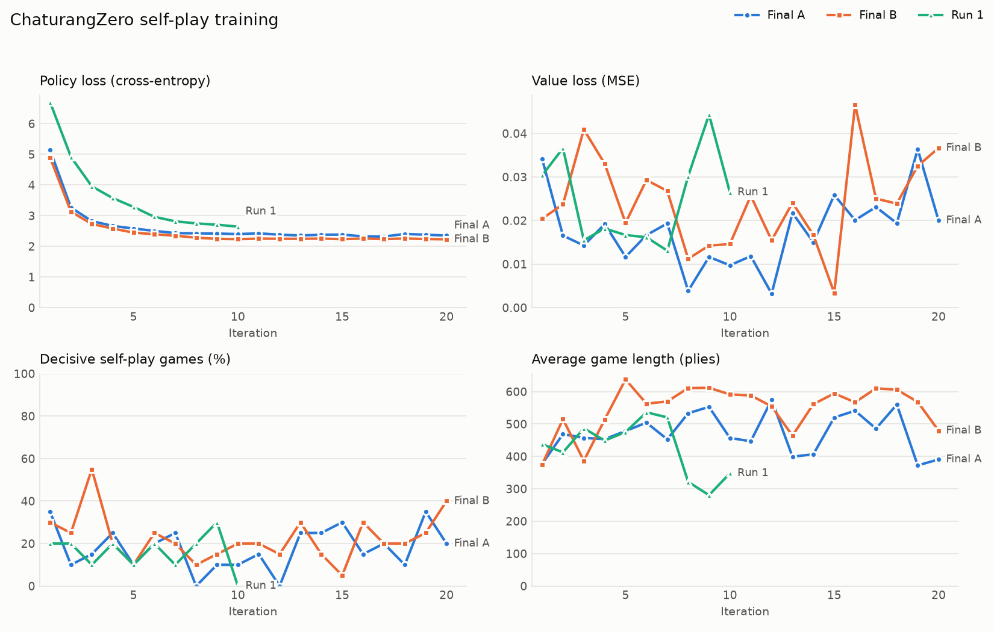
Training curves of the first runs: policy loss, value loss, share of decisive games and game length.
What the curves showed. The policy loss fell quickly for about 5 iterations and then flattened around 2.2 to 2.4: the network learned to predict its own search, but the search was not getting better. The value loss stayed below 0.05 and noisy, because most targets were 0. The share of decisive games did not rise, and games stayed very long (400 to 600 plies).

8.2 The benchmarks
Iteration (final B) | vs untrained | vs random | vs greedy-capture
0 (untrained) | 0.5 by definition | 0.550 +/- 0.066 | 0.550 +/- 0.066
4 | 0.500 +/- 0.103
8 | 0.500 +/- 0.115
10 |  | 0.444 +/- 0.106 | 0.474 +/- 0.050
12 | 0.423 +/- 0.098
16 | 0.393 +/- 0.108
20 | 0.500 +/- 0.087 | 0.472 +/- 0.093 | 0.425 +/- 0.078
Final A against untrained: 0.444, 0.433, 0.382, 0.393 and 0.500 at iterations 4, 8, 12, 16 and 20.
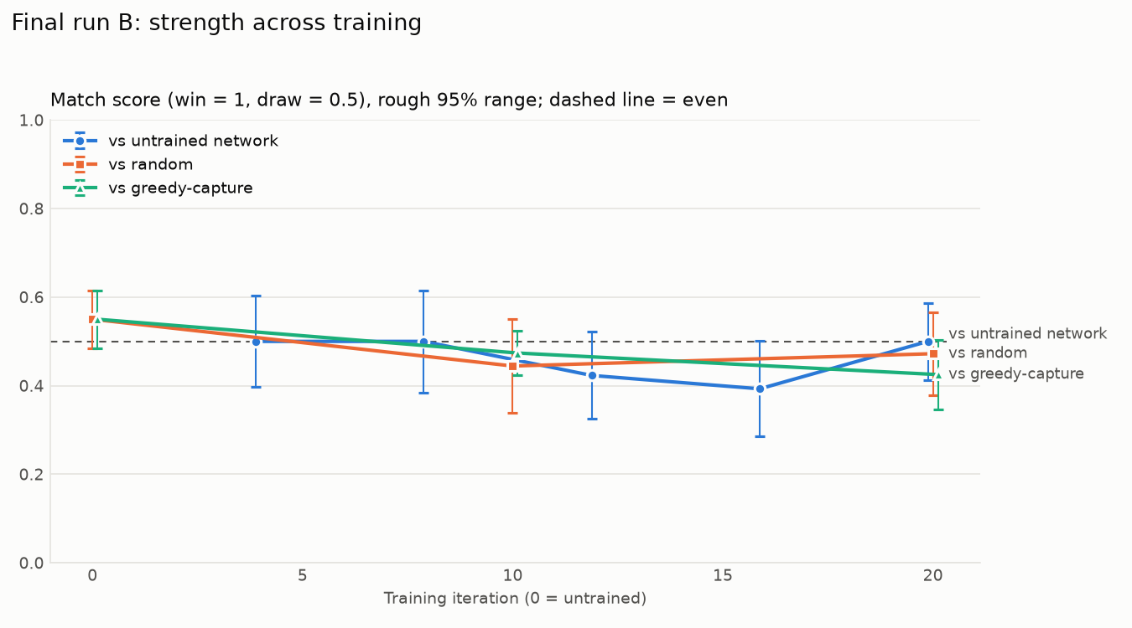
Final B benchmark scores per iteration.
Every score was within its margin of 0.5. In head-to-head matches, final B at iteration 20 against final A at iteration 20 scored 0.500 (1 win each, 15 draws, 3 unfinished), and final B at iteration 20 against its own iteration 10 also scored 0.500 (0 wins, 0 losses, 15 draws, 5 unfinished). Ten more iterations of training did not produce a single win.
Conclusion: after 400 games, the AI was not measurably stronger than an untrained network, than random play or than greedy capture.

8.3 Human games against final B
A team member new to chess played six games against final B (50 simulations), alternating colors:
Game | Human plays | Result | Ending | Plies | Pieces left (human / AI)
1 | White | Human win | Checkmate | 91 | 11 / 2
2 | Black | Human win | Checkmate | 128 | 12 / 2
3 | White | Draw | Stalemate | 137 | 12 / 1
4 | Black | Human win | Checkmate | 90 | 16 / 1
5 | White | Draw | Stalemate | 161 | 8 / 1
6 | Black | Draw | Stalemate | 260 | 7 / 1
The AI won none. Its score was 0.250 (Wilson range 0.060 to 0.635). The draws were all stalemates: the AI had only its king left, and the human stalemated it while trying to checkmate. The AI gave material away steadily.

8.4 How the games ended
Final B at iteration 16, 10 games against each opponent:
Ending | vs itself | vs random | vs greedy-capture
No-progress rule | 5 | 5 | 7
Threefold repetition | 2 | 3 | 3
Checkmate | 2 | 1 | 0
800-ply cap | 1 | 1 | 0
The main cause of draws was the no-progress rule, not repetition. The agent reached positions it could win but could not convert, and shuffled pieces until the 100-ply rule ended the game.

8.5 The diagnosis
Before accepting a negative result, we checked for bugs. Tests confirmed that value targets have the correct sign for both colors, policy targets match the visit counts, and the encoding and actions agree for Black. A full train-and-resume run is also tested. So we concluded the result reflected the method at that scale, not an error. Three causes stood out:
- Too little data. 400 games (about 200,000 positions) is tiny for this method. AlphaZero used millions of games, with far more search per move.
- The value head learns almost nothing. With about 80% of games drawn, nearly every value target is 0. In run 1, 81% of value predictions were within 0.05 of zero, and their correlation with the material balance was only +0.07 (essentially none). Without a useful value, a 50-simulation search cannot tell losing a piece from a quiet move.
- Games are long and rarely decisive. With 400 to 600 plies per game, the rare win or loss signal is spread across hundreds of quiet positions.

8.6 Exploratory runs (outside the rules, to test the diagnosis)
These two short runs break the constraints on purpose, only to test the diagnosis. They are clearly labeled and are not part of the final agent.
- Material value targets (30 simulations, 10 x 10 games): drawn games got a value target from the final material balance, which uses piece values (human knowledge). The value head did learn material (correlation +0.45, against +0.07 before), but strength did not improve (0.474 and 0.469 against untrained at iterations 5 and 10).
- 100 simulations per move (10 x 10 games, also with material targets): decisive games peaked at 60% in iteration 3, but strength against untrained was 0.421 at iteration 5 and 0.346 at iteration 10.
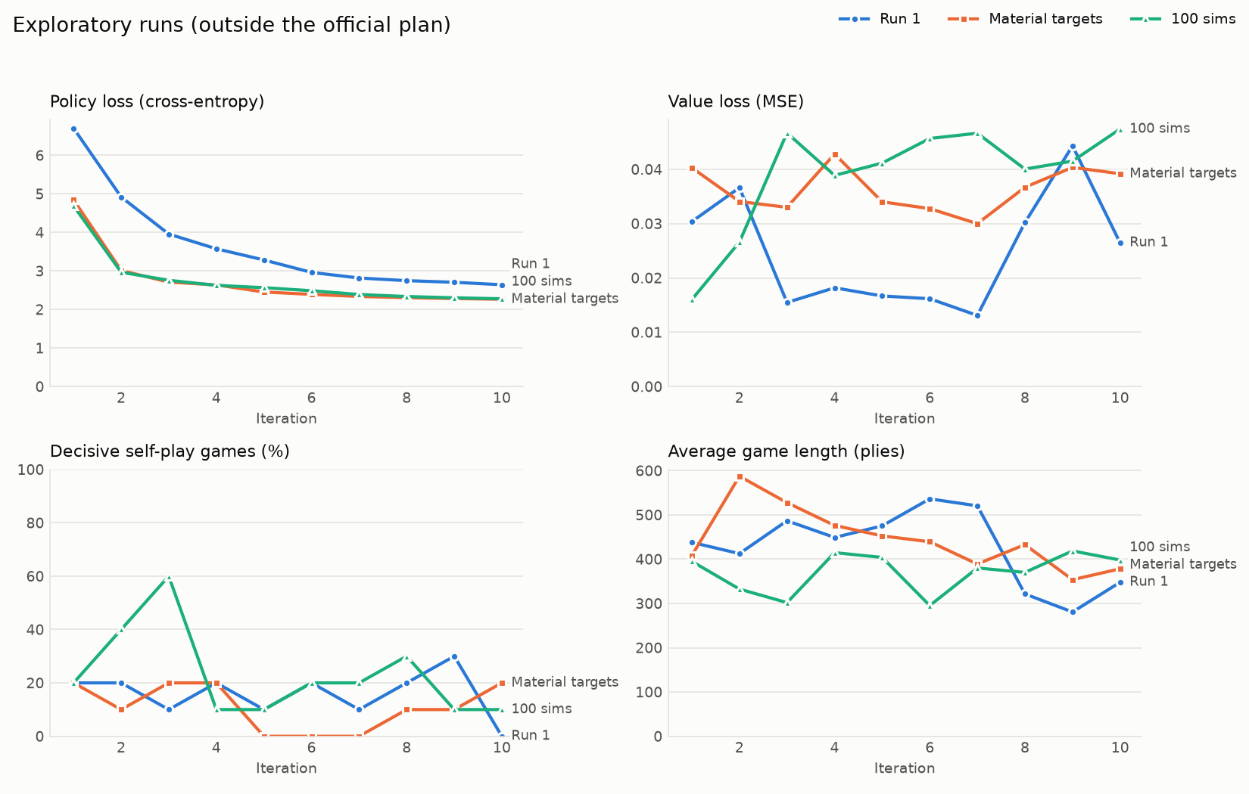
Exploratory runs: loss, decisive share and game length.
These suggested that a better value signal alone was not enough at that tiny scale. The clearest fixable cause was the amount of data, and the limit on data was speed: about 20 minutes per iteration of 20 games on one CPU core.

9 Making training about 11 times faster
To train on much more data, we made self-play faster without changing what it computes: the same rules, the same search, the same results, just quicker.

9.1 Where the speed came from
Measured on one game at 50 simulations per move:
Change | Milliseconds per move
Original | 259
Faster rules engine | 48
Faster network copy for search | 19
The faster rules engine.
- Legal moves are computed once per position and cached, instead of every time they are asked for.
- Check detection looks outward from the king along the lines a piece could attack from, instead of generating every opponent move.
- Move tables (where a horse or elephant can jump from each square, for example) are precomputed once.
The faster network copy. During search, the network is only used to make predictions, never trained. So for search we use a copy in which batch normalization is folded into the convolutions (the two operations are combined into one with the same result), which is faster.
Proving nothing changed. A test compares the fast engine with a frozen copy of the original engine on every ply of 40 random games and on 3,000 random positions: the same legal moves in the same order, the same check status and the same game results.

9.2 Parallel self-play and GPU training
- 6 worker processes play an iteration’s games in parallel, roughly one per CPU core. Each game’s random seed is computed from the run’s seed, the iteration number and the game number, so the games are the same no matter how many workers are used. This keeps every run reproducible.
- Training steps run on the laptop’s GPU (Apple’s “mps” device), about 8 to 10 times faster than one CPU core for this network.
The laptop is an Apple machine with an A18 Pro chip (2 performance cores and 4 efficiency cores, 8 GB of memory). Overall, an iteration of 100 games went from hours to about 9 minutes, and later, with GPU self-play, to about 4 minutes.

10 The long run and the final model

10.1 Setup
The long run continued from final B (iteration 20) with the same official settings: 4 x 64 network, 50 simulations, root noise, repetition avoidance, 800-ply cap, draws valued 0, no domain knowledge. Each iteration played 100 self-play games and then took 500 Adam steps of batch 256 from a replay buffer of 250,000 positions.
Iterations | Learning rate | Notes
21 to 420 | 1e-3 | Restarted once at 220; after a restart the buffer refills before training continues
421 to 500 | 1e-4 | Two stretches of 40 iterations
501 to 560 | 3e-5 | Final stretch
In total: 540 iterations, 54,000 games, about 23.7 million positions, about 144 hours on one laptop.

10.2 The learning curves
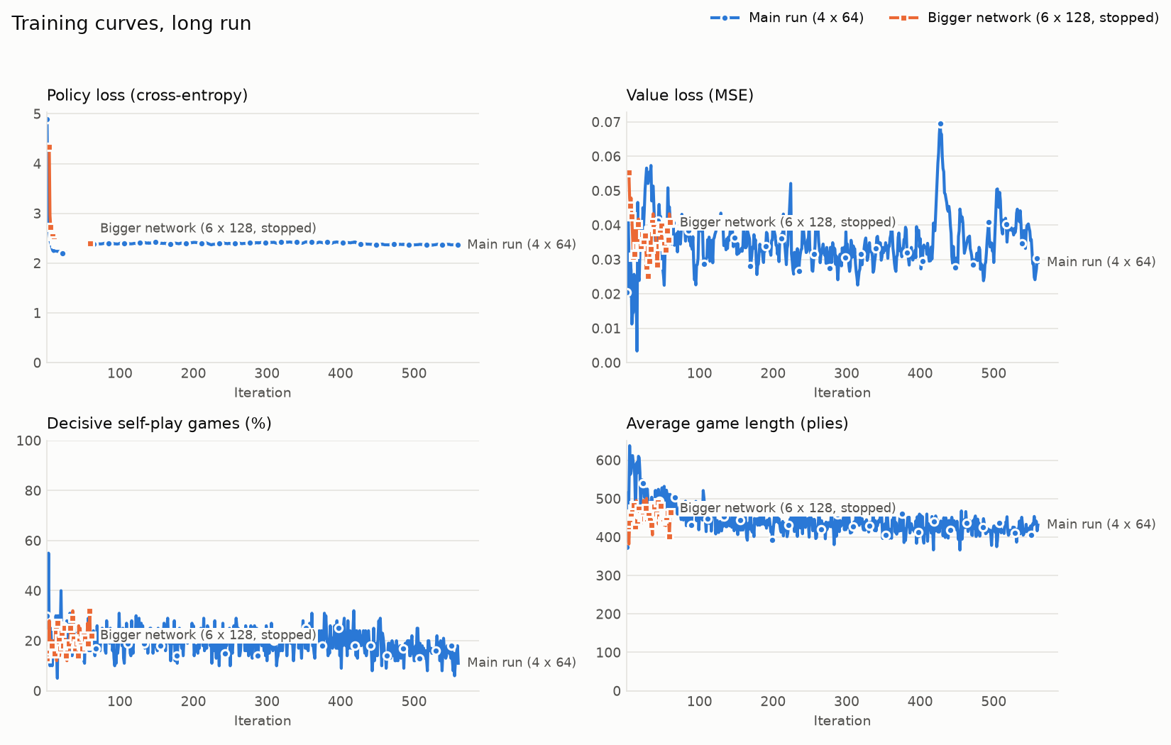
Long run learning curves.
The policy loss stayed around 2.4 and decisive games stayed around 15 to 25%. These curves do not show the improvement, because the targets move with the network: as the AI improves, so does its opponent (itself). Game length fell from about 530 to about 430 plies. Strength has to be measured by matches.

10.3 Progress against the starting model
Checkpoints against final B, 100 games each:
Iteration | Wins | Losses | Draws | Unfinished | Score
40 | 10 | 3 | 61 | 26 | 0.547 +/- 0.047
100 | 18 | 4 | 61 | 17 | 0.584 +/- 0.052
140 | 27 | 2 | 57 | 14 | 0.645 +/- 0.053
220 | 21 | 5 | 57 | 17 | 0.596 +/- 0.057
300 | 27 | 5 | 52 | 16 | 0.631 +/- 0.060
380 | 11 | 5 | 63 | 21 | 0.538 +/- 0.049
500 | 27 | 3 | 60 | 10 | 0.633 +/- 0.053
560 (final) | 27 | 0 | 59 | 14 | 0.657 +/- 0.049
Training now clearly helped. Every checkpoint beat the starting model, and the final one won 27 games and lost none. Most of the gain came in the first 100 to 140 iterations; after that, at learning rate 1e-3, the score moved up and down by about its own margin.

10.4 Lowering the learning rate
To choose a model, iterations 140, 300, 420 and 460 played each other, 100 games per pair (row model’s score against column model):
 | vs 140 | vs 300 | vs 420 | vs 460
140 |  | 0.511 | 0.488 | 0.413
300 | 0.489 |  | 0.500 | 0.463
420 | 0.512 | 0.500 |  | 0.453
460 | 0.587 | 0.537 | 0.547
Iterations 140, 300 and 420 were even with each other: at learning rate 1e-3 the network kept moving around one level of play. Iteration 460, the first after lowering the learning rate to 1e-4, beat all three (41 wins, 9 losses in total). Lowering the learning rate was the clearest single improvement of the run. Further stretches still helped, by smaller steps: iteration 500 scored 0.526 against 460, and iteration 560 scored 0.524 against 500 over 300 games (26 wins, 12 losses). Iteration 560 became the final model, saved as models/chaturangzero_final.pt.

10.5 Benchmarks of the final model
100 games per point:
Iteration | vs random | vs untrained | vs greedy-capture
20 (final B) | 4 W, 6 L: 0.489 | 4 W, 18 L: 0.419 | 0 W, 6 L: 0.469
100 | 6 W, 1 L: 0.525 | 7 W, 9 L: 0.487 | 1 W, 2 L: 0.495
220 | 15 W, 2 L: 0.566 | 23 W, 13 L: 0.560 | 0 W, 0 L: 0.500
420 | 10 W, 2 L: 0.540 | 13 W, 8 L: 0.533 | 1 W, 5 L: 0.480
560 (final) | 16 W, 0 L: 0.581 | 17 W, 4 L: 0.572 | 0 W, 1 L: 0.495
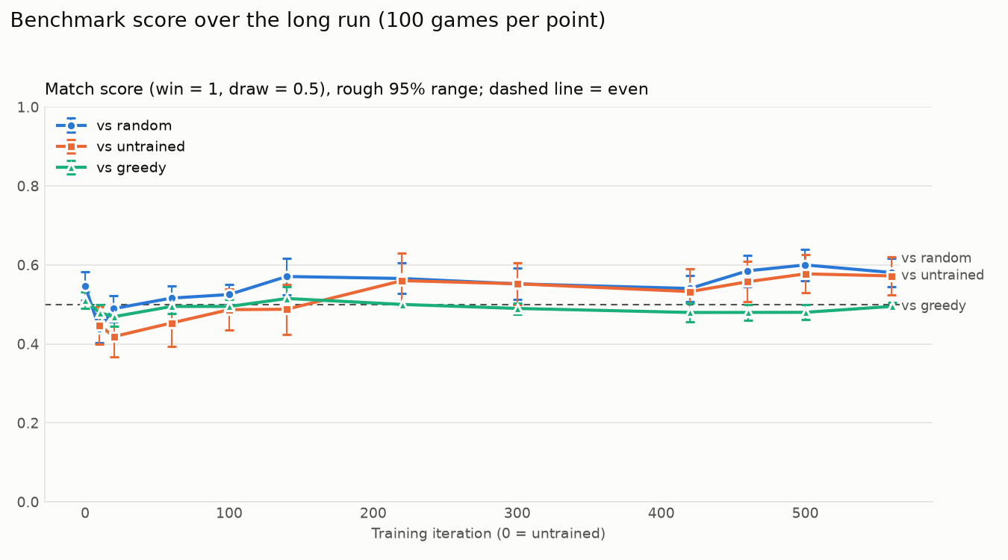
Long-run benchmarks.
The final model beats random play and the untrained network and almost never loses to them, where final B lost more than it won. Against greedy capture, 99 of 100 games were drawn.
How the final model’s games end (30 games each):
Ending | vs random | vs greedy-capture
Checkmate | 3 | 1
Stalemate | 0 | 2
No-progress rule | 12 | 27
Threefold repetition | 14 | 0
800-ply cap | 1 | 0
The AI no longer gives material away, but it rarely turns an advantage into checkmate. Against random, most games end by the no-progress rule or by repetitions caused by the random player (our agent avoids them).

10.6 The larger network, first attempt
We also tried the largest network the rules allow: 6 blocks of 128 filters (about 2.3 million parameters). Its first 5 iterations trained on games played by our best 4 x 64 checkpoint, so it did not start from random play.
Match (100 games) | Wins | Losses | Score
6 x 128 iteration 30 vs 4 x 64 iteration 460 | 4 | 21 | 0.411
6 x 128 iteration 60 vs 4 x 64 iteration 460 | 3 | 17 | 0.427
6 x 128 iteration 60 vs 4 x 64 iteration 420 | 8 | 14 | 0.468
Each iteration took 25 to 30 minutes instead of about 9. After 61 iterations (about 31 hours) it was still behind and improving slowly, so we stopped it and used the time to lower the learning rate of the main run instead.

11 Trying to make it even stronger
After the final model, we tried every reasonable idea within the rules.

11.1 Thinking longer when playing
The 30 to 50 simulation limit applies to training, so we measured the final model with more search at play time, against itself at 50 simulations, 100 games each:
Simulations per move | Wins | Losses | Draws | Unfinished | Score
200 | 9 | 4 | 86 | 1 | 0.525 +/- 0.035
400 | 12 | 0 | 88 | 0 | 0.560 +/- 0.032
800 | 23 | 0 | 76 | 1 | 0.616 +/- 0.042
At 800 simulations the model won 23 games and lost none, a bigger gain than the last 100 iterations of training. Most games are still drawn, so the extra search mainly avoids mistakes and punishes the opponent’s, rather than converting slow advantages. A move takes well under a second to about 2 seconds, which is fine against a person, so 800 simulations is the recommended setting for playing against the final model, and the browser game uses it.

11.2 Counting draws as slightly bad
Idea: if draws are worth a little less than 0, the AI should prefer positions that lead to a decisive result. We continued the final model with a value target of -0.2 for both sides in every drawn or unfinished game, at learning rate 1e-4. This uses only the game result, so it stays within the rules.
Decisive self-play games rose from about 14% to about 19%, but the AI got weaker:
Match (100 games) | Wins | Losses | Draws | Unfinished | Score
Iteration 600 vs final (560) | 4 | 9 | 85 | 2 | 0.474
Iteration 630 vs final (560) | 0 | 9 | 89 | 2 | 0.454
We stopped it at iteration 631. Pushing for decisive results without a better sense of which positions are actually won seems to lead to riskier, worse play.

11.3 Self-play on the GPU
Until now, self-play evaluated positions one at a time on the CPU. GPUs are fast at evaluating many positions at once but slow at one at a time. So we rewrote the search as a generator: a function that pauses every time it needs the network and hands over the position it wants evaluated. Each worker then runs many games side by side, collects all the positions they are waiting on, sends them to the GPU in one batch, and hands each game its answer.
- The games are exactly the same as before: on the CPU, the batched games are identical to the games played one at a time, and tests check this.
- Two changes made the search itself about 20% faster with the same moves: move probabilities are computed only over the legal moves, and a node’s children are created only when first visited (about 111 down to 89 microseconds of tree work per position).
- Small batches are sent to the CPU instead, where that is faster.
Results: for 120 games of the 4 x 64 network, self-play went from 544 to 246 seconds; for 60 games of the 6 x 128 network, from 830 to 351 seconds. That is about 2.2 to 2.4 times faster.

11.4 The larger network, second attempt
With GPU self-play, an iteration of the 6 x 128 network took about 10 minutes instead of 25 to 30. We tried again, this time letting it learn for 30 iterations from games played by the final model first (“bootstrapping”).
Run | Iteration | Wins | Losses | Draws | Score vs final
Learning rate 1e-3 | 30 (end of learning from the final model’s games) | 5 | 6 | 89 | 0.495
Learning rate 1e-3 | 60 | 2 | 13 | 82 | 0.443
Learning rate 1e-3 | 120 | 1 | 16 | 80 | 0.423
Learning rate 1e-4, from iteration 30 | 50 | 4 | 6 | 87 | 0.490
Learning rate 1e-4, from iteration 30 | 70 | 6 | 7 | 86 | 0.495
Learning from the final model’s games made the bigger network as strong as the final model. But on its own games at 1e-3 it got steadily weaker, and at 1e-4 it stayed level without improving. We stopped it at iteration 90. Network size is not what holds the AI back.

11.5 Could hopeless games end early (resignation)?
AlphaZero lets a player resign when its search says the position is clearly lost. This turns long, hopeless games into real results, which would give the value head more wins and losses to learn from. We added resignation to training, but first measured whether it would be safe.
The final model played 160 self-play games, and we recorded its evaluation of every position. Then, for each threshold, we counted how often a resignation would have been wrong (the side that would have resigned did not actually go on to lose):
Resign when below (2 moves in a row) | Would resign | Wrong
-0.3 | 34 | 32
-0.4 | 16 | 14
-0.5 | 7 | 6
-0.6 | 2 | 2
-0.8 | 0 | 0
There is no safe threshold: nearly every resignation would have been in a game that actually ended in a draw. The 21 decisive games were mostly short (11 to 250 plies), and the losing side’s evaluation stayed near 0 until just before the mate. The model does not see a loss coming. Resigning would have turned draws into wrong losses, so we did not use it.
This measurement explains the model’s main weakness from the inside: it wins by punishing sudden mistakes, and it cannot yet tell when a game is slowly being won or lost.

11.6 Even smaller learning steps
Lower learning rates had helped before, so we continued the final model from iteration 560 for 140 more iterations at learning rate 2e-5 (about 10 hours with GPU self-play):
Match vs final (560) | Games | Wins | Losses | Draws | Score
Iteration 620 | 100 | 3 | 1 | 96 | 0.510
Iteration 660 | 100 | 7 | 7 | 84 | 0.500
Iteration 700 | 200 | 15 | 9 | 173 | 0.515
No checkpoint was clearly stronger, so we kept iteration 560 and stopped at iteration 702. Earlier stretches gained about 0.52 to 0.53 each; at 2e-5 the gain was within the margin.

11.7 Why we stopped training
- Every extra idea within the rules (more training, smaller steps, a bigger network, draw penalties, resignation) either did not help or made things worse.
- No university machine was available, and paying for cloud computing was not worth it for the small expected gain.
- The underlying problem (draws starving the value head) is not something more of the same training can fix quickly.

12 Playing against the AI, and the human games

12.1 The terminal game
play_vs_ai.py lets a person play in the terminal. Moves are typed as from-square and to-square, like e2e4. Typing legal lists all legal moves, board reprints the board, resign gives up and quit stops (counted as unfinished). Every game is logged automatically.

12.2 The browser game
For the presentation, we built play_web.py, a clickable board in the browser. It uses only Python’s standard library (no new installs) and runs entirely on the laptop, so it needs no internet.
python play_web.py --player YOUR_NAME
The browser opens at http://127.0.0.1:8000. The page shows:
- the board: click a piece to see its legal moves (dots for moves, rings for captures), then click a square; the last move and a king in check are highlighted;
- buttons for a new game as White or Black, and Resign (click twice to confirm);
- “What the agent thinks”: its evaluation after its last search (from -1 to +1, shown as a bar and in words) and the three moves it searched most, with percentages;
- the move list and a guide to how each piece moves.
It uses the final model at 800 simulations per move and answers in under a second. Games are saved to results/human_games.csv like the terminal version. Four tests cover it.

12.3 Ten games against the final model
The same team member new to chess played ten games against the final model, five with each color:
Game | Human plays | Result | Ending | Plies | Pieces left (human / AI)
1 | White | Human win | Checkmate | 133 | 8 / 4
2 | Black | Draw | Stalemate | 234 | 6 / 1
3 | White | Human win | Checkmate | 105 | 9 / 2
4 | White | Human win | Checkmate | 87 | 12 / 5
5 | Black | Human win | Checkmate | 74 | 11 / 4
6 | Black | AI win | Human resigned | 295 | 6 / 1
7 | Black | AI win | Checkmate | 207 | 5 / 3
8 | White | Draw | Stalemate | 137 | 8 / 1
9 | White | Draw | Stalemate | 183 | 3 / 1
10 | Black | Human win | Checkmate | 66 | 13 / 7
(An eleventh game, stopped after 4 plies, is recorded as unfinished and left out.)
Totals: 5 human wins, 2 AI wins, 3 draws. The AI’s score is 0.350 (Wilson range 0.137 to 0.646), up from 0.250 for final B.
 | Human wins | AI wins | Draws
Human as White (5) | 3 | 0 | 2
Human as Black (5) | 2 | 2 | 1
What the games show.
- The final model kept much more material than final B: two to seven pieces in the games it lost, against one or two for final B.
- It did better when the human played Black.
- Four of the human’s wins came in under 110 plies: a direct attack on its king still usually beats it.
- One of its wins was a resignation by the human in a position where the AI had only its king left, after the human could not find a checkmate in 295 plies. It counts as an AI win because the human resigned.
- The likely reason it struggles against people: it has rarely seen a direct attack on the king in self-play, where about 85% of games are drawn.

13 The decision log: every choice and why it was made
This chapter lists the important decisions in the order they were made, with the question we faced, the reason for the choice, and what came of it. It is the “why” behind the whole project.
# | Question | What we decided | Why | What happened
1 | How should the parts talk to each other? | Fixed “contracts”: square numbering, the 13-plane encoding, from x 64 + to actions, and a network function that returns (move scores, value) | So the rules, network and search could be built at the same time by different people | The parts fit together on the first try
2 | Which starting layout? | The chess-like layout (Raja on d1, Mantri on e1) | Historical sources disagree; this one is simple and unambiguous | Documented in the code
3 | How to test the search before the real network existed? | A stub network with random outputs, and a toy game with a known answer | To check the search mechanics in isolation | Search worked; it beat random play about 70% of decided games
4 | Is the board flipped for Black? | No, absolute orientation plus a “whose turn” plane | Simpler and less error-prone | Tests confirm the encoding is consistent for both colors
5 | How big a network? | 4 residual blocks of 64 filters | The smallest allowed size, fastest to train on a laptop | Kept for the final model; the 6 x 128 size was tried later
6 | How many simulations in training? | 50 | The top of the allowed 30 to 50 range, for the strongest search allowed | Used in every official run
7 | What to do about games stuck in repetition loops? | --avoid_repetition: never pick a move that causes threefold repetition unless every move does | Repetition is a rule, so this uses no outside knowledge | Fewer repetition draws; kept on in all main runs
8 | How long can a self-play game last? | 800 plies, then it counts as unfinished (value 0) | Some games never end otherwise | Some games still hit it, especially early on
9 | How to sample moves in self-play? | Two runs compared: sample for 30 plies (final A) or the whole game (final B) | Sampling gives variety; we did not know how much was best | No clear difference; final B kept
10 | How to measure progress fairly? | A fixed benchmark protocol with the same seeds for every checkpoint | So differences come from the network, not luck | Became the basis of every result
11 | The first runs did not improve. Bug or method? | Check for bugs with tests first, then diagnose | A negative result must be checked before it is believed | No bug found; diagnosis: too little data, too many draws
12 | Would a better value signal help? | Short exploratory runs with material targets and 100 simulations, clearly labeled as outside the rules | To test the diagnosis, not to use in the final model | The value head learned material, but play did not improve at that tiny scale
13 | How to get more data? | Make self-play faster without changing its results | Data was limited by speed, and compute was the bottleneck | About 11 times faster per move, plus 6 workers and GPU training
14 | How long to train? | A long run of hundreds of iterations, 100 games each | The diagnosis said data was the main problem | 540 iterations; clear improvement
15 | Training stopped improving at learning rate 1e-3. What next? | Lower the learning rate to 1e-4, then 3e-5 | Big steps were making the network bounce around one level | Clearest single improvement; iteration 560 became final
16 | Would a bigger network help? | Try 6 x 128, starting from games of our best model | The rules allow up to 6 blocks and 128 filters | Too slow at first; on the second try it matched but never passed the final model
17 | Would more search at play time help? | Test 200, 400 and 800 simulations against 50 | The simulation limit only applies to training | Yes: 800 beat 50 by 23 wins to 0; now the play setting
18 | Could counting draws as slightly bad force more decisive play? | Value target -0.2 for draws | Uses only the game result, so allowed | More decisive games but weaker play; stopped
19 | Could self-play use the GPU? | Rewrite the search as a generator and batch positions across games | GPUs are fast on batches, slow on single positions | 2.2 to 2.4 times faster with identical games
20 | Could resigning hopeless games give more decisive results? | Measure first whether resigning would be safe | A wrong resignation teaches the network the wrong lesson | No safe threshold; not used
21 | Would even smaller learning steps help? | 140 more iterations at 2e-5 | Smaller steps had helped before | No measurable gain; stopped
22 | Pay for cloud computing? | No | No university machine was available, and the expected gain was small | Training ended; the model stayed at iteration 560
23 | How to demonstrate the AI to professors? | A clickable browser board running on the laptop | Easier to watch than typed moves, and needs no internet | play_web.py
24 | How to evaluate against humans? | Logged human games through the browser board, 5 with each color | The project plan asks for agent-vs-human evaluation | 10 games: 5 human wins, 2 AI wins, 3 draws

14 Every training option explained
python -m training.train accepts these options. The values in the last column are what the long run used.
Option | What it controls | Long-run value
--iterations | The total number of iterations to reach | 420, then 500, then 560
--games_per_iter | Self-play games per iteration | 100
--simulations | MCTS simulations per move in self-play | 50
--c_puct | Exploration constant in the PUCT formula | 1.5
--dirichlet_alpha | Shape of the root noise (smaller means spikier noise) | 0.3
--dirichlet_eps | How much noise is mixed into the root priors | 0.25
--temperature_moves | For how many plies moves are sampled instead of picked greedily | 1000 (the whole game)
--max_plies | Game length limit; longer games count as unfinished | 800
--avoid_repetition | Never cause a threefold repetition unless forced | On
--draw_value | Value target for drawn and unfinished games | 0 (-0.2 in the draw-penalty test)
--material_scale | Exploratory only: value targets from material (breaks the rules) | Off
--resign_threshold, --resign_after, --resign_check_fraction | Resignation (tested, not used) | Off
--buffer_capacity | Maximum positions kept in the replay buffer | 250,000
--min_buffer | Positions needed before training starts (after a restart, the buffer refills first) | 150,000
--train_steps | Training steps per iteration | 500
--batch_size | Positions per training step | 256
--lr | Learning rate | 1e-3, then 1e-4, then 3e-5
--weight_decay | L2 regularization strength | 1e-4
--res_blocks, --filters | Network size for a new run | 4 and 64
--bootstrap_model, --bootstrap_iters | Let another model play the first iterations’ games | Used for the bigger network
--resume | Continue from a checkpoint (the buffer starts empty) | Used for each stretch
--checkpoint_dir, --log | Where checkpoints and the CSV log go | Per run
--device | Where training steps run | mps (the GPU)
--workers | Parallel self-play processes | 6
--selfplay_device | Run self-play’s network calls on the GPU in batches | mps, in the later runs
--cpu_below | Batches smaller than this go to the CPU instead | 4
--batch_groups | Split games into groups that take turns on the GPU | 1 (fastest)
--seed | The run’s random seed | A different one per stretch

15 A tour of the code
This chapter explains what the most important pieces of code do, file by file, without needing to read the code itself.

15.1 Rules engine (chaturanga/)
- GameState (in game.py) is the object everything uses. It holds the board, whose turn it is, the no-progress counter, and the history of past positions (needed for threefold repetition). It never changes; making a move creates a new GameState. This “immutable” design means the search can explore many future positions without accidentally changing the real game.
- legal_moves() generates every move the pieces could make, then removes any that would leave the mover’s own king in check. The result is cached, so asking twice is free.
- result() checks, in order: is the side to move’s king missing (loss), does it have no legal moves (checkmate if in check, otherwise stalemate), has the no-progress counter reached 100 (draw), and has the current position occurred three times (draw). Otherwise the game goes on.
- state_to_tensor() and legal_action_mask() (in encoding.py) turn a position into the 13 planes and the list of legal moves into a 4096-long true/false mask.

15.2 Network (network/)
- ChaturangaNet (in model.py) is the network described above.
- AlphaZeroLoss (in loss.py) computes value loss plus policy loss.
- save_checkpoint / load_checkpoint (in checkpoint.py) save and load the weights, the optimizer state, the iteration number and the network’s size.
- make_network_fn (in agent.py) wraps a network into the simple function the search needs: position in, (move scores, value) out. For speed, it uses a copy with batch normalization folded into the convolutions.
- BatchNetwork (in agent.py) evaluates many positions at once on the GPU. It can start a batch and collect the result later, and sends very small batches to the CPU.

15.3 Search (mcts/)
- MCTSNode (in node.py) stores one position in the search tree: its visit count, its total value, and its possible moves with their priors. Children are created only when first visited (“lazy children”). select_child applies the PUCT formula.
- mcts_search (in search.py) runs the simulations. It is written as a generator: whenever it needs the network, it pauses and hands out the position to evaluate, and continues when it gets the answer back. This is what allows many games to share one GPU batch.
- run_mcts is the simple version: it runs a search start to finish with a single-position network function.

15.4 Training (training/)
- self_play_game_steps (in self_play.py) plays one self-play game as a generator, recording each position, the search’s visit distribution and who was to move. At the end it computes the value targets from the result.
- filter_repeating_moves removes moves that would cause a threefold repetition.
- play_games_batched (in batched_self_play.py) runs many game generators side by side, stacks the positions they are waiting on into one batch, gets the network’s answers, and hands each game its own answer.
- ReplayBuffer (in replay_buffer.py) stores training examples in a compact form and returns random batches.
- train.py ties it all together: it reads the options, creates or resumes the network, runs self-play (one process, several worker processes, or batched on the GPU), trains, saves checkpoints and writes the log.

15.5 Evaluation (evaluation/)
- players.py: the random, greedy-capture and MCTS players, and a function that plays one game between any two players.
- benchmark.py: runs the fixed benchmark against every saved checkpoint and writes a CSV.
- parallel_match.py: a match between two models in several processes, with optional GPU batching and different simulation counts per side.
- game_endings.py: classifies how each game ended.
- human_log.py: appends human games to the CSV and computes the score and Wilson range.
- resign_check.py: records the model’s evaluation through self-play games and measures how often resigning would have been wrong.

15.6 Play (play_vs_ai.py, play_web.py, web/play.html)
- play_vs_ai.py: the terminal game.
- play_web.py: a small web server built only from Python’s standard library. It holds the game, answers the page’s requests (state, your move, the AI’s move, new game, resign) and logs finished games.
- web/play.html: the page itself: the board, the panels and the click handling, written in plain HTML, CSS and JavaScript.

16 Presenting the project

16.1 The project in two minutes
“We built an AlphaZero-style AI for Chaturanga, the ancestor of chess, from scratch. It knows only the rules and learns by playing against itself. It has four parts: a rules engine, a residual neural network that suggests moves and judges positions, a Monte Carlo Tree Search that looks ahead using the network, and a self-play training loop. Our first runs of 400 games did not improve the AI, and we found out why: about 80% of games were draws, so the network had almost nothing to learn from, and the data was far too small. We made training about 11 times faster and trained for 54,000 games over 144 hours. The final model beats its starting point 27 wins to 0 and beats random and untrained players, but it rarely checkmates and a beginner can still beat it. We tried a bigger network, draw penalties, resignation and smaller learning steps; none helped. Letting it think longer at play time does help. The main open problem is that its value judgment cannot tell won or lost positions until the very end, because almost all its training games are draws.”

16.2 A suggested slide outline
- Title: ChaturangZero, learning Chaturanga by self-play.
- The game: board, pieces, how it differs from chess, why draws are common.
- The method: network (policy and value), MCTS, self-play loop (one diagram).
- The constraints: rules only, 30 to 50 simulations, 4 to 6 blocks, 4096 actions.
- What we built: the five parts and 127 tests.
- First runs: no improvement, with the benchmark graph.
- Diagnosis: too little data, draws starve the value head, long games.
- Speed-up: 259 to 19 ms per move, workers, GPU.
- The long run: 54,000 games, the progress table, learning-rate effect.
- The final model’s results: against the starting model, random, untrained, greedy capture.
- Trying to go further: bigger network, draw penalty, resignation, smaller steps, more search at play time.
- Human games: the 10-game table.
- Live demo: the browser game.
- What we learned and future work.

16.3 Running the live demo
- Before the presentation, open a terminal in the project folder and run python play_web.py --player Demo --no_log (with --no_log, demo games are not added to the results file).
- The browser opens at http://127.0.0.1:8000. Keep the terminal open.
- During the demo, point out: clicking a piece shows its legal moves, the AI answers in under a second even at 800 simulations, and the “What the agent thinks” panel shows its evaluation and the moves it considered.
- To restart, click New game as White (or Black). Press Ctrl+C in the terminal to stop.
- The demo needs no internet. If the browser does not open by itself, type the address manually. If port 8000 is busy, add --port 8001 and use http://127.0.0.1:8001.

16.4 What to emphasize
- The negative first result was investigated, explained and then fixed by changing only the amount of data, which confirms the diagnosis.
- Every claim is backed by 100-game or 200-game matches with margins.
- The final model follows every course constraint.
- The weakness (converting advantages) is measured and explained, not hidden.

17 What it all means
The first runs failed because of data, not bugs. With 135 times as many games and nothing else changed in the method, the AI became clearly stronger. This confirms the “too little data” part of the diagnosis.
The learning rate matters a lot. At a fixed learning rate of 1e-3 the network stopped improving after about 140 iterations and moved around one level. Lowering it gave the clearest single improvement.
Draws are the central problem. About 80 to 85% of self-play games are drawn even in the long run. So the AI has learned to keep its material and not to lose, but it gets very few examples of how a won position is finished. Most of its games end by the no-progress rule. Greedy capture, which trades whenever it can, is hard to beat for an agent that cannot yet force mate.
The value head does not recognize won or lost positions. The resignation measurement showed that the losing side’s evaluation stays near 0 until just before mate. Decisive games come from sudden mistakes that the search punishes, not from advantages built up and converted. Every change we tried ran into this:
- more training and smaller learning steps: no further gain;
- draw penalties: more decisive games but weaker play;
- a bigger network: reached the same level, no further;
- resignation: impossible, because the value head cannot tell what is lost.
Within the rules and on one laptop, the model is at about its limit. The one clear gain left is outside training: more search at play time.

18 Limitations and future work
Limitations.
- The first runs’ benchmarks used 20 games, so differences smaller than about 0.1 could not be detected. The long run used 100 games per benchmark, and differences smaller than about 0.03 to 0.06 still cannot be detected.
- With most games drawn, a match score says little about how often the AI can actually win.
- The human evaluation is 16 games by one beginner: 6 against final B and 10 against the final model.
- Compute was the main limit: even with GPU self-play, one iteration of 100 games takes about 4 minutes (10 for the bigger network).
What would most likely help, in order.
- A way for game results to reach the value head more often, within the rules, for example a shorter game cap during self-play. Draw penalties did not work, and resignation needs a value head that already recognizes lost positions.
- Far more self-play games with the larger network, which can start from the final model’s level but needs many more games than one laptop can play.

19 Key numbers at a glance
What | Number
Network | 4 residual blocks x 64 filters, 836,359 parameters
Search | PUCT MCTS, c_puct 1.5, 50 simulations in training, Dirichlet noise alpha 0.3 weight 0.25
Action space | 4096 (64 x 64)
Position encoding | 13 planes of 8 x 8
Automated tests | 127
First runs | 2 x 400 games, about 7 hours each, no measurable gain
Speed-up | 259 to 19 ms per move (about 11 times faster per move), plus 6 workers, plus GPU self-play (about 2.2 to 2.4 times faster again)
Long run | 540 iterations, 54,000 games, about 23.7 million positions, about 144 hours
Final model | Iteration 560, models/chaturangzero_final.pt
Final vs starting model | 27 wins, 0 losses, 59 draws (0.657)
Final vs random | 16 wins, 0 losses (0.581)
Final vs untrained | 17 wins, 4 losses (0.572)
Final vs greedy capture | 0 wins, 1 loss, 99 draws (0.495)
800 vs 50 simulations | 23 wins, 0 losses (0.616)
Bigger network (best) | Even with the final model (0.495), never better
Draw penalty | Weaker (0.454)
Smaller learning rate (2e-5) | No gain (0.515)
Resignation | No safe threshold
Human vs final model | 5 human wins, 2 AI wins, 3 draws (AI score 0.350)
Human vs final B | 3 human wins, 0 AI wins, 3 draws (AI score 0.250)

20 The repository, file by file
chaturanga/ rules engine: board, legal moves, game end, tensor + action encoding
network/ the residual network, loss, checkpoints, batched GPU evaluation
mcts/ the search: nodes, PUCT, root noise, lazy children
training/ self-play (single and batched), replay buffer, training loop
evaluation/ baseline players, benchmark, matches, game endings, human log, resign check
results/ every training log, benchmark CSV, match log, plot and the results write-up
models/ the final trained network (chaturangzero_final.pt)
web/ the board page for the browser game
tests/ 127 automated tests
report/ the report (REPORT.md and REPORT.docx) and this document
Top-level scripts.
File | What it does
play.py | Play against a random player in the terminal, or stress-test the rules with random games
play_vs_ai.py | Play against the AI in the terminal (typed moves); --summary prints all logged results
play_web.py | Play against the AI in the browser
evaluate_vs_random.py | MCTS against a random player (the early baseline)
sweep_simulations.py | The simulation-depth sweep and its plot
compare_checkpoints.py | Checkpoint against checkpoint
plot_benchmark.py, plot_training_curves.py | Draw the graphs
integration_preview.py, mcts_preview.py, network_integration_preview.py | Small early demos showing the parts working together
Tests (tests/).
File | What it covers
test_chaturanga.py | The rules
test_engine_equivalence.py, reference_rules.py | The fast engine against a frozen copy of the original
test_mcts.py | The search, including the toy game
test_network.py | The network, loss and checkpoints
test_training.py | Self-play, value targets, policy targets, training and resuming
test_benchmark.py, test_evaluation.py | Scoring, players, matches, endings, human log
test_batched_self_play.py | GPU batching gives the same games, resignation, logs
test_play_web.py | The browser game
Results (results/). The training logs of every run, the benchmark CSVs, the plots, the match logs (long_run_matches/, bigger_network/, draw_penalty/, thinking_time/, smaller_lr/), the resignation measurement (resign_check.txt), the human games (human_games.csv), and results/README.md, which explains all of it.

21 How to run everything
python -m pytest -q # all 127 tests
python play_web.py --player NAME # play in the browser
python play_vs_ai.py --checkpoint models/chaturangzero_final.pt --player NAME --simulations 800
python play_vs_ai.py --summary --checkpoint models/chaturangzero_final.pt
A small training run and its benchmark (about 1 and 5 minutes):
python -m training.train --iterations 2 --games_per_iter 2 \
--checkpoint_dir checkpoints/demo --log checkpoints/demo/log.csv
python -m evaluation.benchmark --checkpoint_dir checkpoints/demo \
--opponent random --games 4 --out checkpoints/demo/bench.csv
A match between two models:
python -m evaluation.parallel_match --a models/chaturangzero_final.pt \
--b checkpoints/final_B/latest.pt --games 100 --workers 6
The exact commands for every training run are in training/README.md and in Appendix B of the report. Requirements: Python 3 with numpy, torch and matplotlib.

22 Questions the professors may ask, with answers
Did you use any chess knowledge? No. The agent only uses the rules. The greedy-capture opponent uses piece values, but it is only an opponent for testing. The exploratory material-value runs did use piece values, which is why they are clearly labeled as outside the rules and are not part of the final model. Repetition avoidance uses only the repetition rule.
Did you follow the simulation limit? Yes. All training used 50 simulations per move. Play-time tests used up to 800, because the limit applies to training.
Why did the first runs not improve? Too little data (400 games) and too many draws (about 80%), so the value head got almost no signal. We checked for bugs with tests first. The long run, with 135 times more games, did improve, which confirms the diagnosis.
How do you know the final model is really stronger? Head-to-head matches of 100 games under a fixed protocol: 27 wins to 0 against the starting model, with a margin of about 0.05. It also beats random and untrained players and almost never loses to them.
Why does it draw against greedy capture? Greedy capture trades pieces whenever it can. Our agent keeps its material and does not lose, but it cannot force checkmate, so most games end by the no-progress rule.
Why can a beginner beat it? It learned mostly from drawn games against itself, so it rarely saw a direct attack on the king. Its value judgment does not recognize danger until the end is near.
Why not just train longer? We did: 140 more iterations at a smaller learning rate gave no measurable gain. We also tried a bigger network, draw penalties and resignation. None helped.
Why is the policy loss flat if the model improved? The training targets come from the model’s own search, which improves along with it. A flat loss means it keeps predicting its own (improving) search equally well. Strength has to be measured by matches, not by loss.
What did the speed-ups change? Only the speed. Tests confirm the faster engine gives the same legal moves and results as the original, and the GPU batching plays exactly the same games.
Is it reproducible? Yes. Every run is seeded; game seeds depend only on the run seed, iteration and game number, so results do not depend on the number of workers.
What would you do with more compute? Train the larger network on far more games, and find a rules-only way to get more decisive games, such as a shorter game cap during self-play.
What is the difference between the policy and the value? The policy is a probability for every move (“which moves look promising here”). The value is one number from -1 to +1 (“how good is this position for the side to move”). The policy guides which moves the search explores; the value judges the positions the search reaches.
Why not just use the network without search? The network alone is a quick guess. The search checks those guesses by looking ahead, which makes play stronger, and the search’s choices then become better training targets for the network. AlphaZero’s strength comes from the two working together.
Why are there no random playouts in your MCTS? Classic MCTS plays random moves to the end of the game to judge a position. AlphaZero replaces that with the network’s value, which is much faster and, once trained, more accurate. We follow AlphaZero.
Why 4096 actions when only about 16 to 40 moves are legal? The course requires a fixed action space covering every from-square and to-square pair. A fixed size makes the network’s output layer simple. Illegal actions are masked out before choosing.
What does “masking” mean? Setting the scores of illegal moves so they get zero probability, so the AI can never choose an illegal move.
Why does the value head matter so much? Without a good value, the search cannot tell a good position from a bad one at the end of its look-ahead, so it cannot avoid losing material or spot winning chances. The value head is trained only on game results, so it needs decisive games.
What is the replay buffer for? It keeps the most recent positions (up to 250,000) so each training step sees a random mix of many games, not just the last one. This makes learning steadier and avoids overfitting to one game.
Why did you lower the learning rate? At 1e-3 the network kept moving around one level of play: iterations 140, 300 and 420 were all even with each other. Smaller steps let it settle, and the first checkpoint after lowering the rate beat all three.
Why is the score against greedy capture 0.495 if the model is stronger? Because 99 of 100 games were draws. Greedy capture trades pieces at every chance; our agent avoids losing, but cannot force checkmate. A score near 0.5 here means “neither can beat the other”, not “they are equally good”.
What does “unfinished” mean in the match tables? The game reached the 800-ply cap without ending. Such games are left out of the score.
How long did everything take? The first runs took about 7 hours each. The long run took about 144 hours. The later experiments added several dozen more hours. All of it ran on one laptop.
Why didn’t the bigger network do better? On its own self-play games it did not improve past the level it reached by learning from the final model’s games. This shows the size of the network is not the bottleneck; the lack of decisive games is.
What is bootstrapping? Letting a new network first learn from games played by an existing, stronger network, instead of starting from random play. We used it for the bigger network.
Why didn’t counting draws as bad work? It made the agent take more risks to avoid draws, but it did not know which risks were good, so it lost more often.
Why didn’t resignation work? Resignation relies on the value head knowing when a position is lost. Ours does not: in games it went on to lose, its evaluation stayed near 0 until just before checkmate. Almost every resignation would have been in a game that was actually drawn.
Is the browser game the same AI as the report’s results? Yes. It uses the final model (models/chaturangzero_final.pt) with the same search, at 800 simulations per move, and logs games to the same file as the terminal game.
Did the speed-ups change the AI’s play? No. Tests check that the fast engine gives exactly the same legal moves and results as the original, and that batched GPU self-play produces exactly the same games as one-at-a-time self-play.
What does the “What the agent thinks” panel show? The root value of the AI’s last search (from -1 to +1, from the AI’s point of view: positive means it thinks it is better) and the three moves it visited most, with the share of visits each received.
What would you change if you started again? Plan for much more data from the start (fast self-play and parallel workers early), lower the learning rate sooner, and look early for a rules-only way to get more decisive games, such as a shorter self-play game cap.
Who did what? The roles are in the team section: Student 1 the rules engine, Student 2 the network and training pipeline, Student 3 the search and evaluation. Later work (the long run, speed-ups, experiments, browser game and report) was merged through the pull requests in the timeline.

23 Glossary
Term | Meaning
Action space | All possible move numbers the network can output (4096 here)
Adam | A standard algorithm for updating a network’s weights
AlphaZero | DeepMind’s method that learns games from rules alone, using a network, MCTS and self-play
Backup | Passing a position’s value back up the search path
Batch | A group of positions processed together
Batch normalization | A network layer that rescales values to help training
Benchmark | A fixed set of games against a fixed opponent to measure strength
Bootstrapping | Letting a new network first learn from games of an existing strong one
Checkpoint | The saved network after an iteration
c_puct | The number that balances exploration and exploitation in the search (1.5)
Cross-entropy | The error measure for the policy
Decisive game | A game that ends in a win or loss, not a draw
Dirichlet noise | Randomness added to the root’s priors during self-play so the agent explores
Draw value | The value target given to drawn games (normally 0)
Expansion | Adding a new position to the search tree using the network’s priors
Filters | The width of each layer of the network (64 here)
Generator | A function that can pause and resume; used so many games can share one GPU batch
GPU / mps | The graphics processor; “mps” is Apple’s GPU device in PyTorch
Greedy capture | A baseline that always captures the most valuable piece it can
Iteration (round) | One cycle of self-play followed by training
Learning rate | The size of each training step
Logits | The network’s raw move scores before they become probabilities
Loss | The error training tries to reduce
Margin (+/-) | The 95% uncertainty range of a score
MCTS | Monte Carlo Tree Search, the look-ahead search
No-progress rule | 100 plies with no capture or soldier move is a draw
Parameters | The network’s learnable numbers (836,359 here)
Ply | One move by one player
Policy | The network’s probabilities for each move
Prior | The policy’s probability for a move, used to guide the search
PUCT | The formula that picks which move to explore next in the search
Replay buffer | A store of recent training positions
Residual block | A network block that adds its input to its output
Resignation | Giving up a game the search thinks is lost
Root | The current position at the top of the search tree
Score | (wins + 0.5 x draws) / finished games; 0.5 is even
Self-play | The agent playing games against itself to create training data
Simulation | One pass of the search from the root to a new position and back
Stalemate | No legal move while not in check; a draw
Stub network | A fake network with random outputs, used for early testing
Temperature | How randomly moves are chosen from the visit counts
Threefold repetition | The same position occurring three times; a draw
Value | The network’s estimate (from -1 to +1) of who will win
Visit count | How many times the search explored a move
Weight decay (L2) | A small penalty that keeps the network’s weights from growing too large
Wilson range | A confidence interval suited to small numbers of games
Worker | A separate process playing games in parallel
More terms, from the basics chapter.
Term | Meaning
Backpropagation | The method for computing how every weight should change to reduce the loss
Bias | An adjustable number added inside a neuron
Branch | A separate line of work in Git
Commit | One saved set of changes in Git
Convolution | A network layer that slides a small window over a grid and looks for patterns
CPU | The computer’s main processor
Domain knowledge | Human expertise about a game, such as piece values or openings (not allowed here)
Gradient | The direction in which each weight should change to reduce the loss
Immutable | Never changed after creation; making a move creates a new game state
Logits | Raw scores before softmax
Machine learning | Programs that improve by adjusting themselves from data or experience
Masking | Giving illegal moves zero probability
Merge | Adding a pull request’s changes into the main branch
Neuron | A unit that multiplies inputs by weights, adds them and applies a simple function
Overfitting | Memorizing training examples instead of learning general patterns
Pull request (PR) | A request to add a branch’s changes to the main branch
Reinforcement learning | Learning from rewards (here, game results) rather than from labeled answers
ReLU | A function that turns negative numbers into 0
Seed | The starting value for a random number generator; the same seed gives the same results
Skip connection | Adding a block’s input to its output, as in a residual block
Softmax | Turns a list of scores into probabilities that add up to 1
Squash merge | Combining all of a pull request’s commits into one commit on main
Stem | The first convolution layer of the network
Supervised learning | Learning from examples with correct answers
Tanh | A function that squashes any number into the range -1 to +1
Tensor | A block of numbers with a shape, such as [13, 8, 8]
Unit test | A small program that checks one piece of code works correctly
Weight | An adjustable number inside the network; training changes the weights

