ChaturangZero: Learning Chaturanga by Self-Play
  - CS F407 course project report
October 2026

Abstract
We built ChaturangZero, an AlphaZero-style agent for Chaturanga, the ancient Indian ancestor of chess. The agent knows only the rules. A residual network with a policy head and a value head guides Monte Carlo Tree Search (MCTS) with PUCT selection, and the network is trained on the games the agent plays against itself. The system has a rules engine checked by unit tests, the network, search, a self-play training loop with a replay buffer, and an evaluation suite. Our first two runs of 400 self-play games each (50 simulations per move, a 4-block, 64-filter network) did not make the agent measurably stronger than an untrained network: about 80% of games were drawn and the data was far too small. We then made self-play about 11 times faster without changing the rules or the search, and trained for 540 more iterations (54,000 games, about 144 hours on one laptop), lowering the learning rate at the end. Under the same course constraints, the final model beats the model it started from 27 wins to 0 (score 0.657 over 100 games), beats a random player 16 to 0 and an untrained network 17 to 4, but still draws almost every game against a greedy-capture player. Its main weakness is converting an advantage: most of its games end by the 100-ply no-progress rule rather than checkmate. A larger 6-block, 128-filter network did not catch up in the time we had. Two later tests, more search per move when playing and counting draws as slightly bad in training, gave a small gain and a loss of strength respectively. After moving self-play to the laptop’s GPU (about 2.2 to 2.4 times faster), a second attempt with the larger network, started from the final model’s games, reached the final model’s level but did not pass it. A measurement of the final model’s own evaluations showed that resigning hopeless games cannot work yet: it does not see a loss coming.

1. Introduction
AlphaZero (Silver et al., 2018) showed that one algorithm can learn chess, shogi and Go to superhuman level from the rules alone, by combining tree search with a neural network trained on self-play. The goal of this project was to build that method from scratch for Chaturanga and to measure how far it gets on the compute of a course project.
The course plan set these constraints:
- no human domain knowledge beyond the rules (no opening books, no piece values, no hand-written evaluation);
- 30 to 50 MCTS simulations per move during training;
- a residual network with 4 to 6 blocks and 64 to 128 filters;
- a 4096-wide action space (every from-square, to-square pair).
The project had four milestones: (1) a rules engine verified by unit tests, (2) MCTS working with an untrained network, (3) a self-play pipeline with the loss tracked over at least 50 to 100 games, and (4) benchmarks against earlier iterations and baseline players, with learning curves. All four are complete.
The report follows the project in order: the first runs (Section 5.1 and 6.1 to 6.5) gave a negative result, the diagnosis (Section 7) led to a faster pipeline and a much longer run, and that long run produced the final model (Sections 5.3 and 6.6 to 6.10). Sections 6.11 to 6.13 test what else could make it stronger.

2. The game
Chaturanga is played on an 8x8 board with the same starting layout as chess, but most pieces are weaker:
Piece | Letter | Move
Raja (king) | K | one square in any direction
Mantri (counselor) | Q | one square diagonally
Ratha (chariot) | R | any distance orthogonally, like a rook
Gaja (elephant) | E | exactly two squares diagonally, jumping the square between
Ashva (horse) | N | an L-shaped jump, like a knight
Padati (foot soldier) | P | one square forward, captures one square diagonally forward, promotes to Mantri on the last rank
There is no castling, no pawn double step and no en passant. Checkmate wins. Stalemate, 100 plies with no capture or pawn move (the no-progress rule) and threefold repetition are draws. Because the Mantri and Gaja are short-range, material advantages are much harder to convert into checkmate than in chess, which turns out to matter for learning (Section 7).

3. Method

3.1 State and action encoding
A position is encoded as 13 planes of 8x8: one plane per piece type and color (12) and one plane for the side to move. Squares are absolute (the board is not flipped for Black). A move is the action from * 64 + to, giving 4096 actions; illegal actions are masked out of the policy before the softmax. We checked that the encoding and the action indices agree for both colors.

3.2 Network
ChaturangaNet is a residual network:
- an input 3x3 convolution to 64 filters with batch normalization and ReLU;
- 4 residual blocks, each two 3x3 convolutions with batch normalization and a skip connection;
- a policy head (1x1 convolution to 2 planes, then a linear layer to 4096 logits);
- a value head (1x1 convolution to 1 plane, a 64-unit hidden layer, then a tanh output in [-1, 1], the expected result for the side to move).
It has 836,359 parameters. The loss is value mean squared error plus policy cross-entropy against the MCTS visit distribution, with L2 regularization (weight decay 1e-4).

3.3 Monte Carlo Tree Search
Each simulation descends the tree from the root by choosing the child that maximizes
$$−Q(s^{′})+c_{puct} P(s,a) \frac{\sqrt{N(s)}}{1+N(s^{′})}$$
where $Q(s^{′})$ is the child’s mean value from the child’s side (negated to give the parent’s view), $P(s,a)$ is the network’s prior for the move, $N$ are visit counts and $c_{puct}=1.5$. At a new leaf, the network gives the priors for its children and a value, which is backed up the path with its sign flipped at each ply. There are no random rollouts. Child states are created only when first visited. During self-play, Dirichlet noise ($α=0.3$, weight 0.25) is mixed into the root priors so that the agent explores moves the network does not yet favor.

3.4 Self-play and training
Each training iteration:
- Self-play. The current network plays 20 games (100 in the long run) against itself with 50 simulations per move. Moves are sampled in proportion to visit counts. Every position becomes an example (state, visit distribution, result from the mover’s view: +1, -1 or 0 for a draw). Games longer than 800 plies stop and count as draws.
- Training. Examples go into a replay buffer of the latest positions (20,000 in the first runs, 250,000 in the long run). The network takes Adam steps on random batches (400 steps of 64 in the first runs, 500 steps of 256 in the long run).
- Checkpoint. The network is saved, so every iteration can be evaluated later.
One rules-only addition: with --avoid_repetition, the agent never picks a move that causes a threefold-repetition draw unless every searched move does. This uses only the rules, so it fits the no-domain-knowledge requirement. We added it because early self-play games often ended in repetition loops.

4. Implementation and testing
The code is plain Python with NumPy and PyTorch, organized by component:
Folder | Contents
chaturanga/ | rules engine, move generation, game end, encoding
network/ | the network, loss and checkpoints
mcts/ | tree nodes, PUCT search, root noise
training/ | self-play, replay buffer, training loop
evaluation/ | baseline players, benchmark, parallel matches, game-ending classifier, human-game log
123 automated tests cover the rules (36 tests, including check, checkmate, stalemate, promotion and the draw rules), the search (including a toy game with a known best move), the network, value-target signs, policy targets, a complete small training run including resuming from a checkpoint, the benchmark scoring, the evaluation tools and batched GPU self-play. All runs are seeded and repeatable.
Faster self-play. For the long run we sped up self-play about 11 times on the same hardware, without changing what it computes:
Change | ms per move (50 simulations)
Original | 259
Faster rules engine: legal moves cached per position, check detection that looks outward from the king, precomputed move tables | 48
Network copy for search with batch normalization folded into the convolutions | 19
On top of that, 6 worker processes play games in parallel, each with its own seed derived from the run seed, the iteration and the game number, so a run does not depend on the number of workers. Training steps run on the laptop’s GPU. A test compares the fast rules engine with a frozen copy of the original on every ply of 40 random games and on 3,000 random positions (same legal moves in the same order, same check and game results).
Self-play on the GPU. Later we moved the network evaluations of self-play to the laptop’s GPU. The search is written as a generator that pauses whenever it needs the network, so each worker can run many games side by side and send all the positions they are waiting on to the GPU in one batch. The moves do not change: on the CPU the batched games are exactly the games played one at a time, which tests check. Two changes made the search itself about 20% faster with the same moves: move probabilities are computed on the legal moves only, and a node’s children are created when the search first visits them. For 120 games of the 4 x 64 network, self-play went from 544 to 246 seconds; for 60 games of the 6 x 128 network, from 830 to 351 seconds.

5. Experiments

5.1 Training runs
Run | Simulations | Games | Move choice in self-play | Decisive games | Policy loss | Time
Run 1 (early) | 30 | 10 x 10 | earlier settings | 16 of 100 (16%) | 6.70 to 2.64 | 0.5 h
Final A | 50 | 20 x 20 | sample 30 plies, then best | 71 of 400 (18%) | 5.15 to 2.35 | 7.1 h
Final B | 50 | 20 x 20 | sample the whole game | 90 of 400 (22%) | 4.89 to 2.23 | 6.8 h
Final B is the model we kept.

5.2 Benchmark protocol
To compare checkpoints fairly, every checkpoint plays 20 games against a fixed opponent under the same conditions: 50 simulations, no root noise, temperature 0.3, repetition avoidance, alternating colors, the same random seed for every checkpoint, and an 800-ply cap (unfinished games are left out). The score is (wins + 0.5 x draws) / finished games, with a 95% margin of $1.96\sqrt{p(1−p)/n}$. The opponents are:
- untrained: the same MCTS agent with a freshly initialized network;
- random: a uniformly random legal move;
- greedy-capture: captures the most valuable piece it can, otherwise plays randomly. Its piece values are used only by this baseline, never by our agent.
Head-to-head matches between two checkpoints use the same protocol. In the long run every benchmark and match uses 100 games, with margins of about 0.03 to 0.06.

5.3 The long run
The long run continues from final B (iteration 20) with the same official settings (4 x 64 network, 50 simulations, root noise, repetition avoidance, 800-ply cap, draws valued 0). Each iteration plays 100 self-play games and then takes 500 Adam steps of batch 256 from a buffer of 250,000 positions.
Iterations | Learning rate | Notes
21 to 420 | 1e-3
421 to 500 | 1e-4 | two stretches of 40 iterations
501 to 560 | 3e-5 | final stretch
That is 540 iterations, 54,000 games and about 23.7 million positions, in about 144 hours. We also tried a larger network (6 blocks, 128 filters, 2.3 million parameters) for 61 iterations; its first 5 iterations trained on games played by our best 4 x 64 checkpoint so it did not start from random play (Section 6.10).

6. Results
Sections 6.1 to 6.5 are the first runs; 6.6 to 6.10 are the long run; 6.11 to 6.13 are later attempts to go further; 6.14 breaks the constraints.

6.1 Learning curves
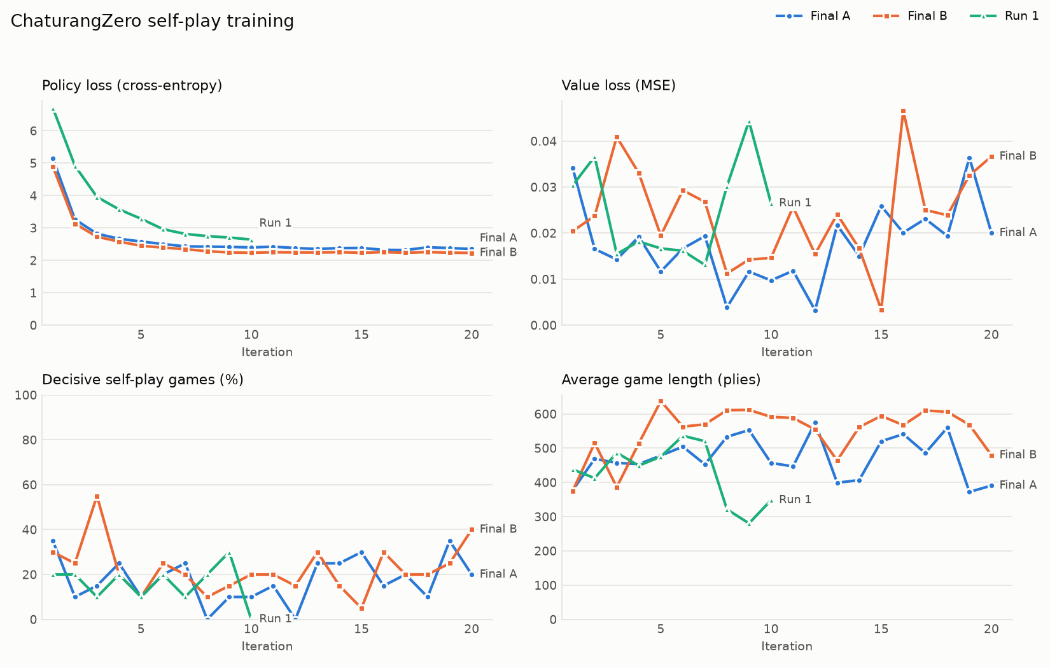
Policy loss, value loss, share of decisive games and game length per iteration for the final runs and run 1.
The policy loss falls quickly over the first 5 iterations and then flattens around 2.2 to 2.4: the network learns to predict its own search, but search is not getting better. The value loss stays below 0.05 and noisy, because most targets are 0. The share of decisive games does not trend upward, and games stay long (400 to 600 plies on average).

6.2 Benchmarks against fixed opponents
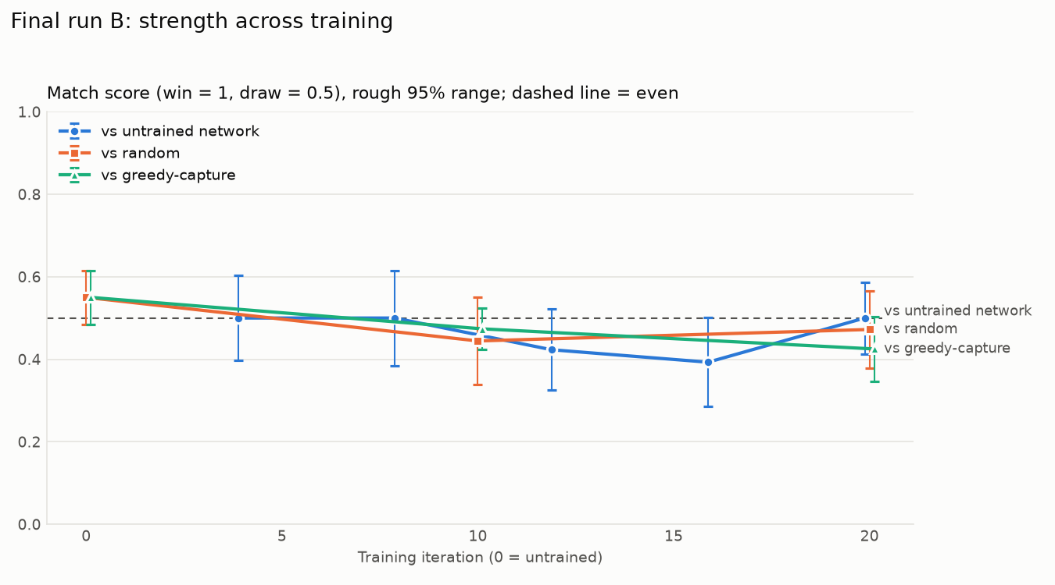
Benchmark score per iteration for final run B against the untrained network, random and greedy-capture players. The dashed line is an even score.
Iteration (final B) | vs untrained | vs random | vs greedy-capture
0 (untrained) | 0.5 by definition | 0.550 +/- 0.066 | 0.550 +/- 0.066
4 | 0.500 +/- 0.103
8 | 0.500 +/- 0.115
10 |  | 0.444 +/- 0.106 | 0.474 +/- 0.050
12 | 0.423 +/- 0.098
16 | 0.393 +/- 0.108
20 | 0.500 +/- 0.087 | 0.472 +/- 0.093 | 0.425 +/- 0.078
Final A against the untrained network scored 0.444, 0.433, 0.382, 0.393 and 0.500 at iterations 4, 8, 12, 16 and 20. Every score in both runs is within its margin of 0.5.
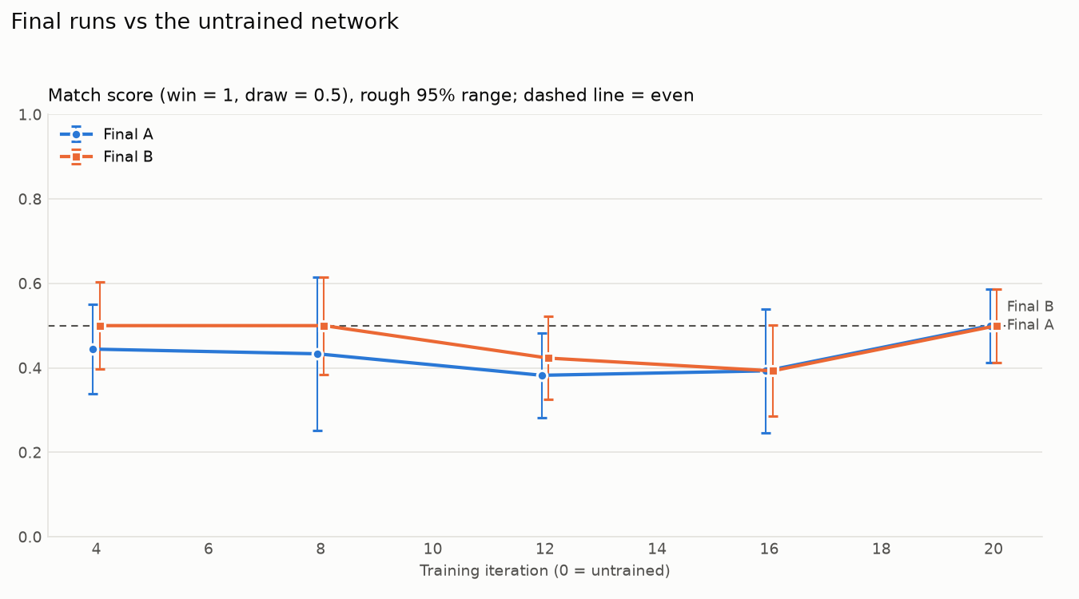
Final A and final B against the untrained network.

6.3 Against earlier iterations
Match (20 games) | Wins | Losses | Draws | Unfinished | Score
Final B iter 20 vs final A iter 20 | 1 | 1 | 15 | 3 | 0.500
Final B iter 20 vs final B iter 10 | 0 | 0 | 15 | 5 | 0.500
Ten more iterations of training did not give a single win over the older network.

6.4 Agent vs. human
A team member who is new to chess played six games against final B, alternating colors.
Game | Human plays | Result | Ending | Plies | Pieces left (human / agent)
1 | White | Human win | Checkmate | 91 | 11 / 2
2 | Black | Human win | Checkmate | 128 | 12 / 2
3 | White | Draw | Stalemate | 137 | 12 / 1
4 | Black | Human win | Checkmate | 90 | 16 / 1
5 | White | Draw | Stalemate | 161 | 8 / 1
6 | Black | Draw | Stalemate | 260 | 7 / 1
The agent won none of the six games. Its score is 0.250, with a 95% Wilson range of 0.060 to 0.635. Six games are too few to separate that from 0.5 statistically, but the final positions are one-sided: the agent always ended with at most two pieces, and in each draw it had only its king left, which the human stalemated while going for checkmate.

6.5 How games end
Final B at iteration 16, 10 games against each opponent under the benchmark protocol:
Ending | vs itself | vs random | vs greedy-capture
No-progress rule | 5 | 5 | 7
Threefold repetition | 2 | 3 | 3
Checkmate | 2 | 1 | 0
800-ply cap | 1 | 1 | 0

6.6 Long run: learning curves
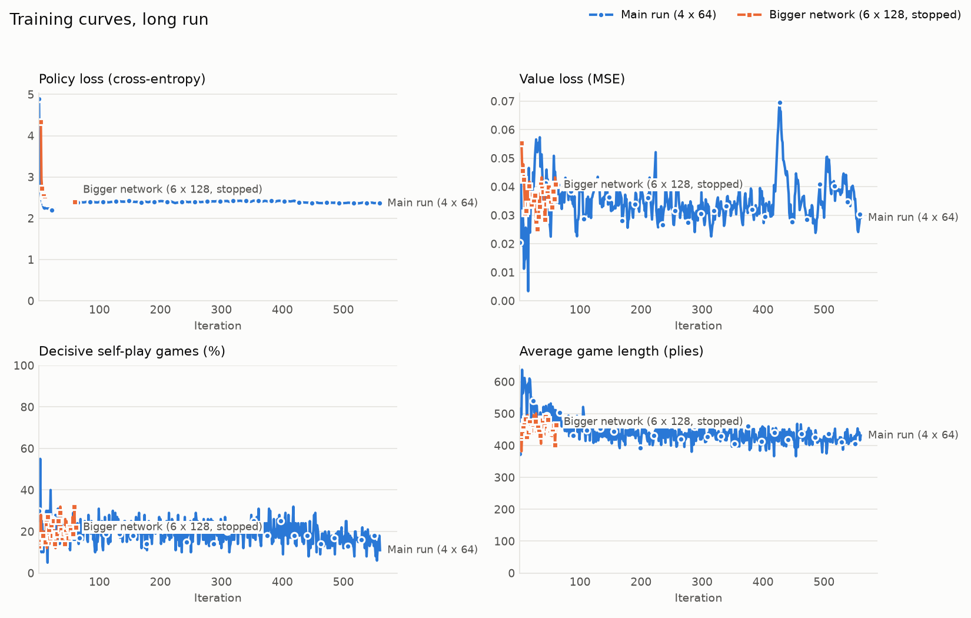
Long run: policy loss, value loss, share of decisive self-play games and game length per iteration, with the stopped 6 x 128 network.
The policy loss stays around 2.4, and the share of decisive self-play games stays around 15 to 25%. These curves do not show the improvement, because the targets move with the network: as the agent improves, so does its opponent. Game length fell from about 530 to about 430 plies. Strength has to be measured by matches.

6.7 Long run: progress against the starting model
Checkpoints of the long run against final B (iteration 20), 100 games each:
Iteration | Wins | Losses | Draws | Unfinished | Score
40 | 10 | 3 | 61 | 26 | 0.547 +/- 0.047
100 | 18 | 4 | 61 | 17 | 0.584 +/- 0.052
140 | 27 | 2 | 57 | 14 | 0.645 +/- 0.053
220 | 21 | 5 | 57 | 17 | 0.596 +/- 0.057
300 | 27 | 5 | 52 | 16 | 0.631 +/- 0.060
380 | 11 | 5 | 63 | 21 | 0.538 +/- 0.049
500 | 27 | 3 | 60 | 10 | 0.633 +/- 0.053
560 (final) | 27 | 0 | 59 | 14 | 0.657 +/- 0.049
Unlike the first runs, training now clearly helps: every checkpoint beats the starting model, and the final one won 27 games and lost none. Most of the gain came in the first 100 to 140 iterations. From there to iteration 420 the score moved up and down by about its own margin.

6.8 Lowering the learning rate
To choose a model, iterations 140, 300, 420 and 460 (the first 40 iterations at learning rate 1e-4) played each other, 100 games per pair. The table gives the row model’s score against the column model.
 | vs 140 | vs 300 | vs 420 | vs 460
140 |  | 0.511 | 0.488 | 0.413
300 | 0.489 |  | 0.500 | 0.463
420 | 0.512 | 0.500 |  | 0.453
460 | 0.587 | 0.537 | 0.547
Iterations 140, 300 and 420 are even with each other, while 460 beats all three (41 wins, 9 losses in total). At learning rate 1e-3 the network kept moving around one level of play; the lower rate let it settle. Further stretches still helped, by smaller steps: iteration 500 scored 0.526 against 460 (8 wins, 3 losses), and iteration 560 scored 0.524 against 500 over 300 games (26 wins, 12 losses). Iteration 560 is the final model.

6.9 Long run: benchmarks of the final model
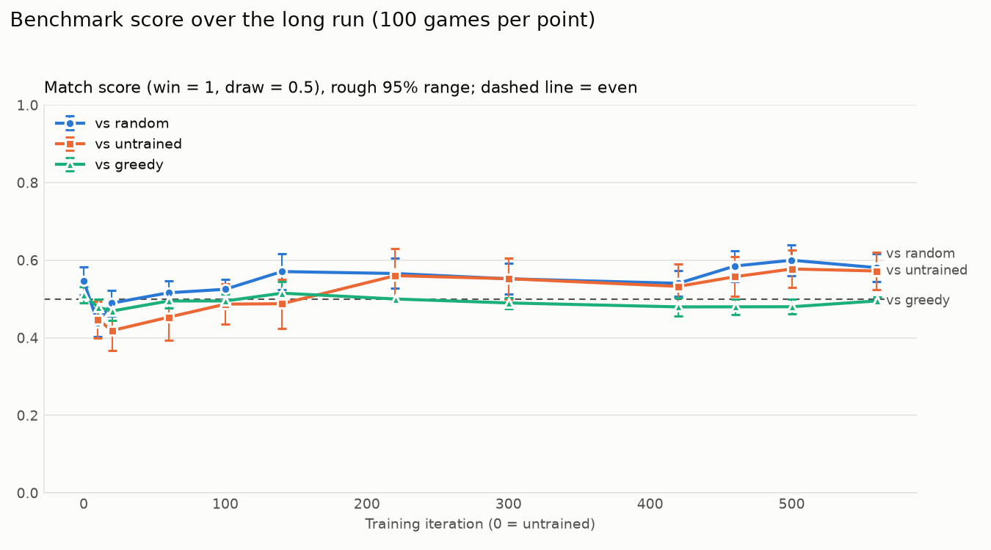
Benchmark score of long-run checkpoints against random, untrained and greedy-capture players, 100 games per point.
Iteration | vs random | vs untrained | vs greedy-capture
20 (final B) | 4 W, 6 L: 0.489 | 4 W, 18 L: 0.419 | 0 W, 6 L: 0.469
100 | 6 W, 1 L: 0.525 | 7 W, 9 L: 0.487 | 1 W, 2 L: 0.495
220 | 15 W, 2 L: 0.566 | 23 W, 13 L: 0.560 | 0 W, 0 L: 0.500
420 | 10 W, 2 L: 0.540 | 13 W, 8 L: 0.533 | 1 W, 5 L: 0.480
560 (final) | 16 W, 0 L: 0.581 | 17 W, 4 L: 0.572 | 0 W, 1 L: 0.495
The final model beats random play and the untrained network and almost never loses to them, where final B lost more than it won. Against greedy capture, 99 of 100 games were drawn.
How the final model’s games end, 30 games each:
Ending | vs random | vs greedy-capture
Checkmate | 3 | 1
Stalemate | 0 | 2
No-progress rule | 12 | 27
Threefold repetition | 14 | 0
800-ply cap | 1 | 0
The agent no longer gives material away, but it rarely turns an advantage into checkmate. Against random most games end by the no-progress rule or by repetitions that the random player causes (our agent avoids them).

6.10 A larger network
Match (100 games) | Wins | Losses | Score
6 x 128 iteration 30 vs 4 x 64 iteration 460 | 4 | 21 | 0.411 +/- 0.048
6 x 128 iteration 60 vs 4 x 64 iteration 460 | 3 | 17 | 0.427 +/- 0.043
6 x 128 iteration 60 vs 4 x 64 iteration 420 | 8 | 14 | 0.468 +/- 0.049
Each iteration of the larger network took about 25 to 30 minutes instead of about 9. After 61 iterations (about 31 hours) it was still behind and improving slowly, so we stopped it and used the time for the lower learning rate instead. Section 6.12 tries it again with faster self-play.

6.11 Two more tests on the final model
More search when playing. The 30 to 50 simulation limit applies to training, so we also measured the final model with more search at play time. With 200 simulations per move against itself at 50 (100 games) it scored 9 wins, 4 losses and 86 draws (0.525 +/- 0.035). Four times the search gives only a small edge, since the extra search does not help it finish games.
Counting draws as slightly bad. We continued the final model from iteration 560 with a value target of -0.2 for both sides in every drawn or unfinished self-play game, instead of 0, at learning rate 1e-4. It uses only the game result, so it stays within the rules-only constraint. Decisive self-play games rose from about 14% to about 19%, but play got weaker:
Match (100 games) | Wins | Losses | Draws | Unfinished | Score
iteration 600 vs final (560) | 4 | 9 | 85 | 2 | 0.474 +/- 0.036
iteration 630 vs final (560) | 0 | 9 | 89 | 2 | 0.454 +/- 0.029
We stopped it at iteration 631 and kept iteration 560 as the final model.

6.12 The larger network, second attempt
With GPU self-play an iteration of the 6 x 128 network takes about 10 minutes instead of 25 to 30. We trained it again, this time learning for 30 iterations from games played by the final model before playing its own.
Run | Iteration | Wins | Losses | Draws | Score vs final (560)
learning rate 1e-3 | 30 (end of learning from 560’s games) | 5 | 6 | 89 | 0.495 +/- 0.032
learning rate 1e-3 | 60 | 2 | 13 | 82 | 0.443 +/- 0.037
learning rate 1e-3 | 120 | 1 | 16 | 80 | 0.423 +/- 0.039
learning rate 1e-4, from iteration 30 | 50 | 4 | 6 | 87 | 0.490 +/- 0.032
learning rate 1e-4, from iteration 30 | 70 | 6 | 7 | 86 | 0.495 +/- 0.036
Learning from the final model’s games made the larger network as strong as the final model. On its own games at 1e-3 it got steadily weaker; at 1e-4 it stayed level but did not get stronger, and we stopped it at iteration 90.

6.13 Can hopeless games end early?
AlphaZero resigns a game when the search rates the position as clearly lost, so lost games give a real result instead of a long draw. Before training with it, we recorded the final model’s evaluation of every position in 160 self-play games and counted, for each threshold, how often a resignation would have been wrong (the side did not go on to lose):
Resign when below (2 moves in a row) | Would resign | Wrong
-0.3 | 34 | 32
-0.4 | 16 | 14
-0.5 | 7 | 6
-0.6 | 2 | 2
-0.8 | 0 | 0
Nearly every resignation would have been in a game that ended in a draw. The 21 decisive games were mostly short (11 to 250 plies), and the losing side’s evaluation stayed near 0 until just before the mate. Resigning would have turned draws into wrong losses, so we did not train with it.

6.14 Exploratory runs (outside the course constraints)
We ran two short experiments that break the constraints, to test the diagnosis below. They are not the final agent.
- Material value targets (30 simulations, 10 x 10 games): drawn games get a value target from the final material balance, which uses piece values. The value head did learn material (correlation +0.45 with the material balance, against +0.07 in run 1), but strength did not improve (0.474 and 0.469 against untrained at iterations 5 and 10).
- 100 simulations per move (10 x 10 games, also with material targets): decisive games peaked at 60% in iteration 3, but strength against untrained was 0.421 at iteration 5 and 0.346 at iteration 10.
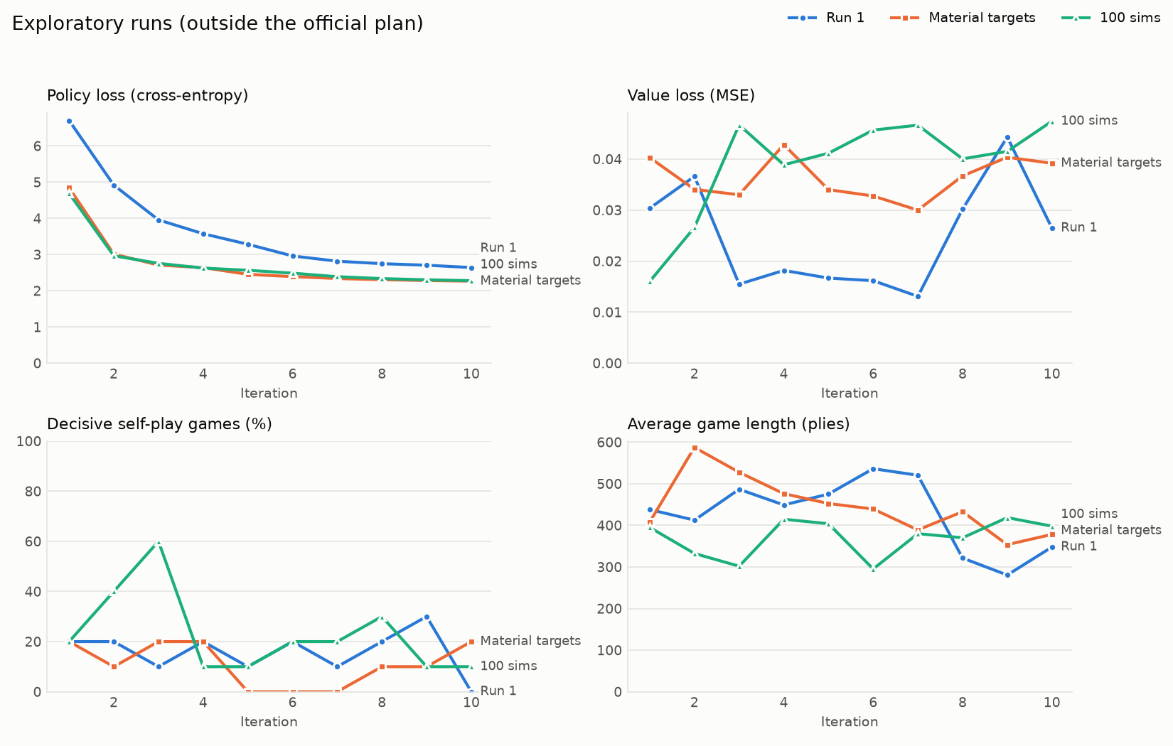
Exploratory runs: loss, decisive share and game length.

7. Discussion
The first runs. We first checked for a bug. The tests confirm the value targets have the right sign for both colors, the policy targets match the visit counts, and the encoding and actions agree for Black, so we believe the result reflected the method at that scale, not an error. Three causes stood out:
- Too little data. 400 games (about 200,000 positions) per run is tiny for this method. AlphaZero used millions of games, with far more search per move.
- The value head learns almost nothing. With about 80% of games drawn, nearly every value target is 0. In run 1, 81% of value predictions were within 0.05 of 0, and their correlation with the material balance was only +0.07. Without a useful value, 50-simulation search cannot tell losing a piece from a quiet move, so trained play is no sharper than untrained play.
- Games are long and rarely decisive. Chaturanga’s short-range pieces make checkmate hard to force. Games average 400 to 600 plies, and most end by the no-progress rule (Section 6.5), so the rare win or loss signal is spread over hundreds of quiet positions.
The human games show the same weakness from the outside: the agent gives away material steadily and cannot defend, and a beginner can win.
The exploratory runs suggested that a better value signal alone is not enough at that scale: the value head learned material, but 30 to 100 simulations with a weak policy still did not produce stronger play in 100 games.
The long run confirms the first cause. With 135 times as many games and nothing else changed in the method, the agent became clearly stronger than its starting point and than random and untrained play (Sections 6.7 and 6.9). Two lessons stand out. First, most of the gain came early, and at a fixed learning rate of 1e-3 the network then moved around one level of play; lowering the learning rate gave the clearest single improvement of the run (Section 6.8). Second, the third cause above remains: about 80% of self-play games are still drawn, so the agent has learned to keep material and not to lose, but it gets few examples of how a won position is finished, and most of its games end by the no-progress rule. Greedy capture, which trades whenever it can, is hard to beat for an agent that cannot yet force checkmate.
The limit of this setup. The last tests point the same way. Lowering the learning rate further gave only small steps (0.505 and 0.531 against the previous checkpoint), four times more search at play time gave 0.525, and penalizing draws made the agent play more decisive games against itself but lose more against the final model (Section 6.11). Pushing for decisive results without a better sense of which positions are won seems to lead to riskier, worse play. Within the constraints and our compute, the 4 x 64 network at 50 simulations appears close to its limit.
Size and what the value head knows. The larger network learned to play as well as the final model from its games, but its own games did not take it further, so network size is not what holds the agent back. The resignation measurement (Section 6.13) shows what does: the value head does not know when a position is won or lost. Decisive games come from sudden mistakes that the search punishes, not from advantages built up and converted, and the losing side does not see its loss coming. With about 85% of self-play games drawn, the value head gets too few clear results to learn from, and that is the problem every change we tried ran into.

8. Limitations and future work
- The first runs’ benchmarks use 20 games per checkpoint, so differences smaller than about 0.1 cannot be resolved there. The long run uses 100 games per benchmark, and differences smaller than about 0.03 to 0.06 still cannot.
- With most games drawn, a match score says little about how often the agent can actually win.
- The human evaluation is six games by one beginner, against final B, not the final model.
- Compute was the main limit: even with GPU self-play, one iteration of 100 games takes about 4 minutes, and the larger network about 10.
What we expect would help most, in order:
- A way for results to reach the value head more often, within the rules, for example a shorter game cap during self-play. Counting draws as slightly bad did not work (Section 6.11), and resigning needs a value head that already recognizes lost positions (Section 6.13).
- Far more self-play games with the larger network, which can start from the final model’s level (Section 6.12) but needs many more games than we could play to improve on it.

9. Conclusion
We implemented every part of an AlphaZero-style system for Chaturanga under the course constraints and verified it with 123 tests. With 400 self-play games per run the agent did not improve, and we measured why: draws starve the value head, and the data was far too small. After making self-play about 11 times faster, a run of 54,000 games with the same method produced a clearly stronger agent. The final model beats its starting point 27 wins to 0 and beats random and untrained play, losing almost no games. It still draws nearly every game against greedy capture and rarely checkmates, so learning to convert an advantage remains the open problem: neither more search at play time, counting draws as bad in training, nor a larger network solved it, and the model’s own evaluations show why: it does not yet recognize won or lost positions until the end is near. The evaluation tools (a fixed benchmark protocol, head-to-head matches, game-ending counts and human-game logging) made both the negative and the positive result measurable.

References
- Silver, D. et al. (2018). A general reinforcement learning algorithm that masters chess, shogi, and Go through self-play. Science, 362(6419), 1140-1144.
- Silver, D. et al. (2017). Mastering the game of Go without human knowledge. Nature, 550, 354-359.

Appendix A: Team roles
Role | Area
Student 1: Environment and logic | rules engine (chaturanga/), play.py
Student 2: Deep learning and pipeline | network, training loop, replay buffer
Student 3: Search and evaluation | MCTS, evaluation suite, benchmarks, plots, play_vs_ai.py

Appendix B: Reproducing the results
python -m pytest -q
OMP_NUM_THREADS=1 python -m training.train --iterations 20 --games_per_iter 20 \
--simulations 50 --avoid_repetition --temperature_moves 1000 \
--max_plies 800 --train_steps 400 \
--checkpoint_dir checkpoints/final_B --log checkpoints/final_B/log.csv
python -m evaluation.benchmark --checkpoint_dir checkpoints/final_B --opponent untrained --every 4
python -m evaluation.game_endings --checkpoint checkpoints/final_B/iter_0016.pt --opponent self --games 10
# long run (continues final B; see training/README.md for the later stretches)
OMP_NUM_THREADS=1 python -m training.train --resume checkpoints/final_B/latest.pt \
--iterations 420 --games_per_iter 100 --simulations 50 --avoid_repetition \
--temperature_moves 1000 --max_plies 800 --buffer_capacity 250000 \
--min_buffer 150000 --batch_size 256 --train_steps 500 --lr 1e-3 \
--device mps --workers 6 --seed 1 \
--checkpoint_dir checkpoints/long --log checkpoints/long/log.csv
python -m evaluation.parallel_match --a models/chaturangzero_final.pt \
--b checkpoints/final_B/latest.pt --games 100 --workers 6
python play_vs_ai.py --checkpoint models/chaturangzero_final.pt --player NAME
Every log, benchmark CSV, match log and plot is in results/, and the final model is models/chaturangzero_final.pt.

