Lab Task 1
COAL LAB
Areeba Abbas
F2024408012

Program:
.text
main:
li $v0,4
la $a0, x
syscall
li $v0,4
la $a0, y
syscall

li $v0, 10
syscall
.data
x: .asciiz "Hello World\n"
y: .asciiz "Areeba"

Step-by-step execution of the program:
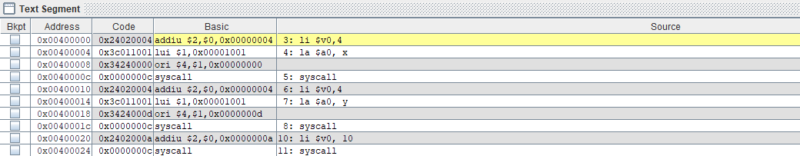

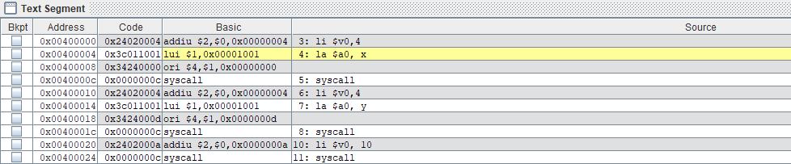

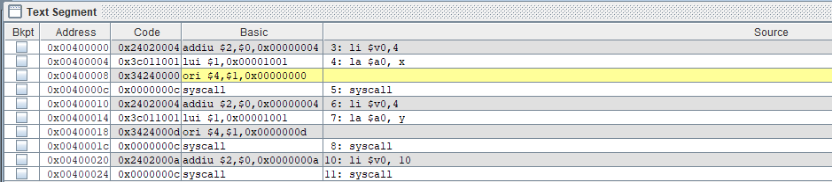

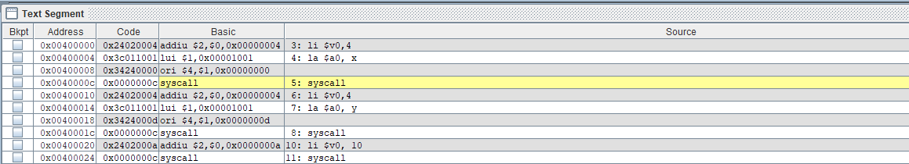

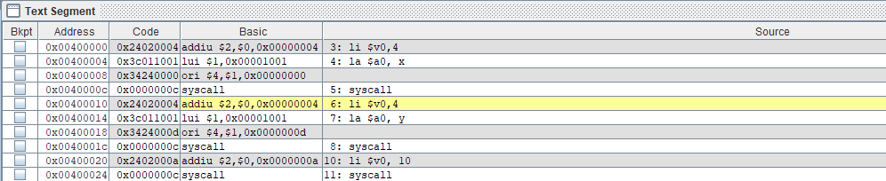

This step prints:
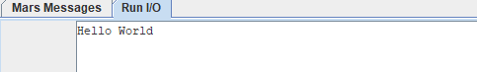

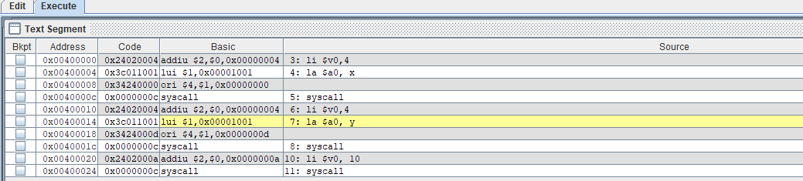

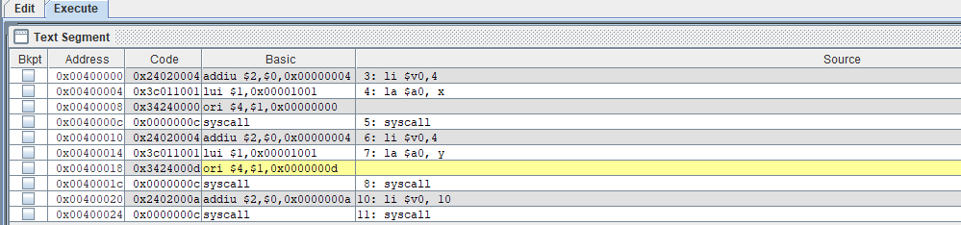

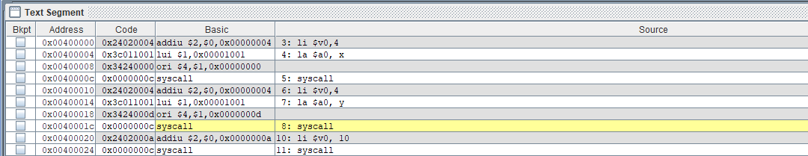

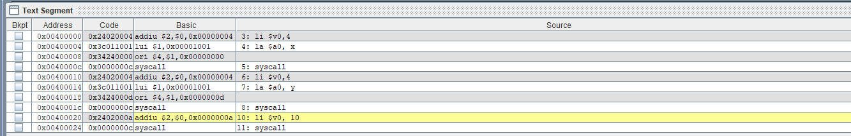

This step prints my name:
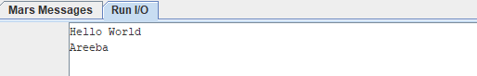

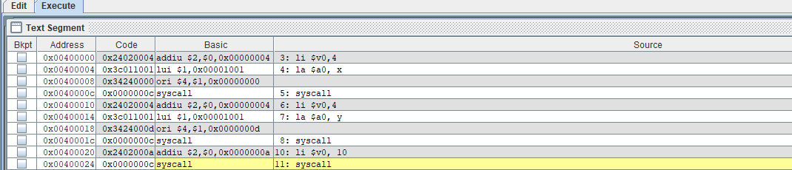

Final Output:
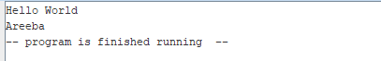
The end…

