**Question no 1:  
 Kindly see this repository link**[**https://github.com/f21-9337MaryamTariq/Web-assignment**](https://github.com/f21-9337MaryamTariq/Web-assignment) **Here is branch link for assignment 1:**[**https://github.com/f21-9337MaryamTariq/Web-assignment/tree/f21-9337_web_Assignment-01**](https://github.com/f21-9337MaryamTariq/Web-assignment/tree/f21-9337_web_Assignment-01)

**Here is branch link for class tasks:**[**https://github.com/f21-9337MaryamTariq/Web-assignment/tree/ClassActivities**](https://github.com/f21-9337MaryamTariq/Web-assignment/tree/ClassActivities)

You can move to these link by ctrl + click to follow link.

**Question no 2:**<!DOCTYPE html>

<html>

<head>

<title>Sign In / Sign Out</title>

<style>

/* Styles remain the same */

</style>

</head>

<body>

<div class="container">

<h4>Welcome TO OUR SITE</h4>

<!-- 1. Identify required fields. -->

<form id="signInForm" onsubmit="return signIn()">

Username: <input type="text" id="username" required><br>

Password: <input type="password" id="password" required><br>

Birthdate: <input type="date" id="birthdate" required><br> <!-- Date input field -->

<input type="submit" value="Sign In">

</form>

<h4 id="signInMessage" style="display: none;">THANKS FOR SIGNING IN </h4>

<form id="signOutForm" onsubmit="return signOut()">

<input type="submit" value="Sign Out">

</form>

</div>

<script>

function signIn() {

var username = document.getElementById("username").value;

var password = document.getElementById("password").value;

var birthdate = document.getElementById("birthdate").value;

if (username.trim() === "") {

alert("Please enter your username.");

return false;

}

if (password.trim() === "") {

alert("Please enter your password.");

return false;

}

if (birthdate.trim() === "") {

alert("Please enter your birthdate.");

return false;

}

// Validate input data length

if (username.length < 5) {

alert("Username must be at least 5 characters long.");

return false;

}

if (password.length < 8) {

alert("Password must be at least 8 characters long.");

return false;

}

// Validate date input

var today = new Date();

var inputDate = new Date(birthdate);

if (inputDate >= today) {

alert("Please enter a valid birthdate.");

return false;

}

// Use pattern matching with regular expressions

if (!/^[a-zA-Z0-9]+$/.test(username)) {

alert("Username can only contain letters and numbers.");

return false;

}

if (!/^[a-zA-Z0-9]+$/.test(password)) {

alert("Password can only contain letters and numbers.");

return false;

}

// Provide clear error messages (already done)

// Thoroughly test validation process

console.log("Username:", username);

console.log("Password:", password);

console.log("Birthdate:", birthdate);

console.log("Validation passed.");

document.getElementById("signInMessage").style.display = "block"; // Show the message

return false; // Prevent form submission

}

</script>

</body>

</html>

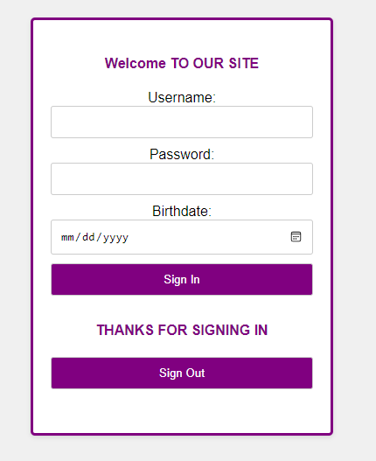

**Question no 3:  
index:  
<!DOCTYPE html>**

**<html lang="en">**

**<head>**

**<meta charset="UTF-8">**

**<meta name="viewport" content="width=device-width, initial-scale=1.0">**

**<title>Welcome</title>**

**<link href="https://cdn.jsdelivr.net/npm/bootstrap@5.4.3/dist/css/bootstrap.min.css" rel="stylesheet">**

**<style>**

**body {**

**margin: 0;**

**padding: 0;**

**background-color: #ffe4b2;**

**display: flex;**

**justify-content: flex-start;**

**align-items: flex-start;**

**min-height: 100vh;**

**}**

**.container-fluid {**

**margin-top: 50px;**

**margin-left: 50px;**

**}**

**.welcome-heading {**

**background-color: purple;**

**color: white;**

**padding: 40px;**

**border-radius: 5px;**

**margin-bottom: 20px;**

**}**

**.purple-button {**

**background-color: blue;**

**color: white;**

**border: none;**

**padding: 15px 30px;**

**border-radius: 5px;**

**text-decoration: none;**

**width: 100%;**

**max-width: 800px;**

**display: inline-block;**

**margin-top: 20px;**

**}**

**.purple-button:hover {**

**background-color: #0056b3;**

**}**

**.card-container {**

**background-color: #d8baf9;**

**padding: 20px;**

**border-radius: 5px;**

**margin-top: 20px;**

**}**

**.card {**

**margin-bottom: 20px;**

**}**

**</style>**

**</head>**

**<body>**

**<div class="container-fluid">**

**<h1 class="welcome-heading">Welcome to our website</h1>**

**<a href="description.html" class="btn btn-primary purple-button">Learn More</a>**

**<div class="card-container">**

**<div class="row">**

**<div class="col-md-4">**

**<div class="card">**

**<h5 class="card-title">Tulip</h5>**

**<img src="tulip.jpg" class="card-img-top" alt="Tulip Image">**

**<div class="card-body">**

**Tulips are known for their vibrant colors and simple beauty. They are often associated with spring and symbolize perfect love.**

**</div>**

**</div>**

**</div>**

**<div class="col-md-4">**

**<div class="card">**

**<h5 class="card-title">Rose</h5>**

**<img src="rose.jpg" class="card-img-top" alt="Rose Image">**

**<div class="card-body">**

**Roses are one of the most popular and recognizable flowers. They symbolize love, beauty, and romance.**

**</div>**

**</div>**

**</div>**

**<div class="col-md-4">**

**<div class="card">**

**<h5 class="card-title">Jasmine</h5>**

**<img src="jasmine.jpg" class="card-img-top" alt="Jasmine Image">**

**<div class="card-body">**

**Jasmine flowers are known for their sweet fragrance. They are often used in perfumes and teas.**

**</div>**

**</div>**

**</div>**

**</div>**

**</div>**

**</div>**

**<script src="https://cdn.jsdelivr.net/npm/bootstrap@5.4.3/dist/js/bootstrap.bundle.min.js"></script>**

**</body>**

**</html>  
decription:  
<!DOCTYPE html>**

**<html lang="en">**

**<head>**

**<meta charset="UTF-8">**

**<meta name="viewport" content="width=device-width, initial-scale=1.0">**

**<title>Description</title>**

**<link href="https://cdn.jsdelivr.net/npm/bootstrap@5.4.3/dist/css/bootstrap.min.css" rel="stylesheet">**

**<style>**

**body {**

**margin: 0;**

**padding: 0;**

**}**

**.container {**

**max-width: 800px;**

**margin: 50px auto;**

**padding: 20px;**

**}**

**</style>**

**</head>**

**<body>**

**<div class="container">**

**<h2>Description of our website</h2>**

**<p>webpage</p>**

**</div>**

**<script src="https://cdn.jsdelivr.net/npm/bootstrap@5.4.3/dist/js/bootstrap.bundle.min.js"></script>**

**</body>**

**</html>**