**WEB PROGRAMING**

LAB NO 1

TASK NO 1:

CODE:

<!DOCTYPE HTML>

<HMTL lang="en">

<head>

<meta charset="UTF-8">

<meta name="viewport" content="width=device-width, initial-scale=1.0">

<title> My First WebPage </title>

</head>

<body>

<h1> Hi Everyone</h1>

<h6> NAME : MARYAM TARIQ. </h6>

<h6> ROLLNO : 21F-9337. </h6>

<hr>

<p> I am 20 years old and studying in FAST NUCES, doing BSCS.

my hobbies is to spend time with family and cooking,

however, I am expert at assignment writting and started freelauncing in it.</p>

</BODY>

</html>

OUTPUT:

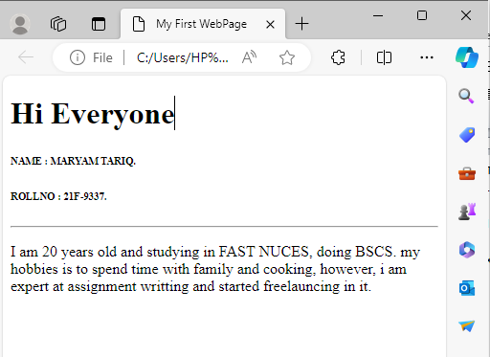

TASK NO 2:

CODE:

<!DOCTYPE HTML>

<HMTL lang="en">

<head>

<meta charset="UTF-8">

<meta name="viewport" content="width=device-width, initial-scale=1.0">

<title> FORMATING PAGE </title>

</head>

<body>

<p>

<br>

<b> This text is bold.</b>

<br>

<strong> This text is strong. </strong>

<br>

<i> This text is italic..</i>

<br>

<big> this text is big</big>

<br>

<em> This text is emphasized.</em>

<br>

<output> this text is computer output. </output>

<br>

<p> This text is <sub> subscript </sub> and <sup>superscript. </sup> </p>

<br>

</p>

</BODY>

</html>

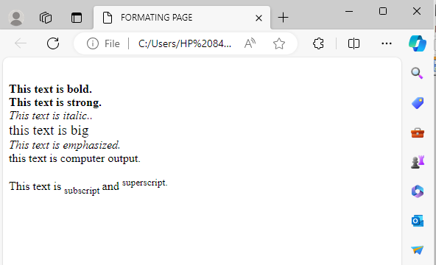

TASK NO 3:

CODE:

<!DOCTYPE HTML>

<HMTL lang="en">

<head>

<meta charset="UTF-8">

<meta name="viewport" content="width=device-width, initial-scale=1.0">

<title> IMAGE </title>

</head>

<body>

<h1> FAST NUCES </h1>

<img src= "logo.png" alt="NATIONAL USIVERSITY OF COMPUTER & EMERGING SCIENCES" width="500px" height="500px" >

</BODY>

</html>



TASK NO 4:

CODE:

<!DOCTYPE HTML>

<HMTL lang="en">

<head>

<meta charset="UTF-8">

<meta name="viewport" content="width=device-width, initial-scale=1.0">

<title> IMAGE </title>

</head>

<body>

<h1> FAST NUCES </h1>

<br>

<p>

<a href="https://www.nu.edu.pk"> FAST-NU

<img src= "logo.png" alt="NATIONAL USIVERSITY OF COMPUTER & EMERGING SCIENCES">

</a>

</p>

</BODY>

</html>

