**WEB-PROGRAMMING**

**LAB TASKS**

**TASK 1 :  
CODE:**  
<!DOCTYPE html>

<html lang="en">

<head>

<meta charset="UTF-8">

<meta name="viewport" content="width=device-width, initial-scale=1.0">

<title>CSS</title>

<style>

body {

background-color: black;

color: white;

font-family: Arial, Calibri;

padding-left: 20px;

}

h1 {

font-size: 24px;

text-align: left;

}

p {

font-size: 16px;

line-height: 1.5;

}

.button {

display: inline-block;

width: 200px;

height: 50px;

background-color: green;

color: white;

text-align: center;

line-height: 50px;

margin-left: 1px;

}

</style>

</head>

<body>

<h1>Start CSS Exercises</h1>

<p>Good Luck!</p>

<div class="button">Start CSS Exercises></div>

</body>

</html>

**OUTPUT:**  
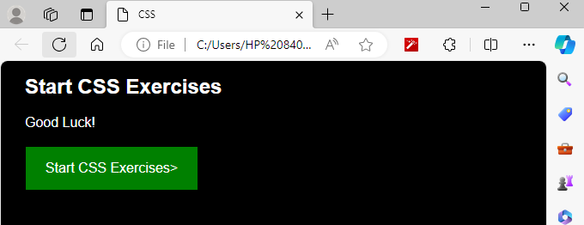

**TASK 2 :**

**CODE:**

<!DOCTYPE html>

<html lang="en">

<head>

<meta charset="UTF-8">

<meta name="viewport" content="width=device-width, initial-scale=1.0">

<title>Form page</title>

<style>

body {

background-color: blue;

font-family: Arial, Calibri;

text-align: center;

}

.container {

margin-top: 5px;

}

input[type="text"],

input[type="submit"] {

width: 400px;

height: 30px;

margin: 8px;

padding: 5px;

border: 1px solid #ccc;

border-radius: 1px;

box-sizing: border-box;

}

input[type="submit"] {

background-color: red;

color: white;

cursor: pointer;

}

</style>

</head>

<body>

<div class="container">

<form>

<input type="text" placeholder="Name">

<br>

<input type="text" placeholder="Username">

<br>

<input type="text" placeholder="Password">

<br>

<input type="text" placeholder="Phone Number">

<br>

<input type="text" placeholder="E-mail">

<br>

<input type="submit" value="REGISTER">

</form>

</div>

</body>

</html>

**OUTPUT:**

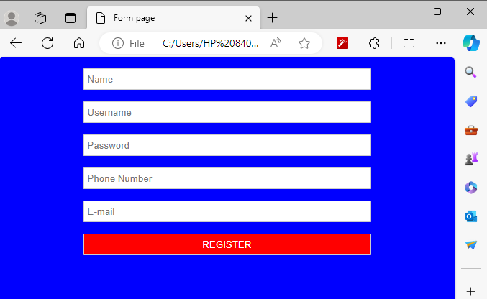

**TASK NO 3:**

**CODE:**

<!DOCTYPE html>

<html lang="en">

<head>

<meta charset="UTF-8">

<meta name="viewport" content="width=device-width, initial-scale=1.0">

<title>Card Example</title>

<style>

body {

background-color: white;

margin: 0;

padding: 0;

font-family: Arial, sans-serif;

}

.card {

width: 300px;

padding: 20px;

border-radius: 10px;

box-shadow: 0 4px 8px rgba(0, 0, 0, 0.1);

background-color: #fff;

margin: 20px;

float: left;

}

.card h2 {

font-size: 24px;

margin-bottom: 10px;

}

.card p {

font-size: 16px;

color: #666;

text-align: center;

}

.card img {

max-width: 100%;

border-radius: 10px;

margin-bottom: 10px;

}

</style>

</head>

<body>

<div class="card">

<img src="image.jpg" >

<p>Nature View</p>

</div>

</body>

</html>

**OUTPUT:**

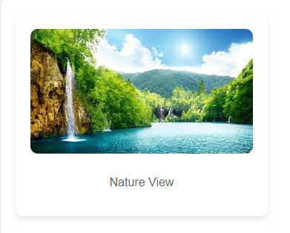

**TASK 4:**

**CODE:**

<!DOCTYPE html>

<html lang="en">

<head>

<meta charset="UTF-8">

<meta name="viewport" content="width=device-width, initial-scale=1.0">

<title>Card Example</title>

<style>

body {

background-color: white;

margin: 0;

padding: 0;

font-family: Arial, sans-serif;

}

.card {

width: 300px;

padding: 20px;

border-radius: 10px;

box-shadow: 0 4px 8px rgba(0, 0, 0, 0.1);

background-color: #fff;

margin: 20px;

float: left;

animation: slideFromLeft 1s ease-out forwards;

opacity: 0;

}

@keyframes slideFromLeft {

from {

transform: translateX(-100%);

opacity: 0;

}

to {

transform: translateX(0);

opacity: 1;

}

}

.card h2 {

font-size: 24px;

margin-bottom: 10px;

}

.card p {

font-size: 16px;

color: #666;

text-align: center;

}

.card img {

max-width: 100%;

border-radius: 10px;

margin-bottom: 10px;

}

</style>

</head>

<body>

<div class="card">

<img src="image.jpg" >

<p>Nature View</p>

</div>

</body>

</html>

**OUTPUT:**  
