**WEB PROGRAMMING**

**Task 1:**  
<!DOCTYPE html>

<html lang="en">

<head>

<meta charset="UTF-8">

<meta name="viewport" content="width=device-width, initial-scale=1.0">

<title>Bootstrap Example</title>

<link href="https://cdn.jsdelivr.net/npm/bootstrap@5.3.0/dist/css/bootstrap.min.css" rel="stylesheet">

</head>

<body>

<div class="container">

<div class="row">

<div class="col"><a href="https://www.w3schools.com/bootstrap/bootstrap_ver.asp" target="_blank" style="display: block; background-color: #9ACD32; padding: 10px;">bootstrap 1</a></div>

</div>

<div class="row">

<div class="col"><a href="https://www.w3schools.com/bootstrap/bootstrap_ver.asp" target="_blank" style="display: block; background-color: #87CEEB; padding: 10px;">bootstrap 2</a></div>

</div>

<div class="row">

<div class="col"><a href="https://www.w3schools.com/bootstrap/bootstrap_ver.asp" target="_blank" style="display: block; background-color: #FFE4C4; padding: 10px;">bootstrap 3</a></div>

</div>

<div class="row">

<div class="col"><a href="https://www.w3schools.com/bootstrap/bootstrap_ver.asp" target="_blank" style="display: block; background-color: #FFE4C4; padding: 10px;">bootstrap 4</a></div>

</div>

<div class="row">

<div class="col"><a href="https://www.w3schools.com/bootstrap/bootstrap_ver.asp" target="_blank" style="display: block; background-color: #FFE4C4; padding: 10px;">bootstrap 5</a></div>

</div>

<div class="row">

<div class="col"><a href="https://www.w3schools.com/bootstrap/bootstrap_ver.asp" target="_blank" style="display: block; background-color: #FFC0CB; padding: 10px;">bootstrap 6</a></div>

</div>

</div>

<script src="https://cdn.jsdelivr.net/npm/bootstrap@5.3.0/dist/js/bootstrap.bundle.min.js"></script>

</body>

</html>

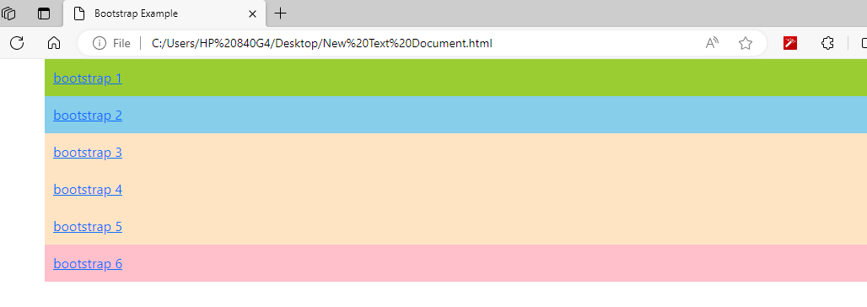

**TASK 2:**

<!DOCTYPE html>

<html lang="en">

<head>

<meta charset="UTF-8">

<meta name="viewport" content="width=device-width, initial-scale=1.0">

<title>Lab Task 2</title>

<link href="https://cdn.jsdelivr.net/npm/bootstrap@5.3.0/dist/css/bootstrap.min.css" rel="stylesheet">

<style>

.message {

margin-top: 20px;

}

</style>

</head>

<body>

<div class="container">

<button class="btn btn-light" id="basic">Basic</button>

<button class="btn btn-light border border-dark rounded-1" id="default">Default</button>

<button class="btn btn-primary" id="primary">Primary</button>

<button class="btn btn-success" id="success">Success</button>

<button class="btn btn-info" id="info">Info</button>

<button class="btn btn-warning" id="warning">Warning</button>

<button class="btn btn-danger" id="danger">Danger</button>

<button class="btn btn-link" id="link">Link</button>

<div class="message" id="message"></div>

</div>

<script>

document.getElementById("basic").addEventListener("click", function() {

document.getElementById("message").innerHTML = "Basic button clicked";

});

document.getElementById("default").addEventListener("click", function() {

document.getElementById("message").innerHTML = "Default button clicked";

});

document.getElementById("primary").addEventListener("click", function() {

document.getElementById("message").innerHTML = "Primary button clicked";

});

document.getElementById("success").addEventListener("click", function() {

document.getElementById("message").innerHTML = "Success button clicked";

});

document.getElementById("info").addEventListener("click", function() {

document.getElementById("message").innerHTML = "Info button clicked";

});

document.getElementById("warning").addEventListener("click", function() {

document.getElementById("message").innerHTML = "Warning button clicked";

});

document.getElementById("danger").addEventListener("click", function() {

document.getElementById("message").innerHTML = "Danger button clicked";

});

document.getElementById("link").addEventListener("click", function() {

document.getElementById("message").innerHTML = "Link button clicked";

});

</script>

</body>

</html>

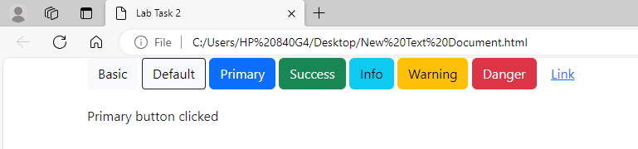

**Task 3:**

<!DOCTYPE html>

<html lang="en">

<head>

<meta charset="UTF-8">

<meta name="viewport" content="width=device-width, initial-scale=1.0">

<title>Lab Task 3</title>

<link href="https://cdn.jsdelivr.net/npm/bootstrap@5.3.0/dist/css/bootstrap.min.css" rel="stylesheet">

<style>

.btn-violet {

background-color: violet;

color: white;

}

.btn-black {

background-color: black !important;

color: white !important;

}

/* Remove the dropdown type arrows for input numbers */

input[type="number"]::-webkit-inner-spin-button,

input[type="number"]::-webkit-outer-spin-button {

-webkit-appearance: none;

margin: 0;

}

</style>

</head>

<body>

<div class="container">

<div class="row">

<div class="col-auto">

<label for="num1">Number 1:</label>

<input type="number" id="num1" name="num1" class="form-control">

</div>

<div class="col-auto">

<label for="num2">Number 2:</label>

<input type="number" id="num2" name="num2" class="form-control">

</div>

</div>

<div class="row mt-3">

<div class="col-auto">

<button type="button" class="btn btn-violet" onclick="add(this)">Add</button>

<button type="button" class="btn btn-violet" onclick="subtract(this)">Subtract</button>

<button type="button" class="btn btn-violet" onclick="multiply(this)">Multiply</button>

<button type="button" class="btn btn-violet" onclick="divide(this)">Divide</button>

<button type="button" class="btn btn-primary" onclick="clearButtons()">Clear</button>

</div>

</div>

<div class="row mt-3">

<div class="col-auto">

<label for="result">Result:</label>

<input type="text" id="result" name="result" class="form-control" readonly>

</div>

</div>

</div>

<script>

function add(button) {

toggleButtonColor(button);

var num1 = parseFloat(document.getElementById('num1').value);

var num2 = parseFloat(document.getElementById('num2').value);

document.getElementById('result').value = num1 + num2;

}

function subtract(button) {

toggleButtonColor(button);

var num1 = parseFloat(document.getElementById('num1').value);

var num2 = parseFloat(document.getElementById('num2').value);

document.getElementById('result').value = num1 - num2;

}

function multiply(button) {

toggleButtonColor(button);

var num1 = parseFloat(document.getElementById('num1').value);

var num2 = parseFloat(document.getElementById('num2').value);

document.getElementById('result').value = num1 * num2;

}

function divide(button) {

toggleButtonColor(button);

var num1 = parseFloat(document.getElementById('num1').value);

var num2 = parseFloat(document.getElementById('num2').value);

if (num2 !== 0) {

document.getElementById('result').value = num1 / num2;

} else {

document.getElementById('result').value = 'Cannot divide by zero';

}

}

function clearButtons() {

var buttons = document.querySelectorAll('.btn-black');

buttons.forEach(function(button) {

button.classList.remove('btn-black');

});

}

function toggleButtonColor(button) {

clearButtons();

button.classList.add('btn-black');

}

</script>

</body>

</html>

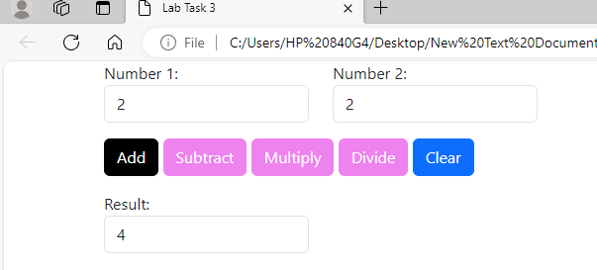

**Task 4:**

<!DOCTYPE html>

<html lang="en">

<head>

<meta charset="UTF-8">

<meta name="viewport" content="width=device-width, initial-scale=1.0">

<title>Lab Task 4</title>

</head>

<body>

<script>

// Function to get the total number of days in a month

function getDaysInMonth(month) {

const months = {

"Jan": 31, "Feb": 28, "Mar": 31, "Apr": 30, "May": 31, "Jun": 30,

"Jul": 31, "Aug": 31, "Sep": 30, "Oct": 31, "Nov": 30, "Dec": 31

};

return months[month];

}

// Function to ask user for the month name and display the total days

function askMonth() {

var month = prompt("Enter the name of the month (e.g., Jan, Feb):");

var days = getDaysInMonth(month);

if (days) {

document.write("<h4 style='color: black;'>Total number of days in " + month + ": " + days + "</h4>");

} else {

document.write("<p style='color: red;'>Invalid month name</p>");

}

}

// Call the function to ask for the month

askMonth();

</script>

</body>

</html>

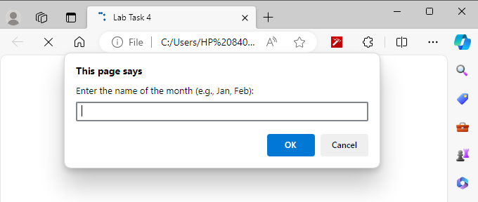

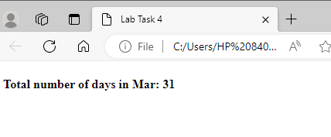

**Task 5:**

<!DOCTYPE html>

<html lang="en">

<head>

<meta charset="UTF-8">

<meta name="viewport" content="width=device-width, initial-scale=1.0">

<title>Lab Task 5</title>

</head>

<body>

<script>

function printTable() {

var number = prompt("Enter a number:");

number = parseInt(number);

if (!isNaN(number)) {

document.write("<h4>Table of " + number + ":</h4>");

for (var i = 1; i <= 10; i++) {

document.write("<p>" + number + " x " + i + " = " + (number * i) + "</p>");

}

} else {

document.write("<p style='color: red;'>Invalid number</p>");

}

}

printTable();

</script>

</body>

</html>

