**TASK_01**

**CODE:**

<!DOCTYPE html>

<html lang="en">

<head>

  <meta charset="UTF-8">

  <meta name="viewport" content="width=device-width, initial-scale=1.0">

<html>

<head>

    <title>HTML CSS JavaScript Comment Example</title>

    <style>

        /* CSS Comment */

        /*We use this to change the background*/

        body {

            font-family: Arial, sans-serif;

            background-color: #f0f0f0;

        }

        /* CSS Comment */

        /*We use this to style the container class*/

        .container {

            padding: 20px;

            background-color: #fff;

            border-radius: 5px;

            box-shadow: 0 0 10px rgba(0, 0, 0, 0.1);

        }

    </style>

</head>

<body>

    <div class="container">

        <h1>HTML CSS JavaScript Comment Example</h1>

        <p>This is a paragraph.</p>

        <!-- <p> HTML </p> HTML Comment -->

        <button onclick="displayMessage()">Submit</button>

    </div>

    <script>

        // JavaScript Comment

        //We use this function for showing name after submit button

        function displayMessage() {

            alert('My name is Ali Imtiaz.!');

        }

    </script>

</body>

</html>

**Explanation:**

**The comments enhance the readability code. By giving the comments other user of the code will understand what the need of the function.**

**HTML COMMENT METHOD:**

The HTML COMMENT are enclosed in

<!--  -->

**CSS COMMENT METHOD:**

The CSS COMMENT are enclosed in

/*  */

**JAVASCRIPT COMMENT METHOD:**

The JAVASCRIPT COMMENT are in

//

**TASK_02**

**jQuery Download Method:**

**CODE:**

<!DOCTYPE html>

<html lang="en">

<head>

<meta charset="UTF-8">

<meta name="viewport" content="width=device-width, initial-scale=1.0">

<title>jQuery Download Method</title>

<script src="node_modules/jquery/dist/jquery.min.js"></script>

<script>

$(document).ready(function(){

    alert("Welcome to jQuery");

});

</script>

</head>

<body>

</body>

</html>

**OUTPUT:**

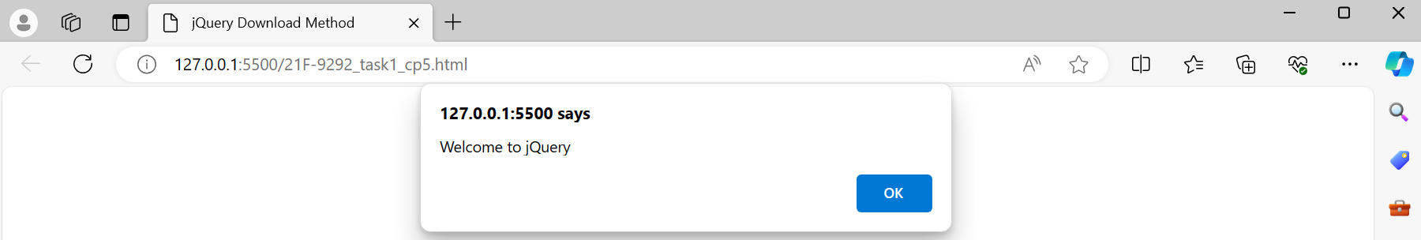

**CDN Method:**

**CODE:**

<!DOCTYPE html>

<html lang="en">

<head>

<meta charset="UTF-8">

<meta name="viewport" content="width=device-width, initial-scale=1.0">

<title>jQuery CDM Method</title>

<script src="https://code.jquery.com/jquery-3.6.0.min.js"></script>

<script>

$(document).ready(function(){

    alert("Welcome to jQuery");

});

</script>

</head>

<body>

</body>

</html>

**OUTPUT:**



**TASK_03**

**CODE:**

**HTML FILE:**

<!DOCTYPE html>

<html lang="en">

<head>

    <meta charset="UTF-8">

    <meta name="viewport" content="width=device-width, initial-scale=1.0">

    <title>Task_3</title>

    <link rel="stylesheet" href="styles.css">

</head>

<body>

   <div id="p1"></div>

   <input id="i2" type="text" placeholder="Enter image URL">

   <button id="i1">Show</button>

</body>

<script src="https://ajax.googleapis.com/ajax/libs/jquery/3.7.1/jquery.min.js"></script>

<script src="21F-9292_task1_cp5.js"></script>

</html>

**CSS FILE:**

html, body {

    margin: 0;

    padding: 0;

    width: 100%;

    height: 100%;

}

#p1 img {

    position: fixed;

    top: 0;

    left: 0;

    width: 100%;

    height: 100%;

    object-fit: cover;

}

**JAVASCRIPT FILE:**

$(document).ready(() => {

    $("button").click(function(){

        if($(this).text() === "Show") {

            var imageUrl = $("#i2").val();

            if (imageUrl) {

                $("#p1").html(`<img src=${imageUrl} alt="Uploaded Image"/>`);

                $(this).text("Hide");

            } else {

                alert("Please enter a valid image URL.");

            }

        } else {

            $("#p1").empty();

            $(this).text("Show");

        }

    });

});

**OUTPUT:**

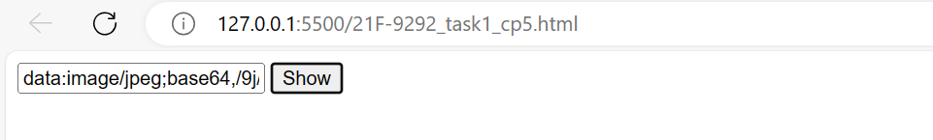

**TASK_04**

**CODE:**

**HTML FILE:**

<!DOCTYPE html>

<html lang="en">

<head>

    <meta charset="UTF-8">

    <meta name="viewport" content="width=device-width, initial-scale=1.0">

    <title>TASK_4</title>

    <link rel="stylesheet" href="index.css">

</head>

<body>

    <table id="myTable" border="2">

        <tr>

            <td>Name</td>

            <td>Roll NO</td>

            <td>Section</td>

            <td><button class="remove-row">Remove</button></td>

        </tr>

        <tr>

            <td>Ali</td>

            <td>21F-9292</td>

            <td>6E</td>

            <td><button class="remove-row">Remove</button></td>

        </tr>

    </table>

    <script src="https://ajax.googleapis.com/ajax/libs/jquery/3.7.1/jquery.min.js"></script>

    <script src="21F-9292_task1_cp5.js"></script>

</body>

</html>

**JAVASCRIPT FILE:**

$(document).ready(() => {

    $(".remove-row").click(function () {

        $(this).closest('tr').remove();

    });

});

**OUTPUT:**

**Before removing:**

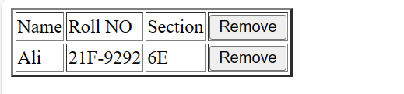

**After removing:**

**TASK_05**

**CODE:**

**HTML File:**

<!DOCTYPE html>

<html lang="en">

<head>

    <meta charset="UTF-8">

    <meta name="viewport" content="width=device-width, initial-scale=1.0">

    <title>Document</title>

</head>

<body>

   <div class="C1" id="92"> Ramadan Mubarak </div>

</body>

<script src="https://ajax.googleapis.com/ajax/libs/jquery/3.7.1/jquery.min.js"></script>

<script src="21F-9292_task1_cp5.js"></script>

</html>

**JavaScript File:**

$(document).ready(()=>{

    $("div").click(function(){

        alert(`Class Name : ${$(this).attr("class")} , ID Name: ${$(this).attr("id")}`)

    });

})

**OUTPUT:**

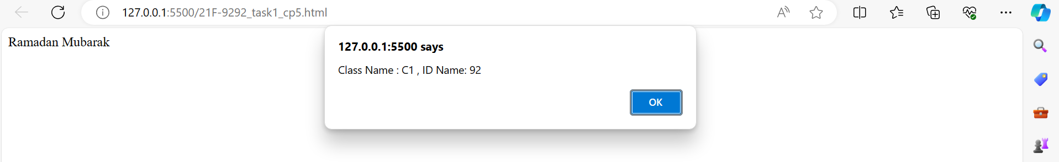

**TASK_06**

**CODE:**

**HTML File:**

<!DOCTYPE html>

<html lang="en">

<head>

    <meta charset="UTF-8">

    <meta name="viewport" content="width=device-width, initial-scale=1.0">

    <title>Document</title>

    <link rel="stylesheet" href="21F-9292_task1_cp5.css">

</head>

<body>

    <p id="myText">jQuery Exercises, Practice, Solution</p>

    <div></div>

</body>

<script src="https://ajax.googleapis.com/ajax/libs/jquery/3.7.1/jquery.min.js"></script>

<script src="21F-9292_task1_cp5.js"></script>

</html>

**CSS File:**

p {

    padding-top: 50px;

    padding-right: 30px;

    padding-bottom: 50px;

    padding-left: 80px;

    }

**JavaScript File:**

$(document).ready(() => {

    $("p").click(function() {

        let width = $(this).width();

        let paddingLeft = parseInt($(this).css("padding-left"));

        let paddingRight = parseInt($(this).css("padding-right"));

        let borderLeft = parseInt($(this).css("border-left-width"));

        let borderRight = parseInt($(this).css("border-right-width"));

        $("div").append(`<h1>Width: ${width}px</h1>`);

        $("div").append(`<h1>Padding Left: ${paddingLeft}px</h1>`);

        $("div").append(`<h1>Padding Right: ${paddingRight}px</h1>`);

        $("div").append(`<h1>Border Left: ${borderLeft}px</h1>`);

        $("div").append(`<h1>Border Right: ${borderRight}px</h1>`);

        let totalWidth = width + paddingLeft + paddingRight + borderLeft + borderRight;

        $("div").append(`<h1>Total Width (Width + Padding + Border): ${totalWidth}px</h1>`);

    });

});

**OUTPUT:**

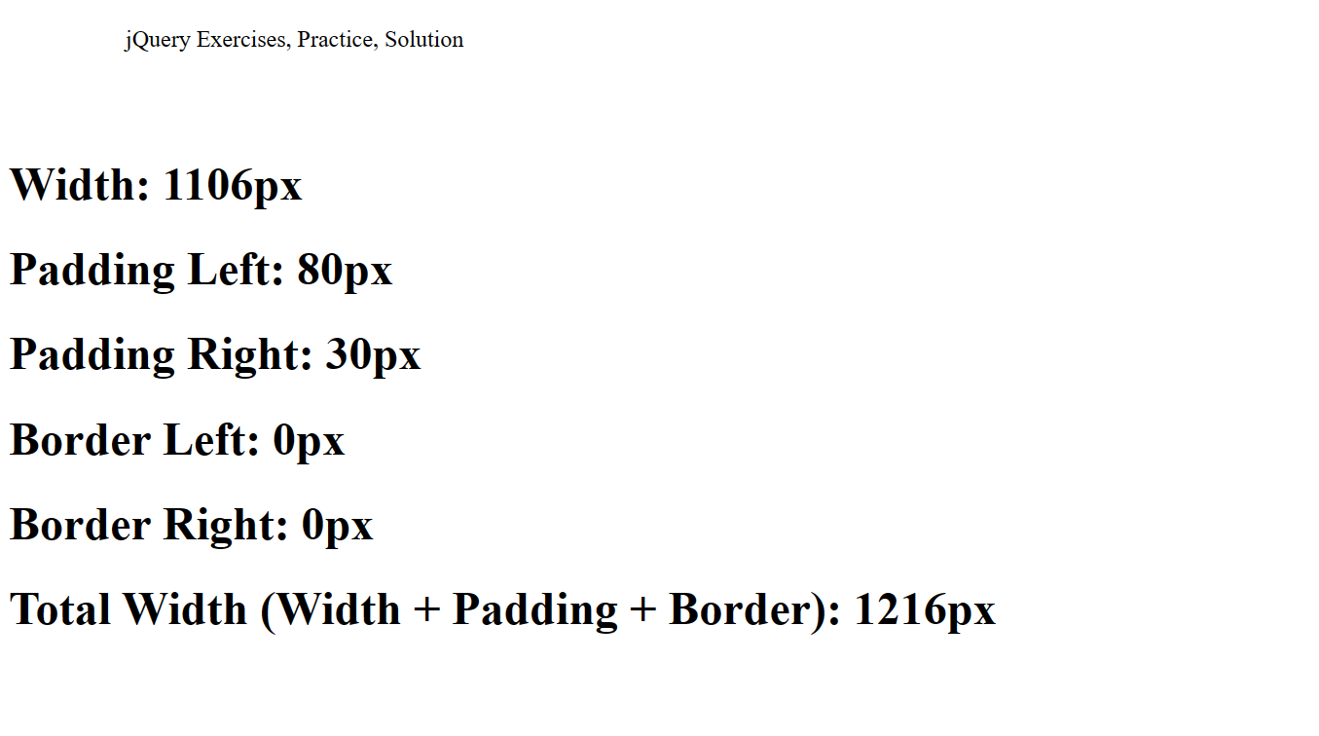

**TASK_07**

**CODE:**

**HTML File:**

<!DOCTYPE html>

<html lang="en">

<head>

    <meta charset="UTF-8">

    <meta name="viewport" content="width=device-width, initial-scale=1.0">

    <title>Document</title>

    <link rel="stylesheet" href="index.css">

</head>

<body>

    <div id="selected">

        <p>Red</p>

        <p>White</p>

        <p>Green</p>

        <p>Black</p>

        <p>Blue</p>

        <p>Orange</p>

        </div>

</body>

<script src="https://ajax.googleapis.com/ajax/libs/jquery/3.7.1/jquery.min.js"></script>

<script src="21F-9292_task1_cp5.js"></script>

</html>

**JavaScript File:**

$(document).ready(

    ()=>{

        alert($("p").length)

    }

)

**OUTPUT:**

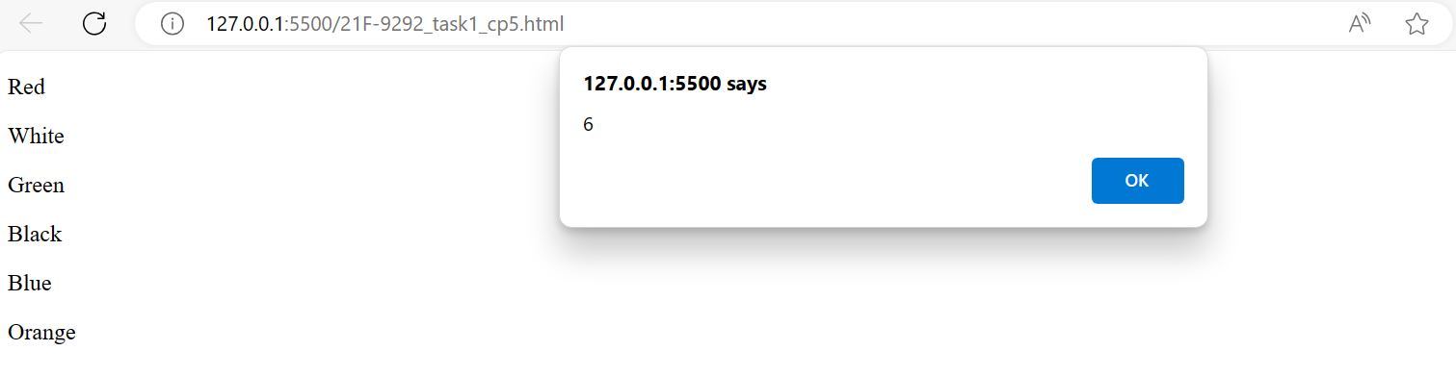

**TASK_08**

**CODE:**

**HTML File:**

<!DOCTYPE html>

<html lang="en">

<head>

    <meta charset="UTF-8">

    <meta name="viewport" content="width=device-width, initial-scale=1.0">

    <title>Task_8</title>

    <link rel="stylesheet" href="21F-9292_task1_cp5.css">

</head>

<body>

    <div id="d1"></div>

    <script src="https://ajax.googleapis.com/ajax/libs/jquery/3.7.1/jquery.min.js"></script>

    <script src="21F-9292_task1_cp5.js"></script>

</body>

</html>

**CSS File:**

#d1 {

    background-color: blueviolet;

    width: 100px;

    height: 100px;

    position: absolute;

}

**JavaScript File:**

$(document).ready(function () {

    $("#d1").animate({ left: "80%" }, 8000);

});

**OUTPUT:**

