**CSIS 4050 Project Proposal**

Group Members: **Yu-Hsiu Chang, Iana Vorobeva, Tung-Yu Chen**

Group Name: 200OK

**Introduction**

The main purpose of our project is to create a desktop application for a movie library. This app contains ability such as:

* Store data about movies(i.e., Title, Release Date, Genre, Director, Reviews) in a relational local database
* Basic CRUD of movie
* Search by keyword
* Filter search results by the director and gerne
* Account system makes users be able to save their favorite movies
* Display “Favorites” in a separated window only for the logged in users
* Show the details of movie by double click the list
* Logged in users can review the films and save it to the database

**WBS**

|  |  |  |
| --- | --- | --- |
| Team Member | Business Object | Additional Features |
| Tung-Yu | Movie | Display the list of movies, support search, and update the list with accordance with search query |
| User | Sign Up/ Log In system with Encryption |
| Iana | Director | Filter the movies by Genre |
| Genre | Filter the movies by Director |
| Yu-Hsiu | Details | Display the details after double click |
| Reviews | Allow users to write reviews and save them to the database |
| Favorites | Allow user to save the favored movies and display them in a separate  tab/window |

**Meeting Minutes**

**Meeting 1 (March 20) - 15 minutes:**

* Attendance (who is present for your meeting): Tung-Yu, Yu-Hsiu, Iana
* Who’s working on what:   
  Everybody together thought about the project ideas.   
  Tung-Yu’s Idea:  POS (buy groceries/ or other)  
  Yu-Hsiu’s Idea:  ToDo list, Users access their toDo lists. Database with ToDo lists of different Users. Tasks can be stored in different tables. Or calories calculator (in database some pre ready products with their calories)  
  Iana’s Idea: Film Library (like IMDB) https://blog.udemy.com/c-sharp-projects/#filmlibrary
* What have you done since the last time we met? – First meeting
* What are you having trouble with?

Settling on a one idea.

**Meeting 2 (March 21) – 30 minutes:**

* Attendance:  Yu-Hsiu, Iana
* Who’s working on what:   
  Both of us worked on drafting the tasks and splitting them between the team members. The split tasks are in our project proposal.
* What have you done since the last time we met?

Since the last time we met, we settled on the project topic.

* What are you having trouble with?   
  No troubles yet.

**Meeting 3 (March 28) In-class**

* Attendance: Yu-Hsiu, Iana, Tung-Yu
* Who’s working on what:

Yu-Hsiu: Drafting out the ERD structure, creating data for the database for her part  
Iana: Drafting out the ERD, creating data for the database

Tung-Yu: Thinking about the ERD structure, investigating hox to do log in/sign in.

* What have you done since the last time we met?

Yu-Hsiu: Thought about the way to implement the technical extensions assigned to her  
Iana: Created basic UI, thought about the way to implement the technical extensions assigned to her.  
Tung-Yu: Thought about the way to implement the technical extensions assigned to him.

* What are you having trouble with?

Yu-Hsiu: No issues  
Iana: Understanding how to link entities in separate tables of ERD   
Tung-Yu: No issues

**Meeting 4 (April 4) In-class**

* Attendance Yu-Hsiu, Iana, Tung-Yu
* Who’s working on what:

Yu-Hsiu: Favorites page implementation and supervising commits and merges.  
Iana:  Populating the filters by user’s command.  
Tung-Yu: Log in/ Sign in page.

* What have you done since the last time we met?

Yu-Hsiu: Set up DB for her business object’s entities

Iana: Set up DB for her business object’s entities  
Tung-Yu: Set up DB for his business object’s enitites, and looked up how to implement log in/log out.

* What are you having trouble with?

Yu-Hsiu: No issues  
Iana: Github

Tung-Yu: Implementing

**Test Case**

|  |  |  |  |  |  |  |
| --- | --- | --- | --- | --- | --- | --- |
| **No** | **Test Case Description** | **Test Data** | **Expected Result** | **Actual Result** | **Pass/Fail** | **Verified by** |
| 1 | Create Account | Account: Anita  Password: 123123 | Account info should be added to User table | Account: Anita  had been created | Pass | Yu-Hsiu |
| 2 | Check response when valid account and password is entered | Account: Anita  Password: 123123 | Login should be successful | Login was successful | Pass | Yu-Hsiu |
| 3 | Add new movie info | Movie Title: Toys Story2  Release Date:2008-07-08  Director ID: 1  Genre Id: 1  IMDB Path: <https://www.imdb.com/title/tt0120363/>  Poster Path:  <https://www.myapifilms.com/imdb/image/poster/g9seio9edd9p7nm76ntimguch1.jpg> | Should add successfully to Database and show in DataGrid | movie was added successfully to Database and show in DataGrid | Pass | Yu-Hsiu |
| 4 | Edit existing movie | Select MovieId =2, and press “Edit ” button, then  Update Release Date from 2007-06-29 to 2021-07-08 | Should update it successfully and show new release date in DataGrid | Release date is updated successfully | Pass | Yu-Hsiu |
| 5 | Delete existing movie | Select MovieId =2, and press “Delete” button | Should delete it from movie table and favorite table where movie id = 2 successfully and disappear on DataGrid | MovieId =2 is deleted from both movie table and favorite table | Pass | Yu-Hsiu |
| 6 | Search by key word | Search by “Matt”, and DataGrid should only show the records that include “Matt”, meaning should only show MovieId =5 which director is “Matt Reeves” | Only show MovieId =5 | Only show MovieId =5 | Pass | Yu-Hsiu |
| 7. | Add movie to my favorite list | Click “Add to my favorite list” | This movie be in the user’s favorite list | This movie is in the user’s favorite list | Pass | Yu-Hsiu |
| 8. | Delete form my favorite list | Click “Delete form my favorite list” | This movie be delete from the user’s favorite list | This movie is deleted from the user’s favorite list | Pass | Yu-Hsiu |
| 9 | Add review | Type movie review in review text area and click “Add Review”, then the comment should be shown in review block | New review shows on review block | New review shows on review block | Pass | Yu-Hsiu |
| 10 | Filter by one director | Selected director “Tom Hooper” | Films of the selected director are the only ones left in the data grid. | Films of the selected director are the only ones left in the data grid. | Pass | Iana |
| 11 | Filter by several directors | Selected directors are “Tom Hooper” and “Matt Reeves” | Films of the selected directors are the only ones left in the data grid. | Films of the selected directors are the only ones left in the data grid. | Pass | Iana |
| 12 | Filter by one genre | Selected genre “Action” | Films of the selected genre are the only ones left in the data grid. | Films of the selected genre are the only ones left in the data grid. | Pass | Iana |
| 13 | Filter by multiple genres | Selected genres are “Action” and “Musical” | Films of the selected genres are the only ones left in the data grid. | Films of the selected genres are the only ones left in the data grid. | Pass | Iana |
| 12 | Filter by one director and one genre | Selected genre “Animation”, selected director “Adam Wingard” | Films of the selected director and the selected genre are the only ones left in the data grid. | Films of the selected director and the selected genre are the only ones left in the data grid. | Pass | Iana |
| 13 | Filter by multiple genres and directors | Selected directors are “Tom Hooper” and “Matt Reeves”, selected genres are “Drama” and “Thriller” | Films of the selected directors and the selected genres are the only ones left in the data grid. | Films of the selected directors and the selected genres are the only ones left in the data grid. | Pass | Iana |
| 14 | Remove all filters | Unselect all filters | All the films are displayed in the data grid | All the films are displayed in the data grid | Pass | Iana |

**6. Project ERD**

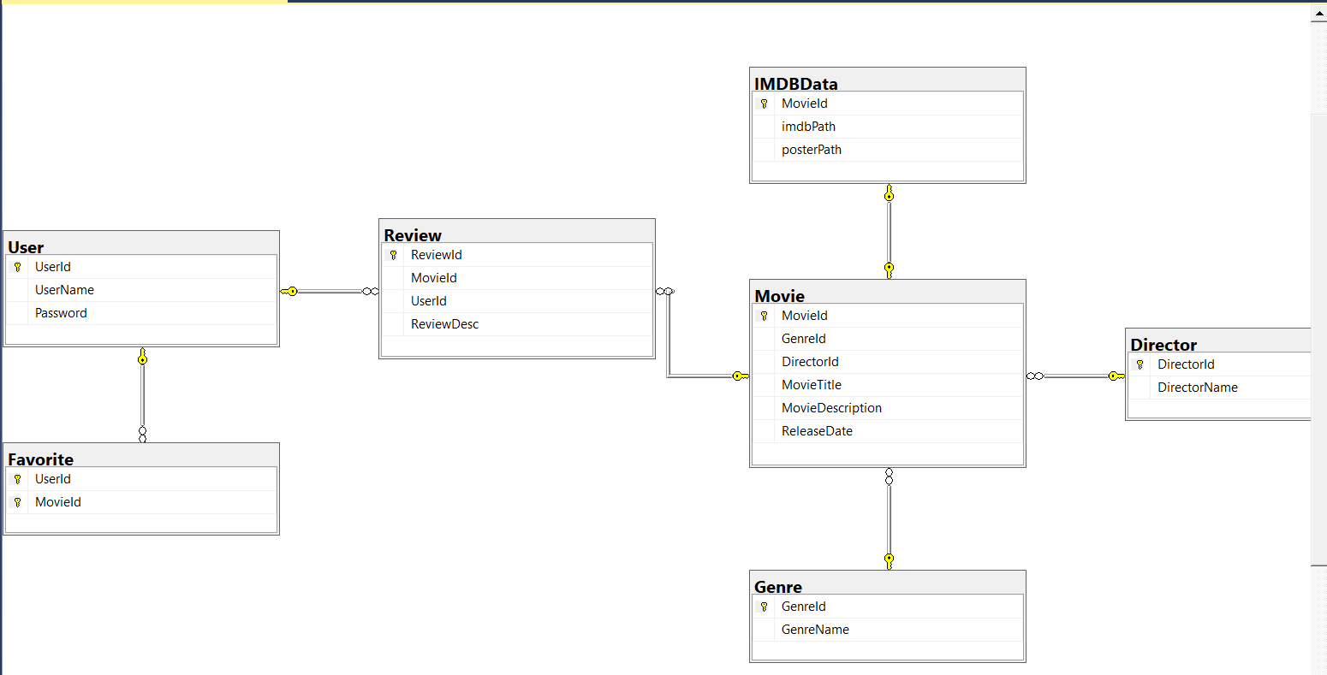

|  |  |  |
| --- | --- | --- |
| **Table** | **Primary Key** | **Foreign Key** |
| Director | [DirectorId] | N/A |
| Favorite | ([UserId], [MovieId]) | User] ([UserId]) |
| Genre | [GenreId] | N/A |
| IMDBData | [MovieId] | [[Movie] ([MovieId]) |
| Movie | [MovieId] | [Director] ([DirectorId])  [Genre] ([GenreId]) |
| Review | [ReviewId] | [Movie] ([MovieId])  [User] ([UserId]) |
| User | [UserId] | N/A |

**User Manual**

**Starting Window**

At the starting window the user is given a choice to upload their own files to the database or to proceed with the one that we have created.

**Upload files to the database**

To upload the files from the database the user is asked to click on the following buttons one by one: “Populate Directors”, “Populate Genres”, “Populate Movies”. Each button is unavailable until the previous one is clicked. After all buttons are clicked, the user can proceed to the application by clicking “Next” button.

**Proceed with existing database**

Another option is to click on “Skip” button. Then the user proceeds to the application using the existing database.

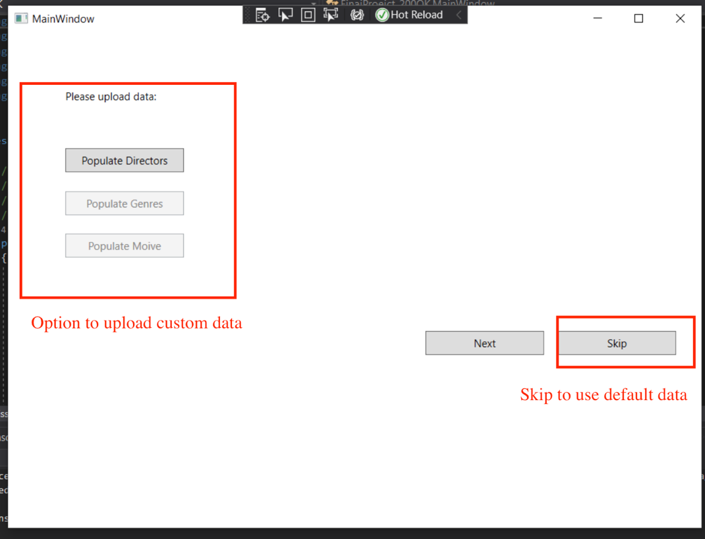

**Main Window**

At the main page the user sees a data grid containing movie information, a search bar, two search result filters, buttons to add, edit, or delete a movie, create account, and log in buttons, and go to favorites button.

**Search Movies**

A user can search the movies using a search bar located on top of the data grid and the buttons. They can use the movie’s title, release date, director, genre as a query. The search is case sensitive.

**Filter Movies**

By clicking on directors and genres list boxes user can filter the movies in the data grid. Multiple selection is available, the filters are inclusive (meaning that the results of filtering by directors and genres will be added up, not intersected).

**Add Movie**

When a user clicks on the “Add Movie” button, a new window is opened where they can enter the details about a new movie and save it after all fields are completed.

**Edit Movie**

To edit a movie a user should select a movie in the data grid and click on the “Edit Movie” button. A new window is opened where they can change any details about a movie except for the movie id. To save changes the user should click on “Edit button”.

**Delete Movie**

To delete a movie a user should select a movie in the data grid and click on the “Delete movie” button and the selected movie will be deleted from the database.

**Create account**

To create an account a user should click on the “Create an account” button and enter their username and password in the newly opened window.

**Log in**

To log in their account a user should click on the “Log in” button and enter their username and password in the newly opened window.

**See movie details**

To see movie details in a separate the user should double click on an entry in the movie data grid. From there a user also can leave a review or add this movie to the “favorites” list

**Leave a review**

To leave a review a user should go to the movie details and enter their review in the corresponding text box.

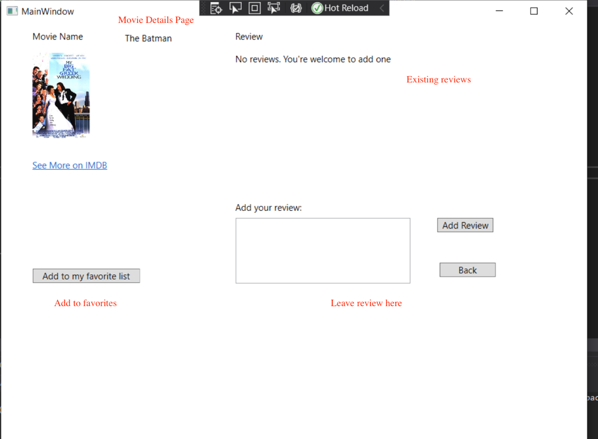

**Go to favorites**

A logged in user can go to see their favorites list. By default, it is empty and is filled in with data only if the user has previously added any movies to the list.