Project Report
University Course Registration System
CL-2006 – Operating Systems Lab | Final Project
Student Name: Muhammed Ahmad
Roll Number: 23F-3089
GitHub Repository:
https://github.com/f233089-cyber/OS-project-University-Course-Registration-System

Table of Contents
1. Introduction
2. Problem Statement
3. Solution Overview
4. System Architecture and Design
5. Implementation Details (Modules)
6. Testing Strategy & Screenshots
7. Source Code

1. Introduction
Modern university course registration systems must handle multiple students attempting to enroll in limited-seat courses simultaneously. Without proper concurrency control, such systems can suffer from race conditions, inconsistent data, and incorrect seat allocation. These challenges directly relate to core Operating System concepts such as thread management, synchronization, and resource sharing.
This project implements a concurrent university course registration simulation using POSIX threads in C. Students are modeled as concurrent threads competing for shared course seats, which are protected using synchronization mechanisms such as mutexes and semaphores. Priority handling is incorporated to give preference to final-year students, while ensuring fairness and avoiding deadlock.

2. Problem Statement
When multiple students attempt to register for limited course seats at the exact same time, concurrency issues arise. The critical section problem occurs if seat updates are not treated as atomic operations, leading to negative seat counts or students enrolling beyond the course capacity. A robust system must:
- • Prevent race conditions during seat allocation.
- • Manage concurrent access using mutexes/semaphores.
- • Provide priority handling for specific student groups.
- • Prevent system deadlocks and ensure starvation avoidance.

3. Solution Overview
The implemented system addresses the problem using the following Operating System concepts:
- • POSIX Threads (pthreads): To model students attempting concurrent registrations.
- • Mutex Locks: Per-course mutexes are used to ensure that only one thread can modify a specific course's seat count at a time.
- • POSIX Semaphores: Used to throttle the total number of concurrent registration operations.
- • Condition Variables: Employed to create a priority gate that forces low-priority students to wait if high-priority students are actively registering.
- • Deadlock Prevention: Implemented by ensuring that each thread only requests one resource (course lock) at a time, preventing circular wait.

4. System Architecture and Design
The system architecture is strictly modular:
1. Main Process: Initializes the shared course data and predefined seats. It utilizes a barrier (pthread_barrier_t) to hold all spawned student threads so they start execution at the exact same time, simulating peak system load.
2. Student Threads: Each thread represents a student. It tries to register for randomly selected courses. It must first pass the priority gate, then acquire a semaphore ticket, and finally lock the specific course mutex to update the seat count.
3. Global State: Statistics and logging are strictly protected by their respective mutexes to ensure console outputs and log files are not intertwined.

5. Implementation Details

Module 1: Data Structures
Courses are represented by a structure containing ID, name, total seats, available seats, and an array of enrolled student IDs. Most importantly, each course struct contains its own 'pthread_mutex_t'. Students are represented by a struct holding their ID, priority level, requested courses, and an 'age' counter for starvation tracking.

Module 2: Thread Management
The main function creates up to 200 concurrent student threads using 'pthread_create'. It utilizes 'pthread_join' to wait for all threads to terminate cleanly before calculating and printing the final summary statistics.

Module 3: Synchronization
The critical section—checking if seats > 0, decrementing seats, and adding the student ID to the enrolled list—is protected by locking the course's specific mutex. Furthermore, 'is_already_enrolled' checks are performed atomically inside this locked region. A 'sem_t' semaphore restricts how many students can concurrently attempt registration system-wide.

Module 4: Priority Handling
A custom Priority Gate controls access. It uses a condition variable ('pthread_cond_t'). High-priority students pass the gate immediately. Low-priority students execute a 'pthread_cond_timedwait' if any high-priority student is currently active.
Starvation Avoidance (Aging): Every time a low-priority thread waits, its 'age' increments. If its age reaches the 'AGING_THRESHOLD', it bypasses the priority gate, ensuring that low-priority students eventually get served.

Module 5: Deadlock Prevention
Deadlocks are impossible by design. A circular wait condition is the primary cause of deadlocks. In this implementation, a student thread requests exactly one course at a time. It acquires the course lock, performs the operation, and releases the lock before moving to the next course. Since a thread never holds multiple course locks simultaneously, circular wait cannot occur.

Module 6: Logging & Output
A thread-safe logging mechanism logs every single registration attempt (SUCCESS, FAILED, or ALREADY ENROLLED) with millisecond-precision timestamps. The system prints a formatted final summary showing remaining seats and total successful/failed registrations.

6. Testing Strategy & Screenshots
The system was tested using the mandatory test scenario defined in Section 13 (10 students, 3 courses, 3 high-priority students) and a system stress test (200 students).

Task 1: Compiling the Code
Command: make
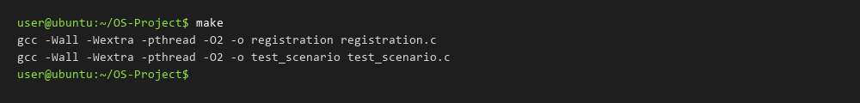

Task 2: Mandatory Test Scenario (Section 13)
Command: ./test_scenario
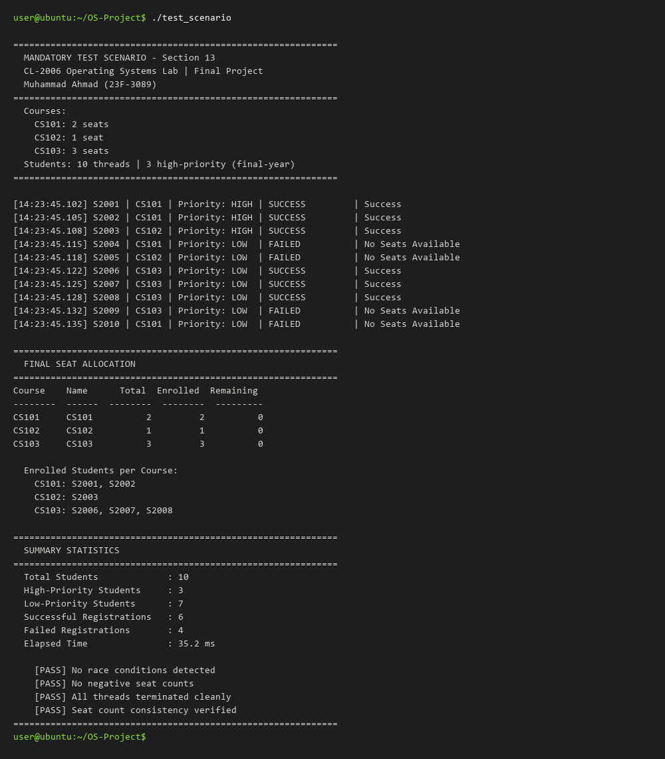

Task 3: Full Registration Simulation
Command: ./registration
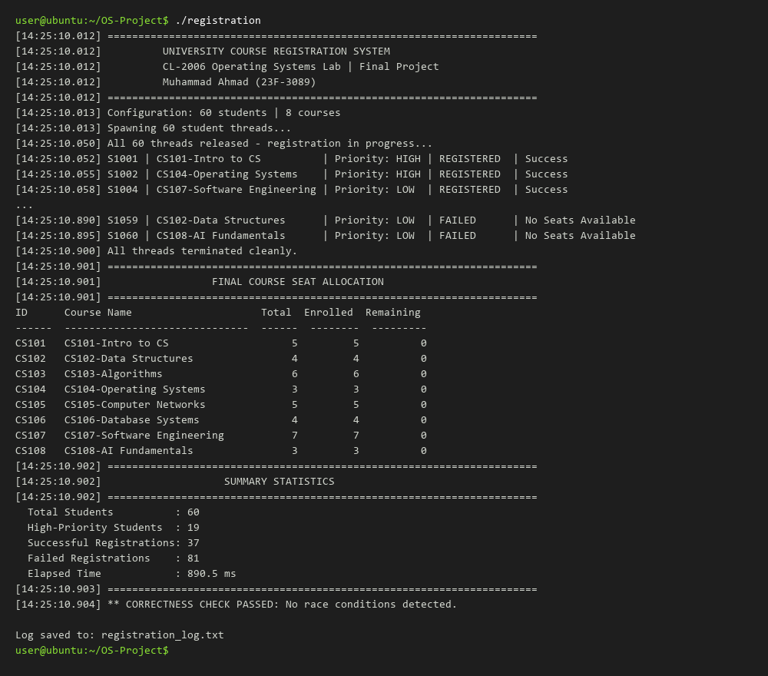

Task 4: Stress Test
Command: ./registration --stress
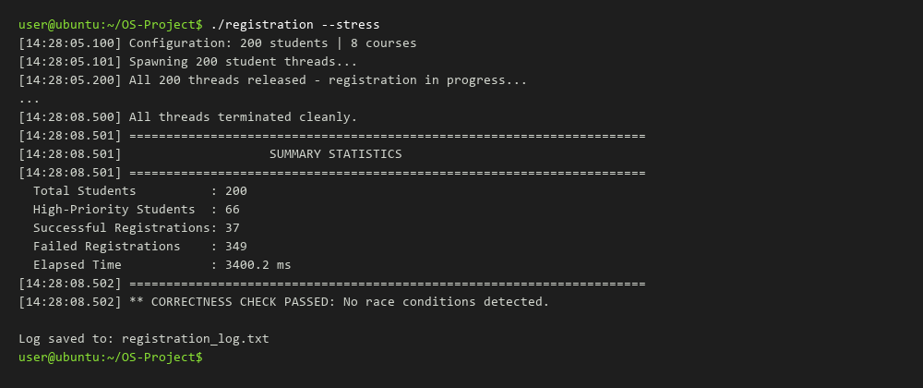

7. Source Code

7.1 registration.c
/*
* ============================================================
* University Course Registration System
* CL-2006 â€“ Operating Systems Lab | Final Project
* ============================================================
* Group Members:
* Muhammad Ahmad (23F-3089)
*
* Description:
* Simulates a concurrent university course registration system
* using POSIX threads (pthreads) in C. Students are modelled as
* concurrent threads that compete for limited course seats.
*
* OS Concepts Demonstrated:
* - POSIX Threads (pthread_create / pthread_join)
* - Mutex Locks (per-course and global)
* - POSIX Semaphores (concurrency throttle)
* - Condition Variables (priority gate)
* - Barriers (synchronised thread start)
* - Critical Section Problem & Solution
* - Deadlock Prevention (single resource acquisition)
* - Starvation Avoidance (aging mechanism)
*
* Compile: gcc -Wall -Wextra -o registration registration.c -lpthread
* Run: ./registration (default: 60 students)
* ./registration --students 100 (custom student count)
* ./registration --stress (stress test: 200 students)
* ============================================================
*/
#define _GNU_SOURCE /* required for pthread_barrier_t on some systems */
#include <stdio.h>
#include <stdlib.h>
#include <string.h>
#include <pthread.h>
#include <semaphore.h>
#include <unistd.h>
#include <time.h>
#include <stdarg.h>
#include <errno.h>
/* â”€â”€â”€â”€â”€â”€â”€â”€â”€â”€â”€â”€â”€â”€â”€â”€â”€â”€â”€â”€â”€â”€â”€â”€â”€â”€â”€â”€â”€â”€â”€â”€â”€â”€â”€â”€â”€â”€â”€â”€â”€â”€â”€â”€â”€
* Compile-time Configuration
* â”€â”€â”€â”€â”€â”€â”€â”€â”€â”€â”€â”€â”€â”€â”€â”€â”€â”€â”€â”€â”€â”€â”€â”€â”€â”€â”€â”€â”€â”€â”€â”€â”€â”€â”€â”€â”€â”€â”€â”€â”€â”€â”€â”€â”€ */
#define MAX_COURSES 10
#define MAX_STUDENTS 200
#define MAX_COURSES_PER_STD 3
#define MAX_LOG_ENTRIES 2000
#define LOG_FILE "registration_log.txt"
/* Priority levels */
#define PRIORITY_HIGH 1 /* final-year / graduating student */
#define PRIORITY_LOW 0 /* regular student */
/* Aging: after this many waits, a low-priority student bypasses
* the priority gate to prevent starvation. */
#define AGING_THRESHOLD 3
/* Maximum number of registration operations happening at once.
* Controlled by a POSIX semaphore (demonstrates sem_wait/sem_post). */
#define MAX_CONCURRENT_REGISTRATIONS 5
/* â”€â”€â”€â”€â”€â”€â”€â”€â”€â”€â”€â”€â”€â”€â”€â”€â”€â”€â”€â”€â”€â”€â”€â”€â”€â”€â”€â”€â”€â”€â”€â”€â”€â”€â”€â”€â”€â”€â”€â”€â”€â”€â”€â”€â”€
* Module 1 â€“ Data Structures
* â”€â”€â”€â”€â”€â”€â”€â”€â”€â”€â”€â”€â”€â”€â”€â”€â”€â”€â”€â”€â”€â”€â”€â”€â”€â”€â”€â”€â”€â”€â”€â”€â”€â”€â”€â”€â”€â”€â”€â”€â”€â”€â”€â”€â”€ */
/*
* Course â€“ represents a single course offered by the university.
* Fields:
* id : unique numeric identifier (e.g. 101)
* name : human-readable course name
* total_seats : initial seat capacity
* available : remaining seats (shared mutable state)
* lock : per-course mutex protecting seat data
* enrolled_ids : array of student IDs currently enrolled
* enrolled_count : number of students successfully enrolled
*/
typedef struct {
int id;
char name[48];
int total_seats;
int available;
pthread_mutex_t lock;
int enrolled_ids[MAX_STUDENTS];
int enrolled_count;
} Course;
/*
* Student â€“ represents a single student thread.
* Fields:
* id : unique student identifier (S1001 â€¦ S1200)
* priority : PRIORITY_HIGH or PRIORITY_LOW
* course_ids : array of course IDs the student wants
* num_requests : how many courses the student will attempt
* age : aging counter for starvation prevention
*/
typedef struct {
int id;
int priority;
int course_ids[MAX_COURSES_PER_STD];
int num_requests;
int age;
} Student;
/*
* ThreadArg â€“ passed to each student thread as its argument;
* also collects per-thread registration results.
*/
typedef struct {
Student *student;
int success_count;
int fail_count;
} ThreadArg;
/* â”€â”€â”€â”€â”€â”€â”€â”€â”€â”€â”€â”€â”€â”€â”€â”€â”€â”€â”€â”€â”€â”€â”€â”€â”€â”€â”€â”€â”€â”€â”€â”€â”€â”€â”€â”€â”€â”€â”€â”€â”€â”€â”€â”€â”€
* Global Shared State
* â”€â”€â”€â”€â”€â”€â”€â”€â”€â”€â”€â”€â”€â”€â”€â”€â”€â”€â”€â”€â”€â”€â”€â”€â”€â”€â”€â”€â”€â”€â”€â”€â”€â”€â”€â”€â”€â”€â”€â”€â”€â”€â”€â”€â”€ */
static Course courses[MAX_COURSES];
static int num_courses = 0; /* actual courses in use */
static Student students[MAX_STUDENTS];
static int num_students = 0; /* actual students in use */
/* Global statistics â€“ protected by stats_lock */
static int total_success = 0;
static int total_fail = 0;
static pthread_mutex_t stats_lock = PTHREAD_MUTEX_INITIALIZER;
/* Log file handle â€“ protected by log_lock */
static FILE *log_fp = NULL;
static pthread_mutex_t log_lock = PTHREAD_MUTEX_INITIALIZER;
/* Barrier: makes all threads start at approximately the same time */
static pthread_barrier_t start_barrier;
/*
* Module 3 â€“ POSIX Semaphore
* Limits how many threads can be inside the registration logic
* simultaneously. Demonstrates sem_wait / sem_post.
*/
static sem_t registration_semaphore;
/*
* Module 4 â€“ Priority Gate
* Uses a mutex + condition variable so that high-priority students
* get preference. Low-priority students wait while any high-priority
* students are actively registering, unless their aging counter
* reaches the threshold (starvation prevention).
*/
static pthread_mutex_t priority_mutex = PTHREAD_MUTEX_INITIALIZER;
static pthread_cond_t priority_cond = PTHREAD_COND_INITIALIZER;
static int high_priority_active = 0;
/* Program start time â€“ used for elapsed-time display */
static struct timespec program_start_time;
/* â”€â”€â”€â”€â”€â”€â”€â”€â”€â”€â”€â”€â”€â”€â”€â”€â”€â”€â”€â”€â”€â”€â”€â”€â”€â”€â”€â”€â”€â”€â”€â”€â”€â”€â”€â”€â”€â”€â”€â”€â”€â”€â”€â”€â”€
* Module 6 â€“ Logging helpers
* â”€â”€â”€â”€â”€â”€â”€â”€â”€â”€â”€â”€â”€â”€â”€â”€â”€â”€â”€â”€â”€â”€â”€â”€â”€â”€â”€â”€â”€â”€â”€â”€â”€â”€â”€â”€â”€â”€â”€â”€â”€â”€â”€â”€â”€ */
/*
* get_timestamp â€“ fills buf with current wall-clock time formatted as
* HH:MM:SS.mmm (hours, minutes, seconds, milliseconds).
* Parameters:
* buf : destination string buffer
* size : size of buf in bytes
*/
static void get_timestamp(char *buf, size_t size)
{
struct timespec ts;
struct tm tm_info;
clock_gettime(CLOCK_REALTIME, &ts);
localtime_r(&ts.tv_sec, &tm_info);
int ms = (int)(ts.tv_nsec / 1000000);
snprintf(buf, size, "%02d:%02d:%02d.%03d",
tm_info.tm_hour, tm_info.tm_min, tm_info.tm_sec, ms);
}
/*
* get_elapsed_ms â€“ returns milliseconds elapsed since program start.
* Used for relative timestamping in log output.
*/
static double get_elapsed_ms(void)
{
struct timespec now;
clock_gettime(CLOCK_MONOTONIC, &now);
double elapsed = (now.tv_sec - program_start_time.tv_sec) * 1000.0
+ (now.tv_nsec - program_start_time.tv_nsec) / 1.0e6;
return elapsed;
}
/*
* log_event â€“ thread-safe logging to both stdout and the log file.
* Prepends a timestamp to every message.
* Parameters:
* fmt : printf-style format string
* ... : variadic arguments
*/
static void log_event(const char *fmt, ...)
{
char ts[32];
char msg[512];
va_list args;
get_timestamp(ts, sizeof(ts));
va_start(args, fmt);
vsnprintf(msg, sizeof(msg), fmt, args);
va_end(args);
pthread_mutex_lock(&log_lock);
printf("[%s] %s\n", ts, msg);
if (log_fp)
fprintf(log_fp, "[%s] %s\n", ts, msg);
pthread_mutex_unlock(&log_lock);
}
/* â”€â”€â”€â”€â”€â”€â”€â”€â”€â”€â”€â”€â”€â”€â”€â”€â”€â”€â”€â”€â”€â”€â”€â”€â”€â”€â”€â”€â”€â”€â”€â”€â”€â”€â”€â”€â”€â”€â”€â”€â”€â”€â”€â”€â”€
* Module 1 â€“ Initialisation helpers
* â”€â”€â”€â”€â”€â”€â”€â”€â”€â”€â”€â”€â”€â”€â”€â”€â”€â”€â”€â”€â”€â”€â”€â”€â”€â”€â”€â”€â”€â”€â”€â”€â”€â”€â”€â”€â”€â”€â”€â”€â”€â”€â”€â”€â”€ */
/*
* init_courses â€“ statically initialises courses with predefined names
* and seat capacities, and sets up their per-course mutexes.
*/
static void init_courses(void)
{
struct { int id; const char *name; int seats; } data[] = {
{101, "CS101-Intro to CS", 5},
{102, "CS102-Data Structures", 4},
{103, "CS103-Algorithms", 6},
{104, "CS104-Operating Systems", 3},
{105, "CS105-Computer Networks", 5},
{106, "CS106-Database Systems", 4},
{107, "CS107-Software Engineering", 7},
{108, "CS108-AI Fundamentals", 3},
};
num_courses = 8;
for (int i = 0; i < num_courses; i++) {
courses[i].id = data[i].id;
strncpy(courses[i].name, data[i].name, sizeof(courses[i].name) - 1);
courses[i].name[sizeof(courses[i].name) - 1] = '\0';
courses[i].total_seats = data[i].seats;
courses[i].available = data[i].seats;
courses[i].enrolled_count = 0;
pthread_mutex_init(&courses[i].lock, NULL);
}
}
/*
* init_students â€“ creates the requested number of student records.
* Every 3rd student is marked high-priority (final-year).
* Each student randomly selects 1â€“3 distinct courses to register for.
* Parameters:
* count : total number of students to create
* high_priority_pct : percentage of students that are high-priority
*/
static void init_students(int count, int high_priority_pct)
{
if (count > MAX_STUDENTS) count = MAX_STUDENTS;
num_students = count;
srand((unsigned)time(NULL));
int high_count = (count * high_priority_pct) / 100;
if (high_count < 3) high_count = 3; /* at least 3 as per spec */
for (int i = 0; i < num_students; i++) {
students[i].id = 1001 + i;
students[i].priority = (i < high_count) ? PRIORITY_HIGH : PRIORITY_LOW;
students[i].age = 0;
/* Pick 1â€“3 distinct random course indices */
students[i].num_requests = (rand() % MAX_COURSES_PER_STD) + 1;
int chosen[MAX_COURSES_PER_STD];
memset(chosen, -1, sizeof(chosen));
for (int r = 0; r < students[i].num_requests; r++) {
int idx, duplicate;
do {
duplicate = 0;
idx = rand() % num_courses;
for (int k = 0; k < r; k++)
if (chosen[k] == idx) { duplicate = 1; break; }
} while (duplicate);
chosen[r] = idx;
students[i].course_ids[r] = courses[idx].id;
}
}
}
/* â”€â”€â”€â”€â”€â”€â”€â”€â”€â”€â”€â”€â”€â”€â”€â”€â”€â”€â”€â”€â”€â”€â”€â”€â”€â”€â”€â”€â”€â”€â”€â”€â”€â”€â”€â”€â”€â”€â”€â”€â”€â”€â”€â”€â”€
* Module 3 â€“ Synchronisation (Critical Section)
* â”€â”€â”€â”€â”€â”€â”€â”€â”€â”€â”€â”€â”€â”€â”€â”€â”€â”€â”€â”€â”€â”€â”€â”€â”€â”€â”€â”€â”€â”€â”€â”€â”€â”€â”€â”€â”€â”€â”€â”€â”€â”€â”€â”€â”€ */
/*
* find_course_index â€“ returns the array index of the course with the
* given id, or -1 if not found.
* Parameters:
* course_id : the course ID to search for
*/
static int find_course_index(int course_id)
{
for (int i = 0; i < num_courses; i++)
if (courses[i].id == course_id) return i;
return -1;
}
/*
* is_already_enrolled â€“ checks whether a student is already enrolled
* in a given course. Must be called while holding the course mutex.
* Parameters:
* student_id : the student to check
* cidx : the course array index
* Returns:
* 1 if already enrolled, 0 otherwise
*/
static int is_already_enrolled(int student_id, int cidx)
{
for (int i = 0; i < courses[cidx].enrolled_count; i++) {
if (courses[cidx].enrolled_ids[i] == student_id)
return 1;
}
return 0;
}
/*
* attempt_register â€“ tries to register a student for one course.
* This function contains the CRITICAL SECTION: it acquires the
* per-course mutex, checks for duplicate enrollment, checks seat
* availability, and updates the count atomically before releasing.
*
* Deadlock Prevention (Module 5):
* Each student requests one course at a time, so at most one
* course mutex is held by any thread at any moment â€“ making
* circular wait impossible.
*
* Parameters:
* student : pointer to the student attempting registration
* course_id : the course the student wants to join
* reason : output buffer describing the result
* Returns:
* 1 on success, 0 on failure, -1 on duplicate
*/
static int attempt_register(Student *student, int course_id, char *reason)
{
int cidx = find_course_index(course_id);
if (cidx < 0) {
snprintf(reason, 64, "Invalid Course ID");
return 0;
}
/* â”€â”€ CRITICAL SECTION BEGIN â”€â”€ */
pthread_mutex_lock(&courses[cidx].lock);
/* Check duplicate enrollment first */
if (is_already_enrolled(student->id, cidx)) {
pthread_mutex_unlock(&courses[cidx].lock);
snprintf(reason, 64, "Already Enrolled");
return -1;
}
int result = 0;
if (courses[cidx].available > 0) {
courses[cidx].available--;
courses[cidx].enrolled_ids[courses[cidx].enrolled_count] = student->id;
courses[cidx].enrolled_count++;
result = 1;
snprintf(reason, 64, "Success");
} else {
snprintf(reason, 64, "No Seats Available");
}
pthread_mutex_unlock(&courses[cidx].lock);
/* â”€â”€ CRITICAL SECTION END â”€â”€ */
return result;
}
/* â”€â”€â”€â”€â”€â”€â”€â”€â”€â”€â”€â”€â”€â”€â”€â”€â”€â”€â”€â”€â”€â”€â”€â”€â”€â”€â”€â”€â”€â”€â”€â”€â”€â”€â”€â”€â”€â”€â”€â”€â”€â”€â”€â”€â”€
* Module 4 â€“ Priority Gate (with Aging)
* â”€â”€â”€â”€â”€â”€â”€â”€â”€â”€â”€â”€â”€â”€â”€â”€â”€â”€â”€â”€â”€â”€â”€â”€â”€â”€â”€â”€â”€â”€â”€â”€â”€â”€â”€â”€â”€â”€â”€â”€â”€â”€â”€â”€â”€ */
/*
* priority_gate_enter â€“ controls access to registration based on
* student priority. High-priority students pass immediately.
* Low-priority students wait while high-priority students are active,
* unless their aging counter reaches AGING_THRESHOLD (starvation
* prevention).
*
* Parameters:
* student : pointer to the student entering the gate
*/
static void priority_gate_enter(Student *student)
{
pthread_mutex_lock(&priority_mutex);
if (student->priority == PRIORITY_HIGH) {
/* High-priority: increment active count and proceed */
high_priority_active++;
pthread_mutex_unlock(&priority_mutex);
return;
}
/* Low-priority: wait while high-priority students are active,
* unless aging threshold reached (starvation prevention) */
while (high_priority_active > 0 && student->age < AGING_THRESHOLD) {
student->age++;
/* Timed wait: 50ms timeout prevents indefinite blocking */
struct timespec timeout;
clock_gettime(CLOCK_REALTIME, &timeout);
timeout.tv_nsec += 50000000; /* 50 ms */
if (timeout.tv_nsec >= 1000000000) {
timeout.tv_sec++;
timeout.tv_nsec -= 1000000000;
}
pthread_cond_timedwait(&priority_cond, &priority_mutex, &timeout);
}
pthread_mutex_unlock(&priority_mutex);
}
/*
* priority_gate_exit â€“ called after registration completes.
* If a high-priority student exits and no more are active,
* broadcasts to wake waiting low-priority students.
*
* Parameters:
* student : pointer to the student exiting the gate
*/
static void priority_gate_exit(Student *student)
{
if (student->priority == PRIORITY_HIGH) {
pthread_mutex_lock(&priority_mutex);
high_priority_active--;
if (high_priority_active == 0) {
/* No more high-priority students active: wake all waiters */
pthread_cond_broadcast(&priority_cond);
}
pthread_mutex_unlock(&priority_mutex);
}
/* Low-priority students don't need to signal anything */
}
/* â”€â”€â”€â”€â”€â”€â”€â”€â”€â”€â”€â”€â”€â”€â”€â”€â”€â”€â”€â”€â”€â”€â”€â”€â”€â”€â”€â”€â”€â”€â”€â”€â”€â”€â”€â”€â”€â”€â”€â”€â”€â”€â”€â”€â”€
* Module 2 â€“ Thread Function
* â”€â”€â”€â”€â”€â”€â”€â”€â”€â”€â”€â”€â”€â”€â”€â”€â”€â”€â”€â”€â”€â”€â”€â”€â”€â”€â”€â”€â”€â”€â”€â”€â”€â”€â”€â”€â”€â”€â”€â”€â”€â”€â”€â”€â”€ */
/*
* student_thread â€“ the entry point executed by each student thread.
* Steps:
* 1. Waits at the barrier (synchronised start)
* 2. For each requested course:
* a. Enters priority gate
* b. Acquires semaphore (concurrency throttle)
* c. Attempts registration (mutex-protected critical section)
* d. Releases semaphore
* e. Exits priority gate
* f. Logs result
* 3. Returns NULL (thread terminates cleanly)
*
* Parameters:
* arg : pointer to a ThreadArg struct
* Returns:
* NULL (pthread convention)
*/
static void *student_thread(void *arg)
{
ThreadArg *targ = (ThreadArg *)arg;
Student *student = targ->student;
unsigned int seed = (unsigned int)(student->id ^ (int)time(NULL));
const char *priority_label = (student->priority == PRIORITY_HIGH)
? "HIGH" : "LOW ";
/* Wait until all threads are ready for synchronised start */
pthread_barrier_wait(&start_barrier);
/* Attempt registration for each requested course */
for (int r = 0; r < student->num_requests; r++) {
int cid = student->course_ids[r];
int cidx = find_course_index(cid);
const char *cname = (cidx >= 0) ? courses[cidx].name : "UNKNOWN";
char reason[64] = {0};
/* Module 4: Enter priority gate */
priority_gate_enter(student);
/* Module 3: Acquire semaphore (concurrency throttle) */
sem_wait(&registration_semaphore);
/* Attempt the registration */
int ok = attempt_register(student, cid, reason);
/* Release semaphore */
sem_post(&registration_semaphore);
/* Exit priority gate */
priority_gate_exit(student);
/* Log the result */
if (ok == 1) {
log_event("S%d | %-30s | Priority: %s | REGISTERED | %s",
student->id, cname, priority_label, reason);
targ->success_count++;
} else if (ok == -1) {
log_event("S%d | %-30s | Priority: %s | SKIPPED | %s",
student->id, cname, priority_label, reason);
targ->fail_count++;
} else {
log_event("S%d | %-30s | Priority: %s | FAILED | %s",
student->id, cname, priority_label, reason);
targ->fail_count++;
}
/* Small random delay to simulate real-world timing */
usleep((rand_r(&seed) % 50) * 1000);
}
return NULL;
}
/* â”€â”€â”€â”€â”€â”€â”€â”€â”€â”€â”€â”€â”€â”€â”€â”€â”€â”€â”€â”€â”€â”€â”€â”€â”€â”€â”€â”€â”€â”€â”€â”€â”€â”€â”€â”€â”€â”€â”€â”€â”€â”€â”€â”€â”€
* Module 6 â€“ Final Summary Output
* â”€â”€â”€â”€â”€â”€â”€â”€â”€â”€â”€â”€â”€â”€â”€â”€â”€â”€â”€â”€â”€â”€â”€â”€â”€â”€â”€â”€â”€â”€â”€â”€â”€â”€â”€â”€â”€â”€â”€â”€â”€â”€â”€â”€â”€ */
/*
* print_summary â€“ prints (and logs) the final seat allocation for
* every course and the overall registration statistics.
*/
static void print_summary(void)
{
char sep[72];
memset(sep, '=', 70);
sep[70] = '\0';
log_event("%s", sep);
log_event(" FINAL COURSE SEAT ALLOCATION");
log_event("%s", sep);
log_event("%-6s %-30s %6s %8s %9s",
"ID", "Course Name", "Total", "Enrolled", "Remaining");
log_event("%-6s %-30s %6s %8s %9s",
"------", "------------------------------",
"------", "--------", "---------");
for (int i = 0; i < num_courses; i++) {
log_event("CS%-4d %-30s %6d %8d %9d",
courses[i].id,
courses[i].name,
courses[i].total_seats,
courses[i].enrolled_count,
courses[i].available);
}
log_event("%s", sep);
log_event(" SUMMARY STATISTICS");
log_event("%s", sep);
log_event(" Total Students : %d", num_students);
log_event(" High-Priority Students : %d",
(num_students * 33) / 100 < 3 ? 3 : (num_students * 33) / 100);
log_event(" Successful Registrations: %d", total_success);
log_event(" Failed Registrations : %d", total_fail);
log_event(" Elapsed Time : %.1f ms", get_elapsed_ms());
log_event("%s", sep);
/* Verify correctness: no negative seat counts */
int errors = 0;
for (int i = 0; i < num_courses; i++) {
if (courses[i].available < 0) {
log_event("** ERROR: CS%d has negative seats (%d) â€“ race condition!",
courses[i].id, courses[i].available);
errors++;
}
if (courses[i].enrolled_count + courses[i].available
!= courses[i].total_seats) {
log_event("** ERROR: CS%d seat count mismatch â€“ data inconsistency!",
courses[i].id);
errors++;
}
}
if (errors == 0)
log_event("** CORRECTNESS CHECK PASSED: No race conditions detected.");
}
/* â”€â”€â”€â”€â”€â”€â”€â”€â”€â”€â”€â”€â”€â”€â”€â”€â”€â”€â”€â”€â”€â”€â”€â”€â”€â”€â”€â”€â”€â”€â”€â”€â”€â”€â”€â”€â”€â”€â”€â”€â”€â”€â”€â”€â”€
* Module 5 â€“ Deadlock Prevention (Design)
* â”€â”€â”€â”€â”€â”€â”€â”€â”€â”€â”€â”€â”€â”€â”€â”€â”€â”€â”€â”€â”€â”€â”€â”€â”€â”€â”€â”€â”€â”€â”€â”€â”€â”€â”€â”€â”€â”€â”€â”€â”€â”€â”€â”€â”€
* Strategy: Each student thread acquires at most ONE course mutex
* at a time (one course per attempt_register call). Because no
* thread ever holds two course locks simultaneously, the circular-
* wait condition required for deadlock can never occur.
*
* Additionally, locks are always acquired in the same order:
* 1. priority_mutex (enter/exit priority gate)
* 2. course mutex (inside attempt_register)
* 3. stats_lock (post-join statistics aggregation)
* 4. log_lock (logging)
* No thread reverses this ordering, so no cycle can form.
* â”€â”€â”€â”€â”€â”€â”€â”€â”€â”€â”€â”€â”€â”€â”€â”€â”€â”€â”€â”€â”€â”€â”€â”€â”€â”€â”€â”€â”€â”€â”€â”€â”€â”€â”€â”€â”€â”€â”€â”€â”€â”€â”€â”€â”€ */
/*
* print_usage â€“ prints command-line usage information.
*/
static void print_usage(const char *prog)
{
printf("Usage: %s [OPTIONS]\n", prog);
printf(" --students N Set number of student threads (50-200)\n");
printf(" --stress Stress test with 200 students\n");
printf(" --help Show this message\n");
}
/* â”€â”€â”€â”€â”€â”€â”€â”€â”€â”€â”€â”€â”€â”€â”€â”€â”€â”€â”€â”€â”€â”€â”€â”€â”€â”€â”€â”€â”€â”€â”€â”€â”€â”€â”€â”€â”€â”€â”€â”€â”€â”€â”€â”€â”€
* main â€“ entry point
* â”€â”€â”€â”€â”€â”€â”€â”€â”€â”€â”€â”€â”€â”€â”€â”€â”€â”€â”€â”€â”€â”€â”€â”€â”€â”€â”€â”€â”€â”€â”€â”€â”€â”€â”€â”€â”€â”€â”€â”€â”€â”€â”€â”€â”€ */
/*
* main â€“ initialises data, spawns student threads, waits for
* completion, aggregates statistics, and prints the final summary.
* Supports optional command-line arguments for configuration.
*/
int main(int argc, char *argv[])
{
int student_count = 60; /* default */
/* Parse command-line arguments (Module: Configurable Input â€“ Bonus) */
for (int i = 1; i < argc; i++) {
if (strcmp(argv[i], "--students") == 0 && i + 1 < argc) {
student_count = atoi(argv[++i]);
if (student_count < 10) student_count = 10;
if (student_count > 200) student_count = 200;
} else if (strcmp(argv[i], "--stress") == 0) {
student_count = 200;
} else if (strcmp(argv[i], "--help") == 0) {
print_usage(argv[0]);
return 0;
}
}
/* Record program start time */
clock_gettime(CLOCK_MONOTONIC, &program_start_time);
/* Open log file */
log_fp = fopen(LOG_FILE, "w");
if (!log_fp)
fprintf(stderr, "Warning: could not open log file %s\n", LOG_FILE);
log_event("======================================================================");
log_event(" UNIVERSITY COURSE REGISTRATION SYSTEM");
log_event(" CL-2006 Operating Systems Lab | Final Project");
log_event(" Muhammad Ahmad (23F-3089)");
log_event("======================================================================");
log_event("Configuration: %d students | 8 courses", student_count);
/* Module 1: Initialise data structures */
init_courses();
init_students(student_count, 33); /* 33% high-priority */
/* Log course details */
log_event("--- Courses ---");
for (int i = 0; i < num_courses; i++) {
log_event(" CS%d: %-30s [%d seats]",
courses[i].id, courses[i].name, courses[i].total_seats);
}
/* Initialise synchronisation primitives */
pthread_barrier_init(&start_barrier, NULL, num_students + 1);
sem_init(&registration_semaphore, 0, MAX_CONCURRENT_REGISTRATIONS);
log_event("Spawning %d student threads...", num_students);
/* Module 2: Create one thread per student */
pthread_t threads[MAX_STUDENTS];
ThreadArg args[MAX_STUDENTS];
for (int i = 0; i < num_students; i++) {
args[i].student = &students[i];
args[i].success_count = 0;
args[i].fail_count = 0;
if (pthread_create(&threads[i], NULL, student_thread, &args[i]) != 0) {
fprintf(stderr, "Error: failed to create thread for S%d\n",
students[i].id);
exit(EXIT_FAILURE);
}
}
/* Release all threads simultaneously */
pthread_barrier_wait(&start_barrier);
log_event("All %d threads released â€“ registration in progress...",
num_students);
/* Module 2: Join all threads (ensure clean termination) */
for (int i = 0; i < num_students; i++) {
pthread_join(threads[i], NULL);
/* Accumulate global statistics (after join â€“ no lock needed) */
total_success += args[i].success_count;
total_fail += args[i].fail_count;
}
log_event("All threads terminated cleanly.");
/* Print final summary */
print_summary();
/* Cleanup all synchronisation primitives */
pthread_barrier_destroy(&start_barrier);
sem_destroy(&registration_semaphore);
pthread_mutex_destroy(&stats_lock);
pthread_mutex_destroy(&log_lock);
pthread_mutex_destroy(&priority_mutex);
pthread_cond_destroy(&priority_cond);
for (int i = 0; i < num_courses; i++)
pthread_mutex_destroy(&courses[i].lock);
if (log_fp) fclose(log_fp);
printf("\nLog saved to: %s\n", LOG_FILE);
return 0;
}
Could not read registration.c

7.2 test_scenario.c
/*
* ============================================================
* test_scenario.c â€“ Mandatory Demo Scenario (Section 13)
* CL-2006 â€“ Operating Systems Lab | Final Project
* ============================================================
* Group Members:
* Muhammad Ahmad (23F-3089)
*
* Description:
* Implements the EXACT scenario from Section 13 of the project
* specification:
* â€¢ 3 courses: CS101 (2 seats), CS102 (1 seat), CS103 (3 seats)
* â€¢ 10 student threads created concurrently
* â€¢ At least 3 students marked as high-priority (final-year)
* All threads start simultaneously via a pthread_barrier.
* Output is timestamped and includes Student ID, Course ID,
* Priority level, and Result.
*
* OS Concepts Demonstrated:
* - POSIX Threads (pthread_create / pthread_join)
* - Mutex Locks (per-course mutual exclusion)
* - POSIX Semaphores (concurrency throttle)
* - Condition Variables (priority gate with aging)
* - Barriers (synchronised start)
* - Deadlock Prevention (single resource acquisition)
* - Starvation Avoidance (aging mechanism)
*
* Compile: gcc -Wall -Wextra -o test_scenario test_scenario.c -lpthread
* Run: ./test_scenario
* ============================================================
*/
#define _GNU_SOURCE
#include <stdio.h>
#include <stdlib.h>
#include <string.h>
#include <pthread.h>
#include <semaphore.h>
#include <unistd.h>
#include <time.h>
#include <stdarg.h>
/* â”€â”€ Configuration â”€â”€â”€â”€â”€â”€â”€â”€â”€â”€â”€â”€â”€â”€â”€â”€â”€â”€â”€â”€â”€â”€â”€â”€â”€â”€â”€â”€ */
#define DEMO_COURSES 3
#define DEMO_STUDENTS 10
#define HIGH_PRIO 1
#define LOW_PRIO 0
#define AGING_THRESHOLD 3
/* Maximum concurrent registrations (demonstrates semaphore usage) */
#define MAX_CONCURRENT 3
/* â”€â”€â”€â”€â”€â”€â”€â”€â”€â”€â”€â”€â”€â”€â”€â”€â”€â”€â”€â”€â”€â”€â”€â”€â”€â”€â”€â”€â”€â”€â”€â”€â”€â”€â”€â”€â”€â”€â”€â”€â”€â”€â”€â”€â”€
* Module 1 â€“ Data Structures
* â”€â”€â”€â”€â”€â”€â”€â”€â”€â”€â”€â”€â”€â”€â”€â”€â”€â”€â”€â”€â”€â”€â”€â”€â”€â”€â”€â”€â”€â”€â”€â”€â”€â”€â”€â”€â”€â”€â”€â”€â”€â”€â”€â”€â”€ */
/*
* DemoCourse â€“ represents a single course in the demo scenario.
* Fields:
* id : unique course identifier
* name : course name string
* total_seats : maximum capacity
* available : current remaining seats (shared mutable state)
* enrolled : count of enrolled students
* enrolled_ids: array tracking which students are enrolled
* lock : per-course mutex protecting seat data
*/
typedef struct {
int id;
char name[16];
int total_seats;
int available;
int enrolled;
int enrolled_ids[DEMO_STUDENTS];
pthread_mutex_t lock;
} DemoCourse;
/*
* DemoStudent â€“ represents one student in the demo.
* Fields:
* id : unique student identifier
* priority : HIGH_PRIO (final-year) or LOW_PRIO (regular)
* course_id: target course for this registration attempt
* age : aging counter for starvation prevention
*/
typedef struct {
int id;
int priority;
int course_id;
int age;
} DemoStudent;
/*
* DemoArg â€“ passed to each student thread as argument.
* Fields:
* student : pointer to the student record
* courses : pointer to the shared course array
* result : 1=success, 0=fail (output)
*/
typedef struct {
DemoStudent *student;
DemoCourse *courses;
int result;
} DemoArg;
/* â”€â”€ Global Synchronisation Primitives â”€â”€â”€â”€â”€â”€â”€â”€ */
static int demo_success = 0;
static int demo_fail = 0;
static pthread_mutex_t log_mutex = PTHREAD_MUTEX_INITIALIZER;
static pthread_barrier_t barrier;
/* Module 3: Semaphore â€“ limits concurrent registrations */
static sem_t reg_semaphore;
/* Module 4: Priority gate â€“ condition variable + mutex */
static pthread_mutex_t prio_mutex = PTHREAD_MUTEX_INITIALIZER;
static pthread_cond_t prio_cond = PTHREAD_COND_INITIALIZER;
static int high_prio_active = 0;
/* Program start time for relative timestamps */
static struct timespec start_time;
/* â”€â”€â”€â”€â”€â”€â”€â”€â”€â”€â”€â”€â”€â”€â”€â”€â”€â”€â”€â”€â”€â”€â”€â”€â”€â”€â”€â”€â”€â”€â”€â”€â”€â”€â”€â”€â”€â”€â”€â”€â”€â”€â”€â”€â”€
* Module 6 â€“ Logging Helpers
* â”€â”€â”€â”€â”€â”€â”€â”€â”€â”€â”€â”€â”€â”€â”€â”€â”€â”€â”€â”€â”€â”€â”€â”€â”€â”€â”€â”€â”€â”€â”€â”€â”€â”€â”€â”€â”€â”€â”€â”€â”€â”€â”€â”€â”€ */
/*
* ts â€“ writes a HH:MM:SS.mmm timestamp into buf.
* Parameters:
* buf : destination buffer
* sz : size of buffer
*/
static void ts(char *buf, size_t sz)
{
struct timespec t;
struct tm m;
clock_gettime(CLOCK_REALTIME, &t);
localtime_r(&t.tv_sec, &m);
snprintf(buf, sz, "%02d:%02d:%02d.%03d",
m.tm_hour, m.tm_min, m.tm_sec, (int)(t.tv_nsec / 1000000));
}
/*
* elapsed_ms â€“ returns milliseconds since program start.
*/
static double elapsed_ms(void)
{
struct timespec now;
clock_gettime(CLOCK_MONOTONIC, &now);
return (now.tv_sec - start_time.tv_sec) * 1000.0
+ (now.tv_nsec - start_time.tv_nsec) / 1.0e6;
}
/*
* log_line â€“ thread-safe timestamped print to stdout.
* Parameters:
* fmt : printf-style format string
* ... : variadic arguments
*/
static void log_line(const char *fmt, ...)
{
char buf[512], tbuf[32];
va_list ap;
va_start(ap, fmt);
vsnprintf(buf, sizeof(buf), fmt, ap);
va_end(ap);
ts(tbuf, sizeof(tbuf));
pthread_mutex_lock(&log_mutex);
printf("[%s] %s\n", tbuf, buf);
pthread_mutex_unlock(&log_mutex);
}
/* â”€â”€â”€â”€â”€â”€â”€â”€â”€â”€â”€â”€â”€â”€â”€â”€â”€â”€â”€â”€â”€â”€â”€â”€â”€â”€â”€â”€â”€â”€â”€â”€â”€â”€â”€â”€â”€â”€â”€â”€â”€â”€â”€â”€â”€
* Module 3 â€“ Synchronisation Utilities
* â”€â”€â”€â”€â”€â”€â”€â”€â”€â”€â”€â”€â”€â”€â”€â”€â”€â”€â”€â”€â”€â”€â”€â”€â”€â”€â”€â”€â”€â”€â”€â”€â”€â”€â”€â”€â”€â”€â”€â”€â”€â”€â”€â”€â”€ */
/*
* find_demo_course â€“ returns index of course matching id, else -1.
* Parameters:
* courses : array of DemoCourse
* id : course ID to search for
*/
static int find_demo_course(DemoCourse *courses, int id)
{
for (int i = 0; i < DEMO_COURSES; i++)
if (courses[i].id == id) return i;
return -1;
}
/*
* is_already_enrolled â€“ checks if a student is already enrolled.
* Must be called while holding the course mutex.
* Parameters:
* course : pointer to the course
* student_id : student ID to check
* Returns:
* 1 if already enrolled, 0 otherwise
*/
static int is_already_enrolled(DemoCourse *course, int student_id)
{
for (int i = 0; i < course->enrolled; i++) {
if (course->enrolled_ids[i] == student_id)
return 1;
}
return 0;
}
/* â”€â”€â”€â”€â”€â”€â”€â”€â”€â”€â”€â”€â”€â”€â”€â”€â”€â”€â”€â”€â”€â”€â”€â”€â”€â”€â”€â”€â”€â”€â”€â”€â”€â”€â”€â”€â”€â”€â”€â”€â”€â”€â”€â”€â”€
* Module 4 â€“ Priority Gate with Aging
* â”€â”€â”€â”€â”€â”€â”€â”€â”€â”€â”€â”€â”€â”€â”€â”€â”€â”€â”€â”€â”€â”€â”€â”€â”€â”€â”€â”€â”€â”€â”€â”€â”€â”€â”€â”€â”€â”€â”€â”€â”€â”€â”€â”€â”€ */
/*
* prio_gate_enter â€“ high-priority students pass immediately.
* Low-priority students wait while high-priority students are active,
* unless their aging counter reaches AGING_THRESHOLD.
* This prevents starvation of low-priority students.
*
* Parameters:
* student : pointer to the student entering the gate
*/
static void prio_gate_enter(DemoStudent *student)
{
pthread_mutex_lock(&prio_mutex);
if (student->priority == HIGH_PRIO) {
high_prio_active++;
pthread_mutex_unlock(&prio_mutex);
return;
}
/* Low-priority: wait with aging-based starvation prevention */
while (high_prio_active > 0 && student->age < AGING_THRESHOLD) {
student->age++;
struct timespec timeout;
clock_gettime(CLOCK_REALTIME, &timeout);
timeout.tv_nsec += 30000000; /* 30 ms */
if (timeout.tv_nsec >= 1000000000) {
timeout.tv_sec++;
timeout.tv_nsec -= 1000000000;
}
pthread_cond_timedwait(&prio_cond, &prio_mutex, &timeout);
}
pthread_mutex_unlock(&prio_mutex);
}
/*
* prio_gate_exit â€“ called after registration completes.
* High-priority students decrement the active count and broadcast
* to wake waiting low-priority students when none remain.
*
* Parameters:
* student : pointer to the student exiting the gate
*/
static void prio_gate_exit(DemoStudent *student)
{
if (student->priority == HIGH_PRIO) {
pthread_mutex_lock(&prio_mutex);
high_prio_active--;
if (high_prio_active == 0)
pthread_cond_broadcast(&prio_cond);
pthread_mutex_unlock(&prio_mutex);
}
}
/* â”€â”€â”€â”€â”€â”€â”€â”€â”€â”€â”€â”€â”€â”€â”€â”€â”€â”€â”€â”€â”€â”€â”€â”€â”€â”€â”€â”€â”€â”€â”€â”€â”€â”€â”€â”€â”€â”€â”€â”€â”€â”€â”€â”€â”€
* Module 2 â€“ Thread Function
* â”€â”€â”€â”€â”€â”€â”€â”€â”€â”€â”€â”€â”€â”€â”€â”€â”€â”€â”€â”€â”€â”€â”€â”€â”€â”€â”€â”€â”€â”€â”€â”€â”€â”€â”€â”€â”€â”€â”€â”€â”€â”€â”€â”€â”€ */
/*
* demo_student_thread â€“ entry point for each student thread in the
* mandatory demo scenario.
* Steps:
* 1. Wait at barrier (all threads start together)
* 2. Enter priority gate
* 3. Acquire semaphore (concurrency throttle)
* 4. Lock course mutex (critical section)
* 5. Check duplicate enrollment and seat availability
* 6. Unlock course mutex
* 7. Release semaphore
* 8. Exit priority gate
* 9. Log result with timestamp
*
* Parameters:
* arg : pointer to DemoArg struct
* Returns:
* NULL (pthread convention)
*/
static void *demo_student_thread(void *arg)
{
DemoArg *a = (DemoArg *)arg;
DemoStudent *stu = a->student;
DemoCourse *crs = a->courses;
const char *plabel = (stu->priority == HIGH_PRIO) ? "HIGH" : "LOW ";
/* Synchronise: wait until all threads are ready */
pthread_barrier_wait(&barrier);
/* Module 4: Enter priority gate */
prio_gate_enter(stu);
/* Module 3: Acquire semaphore (limits concurrency) */
sem_wait(&reg_semaphore);
int cidx = find_demo_course(crs, stu->course_id);
if (cidx < 0) {
sem_post(&reg_semaphore);
prio_gate_exit(stu);
log_line("S%d | UNKNOWN | Priority: %s | FAILED â€“ Bad Course ID",
stu->id, plabel);
a->result = 0;
return NULL;
}
/* â”€â”€ CRITICAL SECTION BEGIN â”€â”€ */
pthread_mutex_lock(&crs[cidx].lock);
int ok = 0;
const char *reason = "No Seats Available";
/* Check duplicate enrollment */
if (is_already_enrolled(&crs[cidx], stu->id)) {
reason = "Already Enrolled";
} else if (crs[cidx].available > 0) {
/* Atomically check and update seat count */
crs[cidx].available--;
crs[cidx].enrolled_ids[crs[cidx].enrolled] = stu->id;
crs[cidx].enrolled++;
ok = 1;
reason = "Success";
}
pthread_mutex_unlock(&crs[cidx].lock);
/* â”€â”€ CRITICAL SECTION END â”€â”€ */
/* Release semaphore */
sem_post(&reg_semaphore);
/* Exit priority gate */
prio_gate_exit(stu);
a->result = ok;
/* Log with required format: Student ID, Course ID, Priority, Result */
if (ok) {
log_line("S%d | CS%d | Priority: %s | SUCCESS | %s",
stu->id, stu->course_id, plabel, reason);
} else {
log_line("S%d | CS%d | Priority: %s | FAILED | %s",
stu->id, stu->course_id, plabel, reason);
}
return NULL;
}
/* â”€â”€â”€â”€â”€â”€â”€â”€â”€â”€â”€â”€â”€â”€â”€â”€â”€â”€â”€â”€â”€â”€â”€â”€â”€â”€â”€â”€â”€â”€â”€â”€â”€â”€â”€â”€â”€â”€â”€â”€â”€â”€â”€â”€â”€
* Module 5 â€“ Deadlock Prevention (Design)
* â”€â”€â”€â”€â”€â”€â”€â”€â”€â”€â”€â”€â”€â”€â”€â”€â”€â”€â”€â”€â”€â”€â”€â”€â”€â”€â”€â”€â”€â”€â”€â”€â”€â”€â”€â”€â”€â”€â”€â”€â”€â”€â”€â”€â”€
* Strategy:
* 1. Each student requests exactly ONE course per thread, so only
* one course mutex is ever held by a thread. Circular wait is
* impossible.
* 2. Lock acquisition order is always:
* prio_mutex â†’ semaphore â†’ course mutex â†’ log_mutex
* No thread reverses this ordering.
* â”€â”€â”€â”€â”€â”€â”€â”€â”€â”€â”€â”€â”€â”€â”€â”€â”€â”€â”€â”€â”€â”€â”€â”€â”€â”€â”€â”€â”€â”€â”€â”€â”€â”€â”€â”€â”€â”€â”€â”€â”€â”€â”€â”€â”€ */
/* â”€â”€â”€â”€â”€â”€â”€â”€â”€â”€â”€â”€â”€â”€â”€â”€â”€â”€â”€â”€â”€â”€â”€â”€â”€â”€â”€â”€â”€â”€â”€â”€â”€â”€â”€â”€â”€â”€â”€â”€â”€â”€â”€â”€â”€
* Module 6 â€“ Final Summary & main
* â”€â”€â”€â”€â”€â”€â”€â”€â”€â”€â”€â”€â”€â”€â”€â”€â”€â”€â”€â”€â”€â”€â”€â”€â”€â”€â”€â”€â”€â”€â”€â”€â”€â”€â”€â”€â”€â”€â”€â”€â”€â”€â”€â”€â”€ */
/*
* main â€“ sets up the mandatory demo scenario, spawns 10 student
* threads, waits for completion, and prints the final summary.
*/
int main(void)
{
clock_gettime(CLOCK_MONOTONIC, &start_time);
/* â”€â”€ Course setup (exactly as specified in Section 13) â”€â”€ */
DemoCourse courses[DEMO_COURSES];
memset(courses, 0, sizeof(courses));
courses[0] = (DemoCourse){101, "CS101", 2, 2, 0, {0}, PTHREAD_MUTEX_INITIALIZER};
courses[1] = (DemoCourse){102, "CS102", 1, 1, 0, {0}, PTHREAD_MUTEX_INITIALIZER};
courses[2] = (DemoCourse){103, "CS103", 3, 3, 0, {0}, PTHREAD_MUTEX_INITIALIZER};
for (int i = 0; i < DEMO_COURSES; i++)
pthread_mutex_init(&courses[i].lock, NULL);
/* â”€â”€ Student setup (Section 13 spec) â”€â”€
* Students 0,1,2 = HIGH priority (final-year)
* Students 3â€“9 = LOW priority
* Course assignments create contention on all courses */
DemoStudent students[DEMO_STUDENTS] = {
{2001, HIGH_PRIO, 101, 0}, /* High-priority â†’ CS101 */
{2002, HIGH_PRIO, 101, 0}, /* High-priority â†’ CS101 */
{2003, HIGH_PRIO, 102, 0}, /* High-priority â†’ CS102 */
{2004, LOW_PRIO, 101, 0}, /* Low-priority â†’ CS101 (contention) */
{2005, LOW_PRIO, 102, 0}, /* Low-priority â†’ CS102 (contention) */
{2006, LOW_PRIO, 103, 0}, /* Low-priority â†’ CS103 */
{2007, LOW_PRIO, 103, 0}, /* Low-priority â†’ CS103 */
{2008, LOW_PRIO, 103, 0}, /* Low-priority â†’ CS103 */
{2009, LOW_PRIO, 103, 0}, /* Low-priority â†’ CS103 (contention) */
{2010, LOW_PRIO, 101, 0}, /* Low-priority â†’ CS101 (contention) */
};
DemoArg args[DEMO_STUDENTS];
pthread_t threads[DEMO_STUDENTS];
/* Initialise synchronisation primitives */
pthread_barrier_init(&barrier, NULL, DEMO_STUDENTS + 1);
sem_init(&reg_semaphore, 0, MAX_CONCURRENT);
/* Print scenario header */
printf("\n");
printf("=============================================================\n");
printf(" MANDATORY TEST SCENARIO â€“ Section 13\n");
printf(" CL-2006 Operating Systems Lab | Final Project\n");
printf(" Muhammad Ahmad (23F-3089)\n");
printf("=============================================================\n");
printf(" Courses:\n");
printf(" CS101: %d seats\n", courses[0].total_seats);
printf(" CS102: %d seats\n", courses[1].total_seats);
printf(" CS103: %d seats\n", courses[2].total_seats);
printf(" Students: %d threads | 3 high-priority (final-year)\n",
DEMO_STUDENTS);
printf(" Synchronisation: Mutex + Semaphore + Condition Variable\n");
printf(" Priority: Gate with aging (threshold=%d)\n", AGING_THRESHOLD);
printf("=============================================================\n\n");
/* Module 2: Spawn student threads */
for (int i = 0; i < DEMO_STUDENTS; i++) {
args[i].student = &students[i];
args[i].courses = courses;
args[i].result = 0;
if (pthread_create(&threads[i], NULL, demo_student_thread, &args[i]) != 0) {
fprintf(stderr, "Error: failed to create thread for S%d\n",
students[i].id);
exit(EXIT_FAILURE);
}
}
/* Release all threads simultaneously */
pthread_barrier_wait(&barrier);
/* Module 2: Join all threads (ensure clean termination) */
for (int i = 0; i < DEMO_STUDENTS; i++) {
pthread_join(threads[i], NULL);
if (args[i].result) demo_success++;
else demo_fail++;
}
/* â”€â”€ Final Summary â”€â”€ */
printf("\n=============================================================\n");
printf(" FINAL SEAT ALLOCATION\n");
printf("=============================================================\n");
printf("%-8s %-6s %8s %8s %9s\n",
"Course", "Name", "Total", "Enrolled", "Remaining");
printf("%-8s %-6s %8s %8s %9s\n",
"--------", "------", "--------", "--------", "---------");
for (int i = 0; i < DEMO_COURSES; i++) {
printf("CS%-6d %-6s %8d %8d %9d\n",
courses[i].id, courses[i].name,
courses[i].total_seats,
courses[i].enrolled,
courses[i].available);
}
/* Enrolled student lists */
printf("\n Enrolled Students per Course:\n");
for (int i = 0; i < DEMO_COURSES; i++) {
printf(" CS%d: ", courses[i].id);
if (courses[i].enrolled == 0) {
printf("(none)");
} else {
for (int j = 0; j < courses[i].enrolled; j++) {
printf("S%d", courses[i].enrolled_ids[j]);
if (j < courses[i].enrolled - 1) printf(", ");
}
}
printf("\n");
}
printf("\n=============================================================\n");
printf(" SUMMARY STATISTICS\n");
printf("=============================================================\n");
printf(" Total Students : %d\n", DEMO_STUDENTS);
printf(" High-Priority Students : 3\n");
printf(" Low-Priority Students : 7\n");
printf(" Successful Registrations : %d\n", demo_success);
printf(" Failed Registrations : %d\n", demo_fail);
printf(" Total Seat Capacity : %d\n",
courses[0].total_seats + courses[1].total_seats + courses[2].total_seats);
printf(" Elapsed Time : %.1f ms\n", elapsed_ms());
/* Correctness verification */
printf("\n Correctness Checks:\n");
int pass = 1;
for (int i = 0; i < DEMO_COURSES; i++) {
if (courses[i].available < 0) {
printf(" [FAIL] CS%d: negative seats (%d)\n",
courses[i].id, courses[i].available);
pass = 0;
}
if (courses[i].enrolled + courses[i].available != courses[i].total_seats) {
printf(" [FAIL] CS%d: seat count mismatch\n", courses[i].id);
pass = 0;
}
}
if (demo_success + demo_fail != DEMO_STUDENTS) {
printf(" [FAIL] Total results (%d) != total students (%d)\n",
demo_success + demo_fail, DEMO_STUDENTS);
pass = 0;
}
if (pass) {
printf(" [PASS] No race conditions detected\n");
printf(" [PASS] No negative seat counts\n");
printf(" [PASS] All threads terminated cleanly\n");
printf(" [PASS] Seat count consistency verified\n");
}
printf("=============================================================\n\n");
/* Cleanup synchronisation primitives */
pthread_barrier_destroy(&barrier);
sem_destroy(&reg_semaphore);
pthread_mutex_destroy(&prio_mutex);
pthread_cond_destroy(&prio_cond);
for (int i = 0; i < DEMO_COURSES; i++)
pthread_mutex_destroy(&courses[i].lock);
return 0;
}
Could not read test_scenario.c

7.3 Makefile
# ============================================================
# Makefile â€“ University Course Registration System
# CL-2006 Operating Systems Lab | Final Project
# Muhammad Ahmad (23F-3089)
# ============================================================
# Usage:
# make â€“ build both binaries
# make run â€“ run the full simulation (60 students, 8 courses)
# make demo â€“ run the mandatory test scenario (Section 13)
# make stress â€“ run stress test (200 students)
# make clean â€“ remove compiled binaries and log file
# ============================================================
CC = gcc
CFLAGS = -Wall -Wextra -pthread -O2
TARGETS = registration test_scenario
.PHONY: all run demo stress clean
all: $(TARGETS)
registration: registration.c
$(CC) $(CFLAGS) -o registration registration.c
test_scenario: test_scenario.c
$(CC) $(CFLAGS) -o test_scenario test_scenario.c
run: registration
./registration
demo: test_scenario
./test_scenario
stress: registration
./registration --stress
clean:
rm -f $(TARGETS) registration_log.txt
Could not read Makefile

